
Inverkip Nursery Class
Handbook
2026– 2027
A Warm Welcome to Inverkip Nursery Class
On behalf of all the staff, I would like to extend a very warm welcome to Inverkip Nursery Class. We are delighted that you and your child are joining our nursery community and we look forward to getting to know your family. Our nursery is a vibrant, nurturing environment where children are encouraged to explore, learn and grow through play. We place great value on building strong partnerships with parents and carers, as working together helps us to ensure the very best experiences and outcomes for every child.
I hope you enjoy reading our handbook and that you find the information it contains both useful and reassuring as your child begins, or continues, their learning journey with us.
If you have any questions about the nursery, please do not hesitate to get in touch. Megan (Nursery Depute) and our dedicated staff team are always happy to discuss any queries, concerns or ideas you may have.
You can contact us by calling Inverkip Primary on 01475 715745 or by emailing us directly at una.nicolson@inverkip.inverclyde.sch.uk or megan.martin@inverkip.inverclyde.sch.uk
We also love to share the wonderful learning and play taking place in our nursery each day. You can follow our adventures and keep up to date with our news on Twitter: @InverkipNurser1.
We look forward to working closely with you and your child as part of our caring and inclusive Inverkip Nursery community.
Yours sincerely,
Mrs Una Nicolson
Head Teacher of Inverkip Primary School & Nursery Class
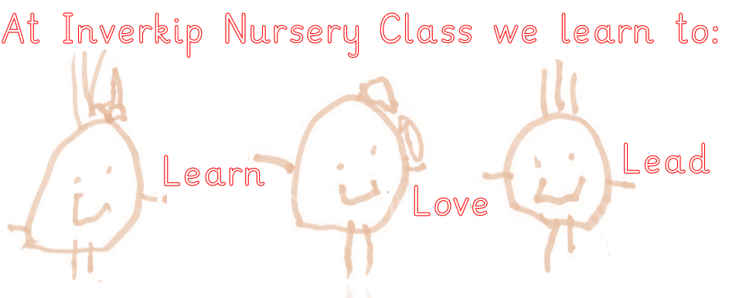

We would like to extend a warm welcome to Inverkip Nursery Class and hope that the time your child spends with us is a happy and enjoyable experience. Throughout our work, we aim for children to be safe, healthy, achieving, active, respected & responsible, included and nurtured. Above all, we value each child individually.
Inverkip Nursery Class provides early learning and child care to children between the ages of three and five years old. Currently, we have places for 30 children for a full day placement. Our Nursery Class is non-denominational. We respect and welcome children and parents of all religions, faiths and beliefs. At Inverkip Nursery Class, we develop strong partnerships with parents which enhances the quality of children’s learning experiences and is vital in meeting the needs of each child.
The Nursery Team and I are very much looking forward to getting to know you and your child
Megan Martin – Nursery Depute
Meet Our Team:
- Mrs Megan Martin
- Mrs Lauren Mitchell - EYECO
- Ms Leanne Wilson – EYECO
- Mrs Leeanne Cairns – EYECO (0.5) Mon, Tues, Wed AM
- Ms Pauline Mitchell EYECO (0.5) Wed PM, Thurs, Fri
- Ms Brogan Shaw EYECO (0.5) with us every fortnight (Wed pm, Thurs & Fri)
- Ms Emma Wilson – Nursery Support Worker

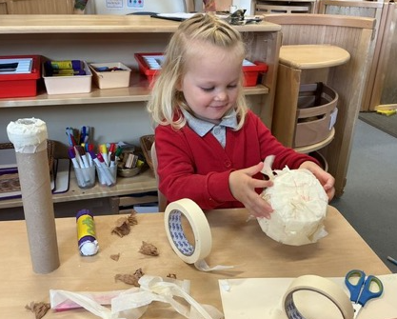

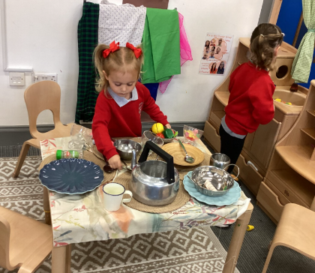

Our Team




Megan- Nursery Depute
Mrs Nicolson- Head Teacher
Mrs Bradley- Deputy Head Teacher



Lauren- Green Group EYEYCO
Leanne- Red Group EYEYCO




Emma-
EYECO Assistant
Pauline-Orange Group EYEYCO
Leeanne- Orange Group EYEYCO

Nursery Hours:
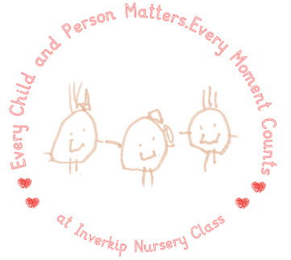
Inverkip Primary and Nursery Class are non-denominational. We respect and welcome children and parents of all religions, faiths and beliefs. Children between the ages of three and five attend. We have capacity for 30 children. This is offered in the following model, times are approximate and subject to change.
- 6 hours per day
- Between 8:45am and 4:15pm
- 38 weeks per year (Term time)
- Lunch: 11.30-12:00

Inverclyde Council are committed to meeting the 1140 nursery hours proposed by the Scottish Government. Our children are entitled to 6 hours per day and parents can arrange an individual attendance pattern from 8:45am with staff to ensure that agreed hours meet the needs of our children and their families.
At Inverkip Nursery, we are Model 1 within Inverclyde’s childcare provision. This means our staffing allocation allows us to offer chargeable additional childcare at the end of the day until 4.15pm, but not in the mornings.
We understand that nurseries across Inverclyde operate with different staffing patterns and childcare models, which is why the options available may vary between settings. Our nursery opening time is 8.45am, and we kindly ask families to plan their arrangements with this in mind.
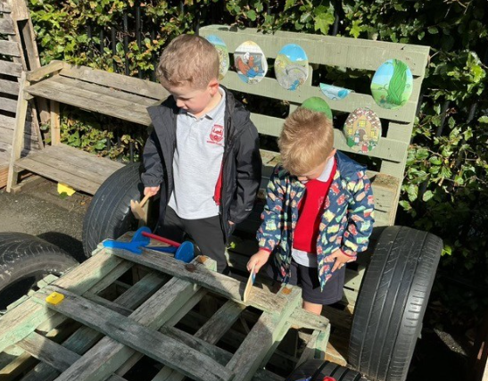

Inverkip Nursery Class has the same holidays / In-service days as other Inverclyde Schools. Please see below or follow the link to view school holidays for 2026/2027 Inverclyde Council school holidays
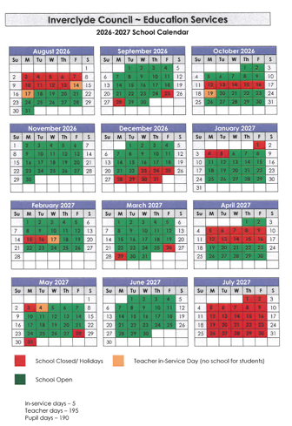

Our Vision
Our vision is to ensure that we learn today for a better tomorrow where ‘Every child matters and every moment counts’. # Learning to Learn # Learning to Love # Learning to Lead
At Inverkip School and Nursery Class, we strive to provide the highest quality of learning and teaching experiences to ensure that all children care about the world they live in and learn and develop the full range of skills to be citizens of the 21st century. Our ethos is a climate of teamwork, respect and trust, where all our children aspire to become successful learners, confident individuals, responsible citizens and effective contributors.
In line with the Inverclyde Education Service Plan, Inverkip Primary School & Nursery Class aims to offer education of the highest quality providing a stable, happy and enriching environment where children can most easily attain their full potential. The school and Nursery community has identified the following values, which reflect the important principles on which we base all of our decisions.

Our Values:
Our ROAR values are:
R | 0 | A | R
Respect | Optimism | Ambition | Resilience

We believe that:
- Every pupil matters and every moment counts
- The highest levels of achievement should be open to all as we learn today for a better tomorrow
- all learners have the right to high quality teaching where pupils Learn to Learn, Learn to Love and Learn to Lead

Our Aims are to:
- To develop a restorative perspective as we navigate and develop a consistent approach that stimulates thinking and decisions as we collectively move forward learning to learn for a better tomorrow whilst embracing digital technology.
- To ensure that planning is values based and needs led where Recognition, Empathy, Safety, Trauma, Opportunity, Relationships and Engagement are at the heart of strategic approaches. (RESTORE) and highlight the importance of relationships for emotional wellbeing, resolving conflict, preventing harm and building resilient communities.
- To provide a nurturing, happy environment where all pupils feel safe, healthy, achieving, nurtured, active, respected, responsible and included.
- To develop positive relationships built on the 6 principles of nurture and respect for the rights of others.
- To provide high quality teaching & learning experiences, cultivating a love of learning and a sense of achievement in all our pupils by work together with parents and partners to build capacity for all pupils to achieve and attain.
- To ensure that there is equity of provision and resources across the school community so that learners are not disadvantaged against their peers, by providing opportunity and exploration alongside expectations.
- To provide a broad, balanced and transparent curriculum which is challenging, has breadth, depth, relevance coherence and is fun and enjoyable where each pupil has the opportunity to thrive emotionally, socially and physically.
- To address any gaps through explicit teaching of metacognitive strategies in conjunction with specific subject content, consulting and co-constructing of learning experiences. Empowering learners to review and reflect when developing an understanding of their individual learning styles.
- To encourage effective learners to achieve their fullest potential within and out with school and nursery who can self-regulate, display resilience, enterprising attitudes, independence, skills for learning, skills for life and skills for work to positively impacting on the community in which they live.
- To foster high quality leadership at all levels through valuing and empowering all members of the school and nursery community. Pupils should consistently feel that their voice, opinions and ideas are listened to and acted upon.
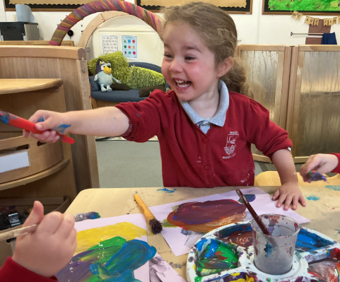
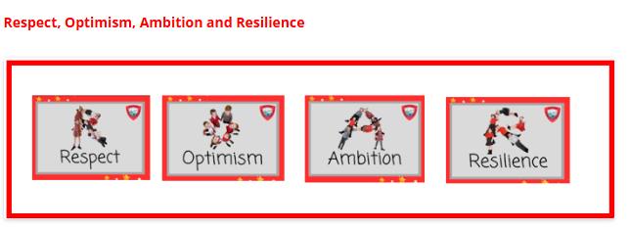
Inverkip Primary School & Nursery Class is committed to delivering on its core business of 'learning' and is thrilled with the achievement gains to date. We are committed to building the necessary knowledge and competencies for pupils to thrive and succeed in learning and life. We have a supportive and active staff, community and partnerships who are open, committed and willing to do whatever it takes to ensure that each learner is stretched and experiences fulfilment in learning.
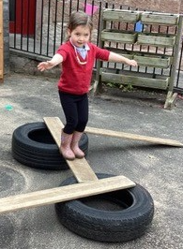

Applying For A Nursery Place:
All children are allocated a nursery place in line with Inverclyde Council’s Early Years Admission Policy.
The application period for 3-5 years opens in the January of each year. An application form must be completed and submitted to your first choice establishment along with proof of your residing address (in the form of council tax invoice) and proof of your child’s date of birth in the form of your child's birth certificate.
HOW DO I APPLY?
- Application forms are available at any ELC local authority establishment, approved childminder or private / voluntary or independent nursery.
- Application forms must be completed and submitted to the first choice provider along with;
- Proof of Residing Address – Either Council Tax Invoice / Gas or Electric bill to confirm your child’s residing address.
- Birth Certificate to confirm your child’s date of birth.
We will not accept any application form without the necessary proof of documents
Admissions:
Below is Inverclyde Council’s admission timeline. Children are allocated a place the term after their 3rd birthday.
All 3 and 4 year olds, and eligible 2 year olds, in Scotland have a statutory entitlement of up to 1140 hours of funded early learning and childcare the term after their 2nd or 3rd birthday.
If your child turns 3 between 01 March 2026 and 28 February 2027 you should be applying within the following application windows.
ANNUAL ADMISSIONS
- Application window to be presented at the Annual Admissions Panel for 3 - 5 years is;
- ELC Application window opens: 5th January
- ELC Application window closes: 16th January

Applications received after the window will be considered as a late application and will be presented at the post admissions panel.
POST ADMISSIONS
Application window to be presented at the Post Admissions Panel
ALLOCATION OF ELC PLACES
All ELC places are allocated in line with Inverclyde Council ELC Admission Policy. (Available in the document section on Inverclyde Council’s website)) and are allocated centrally.
We will always try and allocate a place based on your preference(s) from your submitted application form); however, this is not guaranteed. If your preferred option(s) is full, a ballot may be necessary to allocate places alternative provider.
This can occur in the following scenarios:
- Oversubscription of applications for 3-5-year-olds.
- Oversubscription for certain delivery models.
- Oversubscription for specific establishments or childminder or PVI provider.
If your preferred choices are unavailable, you will be offered a place in an ELC establishment within your ELC Defined Area based on your residing address. Childcare arrangements that are in place are not classed as a residing address.
Please note:
Having a sibling in the associated primary school does not provide any extra priority for ELC admission. ELC places and School places have no association.

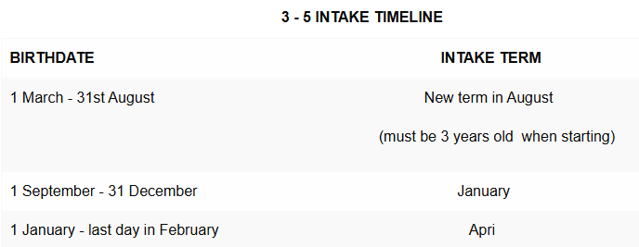
Should your child receive a place at our nursery an email offer will be sent out each May. Following on from this should you wish to accept the space you will be offered a home visit and stay and play session as part of our home to nursery transition process.
Out with your child’s entitled hours, Inverkip Nursery Class offer a chargeable childcare service for parents working or in training for employment. This is a limited paid service. If you are interested in more information regarding wraparound please speak to any of our Nursery staff about the application process. Please note we only offer chargeable childcare at the end of the day and this is not available at Inverkip Nursery class in the mornings.
For further information, please click on the link below to view Inverclyde’s application guidance- 3 - 5 Year Old Places - Inverclyde Council
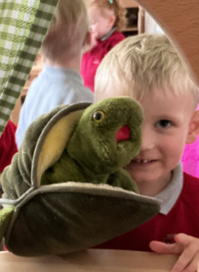
Our Curriculum- What learning looks like
.
Play is the main vehicle through which children learn. It is our aim to offer a wide variety of learning experiences, in a rich, stimulating environment which allow children to learn through play. We use the children’s interests to plan and support them in their learning.

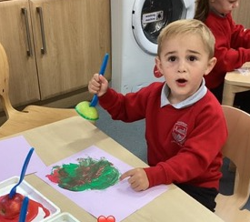
Sometimes children’s play will be busy and noisy, sometimes quiet and reflective. Staff work collaboratively with the children to plan and develop the environment and resources both indoors and outdoors. A range of open-ended materials are freely available to enable independent and active learning. Staff work alongside children whilst they play, observing, supporting and extending the learning

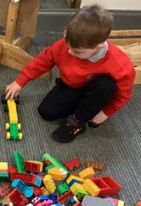
We plan and evaluate these experiences following the Curriculum for Excellence guidelines. The Curriculum for Excellence establishes clear values, purposes and principles for education from 3 to 18 in Scotland. It sets out to enable children to develop their capacities as Successful Learners, Confident Individuals, Responsible Citizens and Effective Contributors

.

Curriculum for Excellence promotes the need to view learning and teaching across curriculum subjects and areas as inter-connected and integrated. This is particularly important for young children, who will develop their understanding of, for example, science, language, communication, technology and mathematics from an everyday experience, such as water or sand play. Staff ensure that these experiences are enriching and stimulating and that adults working with children are able to understand, appreciate and assess children’s achievements and learning.

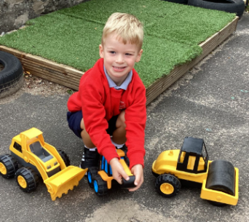

It is important to remember that it is not a final product that is important, but the skills and experiences we are developing while taking part. If your child comes home with no paintings or drawings - don’t worry! They will still have been learning – just learning through different experiences. Your child may have been busy building in the construction area, playing in the sand or playing in the house to name a few, they simply may have chosen to participate in other experiences on offer.
At Inverkip Nursery Class we consider the child under the following three categories (Realising the Ambition document):

Me as an individual:
- Each child’s needs should be at the centre of how we think about and plan for their unique development.
- Children have their own ideas and plans, and their brains and bodies are good at seeking out the kinds of activities, environments and encounters that they need to help them develop.
- Everything we do is about helping each child to grow emotionally, socially, physically and cognitively.

- Their individual learning is tracked throughout the year and appropriate next steps for learning are chosen. Children’s progress in learning is sheared via digital Learning Journals

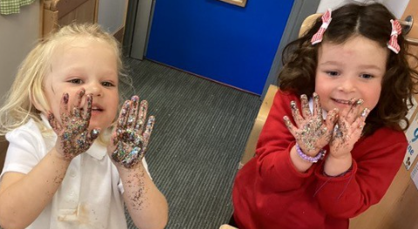

Me and my environment:
- A key part of our nursery environment for children is the human, social environment of positive nurturing interactions.

- Children need to learn things for themselves, but this does not mean they should always do so by themselves. We can, by following and building on children’s motivations and interests, support young children to make the most of the environment for learning and development.
- We promote a happy, interesting and empowering learning environment, considering the interactions, experiences and spaces on offer, to ensure we add value to what children already know and can do.
- Outdoor education plays a vital part of our provision and is maximised in all weathers. Staff support children when outdoors and ensure they have opportunities for adventure, risk and challenge in all areas of the curriculum.

My surrounding culture
- We want our children to have the strongest start in life, in a culture where they receive the right kind of support and experiences to lead secure and flourishing future lives.
- We strive to provide a balanced experience where there is the knowledge and skills that we want children to develop, such as self-regulation, confidence, and curiosity.
- We adopt a child centred way where children have permission to follow their interests and to develop at their own pace.
- High quality experiences and sensitive interactions in a variety of outdoor and indoor spaces, which will develop the emotional resilience they need to form a secure wellbeing base.

We promote children’s learning in a variety of ways through observing, planning and discussing next steps to extend, support or challenge children in their learning. Staff will be glad to discuss what your child will be learning.
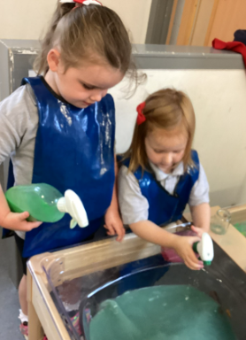
At Inverkip Nursery Class we understand that every child develops differently and in different patterns across the following dimensions of child development:
- Executive function and self-regulation
- Communication and language
- Confidence
- Creativity and curiosity
- Movement and coordination
- Self and social development.

We use an online Learning Journal with your child to collect information and examples of learning. The journals will be updated regularly and provide vital home/nursery links. Your voice matters and parents are invited to share home learning via your child’s learning journal. Staff will meet with you formally twice per year to advise you of your child’s progress. If, at any stage, you have a question, or concern, about your child’s progress please do not hesitate to speak to a member of staff who will be more than happy to discuss any concerns.

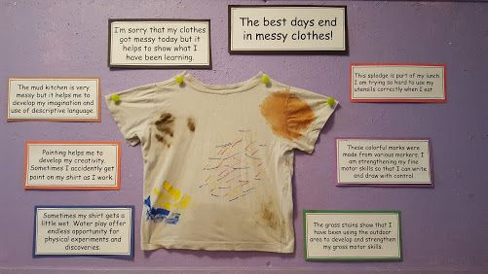
Please ensure that your child is appropriately dressed for the Scottish weather as they go outdoors every day, regardless of the weather. We have suitable waterproof clothing that ensures the children will be comfortable and dry when outside. We have spare pairs of welly boots at the nursery, but it would also be good if your child had a pair of wellies that they could keep at nursery for outdoor play. It would also be beneficial if you could provide your child with a spare set of clothes they can change into if required.

Inclusion and Equality:
Inverclyde Council Education service aims to:
- Offer education of the highest quality to all young people within a developing culture of inclusion
- Endorse the principles of inclusion, entitlement and equality of opportunity in the development of best practice
- Value the diversity of interests, qualities and abilities of every learner
- Believe that every child and young person is entitled to educational opportunities which enable the achievement of success and further development of the individual’s learning potential within the least restrictive environment
- Affirm the right of all young people to have access to the highest quality of educational provision which is appropriate to learning needs, is supportive of the young person and is delivered in partnership with young people, parents and the wider community.
- In meeting the needs of all our pupils we will demonstrate no discrimination on the basis of race, gender, disability, sexual orientation, religion or belief. This encompasses curricular, extra-curricular and playroom activities and is foremost in the attitudes which we develop in our pupils.
Inclusion and Equalities:
The Equality Statement for Inverclyde Schools and Nurseries outlines the Council’s commitment to ensuring an inclusive approach:
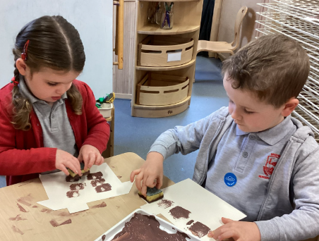
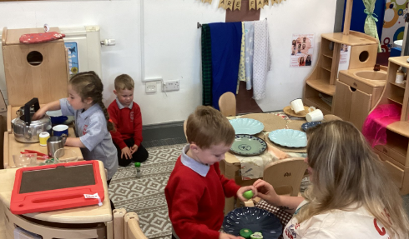

‘Inverclyde Education Service is committed to ensuring that no children or members of staff or service users receive less favourable treatment on any ground including gender, race, disability, age, sexual orientation, religion or belief. We have a moral, social and legal obligation to mainstream and put equality at the heart of everything we do. We aim to promote a culture in which equality of opportunity exists for all. We are opposed to all forms of discrimination, direct or indirect, and aim to eliminate all discriminatory practices. We will ensure that, in our schools and other educational establishments, equality permeates the curriculum and underpins all our policies and practices in terms of access to education. We must ensure that all our children achieve their full potential to develop physically, emotionally and academically. Finally, we believe that equality and inclusion should be a given right, where everyone is valued and treated with respect.

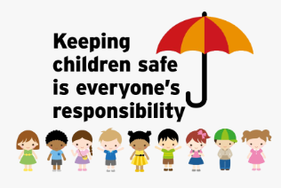
Child Protection
Inverclyde Council Education Services has Child Protection Guidelines and Procedures which all schools and establishments are required to follow. Education Services work very closely with other agencies namely Police Scotland, Social Work Services, NHS Greater Glasgow and Clyde and the Children’s Reporter to support children. Common responsibilities of all staff are to protect children from abuse and exploitation, to respond appropriately when abuse is identified, and to ensure whenever possible that all children are able to exercise their right to be raised in a warm, stimulating and safe environment with the support of staff, their families and carers.
At Inverkip Nursery Class, the safety and wellbeing of every child is our highest priority. All staff have a duty of care to protect children from harm and to promote their welfare. We follow Inverclyde Council’s Child Protection Procedures and staff are trained regularly to ensure they are confident in recognising and responding to any concerns. If we are ever worried about a child’s safety or wellbeing, we are required to share these concerns with the appropriate services. Please be assured that this is always done sensitively and in the best interests of the child.
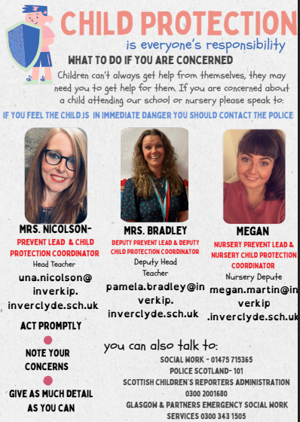
Our designated Child Protection Co-ordinator is Mrs Una Nicolson (Head Teacher).
The Depute Child Protection Co-ordinators are Megan Martin (Depute Head of Nursery) and Mrs Pam Bradley (Depute Head Teacher, Primary).
Parents and carers are encouraged to share any concerns they may have about a child with us as soon as possible. You can speak directly to a member of staff, or contact one of our Child Protection Co-ordinators. Working together helps us to keep every child safe, happy and supported.

Additional Support Needs:
Every member of staff has a responsibility to support learning of all children. The type of support offered will vary according to the needs of children. This includes consideration given to children who have a disability, children with social, emotional and behavioural difficulties, children with learning difficulties of a specific or general nature, children who are exceptionally able, those who demonstrate underachievement relating to gender issues, children whose learning has been interrupted through absence or illness, bilingual children who have English as an additional language, travelling children and those children whose family circumstances impact on attendance and learning. With the agreement of parents/carers, partner agencies may be asked to offer support where necessary.
The Nursery staff are always available to discuss any concerns with parents. If you are worried about any area of your child’s development please bring it to the attention of a member of staff.
Although we do not have a routine medical examination in Nursery we do have contacts with our local Health Visitors, Oral Health, Dentist and Speech Therapists.
Occasionally it is necessary to call on the expertise of other professionals to seek advice on a child’s area of development. This action would only be taken after thorough discussion with parents. Parents can approach any one of the above services themselves.
Enquire also provide a range of clear and easy-to-read guides and factsheets explaining everything from 'additional support in the early years' to 'what planning should take place for moving on from school'.
- www.enquire.org.uk (for parents/carers and practitioners)
- www.enquire.org.uk/yp (for children and young people)
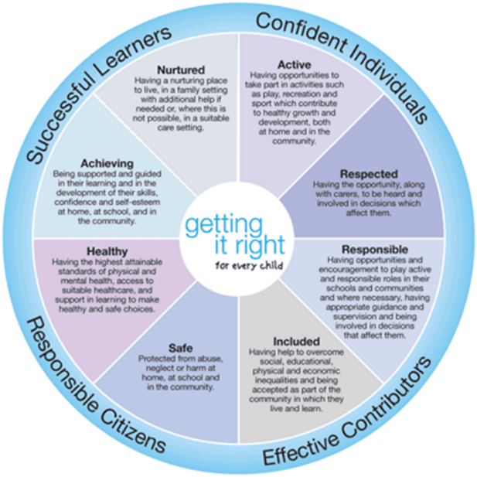
Getting it Right for Every Child (GIRFEC)
GIRFEC is the national approach to improve the wellbeing of children in Scotland. At Inverkip nursery everything that we do is designed to promote, support and safeguard your child’s wellbeing. Below is an example of the wellbeing wheel and the indicators we would look at in order to ensure we are getting it right for your child. We ensure the wellbeing of all children and their learning and progress by having monthly GIRFEC meetings to assess children emotional and social wellbeing and put in place any short term supports.
We complete SHANNARI reports to outline children’s progress in each wellbeing indicator aspect. This is following parents completing individual care plans and all about me documentation to share learning from home
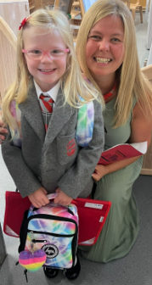
Transition:
The key to effective transition is effective communication between the early years establishment, school and parents. The transition process will begin early in the
Pre-school year and continue into early Primary 1.
Children usually transfer to primary school between the ages of four and a half and five and a half although, this may be negotiated in certain circumstances. Due to our fortunate position within the school, we are able to make the transition a smooth and happy one. During their time in Nursery, the children will be visiting different parts of the school and will become familiar with the environment and many of the staff.
Throughout the year we will be working closely with our primary colleagues to ensure a smooth and seamless transition to Primary 1. Primary 1 is not simply a fresh start; it’s all about taking learning forward and continuing the Early Level curriculum. Pre-school children will also have opportunities to visit their Primary 1 class in small groups and be visited by their future teacher.
An Inverclyde Council ‘Nursery to Primary Transition Record’ is completed for each pre-school child. This record will be given to you in May/June when you will be invited to add comments or highlight information you would like shared with your child’s Primary School.

Information on registration and enrolment procedures for school will be given in the local press during January as well as in the Nursery
Key Person:
When your child starts Nursery, they will be allocated a group and key worker. This gives staff the opportunity to observe children every day during planned experiences and to assess their progress. Through these observations staff can plan the next stage of individual children’s learning. What children can do with the help of an adult today, we want them to do on their own tomorrow! Children are regularly involved in a wide range of activities that reflect all areas of The Curriculum for Excellence. This play takes play both indoors and outdoors. As practitioners we are able to building on each child’s prior knowledge and interests and adapt our learning to provide a rich and stimulating environment.
Green Group:
- Mrs Lauren Mitchell - EYECO

Red Group:
- Ms Leanne Wilson – EYECO

Orange Group:
- Mrs Leanne Cairns – EYECO (0.5)
- Ms Pauline Mitchell EYECO (0.5)
Home Visit and Stay and Play
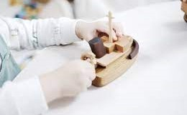
We offer a home visit for our families. This visit is not a compulsory visit, however provides an opportunity for children to meet their keyworker within their own comfortable environment. During the home visit, staff and parents can discuss the nursery routine and general life of the nursery. A follow up stay and play session is offered the following week of home visit, which is an opportunity for your child to explore the nursery environment whilst out with session times.
Settling in to Nursery:
It may take a few days for your child to settle at Nursery. To aid with this process we offer a settling in procedure however, is it important to remember that every child is unique and this may look different to each family.
For your child’s first day they will attend for one hour and then gradually build up over the course of the week. It is important to work in partnership throughout this period to ensure we are supporting and meeting the needs of your child. Your key worker will keep you up to date with how they are settling in to their new environment.
Emergency Contacts and Security:
Parents are asked to provide the staff with the names, addresses and telephone numbers of 2 contact persons for use in case of emergency. It is important for you to keep the Nursery up to date with any changes in this information, especially mobile phone numbers.
An adult, or someone over the age of sixteen, must bring and collect your child. If you are unable to get to Nursery by the end of a session you must contact us. If you ask someone unfamiliar to the nursery to collect your child you must share with them your child’s password and let a staff member know. If you have not left a message for an unfamiliar adult to collect, staff will contact you by phone to confirm the adult has permission to collect. If you have any instructions about who has NOT to take your child out of Nursery please discuss it with staff. If you share your child’s password with an adult no longer allowed to collect please advise staff of this and passwords can be altered. Please note that parents’ cars must not enter the school premises.
Absence:
You must also contact the Nursery by 10am if your child is going to be absent on any day. If we do not hear from you, we will telephone you or the emergency contact number on the enrolment form. We really do appreciate a quick call to let us know if your child will be absent.

Insurance:
Sometimes children like to bring in something new or something special to the Nursery for their friends to see. Parents should ensure that valuable items are not left at Nursery as the Authority has no insurance to cover the loss of such personal items. Clothing left in the cloakroom is also not the responsibility of the Nursery.
Clothing:
Children have the best fun when they are having the messiest fun! For nursery, please dress your child in clothes which you don’t mind getting messy as we cannot exclude children from experiences. This includes appropriate shoes and coats for outdoor use. Also, as the children have lots of physical play, they should not wear jewellery.
We also respectfully request that you put your child’s name on items of shoes and clothing which they wear to nursery to avoid mix ups.
Nursery polo shirts and sweatshirts embroidered with the school badge are available to purchase from several outlets. It is not compulsory for the children to wear this uniform. You’ll find Nursery uniforms in the School Uniform Recycling Bank. All items here are completely free of charge. Ask at the school office to browse this facility.

Illness at Nursery
The safety of your child is of paramount importance to us and although every care is taken, accidents do occur. If a child becomes ill or has an accident we would immediately contact you and if unable to reach you we would use the emergency numbers on the enrolment form.
If your child has an infectious disease he / she should not attend the Nursery. A copy of policies and guidance relating to illness and preventing the spread of infection can be found in the cloakroom.
Medication, illness and allergies
On enrolment, parents are asked to give information about their child’s health. It is important that your key worker is informed of any medication given or allergies your child may have. Please keep staff informed so that information can be kept up to date at all times.
If your child is in need of medication during their time at the nursery you should discuss this with your child’s key worker. Prescribed drugs will be administered at the discretion of the Head Teacher/Depute and will require you to complete a consent form. If your child requires an inhaler you must provide one to be kept at nursery. There will be paperwork required to be completed. Your child’s inhaler must be provided in its original packaging (box) with the child’s name and the date clearly visible on the doctor’s label. A spacer for your child’s inhaler must also be provided.
If your child becomes ill while at nursery, we will contact you and ask you to collect your child. If we are unable to contact you, we will endeavour to reach the emergency contacts provided at enrolment. Please note, NHS guidelines recommend keeping children at home for 48 hours after any sickness or diarrhoea. This helps to stop the spread of viruses and illness.
Healthy Eating:
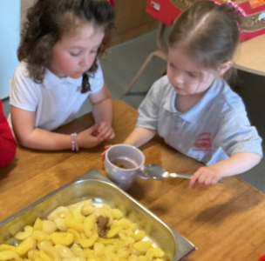
We are very interested in fostering good eating habits in the children. Inverkip Nursery Class aims to promote positive attitudes towards healthy eating together with providing opportunities for physical activity which contributes to becoming a “health promoting establishment.”
As part of the increased hours, children will receive a well-balanced and nutritious hot meal at lunchtime, served in the school lunch hall. You will receive information on this from the nursery, including the lunch menu and the process of helping your child choose lunch on a daily basis. Each day we provide a snack for children which consists of milk or water and fruit or vegetables. Children will be given a variety of different snacks throughout the year to celebrate festivals, parties etc. Parents will be notified of these events.
The daily snack will often consist of a variety of fruit. We also provide milk and water. If your child has an allergy, it is essential you bring it to the attention of staff immediately. Please note that Inverkip Nursery Class is an ‘Allergy Aware’ zone.
Nursery Funds
A voluntary contribution of £1 per week is much appreciated. This provides funds to finance treats and helps purchase resources for rich learning experiences such as woodwork and baking.
During the year we may have additional fundraising events which we hope you will support. There may be times when we have to raise funds for specific events. However, we will only fund raise if it is necessary!

Visitors:
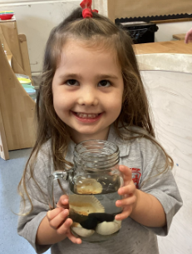
We have a variety of people who visit the Nursery during the year. The photographer usually visits the school and we also have visits from a variety of specialists depending on the additional support needs e.g. speech therapist, psychologist, health visitors etc. Throughout the year we help train a variety of students from West College Scotland, Glasgow and Strathclyde University. Pupils from our local Secondary Schools also come for their work experience.
The children take part in a tooth brushing programme and will have a visit from an Oral Health Educator.
Photographing/ Filming Of Children
We regularly take photographs of the children in our Nursery for their Learning Journals. Occasionally, we may use these images in our handbook or in our other printed publications, as well as on our website, Twitter or on display boards. We may also make video or webcam recordings for conferences, monitoring or other educational use. Inverclyde Council may also use our photographs of children to illustrate work in Inverclyde schools and establishments in council publications, publicity materials and the Internet. You will be asked to sign a form when your child enrols within Nursery seeking your permission before any of this takes place
Partnership with Parents:
Our relationship with you, as parents, is vital in supporting your child’s development and learning. We aim to:
- foster a common understanding between staff and parents about the aims of the Nursery
- advise parents on how to help with their children’s learning and development
- keep parents in touch with their children’s progress
- encourage parents to take part, if possible, in Nursery life
- keep parents informed about Nursery matters

We will provide you with information about the Nursery in a range of ways through our notice boards, daily contact with staff and regular newsletters.
Parents can access information and photos of their child’s learning through our online profiling platform: Learning Journals.
Your child’s development and progress is monitored continuously throughout the year by nursery staff. Our floor books of learning and achievements are kept in Nursery, which parents can view during parents’ meetings and can contribute to throughout the year. Staff are always happy to discuss your child’s progress any time of the year. For matters that may require in-depth discussion an appointment can be organised by staff.
Promoting Positive Behaviour
Within Inverkip Nursery Class all our work is underpinned by policy and procedure. We have a promoting positive behaviour policy within the nursery which is implemented by all staff. Please feel free to speak to a member of staff in order to look at any of our policies, these are available at any time. Within the nursery we also value the importance of building relationships and providing a nurturing and caring environment.
The relationship between children and practitioner is similar to that between child and his/her own parent requiring mutual consideration on both sides. In Inverkip Nursery we follow Inverclyde Council’s Positive Relationships policy. A copy can be found on our school website. Additionally, we implement the PAThS programme which supports children in their emotional understanding and regulation development
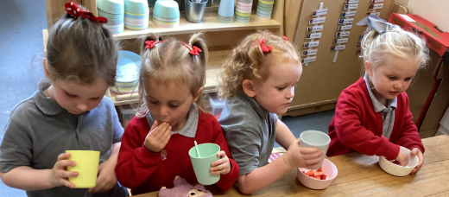

Equal Opportunities and Social Justice:
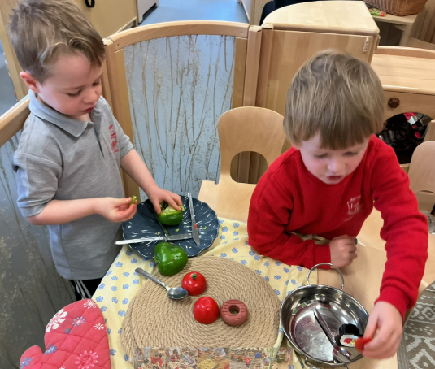
We aim to promote equal opportunities throughout the nursery. Experiences and resources take account of cultural diversity and are not associated with girls or boys. Children are given a sense of belonging within our community and are encouraged to be thoughtful and responsible - for themselves as well as others. Staff are careful to model ways of behaving with courtesy and respect towards the children and each other. Children’s views, opinions and ideas are listened to and are valued by staff.

Gender Equal Play:
Within society, gender stereotyping is a deep-rooted and common issue. At Inverkip Nursery Class, by adopting a gender equality approach we are helping children to achieve and aspire. We want children to be whoever they want to be and make them feel equally comfortable playing football or taking part in dance and aspiring to a wide variety of careers and pathways.
By helping to challenge these gender stereotypes from a young age, we can help to stop the negative consequences of inequality and discrimination by supporting children to grow into adults who aren’t limited by expectations based on their sex. By providing children with environments that encourage non-gendered norms and expectations, children can feel more accepted and celebrated for their individuality. They can broaden their aspirations and be more open to a wide range of opportunities
Trips and outings:
When trips or outings are planned for children, staff will let you know in advance. Parents may from time to time be asked to accompany children and staff.
Children, staff and parents all enjoy outings, and they are a valuable part of the children’s learning. When you enrol your child you will be asked to give permission for local outings e.g. for walks to the park or local shops.
Students:
We welcome students training to become Early Years Education and Childcare Officers at both NC and HNC levels. We also have PDGE teaching students and have also welcomed work experience pupils from local high schools. Staff and children benefit from enthusiastic students and the students have the opportunity to learn from the staff expertise. Students are supervised at all times by our experienced staff.
Concerns or complaints
If you have any concerns please do not hesitate in contacting your child’s keyworker, the nursery staff or the Head teacher, Mrs Una Nicolson.
If parents are unhappy about any aspect of the nursery, we would again ask that they contact the nursery as soon as possible to arrange a meeting with either Andrea or Mrs Nicolson. It may help if when contacting the nursery, if you give some details of the issue to allow prompt investigation. We will arrange a meeting to hear your complaint and would hope that it will be resolved satisfactorily and quickly. If the complaint is found to be justified, we will endeavour where at all possible to put right what went wrong, to make adjustments to try to prevent a similar problem arising in the future and to offer an apology where appropriate. If you are still unhappy with the service or with our response then you will have the right to take up the matter further with the Education Department. Complaints can be made in writing, by telephone or e-mail or by visiting the office in person.
Callers can contact the Education Department during office hours for information on how to raise a complaint – Tel: 01475 712850.
You can also contact the Care Inspectorate. If you have any complaints regarding any issues with the service. The Care Inspectorate address is below.

Care Inspectorate:
The Care Inspectorate is responsible for the registration and inspection of Inverkip Nursery Class. If you have any complaints, suggestions, comments or criticisms then you are able to contact the Care Inspectorate independently and any complaint will be replied to and investigated within 28 days. The Care Inspectorate inspects the Nursery on a regular basis.
Our Inspector for Inverkip Nursery Class is:
- Inspector: Lisa McDonagh
- Email: Lisa.McDonagh@careinspectorate.gov.scot

Please click the link below to view a copy of our last inspection report (October 2023):
Nursery Care Inspectorate Report October 2023

The nearest office is:
The Care Inspectorate
4th Floor
No1 Smithhills Street
Paisley
PA1 1EB
The telephone contact number is 0141 843 4230
USEFUL ADDRESSES
Inverclyde Council
Education Services
Wallace Place
Greenock
PA15 1J

Ruth Binks
Corporate Director of Education, Communities & Organisational Development

Michael Roach
Head of Education Communities and Organisational Development

Alison McLellan
Education Officer

Yvonne Gallacher
Pre 5 Development Manager

Councillor Jim Clocherty
Convenor of the Education & Communities Committee
Inverclyde Council
Municipal Buildings
Greenock

