Primary 4 Term 2 bulletin.
Dear parent,
I hope everyone had a relaxing October Break! I am very excited to be starting our second term. Primary 4 have worked very hard through term 1, let’s keep it up for term 2! P.S. I’m still in awe of how lucky I am to have this class. Every day your lovely children bring smiles to my face! I am so proud of them all. This newsletter will provide you with important information regarding our class learning and skills that will be developed during this first term.

Health and Wellbeing.
As previously mentioned in my last bulletin, your child’s happiness, health, and wellbeing are extremely important to me and our school. I will continue to nurture, support and guide all my pupils through their new learning and life experiences. Any challenges we come across, we work together as a team to solve it. Primary 4 are excellent at sharing their emotions and problem solving together. There will still be a health and wellbeing check-in every morning. I am so glad to say our classroom is a place where pupils feel safe and can freely discuss any of their concerns, feelings, and emotions. It was very important to me that we established that positive atmosphere in our classroom from the beginning. Our Health and Wellbeing focus for this term will be SHRE (Sexual Health and Relationships Education).
To be covered:
RSHP – Names of Parts of My Body
RSHP - Similarity, Diversity and Respect
Ø I am unique/My self-portrait
Ø We are Similar and Different
RSHP - Similarity, Diversity and respect
Ø Boys and Girls
RSHP - Similarity, Diversity and Respect
Ø Disability
RSHP – Similarity, Diversity and Respect
Ø Heterosexual, Lesbian, Gay, and Bisexual

Numeracy and Maths.
This term our numeracy focus will be addition, subtraction, multiplication, and division. This will involve:
- Exploring non-count by one strategies for addition and subtraction.
- Adding and subtracting 3-digit numbers.
- Solving problems using grouping and sharing methods.
- Applying various strategies and using this knowledge to develop our skill of recalling multiplication and division facts.
Our Maths focus this term is data analysis and information handling. This will involve:
- Designing and using own data collection methods.
- Drawing diagrams, table and charts to display data.
- Reading information from diagrams and tables.
Health and Wellbeing continued…

We have been loving our group point system. This encourages pupils to maintain the high expectations for learning, behaviour, and displaying our school and class values. We have had two winning teams so far, but I have to say it has been close calls each time. I will be continuing to choose a Miss O’Neill Superstar to receive a Miss O’Neill sticker. I must reiterate these are gold dust. If your child receives one, it must be celebrated. This means Miss O’Neill is bursting with pride. We will also be continuing awarding the Kind Koala. This sits on the chosen pupil’s desk for a week. Pupils receive this if they have displayed an act of kindness in the previous week or display it all the time. This value must be celebrated.

Listening and Talking.
Pupils are given frequent opportunities to work independently, with peers, and with grouping of differing sizes. This term within listening and talking we will be continuing our previous learning alongside
- Constructing classroom debates and discussions.
- Responding to videos.
- Develop our asking and creating questions skills.

Reading
Starbooks is thriving with lots of frequent customers. There have been quite a few bookmarks filled and prizes given already. This is very impressive. Pupils have enjoyed completing their book reviews. This term we will be expanding our book reviews and going into a little more depth.

Core reading work will continue alongside the accompanying comprehension activities completed in class. Reading permeates the entire curriculum. Therefore, in class other reading activities will develop the following skills:
- Recognising writer’s techniques within text.
- Recognising the difference between fact and opinion.
- Continuing to develop summarising, clarifying, questioning, and predicting skills.

Accelerated Reader
You may have heard your child talk about Accelerated Reader (AR). Accelerated Reader is a programme designed to help improve children’s reading skills and ‘accelerate’ their reading age over time.
In class, the children have taken a Star Reading Test and the results of this test help direct the children towards books within a certain level/range, most suited to them. This range is known as the Zone of Proximal Development or ZPD.
Pupils then select books to read (within this ZPD) and once each book has been read, pupils complete an online quiz to check their comprehension and understanding of the text. Scores from these quizzes are tracked, allowing teachers to monitor pupil progress in reading. The target for quizzes is to achieve 90% or above to show growth in reading.
Star Reading Tests are carried out 3 times per year to allow teachers to monitor progress.
The children have been given login details for Accelerated Reader and these can be found on the little card (inside the spelling homework jotter) containing logins for Glow, and accelerated reader. Also on this card is a note of the ZPD which shows the level of books that children should choose. There will also be a grid sent home where pupils can document their book, author, and score. Pupils can access Accelerated Reader quizzes by clicking on the link below:
https://bit.ly/3QsHbWC
Another advantage of Accelerated Reader is that pupils can also use some of their own books from their bookshelves at home. You can check to see if there is a quiz for these books by visiting the link below:
https://bit.ly/3GjkVHR
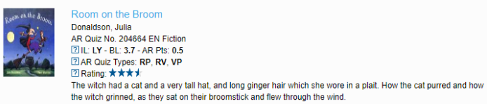
Above is an example of what you would find if you searched for a book using this link. The letters BL represent the Book Level for this book, which, in this case would be 3.7.
At home pupils can read the AR book borrowed from class and can quiz using the link above. They can also read their own books if they would prefer to. Parents can also read these books to their children as the quiz will ask pupils if they have read it themselves, with an adult, or if the book was read to them. Pupils should answer the quiz questions themselves.

Writing
In our writing we will always have a focus on Vocabulary, Connectives, Openers, and Punctuation (VCOP). This term particular skills we will focus on will be:
- Discussing features of writer’s craft.
- Functional writing which involves organising and presenting information in different ways, including your opinion, and using vocabulary and specific language to convey information, describe events or processes.

P.E.
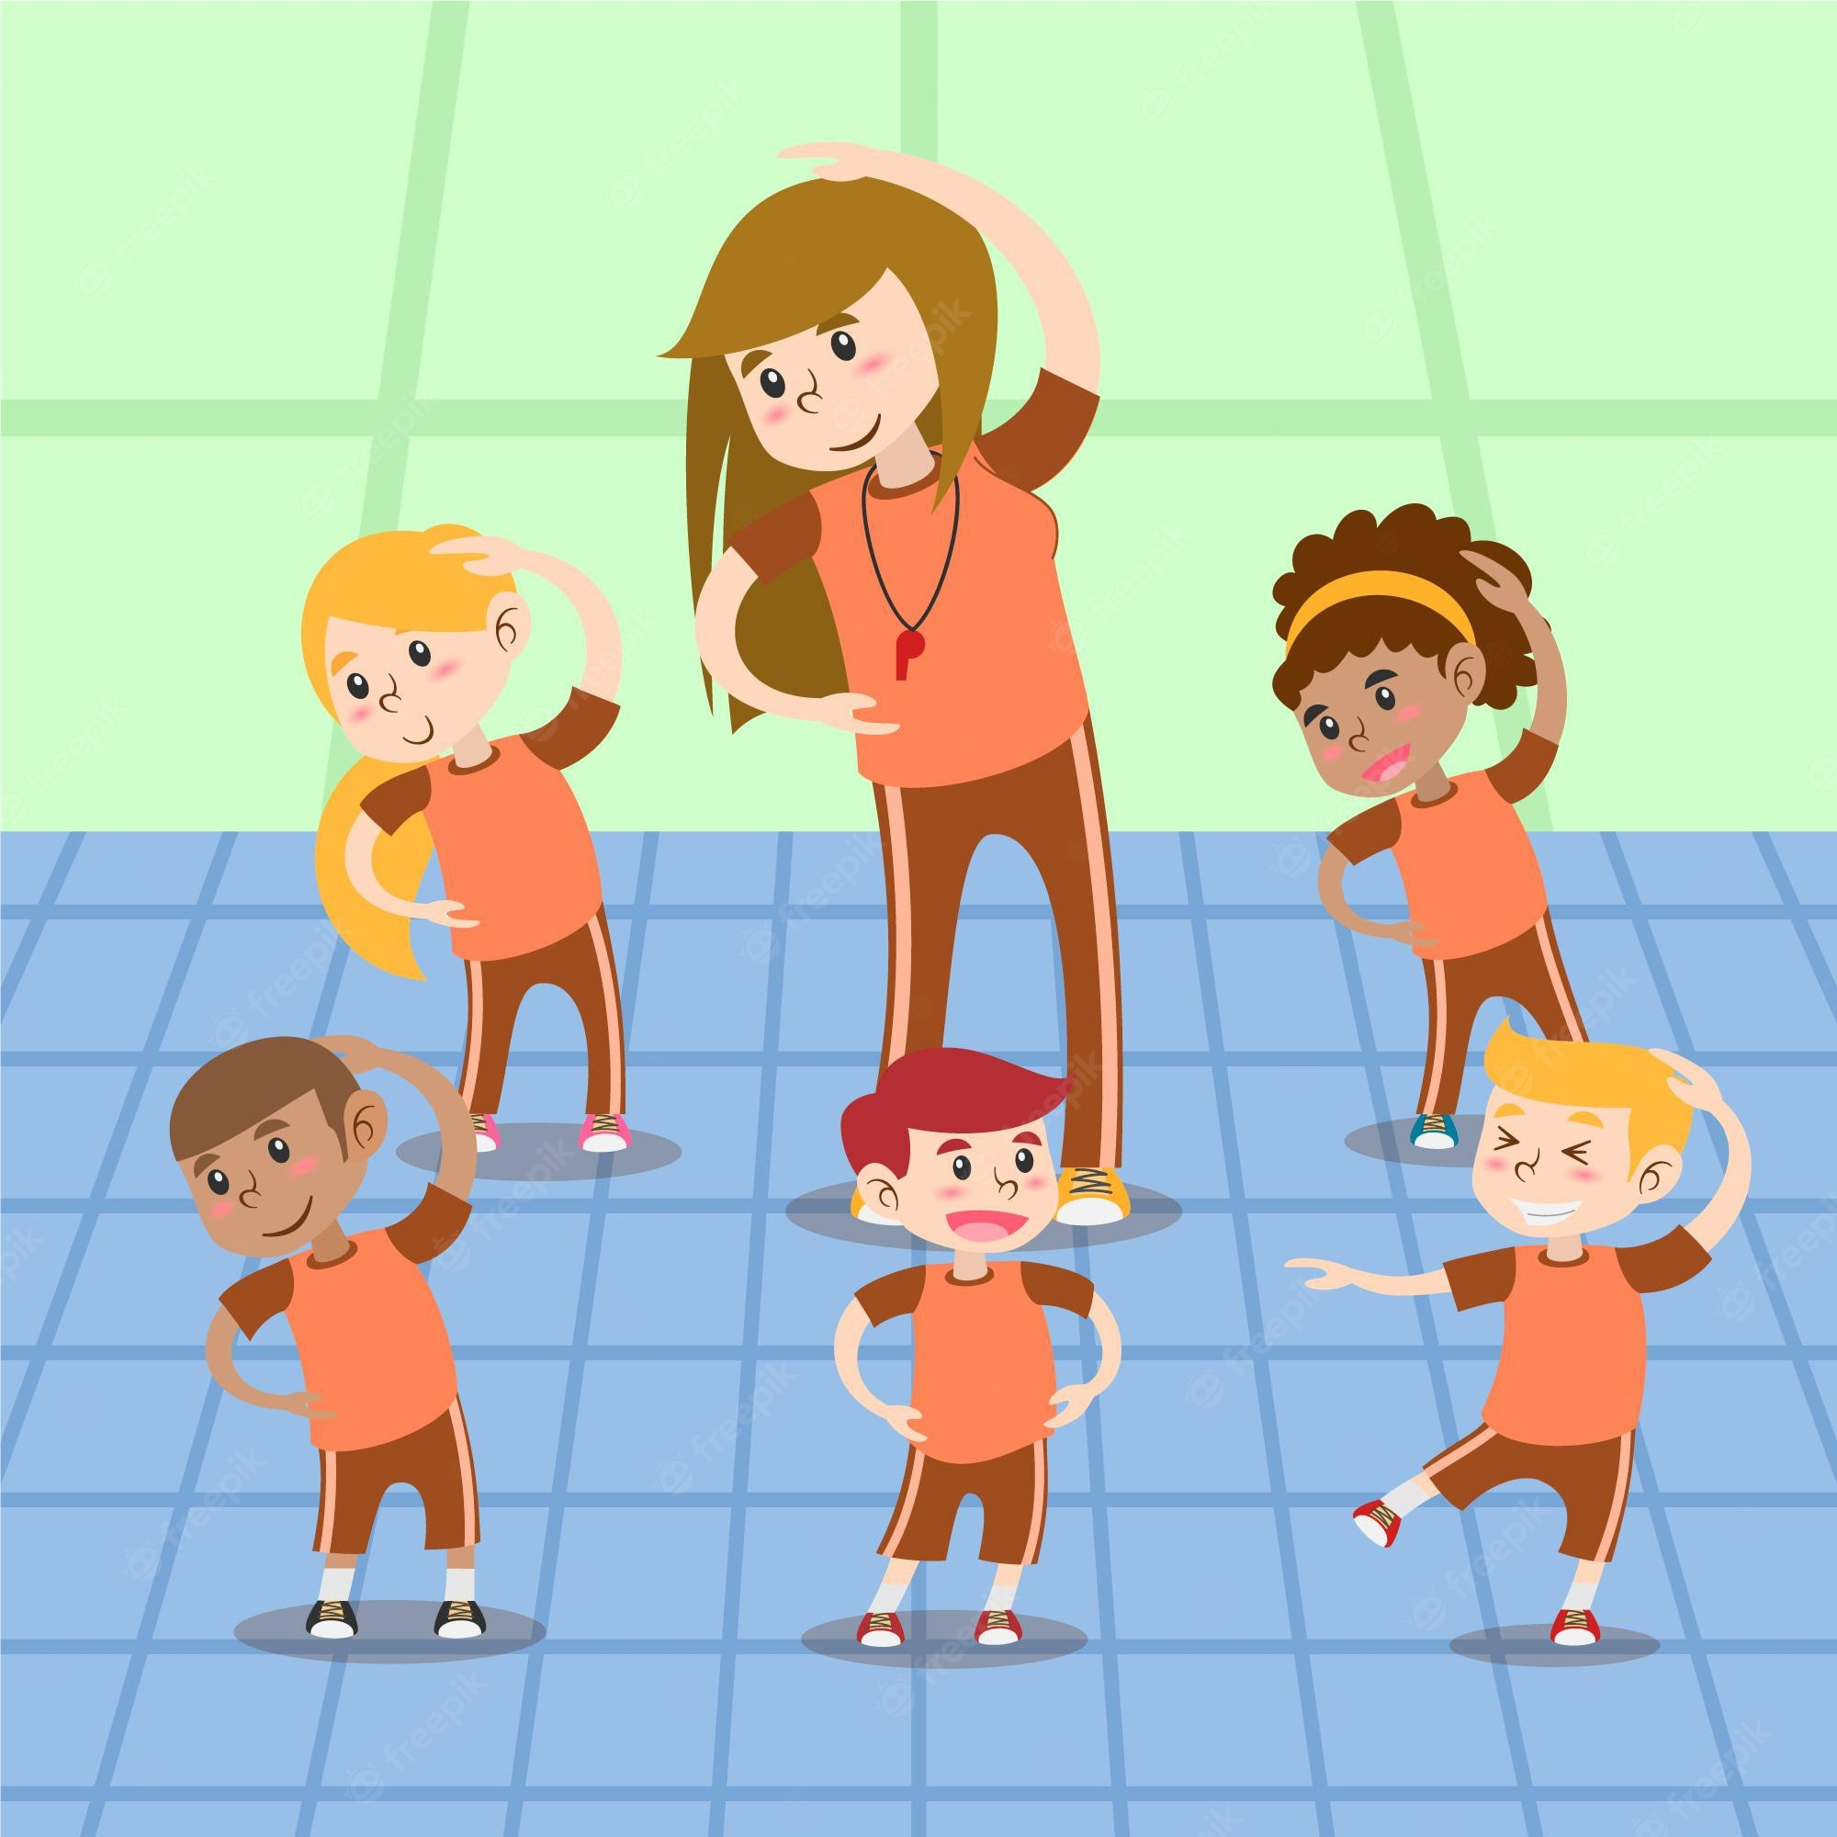
Our P.E. days are Tuesday mornings and Wednesday afternoons. Full gym kit comprising of a red polo shirt, a pair of black shorts and a change of shoes should be brought on these days. For ease of changing, polo shirts can be worn to school on P.E. days. To comply with authority guidance, all long hair must be tied back, and jewellery should be left at home. This includes earrings, as these can be especially difficult for pupils to remove themselves.

Homework
Homework will be given out on a Monday and collected on a Friday. I will give out a homework grid each week. This grid will have on it spelling words, a numeracy task, and a reminder to create 2 reading questions. I would like both the spelling homework and numeracy activities to be done in the homework jotter. The reading question should be completed in the reading record.
Reading
Reading books will be given home on a Monday. I will hear them read in class on Mondays. Pupils should be heard reading at home every night. Pupils should write 2 questions about their book in their reading record for others in their group to answer on Thursdays during literacy time. Please support your child to do this, emphasizing the importance of a question word at the beginning (e.g., Who? When? Where? What? Why? How?) and a question mark at the end. Please sign your child’s reading record once to show they have completed this task each week. Furthermore, ensure that reading books come to school in the reading wallet every day.
Spelling
Spelling homework will be issued on Mondays after the new spelling rule has been taught in class. Pupils must complete look, cover, write and check for their list of words 3 times. Then, choose 4 activities to complete from the spelling activities stuck in the front of their jotter. Shading in a circle beside an activity once completed. Trying to vary their activities each week.
Numeracy
Each week pupils will get a numeracy task reinforcing the work they have previously done in class. This should be completed in the homework jotter, which should be signed by an adult, and returned to class on Friday.
Occasionally other homework may be given in relation to our topic study.

Staffing
On Mondays, Tuesdays, Wednesday mornings, and Thursdays I will be teaching in class. Mrs Chalmers has the responsibility of the class on Wednesday afternoons and all-day Friday. Our pupils support assistants this year are Mr McCauley and Mrs Nichol who will support pupils in class each week.

Reading wallets
It is very important that reading wallets are brought to school every day. Homework, letters, and important information will be put in here. Please check these at home each night and ensure they are kept tidy and free of unnecessary clutter.

I hope this bulletin provide you with all the information you need. Please do not hesitate to contact me if otherwise. Always happy to help. Any questions, worries, queries are welcome. You can catch me at the end of the day at hall 1, or by contacting the school on the usual number.
I can’t wait to see Primary 4 smash this term! I can already see their talents, and skills developing. I am so proud!

Yours sincerely,
Miss O’Neill.

