Primary 3 Bulletin (Term 2)



Dear Parent/Guardian,

I hope you and your children enjoyed your October break. I have been enjoying hearing about some of your lovely days out and holidays that the pupils have been sharing with the class.

The pupils had settled in well to Primary 3 during Term 1 and I am looking forward to continuing to work with them in Term 2. This new bulletin will detail our learning for the new term ahead.

Health and Wellbeing

Your child’s happiness, health, and wellbeing continue to be of the upmost importance to me. Our topic this term will focus on the Disney Pixar movie, ‘Inside Out’. We will be exploring how our emotions can make us feel or react. Through this focus we will engage with varying topics to help us develop a stronger understanding of our own emotions and the emotions of others around us.



As part of our Drugs Education, Mrs Provan will help P3 explore how medicines and other substances can be used in a safe way to improve health.

Numeracy and Maths



During this term in Primary 3 Numeracy and Maths we will focus on:

* Using symbols to help describe number relationships, up to 100.
* Addition and Subtraction strategies using 2 digit numbers.
* Multiplication and Division, focusing on times tables and grouping numbers.
* Fractions, focusing on halves and quarters.
* Mrs Provan will be focusing on Money this term in Primary 3 also.

Reading



Core reading work will continue using the Rigby Star and Dandelion reading programme, and comprehension activities associated with these texts will be done in class. The many other varied reading activities provided in class this term will allow the pupils to focus on developing the following skills:

* Reading, retelling, and discussing story sequences.
* Discussing simple features of text structures including main events, characters actions, story beginnings and endings.
* Using punctuation when reading aloud.
* Using word attack strategies to decode unfamiliar words.

Our focus during reading sessions in Term 2 will be to add more expression by taking note of important punctuation.

Listening and Talking

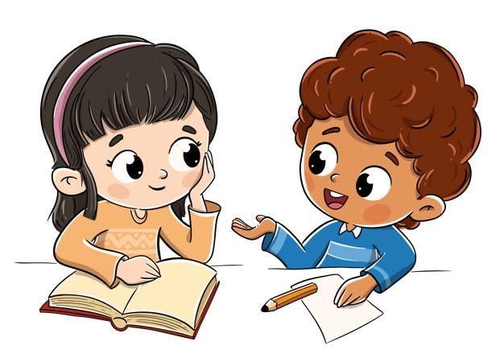

Within Term 1 the pupils worked hard on developing their listening and talking skills. Moving into Term 2 we will be continuing to develop these skills. Towards the end of Term 1 we co-created a ‘Good Listening’ Y-chart. This depicts what good listening looks like, sounds like and feels like. The children were able to add relevant information to this chart and this will be displayed in class so they can refer to this.

Writing



In Term 2 we will continue to use the Big Write programme for writing which focusses on developing the children’s Vocabulary, their use of Connectives, Openers and Punctuation (VCOP). This term we will concentrate on developing:

* Our range of vocabulary (WOW words).
* Our use of basic punctuation.
* Our use of connectives.
* Our ability to write independently.
* Our presentation and legibility of writing.



Reading

Reading books will be issued each Monday morning and the children will be heard reading in class with me on Mondays, Tuesdays and Wednesdays. Pupils should **ideally** be heard reading at home every night and should discuss the ideas as set out in the homework information letters. Each week, pupils should prepare **one** reading question about the story they have read, and this should be written in their reading notebook. Please support your child to do this, reinforcing the importance of a question word at the beginning (e.g. Who? Where? When? What? Why? How?) and a question mark at the end. Pupils will then put these questions to their classmates on a Thursday afternoon during literacy time. Reading books will be gathered in on Friday mornings. Pleasure ensure that reading books come to school in the reading wallet **every** day.

Spelling

Spelling homework will be issued on Mondays after the new spelling rule has been taught in class. Pupils can choose **up to three** activities from the Spelling Choice Board inside the jotters to complete by Friday. Please ensure your child chooses different tasks and does not always choose the same ones. These activities should be signed in the jotter each night by an adult. Revision of the spelling rule and all spelling words should be done on Thursday nights in advance of the weekly spelling test on a Friday. Spelling homework jotters should come to school each day in the reading wallet and will be gathered in on Friday mornings for marking.

Numeracy/Maths

A Numeracy/Maths homework activity sheet will be issued on a Monday morning and will be a reinforcement of work done in class the week prior. This should be completed, signed by an adult, and returned to the class on the Friday.

Other Homework Activities

Occasionally, other homework activities may be given which link with our topic study. Plenty of notice will be given for this.

Accelerated Reader

You may have heard your child talk about Accelerated Reader (AR). Accelerated Reader is a programme designed to help improve children’s reading skills and ‘accelerate’ their reading age over time.

In class, the children have taken a Star Reading Test and the results of this test help direct the children towards books within a certain level/range, most suited to them. This range is known as the Zone of Proximal Development or ZPD.

Pupils then select books to read (within this ZPD) and once each book has been read, pupils complete an online quiz to check their comprehension and understanding of the text. Scores from these quizzes are tracked, allowing teachers to monitor pupil progress in reading. The target for quizzes is to achieve 90% or above to show growth in reading.

Star Reading Tests are carried out 3 times per year to allow teachers to monitor progress.

The children have been given login details for Accelerated Reader and these can be found on the little card (inside the spelling homework jotter) containing logins for Glow and Sumdog. Also on this card is a note of the ZPD which shows the level of books that children should choose. Pupils can access Accelerated Reader quizzes by clicking on the link below:

<https://bit.ly/3vOQiVS>

Another advantage of Accelerated Reader is that pupils can also use some of their own books from their bookshelves at home. You can check to see if there is a quiz for these books by visiting the link below:

<https://bit.ly/3GjkVHR>

Above is an example of what you would find if you searched for a book using this link. The letters BL represent the Book Level for this book, which, in this case would be 3.7.

At home pupils can read the AR book borrowed from class and can quiz using the link above. They can also read their own books if they would prefer to. Parents can also read these books to their children as the quiz will ask pupils if they have read it themselves, with an adult, or if the book was read to them. Pupils should answer the quiz questions themselves.

I hope you found this newsletter sheet both informative and helpful. Throughout the term if you have any queries or questions please continue to feel free to catch me at the end of the day or by phoning the school.

Thank you all for your support and efforts with the children throughout term 1. It is very much appreciated!

Yours sincerely,

Aimee McFadyen

P3 Class Teacher

Reading Wallets

It is important that reading wallets are brought to school every day as homework, some letters and important information will be put in here. Please check these at home each night and ensure they are kept tidy and free of unnecessary clutter.

P.E.



Gym lessons will continue to take place on Monday mornings and Wednesday afternoons. Full gym kit, comprising of a red polo shirt, a pair of black shorts/leggings and a change of shoes should be brought on these days. For ease of changing, polo shirts can be worn to school on gym days. To comply with authority guidance, all long hair must be tied back, and jewellery should be left at home including earrings, as these can often be fiddly and take some time for young pupils to remove.