Inverkip Primary School & Nursery Class

Newsletter: October 2021



**General Update:**

* Government Guideline are unchanged for now. This means that things will stay the same. We are still unable to have parents into school and we are hoping this will ease as we move through the term. Unfortunately, we are still not allowed whole school assemblies.
* Our front playground remains a hot spot at the end of the day. We urge parents not to use this area and encourage children to walk to a prearranged meeting point. It is becoming very congested and this makes social distancing difficult with children having to navigate through a number of adults. Please leave this area as clear as possible.
* We still have risk assessments in place across our setting and ask that children do not used the nursery area at the end of the day.
* We love our furry friends but a gentle reminder that dogs are not allowed on school grounds.
* We will continue to send out a ‘Warn and Inform’ letter if there is a positive case. We have adapted the email to share which year group bubble the case has been identified in. Due to GDPR and to protect our families we will not identify the actual class.
* We are coming into the season of colds/bugs. Can we ask that if your child is unwell that they remain at home and have a few days tucked up in bed! We absolutely support sending children into school if the symptoms are mild or just a sniffle! If your child is absent then please call and let the office know before 10am.
* There is a ‘nip’ in the air so please ensure your child has a warm coat as we will be continuing to encourage outdoor learning unless it’s pouring.

**Dates for the diary**



**Please note the key dates below for this term:**

* Friday 29th October – Children may come into school/nursery in Halloween costumes. (Age appropriate)
* Friday 12th November – Children In need Day (come as you please)
* Monday 15th November – Tempest Photographer in school
* Week beg: 15th November – Book Week Scotland. Classes will focus on celebrating the joy of reading.
* Friday 26th November – Flu vaccinations
* Tuesday 30th November – Parent Council Meeting 7pm.
* Thursday 9th December – Interim reports out to parents
* Friday 10th December – Santa Dash – children can wear Christmas accessories/Santa suit and we will have a sponsored run/dash around the school.
* Wednesday 15th December – Nursery (am) , P1 and P2/1 (pm)
* Thursday 16th December – P3/2 and P3 (am), P4 and P5/4 (pm)
* Friday 17th December – P5 and P6 (am) , P7/6 and P7 (pm)
* Tuesday 7th December – Infant Nativity am & pm (depending on restrictions)
* Wednesday 8th December – Infant Nativity am & pm (depending on restrictions)
* Tuesday 14th December – Christmas Lunch
* Wednesday 22nd December – close 2.30pm for Christmas – reopen Thursday 6th January.

**Halloween**

Our children are welcome to come to school on Friday 29th October in Halloween costumes (or own clothes if your child doesn’t like dressing up).

We urge parents to ensure that all costumes are age appropriate (For example, if the costume is from an aged 18 game/movie then please consider the impact this could have on our younger pupils).

Halloween is over the weekend and our Parent Council have organised a trail around the village. Prizes and pumpkins have been kindly donated from the Gallacher family who own Foresters House, This is such a kind gesture and very much appreciated. The nursery twitter is #Inverkipnurser1 which is different from the leaflet!

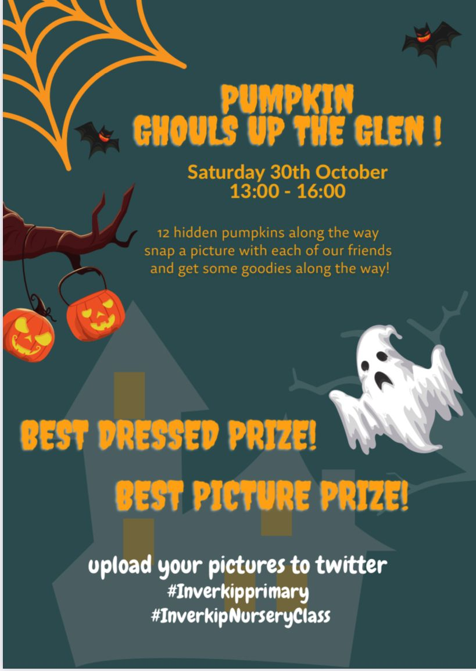

.

**P6 Salmon School**

P6 had a fabulous visit from the Clyde River Foundation in association with the Smithsonian Museum in Washington DC. This was an amazing opportunity for pupils to learn about the health of our rivers and their importance to climate change.

The children visited the Kip Burn to gather water samples to check for quality, investigate the relationship between plants and animals at the river, and find out what fish species were present. Information was gathered in their field booklets.

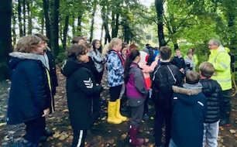

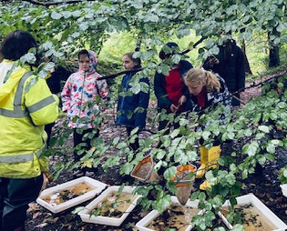

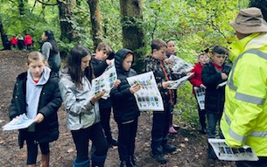

**Show Racism the Red Card**

It was lovely to see so many of our pupils wearing their own clothes and something red to support ‘Show Racism the Red card’. Thank you for helping to highlight the importance of equality and diversity.



**Dental & School Nurse Screening**

Our school nurse team were in school to complete eye test screening with our P7 pupils on Tuesday 19th October.

We are awaiting a date for dental screening from P1-7 which will happen at some point this term. We will let you know when a date is confirmed. Parents will be issued a consent form for this before the date.



**Learning Journals**

We hope that you are finding the learning journals useful that are being sent home fortnightly. This is allowing the children to reflect on their learning and identify next steps. Please remember to ask your child about them when they come home.

**If you would like to give us feedback on what’s working well and what we could improve upon then please complete the short form below. #Your Voice Matters! We had no response last month to our questionnaire…… all feedback welcomed.**

<https://forms.office.com/Pages/ResponsePage.aspx?id=oyzTzM4Wj0KVQTctawUZKfMQ2k9ZS0ZAmbMY5zdl4KtUNklKUkRJSDZUR1dPRkxRRkRUS1Y5RERKSC4u>

**Phone calls**

We hope you found our teacher/parent phone calls useful. Staff were delighted to chat and update parents on their child’s progress. We know our parents will be feeling frustrated that parents evening was not in person and staff felt the same. Fingers crossed we can get parents back into school for our next scheduled parents evening!

Mrs Bradley will continue to arrange review meetings for pupils who require additional support and if you have any concerns please just pick up the phone….we are here to work with our parents and will help in any way we can.



**P7/6 Magic Torch Comics**

P7/6 completed a comic survey to win a comic book session. We were successful and feel incredibly lucky to have secured the chance to participate in a workshop with Paul Bristow from Magic Torch Comics.

The session will form part of a larger project. The comic we create together on the day will be used as part of Tales of the Oak – a storytelling performance happening at the Beacon on Thursday 28th October as part of the Scottish International Storytelling Festival. Look out for us in the Telegraph who are featuring the project!

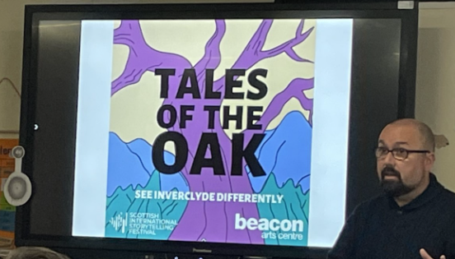

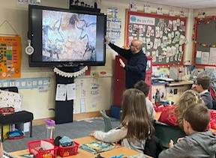

**School Lunches**

Parents should have received a letter from HQ regarding possible changes to our school menus due to delivery issues. We will endeavour to inform parents beforehand if this is the case.

Please note that our lunch service may be impacted if there is staff absence. (Catering staff may need to drop one of the options at short notice but we will try our best to only do this as a last resort!)

Our thanks go to the canteen who have delivered a full menu daily despite significant staff shortages over the past few weeks.



**Flu Vaccination**

A reminder that the Flu vaccination will be delivered on **Friday 26h of November** to all pupils who have returned the permission slip.



**Sponsored Walk**

We all thoroughly enjoyed our annual sponsored walk and are so thankful for the amazing amount raised from this event. Once all monies have been returned we will give you an updated total. THANK YOU!

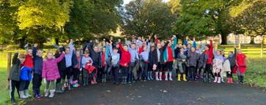

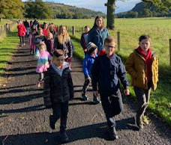

**Dogs Trust**

Our P4-7 pupils will participate in a workshop from Dogs Trust across the 11th and 12th of November. We know the children will enjoy chatting about our four legged friends!



**Children In Need**

A reminder that **Friday 12th November** is a ‘Come as You Please’ day to celebrate children in need. All donations on the day welcome. We will sell raffle tickets the week before to raise funds for such a worthy charity.



**Class Assemblies**

Our P7/6 class delivered our first class assembly of the year. As parents were unable to visit this was recorded and shared through our YouTube channel. Class assemblies are scheduled throughout the year. Depending on restrictions – these will all be recorded and shared. If restrictions ease we may be allowed to invite parents along to watch! Click on the link below to watch our p7/6 ‘Space’ themed assembly.

<https://youtu.be/v3ssFqU3ukw>

**Dates below for future assemblies:**

* P6 assembly – Friday 12th November
* P5/4 assembly - Friday 10th November
* P3/2 assembly – Friday 21st January
* P7 assembly – Friday 4th February
* P2/1 assembly – Friday 4th March
* P5 assembly – Friday 18th March
* P3 assembly – Friday 22nd April
* P1 assembly – Friday 13th May
* P4 assembly – Friday 10th June



**P5 Virtual Library Visit**

P5 had a virtual visit to the library and discussed different book genres and authors. They then completed Book Personality Quizzes which used their answers to predict what types of novels they would enjoy. We look forward to receiving our recommended novels from the library!

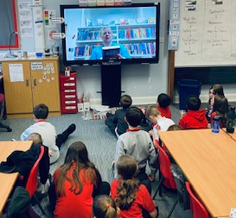

**Book Week Scotland/Anti Bullying Week**

Book Week Scotland is on the **week beginning 15th – 19th of November**. Rather than add to the pressure of families trying to put together a ‘costume’ we will be focussing on the promoting the importance of reading and the joy of picking up a book.

We hope to encourage a ‘Book Swap’ where children bring in a book and swap it with a friend. Classes will be focussing on their favourite authors and participating in live online author events.



This week is also Anti-bullying week and classes will be focussing on the ‘One Kind Word’ campaign by encouraging random acts of kindness throughout that week.



**Booze Busters**

Our P6. P7/6 and P7 pupils are participating in a number of workshops to highlight the ways that children can stay safe and make sensible choices. The children are learning a lot and have thoroughly enjoyed this input.

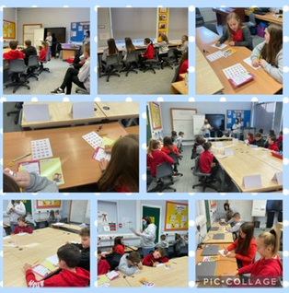

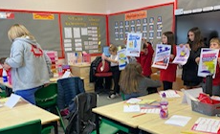

**Christmas**

Our P1 and P2 pupils will begin working on our Christmas Nativity. We are hoping that parents will be able to come along to see this and if not we will record the performance. We have identified the dates below but this will be dependent on restrictions at the time:

* Tuesday 7th December – Infant Nativity am & pm
* Wednesday 8th December – Infant Nativity am & pm

On Friday 10th December is National Christmas Jumper day. We will have a Santa Dash around the school just for fun – children can wear Christmas Jumpers/accessories/Santa suit or own clothes.

On Tuesday 14th December we will have Christmas Lunch and information and menu choices will be issued nearer the time.

Christmas parties – children can come to school dressed in their party clothes on the day of their party. See dates below:

* Wednesday 15th December – Nursery (am) , P1 and P2/1 (pm)
* Thursday 16th December – P3/2 and P3 (am), P4 and P5/4 (pm)
* Friday 17th December – P5 and P6 (am) , P7/6 and P7 (pm)

The children will have a mixture of traditional games in the gym hall with other classes and then individual classrooms for food. We hope that our Nursery and P1-3 children will have a special visitor coming along to their party.

Wednesday 22nd December – close 2.30pm for Christmas – reopen Thursday 6th January

**Celebrating Success**

If you have any achievements that you would like included in our monthly newsletter then please just call or email and we will include in our next one.

We will continue to encourage our children to go ‘Above and Beyond’. Staff will recognise any child who has risen above our normal high standards and expectations. Mrs Nicolson and Mrs Bradley will give a positive phone calls home to anyone who get a certificate.

So proud of this beautiful P4 girl who wrote to the Prime Minister regarding concerns about climate change. Here she is with her response! #Eco Warrior

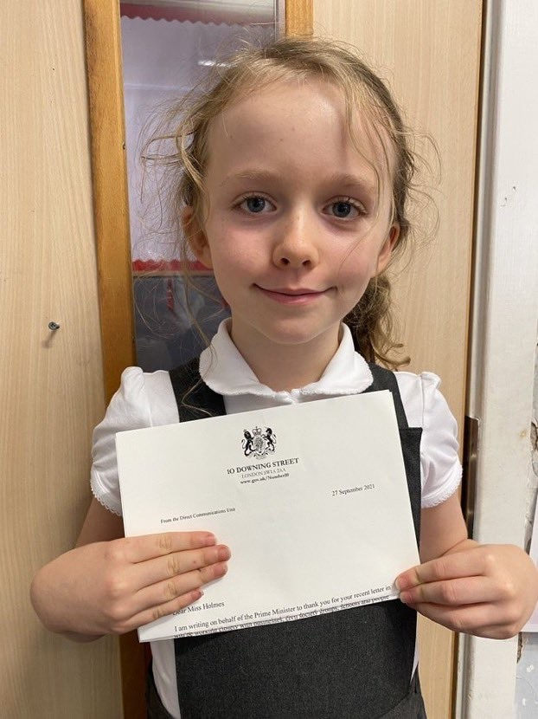

Mrs Bradley and Mrs Nicolson have been hosting pupil focus groups to discuss learning and next steps for pupils. We are so proud of how articulate our children are when discussing their learning and this will be an ongoing feature throughout the year. Our Committee groups are up and running and they are all working on aspects of our school improvement plan.

It has been a busy term 1 and despite a degree of restrictions being in place we are thankful to have such a supportive school community.

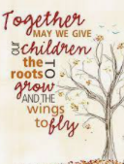

Our next monthly newsletter will be issued on Friday 26th November. If you would like any info/items included in this then please get in touch……we are here to listen. As always, thank you for your support.

Kindest regards

Mrs Una Nicolson ([inunn621@glow.sch.uk](mailto:inunn621@glow.sch.uk)) and Mrs Pamela Bradley ([inpao078@glow.sch.uk](mailto:inpao078@glow.sch.uk))