Inverkip Primary School & Nursery Class

Newsletter: September 2021

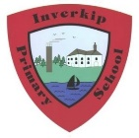

**Dates for the diary**



**Please note the key dates below for this term:**

* Week begin: 27th September – Math Week Scotland & P4 SNSA assessments
* Thursday 30th September – P6 – Salmon school workshop
* Tuesday 5th Oct – Sponsored Walk
* Parent calls: week begin 27th Sept/4th Oct
* Friday 22nd October – Come as you please – wear something red to support ‘Show racism the Red Card’
* 8th October – close for October week and reopen Tuesday 19th for our children.
* Parent Council meeting 19th October – 7pm
* Friday 29th October – Children may come into school/nursery in Halloween costumes. (Age appropriate)
* Friday 12th November – Children In need Day (come as you please)
* Week beg: 15th November – Book Week Scotland. Classes will focus on celebrating the joy of reading.
* Friday 26th November – Flu vaccinations
* Tuesday 30th November – Parent Council Meeting 7pm.
* Thursday 9th December – Interim reports out to parents
* Friday 10th December – Santa Dash – children can wear Christmas accessories/Santa suit and we will have a sponsored run/dash around the school.
* Tuesday 14th December – Christmas Lunch
* Wednesday 22nd December – close 2.30pm for Christmas – reopen Thursday 6th January.

**Covid Update:**

**Warm and Inform letter:**

If we have an identified positive case in a class/year group then a ‘warn and inform’ letter will be issued.

**PCR results:**

We have had a number of children who have needed a PCR test and we must emphasise the need for parents to inform the school of the result before sending children back into school. We have a small limited stock of home PCR tests available in school. Parents can call the office if they are having issues arranging a test. The test would be used at home then posted back – results then take slightly longer than an in-person PCR appointment and should only be used where an in-person test is not an option.

**Pick up congestion:**

We are noticing an increased number of adults in the front playground and this area is now becoming very congested. Our P4-7 pupils are older so we ask that parents find an agreed spot to meet children where possible rather than crowding into the front exit area.

Adults must wear face coverings and distance from each other.

**Class/year group bubbles:**

If we have more than 2 positive cases in a class then the class involved will then have to become a bubble for a short period of time. This means that the class will then have a staggered break/lunch and will be unable to mix with their year group. This will be monitored and if we have no further cases within a 3-5 day period we will revert back to the year group bubble.

**Sign/symptoms:**

We ask that parents work with us and do not send pupils into school if they are unwell. We empathise with parents and understand that children will have the usual colds/sniffles. However, we ask that parents remain vigilant.

**CO2 Monitors:**

All classes have now been fitted with CO2 monitors and we will continue an open window policy on a regular basis throughout the day to increase ventilation.

**Attendance Matters**

If your child is absent for any reason then we ask that parents contact the school office as soon as possible. What the school needs to do if we don’t hear from you by **10am:**

* Firstly a text will be sent to the main contact
* If no response is received to the text a phone call will be made to the main contact
* If there is no reply then we will contact your emergency numbers
* If we are still unclear as to the whereabouts of your child then we may choose to contact other agencies who may wish to make a home visit to check all is well and your child is safe.

*Our priority in following all these steps is to ensure that your child is safe and well and are in line with Inverclyde’s attendance & child protection guidelines.*

A copy of Inverclyde’s attendance policy can be found on our school website.



.

**Parent Calendar**

* Unfortunately restrictions have been extended to October meaning that we are limited in inviting parents in to school. I have therefore included key dates up to December for now and we will hopefully be able to send out a fuller calendar as restrictions ease.
* An updated holiday list can be found on the council and school website. Please note that there is a change to the holidays due to the Queen’s Jubilee – all parents should have been sent a letter about this.
* We are disappointed not to be allowed to have face to face parent meetings this term. However, we are bound by restrictions. Should anyone struggle in advance to arrange the 10 minutes needed for the call(s) then please contact the office to discuss.
* This will be an opportunity to chat to your child’s teacher and hopefully we will have an in-person Parent Evening later in the session. Calls will happen across the week beginning 27th September and 4th October.
* Calls must be across two weeks due to the number of available telephones and also staff cover needed to facilitate. The IT connection for virtual Teams meetings is temperamental at best and therefore telephone calls are our only option.
* The next parent’s night is scheduled for 25th May and we hope that this will be in person but this is subject to change depending on restrictions at that point.
* An interim report will be issued on the 9th December and a further report on the 17th March.
* We are planning Class assemblies this year…our first assembly is P7/6 on the 8th October. We will film the assembly and share the link until we are permitted to allow parents in to the building. Fingers crossed for after October.

**Parent Council**

It was lovely to meet parents old and new at our parent council AGM this month. The group are planning a number of fundraising activities and events but these need your support. Every penny raised goes towards the children.

There are a number of fundraising activities that our parent Council are planning and details of which will be in their first newsletter of the session. You can follow our Parent Council on Face Book.



**Sponsored Walk**

We are looking forward to our annual sponsored walk on **Tuesday 5th October**. This is a great opportunity to explore our local environment and raise some much needed school funds. Sponsored forms have been issued and we know our parent community will raise as much as they can. Families can fill out one form per family or one per child – the choice is yours and there is no obligation to donate.



**Photographs**

The school is aiming to have class and individual/family group photos this year. The office have been in touch with Tempest re: bundles on offer. A decision will be made about which photographer to go with and we will let you know when a photographer has been booked and the date.

The Greenock Telegraph have taken our P1 photo and that will be in the paper soon.

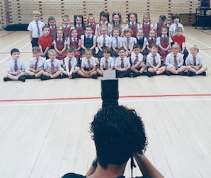

**Learning Journals**

Each class will send home a learning journal every two weeks which will highlight numeracy/literacy targets that the children are working on. The children will then show evidence of how they have achieved their targets. We feel that this is more beneficial than sending home a target sheet termly as often the targets are not specific enough and feedback indicated that parents found these unhelpful.



**P7 Hoodies/Residential**

We are thankful to one of our P7 parents who has organised the P7 hoodies. These will be given to the pupils at the same time at an assembly to ensure that our P7 superstars feel important in their Leadership Hoodies.

The residential trip is provisionally booked to Dalguise from 13th-17th June. This will be dependent on restrictions at that time.



**Pupil Equity Fund (PEF)**

The school has just submitted our PEF plan for the coming year. This can now be viewed on our school website. Our main priorities this year will be to:

* Continue with our Accelerated Reading programme
* Additional Recovery teacher one day a week – Ms Shannon Mackay who will target our SIMD 1 pupils who are behind expectation
* Create a Health and Wellbeing Zone
* Support to reduce the cost of the school day for identified SIMD 1 pupils

Our School Improvement and Standards & Quality Report can now also be found on our website.

**School Lunches**

All P1-5 pupils now receive a free meal and we are now seeing a rise in our school dinner numbers.

We have started to phase classes back into the lunch hall with our nursery, P1 + P2 + P3 pupils eating in the hall. The P1-2 pupils have not eaten in the hall before and it is important that they have had the space and time to get used to the canteen protocols before introducing any more classes.

We are also restricted on how many classes we can facilitate due to cleaning and H & S Covid protocols that we need to adhere to in-between class groups. Classes will build up over time in a safe and appropriate manner taking in to account the organisation and staffing needed over lunch time to clean between classes in the canteen and to supervise inside/outdoor.

A recent pupil survey indicated that a large percentage of pupils are enjoying school dinners with Mac Cheese/pizza and sausages being a favourite.

**Committee Groups**

Our committee groups are now organised and raring to go. The children will meet over the coming weeks and create an action plan of priorities for the coming term. The P4-7 pupils applied for the role and P1-3 had a class vote. We now have the following groups:

* Pupil Leadership
* Eco
* Rights Respecting
* Literacy
* Numeracy
* Digital Champions
* HWB/Outdoor learning
* Community Partnerships/Charities
* JRSO (Junior Road Safety Officers)

**Play Pedagogy**

The development of play pedagogy across our nursery and P1 is a school improvement priority. We are developing our approaches to support curiosity and enquiry of learning that is exciting and challenging to our children. We are currently in the early phase of defining our ‘play vision’ and accessing the resources and space that we have available.

This will be an ongoing focus and we are currently utilising our recovery teacher (0.7) across P1-3 to ensure early interventions are in place.

**P1 and P7 Buddies**

Our P1 and P7 pupils have been allocated a buddy. They have already started the process of getting to know each other and this will continue throughout the year depending on restrictions.

Our P7 pupils have already shown great leadership skills and have risen to their responsibilities such as class monitors. They have started the year as amazing role models for our younger pupils.

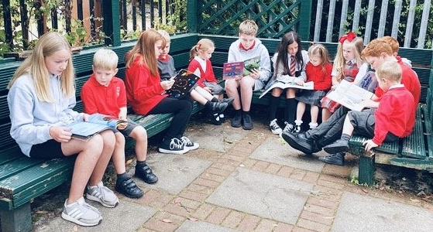

**Road safety and Parking**

The school will continue to highlight this issue. Mrs Nicolson has already received a concern from a parent regarding parking on the zig zag line. Our JRSO group will be re-issuing our parking charter soon and this will be a continued focus.

A permission sign has went up on the gate regarding the renewal of our side gates which will have a metal post rather than brick wall which should help with the ability to see traffic coming up the hill.

Mr Deveney will continue to alternate the parking signs on the double yellow lines and Mrs Nicolson has already spoken to our community police officers re the problem. They will pop down as and when they are available.

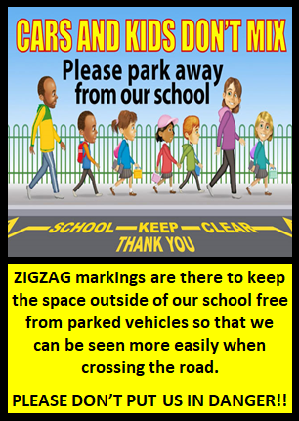

**Clothing Bank**

The school currently has a huge amount of stock. As an ECO school we actively encourage parents to get in touch if they need any items. We ask that parents only drop in items branded with the Inverkip badge due to the amount we have and lack of storage facilities. We know local charity shops will be grateful for other items. Please feel free to hand in any old Halloween costumes. #Reuse, Recycle



**Head Lice**

We ask that parents remain vigilant and check hair on a regular basis. Schools are no longer permitted to send out a letter to classes if there has been a reported case of head lice so we ask that parents build in a regular check as they can be highly contagious and love to jump onto clean hair!



**Show racism the Red Card**

Show Racism the Red Card is the UK’s largest anti-racism educational charity. Wear Red Day is their national day of awareness and fundraising. We are showing support on Friday 22nd of October this year. Children may come to school as a ‘Come as you please’ and we encourage the children to also wear something **RED** to show support. All donations welcome to support the charity.



We cannot believe how quickly the term is passing. Thank you for your continued support over the term.



We are here to listen and if you have any feedback on what we are doing well and how we can improve then please complete the survey below…..

<https://forms.office.com/Pages/ResponsePage.aspx?id=oyzTzM4Wj0KVQTctawUZKfMQ2k9ZS0ZAmbMY5zdl4KtUNklKUkRJSDZUR1dPRkxRRkRUS1Y5RERKSC4u>

We will continue to work as a team to support our youngsters. We strive to get it right for every child and need your feedback to help us do this!

**Halloween**

We had hoped to organise a Halloween disco but restrictions prevent this from happening. Children may come into school on Friday 29th October in costume/or bring a bag to change into a costume at lunchtime. Each class will organise their own Halloween celebrations. We ask that all costumes are **age appropriate** and where possible accessories are kept to a minimum. Halloween can be scary for many of our children and we need to be mindful of our nursery and younger pupils. We know our parents will be sensible on what costume they allow their child to wear.

As an Eco school, we are appealing to our parents to recycle any old Halloween costumes that pupils could then reuse for Halloween. If you have any old ‘dressing up clothes/costumes’ then please pass them into the school office. If we manage to build up a good supply of costumes this would allow classes to have a good rummage around and take a new costume home in time for Halloween!

Our Parent Council are planning a Halloween raffle and over the weekend will help to organise a Halloween trail around the village that children can complete with their families ……details to follow.



**Celebrating Success**

|  |  |
| --- | --- |
| We are so proud of 3 of our super star children who walked the last 3 miles of the Inverclyde Stride on Saturday 28th August. What an amazing example of promoting Health and Well-Being in the community. The walk supports a variety of Inverclyde Community Fund Projects. | We are so proud of this beautiful P6 Dancer who came 2nd place in a recent dance competition. Fantastic news….what a star! |

If you have any achievements that you would like included in our monthly newsletter then please just call or email and we will include in our next one.

We will continue to encourage our children to go ‘Above and Beyond’. Staff will recognise any child who has risen above our normal high standards and expectations. Mrs Nicsolson and Mrs Bradley will give a positive phone calls home to anyone who get a certificate.

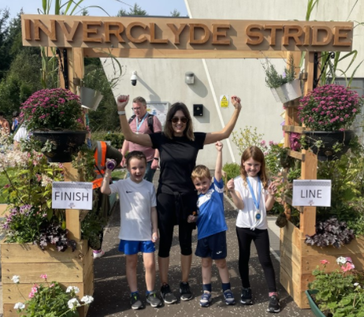

We continue the term with restrictions in place and we know how frustrating this can be to our children and parents. However, we have no control over these and are working hard behind the scenes to ensure that the children are at the forefront of our decisions.

As these restrictions continue and cases remain high we will wait before considering any ‘After School ‘activities. After school clubs rely on staff to volunteer their time freely and our first priority is to ensure that staff are not mixing across too many year groups for trace and protect purposes and to minimise risk for staff. The main thing is our children are in school and are very happy and settled. We have everything crossed that things ease as the year progresses. Collectively we will face challenges and continue to find the positives.



Our next monthly newsletter will be issued on Friday 29th October. If you would like any info/items included in this then please get in touch……we are here to listen. As always, thank you for your support.

Kindest regards

Mrs Una Nicolson ([inunn621@glow.sch.uk](mailto:inunn621@glow.sch.uk)) and Mrs Pamela Bradley ([inpao078@glow.sch.uk](mailto:inpao078@glow.sch.uk))