Inverkip Nursery Class
Handbook:
2020 – 2021
A Warm Welcome to Inverkip Nursery Class:
On behalf of all the staff, I would like to welcome you to Inverkip Nursery Class. I hope you enjoy reading our handbook and that you find the information it contains useful and interesting.
If you have any questions about the nursery, please do not hesitate to get in touch. Lauren, our staff team or myself are happy to discuss any concerns or issues you may have. Please contact us by calling Inverkip Primary (01475 715745) or emailing me directly. We share our learning daily on our Twitter feed – why not follow us to see how much fun we have at Inverkip Nursery Class: @InverkipNurser1
Yours sincerely
Mrs Una Nicolson
Head Teacher of Inverkip Primary School & Nursery Class
Inunn621@glow.sch.uk
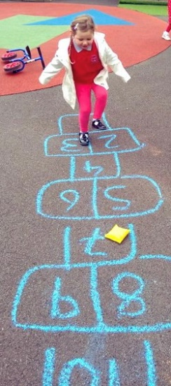
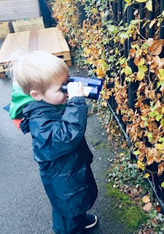

I would like to extend a warm welcome to Inverkip Nursery Class and hope that the time your child spends with us is a happy and enjoyable experience. Throughout our work, we aim for children to be safe, healthy, achieving, active, respected & responsible, included and nurtured. Above all, we value each child individually.
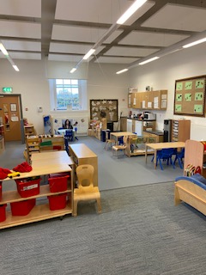
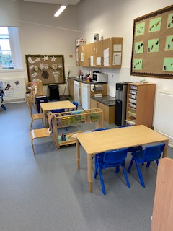
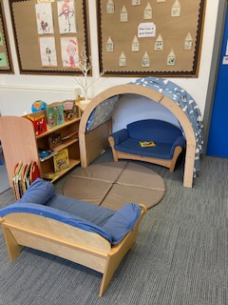

Inverkip Nursery Class provides early learning and child care to children between the ages of three and five years old. Currently, we have places for 30 children for a full day placement. Our Nursery Class is non-denominational. We respect and welcome children and parents of all religions, faiths and beliefs. At Inverkip Nursery Class, we develop strong partnerships with parents which enhances the quality of children’s learning experiences and is vital in meeting the needs of each child.
The Nursery Team and I are very much looking forward to getting to know you and your child.
Lauren Mitchell (Senior EYECO)
Meet Our Team:
- Mrs Lauren Mitchell - Senior EYECO
- Mrs Anne Frances Johnstone - EYECO
- Ms Leanne Wilson – EYECO
- Mrs Leanne Cairns – EYECO (0.5)
- Ms Pauline Mitchell EYECO (0.5)
- Ms Stephanie Gibson EYECO (0.5)
- Ms Emma Wilson – Nursery Support Worker
- Mrs Allison MacSween – Nursery Apprentice

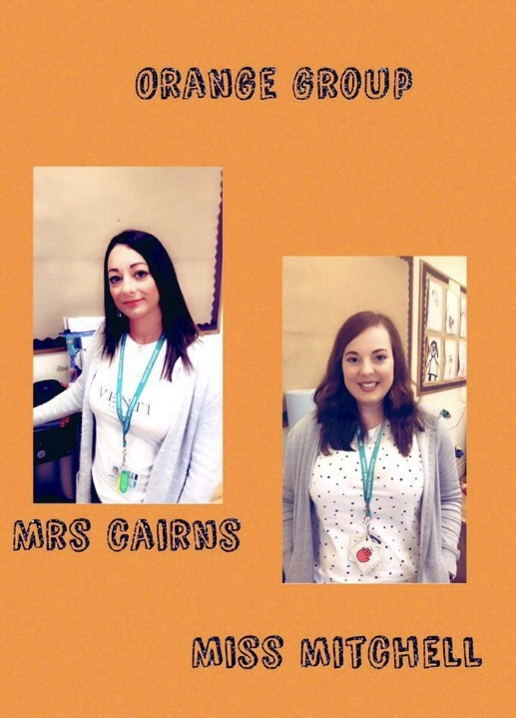

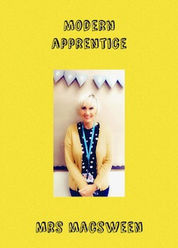

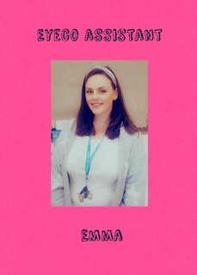

Nursery Hours:
Inverkip Primary and Nursery Class are non-denominational. We respect and welcome children and parents of all religions, faiths and beliefs. Children between the ages of three and five attend. We have capacity for 30 children. This is offered in the following model, times are approximate and subject to change.
- 6 hours per day
- Between 8:30am and 4:30pm
- 38 weeks per year (Term time)
- Lunch: 11.45-12.45

Inverclyde Council are committed to meeting the 1140 nursery hours proposed by the Scottish Government. Our children are entitled to 6 hours per day and parents can arrange an individual attendance pattern with staff to ensure that agreed hours meet the needs of our children and their families.
Inverkip Nursery Class has the same holidays / In-service days as other Inverclyde Schools and a copy of these days are available from the office or www.inverclyde.gov.uk
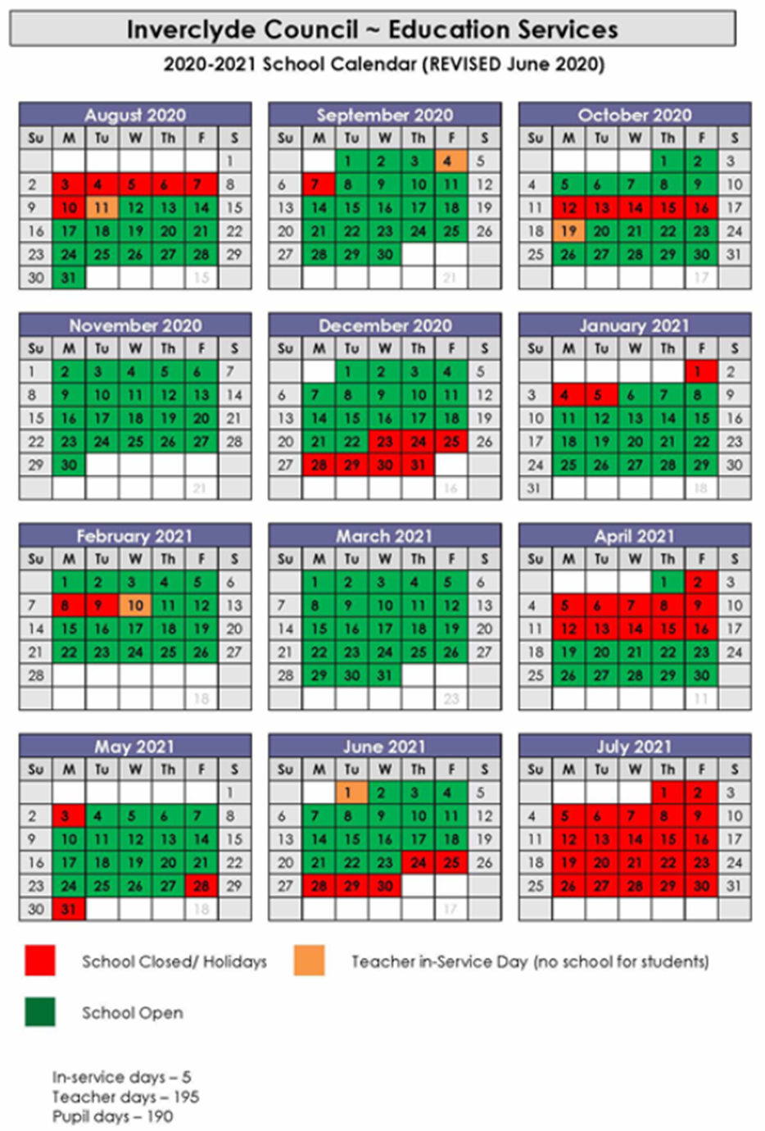

Our Vision:
We are passionate about getting it right for every child. Your child is at the centre of all that we do. Our vision is to ensure that we learn today for a better tomorrow where every child matters and every moment counts.
# Learning to Learn # Learning to Love # Learning to Lead
In Inverkip Nursery Class, we strive to provide an enriching environment where all children are given the opportunity to play, learn and grow together to become confident, resilient, happy and secure. We inspire young minds and set the foundations for lifelong learning. Our Nursery is a happy place full of friends where your child can be themselves. It’s a place full of interesting things to do, but also a place where your child can take time out and just be quiet if they want to. It is somewhere where they can grow up knowing that they belong and that they are uniquely special.
We know that your child will leave us at the end of each day with a smile on their face.
Our ethos is a climate of teamwork, respect and trust, where all our children aspire to become successful learners, confident individuals, responsible citizens and effective contributors. Strong partnership between home and nursery are cultivated and we value all communication from our parent community.
Our Aim:
Through the provision of a safe, secure, bright and happy environment at Inverkip Nursery Class for your child we aim to:
- Encourage and develop your child’s independence and to enhance self-confidence and respect for others, not only in preparation for starting school, but for the rest of their lives
- Develop your child’s beautiful and full potential
- Ensure your child’s interaction with their peer group and other children as well as staff are positive and encouraging
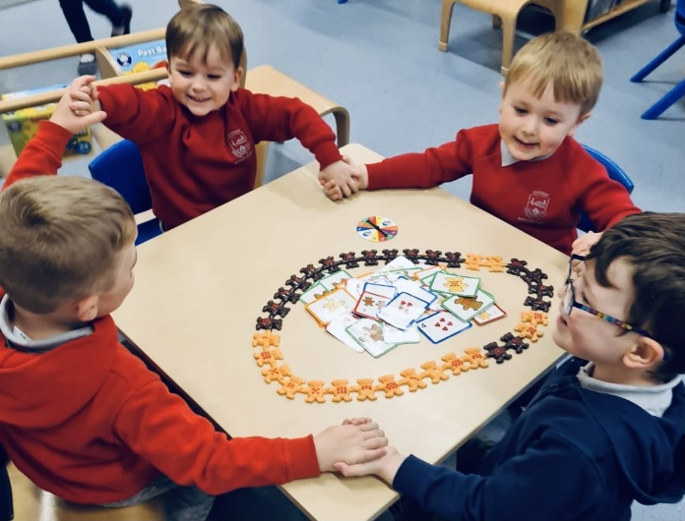
- Give all children the freedom to investigate the safe space around them, so that our inquisitive learners are active participants in their learning journey
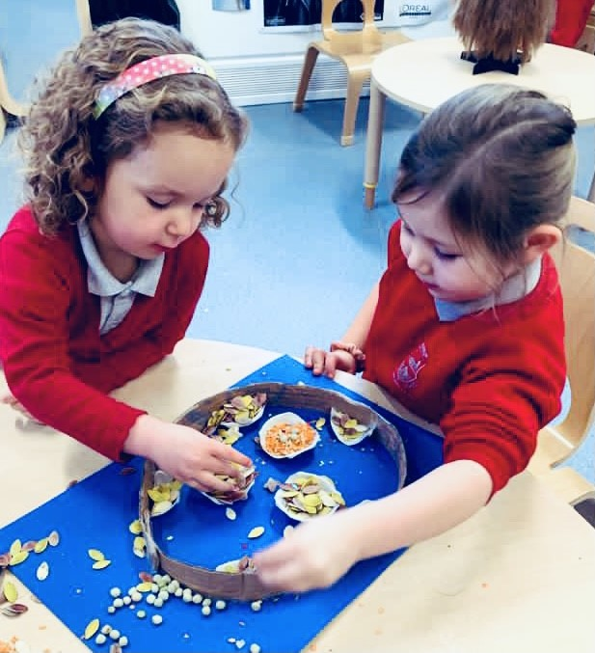

Applying For A Nursery Place:
All children are allocated a nursery place in line with Inverclyde Council’s Early Years Admission Policy.
Parents are welcome to call at the Nursery any time after their child’s second birthday to put their name on the Register of Applicants. At this time, an application form will be filled in and parents are welcome to look around the Nursery to see the children learning through play. However, it should be noted that this year applications will be made online and Covid guidelines may restrict any visits to our nursery. However, a video will be also be available to show you around our Nursery and our Twitter feed is also a fabulous source of information.
Admissions:
Below is Inverclyde Council’s admission timeline. Children are allocated a place the month after their 3rd birthday.
Date of Birth | Month due to start | Email / Letter Sent
March - July | August | June
August | September | June
September | October | June
October | November | October
November | December | October
December | January | October
January | February | December
February | March | December

Out with your child’s entitled hours, Inverkip Nursery Class offer a wraparound service for parents working or in training for employment. This is a limited paid service. If you are interested in more information regarding wraparound please speak to Lauren or any of our Nursery staff about the application process.

Our Curriculum:
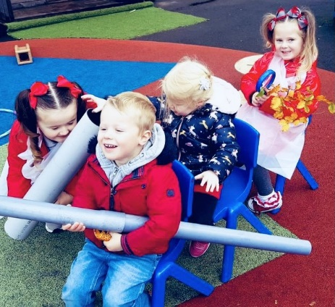
Play is the main vehicle through which children learn. It is our aim to offer a wide variety of learning experiences, in a rich, stimulating environment which allow children to learn through play. We use the children’s interests to plan and support them in their learning.

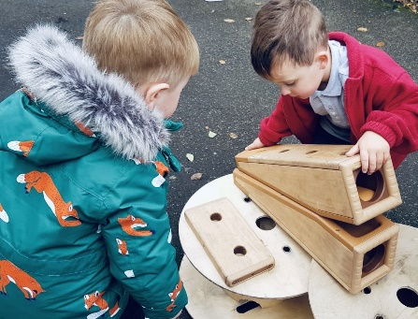
Sometimes children’s play will be busy and noisy, sometimes quiet and reflective. Staff work collaboratively with the children to plan and develop the environment and resources both indoors and outdoors. A range of open-ended materials are freely available to enable independent and active learning. Staff work alongside children whilst they play, observing, supporting and extending the learning.
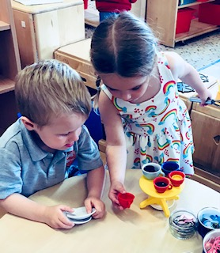
We plan and evaluate these experiences following the Curriculum for Excellence guidelines. The Curriculum for Excellence establishes clear values, purposes and principles for education from 3 to 18 in Scotland. It sets out to enable children to develop their capacities as Successful Learners, Confident Individuals, Responsible Citizens and Effective Contributors.

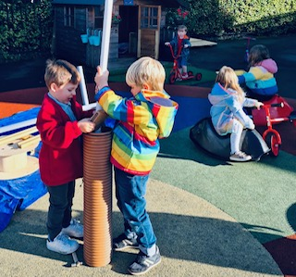
Curriculum for Excellence promotes the need to view learning and teaching across curriculum subjects and areas as inter-connected and integrated. This is particularly important for young children, who will develop their understanding of, for example, science, language, communication, technology and mathematics from an everyday experience, such as water or sand play. Staff ensure that these experiences are enriching and stimulating and that adults working with children are able to understand, appreciate and assess children’s achievements and learning.

It is important to remember that it is not a final product that is important, but the skills and experiences we are developing while taking part. If your child comes home with no paintings or drawings - don’t worry! They will still have been learning – just learning through different experiences. Your child may have been busy building in the construction area, playing in the sand or playing in the house to name a few, they simply may have chosen to participate in other experiences on offer.

At Inverkip Nursery Class we consider the child under the following three categories:

Me as an individual:
- Each child’s needs should be at the centre of how we think about and plan for their unique development.
- Children have their own ideas and plans, and their brains and bodies are good at seeking out the kinds of activities, environments and encounters that they need to help them develop.
- Everything we do is about helping each child to grow emotionally, socially, physically and cognitively.

Me and my environment:
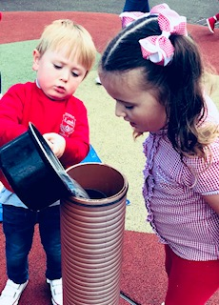
- A key part of our nursery environment for children is the human, social environment of positive nurturing interactions.
- Children need to learn things for themselves, but this does not mean they should always do so by themselves. We can, by following and building on children’s motivations and interests, support young children to make the most of the environment for learning and development.
- We promote a happy, interesting and empowering learning environment, considering the interactions, experiences and spaces on offer, to ensure we add value to what children already know and can do.
- Outdoor education plays a vital part of our provision and is maximised in all weathers. Staff support children when outdoors and ensure they have opportunities for adventure, risk and challenge in all areas of the curriculum.

My surrounding culture
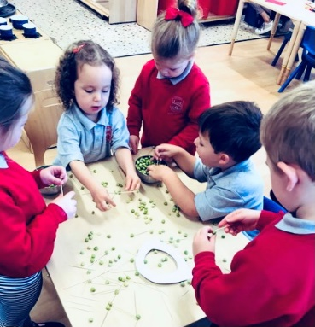
- We want our children to have the strongest start in life, in a culture where they receive the right kind of support and experiences to lead secure and flourishing future lives.
- We strive to provide a balanced experience where there is the knowledge and skills that we want children to develop, such as self-regulation, confidence, and curiosity.
- We adopt a child centred way where children have permission to follow their interests and to develop at their own pace.
- High quality experiences and sensitive interactions in a variety of outdoor and indoor spaces, which will develop the emotional resilience they need to form a secure wellbeing base.
We promote children’s learning in a variety of ways through observing, planning and discussing next steps to extend, support or challenge children in their learning. Staff will be glad to discuss what your child will be learning. We have an active planning wall that is responsive to our child centred approach. This enables us to capture individual interests, curiosity and passions.

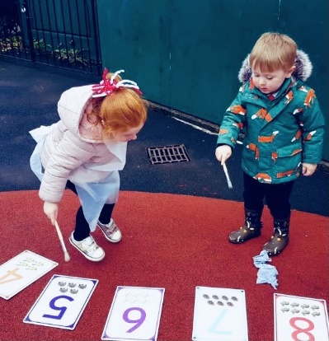
At Inverkip Nursery Class we understand that every child develops differently and in different patterns across the following dimensions of child development:
- Executive function and self-regulation
- Communication and language
- Confidence
- Creativity and curiosity
- Movement and coordination
- Self and social development.

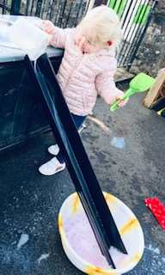
We use an online Learning Journal with your child to collect information and examples of learning. The journals will be updated regularly and provide vital home/nursery links. Your voice matters and parents are invited to give their views via our monthly Self-Evaluation process. Look out for our comment sheet in the cloakroom area.
Staff will meet with you formally twice per year to advise you of your child’s progress. This will take the form of a phone call whilst Covid 19 restrictions are in place. If, at any stage, you have a question, or concern, about your child’s progress please do not hesitate to speak to a member of staff who will be more than happy to discuss any concerns.

Please ensure that your child is appropriately dressed for the Scottish weather as they go outdoors every day, regardless of the weather. We have suitable waterproof clothing that ensures the children will be comfortable and dry when outside. We have spare pairs of welly boots at the nursery, but it would also be good if your child had a pair of wellies that they could keep at nursery for outdoor play. It would also be beneficial if you could provide your child with a spare set of clothes they can change into if required.
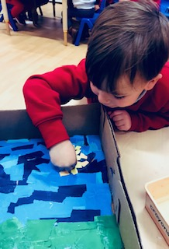
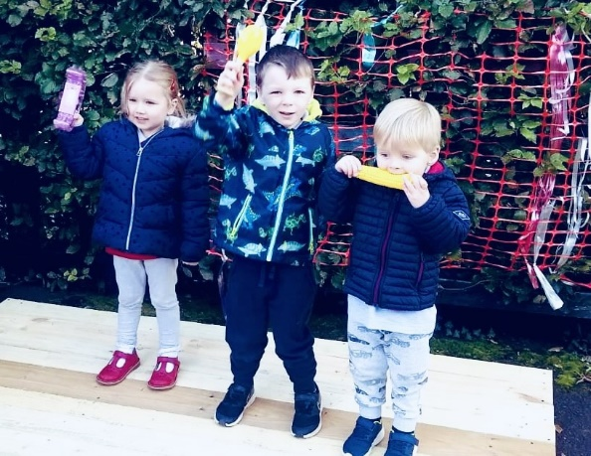

Inclusion and Equality:
Inverclyde Council Education service aims to:
- Offer education of the highest quality to all young people within a developing culture of inclusion
- Endorse the principles of inclusion, entitlement and equality of opportunity in the development of best practice
- Value the diversity of interests, qualities and abilities of every learner
- Believe that every child and young person is entitled to educational opportunities which enable the achievement of success and further development of the individual’s learning potential within the least restrictive environment
- Affirm the right of all young people to have access to the highest quality of educational provision which is appropriate to learning needs, is supportive of the young person and is delivered in partnership with young people, parents and the wider community.
- In meeting the needs of all our pupils we will demonstrate no discrimination on the basis of race, gender, disability, sexual orientation, religion or belief. This encompasses curricular, extra-curricular and playroom activities and is foremost in the attitudes which we develop in our pupils.

Equalities:
The Equality Statement for Inverclyde Establishments ‘Inverclyde Education Service is committed to ensuring that no children or members of staff or service users receive less favourable treatment on any ground including gender, race, disability, age, sexual orientation, religion or belief. We have a moral, social and legal obligation to mainstream and put equality at the heart of everything we do. We aim to promote a culture in which equality of opportunity exists for all. We are opposed to all forms of discrimination, direct or indirect, and aim to eliminate all discriminatory practices. We will ensure that, in our schools and other educational establishments, equality permeates the curriculum and underpins all our policies and practices in terms of access to education. We must ensure that all our children achieve their full potential to develop physically, emotionally and academically. Finally, we believe that equality and inclusion should be a given right, where everyone is valued and treated with respect.
Child Protection
Inverclyde Council Education Services has Child Protection Guidelines and Procedures which all schools and establishments are required to follow. Education Services work very closely with other agencies namely Strathclyde Police, Social Work Services, NHS Greater Glasgow and Clyde and the Children’s Reporter to support children. Common responsibilities of all staff are to protect children from abuse and exploitation, to respond appropriately when abuse is identified, and to ensure whenever possible that all children are able to exercise their right to be raised in a warm, stimulating and safe environment with the support of staff, their families and carers.
Additional Support Needs:
Every member of staff has a responsibility to support learning of all children. The type of support offered will vary according to the needs of children. This includes consideration given to children who have a disability, children with social, emotional and behavioural difficulties, children with learning difficulties of a specific or general nature, children who are exceptionally able, those who demonstrate underachievement relating to gender issues, children whose learning has been interrupted through absence or illness, bilingual children who have English as an additional language, travelling children and those children whose family circumstances impact on attendance and learning. With the agreement of parents/carers, partner agencies may be asked to offer support where necessary.
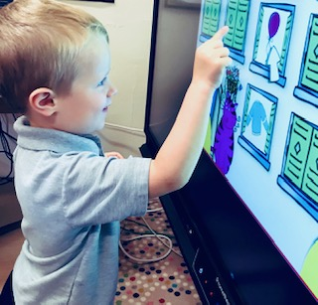
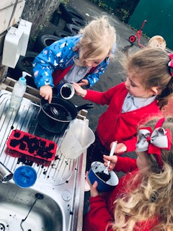

Children with Additional Support Needs
The Nursery staff are always available to discuss any concerns with parents. If you are worried about any area of your child’s development please bring it to the attention of a member of staff.
Although we do not have a routine medical examination in Nursery we do have contacts with our local Health Visitors, Dentist and Speech Therapists.
Occasionally it is necessary to call on the expertise of other professionals to seek advice on a child’s area of development. This action would only be taken after thorough discussion with parents. Parents can approach any one of the above services themselves.
Enquire also provide a range of clear and easy-to-read guides and factsheets explaining everything from 'additional support in the early years' to 'what planning should take place for moving on from school'.
- www.enquire.org.uk (for parents/carers and practitioners)
- www.enquire.org.uk/yp (for children and young people)

Getting it Right for Every Child (GIRFEC)
GIRFEC is the national approach to improve the wellbeing of children in Scotland. At Kilmacolm nursery everything that we do is designed to promote, support and safeguard your child’s wellbeing. Below is an example of the wellbeing wheel and the indicators we would look at in order to ensure we are getting it right for your child.
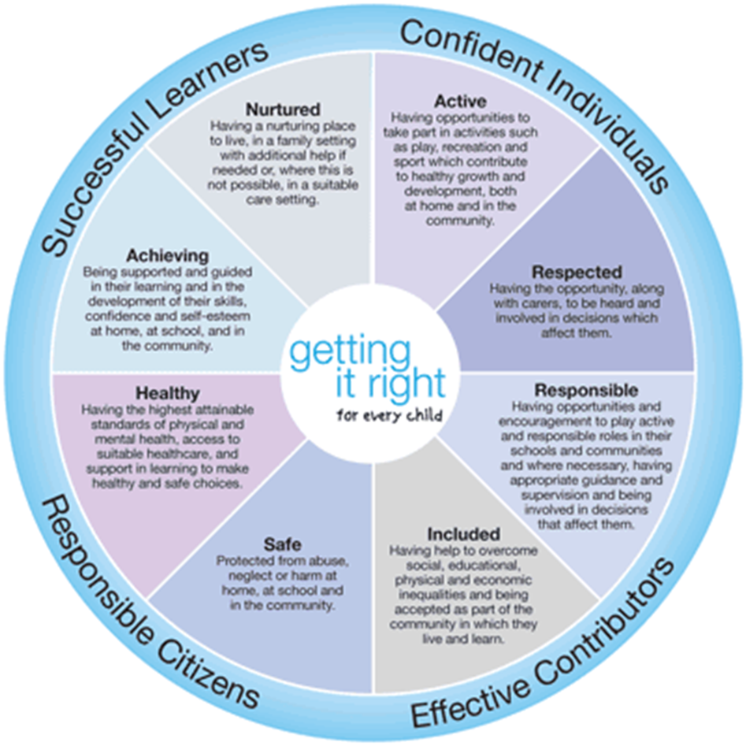

Inverclyde Council child protection guidelines are published on the council website, copies are in policy documents within the nursery. The framework within which child protection is set: Getting it Right for Every Child (GIRFEC).
• Identifying and managing risk.
• Responding to concerns about children.
• Confidentiality and consent.
• Children affected by disability or parental substance misuse.
• The overlap between child protection and adult protection.
• Historical abuse.
• Online and mobile phone safety.

Transition:
The key to effective transition is effective communication between the early year establishment, school and parents. The transition process will begin early in the
Pre-school year and continue into early Primary 1.
Children usually transfer to primary school between the ages of four and a half and five and a half although this may be negotiated in exceptional circumstances. Due to our fortunate position within the school, we are able to make the transition a smooth and happy one. During their time in Nursery, the children will be visiting different parts of the school and will become familiar with the environment and many of the staff.
Throughout the year we will be working closely with our primary colleagues to ensure a smooth and seamless transition to Primary 1. Primary 1 is not simply a fresh start; it’s all about taking learning forward and continuing the Early Level curriculum. Pre-school children will also have opportunities to visit their Primary 1 class in small groups and be visited by their future teacher.
An Inverclyde Council ‘Nursery to Primary Transition Record’ is completed for each pre-school child. This record will be given to you in May/June when you will be invited to add comments or highlight information you would like shared with your child’s Primary School.

Information on registration and enrolment procedures for school will be given in the local press during January as well as in the Nursery.
Key Worker:
When your child starts Nursery, they will be allocated a group and key worker. This gives staff the opportunity to observe children every day during planned activities and to assess their progress. Through these observations staff can plan the next stage of individual children’s learning. What children can do with the help of an adult today, we want them to do on their own tomorrow! Children are regularly involved in physical activities both indoors and out, and enjoy opportunities to sing and learn rhymes. Activities are planned so that children are building on their prior knowledge and experiencing a wide range of activities.
Green Group:
- Mrs Lauren Mitchell - Senior EYECO
- Ms Stephanie Gibson EYECO (0.5)

Blue Group:
- Mrs Anne Frances Johnstone - EYECO

Red Group:
- Ms Leanne Wilson – EYECO

Orange Group:
- Mrs Leanne Cairns – EYECO (0.5)
- Ms Pauline Mitchell EYECO (0.5)
The First Few Days:
It may take a few days for your child to settle at Nursery and so to begin with they will attend for an hour on the first day, gradually building up to a full session. Even if your child is confident we still suggest a settling-in period of a few days before attending for the whole session. Discussion between staff and parents will allow each child the time needed to settle.
Emergency Contacts and Security:
Parents are asked, where possible, to provide the staff with the names, addresses and telephone numbers of 2 contact persons for use in case of emergency. It is important for you to keep the Nursery up to date with any changes in this information, especially mobile phone numbers.
An adult, or someone over the age of sixteen, must bring and collect your child. If you are unable to get to Nursery by the end of a session you must contact us. If you ask someone else to collect your child and you have not informed the nursery staff, at their discretion they may not hand your child over without having spoken to you.
If you have any instructions about who has NOT to take your child out of Nursery please discuss it with staff. Please note that parents’ cars must not enter the school premises.
Absence:
You must also contact the Nursery by 9.30 am if your child is going to be absent on any day. If we do not hear from you, we will telephone you or the emergency contact number on the enrolment form. We really do appreciate a quick call to let us know if your child will be absent.
Insurance:
Sometimes children like to bring in something new or special to the Nursery for their friends to see. Parents should ensure that valuable items are not left at Nursery as the Authority has no insurance to cover the loss of such personal items. Clothing left in the corridor is also not the responsibility of the Nursery.
Clothing:
Children have the best fun when they are having the messiest fun! For nursery, please dress your child in clothes which you don’t mind getting messy as we cannot exclude children from experiences. This includes appropriate shoes and coats for outdoor use. Also, as the children have lots of physical play, they should not wear jewellery.
We also respectfully request that you put your child’s name on items of shoes and clothing which they wear to nursery to avoid mix ups.
Nursery polo shirts and sweatshirts embroidered with the school badge are available to purchase from several outlets. It is not compulsory for the children to wear this uniform. You’ll find Nursery uniforms in the School Uniform Recycling Bank. All items here are completely free of charge. Ask at the school office to browse this facility.
Illness at Nursery
The safety of your child is of paramount importance to us and although every care is taken, accidents do occur. If a child becomes ill or has an accident we would immediately contact you and if unable to reach you we would use the emergency numbers on the enrolment form.
If your child has an infectious disease he / she should not attend the Nursery. A copy of policies and guidance relating to illness and preventing the spread of infection can be found in the cloakroom.
Medication, illness and allergies
On enrolment, parents are asked to give information about their child’s health. It is important that your key worker is informed of any medication given or allergies your child may have. Please keep staff informed so that information can be kept up to date at all times.
If your child is in need of medication during their time at the nursery you should discuss this with your child’s key worker. Prescribed drugs will be administered at the discretion of the Head Teacher/Depute and will require you to complete a consent form. If your child requires an inhaler you must provide one to be kept at nursery. There will be paperwork required to be completed. Your child’s inhaler must be provided in its original packaging (box) with the child’s name and the date clearly visible on the doctor’s label. A spacer for your child’s inhaler must also be provided.
If your child becomes ill while at nursery, we will contact you and ask you to collect your child. If we are unable to contact you, we will endeavour to reach the emergency contacts provided at enrolment. Please note, NHS guidelines recommend keeping children at home for 48 hours after any sickness or diarrhoea. This helps to stop the spread of viruses and illness.

Healthy Eating:
We are very interested in fostering good eating habits in the children. Inverkip Nursery Class aims to promote positive attitudes towards healthy eating together with providing opportunities for physical activity which contributes to becoming a “health promoting establishment.”
As part of the increased hours, children will receive a well-balanced and nutritious hot meal at lunchtime, served in the school lunch hall. You will receive information on this from the nursery, including the lunch menu and the process of helping your child choose lunch on a daily basis. Each day we provide a snack for children which consists of milk or water and fruit or vegetables. Children will be given a variety of different snacks throughout the year to celebrate festivals, parties etc. Parents will be notified of these events.

The daily snack will often consist of a variety of fruit. We also provide milk and water. If your child has an allergy, it is essential you bring it to the attention of staff immediately. Please note that Inverkip Nursery Class is a ‘Nut Free’ zone.
Nursery Funds
A voluntary contribution of £1, payable on a Monday. This provides funds to finance treats and helps purchase resources for rich learning experiences such as woodwork and baking. During the year we may have additional fundraising events which we hope you will support. There may be times when we have to raise funds for specific events. However, we will only fund raise if it is necessary!
Visitors:
We have a variety of people who visit the Nursery during the year. The photographer usually visits the school and we also have visits from a variety of specialists depending on the additional support needs e.g. speech therapist, psychologist, health visitors etc. Throughout the year we help train a variety of students from West College Scotland, Glasgow and Strathclyde University. Pupils from our local Secondary Schools also come for their work experience.
The children take part in a tooth brushing programme and will have a visit from an Oral Health Educator.

Photographing/ Filming Of Children
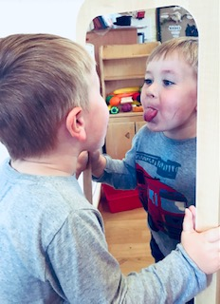
We regularly take photographs of the children in our Nursery for their Learning Journals. Occasionally, we may use these images in our handbook or in our other printed publications, as well as on our website, Twitter or on display boards. We may also make video or webcam recordings for conferences, monitoring or other educational use. Inverclyde Council may also use our photographs of children to illustrate work in Inverclyde schools and establishments in council publications, publicity materials and the Internet. You will be asked to sign a form when your child enrols within Nursery seeking your permission before any of this takes place.
Partnership with Parents:
Our relationship with you, as parents, is vital in supporting your child’s development and learning. We aim to:
- foster a common understanding between staff and parents about the aims of the Nursery
- advise parents on how to help with their children’s learning and development
- keep parents in touch with their children’s progress
- encourage parents to take part, if possible, in Nursery life
- keep parents informed about Nursery matters
We will provide you with information about the Nursery in a range of ways through our notice boards, daily contact with staff and regular newsletters. We will share our learning intentions by displaying our plans on our ‘Nursery Class Learning Wall’ and through displays of photographs and children’s work.
Your child’s development and progress is monitored continuously throughout the year by nursery staff. A profile of work and achievements is kept in Nursery, which parents can view during parents’ meetings and can contribute to throughout the year. Staff are always happy to discuss your child’s progress any time of the year. For matters that may require in-depth discussion an appointment can be organised by staff.
Promoting Positive Behaviour
Within Inverkip Nursery Class all our work is underpinned by policy and procedure. We have a promoting positive behaviour policy within the nursery which is implemented by all staff. Please feel free to speak to a member of staff in order to look at any of our policies, these are available at any time. Within the nursery we also value the importance of building relationships and providing a nurturing and caring environment.
The relationship between children and teacher is similar to that between child and his/her own parent requiring mutual consideration on both sides. In Inverkip Nursery we follow Inverclyde Council’s Positive Relationships policy. A copy can be found on our school website.
Equal Opportunities and Social Justice:
We aim to promote equal opportunities throughout the nursery. Experiences and resources take account of cultural diversity and are not associated with girls or boys. Children are given a sense of belonging within our community and are encouraged to be thoughtful and responsible - for themselves as well as others. Staff are careful to model ways of behaving with courtesy and respect towards the children and each other. Children’s views, opinions and ideas are listened to and are valued by staff.
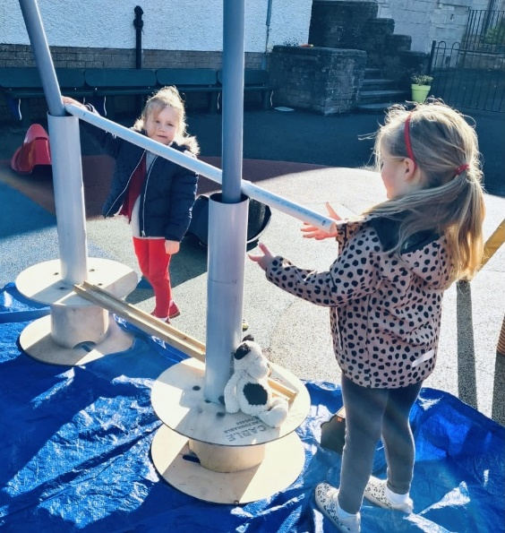
Gender Equal Play:
Within society, gender stereotyping is a deep-rooted and common issue. At Inverkip Nursery Class, by adopting a gender equality approach we are helping children to achieve and aspire. We want children to be whoever they want to be and make them feel equally comfortable playing football or taking part in dance and aspiring to a wide variety of careers and pathways.
By helping to challenge these gender stereotypes from a young age, we can help to stop the negative consequences of inequality and discrimination by supporting children grow into adults who aren’t limited by expectations based on their sex. By providing children with environments that encourage non-gendered norms and expectations, children can feel more accepted and celebrated for their individuality. They can broaden their aspirations and be more open to a wide range of opportunities
Nursery Policies:
You will find a range of policies that the Nursery will follow. There is a Nursery policy folder which can be found at the entrance area. Please feel free to look at the policies and if you have any questions please ask the Nursery staff.
Deferred Entry to School:
Some children may benefit from another year in the Nursery although they may be old enough to start school. This is known as Deferred Entry.
Children whose birthdays are in January or February and who are eligible to start Primary 1 the following August, have an automatic right to defer entry if parents wish.
Further information on deferrals can be requested from nursery staff or the Head Teacher.

Transport:
Transport is not normally provided for children attending nursery. Inverclyde Council may however provide transport to and from nursery for children with additional support needs who may require travelling some distance to take up their placement.
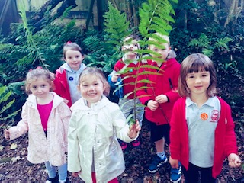
Trips and outings:
When trips or outings are planned for children, staff will let you know in advance. Parents may from time to time be asked to accompany children and staff.
Children, staff and parents all enjoy outings, and they are a valuable part of the children’s learning. When you enrol your child you will be asked to give permission for local outings e.g. for walks to the park or local shops. When other outings are planned you will be asked to fill in a separate form stipulating when your child is leaving nursery, where they are going and when your child is expected to return. Children cannot be taken on these planned trips without this consent form being signed by the parent or carer so please ensure all consent forms are returned as soon as possible.
Students:
We welcome students training to become Early Years Education and Childcare Officers at both NC and HNC levels. We also have PDGE teaching students and have also welcomed work experience pupils from local high schools. Staff and children benefit from enthusiastic students and the students have the opportunity to learn from the staff expertise. Students are supervised at all times by our experienced staff.
Minor Accidents
If your child has a minor accident or incident while at nursery this will be dealt with and recorded. We will inform you at the time if necessary, or when you collect your child. You will be asked to sign our accident or incident book.

Concerns:
If you have any concerns please do not hesitate in contacting your child’s keyworker, Mrs Lauren Mitchell or the Head teacher, Mrs Una Nicolson.
Complaints:
If parents are unhappy about any aspect of the nursery, we would again ask that they contact the nursery as soon as possible to arrange a meeting with either Lauren or Mrs Nicolson. It may help if when contacting the nursery, you give some details of the issue to allow prompt investigation. We will arrange a meeting to hear your complaint and would hope that it will be resolved satisfactorily and quickly. If the complaint is found to be justified, we will endeavour where at all possible to put right what went wrong, to make adjustments to try to prevent a similar problem arising in the future and to offer an apology where appropriate. If you are still unhappy with the service or with our response then you will have the right to take up the matter further with the Education Department. Complaints can be made in writing, by telephone or e-mail or by visiting the office in person.
Callers can contact the Education Department during office hours for information on how to raise a complaint – Tel: 01475 712850.
You can also contact the Care Inspectorate. If you have any complaints regarding any issues with the service. The Care Inspectorate address is below.
Care Inspectorate:
The Care Inspectorate is responsible for the registration and inspection of Inverkip Nursery Class. If you have any complaints, suggestions, comments or criticisms then you are able to contact the Care Inspectorate independently and any complaint will be replied to and investigated within 28 days. The Care Inspectorate inspects the Nursery on a regular basis.
The nearest office is:
The Care Inspectorate
4th Floor
No1 Smithhills Street
Paisley
PA1 1EB
The telephone contact number is 0141 843 4230

USEFUL ADDRESSES
Inverclyde Council
Education Services
Wallace Place
Greenock
PA15 1J

Ruth Binks
Corporate Director of Education, Communities & Organisational Development

Michael Roach
Head of Education Communities and Organisational Development

Alison McLellan
Education Officer

Linda Wilkie
Pre 5 Development Manager

Councillor Martin Brennan
Convenor of the Education & Communities Committee
Inverclyde Council
Municipal Buildings
Greenock
