Primary 1 Newsletter
22nd February 2021

Dear Parents,
Welcome back! We are so pleased to be reunited again. We would like to say a huge thank you to you all for your support and patience during our Home Learning time.
This week we will be reacquainting ourselves with routines, re-establishing friendships, chatting about our feelings and looking back at the learning that we have already covered this term. As this month only has a couple of weeks left, our newsletter will cover from now until the Easter break.
Literacy Learning
This week:
- We will be revising all our sounds and words to date and working on our sentence writing. We will add the missing sounds and words to wallets this week. We will also be looking at our latest Rigby Star word list.

Week beginning 1st March:
- New sounds: sh’ and ch’
- New words: ‘have’ and ‘just’

Week beginning 8th March:
- New sounds: ‘th’ and ‘wh’
- New words: ‘to’ and ‘your’

Week beginning 15th March:
- New sounds: ‘ai’ and ‘ay’
- New words: ‘by’ and ‘only’

Week beginning 22nd March:
- Consolidation of sounds and words

Week beginning 29th March:
- New sounds: ‘oi’ and ‘oy’
- New words: ‘are’ and ‘dad’

We will be using a Rigby Star book in class this week and will return to ‘books home’ .
Handwriting will also be a focus this term looking at the correct formation of letters. We’ll be building on all that great writing you have been doing at home by looking at sentence structure and writing.
This week we will be checking all our sounds and word wall words for speedy recognition. Keep an eye on reading wallets for an update.

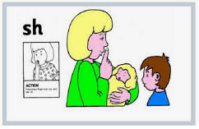

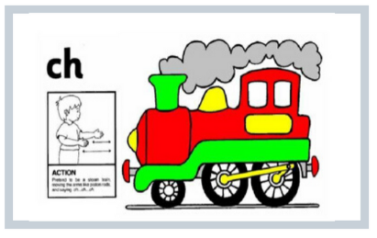

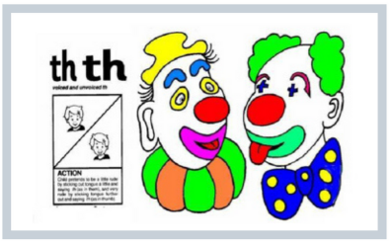

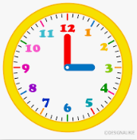
Maths Learning
We will be looking more closely at the numbers 15- 20 over the rest of the term. We will continue with our partitioning practising and we will begin to look at ‘taking away’ (subtraction).
We will also be building on the ‘time’ learning that you started at home. We will explore o’clock and half past in analogue and digital clocks. Through our topic based loosely around ‘The Hospital Dog’ we will learn about data handling (reading and making charts and graphs to display information) and measure.

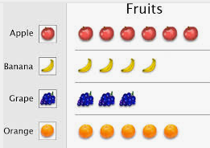

Our other learning

We will be using the Julia Donaldson story, The Hospital Dog to start us off looking at what makes us all unique, people who help us and how we look after ourselves. This will include keeping safe around medicines, electricity and roads and how we look after our bodies (we will be learning the correct terms for our body parts). We will explore a range of jobs and services that are there to help us in day-to-day life, and emergencies, and we will role play how to access help e.g. making a call to emergency services.

In PE we will be looking at fitness and different ways we can exercise.

We will be revisting our French phrases and words that we had previously learned and then we will learn some new ones (and some new songs!)

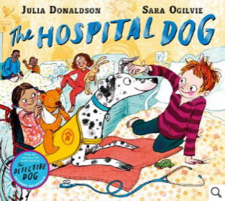

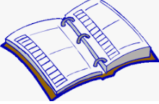
Dates for your Diary

Monday 6th March: P1 Phonecalls to Parents (appointments to follow)
Thursday 1st April: Last day of term
Monday 19th April: Return to school

Letter formation rhymes and song links for next few weeks

sh | 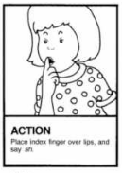  Action: | Jolly Phonics 'sh' song | ch | Action:  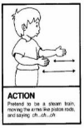 | Jolly Phonics 'ch' song
th | Action:  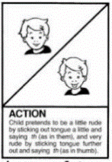 | Jolly Phonics 'th' song | wh | Action:  We ‘whoosh’ our arms above our heads like the water ‘whooshing’ out of a whale’s blowhole. | No Jolly Phonics song for this, so we sing:  Did you ever see a whale blow, a whale blow, a whale blow,  Did you ever see a whale blow water from its blowhole?  To the tune of ‘Did you ever see a lassie’
ai | Action:  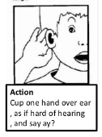 | Jolly Phonics 'ai' song | ay | Action:  Same ‘ai’ action | Same ‘ai’ song
oi | Action:  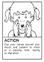 | Jolly Phonics 'oi' song | oy | Action:  Same ‘oi’ action | Same ‘oi’ song

Our next newsletter will be on Monday 19th March. As always, if you have any concerns or questions then please don’t hesitate to get in touch.

Kind regards,
Jacqui Milliner and Susie Provan

