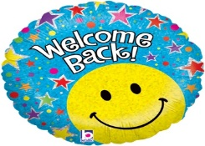
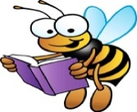
Welcome Back to Primary 3
This Photo by Unknown Author is licensed under CC BY-NC-ND
This Photo by Unknown Author is licensed under CC BY-NC-ND

Dear Parents,
It is lovely to have the children back in school and teach them face to face again. Thank you so much for the hard work you put in during our time of home learning. We are both very grateful to you for keeping the children engaged in their learning.
We will pick up the reins and move forward!
In language we return to Rigby Star Reading books (with the associated follow up work done in school) and we will also continue with The Giraffe the Pelly and Me to complete the novel together! The accelerated reading programme will continue in school, but the opportunity is still there for the children to add the books they read at home. Please do this if you wish. Spelling will be as before with words written out nightly (twice on a Thursday) and two spelling activities chosen, one of which should be sentences. We continue with our Jolly Grammar programme. In writing the children will write personal pieces in their news jotters and have the opportunity to write imaginative and functional pieces as well.
In Number we will continue with addition and subtraction using our strategies to work mentally and also to learn to set out written sums neatly in jotters. We will develop these skills in problem solving activities. The children will be reintroduced to arrays and this will lead on to more formal multiplication and the multiplication tables. We will continue to learn more about 3D shape.
We will investigate the topic of Castles, learning the skills of research and report writing and finding out how we know so much about the past. This lends itself to lots of art and craft work as well as drama!
Health and Well – Being will be a big part of our focus and the children will be encouraged to explore their feelings and talk about how to stay healthy both physically and mentally.
Thank you again for encouraging your children in their schoolwork and we look forward to working with them again in class with your support as always!

Marion Hanschell Sarah McCallion.

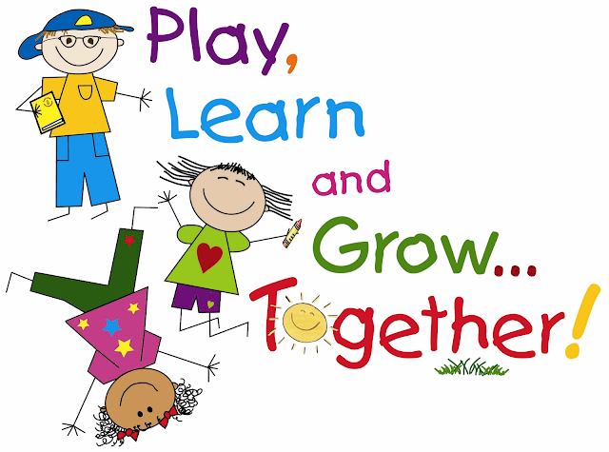
This Photo by Unknown Author is licensed under CC BY-NC

