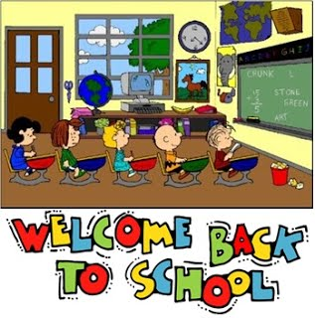
Primary 7/6 Bulletin

August –October 2020

Welcome to the Primary7/6 Bulletin. You will receive one every term to help keep you up-to-date with what is going on in the Primary 7/6 classroom. I hope you find it useful.

Inverkip –Welcome Back –
This context will encompass Health and Wellbeing; Literacy; Technology/ICT and Art. The primary focus will be on Health and Wellbeing, which will include:-
- SELF-EFFICACY –
1) Believing in ourselves
2) New skills
3) Strengths/qualities
4) Set goals (G.R.E.A.T.)
5) People making a difference –How did you help?
6) Inverkip as a community.
7) Emotions

- PROMOTING HOPE –
1) Rainbows as a symbol during Lockdown.
2) Hopes and dreams –links to setting goals

- PROMOTING GRATITUDE –
1) Acts of Kindness – Bucket filling.

- PROMOTING CONNECTEDNESS –
- Look at community spirit in Inverkip during Lockdown
- How to build it as a class/one team
- How to build it as a school again.

Literacy
Much of the literacy work this term will be following on from work taught in Primary 5 and Primary 6. For example -:

- Big Write – we will focus again on VCOP and will practise these targets in a variety of creative writing passages and stories.
- Comprehension of familiar and unfamiliar texts; context clues; reading between the lines; analysis of texts.
- Listening and talking in groups –being the leader; taking turns; discussing.
- Descriptive writing –use of adjectives; thesaurus.
- Personal writing/poetry

Maths
*All groups to work on times tables – needs constant practice and revision. In general, the children will work as two groups (P7 AND P6) with varying degrees of support.

- Mental maths strategies
- Times tables
- Addition/subtraction/multiplication/division - revision
P6 – P7 -
- Numbers beyond 5 digits Factor pairs/prime numbers
- Multiplying/dividing by 10,100,1000 Numbers beyond one million
- Probability Rounding to nearest 10,100,1000
- Time Percentages
- Tessellation Co-ordinates
- Improper fractions/Mixed numbers Angles
Directions

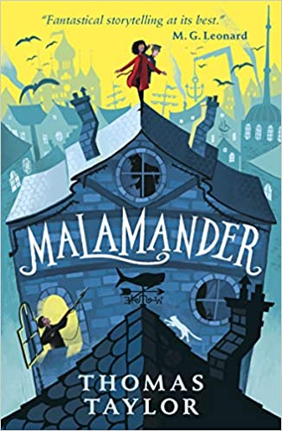
Class novel
This term we will start reading the novel “Malamander” by Thomas Taylor. It is an adventure book full of twists and turns with interesting and mysterious characters and unusual settings. We will use the novel as a focus for some of our literacy work this term.

Primary 7/6 will be a year full of challenges, responsibilities, hard work and hopefully fun. This is just a sample of what we hope to cover this term!! Please remember if there are any concerns, don’t hesitate to get in touch with me. Any help you can give to the pupils at home is much appreciated.

Follow our class on Twitter using –
@IPS_Primary76

Rhona Findlay
(Class Teacher)

