Primary 1 Newsletter
12th August 2020

Dear Parents,
Well we all had a fab day today on our first day of school! We hope you managed to relax a bit and have a wee cuppa. This wee newsletter is just to keep you up to date with our P1 goings-on.
Your newsletter
Your child will be given a newsletter at the start of each week providing an outline of the work we will be covering in class so you can talk to your child about what they are learning. We will also add other useful information from time to time for you to add to your diary!
Next newsletter due Monday 26th August. You will receive this by email.

The next few weeks
We will be concentrating on our class routines, getting to know each other and helping your child to become familiar with the class and school life. There will be a big focus on phonological awareness including rhyme and syllable work. We have lots to learn!
Our Jolly Phonics will begin on Monday 31st August/ Tuesday 8th September (PREFERENCE UNA?)
We will keep you posted in your newsletters.

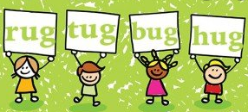

Coats and Bags
As you know, we currently have a relaxed school uniform policy. Please make sure your child has appropriate footwear and coat as we will be outside as much as we can.
Anyone who does not yet have a reading wallet can purchase one at the school office. We will put any correspondence to parents in the reading wallets and if you have a note for us please put it in there too. Please remove letters as you get them as wallets can become cluttered and we / you may miss important notes.

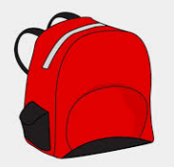

Lunchtime, Snacks and Water
To help with organising our lunches it would be a great help if you could complete the sheet attached at the end outlining your child’s lunch choices for tomorrow until Monday 24th August.
Snacks and Lunches will be eaten in class for the time being.
Children are encouraged to bring water into the class to drink during the school day. Diluting juice, cartons and fizzy juice are not permitted. Staff will refill bottles during the day if required.

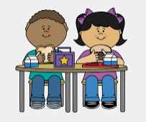

The Invisible String and The Colour Monster
In P1 we will be looking at the books ‘The Invisible String’ and ‘The Colour Monster’ to explore the emotional bonds we have with people and places (The Invisible String) and how a variety of situations can cause different emotional responses and how this impacts on us (The Colour Monster). With this in mind, we might ask you to send in some photos to support this. We will be in touch!

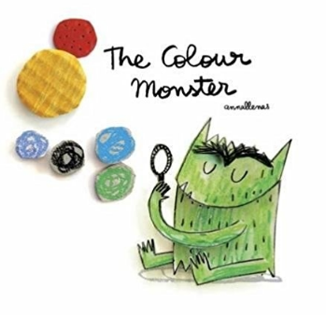

Follow Miss Milliner’s class on twitter using:

We are both so excited to be working with your wee stars this year!
Please remember that if you have any concerns or questions, don’t hesitate to contact the school.

Kind regards,
Jacqui Milliner and Susie Provan (OR JACLYN?- UNA)

P1 School Lunch Preference

Child’s Name: _____________________________

Please complete the form and return to school in your child’s reading wallet by Thursday 13th August. Please indicate school lunch choice or if your child is a packed lunch or home lunch, include this too.

Thursday 13th August

Friday 14th August

Monday 17th August

Tuesday 18th August

Wednesday 19th August

Thursday 20th August

Friday 21st August

Monday 24th August

