Inverkip Primary & Nursery Class
- Standards and Quality 19/20
- Recovery Action plan Autumn 2020/21

Context of the school:

Our School
Inverkip Primary School and Nursery class is a non-denominational school which serves the village of Inverkip. In session 2019/20 we had 256 pupils over 10 classes. Staff included a newly appointed Head Teacher, Depute Head Teacher, one class committed Principal Teacher, 10 further full time teachers, one teacher 0.8 and one teacher 0.6. Our support staff consisted of 7 full time and two part time staff members and an additional ASN employed through PEF funding. Our Nursery class has 44 children across am/pm places with one Senior EYECCO, two EYECCO’s and one Nursery assistant. We also had two clerical staff plus one janitor.
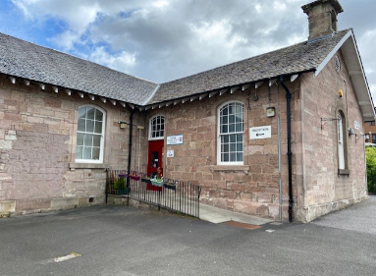
Our L shaped building also houses two gym halls, an ICT suite and three playground areas including a Multi-Use Games Area (MUGA). A virtual tour & 360 degree map can be found on our school website. We hope to see a new ‘Trim Trail’ installed in our playground in the coming session thanks to the dedication and commitment of our Parent Council who have worked tirelessly to facilitate this.

Vision
In Inverkip Primary & Nursery Class, we strive to provide the highest quality learning and teaching experiences to ensure that all children care about the world they live in and learn and develop the full range of skills to be citizens of the 21st century. We are developing our full potential and inspiring others to succeed within a climate of teamwork, respect and trust, where all our children aspire to become successful learners, confident individuals, responsible citizens and effective contributors.

Values
Children, staff and parents have an excellent understanding of the school’s values which reflect the principles on which we base all our decisions and use them to influence day-to-day practice.

Our CHEER Values are:
C | H | E | E | R
Commitment | Honesty | Endeavour | Equality | Respect

Aims
- To develop a restorative perspective as we navigate and develop a consistent approach that stimulates thinking and decisions as we collectively move forward with a new blended learning approach that embraces digital technology.
- To ensure that Recovery planning is values based and needs led where Recognition, Empathy, Safety, Trauma, Opportunity, Relationships and Engagement are at the heart of strategic approaches. (RESTORE) and highlight the importance of relationships for emotional wellbeing, resolving conflict, preventing harm and building resilient communities.
- To provide a nurturing, happy environment where all pupils feel safe, healthy, achieving, nurtured, active, respected, responsible and included.
- To develop positive relationships built on the 6 principles of nurture and respect for the rights of others.
- To provide high quality teaching & learning experiences, cultivating a love of learning and a sense of achievement in all our pupils by work together with parents and partners to build capacity for all pupils to achieve and attain.
- To ensure that there is equity of provision and resources across the school community so that learners are not disadvantaged against their peers, by providing opportunity and exploration alongside expectations.
- To provide a broad, balanced and transparent curriculum which is challenging, has breadth, depth, relevance coherence and is fun and enjoyable where each pupil has the opportunity to thrive emotionally, socially and physically.
- To address any gaps through explicit teaching of metacognitive strategies in conjunction with specific subject content, consulting and co-constructing of learning experiences. Empowering learners to review and reflect when developing an understanding of their individual learning styles.
- To encourage effective learners to achieve their fullest potential within and outwith school who can self-regulate, display resilience, enterprising attitudes, independence, skills for learning, skills for life and skills for work to positively impacting on the community in which they live.
- To foster high quality leadership at all levels through valuing and empowering all members of the school and nursery community. Pupils consistently feel that their voice, opinions and ideas are listened to and acted upon

Inverkip Primary School & Nursery Class is committed to delivering on its core business of 'learning' and is thrilled with the achievement gains to date. We are committed to building the necessary knowledge and competencies for pupils to thrive and succeed in learning and life. We have a supportive and active staff, community and partnerships who are open, committed and willing to do whatever it takes to ensure that each learner is stretched and experiences fulfilment in learning.
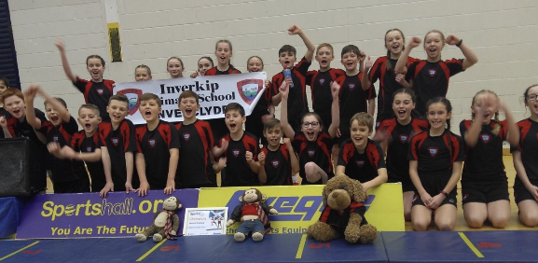
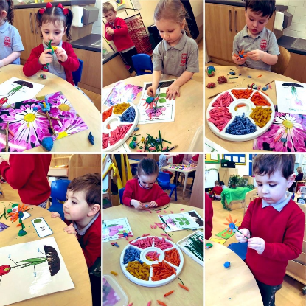
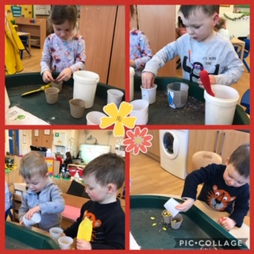
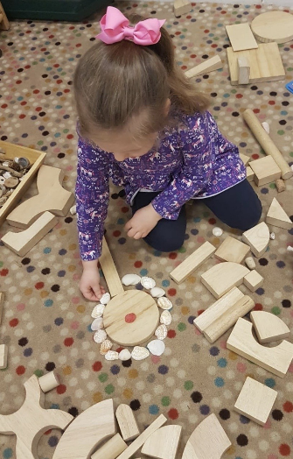

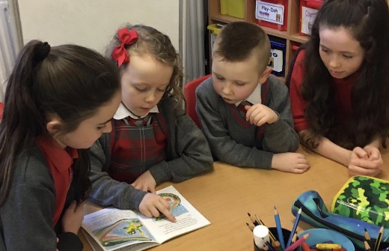

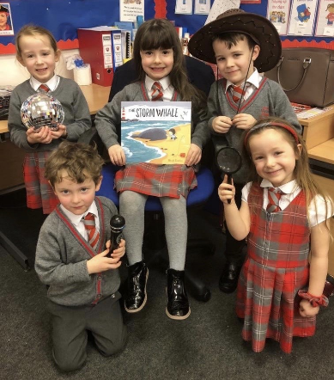

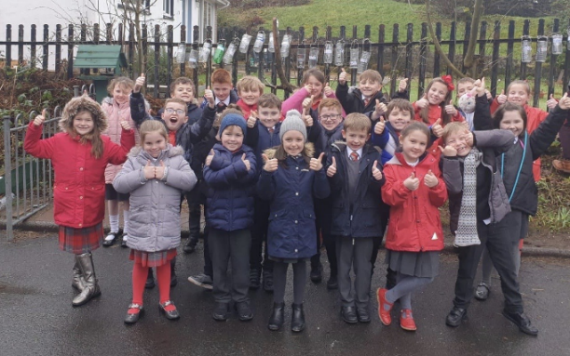

Review of progress for session Aug 2019- March 2020
School priority 1: Improvements in attainment, particularly in literacy and numeracy

NIF Priority  Improvements in attainment, particularly in literacy and numeracy  NIF Driver  Assessment of children's progress  Teacher professionalism | HGIOS?4 QIs  3.2 Raising attainment and achievement  2.3 Learning, teaching and assessment  2.2 Curriculum  Other Drivers  HGIOELC  RRS  Article 28: (Right to education):  Article 12 (Respect for the views of the child):  Article 29 (Goals of education):
Strategies:
1.1 Inverclyde Progression Pathways used systematically in planning
- Staff training opportunities to build and enhance capacity in the use of Digital Literacy/IT to support learning/pathways.
- Embed Inverclyde Numeracy & Mathematics Progression and Inverclyde Literacy & English Progression Pathways into mid-term planning to ensure consistency.
1.2 Nursery STEM Moderation and development (Outdoor Play)
- Education Scotland funding for development of a pilot project to involving Kilmacolm/Lady Alice/Inverkip Nurseries.
1.3 SEAL planning embedded in Early Level & P2 and rolled out to P3 to develop early arithmetical thinking skills
- Further develop the use of SEAL at Nursery, P1 and P2 and introduce at P3 stage.
1.4 School Moderation:
- Embed, monitor and evaluate the use of Number Talks at all stages.
- Continue to develop moderation opportunities across the school, cluster and authority with a focus on Reading /Listening & Talking.
- Participation in an Education Scotland Nursery pilot re: STEM Moderation and the development of Outdoor Play.
1.5 ASD Communication Plan
- Implementation Cycle used to create an ASD Communication Plan (Bronze Award).
1.6 Visible Learning
- Review the use of Visible Learning pedagogy and strategies: focus on pupil targets/next steps.
Progress:
  - Inverclyde Progression Pathways used systematically in planning
- Teaching staff using Literacy and Numeracy Pathways for planning and for moderation with colleagues across the cluster and authority.
- Senior EYECO has begun to use progression pathways when planning in collaboration with staff.
- Process underway of linking the Numeracy and Maths Pathways to available resources in school started.
- Regular stage meetings held to make ensure moderation and consistency planning across levels.
- Continued reinforcement and opportunity presented to staff with numerous Digital Literacy/IT professional learning activities during staff collegiate sessions. Webinars in Coding, Microsoft Teams, Immersive Reader and the use of One Drive.
- Ongoing development of a new school website, class Team’s and a school YouTube Channel to share learning.
- P5-7 Pupils introduced to coding through Microbits programming sessions.

  - Nursery STEM Moderation and development (Outdoor Play)
- Early Years’ staff attended training ‘Loose Parts’ training sessions with pilot staff from lady Alice & Kilmacolm Nurseries.
- Professional reading materials purchased to support and build staff knowledge and understanding on outdoor play pedagogy.
- Early Years’ staff visited other establishments – sharing good practice.
- Materials and resources collated and gathered to support loose parts play.
  - SEAL planning embedded in Early Level & P2 and rolled out to P3 to develop early arithmetical thinking skills
- All nursery staff have attended SEAL training, SEAL planning referred to when planning for block/term and SEAL strategies embedded through daily activities and learning.
- Nursery, P1 and P2 continuing to use SEAL for planning mental maths activities.
- Some P3’s using SEAL with P4 using for mental maths.
- SEAL master resource packs made up for: Phase 1 Emergent, Phase 2 Perceptual & Phase 3 Figurative.
- Number Talks embedded across the school.
- Numerals displayed in different areas of the nursery playroom to encourage identification and number conversations and enquiry. Number songs bags introduced at group time.
  - School Moderation:
- Cluster Moderation of evidence at First Level for reading (focus on questioning) and Listening & Talking.
- Resources developed and shared to enhance our Nursery to P1 transition: video/interactive map/360 tour.
  - ASD Communication Plan
- ASD training for all school and nursery staff and bespoke plan created alongside the ICOS team based on evaluative evidence.
  - Visible Learning
- Pupil engagement and evidence of Target sheets on pupil desks P3-7 and orally for P1-2.
- Participation of all Support Staff in training on how to support/scaffold learners using individual targets.
- Development of a shared understanding of targets with parents via an Information leaflet.

Impact:
1.1 Inverclyde Progression Pathways used systematically in planning
- Increased staff and pupil capacity and confidence in the use of IT to support remote learning.
- Nursery staff have an increased understanding on bundling and delivering learning outcomes through daily activities. Staff now planning more efficiently and natural links made across curriculum areas.
- Staff planning in a more collegiate manner which has ensured moderation of pace, challenge and differentiation.
- Improved efficiency noted in the planning process since Numeracy resources aligned to progression pathways. Staff now more focused on the learning process rather than being resource led.
- Staff enhanced use of SEAL due to readily available resources to support. This has ensured a more consistent use of strategies impacting on a noted increase in skills development.
- Quality assurances measures highlight a greater consistency of approach in use of Number Talks. Pupils are using a shared language of learning across the school.
1.2 Nursery STEM Moderation and development (Outdoor Play)
- Increased nursery staff knowledge, understanding and pedagogy in outdoor play/messy numbers. Staff now using this to increase and improve our outdoor learning provision.
- Staff confidence improved in developing woodworking/skills agenda through play. This will now be embedded in the planning process moving forward.
- Increased collaboration and sharing of good practice across pilot nurseries. Staff are now keen to build on identified good practice and will align systems/processes relevant to our nursery context.

1.3 SEAL planning embedded in Early Level & P2 and rolled out to P3 to develop early arithmetical thinking skills
- Pupils demonstrate increased confidence in articulating their mathematical thinking/explanations impacting on an increased focus, collaboration and sharing of strategies being used.
- Timetabled focus in P1-4 on SEAL development and number talks (P1-7) which has ensured a more consistent approach. Observations/learning visits indicate an increase in the language of maths and pupils are more independent in use of strategies to support problem solving.
- SEAL strategies embedded in daily nursery activities which has led to a more fluid transition of learning experiences into P1.
  - School Moderation
- Increased professional dialogue with staff has ensured consistency of listening and talking and teacher professional judgement better aligned across literacy outcomes.
1.5 ASD Communication Plan
- Enhanced staff understanding of ASD strategies showing an increased proactive approach by teaching staff in the use and understanding of available supports and good practice. This has impacted on individual pupils requiring a more targeted approach.
- Increased pupil self-regulation evident through engagement with ASD strategies e.g. Safe space/visual timetables. Pupil feedback has indicated that they feel more settled and supported.
- School and nursery signage adapted using Board Maker: Visuals, Maps and signage. This has impacted on a less cluttered, calming learning environment.
1.6 Visible Learning
- All P7’s participating in the collaborative use of One Drive to receive feedback on learning tasks. This increased peer to peer feedback and heightened the use of VL strategies in the P7 class.
- Consistent use of Number Talk strategies evident and a shared language of learning now developed across learners.
- Improved Early Years staff engagement in research/pedagogy on outdoor learning which has led to increased staff confidence and an enhanced use of outdoor learning/space noted.

Next Steps:
- Develop staff understanding of Metacognition research and pedagogy.
- Cultivate pupil involvement with Numeracy/Literacy progression pathways to empower learners/identify own next steps.
- Senior EYECO to use progression pathways to identify an overview of the full academic year to ensure quality learning provision.
- Continue to develop Nursery STEM activities and outdoor learning extend to P1-2.
- Review ASD action plan to include aspects of recovery planning: HWB/Social stories/6 principles of Nurture.
- Introduced individual passports for all nursery pupils.
- Embed the use of SEAL at P3 and extend to P4.
- Nursery to align tracking processes to identify individual children’s progress in SEAL.
- Reinforce use of Dialogic Teaching strategies and link to developing a ‘Number Talk’ progression pathway. Develop a ‘Number talk school policy.
- Through quality assurances processed, ensure all nursery staff are consistent in use of number talks and develop strategies to encourage the use at home.
- Revisit use of AiFL strategies and feedback.
- Develop a whole school understanding of ‘learner dispositions’ and create a shared language.
- Develop use of digital technology to support remote learning across the whole school community and Introduce Microsoft Team’s at nursery level to increase home/nursery communication.

School priority 2: Closing the attainment gap between the most and least disadvantaged children

NIF Priority  Closing the attainment gap between the most and least disadvantaged children  NIF Driver  School Improvement  Assessment of children's progress | HGIOS?4 QIs  3.2 Raising attainment and achievement  1.5 Management of resources to promote equity  3.1 Ensuring wellbeing, equality and inclusion  Other Drivers  HGIOELC  RRS  Article 3 (Best interests of the child):  Article 28: (Right to education):  Article 2 (Non-discrimination):
Strategies
  - SNSA data interrogation: BGE Toolkit and impact on Parentzone Dashboard
- Develop staff capacity in the interrogation of data to drive improvements.
  - Accelerated Reading
- Targeted support intervention - Introduce an Accelerated Reading Programme and resources purchased using Pupil Equity Fund.
- Use of Literacy Toolbox to support individual pupils.
  - ASD Whole School Action Plan – & Cluster Moderation focus
- Collaboration across cluster to develop ASD plan – adapt to Inverkip context.
- Safe spaces and One Good Team introduced for targeted children.
Progress
  - SNSA data interrogation: BGE Toolkit and impact on Parentzone Dashboard
- Staff able to access SNSA data and have used information to confirm professional judgements. Progress disrupted due to Covid19 school closure and testing not complete.
  - Accelerated Reading
- Key staff participated in Accelerated Reading training and undertook a leadership role in then delivering training to all teaching staff.
- All children P3-7 completed baselined assessment for Accelerated reading using Star Test. Impact disrupted during school closure but programme embedded in remote learning planning.
- Word Millionaires introduced as a motivator for pupils and inter- class competitions with highest number of words read and announced at assemblies.
2.3 ASD Whole School Action Plan – & Cluster Moderation focus
- Parent Support group established and has multi agencies involved ICOS. Group have had several meetings but this has been impacted in term 4.
- Identified services available to support shared with parents.
- Pupil support group developed.
- Targeted focus on transition to high school – development of pupil passports.
- Safe spaces and One Good Team introduced for targeted children to self-regulate emotions.
Impact
2.1 SNSA data interrogation: BGE Toolkit and impact on Parentzone Dashboard
- Increased staff capacity in the ability to interrogate data to drive improvements evident in professional dialogue/planning meetings. This has streamlined targeted supports for individual pupils.
- Evidence of increased attainment for targeted pupils through individual support. Information from data interrogation used to plan responsive action plans and information shared with both pupil and parent.
  - Accelerated Reading
- Key staff feel empowered through participated in Accelerated Reading training and now confident to lead training to all teaching staff. Accelerated now being used to support reading and initial results show an increase in attainment.
- Staff confident in the use of data to support all children P3-7 in accessing the accelerated reading programme. Completion of a baseline assessment for Accelerated reading (Star Test) used to create bespoke plans.
- Staff note an increased enthusiasm for reading especially for boys through accelerated reading programme.
- Overview created to align and track progress of targeted interventions by cross referencing results of accelerated reading and Literacy Toolbox programmes. This has ensured a more targeted support and will continue to be developed as we move forward.
2.3 ASD Whole School Action Plan – & Cluster Moderation focus
- Some collaboration across the cluster to develop ASD plan but this was disrupted due to school closure.
- Safe spaces and One Good Team introduced for targeted children. However, physical space is an issue and staff will continue to find creative solutions.
- Pupil voice/feedback through focus groups indicated a positive responses to school signage/map.
- All staff, including nursery class use lanyards with visuals to support transitions. Assembly to explain visuals to pupils. This has ensured that our ASD plan is shared at a whole school level and pupils are kept up to date with any progress and involved in the planning process.
- Positive response from parents who indicated that our ASD workshops had increased their confidence and was a valuable experience.
Next Steps:
- Ensure that SIMD pupil participation in Accelerated Programme is rigorously targeted, tracked and monitored.
- Further resourcing for gaps e.g. purchasing extended reading materials/Barrington Stoke.
- Ongoing staff training as required re: accelerated reading.
- Align systems to robustly track attainment and engagement of cohorts of groups in targeted literacy/numeracy supports across nursery and school.
- Develop and use a variety of methods to gather and use a combination of hard and sort data to ensure gaps are identified and targeted interventions put in place.
- Review ASD plan and continue to develop parent workshops/support group.

School priority 3: Improvement in children and young people's health and wellbeing

NIF Priority  Improvement in children and young people's health and wellbeing  NIF Driver  Parental engagement  School Improvement | HGIOS?4 QIs  3.1 Ensuring wellbeing, equality and inclusion  2.1 Safeguarding and child protection  2.5 Family learning  Other Drivers  HGIOELC?  RRS  Article 31 (Leisure, play and culture):  Article 28: (Right to education):
Strategies
3.1 All LAAC pupils to have a SEEMIS Child’s Plan
- Align systems to ensure legislative/Child Protection measures are in place.
3.2 School Mental Health development
- Pupil Focus Groups developed to gain feedback on HWB pathways.
- Create Staff CPD opportunities.
- Parent & Pupil Workshops.
3.3 ASD School Action Plan
- Embed and develop RRS Gold Level.
- Re-visit and promote school values & class charters in all classes to enhance positive relationships.
- Nursery outdoor play area developed:
- Development of new outdoor learning rota
- List of outdoor learning experiences
Progress
3.1 All LAAC pupils to have a SEEMIS Child’s Plan
- All LAAC children now have an appropriate plan in place.
- Collaborative approach with stakeholder to create enhanced universal action plans.

3.2 School Mental Health development
- Bounce Back programme embedded at all stages.
- Be Kind initiative introduced at whole school level through community links with ‘Compassionate Inverclyde’. Certificates awarded at nursery/school assemblies to promote friendships and kindness.
- Input given and sources to support teachers’ ability to recognise and support children’s Mental Health given: Mind Resources/Jammin Fitness/Lucy’s Grey Day author visit.
- Staff started to update HWB Programme to reflect MH&W resources. This will be an ongoing process.
- HWB Pupil Focus Group Initiated to ensure pupil voice is valued and listened to when updating policy.
- Staff undertaken CPD: ICOS delivered training.
- P1 kindness bears sent home with each child for a visit.
- Parent & Pupil Workshops delivered specific to Mental Health awareness.
- Assembly planner updated to ensure a RRS/Mental Health/Be Kind focus.

3.3 ASD School Action Plan
- Implemented new signage in corridors -lunch photographs.
- Increased engagement through the establishment of an ASD Parent support group.
- All staff, including nursery class have lanyards with visuals to support learners.
- Applied colour coding of resource labels in all classes.
- Proactive use of passports to support all ASD pupils.
- Not all actions completed on plan due to school closure.
Impact
3.1 All LAAC pupils to have a SEEMIS Child’s Plan
- Increased alignment of targeted support through identified targets in collaboration with all stakeholders to support children’s individual needs. All enhanced universal pupils have an action plan that is reviewed regularly.
3.2 School Mental Health development
- Pupil voice tracked and recorded through focus groups. This has then led to pupil leadership opportunities being heightened in the quality assurance processes. Feedback indicated that pupils feel valued and changes implemented have been a collaborative process between staff, pupils and parents. Focus groups will now be a regular occurrence.
- Increased staff capacity, knowledge and confidence in pedagogy around mental health. Staff able to articulate strategies and an increased focus on HWB evident within classes. Staff empathetic and understanding of Mental Health.
- Positive feedback noted from Parent & Pupil Workshops. This will be continued next session and pupil/parent leadership roles encouraged in the planning process.
- Increased pupil articulation of feelings through a daily emotions check in evident in nursery and all classes. Staff report that the pupils appear more settled and that there is less low level disruption.
- Improved whole school awareness noted in pupil language of learning and participation in the Be Kind/HWB strategies through regular focusses assemblies.
- Strengthened community links with Compassionate Inverclyde through: Christmas Cards/ Back Home Boxes/ Toiletry bags for hospital. These links will continue next session.
- Collegiate activities has enabled staff to familiarise and engage in some piloting of new RSHP resources. We are currently adding these to HWB Programme which will then be embedded in the planning process next session.

3.3 ASD School Action Plan
- Observations record that daily transitions are smoother for our ASD pupils through increased use of Visual timetable/signage. The school will continue to use signage to support next session.
- DHT membership of Autism Friendly and HWB co-ordinators group has enabled dissemination of information and resources to enhance the learning environment in supporting pupils’ needs.
Next Steps:
- Review ASD action plan and coordinate across Cluster schools using Bronze award criteria/ICOS support.
- Continue to review and create bespoke actions plans for identified high priority pupils on an enhanced universal provision.
- Seasons for Growth was planned for term 4 and will roll over into recovery planning.
- Introduce ‘What Matters to Me’ individual passports across the school community to build on pupil individual experiences during Covid 19 restrictions.
- Introduce materials such as ‘Emotion Works’/PATHS/Good Grief to staff to scaffold and support planning in response to pupil needs as school enters the recovery phase.
- Friendship areas and a sensory path developed to compliment the Be Kind campaign. Introduce massage (depending on restrictions). Trim Trail to be installed in the playground.
- Audit, review and develop an action plan to enhance indoor and playground space to encourage indoor and outdoor play opportunities.
- Purchase PATS puppets to further enhance learning and awareness about acts of kindness and friendships across Nursery/Early level.
- Continue to develop opportunities to celebrate wider achievement and skills development across the school community to build on ‘life skills’ developed during the Covid 19 school closure/remote learning.
- Develop staff knowledge, understanding and pedagogy in:
- 6 principles of Nurture
- Play for recovery
- Coping with Adversity (3 pillars of trauma)
- Bereavement – change/loss
- Pupil Voice
- Boxall profiling/Beyond the Boxall strategies

School priority 4: Improvement in employability skills and sustained positive school leaver destinations for all young people

NIF Priority  Improvement in employability skills and sustained positive school leaver destinations for all young people  NIF Driver  School Improvement  Teacher professionalism | HGIOS?4 QIs  3.3 Increasing creativity and employability  2.7 Partnerships  1.2 Leadership of learning  Other Drivers  HGIOELC  RRS  Article 28: (Right to education):
Strategies
4.1 Digital Learning focus for all classes
- Staff CPD
- Staff/Pupil/Parent workshops
4.2 Development of pupils as Visible Learners
• Embed Learning Logs to tie in with Visible Learning pedagogy
Progress
4.1 Digital Learning focus for all classes
- Staff attended training on Immersive Reader and One Drive.
- Staff participated in Webinar training on how to use Teams and Assignments.
- Team’s introduced to all classes for purposes of Remote Learning.
- Coding introduced to P3-7.
- School website updated and YouTube channel created.
- Technology used to support transition with a video/virtual QE map/360 tour created.
4.2 Development of pupils as Visible Learners
- Questionnaires issued to all pupils and regular focus groups.
- Visible learning action plan created with a focus on targets, Learning Intention and Success Criteria.
- Introduction of ‘learning fans’ in P1.
Impact
4.1 Digital Learning focus for all classes
- Pupils and staff have increased knowledge and capacity in utilising ICT to assist with learning and communicating promoting life-long skills. This has impacted on staff being able to adapt to remote learning in response to Covid 19.
- High level of engagement on Team’s with an average of 79.3% across the school.
- Home Learning questionnaire indicates a 99% positive response in the use of Team’s to support learning at home.
4.2 Development of pupils as Visible Learners
- Pupils are able to articulate targets and next steps in learning and evidence recorded in learning logs.

Next Steps:
- Review/Audit current practice and apply for Digital Literacy Award. Develop school ‘Digital Literacy’ Champions.
- Introduce use ClickView to support ‘blended learning’ from August.
- Develop use of One Drive across upper stages and staff teams to encourage collaboration.
- Continue to upskill staff in use of Microsoft training to support and streamline blended learning provision.
- Regularly update school website, You Tube channel and create individual class Twitter pages.
- School and nursery consultation on Inverkip ‘Learner Dispositions’ and link to school values.
- Revisit AiFL/feedback and Metacognition (learning to Learn) strategies.
- Continue to develop ‘World of Work’ opportunities across the school and nursery drawing on expertise of parent community and community partners.

National priority: How we are ensuring Excellence and Equity?

PEF strategy:
- Inverkip Primary has a roll of 263 pupils. There are currently 7 pupils entitled to a free school meal (FME 2.66%) and 3 LAAC pupils (1.1%). We have 1.52% of our pupils living within SIMD Deciles 1&2 with almost all of our pupils living within SIMD Deciles 5,6,7& 8 (98.48%). SEEMIS data confirms that across the school Inverkip Primary continues to attain in line with, or above our cohort of comparator schools at a local and National level.
- Through discussions with the whole school community, it was agreed that the money would be spent on funding an accelerated reading programme and addition support staff (10 Hours). The support staff role was to target identified gaps in children’s learning through analysis of data, professional dialogue with the class teachers and the School Leadership Team. The information regarding SIMD 1 and 2 and entitlement to free school meals was also taken into account.

Impact:
Overview of strategies in place for session 19/20, as far as it can be determined without final data, for
Attainment Challenge Funding has focussed on raising attainment in literacy and numeracy across the school including those pupils who may be disadvantaged as a result of the poverty related attainment gap.
- As a result, a range of children from across the school were given targeted support. The support was reviewed on a regular basis. There has been an observed increase in confidence in reading, writing and numeracy at all levels as shown through assessment data, jotter monitor, learning conversations (children and staff) and classroom observations.
- Improved staff confidence, knowledge and skills regarding closing the attainment gap has resulted in a more effective use of support strategies and resources. This has contributed to a rise in attainment as shown through assessment data.
- Accelerated Reading affords a termly formative assessment and will form a crucial part of our Reading Policy. However, due to Covid19 measures we only have data from Nov – Feb as the programme was in the infancy of being introduced. Initial results are positive and show increased progress.
Next Steps:
- Scotland’s Curriculum for Excellence helps our children and young people gain the knowledge, skills and attributes needed for life in the 21st century. While the COVID-19 pandemic has changed many things, our curriculum framework continues to apply with our learners at the heart of planning.
- Many of our families and children will have had different experiences dependent on personal circumstances during this period. We will work with learners and their families to draw together evidence of learning and build upon the many skills and attributes that our pupils have learned during this period.
- Therefore, recovery planning will recognise that good health and wellbeing is fundamental to ensuring that our children can engage effectively in their learning. Our initial focus will be on learning across literacy, numeracy and health and wellbeing and this will be responsive to our pupils needs.

Our PEF allocation for session 20/21 is approximately £12,960. Our strategy will be flexible and responsive next session to better meet the needs of pupils on their return to school taking into account scoping exercises to gain hard/soft data before/after return to determine the impact of Covid 19 on our pupils and families:
PEF will therefore been used to continue support all of our pupils to raise attainment through:
- Development of our Visible Learning pedagogy with a focus on AifL strategies.
- Development of HWB strategies to improve Health and Wellbeing.
- Resources to create a new sensory nurture base.
- Increased focus on the development of Outdoor Learning, reources and STEM opportunities.
- Continued enhancement of support staff hours to facilitate targeted support.
- Accelerated Reading Scheme will be continued to raise attainment in Reading and Writing.

Response to Covid 19 Lockdown closure – March 2020 – June 2020

Our school values of Commitment, Honesty, Endeavour, Equity and Respect (CHEER) underpinned our response to the COVID pandemic and resulting school closures. These are unprecedented times and we endeavoured to understand and empathise with the challenges and impact that the school closure has had across our families and school community. Inverkip Primary will continue to be adaptable and responsive to the diverse needs of individual learners during the Recovery Phase.

Whilst schools remained closed to pupils, staff continued to work tirelessly behind the scenes to support and react to an ever changing landscape to ensure that we met the needs of our pupils and families. The school had an added challenge with the appointment of a new Head Teacher (Mrs Nicolson) who took over the leadership of the school at the point of school closure.
- Mrs Nicolson called all families to introduce herself and reassure parents that the school would continue to support and engage with families throughout the school closure phase.
- Weekly Head Teacher update emailed to parents to encourage an open, transparent response and to keep parents updated. A prompt response given to any parent enquiries.
- All families issued with a questionnaire regarding Remote Learning. Feedback was then used to shape and adapt practice to better meet needs.
- Nursery staff sent letter to all children and kept in touch with suggested learning activities via daily Twitter updates.
- School website updated to include additional suggestion to support remote learning from Nursery to P7.
- We had a high number of staff volunteers to support the childcare Hub for critical key workers and vulnerable pupils. We are proud of the dedication and commitment demonstrated by staff, many of whom committed their holiday entitlement to ensure that our childcare Hubs continued to run during the Easter break and public holidays. We had a consistent number of pupils who attended the Hub and response was positive to the experience.
- Staff have built strong relationships amongst cluster colleagues whilst working in partnership at the Inverclyde Academy Childcare Hub.
- Staff worked with pupils/families to ensure that every class had access to a Microsoft Team’s page in the week prior to school closing.
- Home Learning packs were issued with a large collection of learning materials to support families’ deliver home learning.
- A weekly remote learning plan was emailed to parents every Friday and work uploaded on to Team’s. Staff then engaged with pupils daily to answer any questions/queries and to give general support and advice. Staff have also given 1:1 feedback via the ‘Assignments’ tab.
- Staff engaged with pupils on a daily basis to support remote learning and Inverkip Primary has had a high level of engagement through Microsoft Team’s (Average of 79.3%). Staff often responding to pupils’ out-with school hours.
- Staff engaged with several virtual Team meetings with pupils in small groups to ensure that pupils stayed connected and had the opportunity to ‘chat’ to their teacher.
- All staff uploaded personal video message clips to pupils on a regular basis to try and keep pupils motivated. Pupils were also encourage to wear school uniform at points throughout the period and this had a positive response from pupils who loved wearing their uniform again.
- Pupils wrapped a ‘Rainbow Ribbon of Hope’ around our school with positive messages for the school and wider community. Pupils also made a large number of ‘Thank You’ cards that were then distributed to Carer’s across Inverclyde.
- Staff issued a weekly ‘Inverkip All Star’ challenge via video message at the start of every week. This had a variety of themes to engage various interests. A winner was then drawn on a Friday and a prize delivered to the lucky pupil.
- Child protection procedures were in place through weekly pastoral pupil check-in to our vulnerable families and places offered at our childcare Hub for children who needed additional support. This was undertaken by the SMT team who continued to track and monitor throughout.
- Staff reported to SMT on a weekly basis to report engagement and identified any pupils who required a pastoral call home.
- Child protection procedures were in place and SLT liaised weekly with our allocated key person from Social Work Services.
- Staff checked in weekly with SLT through a variety of means such as virtual meetings/phone calls/whatapp and email. Mrs Nicolson and Mrs Crossan were proactive in considering the health and wellbeing needs of staff.
- The school worked hard to create a number of resources to support the ‘Transition’ process and produced: a ‘Welcome to Inverkip’ video, a virtual QR code map and a 360 virtual tour. All new P1 pupils have been invited for a visit on Thursday 18th June.
- We have produced a P7 ‘Year Book’ and a class of 2020 video message to support the transition process. Enhanced transition meetings have taken place to support vulnerable pupils.
- The school and nursery were proactive in the use of Twitter to share advice and support across the school community.
- Mrs Nicolson liaised with the Parent Council Chair regularly and update parents via a ‘virtual’ PC meeting. All correspondence from parents was answered in a prompt manner and parents were positive in their feedback about the school.

Here’s what some of our parents and pupils thought:

I feel a morning pre-recorded motivational chat from their own teacher would be beneficial. Both my children have been fortunate enough to see the All Stars messages from their own teachers, I could see the delight in their faces.
(We responded by staff uploading personal messages to their class!)
I have loved my time and the Hub and have made lots of new friends.

The school support has been fantastic and exceeded any expectations I had.

My Child has really enjoyed the variety of activities which have been offered. They have been easy to follow and Just the right amount to keep engagement up. throughout the week. Thank you very much for making this time a little easier!
You are trying your best in an unprecedented situation. Thank you

Autumn Term recovery plan
PRIORITY 1:
Tasks / action | RAG of progress |  |  | Who is responsible? | Timescales | Partners / LA Links | Resources / CLPL
- Ensure all staff and children are practised in Health & Safety procedures and are familiar with protocols such as - Social Distancing and Hygiene protocol. | S | O | N | SLT | Aug 2020 |  | Risk assessment, protocol
- Ensure that Risk assessments procedures are an ongoing process to ensure the safety of all staff and pupils. |  |  |  | SLT/All staff/Janitor | Ongoing | H & Safety Team | H & S guidance
- Increased staff capacity on HWB principles to support the recovery process:  - 6 Nurture principles  - Play for recovery  - Coping with Adversity (3 pillars of trauma)  - Bereavement – change/loss  - Pupil Voice  - Boxall profiling/Beyond the Boxall strategies |  |  |  | HT/Educational Psychologist  Pupils  Parents | August 2020/on going | Educational Psychologist  Attainment Challenge  ICOS | NurtureUk resources  Emotion Works  Education Scotland  PATHS  Seasons for growth  Inverclyde Bereavement policy  Good Grief materials  Beyond the Boxall
- Develop a sense of belonging and reconnection by focusing on the a RESTORE rational:  - Recognition (of individual experiences)  - Empathy  - Safety  - Trauma  - Opportunity  - Relationships  - Engagement  Introduce a whole school initiative of personal passport: ‘What Matters to Me’ |  |  |  | SLT  All Staff  Pupils  Parents | August 2020 - ongoing | Community Partners e.g. Blooming Inverkip/local businesses  Parent Council
- Modify Inverkip Nursery class and school curriculum rationale to reflect a blended learning model and establish agreed delivery methods. |  |  |  | SLT/All teaching/nursery and support staff | By Aug 2020 |  | Education Endowment Foundation blended learning template
- Ensure continued levels of home/school communication via all available platforms. |  |  |  | SLT/Teaching staff | Continuous
- Develop opportunities for outdoor learning across nursery and school community |  |  |  | SLT  All staff | Ongoing
- Develop manageable tracking of engagement with home learning and attainment:  - Scoping exercise of learning/skills from closure period and  - Engagement with blended approach and strategies from August |  |  |  | SLT  All staff | June 2020
- Refresh visible learning action plan:  - Aifl strategies compatible with socially distanced education  - Focus on Learning dispositions related to recovery e.g. resilience/independence |  |  |  | SLT  VL coaches  All staff | June 2020
- Create training to allow staff to utilise ClickView |  |  |  | SLT  Digital Champions:  - John McGregor  - Jacqui Milliner  - Jaclyn McCready | By Aug 2020 | Digital Literacy CMO | Click view license
- Link to authority project to support families with IT access |  |  |  | Digital champions | From Aug 2020

