



Inverclyde Academy

Learning, Teaching and Assessment Policy

Introduction
At Inverclyde Academy, we aim high, working together with respect, and supporting each other to achieve our potential.
Our Learning, Teaching and Assessment Policy was written by staff and pupils and is underpinned by that of Inverclyde Authority.
Staff are supported by a variety of CLPL sessions, discussion at Department Meetings, and related documents.
We provide a coherent but diverse curriculum with learners at the core; ensuring that they have challenging, relevant, personalised and flexible pathways whilst being supported by teaching and Pupil Support (Pastoral and Learning) staff, support staff and partners at all stages, and especially at transition points. We work closely with our cluster primary schools to ensure a consistent approach to assessment in Literacy and Numeracy.
Rationale
The most effective way to achieve success for all is to provide equity in experience across Inverclyde Academy. It is essential that we all follow the agreed approach to providing high quality learning, teaching and assessment opportunities in every lesson, classroom and department if we are to be successful for our community.
This document will provide information and support for all members of staff on how to provide the highest quality of experience each day in our classrooms. This policy recognises the following:
• Effective learning should be meaningful and motivational and requires highly skilled staff
• High quality learning and teaching is reflective in/of the ethos and culture in our school and ensure the wellbeing indicators are delivered in every class
• Young people learn in a variety of ways and we need to ensure the learning environment and teaching approaches meet their needs
• Young people’s experience should be challenging and enjoyable with the opportunity to take responsibility for their own learning which promotes their curiosity, independence and confidence
• There are a variety of ways to make learning and teaching more effective - the use of assessment allowing young people to demonstrate their knowledge and understanding, skills, attributes and capabilities
• The impact of high quality feedback should be used to inform and support learning which young people are fully involved in planning their next steps

The Language of Learning
All staff are encouraged to ensure that a range of learning strategies are employed in lessons to maximise engagement and support pupil progress and understanding.
Actively engaged

Looks like:
• Having the opportunity to construct your own ideas
• Having the opportunity to improve your problem solving skills by testing out your ideas
• Having the opportunity to develop your logical and creative thinking skills
Feels like:
• Wanting to find out things for yourself
• Remaining focused on a task or activity giving 100% effort until you are content that you have completed it.
Independent learning/ leading your own learning

Looks like:
• Making decisions
• Initiating and organising tasks
• Asking questions and finding information Feels like • Feeling a sense of enjoyment and achievement • Understanding your strengths and next steps in learning
“Being busy and learning are not the same thing. Learning activities are those effective at getting information into long-term memory and out of it.” (Bruce Robertson)
“Everything works somewhere, and nothing works everywhere.” (Dylan Williams)
“The language of learning helps the learning process become explicit so that we can make learning visible in our classrooms and playrooms.” (Inverclyde Council LTA Policy)
Taking responsibility for your own learning

Looks like:
• Having opportunities to make informed choices and decisions
• Seeking out learning opportunities linked to your own interests and aspirations
• Having opportunities to plan your own learning Feels like
• Having personal control over your learning
• Having an increased awareness of yourself as a learner
• Feeling like you are ready to take on challenges with your learning
Collaborative learning
Looks like:
• Working in partnership and in teams
• Debating with others to develop informed views
• Discussing learning and providing explanations to others
• Leading others and taking on a variety of roles and responsibilities
Feels like:
• Having an awareness of opinions and respect for others opinions and ideas
• Becoming learning resource for your peers - they will ask questions to understand and challenge your view
At Inverclyde Academy we have a shared understanding that all lessons should follow the guidance below:
Beginning: recap previous lesson(s) identifying the plan for this lesson
Learning intentions and success criteria will be shared with all young people. These should be clear and easy to understand.
Young people should understand what they are learning and why they are learning this (LI) as well as, criteria to measure the success (SC). All young people should feel confident about what is expected throughout the lesson (including timings, resources, and individual/group activities), and curious to learn more. Pupil involvement in creating success criteria is encouraged.
Starter task
All lessons will begin with a quick task for young people to complete. It could be based on prior learning or it could be about a general skill in the subject. It will focus young people to think and should stimulate interest to ensure the young people are ready to learn.
Planning the lesson/s
Using knowledge of individual assessments, and department curriculum pathways, the teachers plan the learning. They use a Learning Plan template which incorporates prior learning, adapting teaching for pupils in the lesson, and also post-learning planning.

Remember to issue House tokens
Use appropriate praise
Learning not just busy
Greet pupils at the door
Middle: learning experience will be created through high quality teaching
Young people will be actively engaged in a learning experience facilitated by the teacher.
Opportunities for young people to explore new ideas and lead their own learning should be created. Young people should have the opportunity to work alone or with in a variety of different activities.
There should be an appropriate and effect use of PSA and ICT.
Young people will be highly motivated and interested in their learning. They will feel supported and challenged by the work set and should be able to confidently contribute to discussion by providing their opinion, asking and answering questions.
End: assessing progress in learning made
Young people will be actively engaged in reflecting on their learning by revisiting the learning intentions and success criteria. Through plenary activities young people will have the opportunity to assess the progress made in their learning.
Young people will be aware of what they have learned and clear of their strengths and next steps
steps in learning
Our pathway to support teaching for effective learning
Scheduled Learning Visits are a key aspect of self-evaluation and Professional Learning for all staff. The information gathered through Learning Visits, and discussion about planned learning helps to identify key strengths and areas for development in aspects of pedagogy and practice.
All teachers engage in one departmental learning visit during the year. These visits support consistency within a department, identify good practice and reflect progress towards departmental improvement plan priorities. When appropriate the learning visits area arranged across departments.
In addition, the Senior Leadership Team conduct whole-school learning visits with a focus communicated in advance. The information gathered highlights areas of good practice which is shared in future Career Long Professional Learning (CLPL) events, provides evidence of progress in School Improvement Plan priorities, and informs future CLPL needs.
Planning the learning

Reflecting on how we can improve the learning

Facilitating the learning
CLPL
Informed, supportive feedback

During the reflection stage, the informed feedback discussion are centred on a Learning Visit pro forma comprising of four sections:
- learning and engagement
- quality of teaching
- effective use of assessment
Career-long Professional Learning (CLPL)
Over the past few years, our teaching and support staff have participated in a range of planned activities to ensure learning is visible across departments. A number of teachers are involved in Masters-level study, some are involved in West Partnership or Inverclyde CLPL programmes, whilst others lead or participate in the ‘in-house’ CLPCL programme.
Teaching staff identify areas for further development through ongoing self-evaluation culminating in a Professional Review and Development meeting.
Assessment
What have you learnt?
How do we know?

Assessment is an integral part of learning and teaching cycle, used daily to check for understanding and to inform future teaching. It is not ‘just’ tests and exams but is part of the body of evidence used by teachers. The key role of assessment is to support learning. At Inverclyde Academy we agree that assessments should provide an emerging picture of a young person’s strengths and next steps in learning and inform the teaching process. We believe this is best achieved by combining formative and summative assessment.
When we assess:
As part of ongoing learning and teaching
Every lesson by checking for understanding
Why we assess:
To support learning and planning future learning
To promote learner engagement and motivation
To ensure appropriate and timely support
To report on progress and achievement and identify next steps in learning

What we assess
Knowledge and understanding
Skills
Attributes and capabilities

Methods of assessing learning
Assessment methods are the strategies, techniques, tools and instruments a teacher can use to collect information to identify if a young person has achieved the desired learning outcomes. This should include a mixture of the following:
Learning through assessment
Feels like:
• Understanding what you have learned and how well you have learned it
• Understanding your next steps in learning
• Engaging in your learning and feeling motivated to work harder
• Having a sense of achievement
• Formative assessment (this can be individual/ pair or whole class)
o Starter/exit pass
o Questioning
o Peer assessment
• Summative assessment
o End of topic test measured against benchmark
o End of year/stage tests including SQA assessment
Effective assessment should consist of a variety of approaches.
This will allow young people to demonstrate their skills knowledge and attributes allowing them the opportunity to reflect on their strengths and next steps. It is also important that young people’s progress should be assessed in ways and at times appropriate to that person’s learning needs

Effective questioning
Questioning is at the heart of effective learning. It should be a key priority in each lesson
and should:
- Promote a climate of enquiry though the use of open questions
Looks like:
- Linking questions to the Learning Intentions and Success Criteria
- Promoting discussion within the classroom which focuses on learning rather than recalling facts
- Using questions throughout the lesson
- Using lower order and higher order questions
Feels like:
- Having more confidence in your learning
- Prompting you to ask further questions
- Having a deeper understanding of an idea
- Understanding your next steps
- Have a purpose that is clear to pupils and teachers
- Promote discussion about thinking process
- Be linked to LI and SC
At Inverclyde Academy we agree that effective questioning should:
- Develop confident learners
- Create an environment of creativity and thought in the classroom
- Encourage learners to ask questions
- Allow pupils to develop a deeper understanding of an idea
- Promote understanding and thinking
- Focus on learning rather than recall of facts
- Be well planned and be appropriate to the stage of the lesson

What types of questions can we ask?
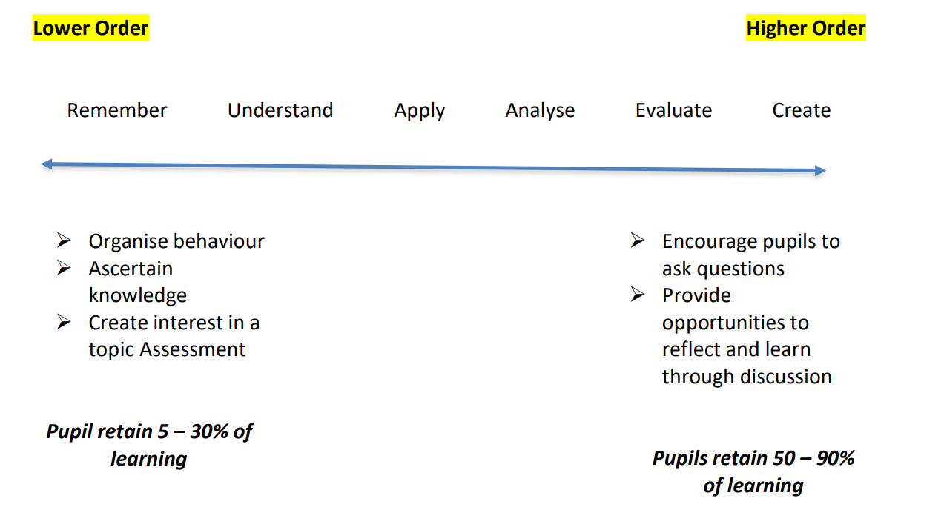
Teachers should assist young people’s learning by asking appropriate and relevant questions.
Indicators that high quality questioning is taking place include the use of:
- Open questions (‘What do you think…?’ etc)
- Higher order questions (predictions – ‘What do you think would happen in…?’)
- Follow-up questions (‘Why? How do you know? What made you think that? Can you
give me an example? Can you think of an occasion when that wouldn’t be the case?’)
- Alternatives (‘Can you think of three possible answers? Now select the best’ etc)
- Thinking time (giving a few seconds for young people to think about their answer: ‘In
two minutes I am going to ask you…’)
- Opportunities for young people to discuss their answer with each other.

Feedback

“Effective feedback reduces the gap between where the learner is and the next step in their learning journey.”
(Inverclyde Council LTA Policy)
Looks like:
- Written comments
- Verbal praise
- Class discussions
- Individual learner conversations
- Peer reviews
- Self-assessments
- Non-verbal cues
Feels like:
- Encouragement to improve
- Clarification on how to progress
- Motivated and excited to learn more

Young people and others involved in their learning need positive, specific feedback which focuses on improvement. At Inverclyde Academy we agree that pupils are should be given regular feedback, both during lessons and also following an assessment activity. Feedback should be timely, supportive and include responsive feedback from learners. This is most often gained through highly effective questioning by teaching staff. Effective questioning enables teachers to be responsive and adaptable in their approaches.
Learner conversations are a vital part of the learning, assessment and feedback process. Pupils have the opportunity to reflect on their progress and current level, identify next steps, and also identify any barriers or support needs.
This feedback might be verbal or written. Either way, it will highlight strengths and identify next steps to make progress.

Specific
Focuses on particular aspects of work, not generic statements
Actionable & Timely
Provides clear guidance on how to improve soon after the pupil completes the task
Positive & Constructive
Offers praise for strengths while also provides suggestions for improvement
Student-centered
Takes into account the pupils individual needs and learning styles
Feed Up
Where am I going?
Feed forward
Where to next?
Feed back
How am I going?
Task level
Process level
Self – regulation level
Self level
Is my work correct?
How effective is process I use to complete the task?
Is my attitude and effort effecting my learning?
Praise, well done,
Inverclyde Academy is a Learning Community
Partnerships
We pride ourselves on establishing strong partnerships with our families and the wider community. Partners make a significant contribution to lifelong learning and can support the development of the four capacities with children and young people as well as improving their soft skills, life skills and employability prospects.
Effective partnerships work with other service providers to deliver a tailored package to children and young people and their families to offer the most appropriate curriculum to meet the needs of both the establishment and the pupil.
Additionally, key partners make a significant contribution to the wider curriculum through contributing to the delivery of the experiences and outcomes and supporting wider achievements for young people. These can include but are not limited to:
- Community Learning & Development
- Educational Psychology Service
- Barnardo’s, Save the Children and other third sector partners
- Local and National Employers
- Further and Higher Education Institutions
Parents as Partners
Parents and guardians play a vital role in the development of children and young people and should be considered key partners from the outset, in line with Inverclyde’s Parental Engagement Strategy. We involve parents in all aspects of school life including curricular and extra-curricular events, parents’ evenings, parent helpers and volunteers, parent council etc.
We are committed to working in partnership with parents and will do as much as we can to inform parents of their children’s progress, encourage shared learning between parents and pupils and encourage parents to make use of online resources.
Pupil at the centre of learning
