**Inverclyde Push and Pull factors – Understanding non-attendance**

It may be useful to consider these for different levels when discussing push/pull factors.

school/classroom, peer/social, family, or individual needs

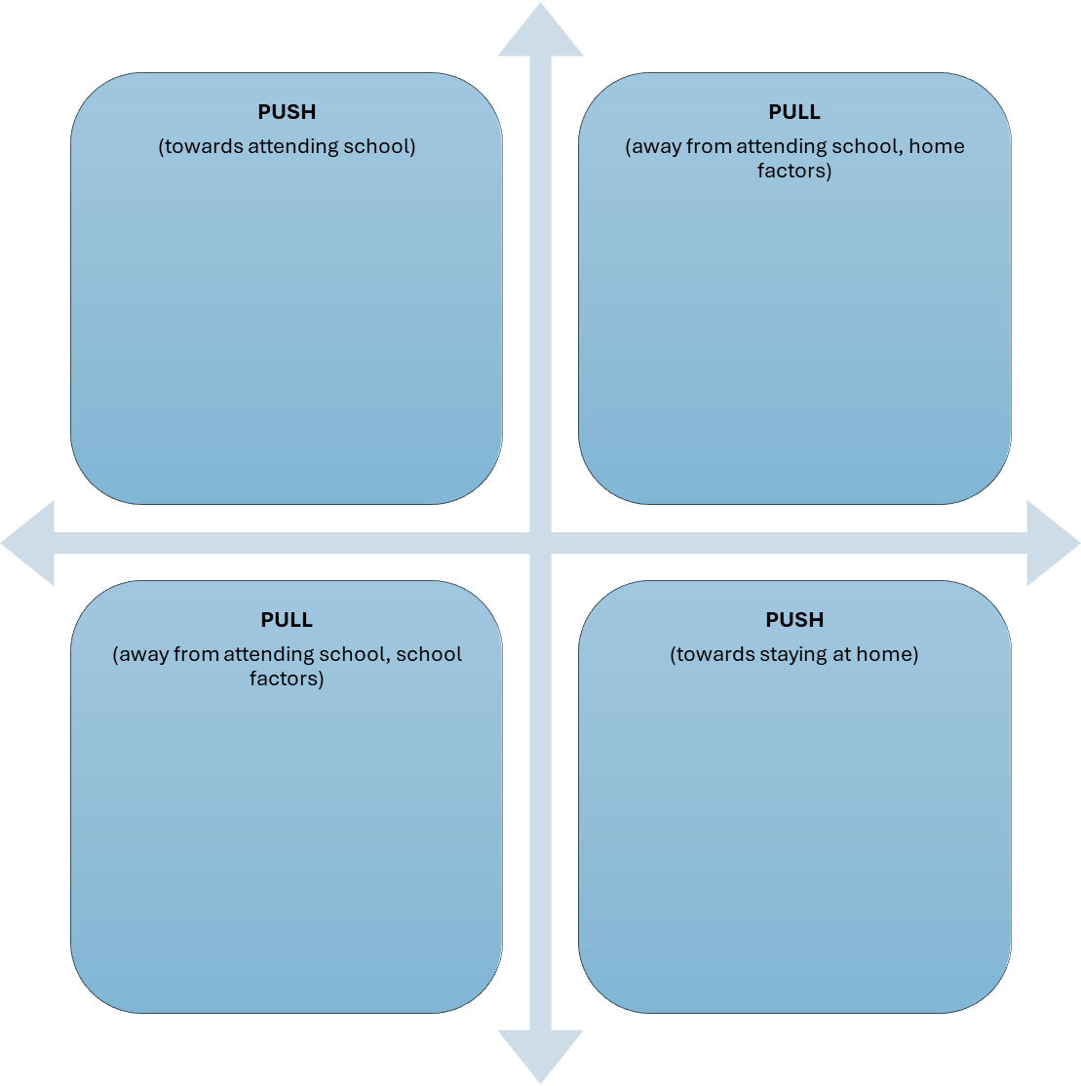

**SCHOOL**

**HOME**