

Hillend Children Centre
Standards and Quality 2024-25

Context of the Establishment

Our Establishment
Hillend Children’s Centre is an integrated pre five establishment situated in the east end of Greenock. We provide an integrated, inclusive and nurturing environment for children across the local area, as well as offering high quality early learning and childcare for children across Inverclyde who have complex and significant additional support needs.

We have 3 very unique playrooms within the establishment. Sunflowers and Snowdrops are our two specialised rooms which provide support for children with multiple health needs, as well as significant social communication difficulties. Bluebells is our integrated mainstream room, catering for children with all abilities. We offer opportunities for inclusion and integration daily throughout the centre.

We are operational for 50 weeks of the year and our continuous provision is open from 8am until 6pm Monday to Friday.

The nursery is registered for 50 children on a full time equivalent basis. 15 of these placements are for children with Additional Support Needs.

52% of our current role of children live in SIMD areas 1 and 2.

The staffing complement of the centre is:
1 Head of Centre, 2 Depute Heads of Centre, 1 Senior Early Years Education and Childcare Officer, 1 Early Learning and Childcare Excellence and Equity Lead, 18 Early Years Education and Childcare Officers, 4 Early Years learning Support Assistants, 1 Early Years support worker, 1 Clerical Assistant and various janitorial / domestic and catering staff.

Our Shared vision
At Hillend we are committed to creating a nurturing and empowering environment where every child feels a deep sense of belonging, is supported in their growth, and thrives through inclusive practices. We aim to foster a space where all children, regardless of their abilities, are embraced with empathy, feel safe, and have opportunities for total communication in their journey of learning and development. Through collaboration with families, the wider community, and professional partners, we strive to foster a sense of belonging, respect, and achievement for all children, helping them develop the skills and confidence to thrive in the world around them.
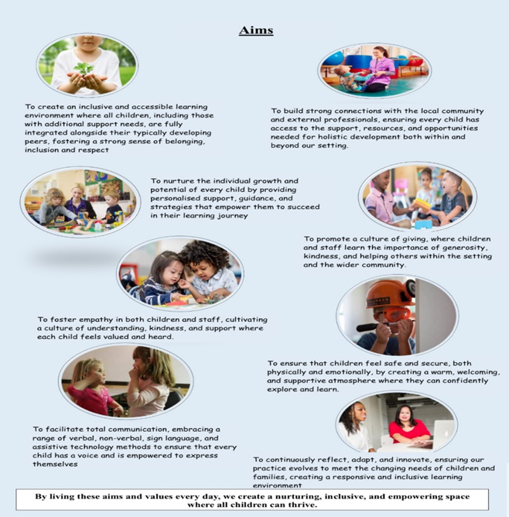

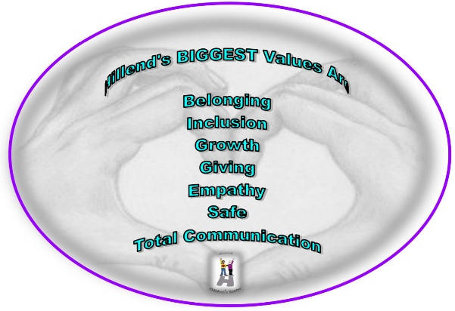
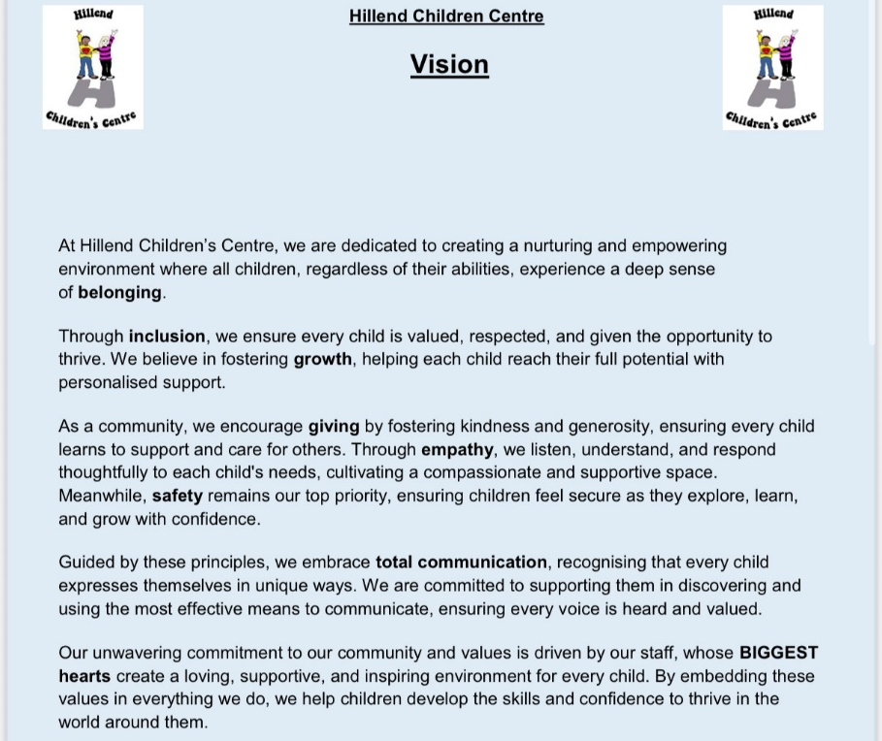

Establishment priority 1/ 2 - Improvements in attainment, particularly in literacy and numeracy
Closing the attainment gap between the most and least disadvantaged children and young people

NIF Priority  Improvements in attainment, particularly in literacy and numeracy  Closing the attainment gap between the most and least disadvantaged children and young people  NIF Driver  Teacher professionalism  Assessment of children's progress  Performance information | HGIOS/ELC QIs  2.2 Curriculum  2.3 Learning, teaching and assessment  3.2 Securing Children’s progress  UNCRC  Article 3 (Best interests of the child):  Article 28: (Right to education):
Outcomes
By June 2025 all of our ASN children will have a differentiated individual plan that shows collaboration, progress and exposure to a diverse curriculum.

By June 2025 All our staff will be upskilled, in regards to the new Inverclyde council skills assessment tracker, with all bluebells staff confident in using this to assess children's progress.

By June 2025 All our mainstream children’s attainment statistics will have increased to 90% or above for literacy, Numeracy and health and well-being.

By January 2025 our environmental audits will show increased levels of engagement with almost all of our children accessing a continuous learning provision in an environment that is purposeful and full of opportunity.

By January 2025 all staff will have received literacy framework training and completed the self-evaluation tool that will inform practice.

Parental contributions through engagement within learning journals and or children's floor books will increase to 95% by June 2025

Progress and impact of outcomes for learners:
All of our children with significant complex needs have a personal learning plan that is individual to them, there is clear evidence of progress made across literacy, numeracy, health and wellbeing and physical support requirements. This is measured and reflected within each plan. Evaluative summaries are uploaded onto Learning Journals regularly that show challenge, application, personalisation and choice and depth across a curriculum that is diverse and skills based. Children with severe complex needs are responding positively to intensive interactions through innovative practice
All children are given opportunities to consolidate and transfer their skills through visiting different places that are specific to their targets and book topic. The use of Learning Journals has led to very good collaborative working with parents. We made the decision to replace all floor books with Learning Journals and the increased interaction between nursery and families has been very good.

All of our staff engaged in the in service day training for the new Inverclyde Council skills assessment tracker and have a good understanding of how this will support children, and children within bluebells are now being exposed to an environment that is empowering children to lead their own learning and meet developmental milestones within the tracker. Learning Journals, observations, room audits and monitoring as well as self-evaluation clearly demonstrate the progress made. Practitioner understanding is developing well, however this coming year will allow us to consolidate this approach more effectively.

All of our mainstream children have made good progress across the three cross cutting themes our
staff’s confidence is developing well using the online journals to assess and record children’s progress over a 12 week period, which highlights areas of challenge or support. This information is shared with parents every 12 weeks, with their views and contributions being recorded.

Children are actively engaged in holistic learning experiences that develop their skills and build their confidence academically. There is a consistent approach between home and nursery. Parents understanding and discussions around their children’s development is leading to more support at home, as well as strengthening partnerships between parents and practitioners. This has been as a result of the highly successful participation in parental workshops and stay and plays across the year.
Questionnaires were completed and actions identified, one being a comment regarding stay and plays, we actioned this by developing a parental workshop/stay and play calendar of events for the year.

29 parents attended the literacy workshop, with 16 completing positive evaluations of the session an example of which are below.
“The literacy workshop was great, great fun amazing to see kids having fun and learning whilst doing it”
“It was good to see all the learning tools and a chance to see this in action in the playroom”
“Picked up some good ideas for some letter puzzles to help my child identify letters”

A very focused session for grandparents was effectively led by staff and attended by almost all grandparents, 27 positive evaluations were returned as a result comments were
“I don’t think any improvements could be made, the love and support here is so evident”
“The day was perfect everyone was so nice and helpful all the kids looked so relaxed”

Almost all children are accessing a learning environment that offers continuous provision, and takes into account children’s choice and interests. The detailed plans for each area show evidence of children’s choice and how this is extended throughout the playroom, as well as continued by staff being reflective in regards to previous learning opportunities. Robust monitoring and self-evaluation processes confirmed this.

As a result of all staff engaging in the literacy framework training on the October in-service day, Bluebells staff completed individual self-evaluation tool for reading, writing, listening and talking which identified a need for further awareness and training on supporting children with English as an additional language. As well as this staff are looking more in depth in regards to Augmentative and Alternative Communication and how this can be fully embedded across the setting to support all of our children who are non-verbal, giving them a voice.

There is a clear link between children’s nursery and home learning and this has been identified through the excellent increase in parental interactions with learning journals.

Next steps
- Ensure a more maths positive mind-set across all playrooms, ensuring a numeracy rich environment.
- Literacy will be meaningfully embedded across all areas of learning – a focus will be on English as an additional language, identified through our Literacy framework self-evaluation.
- Communication for all will continue to be a priority, in particular Augmentative and Alternative Communication.
- The early year’s dashboard will be implemented resulting in high quality information and data being analysed to inform future improvements.

Establishment priority 3 - Improvement in children and young people's health and wellbeing

NIF Priority  Improvement in children and young people's health and wellbeing  Choose an item  NIF Driver  School leadership  School Improvement | HGIOS/ELC QIs  1.3 Leadership of change  3.1 Ensuring wellbeing, equality and inclusion  Partnerships  UNCRC  Article 2 (Non-discrimination):  Article 31 (Leisure, play and culture):
Outcomes
By June 2025 Almost all children will be benefiting from a rich learning outdoor environment on a daily basis.

By December 2024 All children will be involved in participating in entrepreneurial skills using the outdoor Hillend shop.

By January 2025 there will be an increase with Almost all children participating in integrated experiences and planned programmes.

By June 2025 almost all children will be using self-regulating and co regulating strategies.

By June 2025 our average attendance data will show children’s level of attendance to be 90% or higher.

Progress and impact of outcomes for learners:
100% of children now have a personal learning plan that is recorded on Learning Journals. Staff make good use of these to capture and evidence the rich outdoor learning experiences that all children have participated in. Almost all children within our Bluebells room choose which outdoor area they wish to explore daily, using the visual cards on the wall. All children within Snowdrops and Sunflowers explore outdoor areas on a daily basis. Staff are attuned and responsive to children’s preferred mode of communication such as visuals, core boards or hand over hand to guide them too.
All children have engaged in integrated outings across the year that allowed them to explore their local community, allowing the children to gain a vast knowledge and awareness of various organisers across all areas of the curriculum, transferring skills linked to the topic and bringing this to life. The 36 outings that were arranged across the year were well planned and focused around developing specific interdisciplinary skills.

Our Hillend shop has been used effectively and has been highly successful in encouraging learning experiences that are linked to entrepreneurial skills where all children participated in a variety of different ways. Examples of activities were selling produce from our garden, Christmas and Easter crafts, bulbs and seeds that were donated. This is evident within children’s personal learning plans, photographs and wall displays a profit of £283.51 has been made over the year.

Throughout the course of the year all children participated in a range of integrated programmes that linked to their targets and personal plans, these were both formal and informal. This will continue to permeate across the establishment, underpinning the Hillend BIGGEST values.

Through the positive relationships with parents and families we foster an environment that is responsive to children and family’s needs. Children who were becoming disregulated and overwhelmed were supported with individual strategies that were reviewed and monitored, allowing the targeted child to begin to recognise and manage their emotions. Although we recognise the need to support families more and give them a safe space to share experiences, build their confidence and empower them.

Most of our children have 80% attendance or above. Where children fall below this we have measures in place and can identify reasons that lead to their attendance falling below 80%. We are collaborating with cluster colleagues to ensure a consistent approach to managing attendance. The development of our attendance policy will ensure measures are put in place to effectively monitor attendance and implement interventions in a timely manner.

Next steps
- Develop a shared space for parents that is welcoming, comfortable and relaxing for families to feel valued and included, gaining a sense of belonging.
- Our Hillend attendance policy will be reviewed and revisited in line with the updated Inverclyde attendance policy, to ensure we can intervene in a timely manner.
- Continue to evaluate and reflect on outdoor learning, ensuring we incorporate not only literacy, numeracy and health and wellbeing. All children will benefit from rich high quality learning experiences that demonstrate participation and engagement within all areas of the curriculum.
- Re-evaluate our ECO status in regards to being a sustainable nursery.
- Re-visit our trauma informed practice for staff who may be new or who did not access the training, reviewing our own promoting positive relationships policy.

Establishment priority 4 - Placing the human rights and needs of every child and young person at the centre of education

NIF Priority  Placing the human rights and needs of every child and young person at the centre of education  Choose an item  NIF Driver  School leadership  School Improvement  Teacher Professionalism | HGIOS/ELC QIs  1.3 Leadership of change  2.1 Safeguarding and child protection  3.1 Ensuring wellbeing, equality and inclusion  UNCRC  Article 4 (Protection of rights):  Article 2 (Non-discrimination):
Outcomes

By December 2024 we will have confirmation, through participating in our peer review, that our policies and procedures are clear, appropriate and ensure the care and welfare of all stake holders within our service.

By June 2025 begin to embed our new vision, values and aims across the Nursery by aligning systems such as newsletters, workshops, twitter and nursery website. All stakeholders will be able to articulate our vision and values, resulting in a shared ethos.
By June 2025 our environment will promote understanding and appreciation of difference in diversity for all stakeholders within Hillend
By June 2025 all practitioners will have increased knowledge and understanding of Building Racial Literacy within the Centre, impacting positively on the learning environment.

Progress and impact of outcomes for learners:
Our peer review did not take place due to a request to be part of a pilot inspection by Education Scotland on the new shared quality framework. This highlighted strengths across our service in regards to leadership of continuous improvement. One particular quote that was recorded within the summary was “The rights of children, inclusion, and equity for all were at the centre of our visit” They also highlighted the ownership and empowerment practitioners are given to take on lead roles within Hillend, as well as across the authority.

Our vision, values and aims have been updated in line with consultations and collaboration with all stake holders. These are now clearly visible on all our digital platforms, wall displays, newsletters and overall footprint of Hillend. As well as this these values underpin our philosophy at Hillend and will continue to provide opportunities that fully embed and reflect these.

Four of our children with a diagnosis of Cerebral visual impairment have made extensive progress through our collaborative partnership working over the past year with the habilitation nurse specialist, implementing strategies that support children with a significant visual impairment.
Our robust monitoring and self-evaluation processes reinforce the impact our unique strategies are having on children with ASN and their ability to vocalise. By responding in a variety of ways we ensure their multi-sensory impairment is no barrier to their learning.

We have completed the early years inclusive environments good practice audit. This highlighted actions we will implement over the coming year. We were unable to obtain a place on the BRL training for a member of the senior management team, although she has been participating in a cluster working group to develop a basic understanding for all staff. We endeavour to secure a place on racial literacy training this year. As well as this and as a result of practitioner engagement in the annual positive conversations we have a few practitioners who are keen to develop their knowledge and take forward the implementation of an action plan for our establishment and the cluster.

Next steps
- An introduction to racial literacy as a whole staff team to develop a shared understanding with implementation of an updated inclusion policy.
- Practitioners to engage in racial literacy training.
- Consolidate our vision, values and aims and show how they evolve progressively and are interwoven into daily practice.

National Improvement Framework Quality Indicators
1.3 Leadership of change
Very Good

Key Strengths:
Hillend Children’s Centre
- Children, families and practitioners were heavily involved in co creating the revised vision, BIGGEST values and aims for Hillend that are ambitious and focus on improvements in outcomes for all children and families,. They are relevant and shaped by the needs of our community.
- We promote practitioner enquiry and professional dialogue driving continuous improvement, which fosters creativity and innovation. Practitioners feel valued and proud of the ownership they have in key leadership roles that welcome forward thinking solutions.
- The strong ethos and open door approach that permeates our entire establishment which has developed positive sustainable and trusting relationships with families.
- March 2025 we participated in a pilot visit from Education Scotland to evaluate the new shared quality improvement framework, reviewing the new theme Leadership for Continuous Improvement. This gave us insight into what the new joint inspections may look like.

Key Priorities:

- Continue to embed our vision, values and aims throughout the life of the centre and local community.
- Be clear on our pedagogical approaches and ensure a shared understanding of these, being reflective and evaluating impact.
- Developing our inclusion policy demonstrating our journey in regards to racial literacy.
- Ongoing critical reflection and purposeful self-evaluation involving all stakeholders will be relevant and in line with the new shared quality improvement framework.

2.3 Learning, teaching and assessment
Very Good

Key Strengths:
Hillend Children’s Centre
- We continually demonstrate a strong commitment to children’s rights, equity and inclusion these lie at the centre of our offer.
- Within the 3-5 room staff have created, purposeful learning environments both indoors and outdoors to enhance open-ended learning opportunities for the children.
- High quality observations are taking place naturally during daily activities, experiences and responsive interactions.
- Effective tracking and monitoring systems are in place to enable staff to set specific targets relating to developmental milestones within the mainstream playroom, as well as differentiated plans for children with significant ASN.

Key Priorities:

- Developing our outdoor space and assess levels of participation and engagement in regards to interdisciplinary learning.
- Re-visit our eco journey as this has been maintained over recent years. Staff and children have reignited their motivation and naturally been learning about sustainability both indoors and out.
- Fully develop a visual representation of our curriculum rational and design to clearly demonstrate that a balance of rich learning experiences are being provided. This will effectively support our quality assurance processes and continuous improvements and accountability with the setting.

3.1 Ensuring wellbeing, equity and inclusion
Very Good

Key Strengths:
Hillend Children’s centre
- All staff believe each child in Hillend should be considered as an individual with their own needs and rights.
- We ensure a multi – agency approach when engaging in Team around the child meetings to support children with complex additional support needs. We make very good use of the solution focused method.
- Practitioners are forward thinking in regards to promoting children’s care and learning needs. Wellbeing is at the heart of every target developed and unconventional approaches are adopted.

Key Priorities:
- Continue to be forward thinking and proactive when creatively implementing differentiated individual curriculum and personal learning plans for children who require this.
- Review all medical training procedures to ensure practitioners are up to date with relevant and appropriate changes and guidelines in relation to providing personal care and administering medication, particularly for new children.

3.2 Raising attainment and achievement/Securing children’s progress
Choose an item.
Very Good
Key Strengths:
Hillend children’s Centre
- Practitioners value contributions and children’s achievements from beyond the setting. Information shared from all about me/more about me was utilised effectively to ensure children’s starting points were recognised and recorded.
- Parents are kept very well informed about their children’s progress and stage of development through our regular meetings, that drive forward areas of challenge or support required.
- Literacy, numeracy and health and wellbeing opportunities reflect and underpin our learning environment, with the implementation of the new skills assessment tracker.

Key Priorities:

- Ensure practitioners have a shared understanding of children’s progress when assessing and recording information onto Learning Journals, leading to consistency as well as feedback of high quality and accurate data from the dashboard.
- Continue the systematic focus on rigorous tracking of data to meet all children’s needs, including across other curricular areas.
- Practitioners will engage in meaningful professional dialogue and moderation, in house as well as in cluster groups, to ensure consistency and collegiate understanding around children’s outcomes.

Key Achievements of the Establishment

- We had a Sponsored walk Crazy Olympic theme day and raised £970.50.
- We held a very successful Go Yellow day raising awareness and money for Ardgowan hospice. We raised £366.73.
- We were part of a pilot looking at the new quality improvement framework for the joint inspections, receiving some positive feedback and gaining an insight into expectations for the joint inspections for September.
- The Implementation of the Inverclyde skills assessment tracker for all our mainstream children.

- All staff participated in the Literacy framework training on the October in service day which resulted in identifying actions for improvement.
- 100% of staff also participated in Training on high quality learning environments on October in service day.
- All staff in all playrooms have received training on super core grid visual boards by speech and language therapy.
- Staff participation in specific and individual medical training, in regards to administrating medication, providing personal care such as catheterising as well as peg feeding and management of seizures.
- Staff and parents engagement in the Early Bird Plus programme to ensure consistency in approach from nursery to home.
- We had a further 5 staff trained in Paediatric first aid.
- Almost all staff trained in Childsmile training.

- All new children and families engaged well effectively in home visits prior to starting.
- A successful transition programme was developed for all children transitioning to Craigmarloch.
- All children starting within our ASN playrooms received an effective enhanced transition into Hillend, with multiple visits, TAC meetings and invitations to induction day.
- Staff participation in Learning through Landscapes outdoor learning training, which has enhanced children’s interdisciplinary learning through real life experiences.
- Our outdoor area has been enhanced dramatically, especially Snowdrops, which was as a result of collaboration with S&K landscapes, a local landscaping business who was a previous parent at Hillend. He provided labour and tools to resurface and turf the garden. Clyde tool hire also supported this by providing machinery.

- Partnership working with Inverclyde Food Network, allowing the children to explore learning experiences from farm to fork.
- Support we received from Bellville community hub, to send food packs home to families, as well as Bellville community gardens, who ran 4 successful sessions of Dinky Diggers.
- Very successful and well attended stay and play sessions/parental workshops.
- The high percentage of parental contributions through the implementation of the learning journals across all playrooms, this has been extensive.
- The co creation between parents and staff for our new vision, BIGGEST values and aims.
- Robust monitoring and self-evaluation led to amendments in regards to personal learning plans for all ASN children.
- Close partnership working with Children in poverty Inverclyde, has seen 6 families benefiting from a week long caravan holiday, as well as families having free access to the cinema and Excite. Toys were also provided for families at Christmas time and a visit to Cardwell Garden Centre which included breakfast with Santa.
- 2 families benefited from thrive under 5 programme with HSCP.
- Collaborative working with a variety of other professional to support children with additional support needs.
- Participation in the ASN parents/carers group Inverclyde information night.
- Children participating in different entrepreneurial opportunities for the Hillend shop. A very good profit of £283.51 was made through items sold at different times across the year.
- We adapted the way children’s annual celebration of learning was done, this received Positive feedback and 100% attendance at the event.

Our relationships with children, families, parents and partners lie at the heart of everything we do. We are committed to building strong, respectful partnerships and continuously seek their views and feedback to help shape and improve our practice. Their voices guide our decisions and ensure we provide the best possible care and support for every child. Below are a few quotes taken from different parental and partner questionnaires and evaluations over the year.

“The strong support and communication maintained between staff, children and parents”
“Parental play days and information sessions are always so well run and just really good”
“Helpful and understanding with all needs”
“The nursery staff have been incredibly nurturing and attentive, it’s clear they genuinely care for the children and make them feel safe, supported and valued every day”.
“Hillend senior leadership team are terrific honestly feel like I could pick up the phone anytime and have a chat about my child and it would not be a bother, and I would never need to make an appointment, everyone is approachable and runs an effective open door policy.”
“The stay and plays are great getting to see how literacy and mathematics are brought into their learning through play.”
“Love the learning journals, enriches our day when we receive posts of what our child has been doing”

“The staff at the nursery bring a wide range of experience and self-taught skills and their professionalism is evident in every aspect of the nursery. They are dedicated in creating an environment that supports each child. Every time I visit the staff are always hard at work ensuring that the child’s interest remain centre of their attention.”

“The staff’s commitment to working together ensures consistency and helps reinforce the child’s progress. An example of this is when I introduced a resonance board to a child and started a programme. Each staff member involved with the child took the initiative to observe the lesson and show great enthusiasm. They were very supportive of the programme and even requested to keep the resonance board so that they could implement the strategies consistently with the child.”

“I work with children of all ages and abilities, and I visit many nurseries, schools, and educational establishments across Scotland. When I first visited Hillend, I was immediately impressed by the depth of knowledge the staff possess, the way the nursery is organised, and the smoothness of their daily routines. So much so, that I arranged visits for the students I am mentoring and new members of staff who needed to expand their knowledge and they could learn from the staff expertise and setup.
Furthermore, I have been extremely impressed by the way the nursery handles Team Around the Child (TAC) meetings. The approach makes families feel truly involved, alleviating the pressure that can come with being surrounded by numerous professionals. The process they use for these meetings is so effective that I have shared their format with other colleagues.
Working with Hillend makes my job so much easier, knowing that I am always welcome. They are consistently accommodating and helpful no matter how hectic things get. The office staff, the Janitor along with everyone else are equally supportive ensuring a smooth positive experience every time I visit. This supportive, inclusive atmosphere makes a big difference, and it’s one of the many reasons I value working with this wonderful team.”

