Education – Improvement Planning Document – 2025-26

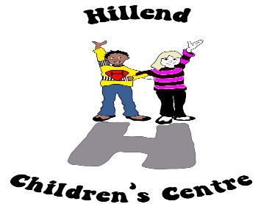
Establishment Name: Hillend Children Centre

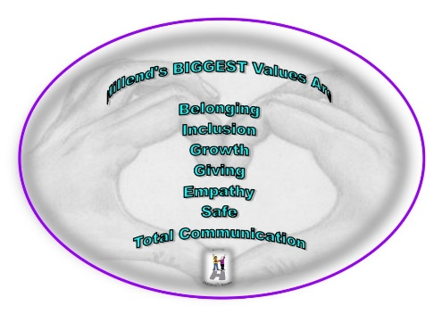
CONTENTS

- Establishment Vision, Values and Aims

- 3 Year overview of priorities – based on the National Improvement Framework

- Action Plan for session 2025-26 including PEF planning

Head of Establishment | Sonia McKay | Date | June 2025

Quality Improvement Officer | Yvonne Gallacher | Date | June 2025

Our Vision, Values and Aims
Our vision for all children and families
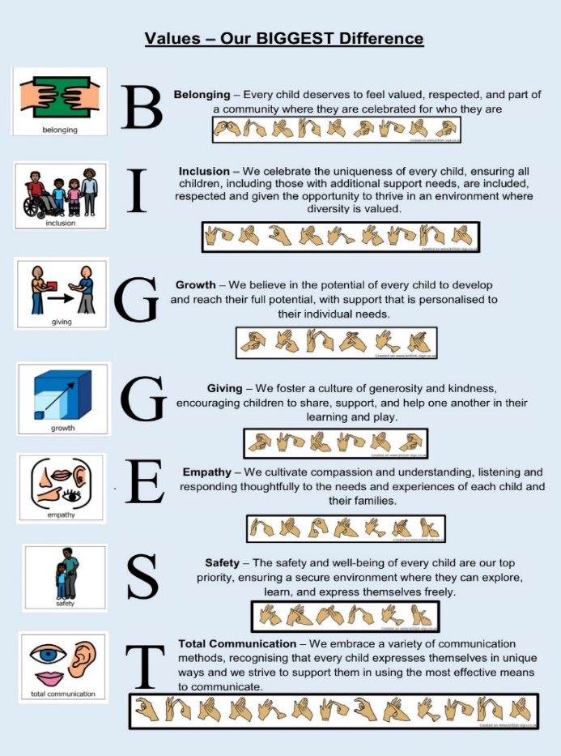
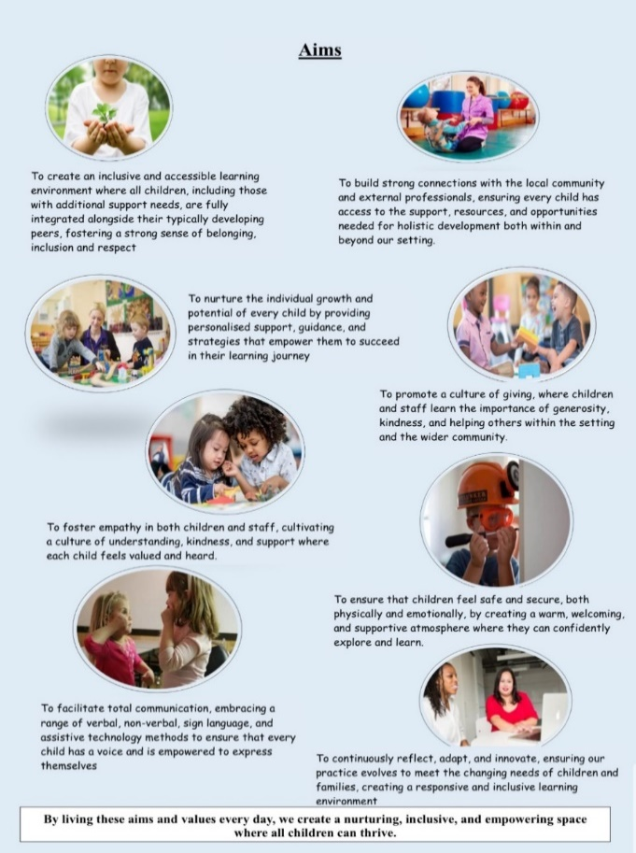
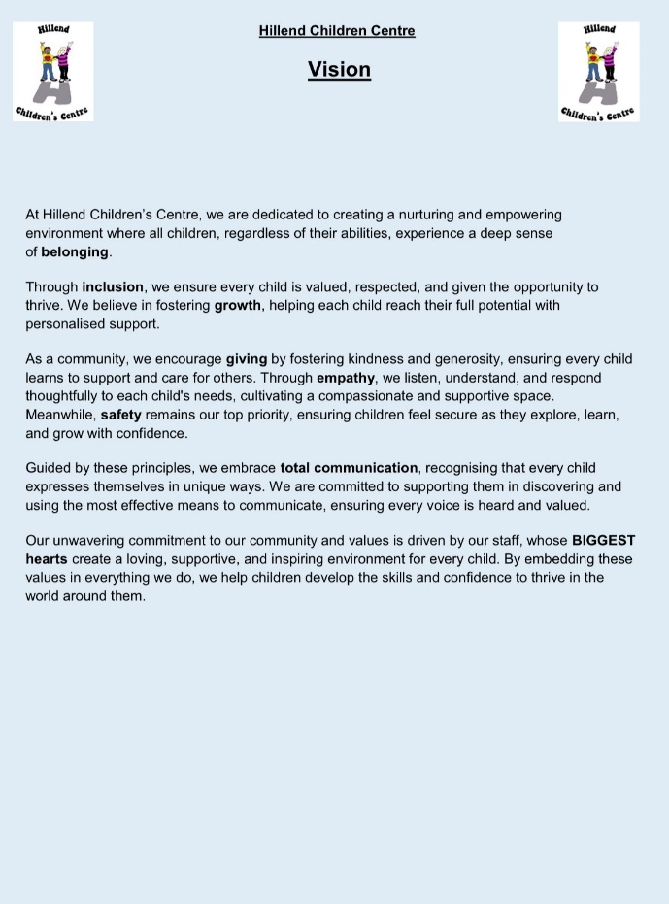
Hillend Children’s Centre is committed to create a nurturing and empowering environment where every child feels a deep sense of belonging, is supported in their growth, and thrives through inclusive practices. We aim to foster a space where all children, regardless of their abilities, are embraced with empathy, feel safe, and have opportunities for total communication in their journey of learning and development. Through collaboration with families, the wider community, and professional partners, we strive to foster a sense of belonging, respect, and achievement for all children, helping them develop the skills and confidence to thrive in the world around them.

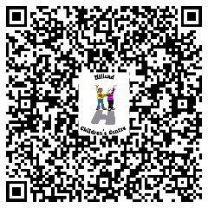
Hover your camera app over the QR code for a larger format of our Vison, Values & Aims

3 Year Overview of Establishment Priorities
The improvement priorities for our establishment are noted on the following page. They have been expressed in the context of the National Improvement Framework
Our Improvement priorities extend in a rolling programme over three years. Each priority has been coded accordingly:

Session 2025-2026
Session 2026-2027
Session 2027-2028

Overview of rolling three year plan

National Priorities | Session 2025-2026 | Session 2026-2027 | Session 2027-2028
Placing the human rights and needs of every child and young person at the centre of education | We are committed to creating an environment where children's rights are actively celebrated and our core values of safety, inclusion, and equity are embedded into every aspect of our practice. Central to this is our focus on building racial literacy and cultural awareness across our setting. We will continue to support staff through continuous professional development, with engagement in our awareness training, building racial literacy and other opportunities across the year.  To promote anti-racist practice, and create spaces where every child and their family sees their identity reflected and valued. In parallel, we will ensure that children with additional support needs are fully included through integrated, child-centred approaches that respond to individual strengths and challenges. By fostering a culture of belonging, where every child’s rights, background, and needs are recognised and respected, we aim to ensure that all children feel seen, supported, and empowered to thrive. | Embed children’s rights and racial literacy, ensuring it is integrated into our curriculum planning and that children’s voice and participation permeates their learning. Collaboration with parents and families to co design learning experiences will add value and build on relationships. | Ensure evaluations are strong, showing sustainability and building on leadership. Continue to evolve and recognise the different cultures and nationalities that are coming into our community, as this can change year on year. Gain awareness and begin to plan for this when we engage in home visits.  Staff will be taking ownership of ongoing developments and leading improvements.
Improvement in children and young people’s health and wellbeing | We will ensure our outdoor provision plays a key role in supporting physical development, offering daily opportunities for active play, movement and exploration in natural environments. We intend to monitor and evaluate in a timely manner to inform changes that may be required.  The success of our Hillend shop is encouraging us to increase the produce we grow, to ensure sustainability. We ensure these spaces are fully accessible so that children with additional support needs can participate fully and meaningfully.  We also actively promote positive risk-taking, encouraging children to test their boundaries, build resilience, and develop confidence in a safe and supported way. Through these inclusive and holistic practices, we aim to foster strong mental and physical wellbeing for every child in our care.  To ensure our practice is adopting a trauma informed approach to supporting children who can become dis- regulated and overwhelmed, as well as supporting families who find this challenging. | Continue to strengthen inclusive practices that ensure all children—especially those with additional support needs—have equitable access to a challenging outdoor space that will support their physical and mental wellbeing.  Our embedded trauma informed approach to practice will be empowering children to lead wellbeing strategies that will allow for self-regulation now and in the future, building resilience. | To ensure sustainability we will evaluate the impact of wellbeing strategies on children’s development and outcomes.  Empower staff to lead initiatives in emotional wellbeing, mental health, and inclusive physical development.  Strengthen partnerships with families and the wider community to support children’s health holistically.  Embed a continuous improvement culture using reflective practice and child voice.
Closing the attainment gap between the most and least disadvantaged children and young people | We aim to have robust and effective processes in place to monitor and track children’s attendance, ensuring we implement interventions in a timely manner that supports families and breaks down barriers.  Creating a safe family space that parents can use for a variety of things that are both formal and informal will foster positive relationships that will build trust and transparency. Giving parents a place to share their views and receive support if they require it, will also build a community for families to interact with each other and feel empowered to support one another. | Fully engaging with the new quality improvement framework for the joint inspections to ensure robust and meaningful self-evaluation is embedded and improvements are identified as a result of self-evaluation and monitoring.  Build on our offer for our family safe space, bring in outside agencies, that are relevant and requested by families themselves. This room will be utilised daily for different reasons and accessible to all. | Fully embed the quality improvement framework into all our policies and processes, including our quality calendar.  Families to have full ownership of the family space, leading on what they would like to see the space used for.
Improvement in achievement, particularly in literacy and numeracy | Continue to further embed and implement positive changes to the skills assessment tracker. We now need to ensure that we have a shared understanding of what our expectations are in relation to children’s progress across literacy, numeracy and health and wellbeing. Our professional judgements should be accurate and measurable through high quality evidence.  This will result in us embracing the implementation of the early year’s dashboard to gather data that will inform individual children’s level of attainment, show success and areas where challenge is required, as well as identifying support strategies.  We will continue to work in close partnership with other agencies such as speech and language therapy to support our children who require augmentative and alternative communication, with a focus on core boards, Makaton, objects of reference real or pictorial. We thrive to adapt our communicative practice in relation to the children and families we support.  We will have a visual representation of our curriculum design, highlighting our curriculum offer that is coherent, embedding the opportunities we offer to develop children’s knowledge, skills and attributes they need to thrive in today’s world. It will be clear and understood by all stakeholders. | Continue to utilise the skills assessment tracker and engage with confidence in recording this information onto learning journals with the focus remaining on analysing data to inform areas for support or challenge, identifying targets for all children across literacy, numeracy and health and wellbeing.  All practitioners to be confident and accurate with their recording and assessments of professional judgements which, as a result will collate data from the early years dashboard that will inform further areas for development.  Ensure we continue to capture all areas of the curriculum and not just literacy, numeracy and health and wellbeing. A priority will be how we record and measure levels of engagement and participation in all areas.  Continue to reflect on the requirements of the children, as new children attend. We need to stay attuned to their needs in regards to communication, adapting our practice and keeping abreast of any updated information, strategies or intensive interactive programmes. We will also ensure all medical training needs are actioned to support children to be fully included and respected.  Look to implement SSERC as a tracking, monitoring and assessment tool for the children in our specialised rooms who it would be beneficial and appropriate for. | All staff to be upskilled in gathering data and understanding the process that will then inform improvements. Providing children with support and challenge naturally and in a timely manner.  Continue to self-evaluate and monitor that high quality data is recorded, in order to reflect the accuracy of information being measured.  Monitoring and tracking methods will be developed to assess all mainstream children’s progress across all areas of the curriculum.  SSERC to be fully embedded within our specialised rooms for children this is relevant to and appropriate for, as well as recording children’s progress on learning journals using SSERC.

Stakeholder’s views
How were stakeholders views collected?
- Staff were consulted across the year using a variety of different methods, such as positive conversations, self-evaluation, solution focused meetings, weekly planning meetings, weekly communication meetings, as well as audits throughout the year.
- Parent’s views feedback and reflections were gathered by completion of paper questionnaires, online survey monkeys, we utilised learning journals to get views from parents if required in a timely manner, we corresponded through email to parents in order to collate information, learning journals have made a significant difference to the life of the centre
- Questionnaires sent out to partners and other professionals were distributed online.

- We used a variety of methods to co create our new vision, values and aims such as:
- Large sheet of paper on the staff room wall to gather staff views and words that describe Hillend.
- Survey monkey put out to all parents to gather information based on what they perceive Hillend to be.
- Newsletter used to invite parents to use three words to describe Hillend.
- Professional dialogue with other professionals to give their thoughts on Hillend’s offer of support, learning and care.
- All information was collated and a draft vision, values and aims was sent out to all parents for them to agree/amend.
- The information that came back was used which has now created our BIGGEST values, our vision and how we aim to do this.

- Consultation with Children (ongoing throughout the year)
- Children’s personal learning plans – Children’s progress meetings with parents
- Professional Dialogue with Outside Agencies
- SLT/Staff Support Meetings every 6 weeks.
- Twitter – Parental Comments
- Parents closed Facebook page
- Online journal comments have made a significant difference to the life of the centre
- TAC meetings and wellbeing assessments captured parents, practitioner and the voice of other agencies.
- Evaluations following each stay and play, parental workshop, sports day, celebration of learning.

Plan: Session 2025-26
Priority 1
Improvements in attainment, particularly in literacy and numeracy
Choose an item
National Improvement Framework Outcomes
3. Inclusive curriculum and assessment for a sustainable future.
1. Empowered and accountable education system supporting lifelong learning.
5. Skilled teachers and leaders delivering excellent, inclusive education.
Education - achieving excellence and equity: National Improvement Framework 2025
How Good is Our School/Quality Improvement Framework ELC  2.2 Curriculum  3.1 Play and learning  3.3 Learning, teaching and assessment  4.3 Children's progress  Choose an item.  Choose an item. | UNCRC  Article 28: (Right to education):  Article 31 (Leisure, play and culture):
Rationale for change based self-evaluation including data and stakeholder views
All practitioners within our mainstream playroom have had the opportunity to engage meaningfully with the new skills assessment tracker over the past year. They have identified targets based on previous learning, assessing and recording children’s progress and uploading this onto learning journals. As we move forward, we are now entering a consolidation phase. With a stronger understanding of how the tracker supports the observation-assessment-planning cycle, practitioners will begin to embed it more consistently into their practice.

As practitioners become more confident in identifying appropriate developmental milestones for all children, the professional judgment of practitioners and the accurate input of data will produce high-quality outputs from the Early Years Dashboard, ultimately leading to positive impacts on children's achievement and progress.

We have high aspirations for all our children and data from last year told us that all of our children with additional support needs made very good progress across our highly responsive curriculum that is unique to individual children and their families. As well as this it identified most children within our mainstream room were making good progress in literacy, with the majority of mainstream children making good progress across numeracy and 81% of mainstream children thriving within health and wellbeing outcomes. Our aim is for all children to thrive and make strong progress in literacy, numeracy, and health and wellbeing.

Having reflected on and refreshed our values in collaboration with all stakeholders, we now aim to align these with our curriculum rationale and design. Our goal is to implement and co-create a curriculum offer that is inclusive and appropriate for all children—including those with additional support needs, complex medical needs, and non-verbal communication—alongside their mainstream peers, providing holistic, individualised, and responsive learning experiences.
Expected outcomes for learners
Who? By how much? By when? What?
By June 2026 all practitioners within our mainstream room will be highly skilled at observing and assessing children’s learning and identifying next steps.

By June 2026 our data will show an increase in progression across literacy for almost all children within our mainstream room.

By June 2026 all of our children across all three playrooms will be exposed to augmentative and alternative communication with most of our ASN children communicating in a way that is suitable and appropriate to them.

By June 2026 our data collection will be showing a significant increase in progression from 62.5% to between 75% and 90% across numeracy for almost all children within our mainstream room.

By June 2026 100% of children will have engaged in a curriculum that is creative, responsive, and dynamic. Our curriculum design will be visual, sharing our collective goals and unified vision.

Tasks to achieve priority | Timescale | RAG | Those involved/responsible – including partners | Resources and staff development
Reflect on where practitioners are currently in setting appropriate individualised targets and their understanding of the skills tracker. | August 2025 completed and returned. |  | SLT to develop a brief but concise questionnaire.  Bluebells (mainstream) practitioners to complete. | Develop a questionnaire, for staff to complete individually, to use as a starting point.  Information collated by SLT to inform further supports required.
Ensure there is a shared and collegiate understanding of expectations in regards to children’s progress | August 2025 - weekly |  | SLT – Specific lead for playrooms.  Sunflowers – Tuesday  Snowdrops – Wednesday  Bluebells - Thursday | Opportunities for staff to engage in professional discussions at weekly planning meetings, using these to inform practice. Minutes of meetings will evidence effectiveness.  Ensure practitioners are aware of the early year’s dashboard. Moderate on the skills tracker in house as well as in cluster groups.
Promote a literacy rich environment within all playrooms, adapting the environment to suit the needs of the children.  Augmentative and alternative communication to permeate throughout the nursery. | August 2025 audit to take place.  By December 2025  September 2025 – June 2026 (6 weekly checkpoints)  August 2025 – June 2026 |  | SLT  Practitioners  Children if appropriate  All practitioners  SLT – Lead for each playroom  All Keyworkers  Speech and language therapy  All practitioners  SLT | Literacy Environmental audit to be reviewed by SLT  Joyce – Bluebells,  Ann – Snowdrops,  Stacey – Sunflowers.  Engagement in professional development training using the literacy framework and PACE.  Keyworker group pro forma sheets to be completed with individual information regarding children’s progress across literacy, highlighting areas of support or challenge.  - Makaton signs and symbols.  - Super core boards.  - Visual timetables.  - Objects of reference.
Creating a numeracy-rich environment making numeracy and maths meaningful, hands-on, and embedded in everyday play and routines.  Distributed leadership opportunity to be encouraged to take forward the numeracy strategy. | August 2025 maths audit to take place.  August 2025 – December 2025  September 2025 – June 2026 (6 weekly checkpoints)  August 2025 – June 2026 |  | SLT for each playroom  Practitioners  Head of centre  All practitioners CLPL  SLT lead for each playroom  All keyworkers  Identified practitioner to lead and oversee.  SLT to support | Numeracy and maths Environmental audit to be reviewed by SLT.  - Joyce – Bluebells,  - Ann – Snowdrops,  - Stacey – Sunflowers.  - Source numeracy training for an in-service day for all staff.  - Practitioners to engage in the training opportunities from the PACE resource, as well as the numeracy strategy training opportunity provided by the authority.  Keyworker group pro forma sheets to be completed with individual information regarding children’s progress across maths and numeracy, highlighting areas of support or challenge.  Any working groups or meetings will be attended by the lead practitioner, with clear information to be shared to all practitioners.
Parental workshops and stay and plays will be held throughout the year, with a specific focus on each occasions. | August 2025 – June 2026 |  | Identified working group for each session.( one member from each playroom) | Working groups to get time to prepare and develop a session for  - Literacy.  - Numeracy.  - Health and wellbeing.  - Grandparent’s day.  - Sensory Workshop.  Dates are all set and within the quality calendar.
Share the purpose of our curriculum with all our children, parents, staff and parents. | August 2025 in service day  By January 2026 |  | Head of centre to lead  All practitioners to be involved. | Using the challenge questions within the new quality improvement framework, we will self-evaluate our curriculum rationale and what our offer is.  Following this we will create and design a user friendly poster that will clearly define our curriculum.

Measure of Impact: What we will see and where?
How will we measure this? What does “better” look like? How will we recognise better when we see it?
- Completed practitioner questionnaires/discussions will inform an action plan for individual practitioners to support them by highlighting areas they require support in.
- All practitioners will have a shared, collegiate understanding of how to set meaningful, developmentally appropriate targets for children. They will assess progress accurately through consistent observation and evidence gathering. This high-quality information is input into the early year’s dashboard in a timely and accurate manner, ensuring the data reflects real progress and informs planning. As a result of this, we will be able to monitor trends, identify gaps, and implement focused interventions that support positive outcomes for all children.
- The completion of the literacy and numeracy environmental audits will provide us with a baseline which will identify strengths and weaknesses which will, as a result, show appropriate resources being purchased. Evidence of children’s participation or level of engagement, through children’s observations on learning journals, as well as monitoring practice.
- Accurate assessments of children’s starting points recorded on learning journals and regular assessments using published observations linking to literacy and numeracy outcomes thereafter will illustrate incremental improvements made by almost all children in our mainstream room.
- SLT and keyworker meetings at six weekly checkpoints will provide an analysis, in a timely manner, of individual children’s area of challenge or support required. Appropriate interventions will be evident as a result, as identified within our robust self-evaluation and monitoring processes.
- Our children using augmentative and alternative communication (AAC) will demonstrate measurable progress in expressing their needs and wants by using preferred communication systems such as communication boards, visuals, Makaton signs, and super core boards independently or with minimal prompting, at least 3–5 times within a session and across multiple familiar routines.
- Analysis of parental questionnaires, practitioner feedback and reflections as well as partner surveys will allow us to measure success and identify areas for improvements that are manageable, relevant and show impact for the children in our care.
- We will have a completed visual framework; documentation of collaborative design process will be evident through photographs, videos, learning stories, observational notes, and personal learning plans.

Priority 2
Closing the attainment gap between the most and least disadvantaged children and young people
Choose an item
National Improvement Framework Outcomes
2. Strong partnerships between schools, services, families, and communities.
6. Positive relationships, behaviour, and attendance in a respectful culture.
Choose an item.
Education - achieving excellence and equity: National Improvement Framework 2025
How Good is Our School/Quality Improvement Framework ELC  4.1 Nurturing care and support  4.4 Safeguarding and child protection  1.3 Leadership of continuous improvement  Choose an item.  Choose an item.  Choose an item. | UNCRC  Article 5 (Parental guidance):  Choose an item.
Rationale for change based self-evaluation including data and stakeholder views
Most of our children have 80% attendance or above, which means a minority of children are below this and although we can tell the story of each child, there is a concern that this will begin to impact negatively on the learning and progression of individual children. As a result we recognise a need to further develop systems and processes that highlight to parents the importance that attendance play in their child’s attainment and overall development.

Through our self-evaluation, practitioner positive conversations and collation of parental feedback throughout the year, it was clear that parents felt welcomed into the nursery to share their child’s experiences and updates on their care, learning and progression. However we would like to address the potential barriers that families face in relation to meeting and connecting with each other, particularly our children with ASN, as they are transported to and from nursery, therefore they are not benefiting from that interaction with each other daily. One of our practitioners has reflected upon this and is creating a safe, comfortable, home from home space that families can use formally and informally.

Our values and everything we do in Hillend ensures the best interests of all our children is at the heart of our practice, keeping them safe is our biggest value it drives all our actions and decisions. Ensuring the safety, protection, and wellbeing of all children is a fundamental obligation in early childhood education. By embedding child protection practices into our improvement plan, we commit to creating a safe, supportive, and responsive environment where every child can thrive.
Expected outcomes for learners
Who? By how much? By when? What?
By June 2026, almost all children will maintain an attendance rate of 90% or above, supporting strong participation and continuity in learning.

By June 2026 85% of families will have engaged with the new family space through regular attendance at events, informal gatherings, or support sessions, as evidenced by participation records, feedback surveys, and observed community interactions.

By June 2026, all staff and stakeholders will be able to articulate how child protection and safeguarding underpin our refreshed vision and values, as evidenced by revised documentation, training completion rates, and ongoing reflective practice.

Tasks to achieve priority | Timescale | RAG | Those involved/responsible – including partners | Resources and staff development
Review and update our establishment attendance policy. | August 2025 – December 2025 |  | SLT – to develop  All practitioners to read | Review and develop a more robust and user friendly attendance policy, setting out clear and concise processes to follow.
Monitor monthly attendance statistics.  Attendance statistics to be shared with parent’s regularly. | August 2025 – August 2026  August 2025 – august 2026 |  | Head of centre  Clerical assistant to print accurate information from SEMMIS.  Key workers  SLT | Head to attend at least one planning meeting per month and bring the individual attendance statistics for that room to discuss specific children. A pro forma will be completed.  Attendance to be on children’s personal learning updates and discussed with parents as part of the 12 weekly check points.  Average attendance for the nursery put on newsletters.  Cluster Infographic shared with parents and put onto our website.
Identify and purchase resources and furnishings to create a calming home from home space. The practitioner who is leading this will be given autonomy to be creative with this new initiative. | August 2025 – September 2025 (for setting up)  September 2025 – June 2026 (To be utilised) |  | Lead practitioner  SLT  Other practitioners  Utilised by families, practitioners, children and partners. | Time to be made available for the practitioner who is leading this to source suitable items, as well as money to fund it.
Review current child protection safeguarding practices and procedures, then review termly. | August 2025 |  | SLT  All Practitioners | Complete the updated child protection audit self-evaluation tool, implementing any changes and develop a working action plan. Update and review termly or as and when required.
Ensure all practitioners have engaged in child protection and safeguarding training. | August 2025 and opportunities to be identified throughout the year. |  | Head of Centre to prepare and deliver on the in-service day. | Local authority annual update used on in-service day, as well as SAMOA guidance. This training will be linked to our new values.
Keep abreast of any child protection changes that are relevant to our practice and the children we support. | August 2025 – June 2026 |  | Depute head of centre  SLT  All Practitioners | Depute Head to make contact with Claire Fallone to enquire about participating in the child protection practitioners sub group – Information will be shared by our depute to all staff at communication meetings.
Fully embrace the transition to pastoral notes. | August 2025 – June 2026 |  | SLT  All practitioners | Develop a robust procedure for reporting and recording significant information.

Measure of Impact: What we will see and where?
How will we measure this? What does “better” look like? How will we recognise better when we see it?
- There will be a marked improvement in our individual attendance statistics, in particular the children who have previously had low attendance. Barriers will be broken down with timely and effective measures being implemented to support children and families who fall below 90% attendance. Our robust attendance policy will be understood and followed by all staff to ensure consistency across the nursery.
- The family space will be seen as a welcoming, regularly used space where families feel comfortable, supported, and actively involved in the life of the school or community. There will be clear evidence of sustained engagement, not just one-time attendance. Staff observations and recorded case studies will capture changes in community interaction, such as increased peer support among families, more consistent participation, and stronger relationships with school or community staff. This will be evidenced through participation records, sign in, sheets, Feedback surveys and informal conversations will provide insight into families’ experiences, perceived value of the space, and suggestions for improvement.
- Safeguarding will be clearly and consistently understood as central to our ethos and approach. It will be visible not only in written materials and training stats but also in how people talk about, prioritise, and act upon the needs and safety of children in all areas of our work. Strategic plans, policies, and vision statements will clearly reflect the integration of child protection and safeguarding as core elements underpinning our refreshed vision and values. 100% of staff will have completed child protection training. Confirmation of this by the local authority will give us clarity of our approach through engagement in our child protection annual review scheduled for autumn 2025/26.

Priority 3
Improvement in children and young people's health and wellbeing
Choose an item.Placing the human rights and needs of every child and young person at the centre of education
National Improvement Framework Outcomes
3. Inclusive curriculum and assessment for a sustainable future.
6. Positive relationships, behaviour, and attendance in a respectful culture.
Choose an item.
Education - achieving excellence and equity: National Improvement Framework 2025
How Good is Our School/Quality Improvement Framework ELC  1.3 Leadership of continuous improvement  2.1 Children experience high quality spaces  4.2 Wellbeing, inclusion and equality  Choose an item.  Choose an item.  Choose an item. | UNCRC  Article 42 (Knowledge of rights):  Article 2 (Non-discrimination):
Rationale for change based self-evaluation including data and stakeholder views
Almost all children at Hillend have benefited from rich outdoor learning experiences that encouraged exploration, connection with nature, and hands-on engagement with the environment. As we continue to value these foundations, we now aim to evolve this approach by placing a stronger emphasis on physical play as a central pillar of outdoor provision. This shift is based on our growing recognition of the vital role that physical activity plays in our children’s overall development—supporting not only physical health and gross motor skills, but also emotional regulation, resilience, teamwork, and self-confidence. These skills are what are important in ensuring all our children, mobile and non-mobile, have inclusive access to the same opportunities. At the same time, we remain committed to our sustainability goals. Children will continue to grow their own vegetables, learning about food systems, environmental care, and healthy lifestyles. Building on this, we will expand our enterprise approach by selling our produce through the on-site shop, giving children real-world experience in planning, marketing, and handling money. This model will support a diverse, inclusive, and interconnected curriculum.

We recognise that in Hillend all our children’s behaviour is a form of communication—and that their ability to regulate, connect, and thrive is deeply influenced by their lived experiences, support and the alternative forms of communication they receive. Therefore we are committed to embedding trauma-informed practice across our setting. This approach ensures that all staff understand the impact of trauma on the developing brain and adopt consistent, compassionate strategies that prioritise safety, connection, and regulation. We were unable to access some of the training last year, although this year will be a priority. This will result in the development of our own positive relationship positive behaviour policy.

Unfortunately we were unable to obtain a place on the building racial literacy programme, however we will ensure training is accessed this year. We have, however, to date got one member of the SLT on a working group for the cluster, as well as other practitioners extremely keen to become involved in implementing change. This was highlighted through practitioner engagement in annual positive conversations. Also our staff self-evaluation and equality audit identified the requirement to adapt our practice and our overall environment.

By June 2026, 100% of children including those with physical mobility needs and their typically developing peers will have daily access to a fully inclusive outdoor learning environment. This space will support meaningful engagement with sustainability, and promote physical development through accessible and adaptive activities.

By June 2026 all staff will be trained in trauma informed practice and Almost all children will be using self – regulating and co- regulating strategies.

By September 2025, all staff will have engaged in racial literacy and equity awareness training, with at least 100% demonstrating increased confidence and understanding through post-training evaluations and reflective practice.

By June 2026, all Early Years practitioners will demonstrate increased racial literacy through inclusive language, culturally responsive pedagogy, and confident engagement in conversations about race, identity, and equity.

Tasks to achieve priority | Timescale | RAG | Those involved/responsible – including partners | Resources and staff development
A full outdoor environmental audit to be carried out.  This will inform the creation of our working group to develop this area. | August 2025 – September 2025  August 2025 – June 2026 |  | Practitioner from each playroom.  Parents | - Environmental audit paperwork to be completed, resources identified and purchased.  - Source appropriate funding.
Review and update our outdoor play policy as a whole staff team.  Develop a pro forma to record children’s participation in outdoor play daily. | August in-service day  August 2025 – June 2026 |  | All practitioners  SLT  SLT – to develop  Practitioners to complete | Current policy to discuss and dissect resulting in the development of a rough draft for our new policy, this will ensure a shared understanding for all and set out clear expectations.  Pro forma developed to record participation in children’s outdoor play, this will be discussed at weekly planning meetings.
All practitioners to engage in trauma training. | August 2025 – June 2026 |  | All practitioners.  Partners | All practitioners to complete the NHS trauma informed practice training.
To develop our positive relationship positive behaviour policy, that is relevant and bespoke to Hillend, using information and shared expectations from our collective understanding of trauma, self-regulations and restrictive practices. | August 2025 – June 2026 |  | SLT  Practitioners.  Partners | Following on from training, as a staff team we need to develop a process and systems in place to support not only children who have experienced trauma within their lives, but also families and staff. All practitioners will be involved in developing a policy that is clear, concise and gives details of how we support everyone consistently.
Build on our understanding as a staff team what our understanding of racial literacy is. | August 2025 – in service day |  | SLT – to develop  All practitioners to participate | A power point introducing practitioners to racial literacy that has been shared with cluster colleagues will be adapted for Hillend and delivered to all staff on the in-service day
Lead staff to participate in the building racial literacy training. | August 2025 – June 2026 |  | Senior EYECO | Obtain a place on the building racial literacy training. Following this, information to be disseminated to all staff and a working group created who will develop a working action plan.  - Complete an audit of our environment.  - Purchase resources in line with the training and any gaps we may have.  - Develop parental questionnaires, surveys and flyers to embed understanding and awareness.
Ensure we focus on English as an additional language where relevant and appropriate to all our children. | August 2025 – June 2026 |  | SLT  All practitioners | Our home visits for all our new children will determine which nationalities we will be supporting this year. We will adapt our training in accordance with this both verbally and non-verbally.
Work in collaboration with cluster colleagues to ensure consistency across our locality. | August 2025 – June 2026 |  | Head of centre to attend cluster meetings.  SLT  All practitioners  Partners within the community  Cluster colleagues | An action plan will be developed with identified priorities across the year, with the plan being to organise a showcase of the different cultures within our community at the end of the year.

Measure of Impact: What we will see and where?
How will we measure this? What does “better” look like? How will we recognise better when we see it?
- The children’s success and achievements will be measured through planning records, individual participation logs, observational assessments of physical skill progression, and children’s voice feedback showing increased confidence, inclusion, and engagement in outdoor learning. A consistent cycle of growing, harvesting, and selling vegetables through our Hillend shop. Financial records showing income generated from produce sales, reinforcing learning in not only maths, but other curricular areas.

- Evidence of impact in relation to how we become truly trauma informed will include adapted planning, curriculum content, and changes to the physical environment. All practitioners, SLT and external partners will share an understanding of our positive relationships, positive behaviour policy which embeds our Hillend values and identifies our approach to supporting children and families to regulate and support challenges, resulting in them experiencing sustained growth and empowerment. Progress will be supported by termly positive conversations and monitored through staff feedback and pupil voice.

- This will be evidenced through staff reflections, planning documents, observations of practice, and changes to the learning environment (e.g. diverse resources, books, and displays). Children will be exposed to a broad representation of cultures, families, and lived experiences through stories, play, and daily interactions, fostering belonging, empathy, and early awareness of fairness and inclusion. Family feedback and staff self-evaluation tools will be used to measure progress and identify next steps.

