Early Years – Improvement Planning Document
Hillend Children’s Centre
Establishment Name:

CONTENTS

- Establishment Vision, Values and Aims

- 3 Year overview of priorities – based on the National Improvement Framework

- Action Plan for session 2022 - 23

Signatures:
Acting Head of Establishment | Sonia McKay | Date | June 2023

Quality Improvement Officer | Yvonne Gallacher | Date | June 2023

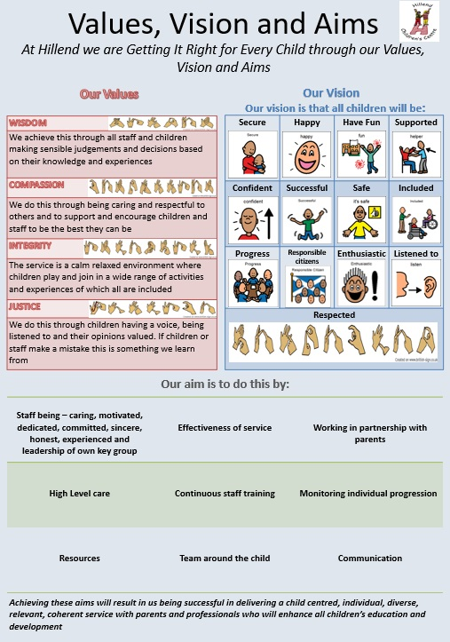

3 Year Overview of Priorities
The improvement priorities for our establishment are noted on the following page. They have been expressed in the context of the National Improvement Framework
Our Improvement Priorities extend in a rolling programme over three years. Each priority has been coded accordingly:

Session 2023-2024
Session 2024-2025
Session 2025-2026

Overview of rolling three year plan
 | Session 2023/24 | Session 2024/25 | Session 2025/2026
Placing the human rights of every child and young person at the centre of education | Hillend staff will become a trauma informed team to be able to support children to self-regulate and become resilient. | Moderate our implementation of our trauma informed practice and embed fully and use this information to enhance staff’s practice. | Deliver Trauma Informed training with Parents / Carers.
Improvements in attainment, particularly in literacy and numeracy | Work collaboratively with almost all parents using Curriculum for Excellence pathways to access and plan next steps in learning for all children.  Implement Inverclyde Council’s single agency and planning document in line with GIRFEC policy | Transfer our tracking, assessment and evaluations onto electronic learning journals. | Moderate our learning journals and develop further as required.
Closing the attainment gap between the most and least disadvantaged children | Create an outdoor environment that allows children to experience all aspects of the broad general curriculum ensuring all areas are resourced, taking into account learning against the 3 cross cutting themes to ensure all children reach their potential.  Continue to create a digital and language rich environment to enhance learning and increase attainment. | Research and evaluate our current service delivery with regards to the importance of nurture for the development of wellbeing. Create an action plan to further enhance our practice, incorporating the 6 nurture principles. | Create action plans with regards to nurture principles as required based on self-evaluation of practice.
Improvement in children and young people's health and wellbeing | Moderate our implementation of UNCRC and develop action plan to embed fully. | Research and create an independence skills programme for children. | Access training for staff and implement bikeability programme.
Improvement in employability skills and sustained positive school leaver destinations for all young people | Develop children’s understanding of the food processes through following farm to fork process of planting our own food. | Evaluate our woodwork programme and enhance our practice. | Research Froebel’s occupations and self-evaluate our practice against these and implement into practice areas needing further implementation.

Action Plan –Session
Priority 1 Placing the human rights and every child and young person at the centre of education

NIF Driver  Parental engagement  Assessment of children's progress  Performance information | HGIOELC?  1.2 Leadership of learning  2.3 Learning, teaching and assessment  3.2 Securing Children's progress  2.2 Curriculum | RRS  Article 28: (Right to education):

Expected outcomes for learners which are measurable or observable
Hillend staff will become a trauma informed team to be able to support children to self-regulate and become resilient
Tasks to achieve priority | Timescale and checkpoints | Those involved – including partners | Resources and staff development
A member of staff who has been trained in trauma informed practice to create an online resource to allow staff to research independently | August 2023 | Key staff member | Online resources, computer, time, staff development feedback sheets
All staff to attend trauma informed training. | Almost all trained by December 2023 | Inverclyde Council, all staff | Access to training, time

Evidence of Impact
- All staff will have access to an online resource were they can research and gain knowledge and skills based on trauma informed practice.
- Trauma trained staff member will support and mentor colleagues in their training and implementation to become a trauma informed team.
- Self-evaluation to reflect on the impact of trauma informed training.

Priority 2 Improvements in attainment, particularly in literacy and numeracy

NIF Driver  Parental engagement  Assessment of children's progress  Performance information | HGIOELC?  1.2 Leadership of learning  2.3 Learning, teaching and assessment  3.2 Securing Children's progress  2.2 Curriculum | RRS  Article 28: (Right to education):  Article 29 (Goals of education):

Expected outcomes for learners which are measurable or observable
Work collaboratively with parents using Curriculum for Excellence pathways to access and plan next steps in learning for almost all children, to create a clear and appropriate learners pathway for all.
Tasks to achieve priority | Timescale and checkpoints | Those involved – including partners | Resources and staff development
Adapt trackers to have a progressive process that shows progress before collaboration, and use data to support learning | August 2023 | SMT | Computer, trackers, time
Moderate the impact of learning and teaching by monitoring and evaluating new trackers | October / January 2023 | SMT and staff | Trackers, self-evaluation sheet, time
Enhance our lending library to include numeracy resources and parental feedback sheet | October 2023 | All staff | Time, resources, computer, maths group
Staff will be trained and transfer to use Inverclyde Council’s GIRFEC guidanceon Single Agency Pupil Assessment & Planning document and update our process in line with this. | ongoing | All staff and SMT | Access to training from Inverclyde Council to suit our current working hours

Evidence of Impact
- All children will have personal plans and we will increase to 95% of parents collaboratively engaging in these.
- Almost all children will be assessed using CFE trackers.( severe and complex learning may have alternative curriculums)
- All children’s assessments will show progress as well as consolidation.
- Evidence from the experience of home learning will be evaluated and show the impact of the learning.

Priority 3 Closing the attainment gap between the most and least disadvantaged children

NIF Driver  Closing the attainment gap between the most and least disadvantaged children | HGIOELC?  2.3 Learning, teaching and assessment  2.4 Personalised support  3.1 Ensuring wellbeing, equality and inclusion | RRS  Article 28: (Right to education):  Article 29 (Goals of education):

Expected outcomes for learners which are measurable or observable
Create an outdoor environment that allows children to experience all aspects of the broad general curriculum ensuring all areas have access to the 3 cross cutting themes to ensure all children reach their potential.
Continue to create a digital and language rich environment to enhance learning and increase attainment.

Tasks to achieve priority | Timescale and checkpoints | Those involved – including partners | Resources and staff development
Working party to create and implement an action plan to enhance outdoors | ongoing | Outdoor curriculum group | Finance, time, labour, computer, visiting other establishments, reflecting on guidance and policy, risk assessing, resource management, professional dialogue
Research and source resources that will enhance children’s experiences in digital technology. | December 2023 | Technology group | Website, staff, time, computer, visits to other establishments, catalogues
Continue to implement 1 plus 2 languages programme supporting children’s understanding of Spanish and BSL. | ongoing | SMT and staff | Spanish programme, time, BSL resources,

Evidence of Impact
- The garden areas will provide curriculum rich experiences and will be evidenced in the children’s floorbooks etc.Playrooms will be digitally rich environments and evidence will be seen through the children’s floorbooks etc.
- All children, parents and the wider community will have experienced aspects of the Spanish language that is relevant to them through different media’s.
- All children, parents and the wider community will have experienced aspect of BSL through different media’s.

Priority 4 Improvement in children and young people's health and wellbeing

NIF Driver  Parental engagement  Assessment of children's progress  Performance information | HGIOELC?  3.1 Ensuring wellbeing, equality and inclusion  1.4 Leadership and management of practitioners  2.4 Personalised support  2.5 Family learning | RRS  Article 28: (Right to education):

Expected outcomes for learners which are measurable or observable
Moderate our implementation of UNCRC and develop action plan to embed fully.

Tasks to achieve priority | Timescale and checkpoints | Those involved – including partners | Resources and staff development
UNCRC group will self-evaluate and moderate our current practice and create an action plan | August 2023 | UNCRC group | Time, computer, self-evaluation sheets, professional dialogue
All children with ASN will be assessed against health and wellbeing tracker linked to CFE and next steps shared with parents to allow for collaborative planning 5 times a year. | Ongoing throughout the year | Keyworkers with ASN children | Time, meetings, trackers, computer, professional dialogue
Use self-evaluation for nurture language is a vital means of communication booklet to train and mentor staff who highlighted training needs. | September 2023 ongoing | Skilled keyworkers mentoring new staff SMT training | Nurture booklet, self-evaluation, presentation, time, resources, professional dialogue
All staff will receive training on I Can tool Kit and use this to reflect on practice | August 2023 training  Evaluatin by October 2023 | All staff | Presentation. Time and current programes

Evidence of Impact
- All children will gain knowledge and skills to further develop their health and wellbeing.
- UNCRC will be embedded throughout the nursery and we will re-establish our Rights Respecting Schools.
- New staff will use communication skills and knowedhge gained to produce children plans and tracking and floorbooks will evidence this
- Staff will use training on “I can trool kit” to self evaluate practice and enhance if required

Priority 5 Improvement in employability skills and sustained positive school leaver destinations for all young people

(Please refer to QI 3.3 Creativity, skills for life and learning and digital skills)

NIF Driver  Assessment of children’s progress  School leadership | HGIOELC?  1.5 Management of resources to promote equity  3.2 Securing Children's progress  3.3 Developing creativity and skills for life  2.2 Curriculum | RRS  Article 28: (Right to education):

Expected outcomes for learners which are measurable or observable
Develop children’s understanding of the food processes through following farm to fork process of planting our own food.

Implement the woodwork programme throughout the year.

Tasks to achieve priority | Timescale and checkpoints | Those involved – including partners | Resources and staff development
Research and establish a garden area that will allow children to plant flowers, and establish an orchard area, accessible raised planting area along with a food growing patch. | ongoing | Garden group | Finance, time, labour, computer, visiting other establishments, reflecting on guidance and policy, risk assessing, resource management, professional dialogue
Resource and add electricity into our woodwork area to allow children to access all year round. | October 2023 | Head of Centre, Inverclyde Council, | Access to woodwork area, finance, Inverclyde council’s woodwork programme.

Evidence of Impact
- Hillend’s outdoors will have a range of areas that will allow children to grow fruit / vegetables, plant flowers and experience rich outdoor learning experiences that will support their life long learning.
- Children will gain new skills by using a range of tools to stimulate their imagination and encourage creativity at different times throughout the year.

