
Gourock Primary
Standards and Quality 2025-26

Context of the Establishment

Our Establishment

Gourock Primary School is a non-denominational school situated in Gourock. The current roll is 195 across 8 classes from Primary 1-7. The school’s Senior Leadership Team (SLT) consists of one Head Teacher and one Depute Head Teacher. There are 11.1 FTE teaching staff, including 0.5 FTE Support for Learning (SfL) Teacher. The school is supported by 3.17 FTE Pupil Support Assistants (PSA), and this is supplemented by an additional 1.74 FTE PSA funded by PEF. There is also support provided by 1 senior clerical and 1 clerical assistant, 1 janitor, 2 breakfast club assistants, 1 catering manager, 4 catering assistants and 2 cleaning staff.

SIMD 1 and 2 – 22% FSM – 17% ASN – 27% LAC – 3%

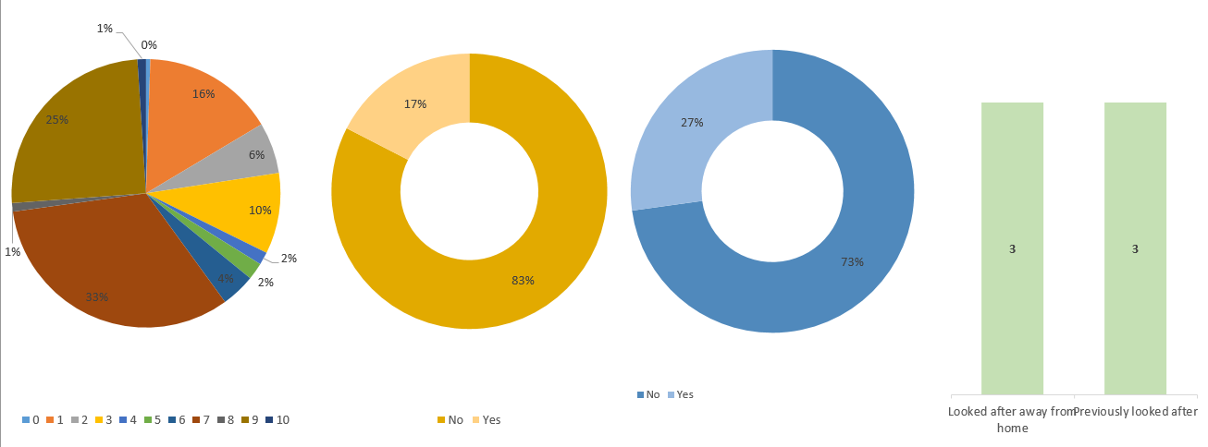

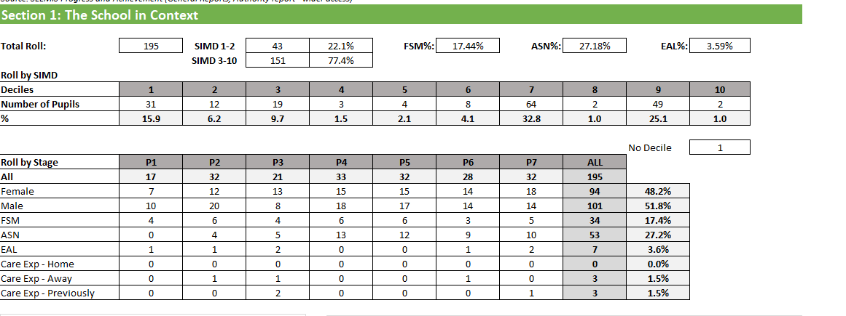

Vision

At Gourock Primary, we strive for excellence in learning and teaching, nurturing learners who are curious, caring and equipped for the future. Our learners are ambitious, resilient, creative, responsible, motivated and engaged citizens who persevere within an inclusive environment.

Our Values
Respect Resilience Kindness Honesty

AIMS
- Create a safe, nurturing and inclusive environment where all pupils are supported to succeed and develop as confident, responsible individuals.

- Deliver a high-quality, engaging curriculum that is challenging, relevant and enjoyable, helping pupils build the knowledge and skills needed for life and learning.

- Work in partnership with families and the wider community to provide excellent learning experiences while promoting leadership, teamwork, resilience and achievement.

Establishment priority 1

NIF Priority  Improvements in attainment, particularly in literacy and numeracy  Choose an item  NIF Driver  Assessment of children's progress  Choose an item. | HGIOS  3.2 Raising attainment and achievement  2.3 Learning, teaching and assessment  UNCRC  Article 28: (Right to education):  Choose an item.
Outcome:

- By October 2025, a review of the school vision, values and aims will have taken place involving all stakeholders.
- To increase the percentage of pupils in Primary 3 making expected progress in Reading from 86.4% to 90% by June 2026.
To increase the percentage of pupils in Primary 4 making expected progress in Reading from 75.8% to 81% by June 2026.

- To increase the percentage of pupils in Primary 3 making expected progress in Writing from 81.8% to 86% by June 2026.
To increase the percentage of pupils in Primary 4 making expected progress in Writing from 75.8% to 81% by June 2026.

- By June 2026, all stages will regularly be adopting a more active, play-based approach to increase pupils’ engagement and enjoyment in literacy and numeracy.

Progress and impact of outcomes for learners:

1.
A review of the school’s Vision, Values and Aims was undertaken through consultation with pupils, parents and staff. Parental views were gathered through a Microsoft Form, which invited feedback on the current Vision, Values and Aims and contributions to their refresh. All learners were fully involved through planned class discussions, during which they identified values that are important to them and suggested areas for development. This ensured that pupil voice was central to the process. Staff engaged in collegiate professional dialogue to evaluate the existing Vision, Values and Aims and to consider how these could more clearly articulate the school’s ethos and strengths. This collaborative approach strengthened shared ownership and understanding across the school community. Feedback from all stakeholders was systematically collated and analysed, resulting in a refreshed Vision, Values and Aims that more accurately reflect the school’s context and aspirations. These will be formally launched in August 2026, providing a clear and shared direction for the school moving forward.

2.

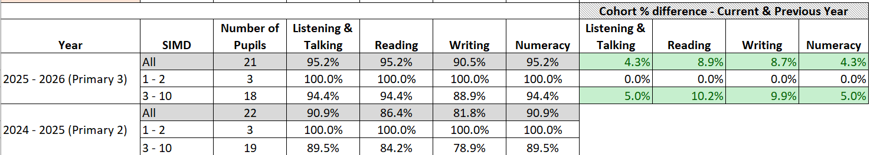
Primary 3 reading attainment has shown significant improvement, reaching 95.2%, which exceeds the original target of 90%. This represents a strong positive outcome and shows that the strategies implemented have been highly effective. In particular, the use of targeted interventions for individual pupils has played a key role, enabling support to be tailored to specific learning needs and helping to close attainment gaps.
However, while this success is encouraging, it is important to consider sustainability and consistency. Continued monitoring will be essential to ensure that high levels of attainment are maintained over time and that progress extends to all learners, including those who still require additional support. Furthermore, evaluating which specific interventions had the greatest impact would help to inform future practice.

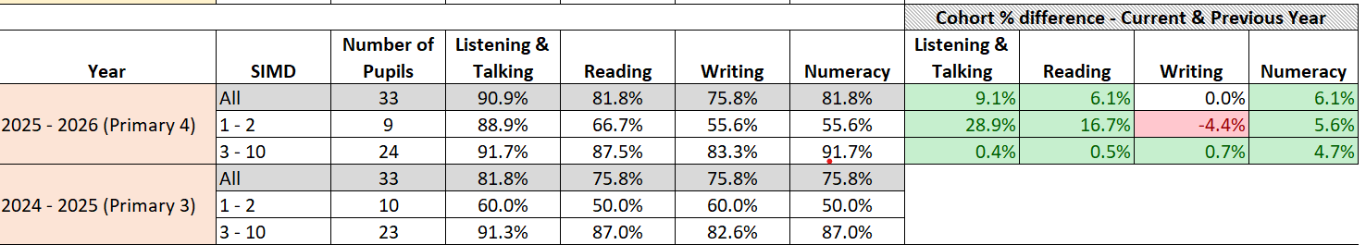
Primary 4 reading attainment has increased to 81.8%, slightly surpassing the target of 81%. This indicates positive progress and shows that the strategies implemented have had a meaningful impact on pupil learning. The combination of effective teacher support and targeted small group interventions with the Learning Support Teacher has been particularly beneficial, allowing for focused instruction and the opportunity to address specific gaps in understanding.
Overall, the improvement reflects a successful collaborative approach to supporting reading development. Moving forward, maintaining strong classroom practice alongside targeted support will be key to building on this progress and achieving even higher attainment levels.

3.
Primary 3 writing attainment has increased to 90.5%, exceeding the target of 86% set for this session. This represents a strong level of progress and indicates that the strategies implemented to support writing development have been highly effective. The improvement shows that pupils are developing greater confidence and competence in their writing skills, contributing to overall attainment gains.
This success reflects consistent teaching approaches, effective feedback, and opportunities for pupils to practise and apply their writing across different contexts. However, while the target has been clearly surpassed, it is important to ensure that this high standard is maintained and that all learners continue to be challenged and supported appropriately. In particular, ongoing monitoring will help identify any pupils who still require targeted support to achieve or sustain expected levels.
Primary 4 writing attainment has remained stable at 75.8% this session, falling short of the target of 81%. There are a number of factors contributing to this outcome, such as gaps in prior learning, inconsistencies in pupil progress, or the need for more targeted support and challenge. This highlights the importance of reviewing current teaching approaches and interventions to identify where adjustments could be made. In particular, a greater focus on targeted support for specific groups of learners and more opportunities for structured writing practice to help raise attainment.
4.
There has been a clear focus on adopting a more active, play-based approach across all stages to increase pupils’ engagement and enjoyment in literacy and numeracy. Early evidence where this approach has been consistently implemented, pupils demonstrate higher levels of motivation, improved shows participation, and greater confidence in their learning. Active and play-based strategies have supported deeper engagement, particularly for younger learners and those who benefit from experiential learning.
However, implementation has not yet been fully consistent across all stages. In some classes, traditional approaches still dominate, which limit the overall impact of this priority. This indicates a need for continued professional learning, sharing of good practice, and support to ensure all staff feel confident in delivering high-quality play-based experiences.
Moving forward, further embedding these approaches across the school will be key. Monitoring pupil engagement and attainment data alongside classroom practice will help to evaluate the effectiveness of this strategy more robustly.

Next steps
- Refresh Curriculum Rationale to ensure our curriculum offer is relevant, intentional and future focused.
- Implement the Curriculum Improvement Cycle as it is introduced
- Review teaching pedagogies in Literacy and Numeracy
- Raise attainment in Reading and Numeracy
- Work alongside cluster schools to streamline writing from Primary 7 into secondary school

Establishment priority 2

NIF Priority  Closing the attainment gap between the most and least disadvantaged children and young people  Choose an item  NIF Driver  Assessment of children's progress  School Improvement | HGIOS  2.3 Learning, teaching and assessment  3.2 Raising attainment and achievement  UNCRC  Article 28: (Right to education):  Article 29 (Goals of education):
Outcome:
Literacy
- To reduce the poverty related attainment gap in Reading from 11% to 8% by June 2026.
- To reduce the poverty related attainment gap in Writing from 8.6% to 6% by June 2026.

Numeracy
- To reduce the poverty related attainment gap in Numeracy from 12.2% to 10% by June 2026.

PEF used to support closing the gap:

PSA (Pupils Support Assistants) x2 (£33,837) PSA (topping up current hours) – providing targeted support for identified pupils.
Use of PSAs as above for regular one to one SEAL sessions, Reading sessions, targeted interventions and timetabled to classes during writing time.

Progress and impact of outcomes for learners:

Literacy
- The poverty-related attainment gap in reading has reduced to 6.3%, exceeding the target of 8%. This represents a very positive outcome and indicates that the strategies in place to support equity and inclusion are having a significant impact. The reduction shows that targeted interventions, effective teaching approaches, and focused support for disadvantaged learners are helping to close the gap and improve overall outcomes.
This progress highlights the importance of continued investment in targeted support, as well as the value of monitoring attainment data closely to ensure that improvements are sustained. Moving forward, maintaining these effective strategies and identifying which approaches have had the greatest impact will be crucial. Further embedding inclusive practices across all stages will help to continue reducing the gap and support long-term improvement.

- The poverty-related attainment gap in writing has reduced to 4.3%, exceeding the target of 6%. This represents a highly positive outcome and demonstrates the strong impact of targeted strategies to support disadvantaged learners. The reduction indicates that interventions, focused teaching approaches, and support systems are effectively helping to close the gap and improve equity in writing attainment. Moving forward, it will be important to sustain these effective approaches and further analyse which strategies have had the greatest impact. Continued tracking and targeted support will help ensure that progress is maintained and that the gap continues to reduce over time.

Numeracy
- The poverty-related attainment gap in numeracy has reduced to 10.1%, down from 12.2% in June 2025, narrowly missing the target by just 0.1%. This represents meaningful progress and demonstrates that the strategies implemented are having a positive impact. The reduction shows that targeted interventions and focused teaching approaches are contributing to closing the gap. Moving forward, sustaining this progress and maintaining a strong focus on equity will be key. Continued monitoring and targeted support should help to further reduce the gap and ensure that all learners achieve their full potential.

Next steps
- Targeted support for pupils in SIMD 1 & 2 to increase attainment in reading, writing and numeracy
- FACT-STORY-ACTION to be evaluated
- Enhanced offer of interventions for individual pupils
- Evaluations of short term supports to adopt, adapt, abandon

Establishment priority 3

NIF Priority  Improvement in children and young people's health and wellbeing  Choose an item  NIF Driver  School leadership  School Improvement | HGIOS  3.1 Ensuring wellbeing, equality and inclusion  2.4 Personalised support  UNCRC  Article 12 (Respect for the views of the child):  Article 28: (Right to education):
Outcome:
- By September 2025, Pupil Participation group will lead the whole school community towards the attainment of Rights Respecting School Award GOLD LEVEL. This will result in improved understanding of everyone’s role within the Children’s Charter.

- By June 2026, our wellbeing interventions will have increased and show positive outcomes for the pupils participating. These will be tracked through GIRFEC meetings.

- By June 2026, attendance across the school to increase from 94.8% to 95%.
By June 2026, to decrease the gap between the attendance of pupils in SIMD 1 & 2 and SIMD 3 – 10 from 3.2% to 2.6%.

Progress and impact of outcomes for learners:
(Please ensure you have explicitly indicated how your PEF spend impacted on the outcome)

- The Right Respecting Schools focus group demonstrated highly effective leadership and pupil participation, which directly contributed to the school successfully achieving reaccreditation at GOLD Rights Respecting Schools status in September 2025. The robust preparation for reaccreditation and its sustained impact have ensured that children’s rights are deeply embedded across the life and work of the school. There is a clear, shared understanding of children’s rights among learners and staff, evidenced through well-established class, playground and canteen charters that consistently promote and uphold these rights in practice. Children are able to articulate their rights confidently and understand how these are realised within their daily experiences. The school maintains a strong and ongoing focus on rights education, with structured approaches such as the ‘Right of the Month’ and regular, purposeful class discussions. Opportunities for learners to engage in leadership roles further strengthens their understanding, responsibility and active participation, demonstrating a positive impact on the school’s inclusive, rights-respecting ethos.

- Wellbeing interventions have increased and are beginning to show positive outcomes for the pupils involved. This reflects a strong commitment to supporting the holistic needs of learners and aligns well with the principles of GIRFEC. The use of targeted interventions and support is being tailored effectively to meet individual needs, contributing to improvements in pupils’ emotional wellbeing, engagement, and readiness to learn.
Tracking these interventions through GIRFEC meetings is a key strength, as it ensures a structured and collaborative approach to monitoring progress. This allows staff to regularly review the impact of interventions, share insights, and adapt support where necessary. It also promotes consistency and accountability in how wellbeing is supported across the school.
Overall, this represents positive progress in strengthening wellbeing support. Continued monitoring and refinement of interventions will be essential to sustain and further enhance outcomes for all pupils.
- For session 2025-2026, attendance across the school was 94.5%. This was slightly below our target of 95%. As a school we have continued to promote attendance and keep parents informed of their child’s attendance throughout the year through attendance letters and the promotion of parents portal.

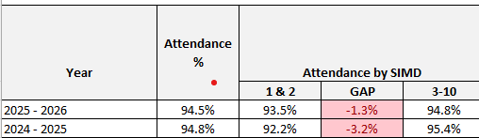

The table above shows the Attendance gap between SIMD 1-2 and 3-10 has decreased to 1.3% exceeding the target of 2.6%. This reduction shows positive impact in supporting improved engagement and inclusion, and reflects sustained progress in closing the poverty-related attainment gap.
However, while the gap has narrowed considerably, continued focus will be required to maintain this progress and ensure that gains are sustained over time. Ongoing tracking and responsive support will help to address any emerging issues and prevent the gap from widening again.

Next steps
- Support and track attendance
- Review use of Glasgow Motivation and Wellbeing Profile (GMWP) wellbeing tracker across the school
- Equalities Policy
- Promoting Positive Relationships Policy

Additional PEF Spend

NIF Priority  Closing the attainment gap between the most and least disadvantaged children and young people | HGIOS QIs  2.4 Personalised support  Choose an item.  UNCRC  Article 31 (Leisure, play and culture):  Article 3 (Best interests of the child):
Spend: £250

Progress and impact of outcomes for learners:

PEF spend allowed all children, disadvantaged by poverty, the opportunity to attend the Primary 7 Residential trip to Dalguise. All pupils reported improved confidence and wellbeing through participating in the outdoor activities.

Next Steps:
Planned spend for PEF 2026-2027:
- Pupil Support Assistants
- Reduce the cost of the school day

Establishment priority 4

NIF Priority  Improvement in skills and sustained, positive school-leaver destinations for all young people  Choose an item  NIF Driver  School Improvement  School leadership | HGIOS  2.7 Partnerships  2.5 Family learning  UNCRC  Article 12 (Respect for the views of the child):  Article 28: (Right to education):
Outcome:
By June 2026, the majority of primary pupils across the cluster will show an increased understanding of financial education. Cluster pupils will demonstrate an increased capacity to engage in meaningful discussion in their skill development around financial education. This will be assessed via cluster voice group and observed in class.
By June 2026, the majority of teaching staff will show an increased confidence in delivering financial education in comparison to the baseline set in August 2025.
By June 2026, the majority of 3-18 year olds across the cluster will be able to identify the link between meta-skills and financial education. This will be assessed via pupil voice.

Progress and impact of outcomes for learners:

- During Term 3, a coherent and well-planned whole-school focus on Financial Education was implemented across the cluster, ensuring clear progression from Early Years through primary and into secondary. All teachers made effective use of high-quality resources provided by Scotland’s Financial Schools, adapting these appropriately to meet the needs of their learners. This consistent approach strengthened continuity of learning across the cluster. The impact of this work was celebrated at a Financial Education Showcase held at Clydeview Academy on 19 March 2026, which provided learners with a meaningful opportunity to articulate and demonstrate their learning.
Pupil voice and classroom observations indicate that the majority of pupils have developed a clearer and more secure understanding of money, including its value and the different ways in which payments are made, both in person and digitally. Learners confidently described how they apply numeracy skills when working with money, such as counting, budgeting and calculating change. Primary 4 pupils who represented the school at the cluster showcase demonstrated a clear understanding of learning intentions and were able to explain their learning to others with confidence. Planned opportunities for peer learning, such as Primary 2 pupils working alongside Primary 5 pupils to support activities using calculators, further strengthened collaboration and communication skills across stages.
- Teaching staff reported increased confidence in planning and delivering Financial Education following the cluster focus. Through collegiate professional dialogue, staff evaluated the impact of the learning and identified that initial baseline discussions with pupils highlighted limited prior understanding of money in our world, confirming the relevance and necessity of this focus. Following the block of learning, staff observed high levels of motivation, engagement and enthusiasm, particularly where learning was contextualised through real-life and play-based experiences. Teachers at Early and First Level created immersive classroom environments, including role-play shops and budgeting activities, which significantly enhanced learner engagement and understanding. This represents a clear improvement in practice compared to the August 2025 baseline.
- Observations of learning and play provide strong evidence that learners are increasingly able to identify and apply meta-skills within a financial context. Learners demonstrated effective communication and collaboration when negotiating spending decisions, working within budgets and agreeing correct change. Through budgeting tasks, pupils showed developing critical thinking skills, including evaluating value for money and making sense of digital transactions. Second Level learners demonstrated curiosity and deeper understanding through informed discussions about taxation, interest and how banks operate.
Overall, feedback from pupils, staff and parents confirms that this cluster focus has been highly effective in improving learners’ financial understanding, developing relevant meta-skills and increasing staff confidence in delivery. This work has provided a strong foundation for future learning and represents an area of practice that the school and cluster are well placed to build upon.

Next steps
- Financial Education to continue next session across the school
- Skills development with clear links with the world of work

Data

The graph below illustrates overall attainment across the stages in June 2026:

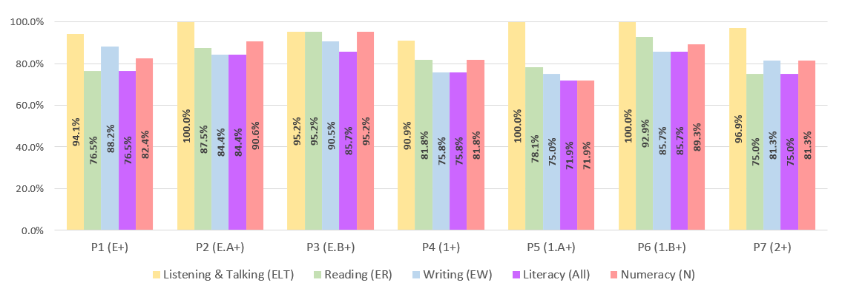

Key Strengths:

- Our attendance remains consistently above the local and national average.
- Attainment in Listening and Talking continues to be a strength across the school with almost all pupils across the school achieving expected levels.
- Most pupils in P1 to P.7 and are on track or beyond expectation in Writing with almost all pupils in P.3 achieving expected levels (90.5%)
- Primary 3 have made significant gains with almost all pupils on track or beyond in listening and talking, reading, writing and numeracy.
- An increasing number of pupils are now working ‘beyond expectation’ across all curricular areas.

Key Priorities:

- Raise attainment in Reading with a focus at P.1 and P.5
- Raise attainment in Numeracy with a focus in P.5
- Continue to strive to close the poverty related attainment gap.
- Maintain the attainment gains made this session in P.3 and P.4

Quality Indicators
1.3 Leadership of Change  Good | 1.3 Leadership of Continuous Improvement (ELC QIF)  Choose an item.
Key Strengths:

- Head Teacher has led on the update of the school’s Vision, Values and Aims through collaboration with staff, pupils and parents.
- The values of the school are celebrated by staff, pupils and parents on a daily, weekly and termly basis.
- Pupils are actively engaged in evaluating the performance of the school through the use of How Good is OUR School.
- The Parents in Partnership Group work with SLT across the school year to discuss school priorities, evaluate progress and agree on use of Pupil Equity Funding. The PiP contribute financially to support school priorities including the creation of our STEM room this session.
- All staff share responsibility for an area of curricular development with pupils. Together they have planned for improvements in identified areas and have led related activities and opportunities for engagement across the whole school community. Staff have contributed to the reaccreditation of our Gold Rights Respecting Schools status as well as Fair Achiever status this session.
- Staff have led charity events across the year to ensure local, national and international charities are supported and awareness raised within the school.
- There are many ways to gather Pupil Voice including, Pupil Council, House Captains and Learning Logs. Pupils speak confidently about feeling their voice is listened to and that their views impact on the life of the school.

Key Priorities:

- Further enhance the impact of the Pupil Focus Groups within the school
- Empower staff to lead on School Improvement priorities
- Staff to build on opportunities to collaborate with staff from other establishments

2.3 Learning, teaching and assessment  Good | 3.3 Learning, teaching and assessment (ELC QIF)  Choose an item.
Key Strengths:

- The school's ethos fosters a learning environment which promotes positive relationships.
- Clear differentiation across lessons to meet the needs of all learners
- Effective deployment of pupil support assistants to support and challenge identified pupils.
- The level of engagement and motivation of the learners across the school.
- Promotion of learning through Play across the school with a focus on promoting creative thinking.
- Learners’ achievements, both within and out with school, are recognised and celebrated.
- The wide range of pupil leadership opportunities across the school.

Key Priorities:

- Focus on pedagogy in literacy and numeracy

- Continue to reflect as a staff team on various pedagogical approaches to offer more challenge to learners.
- Ensure that high quality opportunities for creativity and innovation are embedded and planned for across the curriculum.
- Revisit the Gourock Primary lesson across all areas of the curriculum

3.1 Ensuring wellbeing, equity and inclusion  Good | 4.2 Wellbeing, inclusion and equity (ELC QIF)  Choose an item.
Key Strengths:

- SLT visibility in and around the school provides parents and staff with confidence.
- Positive relationships have been central in fostering a sense of belonging and security resulting in a calm environment.
- Identifying ASN and further developing ways to creatively break down barriers in terms of intervention and PSA allocation.
- There are plans in place which have been actioned and are building confidence in challenging discrimination and ensuring equity and equality.
- Individual Pupil Profiles have been created to clearly show interventions in place.
- Partnership working is strong. This has resulted in successful intergenerational work across the community.
- There are clear transition timelines in place resulting in positive experiences from Early Years to Primary and then Primary to Secondary.
- Alongside the Active Schools Coordinator, staff have ensured that most pupils have experienced the opportunity to access extra-curricular experiences.
- Increase in pupil led lunch clubs to promote leadership and wellbeing.

Key Priorities:

- Continue to develop children’s understanding and awareness of wellbeing indicators.
- Develop a robust whole school wellbeing tracker
- Evaluate Individual Pupil Profiles

3.2 Raising attainment and achievement/Securing children’s progress  Good | 4.3 Children’s progress (ELC QIF)  Choose an item.
Key Strengths:
- Attainment in literacy and numeracy is closely tracked with interventions put in place to provide support to targeted children.
- Through the use of the Fact, Story, Action approach, class teachers have a greater awareness of the data and make up of their class and use this to effectively identify children for targeted interventions within the classroom.
- The whole staff team’s commitment to improving attainment across the school.
- Establishment of effective systems and procedures which are allowing the staff to take ownership of their class data.
- School and wider achievements are well tracked and celebrated.

Key Priorities:

- Develop children’s awareness of targets and CfE levels to allow them to become assessment capable learners.
- The Head Teacher and the Depute Head Teacher should continue to use established tracking systems to support the improvement of children’s attainment and to identify gaps and any dips in progress.
- Ensure that all children can identify the skills being developed through learning activities and wider achievements.
- Build in opportunities for children to develop skills for life.

Key Achievements of the Establishment

- Re-accreditation of our Rights Respecting Gold Award in September 2025
- Raising funds and awareness of Ardgowan Hospice. £432 was raised through our ‘Go Purple’ Day on 10th October 2025.
- Primary 5 organised a Cake and Candy to raise money for Macmillan Cancer Support. £333 was raised on 28th October 2025.
- Pupils participated in football and netball festivals ran by Active Schools
- Pupils took part in the Saturday Cross Country events and our P.5 and P.6 girls won a bronze team medal.
- Our Athletics Team competed in the Competitions at Greenock Sports Centre
- Whole school Christmas Show ran over four days – every pupil involved.
- As a school community we donated to the Inverclyde Foodbank
- Our P.4-P.7 Choir came second in the Greenock Music Festival
- Our Athletics team competed at the Mini Highland Games at Gourock Highland Games and Old Gourock and Ashton Family Fun Day.
- Primary 6 performed ‘Let the Games Begin’ in Old Gourock and Ashton Church for the whole school and their families. This celebrates the Commonwealth Games being hosted in Glasgow.
- Pupils competed in the Burns competition with one Primary 7 pupil being awarded third place in the Robert Burns World Federation Primary National Final.
- Our Rights Respecting Ambassadors, Primary 3, organised a Fun day during ‘Scotland day’ and raised £400 to be shared between UNICEF and play equipment for our outdoors.
- As a whole school we enjoyed a day trip to Blair Drummond Safari Park.
- Two pupils were awarded ‘Local Champion’ awards by the Gourock Community Council at the Gourock Garden Party.

