 Gourock Primary School

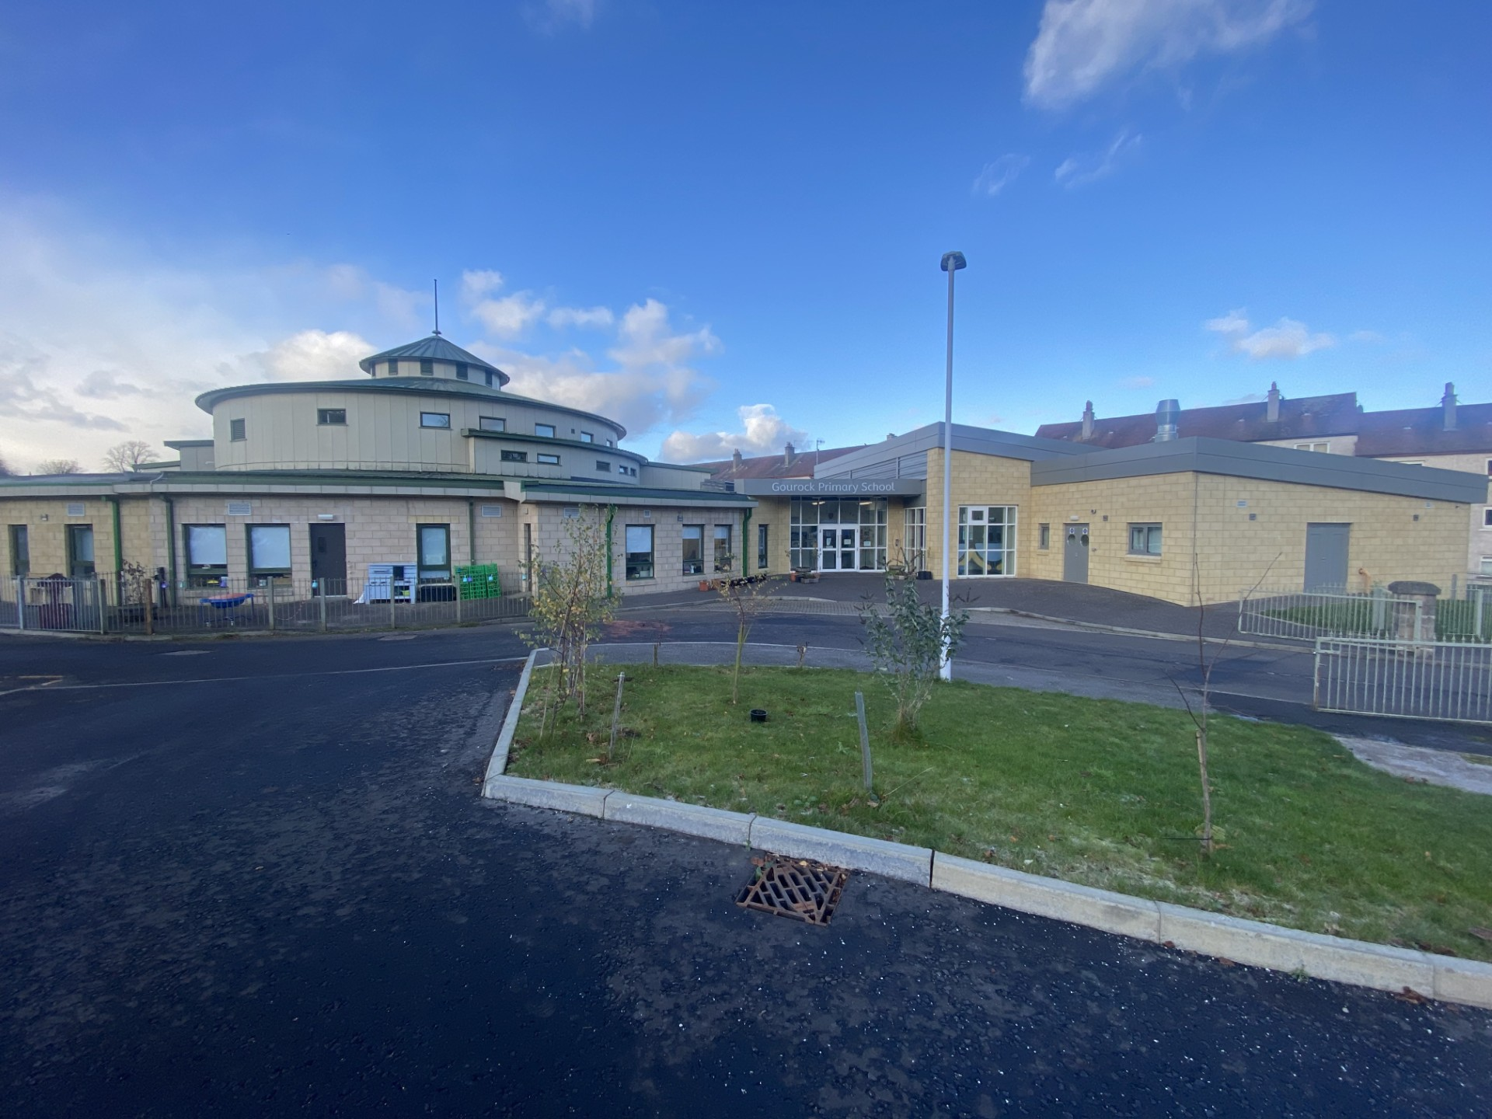

Child Protection Policy
Reviewed January 2026

This policy outlines the procedures and responsibilities for all staff to ensure the safety and wellbeing of children at Gourock Primary School, in line with Inverclyde Council and national guidance. It reflects the principles of Getting It Right for Every Child (GIRFEC) and adheres to the National Guidance for Child Protection in Scotland 2021 (updated 2023) and the Inverclyde Multi-Agency Child Protection Procedures (2023).
Please refer to the Inverclyde Council Child Protection Policy for clarification and understanding of how we meet the wellbeing and needs of all children at Gourock Primary School: Education Services Child Protection Guidelines
We will:
- protect children from harm, abuse, neglect and exploitation
- provide a safe, caring, inclusive environment
- promote wellbeing using the GIRFEC approach
- respond immediately and proportionately to concerns
- work in partnership with families and relevant agencies
Framework and key principles
We work within:
- GIRFEC and the wellbeing indicators
- National Guidance for Child Protection in Scotland (2021, updated 2023)
- Inverclyde Multi-Agency Child Protection Procedures
- Inverclyde Education Services child protection guidance and local authority processes
- UNCRC and The Promise (child-centred, relational, rights-based practice)
- Data protection requirements (UK GDPR / Data Protection Act 2018)
Key principles:
- The child’s safety is paramount.
- Act early; do not wait for certainty.
- Do not investigate; share concerns promptly with the Child Protection Coordinator.
- Record accurately and proportionately.
- High challenge, low threat: focus on improvement and safety, not blame.
Roles and responsibilities
All staff must:
- be vigilant to wellbeing and child protection concerns
- know who the CPC / Deputies are and how to contact them
- act immediately on concerns; complete an Appendix 3 form the same day
- record in SEEMiS Pastoral Notes (as appropriate) and contribute to chronology
- attend annual child protection and Prevent training and follow school procedures

Designated roles (local):
- Child Protection Coordinator (CPC): Lynne Cushnahan (Head Teacher)
- Depute CPC (DCPC): Julie McKellar (Depute Head Teacher)
- Prevent Lead: Lynne Cushnahan (CPC)
- Deputy Prevent Lead: Julie McKellar (DCPC)
Creating a safer culture
We build a visible, child-friendly safeguarding culture by:
- displaying posters with photos/names of CPC/DCPC/child protection leads in key areas
- reinforcing “trusted adults” in every class and nursery areas
- ensuring visitors sign in/out and wear ID; safeguarding expectations are explicit
- embedding safeguarding learning through Health and Wellbeing, online safety, Rights Respecting approaches, and pupil voice opportunities
Responding to concerns and disclosures
If you are worried about a child, you must act the same day.
Immediate safety
- If a child is at immediate risk, call 999. Inform the CPC/DCPC as soon as possible.
- If not immediate, report to CPC/DCPC immediately and complete an Appendix 3 form.
If a child discloses
- Listen, stay calm, take it seriously
- Do not ask leading questions; clarify only the minimum needed (who/what/where/when) by asking open ended questions
- Do not promise confidentiality—explain you must share to keep them safe
- Record the child’s words as accurately as possible (verbatim where you can)
Do not
- investigate
- interview the child/ask leading questions
- confront parents/carers or alleged perpetrators
- share information with colleagues who don’t need to know

Recording and information sharing
- All concerns must be recorded clearly, factually and promptly (same day).
- Records must distinguish between observation, disclosure, and professional opinion.
- SEEMiS Pastoral Notes should be used appropriately and consistently, with restricted access managed by SLT.
- A chronology must be maintained for significant concerns to identify patterns and cumulative risk.
- Information sharing must be necessary, proportionate, relevant and lawful. Consent is not required where child protection concerns exist.
- Use the Record of Concern paperwork available in the staff room/school office/medical room
- Referral and inter-agency processes
The CPC/DCPC will decide next steps and make contact/referrals as required.
Referrals may include:
- Request for Assistance to Children & Families Social Work
- Contact with Police Scotland
- Referral to SCRA (where appropriate)
Where the threshold is met, Social Work and Police may convene an Inter-Agency Referral Discussion (IRD). Education contributes relevant information. This may lead to a Child Protection Planning Meeting and an agreed plan.
Key Inverclyde contacts (keep updated locally):
- Children & Families Social Work (Request for Assistance): 01475 715365
- Out of Hours Social Work: 0300 343 1505
- Police Scotland: 101 (999 emergency)
- SCRA: 0300 200 1680
Attendance, unexplained absence and CME
Attendance is safeguarding. We will:
- monitor attendance daily and follow Inverclyde procedures for unexplained absence immediately
- escalate patterns of absence, frequent lateness, or “explained” absence that raises concern
- apply Children Missing from Education (CME) procedures where relevant – using the absence decision making flowchart
- ensure safeguarding information transfers securely during transitions (Nursery→P1, P7→S1, moves in/out of authority)
Specific safeguarding risks
Staff must be alert to, record and escalate concerns relating to:
- neglect, domestic abuse, parental substance misuse, mental ill-health
- child sexual exploitation (CSE) and child criminal exploitation (CCE)
- trafficking/modern slavery
- female genital mutilation (FGM) and forced marriage
- harmful or problematic sexual behaviour (HSB)
- online harm including grooming, image-based abuse and sextortion
- peer-on-peer abuse and bullying (including prejudice-based bullying)
Where concerns relate to online harm, preserve evidence (do not forward indecent images) and report immediately through the child protection pathway.
Prevent duty (Counter-Terrorism and Security Act 2015)
Prevent is part of safeguarding. Staff must report concerns that a child may be vulnerable to being drawn into terrorism.
- Raise concerns immediately with CPC/Prevent Lead.
- The CPC will follow the local authority/Police Prevent pathway and cooperate with multi-agency processes as required.
- Staff must complete Prevent training and contribute to a safe curriculum (critical thinking, digital literacy, respectful dialogue).
Allegations against staff, volunteers or visitors
Any allegation or concern about the conduct of an adult working with children must be reported immediately:
- to the Head Teacher (CPC)
- if the allegation concerns the Head Teacher, report to the appropriate Inverclyde authority senior officer/HR route (per local authority procedure)
Do not investigate. Secure records separately and follow authority guidance and HR processes. Consider Care Inspectorate notification for nursery where required.
Training, induction and quality assurance
- All staff must complete annual child protection updates and understand this policy.
- Induction is mandatory for new, supply, student and visiting staff and includes a “what to do if worried” briefing.
- The Head Teacher will maintain training records and ensure regular review of: record quality, chronologies, access permissions, signage/visibility, and consistency of practice.
- Learning from incidents, IRDs, and planning meetings will be used to improve practice.
Review
This policy is reviewed annually, or earlier if national/local guidance changes or learning indicates the need to update practice.
