
Gourock Primary School
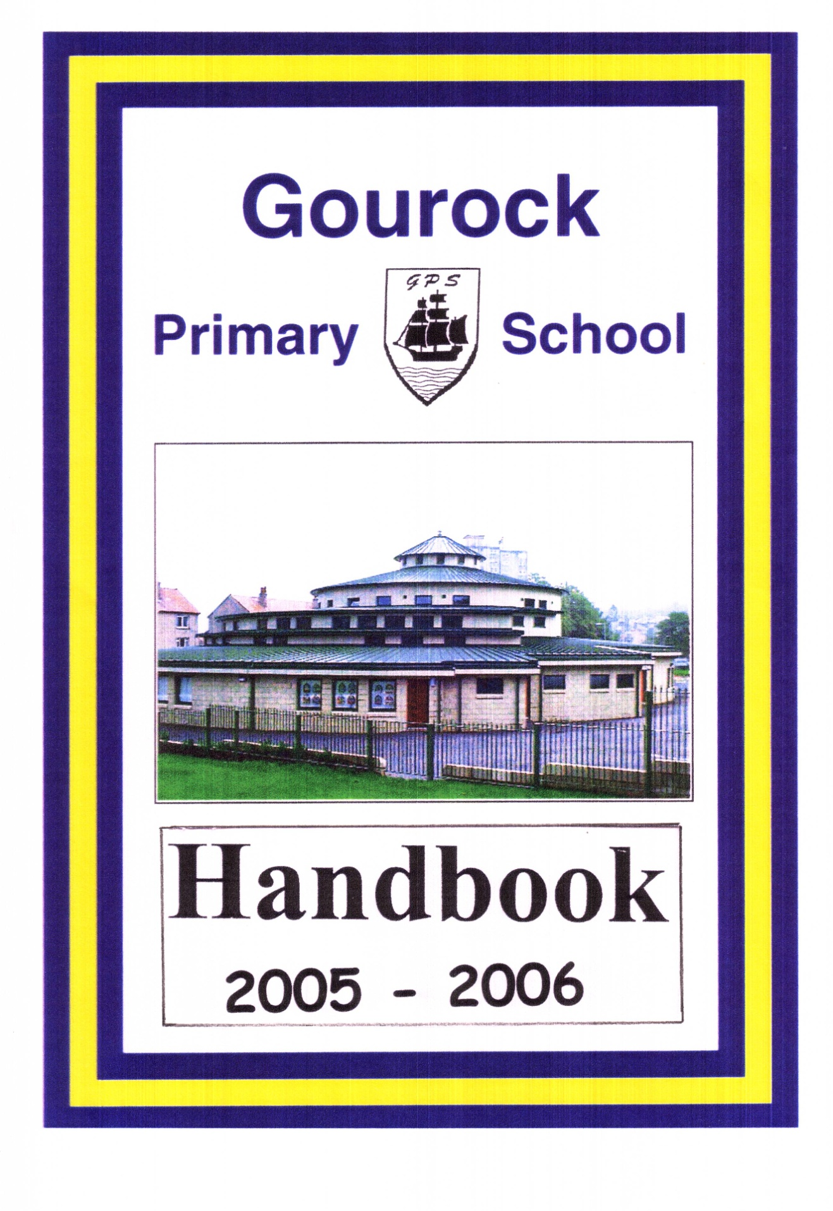
Gourock Primary School
SUCCESSFUL LEARNERS EFFECTIVE CONTRIBUTORS RESPONSIBLE CITIZENS CONFIDENT INDIVIDUALS

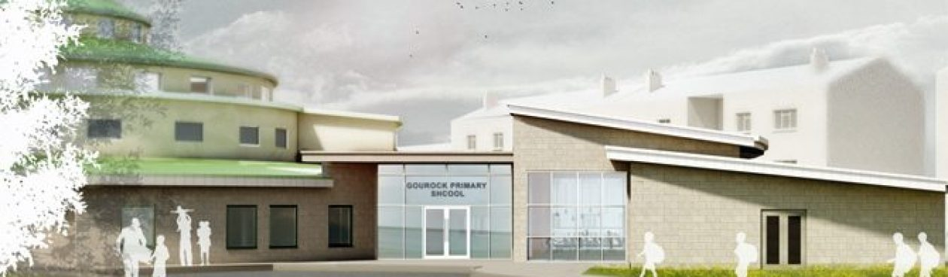
RESPECT KINDNESS RESILIENCE HONESTY TOLERANCE

School Handbook
2026-2027

Gourock Primary School
SUCCESSFUL LEARNERS EFFECTIVE CONTRIBUTORS RESPONSIBLE CITIZENS CONFIDENT INDIVIDUALS

CONTENTS

 | Page No. |  |  | Page No.
Welcome | 2 |  | School & Community Links | 16-17
Goals and Values | 3 |  | Concerns and Issues | 17
School Information | 4 |  | Complaints Procedure | 17
School Hours | 5 |  | Inclusion and Equality | 18
Staffing | 5-6 |  | Positive Relationships &  Positive Behaviour | 18-19
Calendar | 7 |  | Curriculum | 20-32
Information in Emergencies | 8 |  | Home Learning | 33
Supervision of Playground | 8 |  | Assessment | 33
Registration/Enrolment/Transition | 9-11 |  | Pupil Involvement/Pupil Voice | 34
Clothing and Uniform | 11-12 |  | Extra-Curricular Activities | 35
Clothing Grant /Attendance | 13-14 |  | Support for Pupils | 36-38
Meals/ParentPay | 15 |  | Reporting to Parents | 38
Transport | 15 |  | Medical and Health Care | 39
Home and School Links | 15 |  | Child Protection | 39
Nursery Links | 16 |  | Parent Forum/ Parents In Partnership/Engagement | 39-41
Associated Secondary School | 16 |  | School Improvement | 41-43
Transfer from Primary/Secondary | 16 |  | Addresses | 44

Dear Parent,

A warm welcome to Gourock Primary School.

We endeavour to ensure your child receives an education of the highest standard to enable them to reach their full potential and become confident individuals, responsible citizens, effective contributors and successful learners.

Everything we do in Gourock Primary reflects the values shared by all which are Respect, Honesty, Kindness, Resilience and Tolerance.

To support our vision and values we aim to:-

- Provide a curriculum which is challenging, has breadth, depth, relevance, coherence, is fun and enjoyable and prepares our learners for the demands of future careers.
- Ensure opportunities for all to achieve their potential.
- Work together to provide high quality teaching that meets the needs of all pupils and promotes effective learning in a stimulating environment.
- Provide emotional, physical, social and educational support for all pupils and an environment within which children feel secure, happy and included.
- Develop partnerships between staff, pupils, parents and other agencies which promote a positive ethos within the school and a positive image within the community.
- Strive to make effective use of the resources at our disposal – staffing, accommodation and financial to “Get it Right for Every Child.”
- Develop opportunities for staff and pupils in leadership and teamwork.

Should you require any further information or wish to discuss any matter, please do not hesitate to contact me.

Lynne Cushnahan
Head Teacher

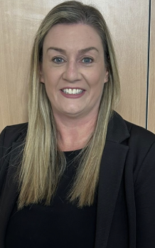


“Building Inverclyde through excellence, ambition and regeneration.”

GOALS AND VALUES

The core values of Inverclyde Council are: Respect, Honesty and Tolerance.

Our vision for the children and young people of Inverclyde is that they should be ambitious for themselves and be successful learners, confident individuals, responsible citizens and effective contributors.

To achieve our ambition of building Inverclyde through excellence, ambition and regeneration our children must be:

- Safe: protected from abuse, neglect and harm by others at home, school and in the community.

- Healthy: enjoy the highest attainable standards of physical and mental health, with access to healthy lifestyles.

- Achieving: have access to positive learning environments and opportunities to develop their skills, confidence and self-esteem to the fullest potential.

- Active: active with opportunities and encouragement to participate in play and recreation including sport.

- Respected and Responsible: involved in decisions that affect them, have their voices heard and be encouraged to play an active and responsible role in their communities.

- Included: have access to high quality services when required and should be assisted to overcome the social, educational, physical, environmental and economic barriers that create inequality.

- Nurtured: educated within a supportive setting.

“GIRFEC – GETTING IT RIGHT FOR EVERY CHILD”

SCHOOL INFORMATION

School Name: Gourock Primary School
Address: Davidson Drive
Gourock
PA19 1QD

Telephone: 01475 715824
Email Address: office@gourock-pri.inverclyde.sch.uk
Website address: https://blogs.glowscotland.org.uk/in/gourockps/
Twitter: @gourockpr
Groupcall: The school will contact parents via email.

Present Roll: 195

Present Roll at each stage: P1- 17, P2 -32 , P3 -22, P4 -33
P5 – 31, P6 – 28 and P7 – 32
Total capacity of school: 297 (Parents should note that the working capacity of
the school might vary dependent upon the number
of pupils at each stage and the way in which classes
are organised.)

Stages covered: P1 – P7

Denominational status: Non-denominational
Co-Educational

The following facilities are available in the school for use by the community – a gymnasium with seating for 96. The school has good disabled access with the appropriate facilities. There is a MUGA adjacent to the school which is used for various sports such as football etc.

Applications for Lets should be submitted to the: Booking Office
Waterfront Complex
Customhouse Way
Greenock
PA15 1EW

Tel: 01475 213131

SCHOOL HOURS

Morning Session 9.00am – 12.30pm
Morning Interval 10.45am – 11.00am
Afternoon Session 1.30pm – 3.15pm

TEACHING STAFF

Head Teacher Mrs Lynne Cushnahan
Acting Depute Head Miss Kirsty McCafferty
Teacher

Depute Head Teacher Mrs Julie McKellar (Maternity Leave)

P1/2 Mrs Kirsty Henry
P2 Miss Mhairi Todd
P3 Mrs Julie Docherty
P4 Mrs Jennifer Mullan
P4/5 Mrs Gillian Workman
P5 Miss Olivia Black and Miss McCafferty
P6 Mrs Lisa Oliver
P7 Mrs Laura Falconer
F.T.E = 11.1

Mrs Lynn Nelis - Additional Support for Learning

Miss Carol McArthur – Reduced Class Contact Time teacher

SUPPORT STAFF

Senior Clerical Assistant Mrs Tracie Cunningham
Clerical Assistant Miss Louise Stewart
Pupil Support Assistants Mrs Kendal Cannon
Mrs Kirsty Sorrell
Mrs Kathleen Brolly
Mrs Eleanor McClafferty
Miss Karen Steele
Miss Emma Lambert

School Janitor Mr Martin Orr
Cook-in-Charge Mrs Jill McNab

OTHER AGENCIES

Educational Psychologist Ms Aroojh Asif

VISITING TEACHERS

Violin Mrs Lillian McColl
Brass Mr Andrew Digger
Woodwind Mrs Angela Charlton
Chanter Mr Andrew McPherson
Voice Coach Mrs Polly Beck
Active Schools Coordinator Mr Craig Mullan

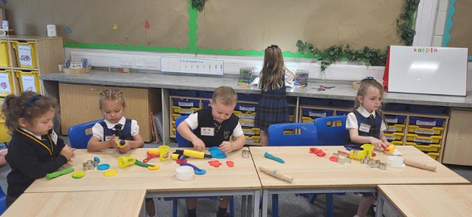


THE SCHOOL CALENDAR 2026 – 2027

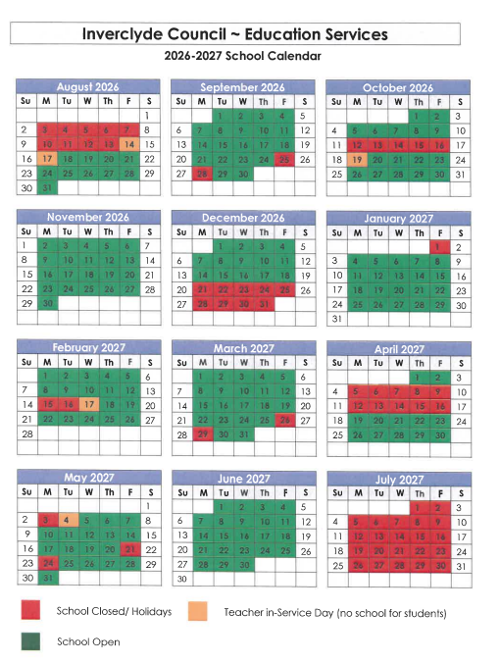

INFORMATION IN CASE OF EMERGENCIES


We make every effort to maintain a full educational service but on some occasions circumstances arise which lead to disruption. Schools may be affected by, for example, severe weather, temporary interruption of transport, power failures or difficulties of fuel supply. In such cases we shall do all we can to let you know about the details of closure or re-opening. Please keep in touch through the school’s website, twitter, email, Inverclyde Council’s Website and announcements in the press and on local radio.

SUPERVISION OF PLAYGROUND

An adult presence is provided in playgrounds at break times in terms of the Schools (Safety and Supervision of Pupils) (Scotland) Regulations 1990.
When dropping off pupils in the morning, please note that an adult is present in the playground from 8.45am.
The school cannot be responsible for supervision of pupils before this time in the morning.
We are a Rights Respecting School and our pupils have developed and follow our Playground Charter:
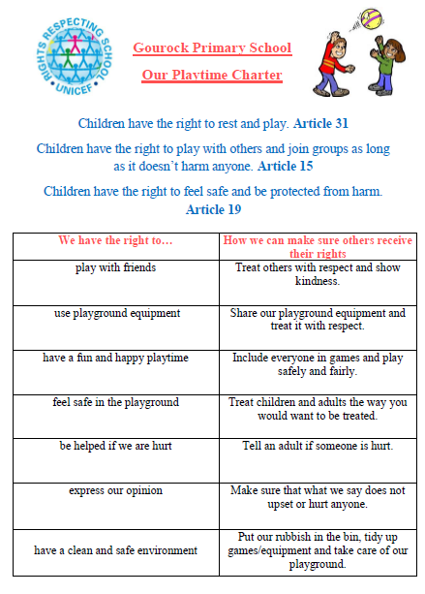

REGISTRATION FOR P1 SCHOOL SESSION 2026 - 2027 WILL BE OPEN BETWEEN 5th and 9th JANUARY 2026 . PLEASE CONTACT THE ADMISSIONS SECTION ON 01475 712850 (OPTION 1) IF YOU REQUIRE ASSISTANCE.
Children who reach the age of five years between 1 March 2026 and 28 February 2027 (this will be children who are born between the 1 March 2021 - 28 February 2022) are due to start primary 1 at the beginning of the new school term in August 2026.
Parents should complete the P1 online registration process between 5th – 9th January 2026 regardless if they are considering a deferred year to school for their child. Please see link below:
http://www.inverclyde.gov.uk/p1-registration
Parents can choose between denominational or non-denominational schools or Gaelic Medium Education. Gaelic Medium Education is available at Whinhill Primary School for all pupils residing in Inverclyde. Please choose Whinhill (Gaelic) School from the online drop down menu when registering.
There are no denominational primary schools within the areas of Quarriers Village, Kilmacolm, Inverkip and Wemyss Bay. Parents often choose to send their children to the local non-denominational primary school because of the travelling distance to their nearest denominational primary school. In such circumstances the following admission arrangements will apply:
- Only those children who have a certificate of baptism into the Roman Catholic faith when registering for primary 1 will have the choice at primary 7 to seek admission to the denominational school assigned to their address. For more information, please read our Pupil Placement Policy which is available in the documents section.
Once parents have completed the primary 1 registration, they will have the choice to complete a placing request application to a school other than the catchment primary.
A deferred entry application is also available to parents considering deferring their child’s entry to primary 1 in August 2026.
No documents will be required at this stage; however, we may have to contact you, should we require further information.
Parents will be notified by 30 April 2026 confirming their child’s place in school and information regarding induction days will follow from the school after this date.

Placing Request
If you have completed the primary 1 registration process and did not apply for a placing request at that time, you can still make an application by completing the form linked on this page under the Related Links heading.
All placing request applications must be submitted by 1st February 2026. Applications received after 1 February will not be considered until the placing request process is complete. Applications will be acknowledged within five working days of receipt of each application (excluding school holidays). If you do not receive an acknowledgement, please contact Admissions Section on 01475 712850 (please select option 1) to ensure your form has arrived. Parents will be advised of the outcome of their request no later than 30 April.

Defer Entry
Defer entry applications for the school term starting August 2026 are open until 1 February 2026. To make an application you should have registered your child for primary 1 between 5th – 9th January 2026. If you have not registered your child please contact the admissions section on 01475 712850 (please select option 1) before completing the defer entry application form under the Related Links heading.
All defer entry applications must be submitted by 1st February 2026.

Entry Age
If a child has not reached the age of 5 years by the last day in February 2027, they would not be eligible to register at this time. In exceptional circumstances, a formal request in writing for early entry should be submitted to Education Services for consideration.
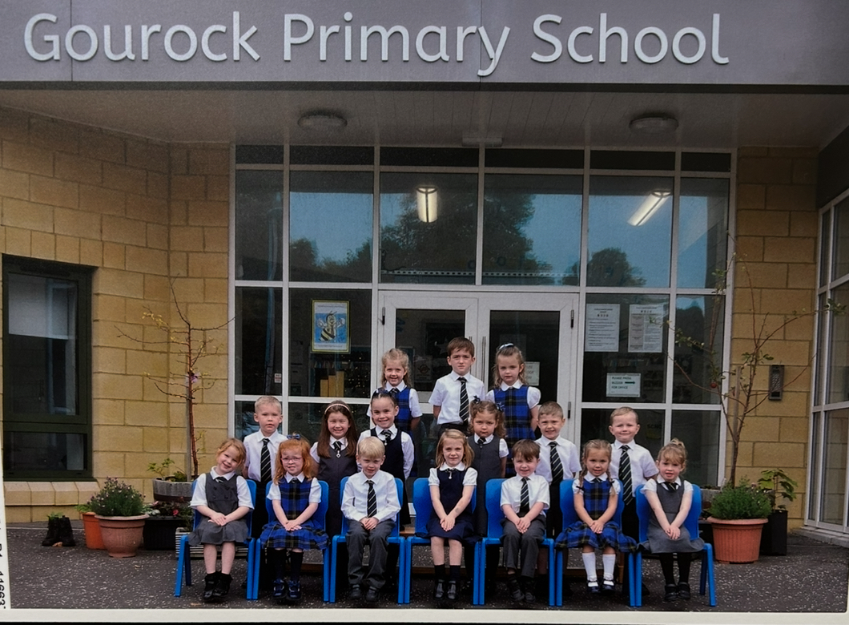

Arrangements for pupils with additional support needs
Inverclyde Council has a policy on inclusion and equality which incorporates the assumption that all children will routinely be educated within their own community. Transitional arrangements for children with additional support needs, moving from nursery to primary or primary to secondary, are discussed at a child’s review meeting. Any child or young person with additional support needs who requires more specialist support will be discussed at Inverclyde’s Additional Support Needs Monitoring Forum. The Forum will make recommendations related to resources, support and necessary specialist placements
TRANSITION

The key to effective transition is effective communication between the Early Years establishments, school and parents. The transition process begins early in pre-school year and continues into P1.

Parents of Primary One pupils are also invited to visit the school at induction days in June. These days offer an opportunity to meet other parents, gain information on the Primary One school curriculum, meet staff, and have a tour of the school building and school grounds.

Parents of children who are moving to the Gourock catchment area and who wish to place their child here should contact the school to arrange a meeting with Mrs Cushnahan. At this meeting parents will have an opportunity to tour the school building. If a place is available and parents live within the school catchment area, parents will be invited to enrol their child, discuss their child’s learning needs, meet class teachers and arrange a starting date.

CLOTHING AND UNIFORM

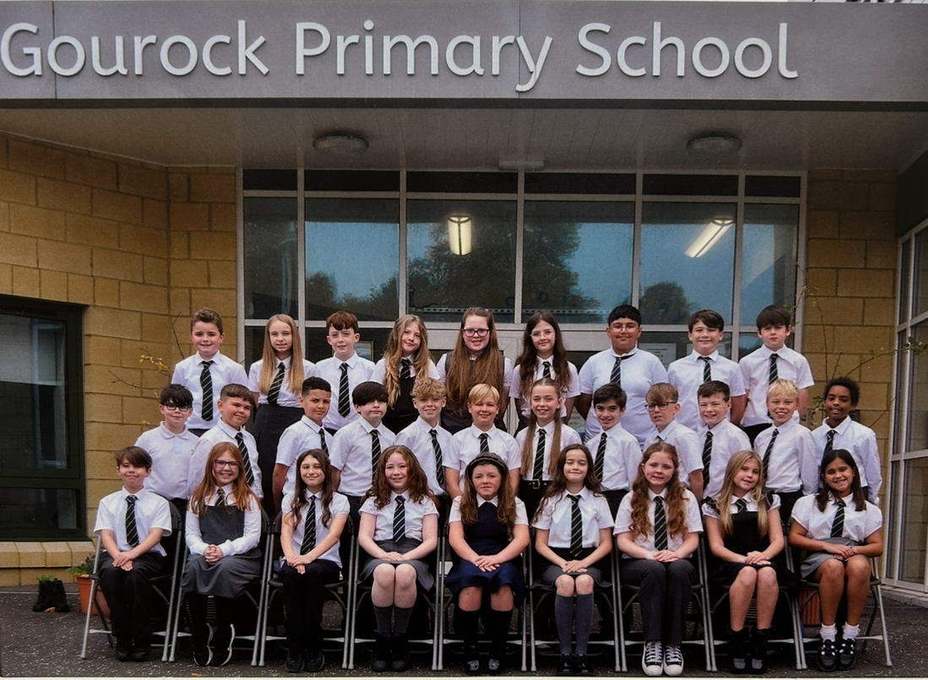

Given that there is a substantial parental and public approval of uniform, schools in Inverclyde are free to encourage the wearing of uniform. When encouraging the wearing of uniform, account is taken in any proposals to prevent any direct or indirect discrimination on the grounds of race or gender. Any proposals will be the subject of widespread consultation with the parents and pupils. Against this background it should be noted that it is the policy of the Education and Lifelong Learning Committee not to insist on pupils wearing uniform or having specialist items of clothing as a prerequisite of their attending and engaging in all of the activities of the curriculum.

In consultation with parents the following items are currently recommended:

Grey skirt or trousers White or blouse
Navy blazer School tie
Navy pullover/cardigan School polo shirt
Navy school sweatshirt
Black school shoes

A ‘relaxed’ form of uniform is strongly encouraged on PE days only:

Navy joggers/leggings/tracksuit bottoms
White school polo shirt
School sweatshirt
Trainers

There are forms of dress which are unacceptable in school, such as items of clothing which:

- potentially, encourages faction (such as football colours);
- could cause offence (such as anti-religious symbolism or political slogans);
- could cause health and safety difficulties, such as loose fitting clothing, or
- clothing made from flammable material
- could cause damage to flooring;
- carry advertising, particularly for alcohol or tobacco;
- could be used to inflict damage on other pupils or be used by others to do so.

Parents are asked to assist the school by ensuring that valuable items and unnecessarily expensive items of clothing are not brought to the establishment. Parents should note that the authority does not carry insurance to cover the loss of such items and any claims submitted are likely to be met only where the authority can be shown to have been negligent.

It is hugely important that ALL CLOTHING ITEMS that can be removed in school MUST have your child’s name clearly marked to allow us to return it, should it become lost.

Parents should note that the activities the children may become involved in may be restricted because health and safety requirements state that jewellery of any kind must not be worn where children are undertaking physical activities. This includes jewellery worn as a result of body piercing.

We have a LOST PROPERTY area within our canteen where items are placed.
Parents are welcome to come and look through the lost property any day after school. Please enter via our front door and check in with office staff before entering the dining hall.

Parents of children receiving one of the following benefits will normally be entitled to monetary grants for footwear and clothing for their children. Links to the application can be found on our school website or Inverclyde Council’s website.

CLOTHING GRANT

Who can apply for a clothing grant?
Since August 2023, all children in P1-P7 now automatically qualify for free school meals.
However, if you wish to be considered for the clothing grant, or your child is or will be in S1 – S6, you must submit an application form. You may qualify for a clothing grant if one of the following statements applies to your family circumstances:
You are currently in receipt of:
- Income Support (IS);
- Income Based Job Seekers Allowance (JSA);
- Income Related Employment and Support Allowance (ESA);
- Child Tax Credit, but not Working Tax Credit, and your income is less than £19,995 (in 2024/2025) as assessed by HMRC;
- Working Tax Credit and/or Child Tax Credit and have an income of no more than £15,051 as assessed by HMRC or
- Universal Credit, where your take home pay does not exceed £1,199, as shown on your most recent monthly Universal Credit Statement.
or
- you are seeking asylum and receiving support under part VI of the Immigration and Asylum Act 1999;
or
- you look after a child/children as part of a formal Kinship Care agreement, registered by Social Work Services.

Approval of any requests for such grants made by parents in different circumstances is at the discretion of the Corporate Director of Education and Communities. Information and application forms may be obtained from schools, download a form from Inverclyde Council website or collect from Customer Service Centre Inverclyde Council.

ATTENDANCE AT SCHOOL

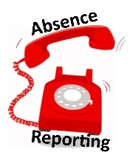
Parents should inform the school by telephone, email or parents portal on the first morning of an absence and provide a reason for the pupil’s absence. The school will contact the pupil’s parent and thereafter other emergency contacts if no explanation is given for the pupil’s absence. This contact will be made before 9.30a.m. on the first morning of an absence and early after the restart after lunch in the case of an afternoon absence. Other agencies may be contacted if no contact with the pupil’s family can be achieved and if there are continuing or emerging concerns about a pupil’s safety or wellbeing.

- Parents should keep the school informed of any changes of address or telephone numbers, both their own and those of the emergency contacts.
- Should school staff be unable to trace the whereabouts of a pupil by 11.30am, the school is required to apply the protocol of Inverclyde’s ‘Unexplained Absence’ policy. This may involve the school contacting outside agencies such as Social Work, Police, etc in order to ascertain the health and wellbeing of the missing pupil.

Section 30 of the Education Act lays down a duty on every parent of a child of ‘school age’ to ensure that their child attends school regularly. Attendance must be recorded twice a day, morning and afternoon.

Regulation 7 of The Education (School and Placing Information) (Scotland) Amendment etc. Regulations 1993 requires each child’s absence from school to be recorded in the school register as authorised: i.e. approved by the authority and unauthorised: i.e. unexplained by the parent (truancy) or temporarily excluded from school.

The Scottish Government has provided guidance on the management of attendance and absence in Scottish Schools in its publication ‘Include, Engaged and Involved Part 1: Attendance in Scottish Schools’. Every effort should be made to avoid family holidays during term time as this both disrupts the children’s education and reduces learning time. Family holidays are recorded as an unauthorised absence, except in exceptional domestic circumstances, where a family needs time together to recover from distress/trauma, or where a parent’s employment is accommodated (e.g. armed services or emergency services).

It is for local authorities and schools to judge when these circumstances apply and authorise absence accordingly. Our main focus is to encourage parents and pupils to recognise the value of learning and the pitfalls of disrupting learning for the pupil, the rest of the class and the teacher.

When an absence occurs with no explanation from the parent, the absence is unauthorised. Schools are tasked with investigating unexplained absence. The Education Service has the power to write to, interview or prosecute parents, or refer pupils to the Children’s Reporter, if necessary. Young people of school age may be unable to attend school for a wide range of reasons including illness, accidents or long term medical conditions. In general there will be an automatic referral by the school for education outwith school after 15 days of continuous or 20 working days of intermittent absence, within a single session, for verifiable medical reasons.

SCHOOL MEALS

Meals are available in the dining room each day.
The three-week menu rota is available on the school website. All Primary pupils are currently entitled to a free school meal.

Gourock Primary is a Healthy Eating School and has established a ‘Healthy Eating Group’, called the Funky Five x 2 plus 3. This group of children is on duty at lunchtime, assisting pupils and helping to organize the smooth running of the canteen.

Pupils with packed lunches are also accommodated in the dining hall.

Special diets are available on request. Parents should alert the school to any specific medical dietary needs either through consultation or written directions from a dietitian; Please contact the school if you have any questions.

PARENTPAY


Inverclyde Council now operates ParentPay in all Secondary and Primary schools which is a cashless system. This allows parents/carers to access a secure website that lets you pay costs such as school meals and school trips online using a debit or credit card. This gives parents the flexibility to pay whenever is convenient to them and allows payment for multiple items in a single transaction. Items such as school trips, can be paid in instalments in a secure manner. This also allows parents to see a full payment history and also to view what their child(ren) have eaten in the course of the day.

For parents who do not wish to set up an online ParentPay account, PayPoint can be used to pay for school lunches/snacks and trips. PayPoint is a system which allows parents to make cash payments at their local shop. The school can issue a barcoded letter or order a PayPoint card to allow you to make payments – the payments will feed through to the school’s Parentpay system within 48 hours.

All trips in primary schools are required to be paid online using ParentPay.
For more information please contact the school or visit www.parentpay.com

TRANSPORT

Most of our pupils in our catchment area live within walking distance from the school. There is no school bus available.

HOME AND SCHOOL LINKS

At Gourock Primary we encourage close partnership with parents/carers. Evidence has shown that children achieve more when parents/carers are involved in their child’s learning. In normal circumstances there are many opportunities for parental involvement at Gourock Primary – please see our school website for more information.

● Meet the Teacher Afternoons
●Informal Parents’ Evenings/Afternoons ●Assemblies ●School Website ● Sharing learning Events
●Home Learning Policy ● Parents In Partnership ●School Musical Performances
●Induction Programme for P1 and their parents
●School Newsletters and Information Sheets ● Open Door Policy● Outings

NURSERY LINKS

Gourock Primary does not have a Nursery class but it has strong links with nurseries within the local area i.e. Moorfoot Nursery, Gourock Pre-5 Nursery and Binnie Street Children’s Centre. There is a programme of visits arranged each year for pre-school pupils to visit. Our Depute Head teacher, Head Teacher or P1 Teacher visits each establishment to help our future pupils establish a rapport with the school before their induction programme commences. Our ‘Buddies’ from P6 also visit our pre-school children in the summer term.

ASSOCIATED SECONDARY SCHOOL

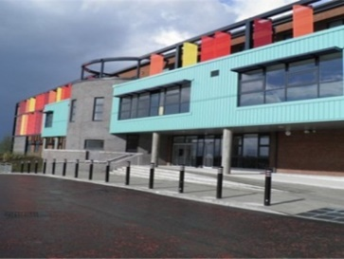
Our school is part of a cluster of schools working together to secure improvements and developments in agreed areas of priority. This cluster of schools includes Moorfoot Primary, Ardgowan Primary, Gourock Primary and Clydeview Academy. We value the strong relationship we have with our cluster schools and endeavour to create opportunities to moderate, share good practice as well as fully prepare our Primary 7 pupils to make the leap effectively from Primary to Secondary education.

TRANSFER FROM PRIMARY TO SECONDARY

Pupils normally transfer between the ages of 11½ and 12½ years of age so that they will have the opportunity to complete at least 4 years of secondary education. Parents will be informed of the arrangements no later than December of the year preceding the date of transfer at the start of the new session.
Most of our pupils live within the Clydeview Academy catchment area. Please be advised that if you wish your child to transfer to Clydeview Academy you must live within the catchment area otherwise a placing request must be submitted.

Contact details for Clydeview Academy:

Burnside Road,
Gourock PA19 1UX
Tel: 01475 715050

SCHOOL AND COMMUNITY LINKS

Gourock Primary is a school that is held with much affection in the local community. Your child is 'the local community.' As part of their education, children learn to appreciate that community, and to realise what it offers them and equally, the part they have to play in it. To encourage their awareness of their environment, pupils study the physical aspects of the community - the buildings, streets, shops, play areas and transport as well as its history and traditions.

Pupils also take part in community activities and events. Personalities in the neighbourhood are invited into the school to talk about their role in the life of the community in the past or present time. The school has close links with the police, the fire service, the health service and the road safety departments.

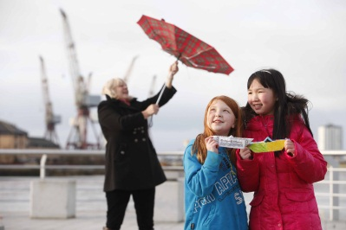
The pupils participate in joint services held in local churches. The collections from church services are donated to local charities. We are supported by Rev. David Burt from Old Gouroak and Ashton Church who regurlary visits the school and leads us in our whole school Church Services throughout the year.
There is close liaison with the local Burns Club the “Jolly Beggars “, some of whose members are invited to attend the P7 Burns Supper. The club also provides judges for the Burns Competition, held within the school, and the Inter-School Burns Competition held in the local schools.

Our school choir routinely takes part in Inverclyde Music and Drama Festival. Individual soloists also participate. In doing this we aim to interest our children in their community so that in turn they will have a pride in being part of the community.

CONCERNS/ISSUES

We promote an open door policy at Gourock Primary and urge parents to contact the school should they have any concerns, queries or feedback. If a parent is unhappy about anything concerning the curriculum or related matters they should contact the school and make an appointment with the Class Teacher or Head Teacher to discuss the issue or concern. Complaints of this nature will be dealt with sensitively and promptly. If required, please refer to ‘Inverclyde Complaints Handling Procedure and Process’ document which can be found on our school website.

COMPLAINTS PROCEDURE

Gourock Primary School aims to provide a high quality service for all pupils, parents and the wider community. We need to know when you are not entirely satisfied with our service so that we can make appropriate changes. Please see Inverclyde Councils ‘Complaints Process and Procedure policy’ document on our school website for further details.

We see any valid complaint as an opportunity to improve our service.

A complaint is defined as any expression of dissatisfaction about the standard of service, action or lack of action by staff affecting an individual child or group.

In the first instance you should contact the school. This can be done by:-
- telephone
- letter/email
- calling at the school and making an appointment

Where a complaint cannot be dealt with and resolved at this level, the Head Teacher will become involved in a further attempt to deal with the matter satisfactorily.

On receipt of a complaint, you will receive an acknowledgement within 3 working days. It is hoped that all complaints can be resolved within a maximum of 2 weeks (this gives time for a full investigation to be carried out if necessary).

When a complaint is still not resolved it will be passed on to Education Services where a senior member of staff will intervene and try to reach an acceptable conclusion.
If satisfaction cannot be reached Education Services can refer the complaints to:-
- Education Appeals Committee
- Dispute Resolution by Independent Adjudication
- Scottish Public Services Ombudsman

INCLUSION AND EQUALITY

Inverclyde Education Service is committed to ensuring that no children or members of staff or service users receive less favourable treatment on any ground including gender, race, disability, age, sexual orientation, religion or belief. We have a moral, social and legal obligation to mainstream and put equality at the heart of everything we do. We aim to promote a culture in which equality of opportunity exists for all. We are opposed to all forms of discrimination, direct or indirect, and aim to eliminate all discriminatory practices. We will ensure that, in our schools and other educational establishments, equality permeates the curriculum and underpins all our policies and practices in terms of access to education. We must ensure that all our children achieve their full potential to develop physically, emotionally and academically. Finally, we believe that equality and inclusion should be a given right, where everyone is valued and treated with respect.’

POSITIVE RELATIONSHIPS POLICY

BETTER RELATIONSHIPS, BETTER LEARNING, BETTER BEHAVIOUR

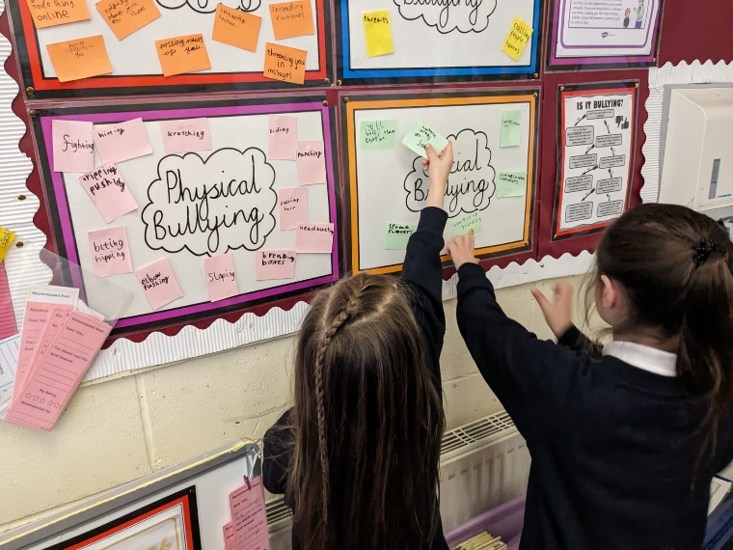

As a Rights Respecting School, it is important that we nurture positive relationships between staff, pupils and parents. Relationships lie at the heart of the learning process and are fundamental to improving outcomes for all our children. Our aim is to get it right for every child and therefore we encourage a positive ethos ensuring children are Safe, Healthy, Achieving, Active, Nurtured, Responsible, Respected, Included and Valued.

Our ethos is based on Inverclyde’s Policy: Promoting Positive Relationships. A link to this policy can be found on our school website.

In Gourock Primary, we use Restorative Approaches to promote positive relationships and provide an opportunity to repair any harm or upset when difficulties have occurred. This moves away from blame and punishment and moves the focus to reasons, cause, responsibilities and feelings.

We adhere to Inverclyde Council’s Anti-Bullying Policy. The school is fully committed to promoting equal opportunities and this is provided through an appropriate curriculum.

The development of a positive learning environment is essential if effective learning and teaching is to take place within an educational establishment. Effective learning and teaching is also dependent on the nurturing of positive relationships through the daily interactions between staff and learners and between learners themselves.”

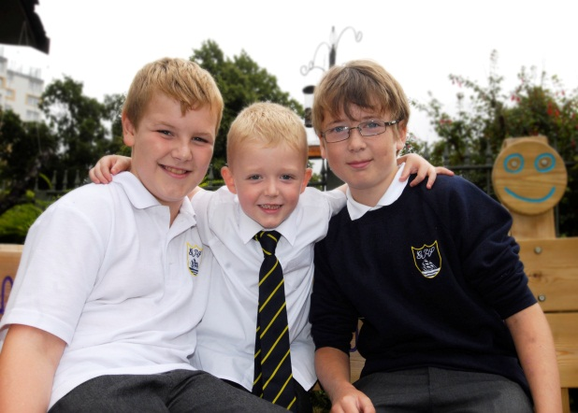
It is important to emphasise that the curriculum is not just about learning facts and developing skills in the subjects taught. Good relationships amongst pupils, between pupils and teachers and between teachers and parents contribute to children’s personal and social development. Children have to learn how to co-operate with and understand other children; how to acquire healthy habits and attitudes; how to solve problems and make decisions; and how to care for the environment. These things are learned not only within the classroom, but also in corridors, in the playground, in extra-curricular activities and in their homes.

At all times in Gourock Primary the emphasis is on a positive approach to behaviour. Each class has a class charter and uses the programme ‘Bounce back’ to promote resilience and friendships. Pupils are recognised at our weekly award assemblies for their efforts, work ethic, attitude and adherence to the school values. When it is necessary, parents will be invited into the school to discuss any support a child may need to help him/her to achieve the skills required.



Pupil activities, achievements and successes are regularly celebrated online via our Twitter (X) account. We urge all parents to follow us online @gourockpr

CURRICULUM FOR EXCELLENCE

Curriculum for Excellence aims to achieve a transformation in education in Scotland by providing an improved, more flexible and enriched curriculum for all children and young people from 3 – 18 years. More information can be obtained by visiting Education Scotland web site or Parentzone. Further information can also be found on our school website under the curricular areas and in the Family Engagement section.

The aims of Curriculum for Excellence are that every child and young person should know that they are valued and will be supported to become a SUCCESSFUL LEARNER, an EFFECTIVE CONTRIBUTOR, a CONFIDENT INDIVIDUAL and a RESPONSIBLE CITIZEN.

We aim to give all pupils a traditionally broad Scottish Curriculum that develops skills for learning, skills for life and skills for work, with a sustained focus on literacy and numeracy that encourages an active, healthy and environmentally sustainable lifestyle and builds an appreciation of Scotland and its place in the world.

The experiences and outcomes under Curriculum for Excellence are written at five levels, with progression to qualifications described under the senior phase.

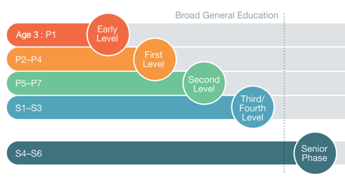
There are eight curriculum areas:

LANGUAGES HEALTH AND WELL BEING MATHEMATICS

EXPRESSIVE ARTS RELIGIOUS AND MORAL EDUCATION
SCIENCES TECHNOLOGIES SOCIAL STUDIES

LANGUAGE and LITERACY

“Language and literacy are of personal, social and economic importance. Our ability to use language lies at the centre of the development and expression of our emotions, our thinking, our learning and our sense of personal identity.”
Curriculum for Excellence May 2009

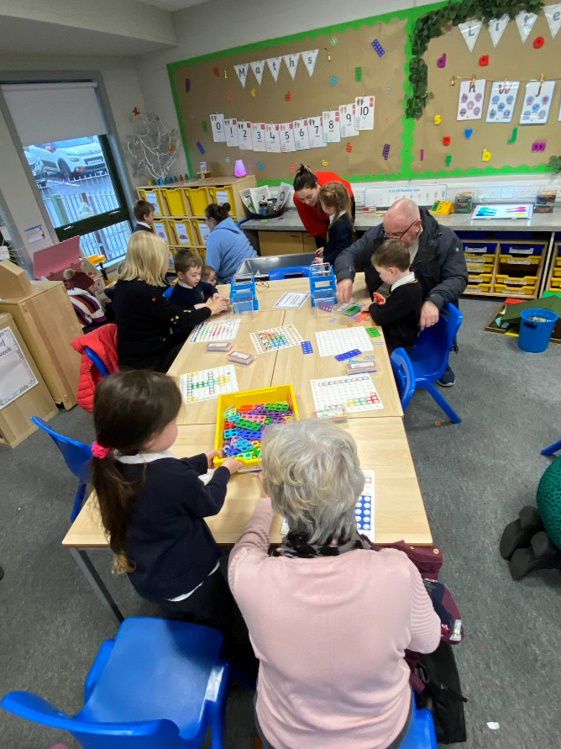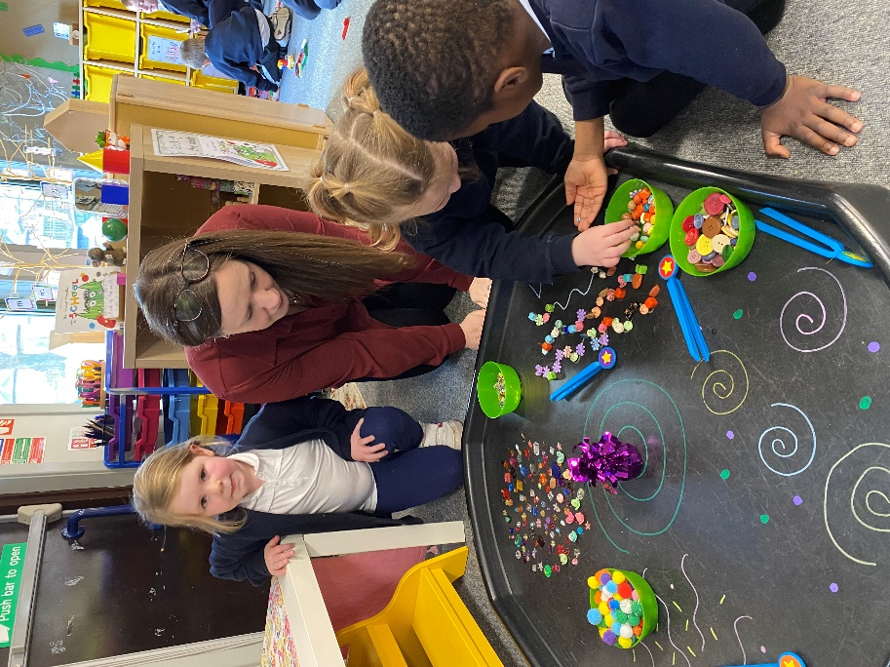

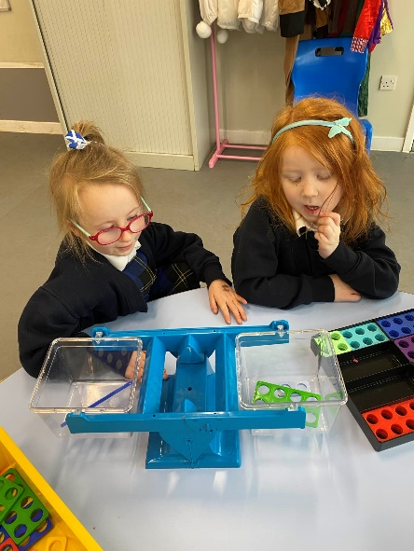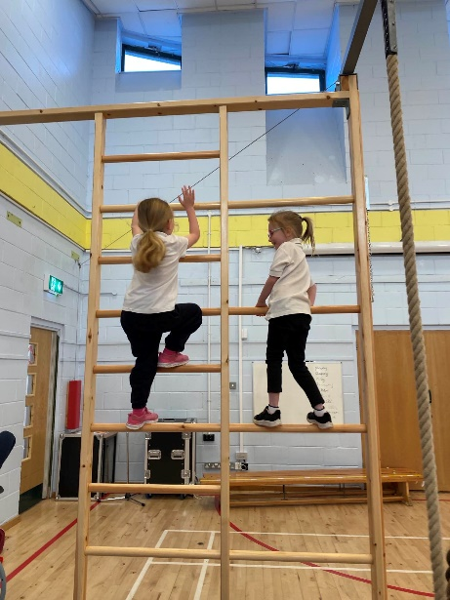

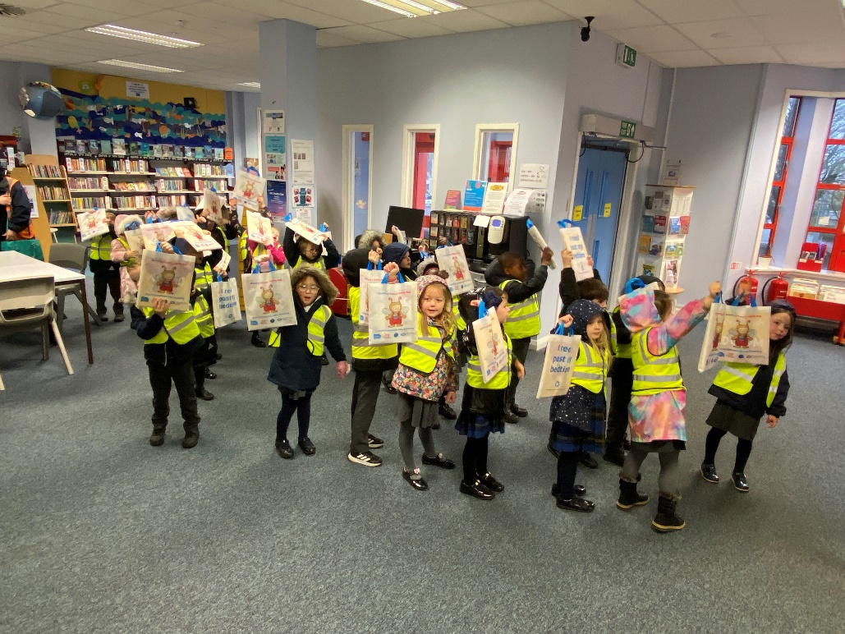

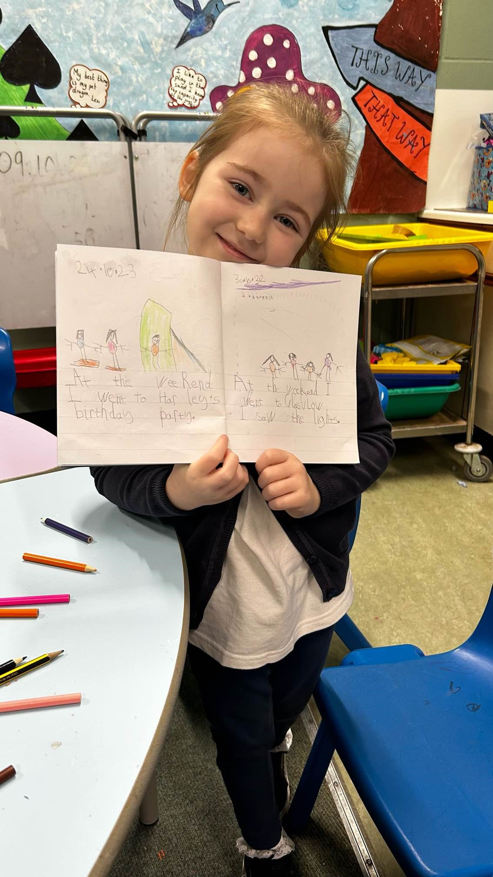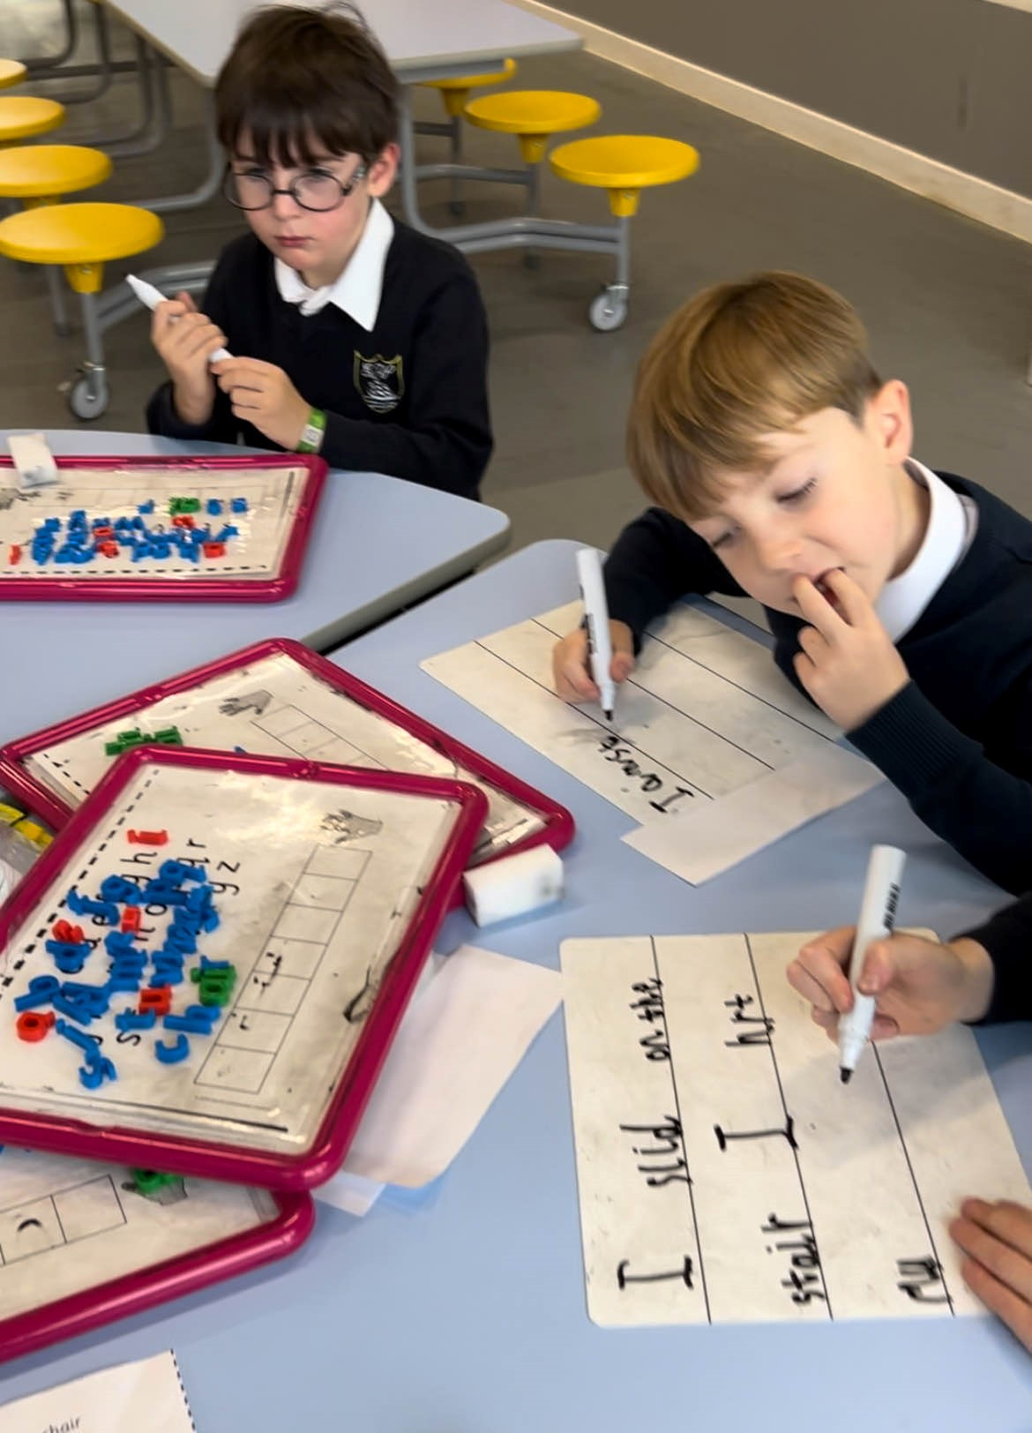

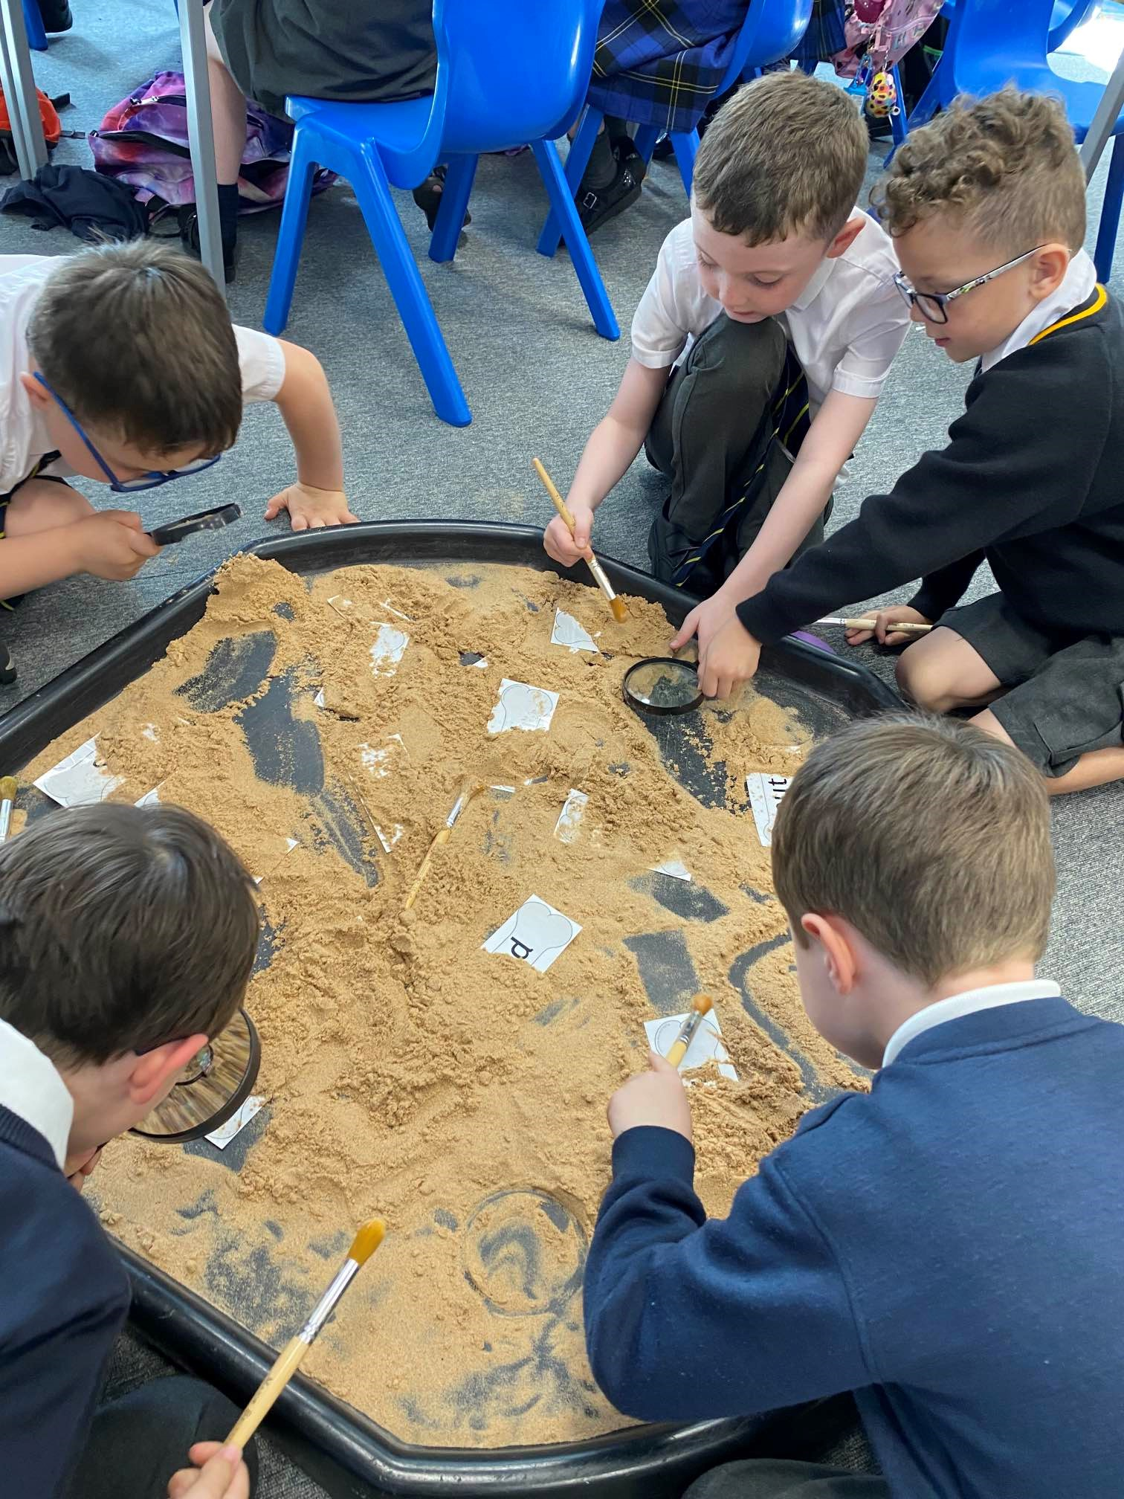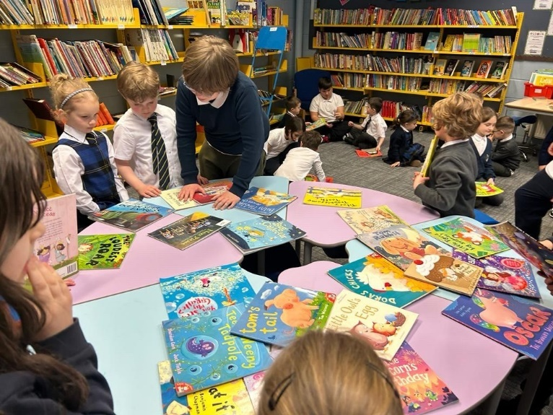

All of our pupils have many opportunities and experiences to develop high level skills in listening, talking, reading and writing which are essential for learning, work and life.
Language permeates the whole curriculum and is fundamental to all other areas of learning.

In reading, pupils are exposed to a wide variety of texts. Some of the resources are used to teach and reinforce phonic rules and reading fluency skills. There is also a variety of children’s novels where higher order questioning is used to help pupils develop their comprehension and thinking skills. Reciprocal teaching is a method also used throughout the school to improve pupils’ comprehension.

Phonological awareness is developed in the Early Years to ensure solid foundations for reading and phonics. The North Lanarkshire Active Literacy is used to develop phonics and spelling. Our writing programme gives pupils experiences in writing to promote skills in spelling, punctuation and grammar through a range of genre. Pupils are encouraged to write with an increasing degree of independence, improved organisation and audience awareness.

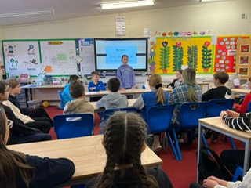

1 PLUS 2 LANGUAGES

Pupils in P1 – P7 are taught French. There is a programme for all pupils P1 to P7 to be taught in everyday situations within the classroom but more importantly for the pupils to have the opportunity to embrace another culture. Pupils are also experiencing Spanish in P5-P7.

MATHEMATICS AND NUMERACY

“Developing essential Numeracy skills, including arithmetical skills, allow pupils to
participate fully in society.”
Curriculum for Excellence May 2009

In Mathematics, pupils’ experiences are structured within three main areas;
- number, money and measure
- shape, position and movement
- information handling.

In the early stages, our pupils follow the SEAL (Stages of Early Arithmetical Learning) programme which gives a sound grounding to all aspects of number concepts.

Our maths/numeracy programme provides learning opportunities to allow pupils to improve and deepen their understanding of mathematical/number concepts. Pupils’ learning involves observing, exploring, investigating, experimenting, playing, discussing and reflecting. Pupils are able to explain their thinking and demonstrate their understanding across other curricular areas and in unfamiliar context.

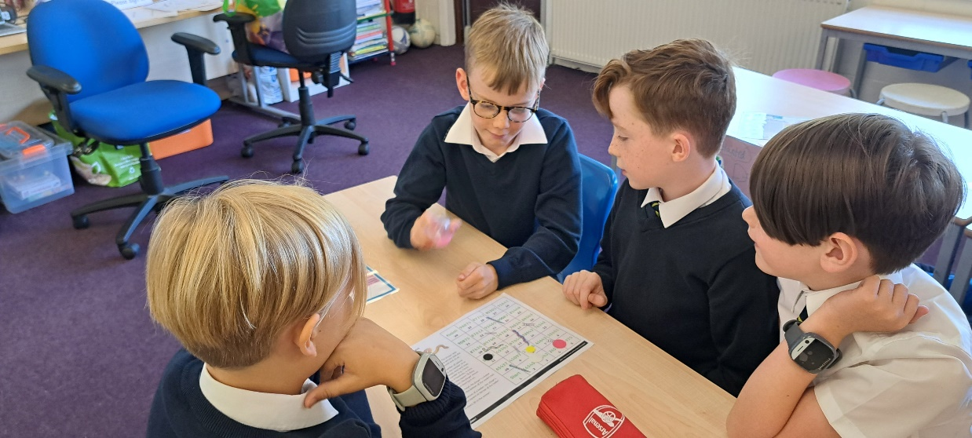

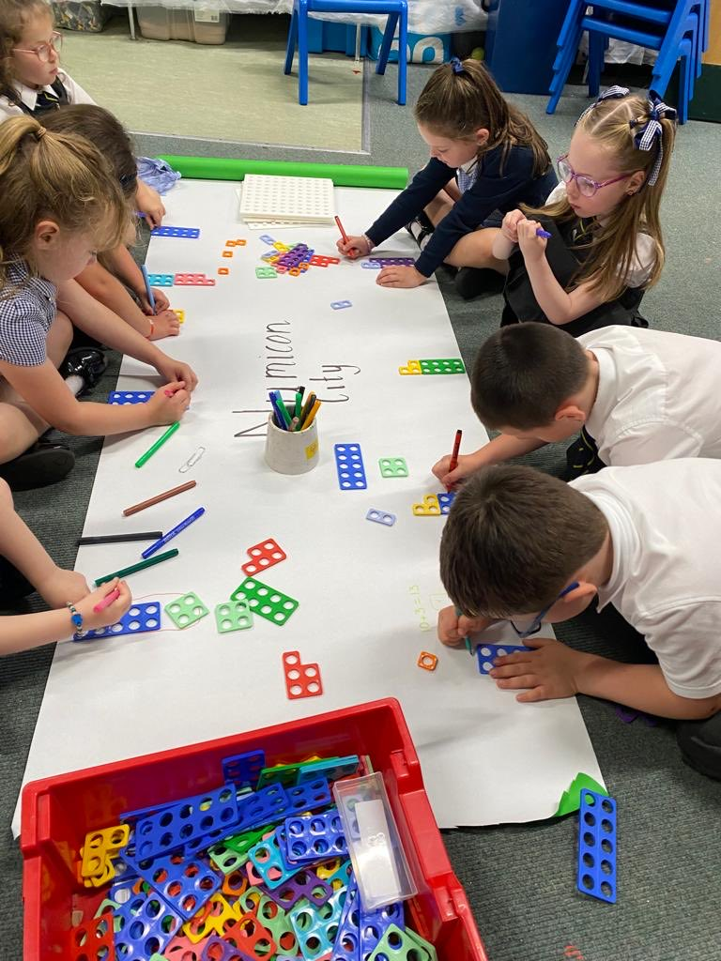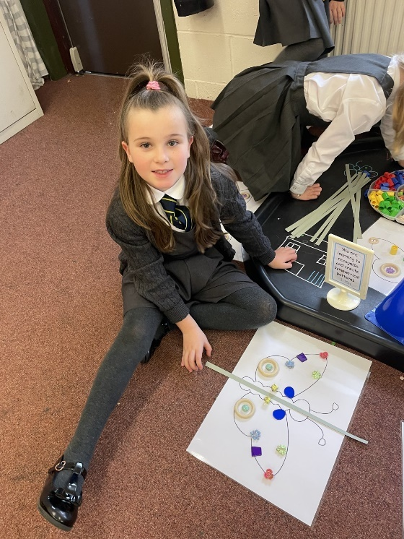

SOCIAL STUDIES

“To broaden their understanding of the world by learning about human activities and achievements in the past and present, political, social and environmental issues and the values underpinning their own society and other societies.”
Curriculum for Excellence May 2009

Pupils’ learning experiences take place within three elements:
- People, past events and societies
- People, place and environment
- People in society, economy and business

There is a variety of social study topics at each stage but pupils will also have the opportunity to choose a topic that is of interest to them. To enhance their learning, all classes are involved in outings to various locations in connection with the study of the environment. A number of visitors also come to the school to meet with pupils to discuss various aspects of their studies.
Where possible, social subjects are integrated into Interdisciplinary Learning blocks where connections are made with other curricular areas. This allows for breadth, depth and application of learning and skills in a meaningful and relevant way.

SCIENCES

“The sciences curriculum area within Curriculum for Excellence has to meet some significant challenges. While every child and young person needs to develop a secure understanding of important scientific concepts, their experience of the sciences in school must develop a lifelong interest in science and its applications.”
Curriculum for Excellence May 2009
The science outcomes have been developed into seven areas:

Planet Earth Energy in the Environment Communication
Forces and Motion Life and Cells Materials Topical Science

The science outcomes are designed to stimulate children’s interest and motivation, and to support staff in planning challenging, engaging and enjoyable learning and teaching activities including active learning, problem solving and scientific enquiry and the use of technology with much more emphasis on children explaining their understanding of concepts.

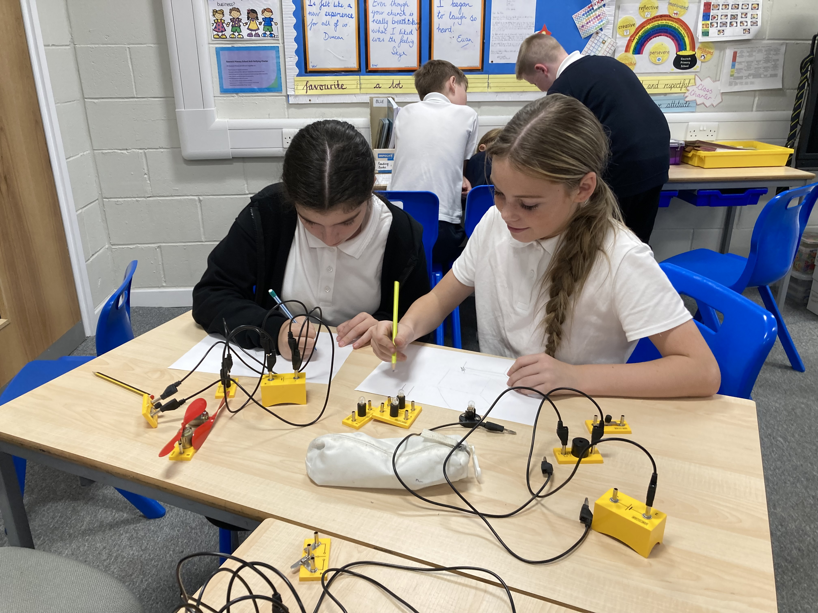

TECHNOLOGIES
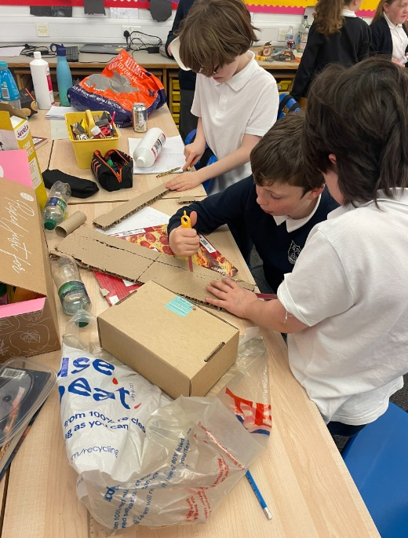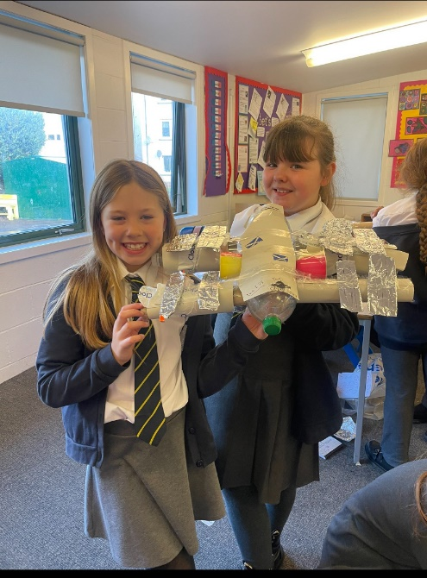

“Within Curriculum for Excellence, the technologies curriculum relates particularly to contexts that provide scope for developing technological skills, knowledge, understanding and attributes through creative, practical and work related activities.”
Curriculum for Excellence 2009

Children can develop their creativity and entrepreneurial skills and be encouraged to become innovative and critical designers of the future.

INFORMATION & COMMUNICATION TECHNOLOGY (ICT)

Being skilled in using ICT is essential if children and young people are to be effective contributors, and to communicate and interact on a global scale.

The school has a mobile charging trolley which holds 30 laptops and all our classrooms have computers and interactive whiteboards.

GLOW

Glow is the world’s first national intranet for education, developed exclusively for Scotland’s educational community. What Glow Provides:
- a trusted and safe environment for pupils, practitioners and parents
- a variety of online tools to enhance learning experiences
- virtual learning to share information and take part in a lesson
- opportunities to engage and immerse young people in powerful and relevant learning experiences
- motivation and support for individualised learning, personalisation and choice

RELIGIOUS AND MORAL EDUCATION

“To develop a knowledge and understanding of Christianity and other world religions and to recognise religion as an important expression of human experiences and to explore moral values such as wisdom, justice, compassion and integrity.”
Curriculum for Excellence May 2009

Each class receives religious education and full details are available from the school. Ordinarily, Church Services are held in Old Gourock and Ashton Parish Church at Christmas, Easter and at the end of the school session.

Parents have the right to withdraw their child from religious education and observances. Any parent wishing to exercise this right should contact the Head Teacher.

Parents from ethnic minority religious communities may request that their children be permitted to be absent from school in order to celebrate recognised religious events. Appropriate requests will be granted on not more than three occasions in any one school session and the pupil noted as an authorised absentee in the register.

HEALTH & WELLBEING

Learning in Health and Wellbeing ensures that children and young people develop the knowledge and understanding, skills, capabilities and attributes which they need for mental, emotional, social and physical wellbeing now and in the future.”
Curriculum for Excellence May 2009

Everyone within our school community, shares the responsibility for creating a positive ethos and climate of respect and trust - one in which everyone makes a positive contribution to the wellbeing of each child and adult within our school and the wider community. Our pupils should feel happy, safe, respected and included in the school environment and all staff should be proactive in promoting positive behaviour in the classroom, playground and the wider school community. Certain aspects of health and wellbeing will be taught through focused programmes such as our personal and social education programme which includes our Anti-Bullying Programme. Other aspects such as Substance Misuse may be taught in partnership with other agencies.

Sex and Relationship education is an integral part of a school’s Health Education programme. It focuses on the physical, emotional, moral and spiritual development of all children. Teachers are central to the delivery of sex education from P1 – 7 and work in partnership with parents and appropriate health professionals.

Parents will be fully informed and consulted on the content and purpose of sex and relationship education in schools, and have the opportunity to raise concerns with school staff. On an occasion where a parent wishes to exercise the right to withdraw his/her child from sex and relationship education they discuss their concerns and alternative arrangements with school staff (as per Inverclyde Council’s Policy ‘Sexual Health and Relationship Education’).

PHYSICAL EDUCATION

P.E. in the curriculum is a valued and important part of the child’s development. All children now receive two hours of quality PE. Our Active Schools Co-ordinator Craig Mullan supports the school in organising and delivering a wide range of sports.

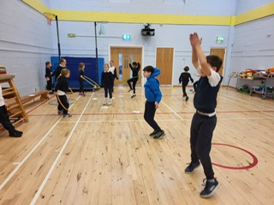

As part of their curriculum, P4 pupils have swimming lessons at the Waterfront. We
actively promote ‘Outdoor Learning’ as being outside brings many health benefits including increased physical activity, and improves emotional wellbeing and mental health. We would strongly ask parents to support us in delivering our PE lessons. Please encourage your child to come to school dressed in ‘relaxed’ uniform on their PE days. Classes will be notified of their PE days at the beginning of the year and these days will be highlighted on our website.

Please note that the wearing of jewellery, including pierced earrings, in P.E. is not permitted.

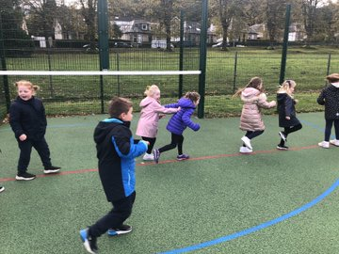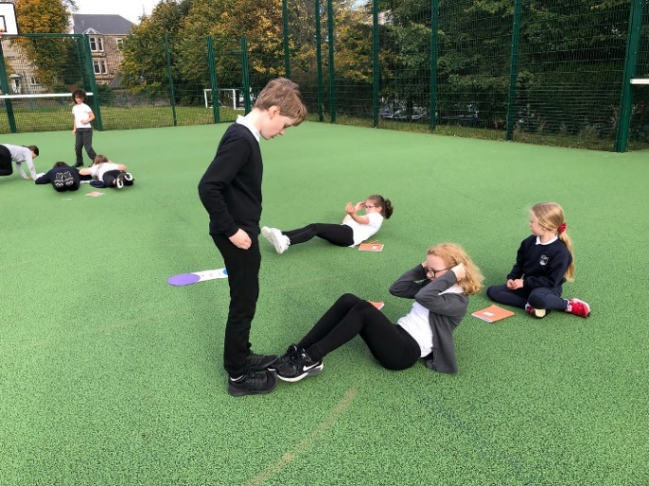

CYCLING

Each year P6 pupils are given the opportunity to take part in the Bikeability programme. Pupils who complete the Bikeability programme are encouraged where possible to cycle to school. We would ask that other pupils who choose to cycle/scoot to school are supervised by a responsible adult.

EXPRESSIVE ARTS

Expressive Arts covers the subjects:-

Art and Design Dance Drama Music

Learning in, through and about the expressive arts enables children and young people to:
- express themselves in different ways and be creative
- experience enjoyment
- develop important skills specific to the expressive arts and also other transferable skills
- develop an appreciation of aesthetic and cultural values, identities and ideas
- for some, prepare for advanced learning and future careers by building foundations for excellence in the expressive arts.

ART & DESIGN

Art plays a major role in the education of the pupils and also greatly enhances the appearance of the school. Pupils have a tremendous sense of pride when their creative work is displayed.

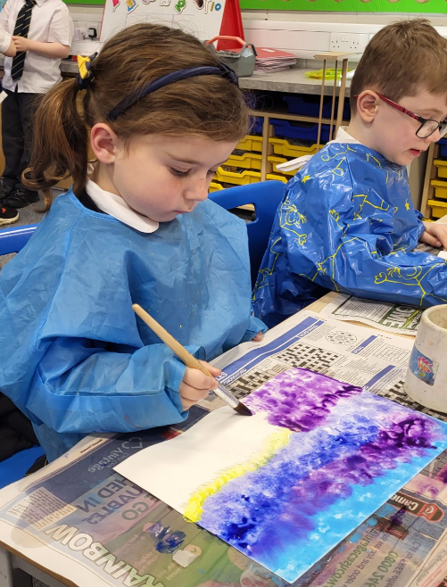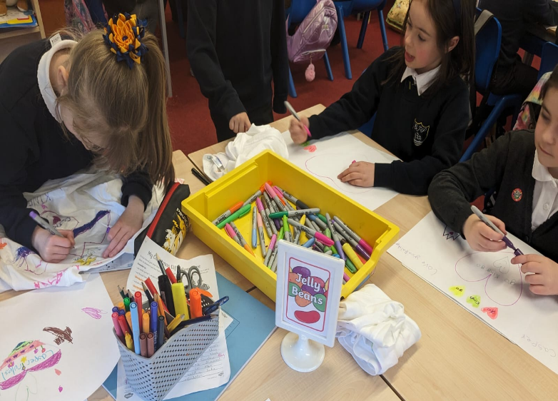

DRAMA

This is taught in a variety of ways by the class teacher. The drama lesson is often related to topic work using techniques such as role-playing or an imaginative play.
Pupils also perform at assemblies, class shows and whole school productions.

DANCE

Through dance, children explore movement and rhythm and performance skills.
Occasionally, we have the opportunity to work with professional arts companies.
Primary Seven pupils learn Scottish dances in preparation for their annual Burns Supper.

MUSIC

Pupils have many musical experiences in class and some stages are assisted to prepare for the Inverclyde Music Festival.
Inverclyde Music services provide tutors who visit all schools regularly and develop musical talents and skills in general.

VOCAL TUITION

Senior pupils and our school choir are taught vocal tuition from Mrs Polly Beck who visits the school weekly.
CHOIR

Our school choir is supported by Mrs Polly Beck and Depute Head Teacher. Our choir performs at church services and various community events throughout the year.

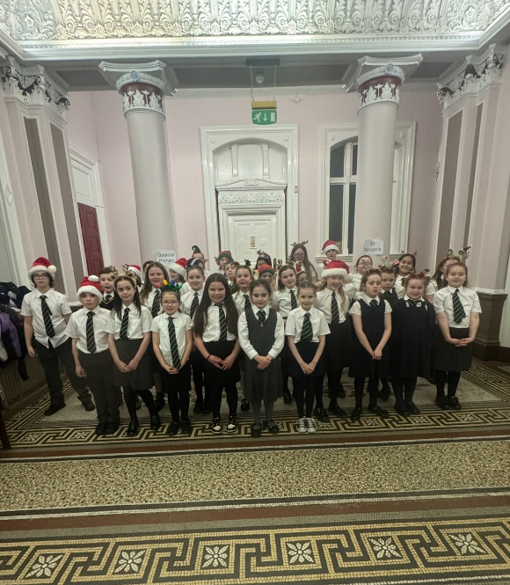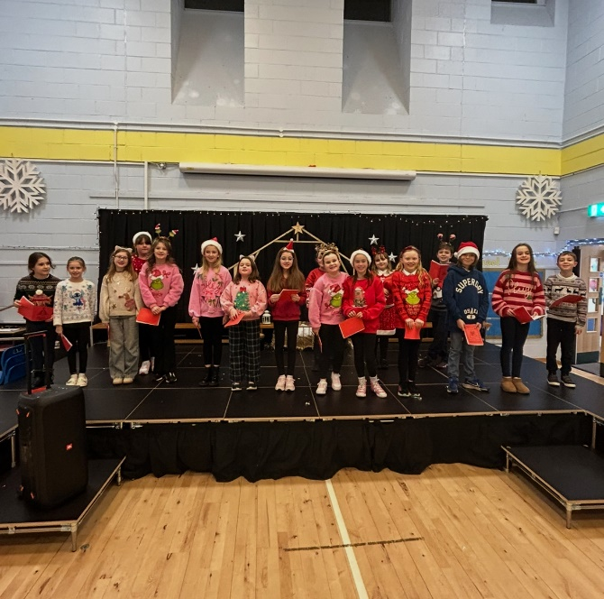

BRASS TUITION

Also during the school day a woodwind, a brass and a violin instructor visits the school for one half day each week. Pupils are tested at P4 (violin) and P6 (woodwind and brass) and, if accepted for lessons, will receive tuition until they leave the school if the parents agree to purchase an instrument after a trial period of one session. There is no charge for lessons.

ACTIVE LEARNING/COOPERATIVE LEARNING

In Gourock Primary School we actively embrace the principles within Curriculum for Excellence. In planning stimulating and motivating activities for our pupils, we actively seek out links within and across a variety of curricular areas, particularly Literacy and Numeracy, providing meaningful contexts for Active Learning and Cooperative Learning approaches and Interdisciplinary Learning which are key features of learning in our school. Our pupils also have access to a variety of ICT equipment, which supports their learning across all curricular areas. Teachers plan all kinds of meaningful, challenging tasks for pupils, taking into account prior learning. Pupils may work individually, in pairs or in groups. Often many curricular areas and activities are linked to ‘topic work’
e.g. Technology and Science tasks are incorporated into a ‘Health and Wellbeing’ topic.

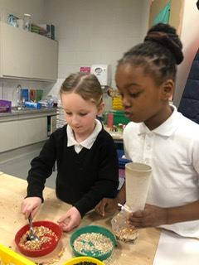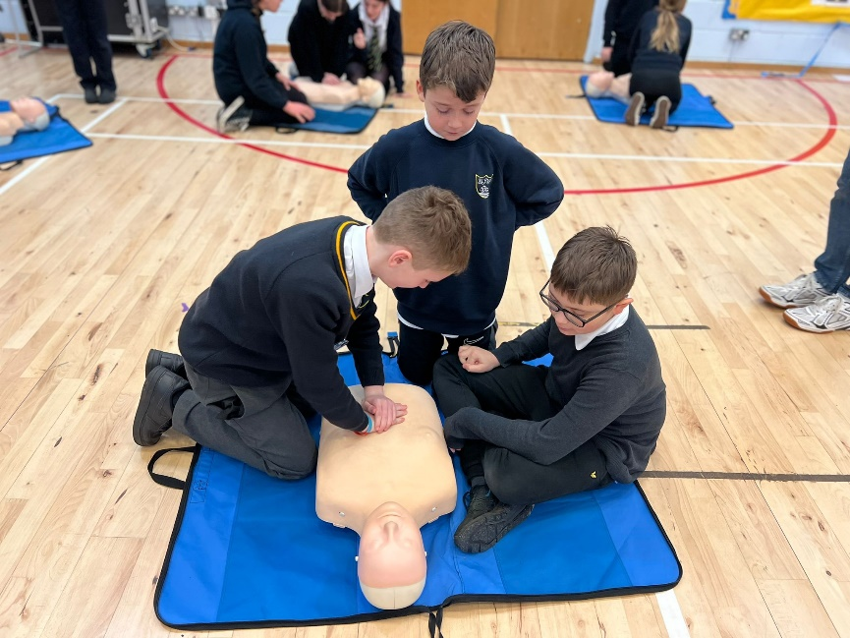

HOME LEARNING

In the early stages, home learning is mainly reading, phonics, spelling and number. Home learning from P3 onwards can consist of reading, composing sentences (using words learned in spelling) or practice of mathematics.

Encouragement is also given to pupils to use their initiative to find out more about topics arising in the class, and parents can help considerably by being prepared to discuss their child’s learning. Home learning may take up to 30 minutes – depending on the stage.

The school is now increasingly making use of the GLOW Teams online platform to develop home learning and all teachers now upload homework assignments weekly online. Pupils are invited to upload completed tasks online where feedback can be given.

We strongly encourage parental engagement between school and home as research shows that parental support with learning can make a significant impact upon a child’s life choices.

We therefore warmly welcome parents to become involved with their child’s learning and we help support communication in this regard through the use of the child’s GLOW Team or parents are also welcome to contact the school at any time to discuss their child’s learning progress

ASSESSMENT

Assessment is an important part of learning and teaching. Your child's work and progress will continually be assessed by the class teacher throughout the year. Your child's teacher is constantly observing his/her progress attitudes, conduct, health and emotional and social development. If at any time any of these aspects give the school reason for concern you will be contacted by the Head Teacher to discuss support, strategies/resources to help your child continue to make progress.
Pupil progress is monitored and tracked regularly throughout the year based on both formative and summative (formal) assessments.
Furthermore, pupils work with teachers to set their own learning targets in Literacy, Numeracy and Health and Wellbeing and these targets are reported upon and shared with parents on a termly basis.

FORMATIVE ASSESSMENT

Formative Assessment is assessment for learning which involves both the teacher and the pupil working together to improve the learning that takes place. It involves:-
- sharing the learning intentions (the aim of the lesson eg: We are learning to add fractions)
- quality feedback from teachers (progress made and next steps for the pupil to move on in their learning)
- self and peer assessment (the pupil assesses him/herself and they also assess each other)
- questioning (the teacher uses open ended questions to encourage deeper thinking)
Research has shown that these kinds of assessment activities, where there is a genuine partnership in the learning and teaching process, not only raises attainment but also raises motivation and self-esteem.

PUPIL INVOLVEMENT/PUPIL VOICE

Curriculum for Excellence promotes pupil involvement and pupil voice to support the children in developing the knowledge and skills required to be citizens of the 21st century. Through a range of activities on a daily basis the children have the opportunity to develop these necessary skills for life, learning and work.

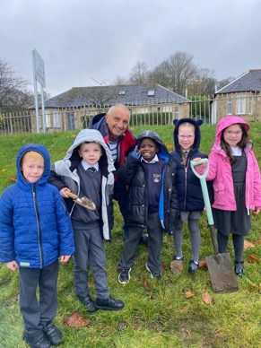

At Gourock Primary the children also develop leadership skills to help them realise their potential and build their confidence. This is supported through the various groups which are led by the children; Pupil Leadership Group, Funky 5, Building Racial Literacy, ECO, Rights Respecting Group, J.R.S.O (Junior Road Safety Officers), Gardening Group, House Captains, Vice House Captains, Buddies, Monitors and Playground Pals.

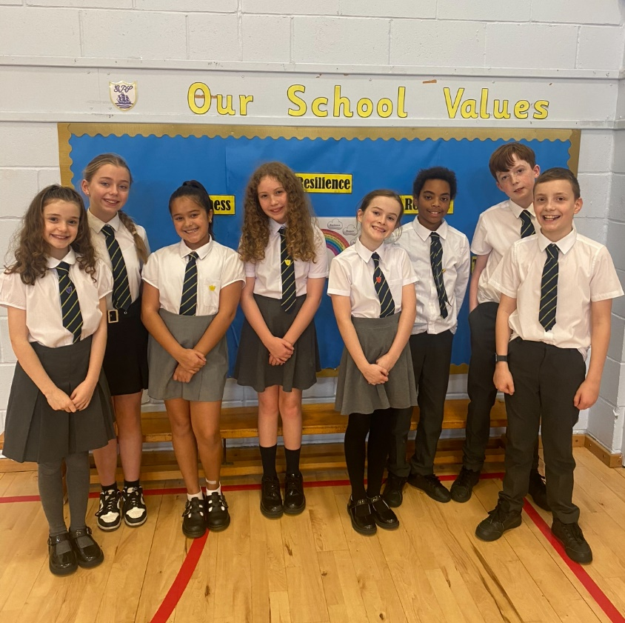
EXTRA CURRICULAR ACTIVITIES

A range of activities is offered throughout the year from school staff and Active School Coordinators such as:-
NETBALL DRAMA ART GYMNASTICS DANCE
FOOTBALL ATHLETICS CROSS COUNTRY
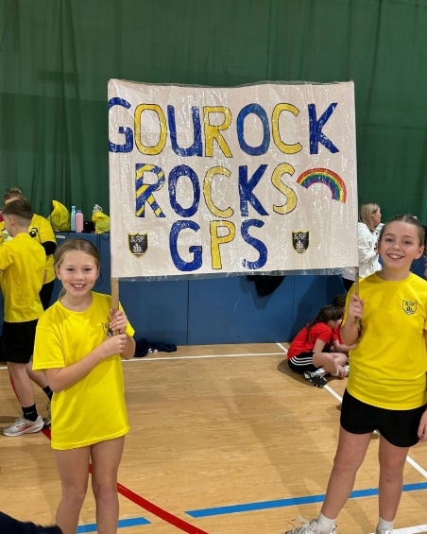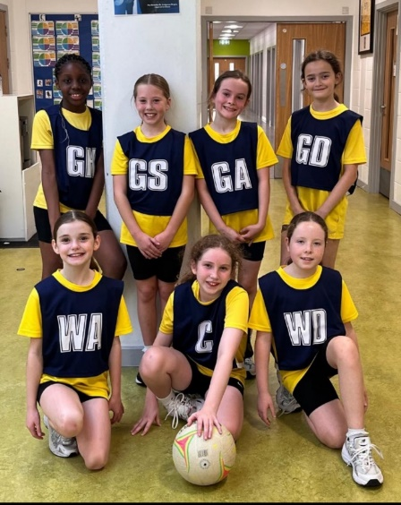

SUPPORT FOR PUPILS

THE ADDITIONAL SUPPORT FOR LEARNING ACT (SCOTLAND) 2009

As with all local authority schools in Scotland, Gourock Primary School operates under the terms of the ‘Additional Support for Learning Act (2009) and its accompanying Code of practice. These procedures have been strengthened through the ‘Children and Young people Act (2014).

Any parent with a concern about their child’s learning may contact the school at any time via email or phone.

Our Depute Head Teacher is responsible for the remit of Additional Support Needs and she will coordinate the appropriate actions, should a concern arise.

Every teacher has a responsibility to support the learning of all pupils in their class. The type of support offered will vary according to the needs of pupils. This includes consideration given to children who have a disability, children with social, emotional and behavioural difficulties, children with learning difficulties of a specific or general nature, children who are exceptionally able, those who demonstrate underachievement relating to gender issues, children whose learning has been interrupted through absence or illness, bilingual children who have English as an additional language, travelling children and those children whose family circumstances impact on attendance and learning.

A child or young person’s needs are identified at the earliest possible stage and can be met in a number of ways, for example by adaptations to the curriculum or learning environment, as well as input from the Support for Learning Teacher and, on occasion, support from visiting specialists. The appropriateness of the support is determined through a process of assessment, planning and monitoring, working jointly with parents and carers, and is regularly reviewed.

Learning outcomes for children and young people with additional support needs are set out in a plan and all educational establishments hold regular review meetings with parents and carers to determine needs and the most appropriate supports. Everyone’s views are equally important in order to consider what is currently working and how to determine next steps. Children and young person’s needs are identified in a number of ways, and the process of assessment is ongoing, shared process with partnerships with parents and carers at the forefront. On some occasions health service staff or other partner agencies make children known to Education Services. Other additional

support needs may be notified to Education Services by parents themselves or identified by one of a range of staff working closely with the child.

Some children and young people will have additional support needs arising from complex or multiple factors which require a high degree of co-ordination of support from both education and other agencies in order that their needs can be met. In these cases, the school will hold a meeting to decide whether the child or young person meets the criteria for a co-ordinated support plan. The coordinated support plan is a statutory document which ensures regular monitoring and review for those children and young people who have one. If your child does not wish to attend meetings or feels unable to, their views must still be sought and considered.

You have the right to ask the education authority to establish whether your child needs a coordinated support plan.

Inverclyde’s Mediation Service can be accessed by contacting Mr Michael Roach, Head of Education at the address below.

For further advice please telephone Education Services on 01475 712850, or write to:-
Education Services
Wallace Place
Greenock PA15 1 JB

Organisations specified by Scottish Ministers which provide advice, further information and support to parents of children and young people with ASN (Additional Support Needs). These organisations are identified under The Additional Support for Learning (Sources of Information) (Scotland) Amendment Order 2011 as:

(a) Children in Scotland: Working for Children and Their Families, trading as
“Enquire – the Scottish advice and information service for additional support
for learning”, a charitable body registered in Scotland under registration
number SC003527;
(b) Scottish Independent Advocacy Alliance, a charitable body registered in
Scotland under registration number SC033576; and

(c) Scottish Child Law Centre, a charitable body registered in Scotland under registration number SCO12741.”

www.enquire.org.uk www.sclc.org.uk www.siaa.org.uk

Further information on school and authority policies can be found on OUR school website, Inverclyde Authority website or by contacting the school directly.

Inverclyde Educational Psychology Service

We have a strong partnership with our Educational Psychology Service which aims to improve the wellbeing and education of children and young people through the application of psychology in practice.

We do this by:

- providing training and coaching to educational staff with the goal of optimising the inclusion of all children and young people.
- using the latest research evidence in psychology to advise and consult with others. This helps to assess and plan for children and young people with Additional Support Needs.
- working with others to seek solutions that build on the existing strengths of children and families.
- ensuring that children and young people’s views are heard and included in any planning.

There are many more roles of the Educational Psychologist, you may find these on our website https://www.inverclyde.gov.uk/education-and-learning/inverclyde-educational-psychology-service.

ARRANGEMENTS FOR REPORTING TO PARENTS

The school holds a ‘Meet the Teacher’ event early in the first term and an Informal Parent’s evening in October. Parents are invited to attend and look at their child’s learning displayed on walls and in jotters and learning logs. Parents receive termly information about their child’s targets and progress and parents will be invited to comment on this progress.

During the third term, you will have a formal appointment with your child’s class teacher to discuss their learning. However, parents who are concerned at any time throughout the year are encouraged to telephone the school and make an appointment with the class teacher or Head Teacher to discuss your concerns.

MEDICAL AND HEALTH CARE

All immunisations and medicals must have parental consent. Here is a list of normal routine health checks:

P1 (five year olds) - Preparation for medicals: height and weight.

P2 (six year olds) - Audiometrician sweep (test of hearing).

P7 (eleven year olds) - Routine eyesight check.

The Dentist visits the school annually to inspect the pupil’s teeth. You will be informed of the date they will attend and have the right to decline the inspection. The Dentist will inform you if your child requires any dental treatment.

It is important that the school is informed of any particular medical requirement concerning a pupil. Before a member of the school staff can administer medicine, the parent must complete a form which is available at the school office.

When a child becomes ill or has an accident in the school the parent or emergency contact named by the parent will be contacted and, if necessary, arrangements will be made to have the child transported home or to hospital. It is important that the school is kept informed of changes of parents’ workplace(s) or emergency contact.

CHILD PROTECTION IN INVERCLYDE

Inverclyde Council Education Services has Child Protection Guidelines and Procedures which all schools are required to follow. Education Services work very closely with other agencies namely Strathclyde Police, Social Work Services, NHS Greater Glasgow and Clyde and the Children’s Reporter to support children. Common responsibilities of all staff are to protect children from abuse and exploitation, to respond appropriately when abuse is identified, and to ensure whenever possible that all children are able to exercise their right to be raised in a warm, stimulating and safe environment with the support of staff, their families and carers.

PARENT FORUM AND PARENTS IN PARTNERSHIP

Scottish Schools (Parental Involvement) Act 2006 led to the establishment of Parent Councils in all schools. The Act recognises the vital role that parents play in supporting their children’s learning. It places a duty on authorities to promote involvement of parents in children’s education and the wider life of the school. It aims to help parents to be:-

- involved with their child’s education and learning
- welcomed as an active participant in the life of the school
- encouraged to express their views on school education generally

Our Parent Council is called our Parents in Partnership group (PIP). We hope you will attend the arranged events that provide an opportunity to meet other parents and members of staff. The PIP meet regularly and report on their activities to all parents. It is important that you give the group your support and show interest in their involvement in the life and work of the school.

All parents who have a child attending the school are automatically members of the Parent Forum for our school. Membership of the forum allows parents to have a say in the local arrangements to enable their collective view to be represented on matters such as the quality and standards of education at the school and other matters of interest to parents. These views can be represented, as appropriate, to the Head Teacher of the school, the Council and HMIe.

Our PIP Chairperson is Mrs Lorna Bryceland.

The Head Teacher and the local Councillor may attend all meetings and have the right to speak although no right to vote.

Bookbug

Bookbug is Scotland's universal early years book gifting programme which supports families to read, sing, and play with their little ones from birth to give them the best start in life. Starting school is an exciting and challenging time for your child and your support at home makes a real difference to their learning. Look out for your Bookbug Primary 1 Family Bag, a free bag of books and activities your child will receive at school in November from Bookbug, to help support their reading, writing and counting skills. You will find films of the books being read aloud and more information about the P1 Bag here.

Read Write Count

Read Write Count with the First Minister is a National gifting programme, aiming to build parents' confidence and encourage families to include easy and fun reading, writing and counting activities in their everyday lives. Every Primary 2 and Primary 3 child in Scotland will receive a free bag with books, educational games and writing materials to be gifted during Book Week Scotland, in November. Resources for schools and extra activities for families to use at home can be found here.

Parentzone Scotland

Parentzone Scotland is a unique website for parents and carers in Scotland, from early years to beyond school. The website provides up-to-date information about learning in Scotland, and practical advice and ideas to support children’s learning at home in literacy, numeracy, health and wellbeing and science. Information is also available on Parentzone Scotland regarding additional support needs, how parents can get involved in their child’s school and education. Parentzone Scotland also has details about schools, including performance data for school leavers from S4-S6 and links to the national, local authority and school level data on the achievement of Curriculum for Excellence levels.

SCHOOL IMPROVEMENT

Please see below a summary of our school priorities. You will find a copy of our School Improvement Plan and Standards & Quality Report on our school website:

https://blogs.glowscotland.org.uk/in/gourockps/

Here you will find information about our school achievements, attainment statistics/trends and school priorities to ensure improved outcomes for our learners.
Our plans for the next three years are described here including how we aim to involve our parents in the process.

Our Standard’s & Quality Report also has details of our main achievements over the past 12 months.

Key Priorities from our School Improvement Plan

In Gourock Primary, we strive to provide the highest quality learning and teaching experiences to ensure that all children care about the world they live in and learn and develop the full range of skills to be citizens of the 21st century. We aim to help our pupils become independent learners, be creative, healthy and develop a positive attitude to life. The School’s learning philosophy rests on the key vision principles of Building Learning Capacity, Collaborating and Making Meaning.

Developing each learner holistically is critical in creating curious individuals who think and relate well to others. Therefore to deliver excellence in learning and teaching within the challenges of the 21st century, Curriculum for Excellence is at the centre of everything we do.

A Gourock Primary Learner Perseveres, is Engaged, Motivated, Creative, Responsible and Effective. These learning dispositions are routinely developed in all of our pupils and celebrated regularly.

The strategic priorities and key messages from our school improvement plan are:

Gourock Primary School is committed to delivering on its core business of learning. We are committed to building the necessary knowledge and competencies for pupils to thrive and succeed in learning and life.
Attainment Challenge Funding has focused on raising attainment in literacy and numeracy across the school including those pupils who may be disadvantaged as a result of the poverty related attainment gap.
We strongly view parents as our partners and regularly involve them in our future improvement plans through surveys, focus groups and regular communications.
We welcome and encourage feedback related to our priorities and practice at all times.

IMPORTANT ADDRESSES

Education, Communities & Ms Ruth Binks
Organisational Development Director
Local Councillors Mr Ian Hellyer
Mrs Lynne Quinn
Mrs Sandra Reynolds

Municipal Buildings, Greenock

For any further information related to Education and Learning, including Inverclyde Council policies, please refer to the council website:

https://www.inverclyde.gov.uk/education-and-learning

General Data Protection Regulations and Data Protection Act 2018

Information on children, parents and guardian is stored on a computer system and may be used for teaching, registration, assessment and other administrative duties. In processing personal information, Inverclyde Council must comply with the General Data Protection Regulation and Data Protection Act 2018.

For further information please refer to:

https://www.inverclyde.gov.uk/site-basics/privacy

Although this information is correct at time of presenting, there could be changes affecting any of the matters dealt with in the document:-

- Before the commencement or during the course of the school year in question.
- In relation to subsequent school years.

Please check our school website or contact the school should further information be needed.

