Gourock Primary School  Standards and Quality Report  Session 2022 to 2023 | 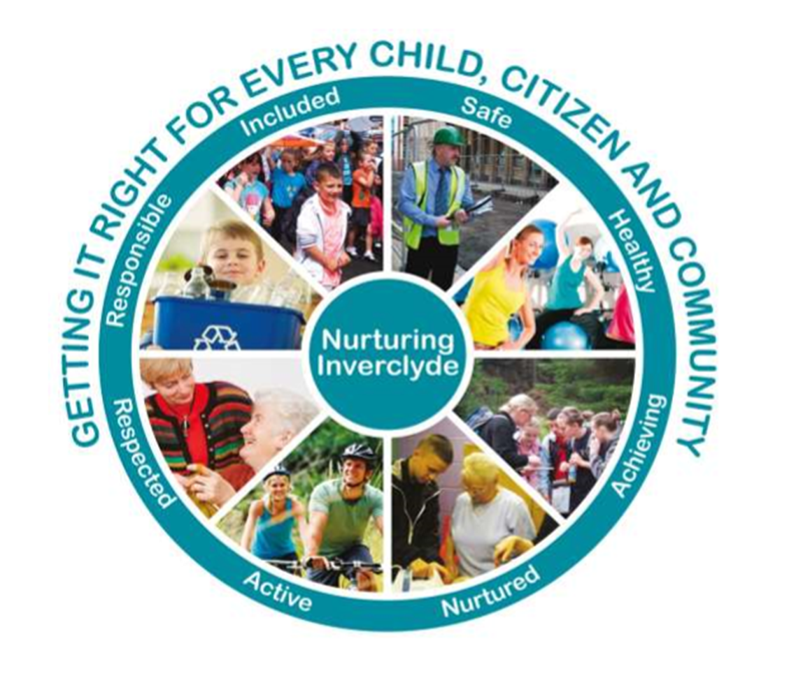
Context of the Establishment:

Our Establishment

Gourock Primary is a non-denominational school situated in the heart of Gourock and is part of the Clydeview Cluster.
The school has recently benefitted from a refurbishment to provide additional space which enhances our quality learning environment.
In the session 2022/23 we had a roll of 218 pupils over 9 classes.
The staffing complement within Gourock Primary School was 12.4 members of teaching staff which included the Head Teacher, Depute Head Teacher, 10 full-time teachers 2 part-time teachers, 1 newly qualified teacher and 1 part time ‘Recovery’ teacher. The school was supported by 7 Pupil Support Assistants – 4 of whom were part-time, 2 clerical staff, 1 of whom is full time and one part time and a janitor
Currently, school attendance is on average 94.6% which is above the local and national average.

Vision

In Gourock Primary, we aim to deliver excellence in learning and teaching within the challenges of the 21st century.
We strive to provide the highest quality learning and teaching experiences to ensure that all children care about the world they live in and learn and develop the full range of skills to be responsible citizens of the future. We believe that developing each learner holistically is critical in creating curious individuals who think and relate well to others.
A Gourock Primary Learner is ambitious, perseveres, engaged, motivated, creative, responsible and resilient.

Our Values

Respect Resilience Kindness Honesty Tolerance

Children, staff and parents have an excellent understanding of the school’s values which reflect the principles on which we base all our decisions and use them to influence day-to-day practice.

Our Aims:
- To provide a nurturing environment for all pupils to feel safe, healthy, achieving, nurtured, active, respected, responsible and included.
- To provide a curriculum which is challenging, has breadth, depth, relevance and coherence and one which is fun and enjoyable.
- To work together with parents and partners to provide high quality learning experiences for all pupils to achieve and attain.
- To encourage effective contributors with enterprising attitudes, resilience and independent skills capable of positively impacting on the communities in which they live.
- To provide a stimulating environment and opportunities for staff and pupils in leadership and teamwork. Gourock Primary School is committed to delivering on its core business of 'learning' and is thrilled with the achievement gains to date.
- To build the necessary knowledge and competencies for pupils to thrive and succeed in learning and life.

Establishment priority 1:
NIF Priority  Improvements in attainment, particularly in literacy and numeracy  ​​-​​-​  NIF Driver  Teacher professionalism  Performance information  ​​ | HGIOS/ELC QIs  3.2 Raising attainment and achievement  3.2 Securing Children's Progress  UNCRC  Article 28: (Right to education):  Article 3 (Best interests of the child):
Outcomes:
By June 2023, an identified group of learners impacted by poverty across the school will raise attainment in writing by 10%
By June 2023, the majority of pupils will be appropriately challenged in numeracy during all lessons.
By June 2023, an identified group of learners across the school will increase fluency in reading by 10%

PEF (Pupil Equity Fund) used to support closing the gap:
Pupil Support Assistants - £30,299 supporting pupils in class with writing skills

Progress and impact of outcomes for learners:

Having received effective training, PEF funded PSAs (Pupils Support Assistants) supported identified pupils with writing. This allowed individual pupils and small groups to successfully reinforce writing skills in a more focussed way. Further additional effective training of all PSAs and teaching staff has resulted in all staff demonstrating an improved understanding and capability to successfully deliver regular interventions to our identified pupils such as using SEAL approaches (Stages of Early Arithmetical Learning). This, along with high quality teaching and learning by classroom teachers, has resulted in raising attainment in the following:

The majority (55%) of an identified group of learners across the school has raised attainment in writing and are now ‘on track’. This significantly exceeds our initial target of raising attainment by 10%.
Whilst challenge in numeracy has been a point for discussion during staff training sessions, staff acknowledge that this remains a focus for further development next session.
An identified group of learners have improved reading fluency by 12%.
It must be noted that across the upper school stages there has been an incremental dip in attainment in Numeracy/maths therefore this will be a focus in next year’s improvement plan.
Next steps:
- To plan for the upskilling of all staff to deliver improved outcomes in numeracy and maths across the school.
- To continue to develop challenge in Numeracy consistently across the school.
- To continue to build upon the success of the reading fluency project.

Establishment priority 2:
NIF Priority  Closing the attainment gap between the most and least disadvantaged children and young people  ​​  ​​  NIF Driver  Assessment of children's progress  Teacher professionalism  Performance information | HGIOS/ELC QIs  3.2 Raising attainment and achievement  3.2 Securing Children's Progress  ​​  UNCRC  Article 28: (Right to education):  Article 3 (Best interests of the child):
Outcomes:
- To increase the percentage of an identified group of pupils impacted by poverty making expected progress in Numeracy by 10% by June 2023.
- Raise attainment by 5% in a targeted group of pupils impacted by poverty across CfE (Curriculum for Excellence) First and Second Level Numeracy by June 2022
- Raise attainment in reading comprehension by 10% of a targeted group of Second Level CfE pupils impacted by poverty by June 2022
- Raise attainment in writing by 10% of a targeted group of pupils across P3, 4, 5 and 7 impacted by poverty by June 2023.
- Raise attainment to beyond expectation of 10% of a targeted group of pupils impacted by poverty in P4 in writing by June 2023.
- Data will show an increase in wellbeing (to a positive from their baseline) of identified pupils impacted by poverty who have benefitted from a quality Outdoor Learning experience by June 2023. This outcome will bear in mind the cost of the school day.
- By June 23, 90% of targeted learners impacted by poverty who are currently on track in numeracy will attain beyond expected levels in P2 to P7

PEF used to support closing the gap:

PSA (Pupils Support Assistants) x2 (£30,299) PSA (topping up current hours) – providing targeted support for identified pupils
Resources: Decodeable Reading books £250
Comprehension materials - £692 (First News) and TJ Literacy programme/assessment materials - £2544
Use of PSAs as above for daily one to one reading sessions.
Salford Reading Test Pack £110
Purchase of ‘Talk for Writing’ programme for all teachers:
- ‘Creating Story Tellers and Writers’ x 15 copies = £450
- Talk for Writing Across the Curriculum x 15 copies = £570

Cost of the School Day (£500) outcomes to be agreed by pupils

Progress and impact of outcomes for learners:
- Using PEF funding, we employed a supply teacher to facilitate effective training of PSAs and teachers in SEAL approaches to learning (Stages of Early Arithmetical Learning). All staff demonstrate improved capability and confidence to successfully deliver regular interventions to identified pupils.
- A range of data including regular assessments, jotter monitoring and teacher observations show that almost all of this group made a year’s progress across this session and 20% are now ‘on track’. However, at the time of writing, the majority of the group remains slightly below the recognised national standard for numeracy.
- PEF funds have allowed the introduction of a range of more engaging and relevant materials for reading comprehension. All pupils state that this has helped to further engage them with different reading genres and has made reading more fun. This has raised attainment across the identified group by 33%.
- The purchase and training in the ‘Talk for Writing’ programme (using PEF funds) has effectively further enhanced writing pedagogy, i.e., how to teach writing and has helped to raise attainment in writing of pupils disadvantaged by poverty by 36%. This exceeds our projected figure by 23%.
- By successfully using PEF funds to alleviate the cost of the school day and by sourcing quality learning provision, 100% of our identified group of pupils successfully engaged in quality outdoor learning opportunities and all stated improved wellbeing. Increased staff confidence has also allowed for regular outdoor learning opportunities, particularly in P6 and P7.
- Following regular input from ‘Lego Therapy’ by 2 trained PSAs (using PEF funding), 100% of an identified group state improved wellbeing.

Next steps:
- To continue to be rigorous and focussed with our interventions for writing and numeracy in particular.
- To continue to develop our outdoor learning provision for those impacted by poverty.
- To continue to focus on the small group of identified pupils who are not yet ‘on track’ in numeracy.
- To build upon our offer of regular ‘Lego Therapy’ sessions to pupils by sourcing further staff training.

Establishment priority 3:
NIF Priority  Priority 3 Improvement in children and young people's health and wellbeing  Priority 5 Placing the human rights and needs of every child and young person at the centre of education  ​​  ​​  NIF Driver  Assessment of children's progress  Teacher professionalism  Performance information  ​​ | HGIOS/ELC QIs  1.2 Leadership of learning  3.1 Ensuring wellbeing, equality, and inclusion  UNCRC  Article 28: (Right to education)  Article 3 (Best interests of the child)  ​​
Outcomes:
By June 2023, the number of stages using play pedagogy to increase pupils’ readiness to learn extended to P2, making more use of outdoors.

By June 2023, the majority of school community will have an enhanced understanding of the importance of wellbeing and how to apply proactive strategies for themselves.

No PEF spend is allocated to this priority.

Progress and impact of outcomes for learners:
- Observations, teacher planning, lesson evaluations and pupil feedback illustrate successful Play pedagogy approaches across both Primary 1 and Primary 2 stages.
- Increased pupil social interactions successfully demonstrate improved social skills, increased vocabulary and problem-solving skills and an increase in the number of pupils ready to engage in learning.
- All P1 and P2 teachers have successfully engaged in In Service training and have had several enlightening opportunities to visit other establishments to take part in collegiate discussion around play pedagogy and witness effective approaches to play. All staff state the beneficial outcomes of these visits allowing them to further refine their playful approaches to learning and teaching from which all pupils have benefitted.
- Focussed, termly tracking meetings with teachers indicate progress for most learners across Primary 1 and Primary 2 stages.
- Successful ‘Stay and Play’ sessions were attended by almost all P1 parents.
- All parents who attended the ‘Stay and Play sessions viewed the experience as being highly positive in building relationships with the school and in their understanding of the benefits of play for their child’s learning and wellbeing.
- Whilst the importance of wellbeing has been addressed across all classes within the school curriculum, the whole school project of 5 Steps to Wellbeing has not been fully or successfully addressed.
Next steps:
- To further develop a playful approach to both indoor and outdoor learning experiences across P1-3.
- To offer parental workshops to assist parents and carers to provide more playful learning experiences for their child. (Family Learning)
- To upskill all staff in the use of Trauma Informed Practice

Establishment priority 4:
NIF Priority  Improvement in employability skills and sustained positive school leaver destinations for all young people  ​​-​​-​  NIF Driver  Assessment of children's progress  Teacher professionalism  Performance information  Parental Engagement | HGIOS/ELC QIs  3.2 Raising attainment and achievement  2.7 Partnerships  3.3 Increasing creativity and employability  ​​Choose an item.​  ​​Choose an item.​  UNCRC  Article 28: (Right to education)
Outcomes:

By June 2023, all teachers will be further upskilled in delivering enhanced learning opportunities in digital technology for all pupils and will be more confident in doing so.
By June 2023, all learners will have dedicated access to a laptop for a minimum of two sessions per week.
By June 2023, all lessons for digital learning will be planned from new progressive planner ensuring a progression of digital skills for all learners.
By June 2023, pupils accessing online homework will have increased by 10%.
By June 23 use of digital tools will enhance learners’ experiences of the curriculum in from most to all classrooms.
By June 2023, all pupils will have an increased understanding of jobs in the technology sector through hearing from workers about their experiences.

No PEF spend was allocated to this priority.

Progress and impact of outcomes for learners:

- Dedicated teacher development sessions allowed for sharing/learning of enhanced learning approaches in digital skills.
- All teachers report increased confidence in the use and application of digital literacy skills to enhance learning experiences for all pupils.
- Using the new digital planner with its inbuilt links to support teachers has increased confidence of all staff to a more positive level.
- Following effective training by the school Digital Leader, the Digital Schools’ Pupil Group members were able to offer exciting training to all classes in coding.
- All teachers report an improved understanding of coding and have now been able to confidently offer enhanced learning opportunities to their pupils.
- All pupils report raised interest in digital lessons and observations by adults show increased engagement and motivation in all classes. These learning experiences are now offered more consistently due to the laptop timetable which ensures at least twice weekly access to a laptop for each pupil.
- Feedback from all staff regarding the piloting of the new Digital Skills planner has been very positive with teachers reporting a more focussed and progressive approach to the teaching of digital skills.
- Observations from Senior Leaders show increased staff confidence when teaching digital skills.
- Following effective training by our Learning Support teacher, all Additional Support Needs pupils (ASN) have access to digital tools which assist with writing tasks. This has improved confidence of all pupils involved when undertaking extended writing tasks.
- All classes, with the exception of Primary 1, successfully undertake homework tasks via their Glow Team. This use of Glow successfully utilises technology to support home learning.
- A few exceptions remain with accessing Glow teams where access at home is limited. In such cases, paper copies of homework are issued to pupils.
- Due to a change in priority during the second half of the year, our staff development focus had to be altered to allow for training of the ‘Circle Intervention’ support techniques. This impacted significantly on our ability to follow through on our plans to raise awareness of jobs in the technology sector. We plan to address this issue in next year’s School Improvement Plan.
Next steps:
- To increase understanding of jobs in the STEM (Science, Technology, Engineering and Mathematics) sector.
- To build upon the development of digital skills, particularly in the use of apps to further support learning.
- To refresh our approach to teaching SCIENCE across the school
- To embed the use of digital skills across the school.

Additional PEF Spend – EG Cost of the School Day
NIF Priority  Closing the attainment gap between the most and least disadvantaged children and young people | HGIOS QIs  ​​2.4 Personalised Support (Removal of Potential Barriers to Learning)  UNCRC  ​​Article 31 (The Right to Play)  ​​ ​
Spend: £500

Progress and impact of outcomes for learners:
PEF spending of £500 allowed us to offer ALL PUPILS in P7 DISADVANTAGED BY POVERTY to attend a residential Outdoor Learning course. We supplemented this amount with donated funds from our partner organisation (Gourock Schools and Churches) allowing a further group of children impacted by the current high cost of living. All pupils reported improved confidence and enhanced levels of wellbeing following the course.
Next Steps: Following survey with pupils, parents and staff, it has been agreed to continue to support pupils impacted by poverty to access quality learning opportunities outdoors.

Data
Interrogation of government statistics, indicate that Gourock Primary is performing above our
comparatives of pupils achieving the Curriculum for Excellence level relevant to their stage across Scotland and Inverclyde.
This is a positive and consistent picture of attainment.
Overall attainment performance exceeds the national and local average.
Our school priority is to maintain a strong performance across all curricular areas and monitor any variation between Reading, Listening and Talking, Writing and Numeracy.
Analysing data across the school highlights the need for our continued focus next year to be on writing and a renewed focus on maths/numeracy, particularly with our pupils impacted by poverty.

This year there has also been a focus on continued ‘Recovery’ i.e., giving additional support to those pupils who had fallen behind in their learning during the two pandemic lockdowns.
Our Recovery staff worked extremely hard to support the identified pupils across the school and we have evidence of all pupils having progressed.

We have a supportive and active staff, community and partnerships which are open, committed and willing to do whatever it takes to ensure that each learner is stretched and experiences fulfilment in learning. Attainment Challenge Funding has focussed on raising attainment in literacy, numeracy and health and wellbeing across the school including those pupils who may be disadvantaged as a result of the poverty related attainment gap.

We have used these teacher professional judgements in June 2023 to assist in planning for our interventions and support going forward in to 2022-2023 session.

The graph below illustrates overall attainment across the stages in June 2023:

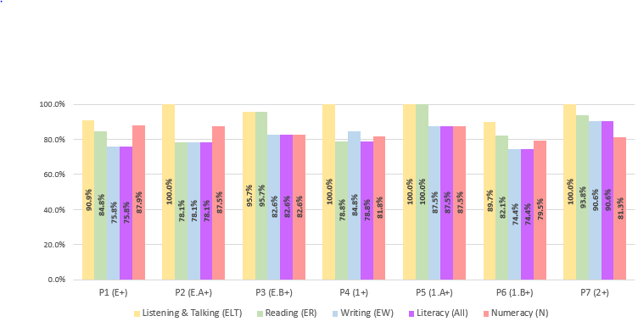

Key Strengths

- Our attendance remains consistently above the local and national average.
- There is evidence of an upward trend over time in raising attainment in Listening and Talking, Reading and Writing across most year groups.
- An increasing number of pupils are now working ‘beyond expectation’ across all curricular areas.
- Listening and Talking continues to be a strength across the school with almost all pupils reaching the national standard.
- This year, attainment in Listening and Talking has risen in P7, P6 and P5, been maintained at 100% in P4 and P2 with a slight dip in P3 and P1.
- Most pupils across the school are on track or beyond expectation in Reading attainment. Attainment in reading has risen in P7, P5, P3 and P1 and has remained at the same level at P6 stage. There has been a slight dip at P4 and P2 stages.
- Most pupils across the school are on track or beyond expectation in Writing attainment. Attainment in writing has risen in P7, P5, P3 and P1 and has stayed level at P6 stage. There has been a slight dip at P4 and P2 stages.
- Most pupils across the school are on track or beyond expectation in Numeracy attainment. However, there has been a slight dip at P7. P6, P5 and P4 whist rising at P3 and maintaining the same level at P2.

Key Priorities:

- To raise attainment in Numeracy across the school, in particular in the upper stages; this has been made a key focus in our school improvement plan.
- To build on progress of attainment in Writing and Reading.
- To further target pupils disadvantaged by poverty, particularly in Writing and Numeracy at P6 and P5 stages.

National Improvement Framework Quality Indicators
1.3 Leadership of change ​GOOD
Key Strengths

Developing a shared vision, values and aims relevant to the school and its community:

- All staff are committed to change and work together to make improvements for learners.

Strategic planning for continuous improvement:

- The pace of change is well managed to allow for improvements to be properly embedded.

Implementing improvement and change:

- Planned activities allow teachers to review and refresh their ways of teaching (pedagogy).

Key Priorities:

- To ensure consistently high expectations across the school.
- To refresh the shared vision of the school ensuring ambition for all pupils.
- To consider opportunities for creativity and innovation.
- To further develop pupil participation across the school to ensure effective change.

2.3 Learning, teaching and assessment ​GOOD​
Key Strengths

Learning and engagement:

- Positive and nurturing relationships across the school.

Quality of teaching:

- Consistent approach in the use of SEAL (Stages of Arithmetical Learning) and use of Active approaches to literacy as described in North Lanarkshire Programme.
- Improved consistency in teaching of writing and reading comprehension and fluency.
- Planning for pupil learning adheres to progressive pathways allowing for a differentiated approach to include support and challenge.

Effective Use of Assessment:

- A range of assessments are used to allow learners to show progress in skills, attributes and capabilities.
- Sound moderation practices planned across the session continue to ensure a shared understanding of standards.

Planning, tracking and monitoring:

- Effective timetable for tracking of progress ensures we have robust and useful information about our learners. Learners are part of this process and collaborate with teachers to plan learning targets.
- Effective targeted support for pupils with Additional Support needs.
- Impact of interventions are tracked and revised as appropriate.

Key Priorities

- Consider more opportunities for pupils to develop independent learning/leading their own learning.
- Continue to embed play pedagogy approaches in P1 and P2.
- Continue to consider and develop the consistent application of challenge for all.

3.1 Ensuring wellbeing, equity and inclusion ​GOOD​
Key Strengths:

Wellbeing

- All staff are well versed in GIRFEC (Getting It Right for Every Child) indicators and demonstrate a shared understanding of wellbeing and the rights of children and act accordingly to ensure children's rights are in place.
- The school updated Anti Bullying Charter (aligned with Inverclyde Anti – Bullying Charter) has raised pupil, staff and parent awareness of the importance of tackling bullying behaviour as soon as it becomes evident.

Fulfilment of Statutory Duties

- The whole school community has a shared understanding of wellbeing and children’s rights.
- All staff and partners are sensitive and responsive to the wellbeing of all our pupils.

Inclusion and Equality

- Effective tracking of pupils’ wellbeing and attainment and a proactive approach to ensure wellbeing and achievement.

Key Priorities:

- To provide more well planned and progressive opportunities to further explore diversity and multi faith issues and, in doing so, challenge racism and religious intolerance across the whole school community.
- To further provide outdoor learning experiences for across the school in a more consistent way.
- To consider and plan for opportunities for more meaningful pupil voice.
- Further training for staff to enable them to support a range of needs within our school.

3.2 Raising attainment and achievement/Securing children’s progress ​GOOD
Key Strengths:

Attainment in literacy and numeracy

- Most pupils are attaining appropriate levels and a few have exceeded these.
- Raising attainment in literacy and numeracy remains a key focus of our school’s priorities.
- Robust tracking and monitoring demonstrate increased attainment in writing and reading this session.
- Strong, confident teacher judgements of standards across the school in literacy and numeracy/maths thanks to sound and regular moderation opportunities within and out with the establishment.
Attainment over time

- Almost all pupils have progressed by at least a year in all areas this last session and over time.

Overall quality of learners’ achievements

- Confident pupils display a range of skills and attributes and actively contribute to the life of the school.

Equity of learners

- All pupils are offered opportunities to share success and achievements on a routine basis.
- Attendance levels are higher than local and national average and continue to improve.
- Formal accreditation of our school as a ‘Reading School’.

Key Priorities:

- More robust approaches for targeted pupils to achieve the standards.
- Continue to target and support attendance of a small number of families.
- Raise awareness of positive destinations for our pupils in the future.

Other quality indictors evaluated from 3-year plan:
2.6 Transitions GOOD
​
Key Strengths:

- Transition arrangements ensure nursery pupils are well supported to begin Primary 1.
- Well planned opportunities are made for all teaching staff to meet to share understanding of pupil progress across the school to ensure continued progression.
- Well planned opportunities for collective staff planning across the curriculum.
- Our processes for sharing pupil information with parents, partners and receiving staff are robust, well planned and shared timeously.
- Good use of tracking and monitoring information to plan for next steps.
- Effective personal learning targets set between pupil and teacher; shared with parents.

Key Priorities:

- To continue to work together with our Cluster High School to ensure smooth, effective transition from P7 to HS.
- To consider opportunities for transfer of information about all children’s learning and achievements across the curriculum and not just for literacy, numeracy and wellbeing.

Key Achievements of the Establishment

- Successful Greenock Festival participation by the choir and several individuals for playing instruments, individual and choir singing.
- Highly successful whole school Christmas Show ran over 3 days – every pupil involved.
- We have become a ‘Reading School’. (May 2023)
- Official opening of the new extension!
- P6 pupils took part in ‘Great Scots’ show alongside pupils from Moorfoot Primary and St Ninian’s Primary. (June 2023)
- Successful teams across P5, 6 and 7 took part in Rugby, Football, Athletics competitions.
- Much increased number of lunchtime clubs now available as hall is now free (due to new extension) during lunch times: netball, Young Leaders, etc.
- A wider range of lunchtime clubs to support pupil wellbeing was offered supported by teaching and PSA staff: Chess Club, Lego Club, Craft Club.
- Pupil run Dyslexia Club
- Supported the community by donating to Food Bank, Clothing Bank, ‘Children in Poverty’ money donations after school services.
- Highly successful partnership with Parents in Partnership; new sports kit purchased and partly funded by Co-op; Summer fete raised over £3000.

