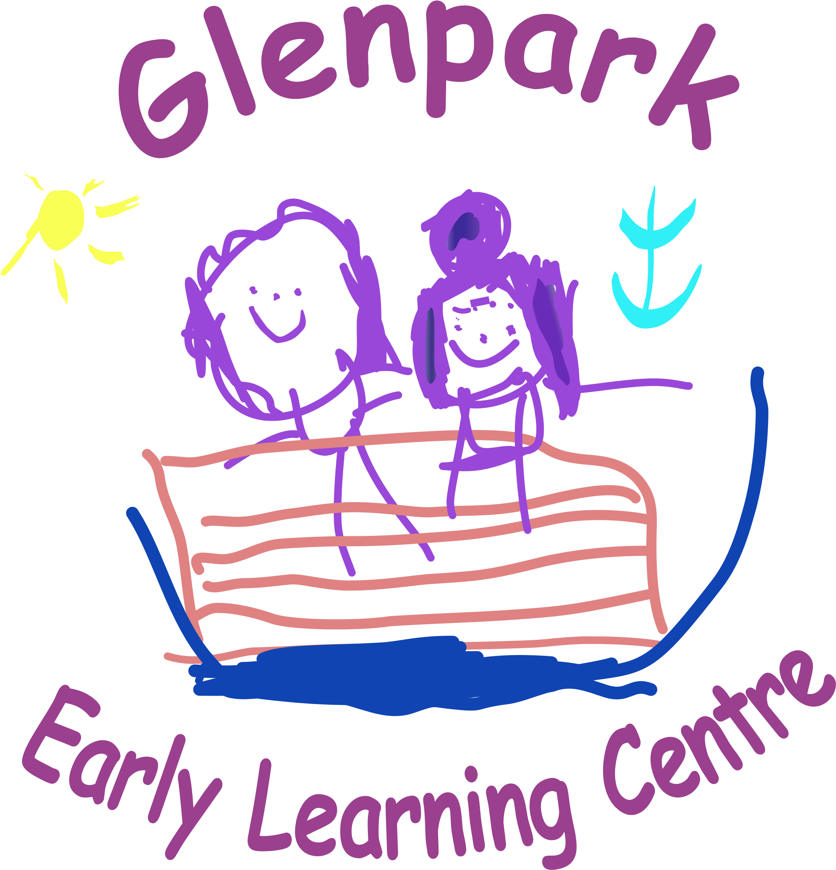

WELCOME
Welcome back to all our returning boys and girls. Our nursery values parental involvement therefore if you have any ideas, suggestions or questions please do not hesitate to speak to Patricia, Gaynor, Roseann or your child’s keyworker. We also have a comments box in the hallway if parents would prefer to post their ideas or suggestions. The centre’s Vision & Values is displayed in the front entrance and staff will continue to reinforce this with your children during their sessions. Spare newsletters are on the stand in the nursery foyer.

CHILD PROTECTION
Inverclyde Council Education Services has Child Protection Guidelines and Procedures which all schools and establishments are required to follow. Education Services work very closely with other agencies namely Strathclyde Police, Social Work Services, NHS Greater Glasgow and Clyde and the Children’s Reporter to support children. It is the responsibility of all staff are to protect children from abuse and exploitation, to respond appropriately when abuse is identified, and to ensure whenever possible that all children are able to exercise their right to be raised in a warm, stimulating and safe environment with the support of staff, their families and carers.
Our Child Protection and PREVENT leads are Patricia Wylie and Gaynor Wiggins if you have any enquiries or would like any further information please do not hesitate to contact the nursery.

GLENPARK’S
PUMPKIN PATCH
We are hoping to create our Autumn pumpkin patch again this year. To get all our children and families involved if you are out shopping and you see some pumpkins we would love it if you could donate one to the nursery. We are looking for different sizes and shapes of pumpkins for the children to compare and are hoping for as many donations as possible from the 22nd - 25th of October.

Our pumpkin patch will be open at the nursery from Monday 28th Oct until Friday 1th Nov.

The children will be outside learning and will have lots of photo opportunities throughout this week.
Parents and families are welcome to visit our pumpkin patch and take their own pictures of their children and family.

HALLOWEEN PARTY 29th October
This year’s Halloween party will be on the 29th October please feel free to come to nursery in your Halloween costume for a day of spooky fun. However don’t worry if your child doesn’t want to dress up as this is optional.

PARKING

The council has stated that our car park is for staff and visitors only. As we know you will agree with us the safety of children comes first therefore we hope that you will all support us with this. We would appreciate if you could pass on this information to any family members who are picking up or dropping off your child.

The council has stated that only blue badge holders can use the car park.

ANNUAL DATA CHECKS
Annual Data forms have been issued to all Parent/Carers for their child. It is vitally important that these are completed, signed and returned to the Centre. It is essential that we have up to date contact numbers, address and emergency contact details.

ADMINISTERING MEDICINE
If your child requires to take any medication please speak to their keyworker about this and the appropriate forms will be issued. All medicines should be signed in and out and should be checked monthly by parents in case medication or dosage has changed. We would ask all parents to make sure there is no medication left in children’s bags within the cloakroom areas.

PICK UP TIME
Please always let us know if someone different is picking up your child. It is for their safety.

CHILDREN’S CLOTHING
Suitable clothing for active play is advised.
Keep in mind that the children’s activities can be quite messy, so please wear appropriate clothing.
We encourage parents to provide a change of clothes that they can keep at their peg as we do sometimes run out of nursery clothes if these get wet outdoors or in the water.
Please help avoid mix-ups by naming all ‘removable’ items of clothing and footwear. Many children have identical coats, shoes etc., so confusion is all too easy. At Glenpark outdoor play is available in all weather and we have a range of waterproof suits available for the children to wear. We do ask that all children bring in their own sun hat and apply sun cream before coming to nursery during the summer term.

]

FUNDRAISING – TEDDY BEAR PICNIC / SINGATHON
Wednesday 5th November

For our winter fundraiser this year we are doing a sponsored Teddy bears picnic/singathon. Please feel free to bring along your favourite teddy to join you for a picnic and teddy themed singathon.

PARENTS EVENING

Wednesday the 19th November
&
Wendesday 26th Novemebr

Parents Evenings are a fantastic opportunity for you to chat to your child’s keyworker about how your child has settled in this year, what friends they have made and how they are progressing in their learning. This year Parents Evenings will be carried out over 2 weeks Wednesday the 19th & Wednesday 26th November from 5.30 p.m. – 6.30p.m. As you will all understand it is very difficult for us to arrange alternative times and days as we need to adhere to staffing ratios. Therefore we would really appreciate that all parents come along on the allocated nights. Your child’s keyworker will be in touch shortly with suitable dates and times.



Pyjama Party Nursery Fundraiser
Friday 28th November 5-7 p.m.

We are hosting our famous Glenpark Pyjama Party. This is an exciting time for the children to come to nursery from 5-7 p.m. for games, films and treats. There will be a small charge of £5.00 per child with all proceeds going towards the children’s Christmas gifts and party.

This is a great opportunity for parents to go out for dinner or start your Christmas shopping while our excellent talented staff entertain the children.

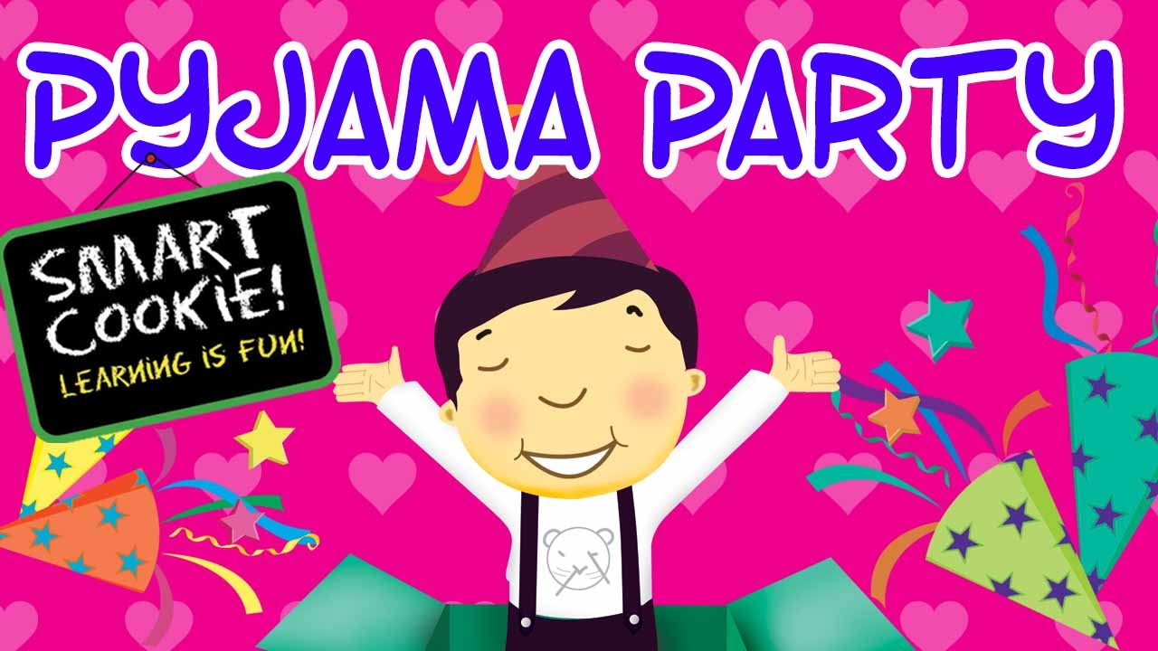

FESTIVITIES IN THE 3-5 ROOM
MONDAY 2nd to FRIDAY 6th DECEMBER
CHRISTMAS CRAFT WEEK

Children can invite a family member to come and join them in making Christmas decorations.
Please see below for time allocations.

Monday 1st December
Blue Group (Model 1) - 10.15 - 11.00
Green Group (Model 1) – 2.00 - 2.45
Yellow Group (Model 2) – 3.30 - 4.15

Tuesday 2nd December
Rainbow Group (Model 1) - 10.15-11.00
Pink Group & Red Group – 2.00 – 2.45
Silver (Model 2)– 3.30 – 4.15

Wednesday 3rd December
Orange Group (Model 2) - 10.15-11.00
Red Group (Model 1) – 2.00-2.45
Yellow Group (Model 3) – 3.30 – 4.15

Thursday 4th December
Purple (Model 4) - 10.15-11.00
White Group (Model 1) – 2.00-2.45
Silver Group (Model 3) - 3.30 – 4.15

Friday 5th December
Gold Group (Model 4) 10.15-11.00
Orange Group (Model 3) & Gold Group Model 5) 2.00-2.45

FESTIVITIES IN THE 2-3 ROOM
MONDAY 2nd to FRIDAY 6th DECEMBER
CHRISTMAS CRAFT WEEK

Children can invite a family member to come and join them in making Christmas decorations.
Please see below for time allocations.

Monday 1st December
Green Group – 1.45-2.45
Tuesday 2nd December
Red Group – 1.45-2.45
Wednesday 3rd December
Blue Group – 1.45-2.45
Thursday 4th December
Yellow Group – 1.45-2.45

CHRISTMAS CAROL CONCERT
WEDNESDAY 10TH DECEMBER
3-5 Room

We would love to invite you along to our Christmas Carol Concert
NOW THAT’S WHAT I CALL GLENPARK CHRISTMAS
Wednesday 10th December.
Children will attend their normal session times.
The children will perform on the stage at the time slots below.
10am-11am | 1.30pm-2.30pm
Orange M2 | Orange M3
Yellow M2 | Yellow M3
Silver M2 | Silver M3
Gold M4 | Gold M5
White | Purple
Blue | Rainbow
Green | Red
 | Pink

Can we ask that your child wear something red OR Christmassy on this day
THANK YOU

CHRISTMAS MOVIE DAY
TUESDAY 16TH & THURSDAY 18TH DECEMBER
Our Christmas Movie week last year was a big success. There will be a choice of two different screenings with different movies and the children will vote for what movies we will play prior to this day. We will also have exciting activities to go along with these movies and sweet treats.


FESTIVITIES IN THE 2-3 ROOM
CHRISTMAS PARTY
CHRISTMAS MOVIE DAY

Your child’s key worker will contact you regarding times and days for your party and movie day depending on your child’s attendance pattern. These events may run over several days in the 2-3 room.

CHRISTMAS PARTY
WEDNESDAY 17TH DECEMBER
3-5 Room
Our Christmas Party will be held on Wednesday 17th December. Our Christmas Party will be a fun filled all day event as we do like a party at Glenpark. Our morning session will be Party Time with fun games, dancing and a visit from you know who. For our afternoon session a favourite for all the children Uncle Billy will be joining us to entertain everyone with his magic tricks, songs and game.

In order for all the children to participate in both sessions we will be inviting all the children in for both sessions on this day. More information to follow regarding times etc

Wall of Wonder
You may have noticed our Wall of Wonder display in the playroom. This is to celebrate the children’s achievements out with the nursery. Join us in celebrating these achievements and marvellous moments by adding to our Wall of Wonder!
Just bring in a photo (if you want you can email the photo for us to print) and write on one of the slips provided in the baskets at the front door. Give these to your child’s keyworker and they will add it to our Wall of Wonder for all to see! Wonder moments can be as small as completing a jigsaw, eating all their dinner, sleeping all night or building a model to big news like toilet training, riding a bike, learning to swim, or becoming a big brother or sister


