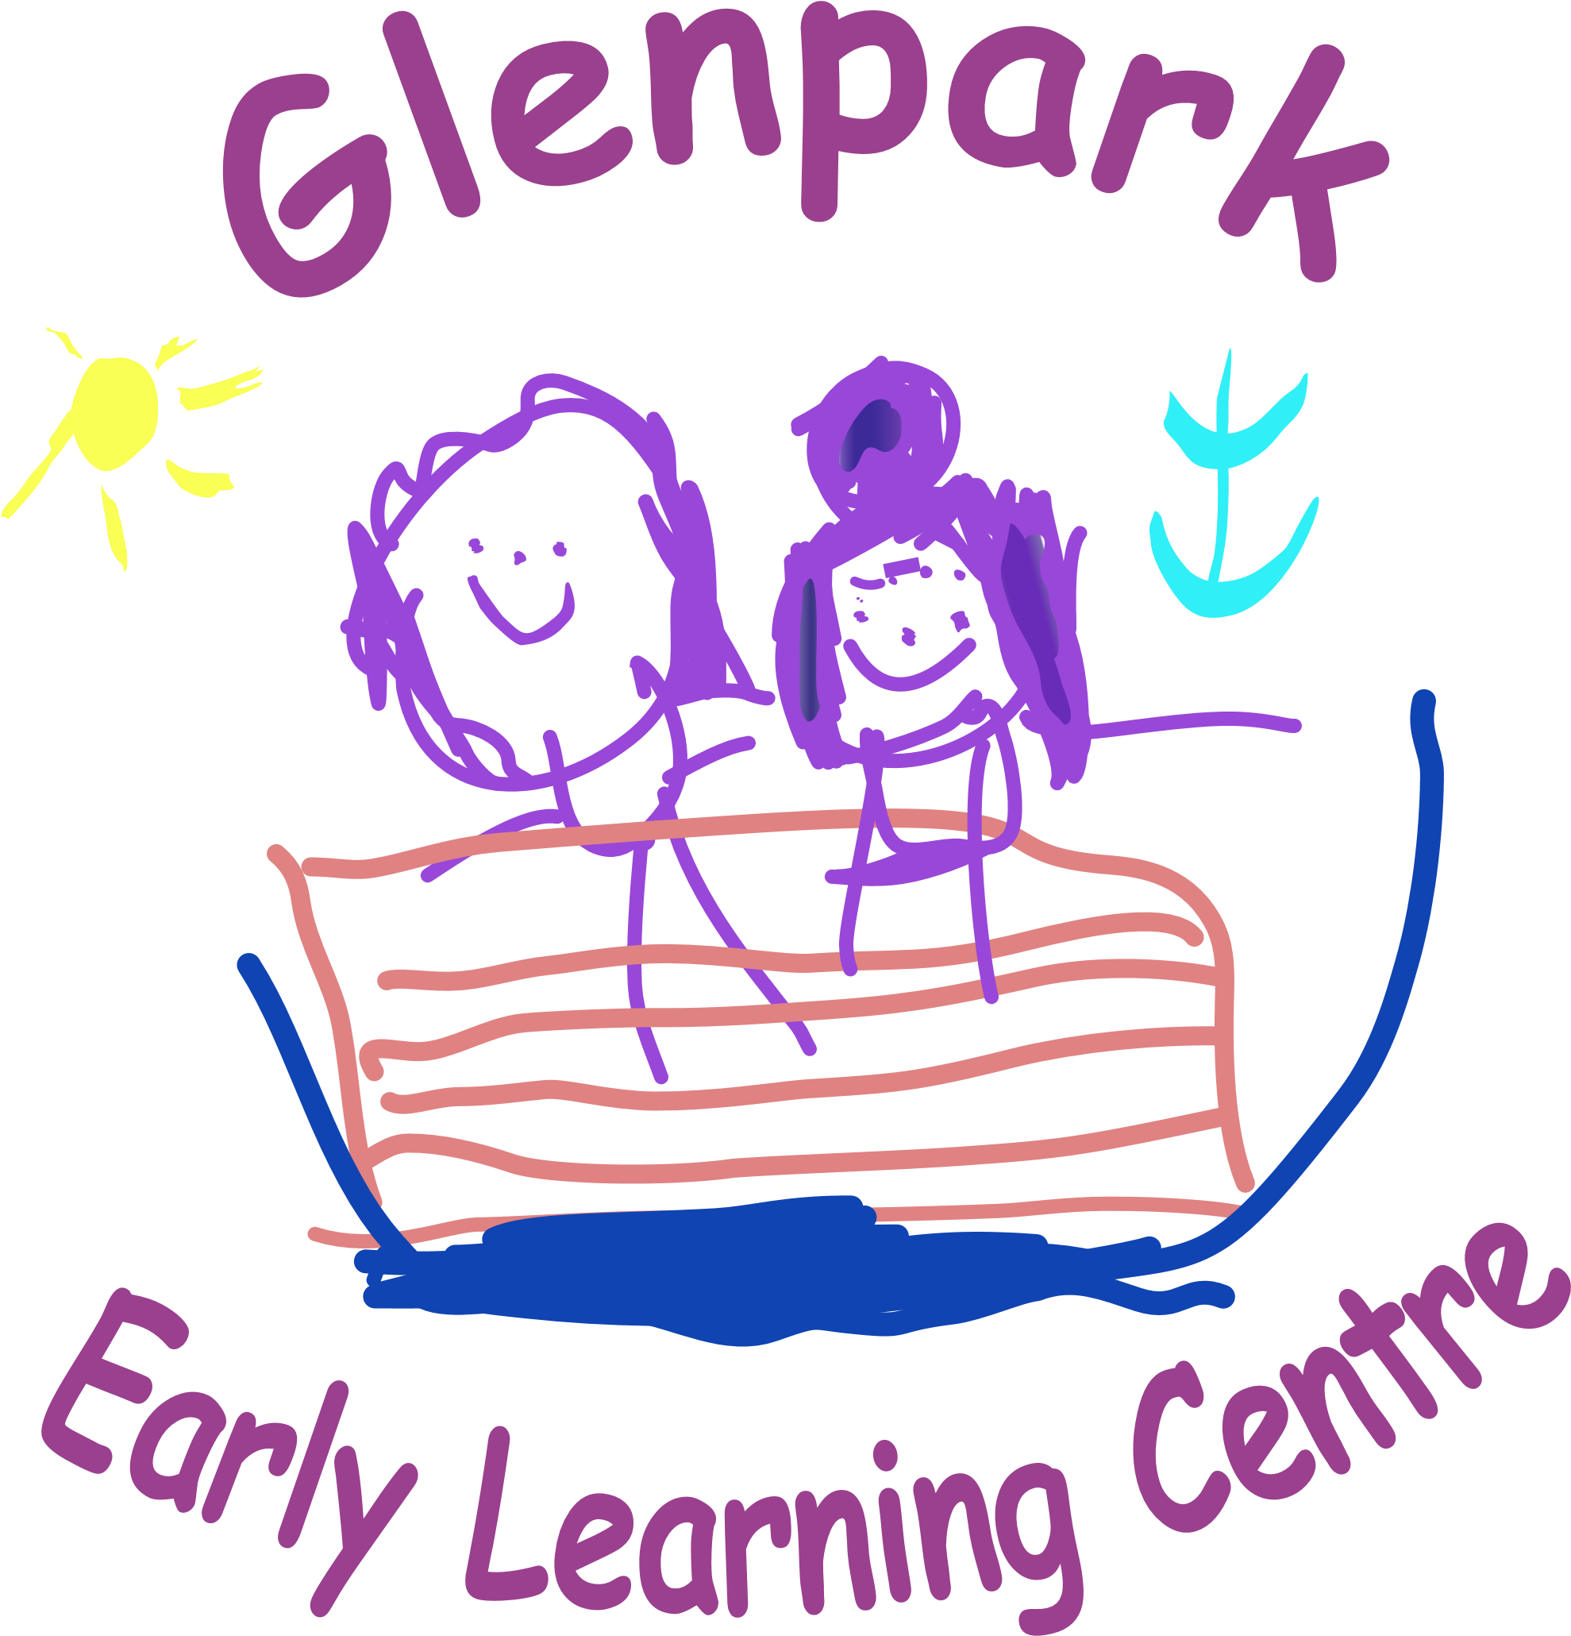



WELCOME

Welcome back to all our returning boys and girls and a huge welcome to all our new children who have started nursery and are all settling in fantastically well. Our nursery values parental involvement therefore if you have any ideas, suggestions or questions please do not hesitate to speak to Patricia, Gaynor, Roseann or your child’s key worker. The centre’s vision and values are displayed in the foyer and staff will continue to reinforce this with your children during their sessions. We are always looking for volunteers to help us in the centre with various activities, always check the chalkboard at the front door for dates.

STAFF NEWS

We are delighted that our Head of Centre, Patricia, has returned to Glenpark Elc this term and we look forward to welcoming her back! Therefore, Gaynor and Roseann will be returning to their substantive posts as Depute head of centre and Senior. Coral and Nicole will also be returning to their substantive posts as Early Years Education Childcare Officers we would like to take this opportunity to thank both girls for all their hard work and support while undertaking the senior posts.

MODEL TIMES

All children have been allocated a model, each model has different timings. We understand that this is very confusing for families as there are children coming in and out of the nursery throughout the day. To accommodate all models with early starts and late finishes staff are required to do shifts, to ensure that we are still within ratios we can only have a specific number of children in the building at any one time and ask that when dropping off your child you do this only at their allocated time and not before. We thank you for your co-operation with this matter and would like to assure you that children's safety is our priority.

MODEL 1
MONDAY TO FRIDAY
8.45AM—2.45PM TERM TIME
MODEL 2
MONDAY & TUESDAY
8.05AM—17.45PM,
WEDNESDAY 8.05AM—12.55PM
MODEL 3
WEDNESDAY 13.00PM—17.45PM
THURSDAY AND FRIDAY 8.05AM—17.45PM
MODEL 4
MONDAY TO FRIDAY
8.05 AM—12.55PM
MODEL 5
MONDAY TO FRIDAY
13.00AM—17.45PM

Although you have been allocated a set time, we understand that some families may want to drop off a little later or pick up earlier and we fully support this. The allocated times can be flexible, in that you can use anything within these times.

OUR VISIONS AND VALUES SONG

At the start of each nursery session the children sing our Visions and Values Song to the tune of Row, Row, Row your boat.

“At Glenpark we try to be the best that we can be. Our visions and our values are always clear to see, Parents, carers, children staff are equal everyone. Play and share and grow and laugh learning is such fun!”

At the start of every New Year we like to consult with parents, children and staff on anything they would like to change about the song or any new suggestions or ideas. We have attached a questionnaire that we hope you will take the time to complete and return to the nursery. Thank you.

PERSONAL LEARNING PLANS

We are keen to keep parents up to date with all aspects of the children’s learning throughout the year. We have always included parents/carers in setting children’s targets in their Personal Learning Plans. We feel this has helped staff and parents work in partnership in progressing the children’s learning in the nursery and support the children getting ready for school. This year we would love to invite all parents to a parents evening at the end of each term. This will enable parents to have more of an insight into the wide variety of learning experiences that your child has participated in and help identify the next steps in their learning journey.

SETTLING IN MEETINGS
Your child’s key worker will be in contact with you to create learning targets for your child for Term 1.

PARENTS INFORMATION NIGHT

Our parent’s information night will be Wed 17th Sept & Wed 24th Sept. This is a great opportunity for parents old & new to learn about Curriculum for Excellence Early Level and all the learning that is taking place each day. The staff will also be able to discuss the wide variety of learning programmes being offered to the children. This is also a great chance for you to look around the nursery and check out our resources too.
Due the large number of children attending the nursery we have had to split this into 2 sessions.

Model 1 Parents

Wednesday 17th September from 5pm – 6pm.

Model 2, 3, 4 & 5

Wednesday the 24th September from 5pm – 6pm,
Please note this evening is for parents only.

PARKING

The council has stated that our car park is for staff and visitors only. As we know you will agree with us the safety of children comes first therefore we hope that you will all support us with this. We would appreciate if you could pass on this information to any family members who are picking up or dropping off your child.

The council has stated that only blue badge holders can use the car park.
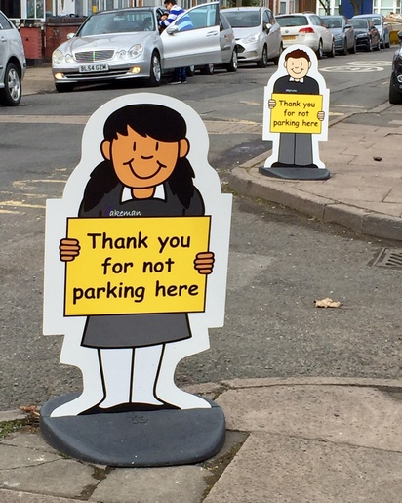

PARENTS EVENING
Wednesday 19th November
&
Wednesday 26th November
We are hosting parents evenings over 2 weeks this year in order try and accommodate parents work commitments. We would really appreciate if you could book one of the dates provided with your child’s keyworker, as booking appointments during the nursery sessions has an impact on the children’s learning. Parents evening is an opportunity to discuss children’s targets and learning achievements for Term 1 and set new learning targets for Term 2.



Learning Journals
At Glenpark Early Learning Centre we are using online learning journals to record children’s learning. These will not replace the old paper profiles that you will receive at the end of the school year. We are keen to use on-line learning alongside our paper profiles.
We update these regularly with photos of your child learning in nursery. We are going to go live with these from September.
You can log on to these anywhere you have internet access – on your phone or tablet.

NUT FREE
Can we please remind everyone that Glenpark is a Nut Free Nursery. Some of our children have severe nut allergies we therefore ask that children do not bring any food containing nuts or traces of nuts into nursery.


WALL OF WONDER
You may have noticed our Wall of Wonder display in the playroom. This has been introduced to celebrate the children’s achievements out with the nursery. Join us in celebrating these achievements and marvellous moments by adding to our Wall of Wonder! Just bring in a photo (if you want you can email the photo for us to print) and write on one of the slips provided in the baskets at the front door. Give these to your child’s keyworker and they will add it to our Wall of Wonder for all to see! Wonder moments can be as small as completing a jigsaw, eating all their dinner, sleeping all night or building a model to big news like toilet training, riding a bike, learning to swim, or becoming a big brother or sister.



CHILDREN’S CLOTHING
Suitable clothing for active play is advised.
Keep in mind that the children’s activities can be quite messy, so please wear appropriate clothing.
We encourage parents to provide a change of clothes that they can keep at their peg as we do sometimes run out of nursery clothes if these get wet outdoors or in the water.
Please help avoid mix-ups by naming all ‘removable’ items of clothing and footwear. Many children have identical coats, shoes etc., so confusion is all too easy. At Glenpark outdoor play is available in all weather and we have a range of waterproof suits available for the children to wear. We do ask that all children bring in their own sun hat and apply sun cream before coming to nursery during the summer term.

NAMES ON CLOTHING
PLEASE remember to put children’s names on their jumpers, jackets etc. to avoid confusion and mix up at the end of the session.

CURRICULUM
The Staff use Curriculum for Excellence Early Level Outcomes to plan appropriate learning activities for all children. Throughout your child’s time at nursery your child’s keyworker will observe, plan and progress your child’s learning in partnership with parents. You’re Personal Learning Plan and Parents Evenings with your child’s keyworker is a great opportunity for discussing your child so that staff can get to know their likes and dislikes, interests and learning styles.

ANNUAL UPDATE AND MEDICATION

Annual Data forms will be issued to all Parent/Carers for their child. It is vitally important that these are completed, signed and returned to the Centre. It is essential that we have up to date contact numbers, address and emergency contact details.
If your child requires to take any medication please speak to their keyworker about this and the appropriate forms will be issued. All medicines should be signed in and out and should be checked monthly by parents in case medication or dosage has changed. We would ask all parents to make sure there is no medication left in children’s bags within the cloakroom areas.
FIRST AID
We have 2 fully trained First Aiders in the nursery and all our staff fully paediatric first aid trained and are always hand to treat all minor accidents. We would like to make you aware that if your child has a head injury a member of staff will give you a phone call as part of our procedures. Parents will be asked to sign for any accidents at the end of the session.

REGISTRATION STATION

Our registration station in both playrooms is to ensure the safety of all our children.
Two members of staff will be taking the register at the beginning and end of each session. In order to help us could you please let us know if someone different is collecting your child.

TOILETING
At Glenpark children are encouraged to go to the toilet themselves, this helps them develop their independence skills which will support them when transferring to primary school. Our staff will always be on hand to help the children, however we would be grateful if you could teach your child to wipe their own bottom.

CHILD PROTECTION
Inverclyde Council Education Services has Child Protection Guidelines and Procedures which all schools and establishments are required to follow. Education Services work very closely with other agencies namely Strathclyde Police, Social Work Services, NHS Greater Glasgow and Clyde and the Children’s Reporter to support children. It is responsibilities of all staff are to protect children from abuse and exploitation, to respond appropriately when abuse is identified, and to ensure whenever possible that all children are able to exercise their right to be raised in a warm, stimulating and safe environment with the support of staff, their families and carers.
Our Child Protection and PREVENT leads are Patricia Wylie and Gaynor Wiggins if you have any enquiries or would like any further information please do not hesitate to contact the nursery.

Nursery Stars
The children will be learning to Promote Positive Behaviour throughout the playroom. This will be implemented through the introduction of our Nursery Stars which will be teaching the children.
*We are all friends at nursery *We help tidy up
*We help each other *We say please and thank you
*We walk in the nursery *We do good sitting
*We use quiet voices inside *We put our thumbs up to answer

HEALTH AND SAFETY
As part of our commitment to providing a safe and enjoyable environment for all our nursery children, we would like to remind you about appropriate footwear for outdoor play.
To ensure your child can participate comfortably and safely in all outdoor activities, we kindly ask that children wear suitable shoes such as trainers or closed-toe shoes rather than Crocs or other open-toe footwear. Suitable shoes provide better protection, support, and grip, helping to prevent slips, trips, or injuries during active play.

ATTENDANCE
Regular attendance at nursery is obviously desirable. If your child is going to be off nursery for whatever reason such as sickness or spending the day with family, it is essential you contact the nursery office on the same day so it can be recorded. If we don’t hear from you the nursery will now be completing a wellbeing call to record the reason your child is not at nursery so it can be updated on our records.

Telephone: 01475 715620

GLENPARK’S
PUMPKIN PATCH
Glenpark children are going to celebrate autumn by making our very own pumpkin patch.
We are hoping to create our Autumn pumpkin patch again this year. To get all our
children and family’s involved if you are out shopping and you see some pumpkins we would
love it if you could donate one to the nursery. We are looking for different sizes and
shapes of pumpkins for the children to compare and are hoping for as many donations
as possible from the 22nd - 24th of October.

Our pumpkin patch will be open the nursery from Monday 27th Oct until Friday 31st Oct.

The children will be outside learning and will have lots of photo opportunities throughout this week.
Parents and families are welcome to visit our pumpkin patch and take their own pictures of their children and family.

HALLOWEEN PARTY
This year’s Halloween party will be on the 29th October please feel free to come to nursery in your Halloween costume for a day of spooky fun. However don’t worry if your child doesn’t want to dress up as this is optional.



FUNDRAISING – TEDDY BEAR PICNIC / SINGATHON
Wednesday 5th November

For our winter fundraiser this year we are doing a sponsored Teddy bears picnic/singathon. This is to go along side our story of the term. Please feel free to bring along your favourite teddy to join you for a picnic and teddy themed singathon.

Stay & Play Sessions 3-5 Playroom
STEM Stay & Play
29th Sept-3rd Oct
We would like to invite parents in to see all the exciting activities the children take part in daily. Due to the amount of children we have we have allocated set days for each group:-
Monday 29th Sept
Blue/Green/Yellow Group
10.15-11.00, 2.00-2.45 and 3.30 -4.15

Tuesday 30th Sept
Rainbow/Pink/Silver Group
10.15-11.00, 2.00-2.45 and
3.30 - 4.15

Wednesday 1st Oct
Orange/Red/Yellow Group
10.15-11.00, 2.00-2.45 and 3.30 – 4.15

Thursday 2nd Oct
Purple/White/Silver Group
10.15-11.00, 2.00-2.45 and 3.30 – 4.15

Friday 3rd October
Gold AM/ Orange& Gold PM Group
10.15-11.00 and 2.00-2.45
If any of the dates above are unsuitable please speak to your child’s keyworker.
j

Thank you so much for your continued support. We are looking forward to the busy year ahead and making memories with all the staff, parents and children.

