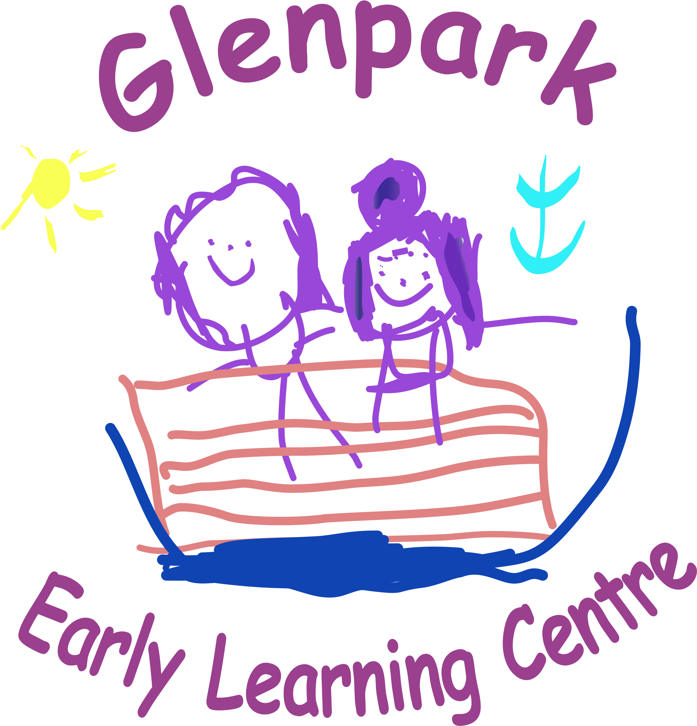

WELCOME
We hope everyone has settled well into our first term and we would like to welcome all of our new children to Glenpark we hope that you and your child will enjoy their time at nursery.
Our Head of Centre Patricia has been seconded to the Head of Centre post at Larkfield Children’s Centre. During this time Gaynor will act as Head of Centre at Glenpark and Roseann as Depute Head of Centre. We have recently interviewed for the Acting Senior post and are delighted to announce that both Coral and Nicole were successful and will take on the Acting Seniors post with immediate effect. After the October holidays, the lovely Carmen Valerio will be taking over as the Rainbow Group’s keyworker. Carmen has been working at the nursery for a few months and is delighted to be taking on this role.

3-5 ROOM STORY OF THE TERM
Children have been learning about the story they voted for
The winner was
Goldilocks and the Three Bears
Children have been learning the song they voted for
The winner was
Little Miss Muffet

GLENPARK’S
PUMPKIN PATCH
Glenpark children are going to celebrate autumn by making our very own pumpkin patch.
We are hoping to create our Autumn pumpkin patch again this year. To get all our
children and families involved, if you are out shopping and you see some pumpkins we would
love if you could donate one to the nursery. We are looking for different sizes, colours and
shapes of pumpkins for the children to compare and are hoping for as many donations
as possible from the 22nd - 25th of October.

Our pumpkin patch will be open at the nursery from Monday 28th Oct until Friday 1th Nov.

The children will be outside learning and will have lots of photo opportunities throughout this week.
Parents and families are welcome to visit our pumpkin patch and
take their own pictures of their children and family.

VOLUNTARY CONTRIBUTION
Throughout the year at Glenpark we try to make nursery as fun and memorable as possible and in doing this we provide lots of extra-curricular activities. To help subsidise these we are going to ask for weekly donations of £1 to £2. This is a voluntary contribution that we really appreciate and we hope this can help make the children’s time at nursery very memorable and special.
Thank you for all your support.

2-3 ROOM LEARNING TOPIC
Throughout the year within the 2-3 Room their learning is linked to books. The current book is October - ROOM ON THE BROOM.
November - STICKMAN

HALLOWEEN PARTY
This years Halloween party will be on the 30th October. Please feel free to come to nursery in your Halloween costume for a day of spooky fun. However don’t worry if your child doesn’t want to dress up as this is optional.
2-3 ROOM
You will receive information soon regarding date and time for your child’s Halloween party depending on their model of attendance.

RESPONSES TO PARENTS QUESTIONAIR
Thank you for your responses to our parent’s questionnaire. Here are some responses to the suggestions of things you would like us to do to improve or develop.
- “Encourage children to eat their dinner”
At Glenpark the children are offered either a hot lunch or a sandwich, staff then encourage the children to eat their lunch using polite table manners.
- Several parents have asked “When will we start to see posts on the online learning journals”
The online learning journals are now all set up, staff are working hard to prepare observations and these will be posted just after the October break.
- Several parents have asked for “more posts on Twitter or other social media platforms”
Managing the twitter account was becoming more difficult due to not being able to use mobile phones within the playroom as time was required out of the playroom to upload the evidence to Twitter. As the children are our priority we feel this time is more beneficial spent with them supporting their learning and this will all be documented in their individual personal profiles which is a wonderful keepsake to receive when the children are moving on and soon on the learning journals. We hope you all understand this and we will continue to post pictures of any special events that happen within the nursery on Twitter. At the parents meeting there was a suggestion about starting a private Facebook group. We will look into the progress on this and get back to you all as soon as we can.

See our ‘You said / We did’ wall in front foyer for more feedback and what we are doing to improve. Suggestion and comment cards are here too, feel free to leave suggestions at anytime.

VISIONS AND VALUES
We have gathered the results of our visions and values questionnaire on whether or not we change our song. The results were pretty unanimous as you can see below so for the meantime we will not be changing our Visions and values song.

Our Visions and Values Song to the tune of Row, Row, Row your boat.
“At Glenpark we try to be the best that we can be. Our visions and our values are always clear to see, Parents, carers, children staff are equal everyone. Play, share, grow and laugh learning is such fun!”

]

PARENTS GROUP MEETING
12th November at 9am-9.30am
This group meet in the nursery and help support us with developing Glenpark in many ways e.g. choosing resources, organising events, fundraising and anything else that they feel they could offer as we are always open to suggestions. If you would be interested, please come along to the meeting or speak to a member of staff.

Road Safety week
18th- 22nd November
During this week we will be participating in lots of activities surrounding the importance of road safety.

FUNDRAISING – TEDDY BEAR PICNIC / SINGATHON
Wednesday 6th November

For our winter fundraiser this year we are doing a sponsored Teddy bears picnic/singathon. This is to go along side our story of the term. Please feel free to bring along your favourite teddy to join you for a picnic and teddy themed singathon. In 2-3 room we will be holding this fundraiser this full week to ensure everyone can participate.

A BIG THANKYOU
We would like to take this opportunity to thank Aria’s Mum Jayne Ann who has donated some lovely items from her work The Salvation Army shop to the nursery, we are very lucky.

PARKING

The council has stated that our car park is for staff
and visitors only. You will agree with us the safety of children comes first therefore we hope that you will all support us with this. We would appreciate if you could pass on this information to any family members who are picking up or dropping off your child.
We have had several complaints about cars being left double parked or blocking the entrance to the car park. Can we ask that you refrain from doing this it is essential that emergency service vehicles have access to the car park at all times.
The council has stated that only blue badge holders can use the car park.

SCHOOL REGISTRATION INFORMATION NIGHT
For Ardgowan Primary and St Mary’s Primary
THURSDAY 28TH NOVEMBER
6.30PM-7.30PM
VENUE - GLENPARK EARLY LEARNING CENTRE
This is an information session for any parents thinking about enrolling their child in these schools in January. This information session will be held within the nursery by the school staff.

NEW GLENPARK LENDING LIBRARY

Our New Lending Library is now up and running from our parent’s room. This will run each Wednesday, each group will be selected to visit the Glenpark Library and choose a book to take home.
We ask that the children return books the following Wednesday.

PHOTOS FOR OUR FAMILY TREE

In Glenpark we have a wall with lots of pictures of us with our families. We are looking for more photographs for our family tree. If you haven’t already sent us a family picture or if you would like us to update your family picture you can either bring them into nursery and give them to a member of staff or email them to us and we can print them.
office@glenparkelc.inverclyde.sch.uk

NEW GLENPARK LITTLE BAKERS

Our New Little Bakers programme will be up and running very soon. This will run each Tuesday Morning and Thursday afternoon.
The advantages of learning to bake go beyond making delicious treats. The Children will learn basic maths and science concepts through measuring and mixing. Baking also encourages creativity and enhances fine motor skills.

Joyful moments across generations.
At Glenpark we are excited about our new programme with our friends at Alt Na Craig Care home.
We are planning lots of intergenerational activities, such as crafts, sharing stories and tales from the past, playing games and singing songs together.
By participating in these activities we hope to create lasting memories together.
At the parents information evening’s parents were asked to vote for what we would like this collaboration to be called.

The Winner is
Memory Makers
We look forward to starting this in November.

HOME LINK ACTIVITIES
Soon we will have the opportunity to take home STEM HOME LEARNING BAGS to share and enjoy with their families. One child per group each week will receive the bag to use for a week before returning for her next child.
Other home link activities can be found on Glenparks Home Link Padlet
These activities are linked to learning targets that you made with your child’s Key worker at their termly meeting.

Scan Me for Access to Padlet

Improvement Planning Document
As part of Inverclyde Council’s Educations Department we are asked to set out our priorities for the nursery for the coming year.
This year we are focusing on:

National Priorities | Session 2024-2025
Improvements in attainment, particularly in literacy and numeracy | Develop staff training on Inverclyde Councils new Skills Assessment Tracker to track children’s progress and development. Enabling staff to understand the key skills when identifying and setting appropriate learning targets for all.
Closing the attainment gap between the most and least disadvantaged children | Further develop parental engagement and awareness of learning, ensuring high expectations for all children and families with particular focus on SIMD 1 & 2.
Improvement in children and young people's health and wellbeing | Enhance outdoors to create a more vibrant, dynamic learning environment that holistically supports every child’s health and wellbeing.

