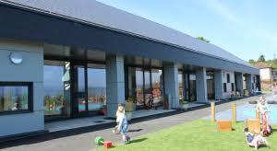

Glenpark Early Learning Centre
Madeira Street
Greenock
PA16 7XF

Handbook
2020 – 2021

Head of Centre – Patricia Wylie
Depute Head of Centre – Gaynor Wiggins

Telephone No: 01475 715620
http://glenparkelc.inverclyde.sch.uk
Email: InGlenpark@glowscotland.onmicrosoft.com
Follow us on Twitter: @Glenpark_Elc

CONTENTS PAGE
Page 3
Introduction
Getting it Right for Every Child

Page 4
Establishment aims Section One
No of Places Available Section Two
Age Range

Page 5
Opening Hours
Staff Information Section Three
Admission Policy
Enrolment Procedures
Page 6
Child Protection Guidelines
Attendance
Promoting Positive Relationships
Curriculum for Excellence Section Four
Curriculum Areas
Page 7
The Curriculum
Assessment Procedures
How we Report to Parents
Page 8
How we Promote Learning
What Active Play Means
Free Play
Education for Citizenship
Page 9
Group Times / Planned Learning Experiences
Promotion of a Positive Ethos within the Establishment
Early Intervention
Establishments Procedure for Reporting to Parents
School Improvement

Page 10
Transitions Section Five
Supporting Children (GIRFEC)
Page 11
Education (Additional Support for Learning) (Scotland) Act 2009
Liaison Arrangements
Links with the Local Community
Page 12
Parental Partnership
Medical & Health Section Six
Minor Accidents
Page 13
Healthy Eating
Smoking
Safety Section Seven
Clothing
Outings
Page 14
Fund Raising
Some of the Centre’s Achievements & Improvements
Suggestions and Complaints Section Eight
Equal Opportunities and Social Justice
Page 15
Equality Statement for Inverclyde Establishments
Data Protection Act 1988
Information in Emergencies Section Nine
Page 16
Useful Addresses
Local Councillors
Useful Websites
Appendix 1
Clothing grant and free school meals for 2018/19
Appendix 2 Public Holidays and In Service Days
For 2018-2019

Introduction

Welcome to Glenpark Early Learning Centre. This handbook has been compiled to provide you with information on a range of issues concerning your child’s time at nursery. I hope you will find it helpful.

We pride ourselves with providing a very warm and welcoming ethos in the nursery. This is reflected through our Vision and Values statement and high quality staff interactions putting relationships at the centre of everything we do.
At Glenpark Early Learning Centre, we recognise that each child is an individual, and this lies at the heart of our approach to childcare and education. We aim to ensure that the wide ranges of educational experiences available in the nursery during these special years are happy and productive.

Your child will experience learning opportunities in line with Building the Ambition and Curriculum for Excellence, leading to the development of a wide range of skills in the 8 curricular areas:- expressive arts, health & wellbeing, languages, mathematics, religious and moral education, science, social studies and technology, through curiosity, inquiry and creativity.

Our emphasis is on learning through play, and each child is encouraged to make his or her own decisions about what to do and how best to approach it. In this way, each child is able to build on his or her own previous knowledge, making the curriculum relevant to them as individuals and developing the children so that they become confident individuals, successful learners, effective contributors and responsible citizens.

Patricia Wylie
Head of Centre

Getting it Right for Every Child at Glenpark Early Learning Centre

(GIRFEC)
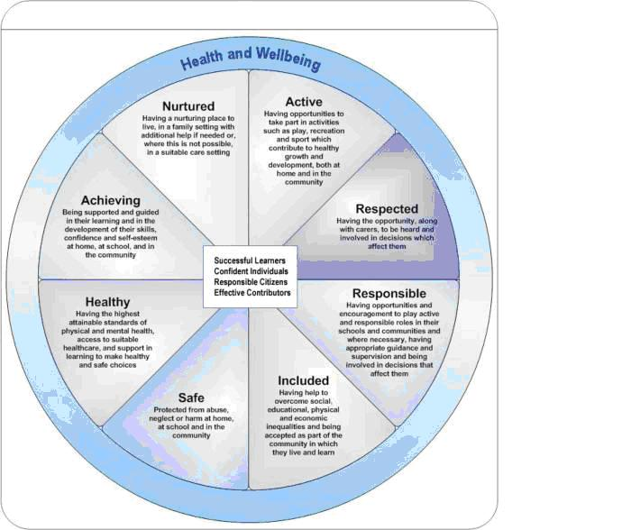

At Glenpark Early Learning Centre we aim to get it right for every child by:-

Nurtured
Every child will be treated as an individual and their needs will be met.
Active
Every child will have the opportunity for a range of physical activities both indoors and out.
Respected
Every child will have the opportunity to express themselves and have their views taken into consideration.
Responsible
Every child will have the opportunity to be responsible for choices within their own learning and have these choices respected by others.
Included
Every child will have the right to be recognised as an individual and included in all aspects of the centre.
Safe
Every child has the right to play in a secure environment which is clean with well-maintained equipment and resources.
Healthy
Every child will have the opportunity to learn about healthy eating and healthy lifestyles.
Achieving
Every child will have the opportunity to reach their full potential and self-assess their own learning

Section One
Establishment Aims
(GIRFEC)

VISION AND VALUES
(Consultation with parents and children)

At Glenpark Early Learning Centre we try to be the best that we can be,
Our vision and our values are always clear to see!
Parents, carers, children, staff, are equal – every one!
Play and share, grow and laugh, learning is such fun!

THE CENTRES AIMS

- Successes and Achievement

The children will be challenged throughout their play in high quality learning activities both indoors and out. They will be encouraged to extend their curiosity through planned and motivating active play. The staff will support the children to sustain their efforts to become successful learners, confident individuals, responsible citizens and effective contributors and develop all children’s capability to become active citizens in their environment. We will encourage all children to think and apply different kinds of learning in new situations through creative and imaginative play and within a context of literacy, numeracy and health and wellbeing. We will value all children and families and all staff will take active steps to ensure that interactions between parents and children are relaxed and friendly but also productive and focused on success and achievements.

- Work and Life of the Centre

We will encourage all children to think creatively and independently, and also as part of a group to communicate in different ways and in different settings to become successful learners, confident individuals, responsible citizens and effective contributors. We aim to offer all families a flexible service within an integrated framework with our partner agencies to provide a service that meets the needs of individual children and families. Parents will be encouraged to be effective contributors and support the work of the centre.

- Vision and Leadership

We aim to develop leadership at all levels where staff embrace teamwork. Parents, staff and children will plan for improvements throughout the nursery.
The staff will be encouraged to reflect on their practice and embrace challenges and change.
The management team will ensure that all parents, staff and children have the opportunity to monitor and evaluate the work of the nursery.
All staff will ensure they offer a service, which takes account of social and culture diversity.

Parents quote: “During my child’s 2 years at nursery he has been given great care and learning experiences.” “He has become more confident and mixes well.” “Each day he comes home singing and retelling nursery rhymes and stories.” “Myself (and my husband) are really pleased with my child’s progress and would like to thank all staff.”



Section Two

Number of Places Available

The 3-5 playroom can accommodate 80 morning and 80 afternoon children at any one time.
The 2-3 room can accommodate 15 morning and 15 afternoon children at any one time.
Our nursery is a non-denominational centre.

Age Range

The nursery caters for children aged 2-5 years.
Current Role: 95 each session.

Opening Hours

The nursery core session times are-
Pattern 1 - 8.45-11.55 Monday to Friday
Pattern 2 - 12.30-3.40 Monday to Friday
Pattern 3 – 8.45-3.20 Mon/Tues 8.45-11.50 Wed
Pattern 4 – 12.30-3.10 Wed. 8.45-3.15 Thur/Fri

We also have a limited wrap round service available.

Section Three

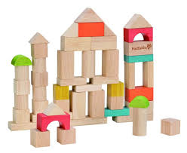

Section Three

Head of Centre - Patricia Wylie
Depute Head of Centre - Gaynor Wiggins
Senior EYECO - Roseann McDonald
EYECO Team - Coral Arkley
- Allison Bell
- Cathy McNellis
- Nicole Mortimer
- Isley Berndt
- Karen O’Donnell
- Cheryl O’Hara
- Rita McKenna
- Casey Roberts
- Jackie Walker
- Lauren Speirs
- Louise Robertson
Peripatetic Teacher - Ailie Rankin
Clerical Assistants - Courtney Galbraith
- Debbie McNellis
Support Staff - Annie Leck
- Christine Allan
- Arlene Bain
Caretaker/Janitor - Elaine Loy



The Centre may have at times Additional Support Workers working and supporting our children.

Glenpark Early Learning Centre
Madeira Street, Greenock
PA16 7XF
Tel: 01475 715620
http://glenparkelc.inverclyde.sch.uk
InGlenpark@glowscotland.onmicrosoft.com
Follow us on Twitter: @Glenpark_Elc

Admissions Policy

All children are allocated a nursery place in line with Inverclyde Council’s Early Years Admission Policy. The normal pattern of attendance is 5 sessions of 3hrs 10 minutes either in the morning or afternoon or limited places of 2.5 days.

Your child's eligibility for pre-school education depends on their birthday:
- 1st March – 31st August birthday Intake 1 – August.
- 1st September – 31st December birthday Intake 2 – January.
- 1st January – 28th (29th) February birthday Intake 3 – April.
This will change with the implementation of the government’s E.L.C expansion in August 2020.

Enrolment Procedures

We offer an open door policy for parents and their child to visit prior to enrolment. Once your child is allocated a place, you will be invited to the nursery to discuss details of the placement and to complete an enrolment form. The enrolment form contains all the relevant information we will need about your child. This includes home details, emergency contacts and medical and dietary information.

At enrolment, you will also have the opportunity to meet your child’s Keyworker. A Keyworker is your child’s ‘special person’. She/he will develop a partnership with you and your family and will keep you up to date with current events at the nursery.

Parents are asked to settle their child at nursery. This means, initially staying with your child in the playroom and gradually increasing periods of attendance. ‘Information for Parents Leaflet’ will be given to all parents.

Child Protection Guidelines and Procedures

Inverclyde Council Education Services has Child Protection Guidelines and Procedures which all schools and establishments are required to follow. Education Services work very closely with other agencies namely Strathclyde Police, Social Work Services, NHS Greater Glasgow and Clyde and the Children’s Reporter to support children. Common responsibilities of all staff are to protect children from abuse and exploitation, to respond appropriately when abuse is identified, and to ensure whenever possible that all children are able to exercise their right to be raised in a warm, stimulating and safe environment with the support of staff, their families and carers.

Attendance

Children benefit considerably from regular attendance at a pre-five establishment. If children do not maintain an overall, reasonable attendance, consideration may be given to offering the place to another child who has been unable to secure a place.

Parents are responsible for informing the nursery if their child is going to be absent for any reason. Parents should telephone the nursery on 01475 715620 and inform the Head or Depute Head of centre that their child is going to be absent.
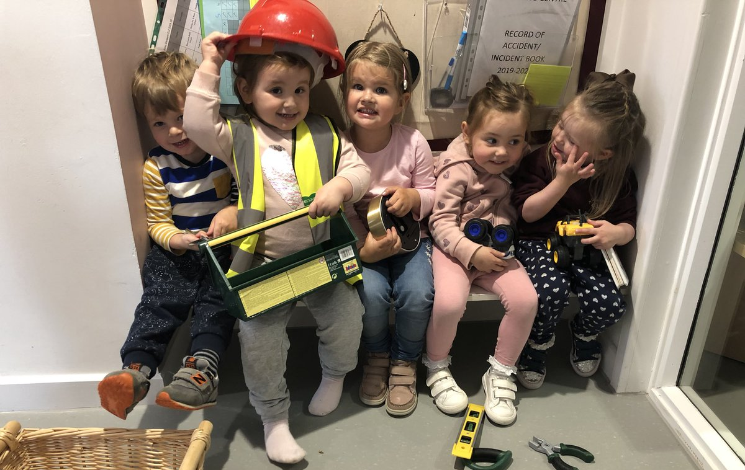

Promoting Positive Relationships

We recognise that the nurture is the foundation for building a positive learning environment. Quality supportive relationships are an essential part of our practice. We embed the core principles of respect, empathy, aspiration, inclusion, resilience, empowerment, nurture, trust, fairness and unconditional positive regard into all our interactions.

We recognise that behaviour is a form of communication and seek to enable children to be able to recognise and cope with their different emotions through loving sensitive support and structure.

The nursery refers to Inverclyde Council’s Positive Relationships and Positive Behaviour Policy.

Section Four

What do we mean by curriculum?

A curriculum can be described as the activities and experiences provided for young children which encourage knowledge, understanding and development of skills. These activities will also develop skills for learning, life and work. This learning will take place both indoors and outdoors.

Building the Ambition

Our 2-3 room plan using this document and design the provision guided by the framework of Communication, Wellbeing and Curiosity, Inquiry and Creativity. Staff intentionally promote developmentally appropriate experiences through the provision of resources, design of the environment, and quality interactions.
Building the Ambition guides us to understand that interactions and experiences are the process of how children learn and that this is inseparable from the content of the curriculum.

This understanding permeates into the 3-5 room where the planning centers around Curriculum for Excellence.

Curriculum for Excellence

Staff plan activities and experiences based on different aspects of children’s development and learning. The children are consulted about their learning by choosing resources for curricular areas.
We aim to develop children as
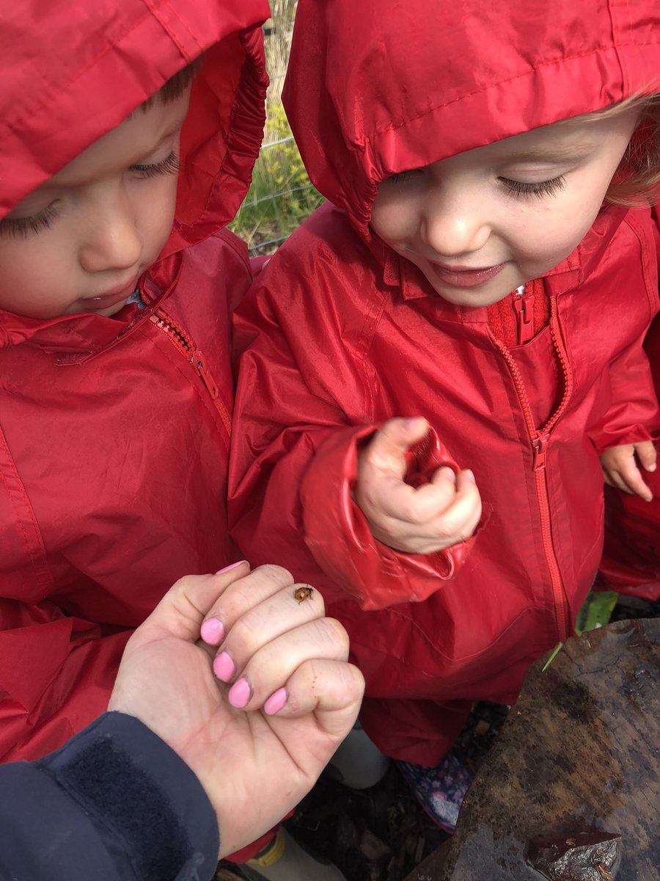
- Confident Individuals
- Successful Learners
- Effective Contributors
- Responsible Citizens

Curriculum Areas

Every child within the nursery is entitled to experience a broad general education. This broad general education takes place from the early years to the end of S3 and is represented by learning across all of the experiences and outcomes which are intertwined within the four capacities detailed above.

Staff in the Centre encourage and support children in developing self esteem and self confidence in an environment where they are secure, have formed warm caring relationships, feel safe, confident and good about themselves. This is necessary if children are to learn effectively.

The 8 curricular areas are:-
- Expressive Arts
- Health & Wellbeing
- Languages
- Mathematics
- Religious and Moral Education
- Science
- Social Studies
- Technologies
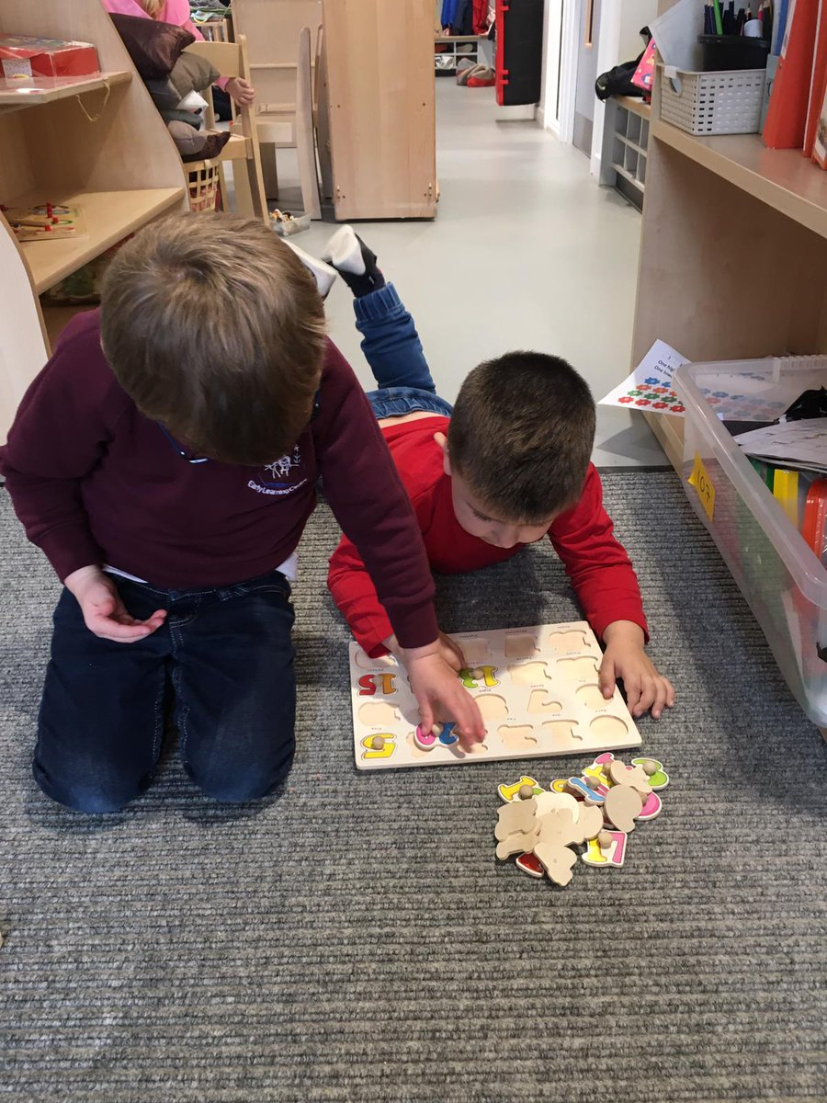

Learning is developed through the four contexts for learning
- Curriculum areas and subjects
the curriculum areas are the organisers for setting out the experiences and outcomes. Each area contributes to the four capacities.
- Interdisciplinary learning
How the curriculum should include space for learning beyond subject boundaries.
- Ethos and life of the school
The starting point for learning is a positive ethos and climate of respect and trust based upon shared values across the school community.
- Opportunities for personal achievement
Pupils need opportunities for achievements both in the classroom and beyond, giving them a sense of satisfaction and building motivation, resilience and confidence

Assessment Procedures

Our assessment procedures involve gathering, reflecting and evaluating evidence of learning to enable staff to check on the children’s progress.

We use assessment to:
> help build learners’ understanding as part of learning and teaching.
> monitor and track progress in learning within the nursery.
> provide information to those outside the nursery on learners’ progress and achievements.
> provide information for use beyond the nursery.
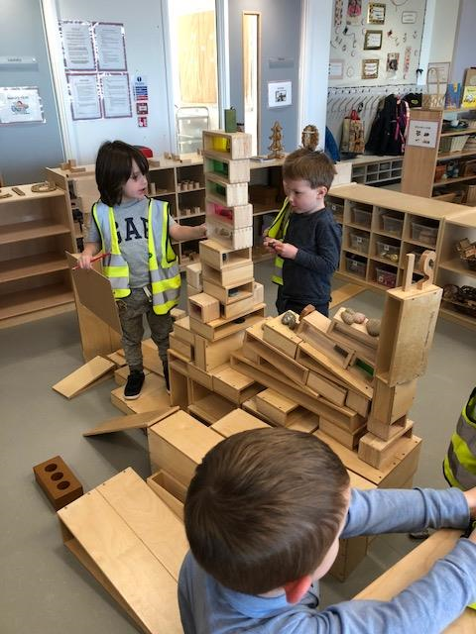

How we report to Parents

Parents will receive information about their children's progress and their journey through the Curriculum.

For new parents each child has a personal plan which includes 6 stages as detailed below:-

Stage 1: Enrolment Pack (complete with parent)
Stage 2: About Me Booklet
Stage 3: About My Nursery Booklet
Stage 4: Review / Settling In Meeting
Stage 5: Termly Learning Stories
Stage 6: Termly Learning Log / Meeting

Learning passports and care plans are shared with parents on a regular basis giving parents the opportunity to be involved in the assessment process.

Staff will consult with parents termly regarding their views on their child’s education and progress within the centre.

Staff are available to talk to parents daily.

How We Promote Learning

We promote learning by:

Understanding that children learn by building on, and extending their previous learning experiences.

Giving children the right to have a say in planning for their own learning.

Providing a stimulating and challenging environment which encourages the individual child to explore, experiment, discover and understand the world around them.

Acknowledge the importance of social inter-action with others, at home, at nursery and in the community.

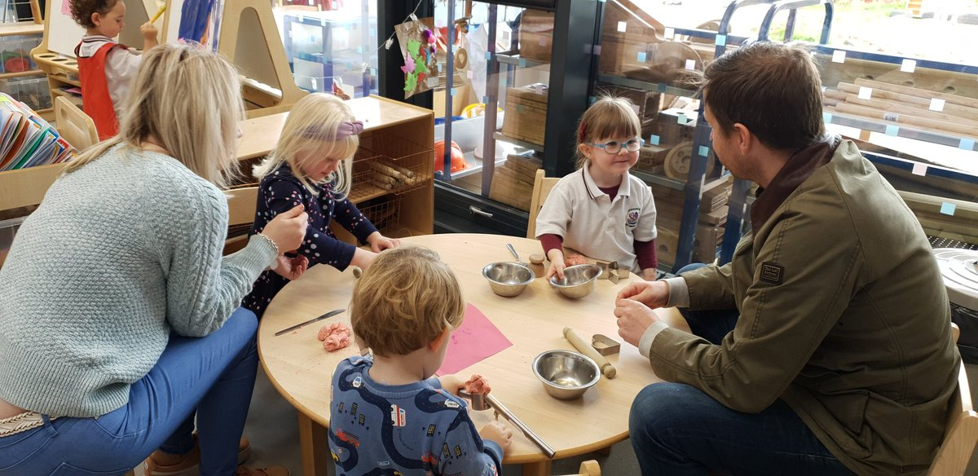

What Active Play Means

Active play is important for the development of children because it is the way a child learns.

Through active play and exploratory situations the individual child is preparing himself/herself for the next stage in their developmental learning.

Free Play

Free play allows the individual child the opportunity to choose from a broad range of activities and experiences. This allows them to develop interests, to try out different ways of learning and to explore materials and relationships. Intervention by adults during free play activities should be sensitively targeted to support or extend the learning experience.

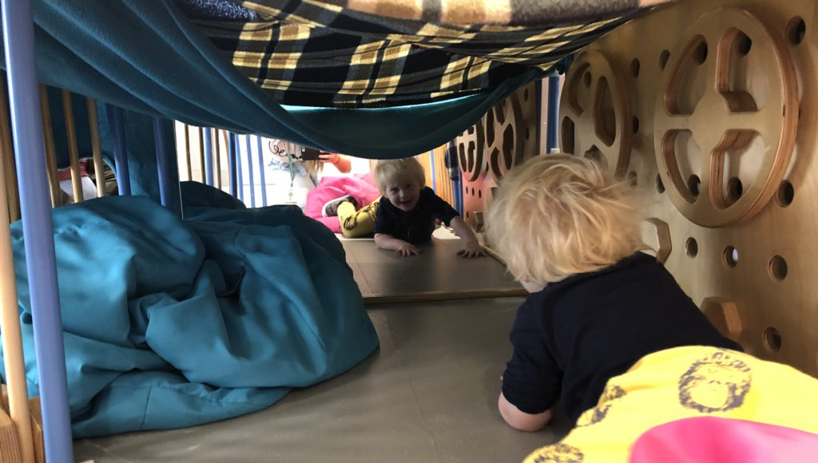

Education for Citizenship

At Glenpark Early Learning Centre, we aim to support the governments’ citizenship priority. The creation of a good citizen is a process which begins at a very early stage in your child’s life. Parents, carers and members of the community and staff within the

Centre will make a powerful contribution to this process.
Citizenship is about making informed choices and decisions, about taking action individually, and as part of collective processes.
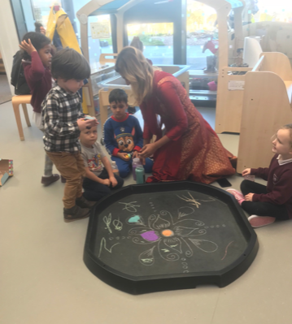

Group Times /Planned Learning Experiences

Group times allow staff to stimulate interests, to teach, develop and practice skills, to revisit and extend previous learning experiences in order to bring continuity to learning and to probe children’s thinking. The observation and assessment of children’s progress will determine the specific activities and experiences provided at such times.

Promotion of a Positive Ethos within the Establishment

This establishment strives to provide a home-like, emotionally secure atmosphere where the staff are friendly, approachable and work towards creating a
warm and caring environment.

This fosters positive attitudes and encourages confidence and self esteem which therefore promotes a positive ethos within the Centre

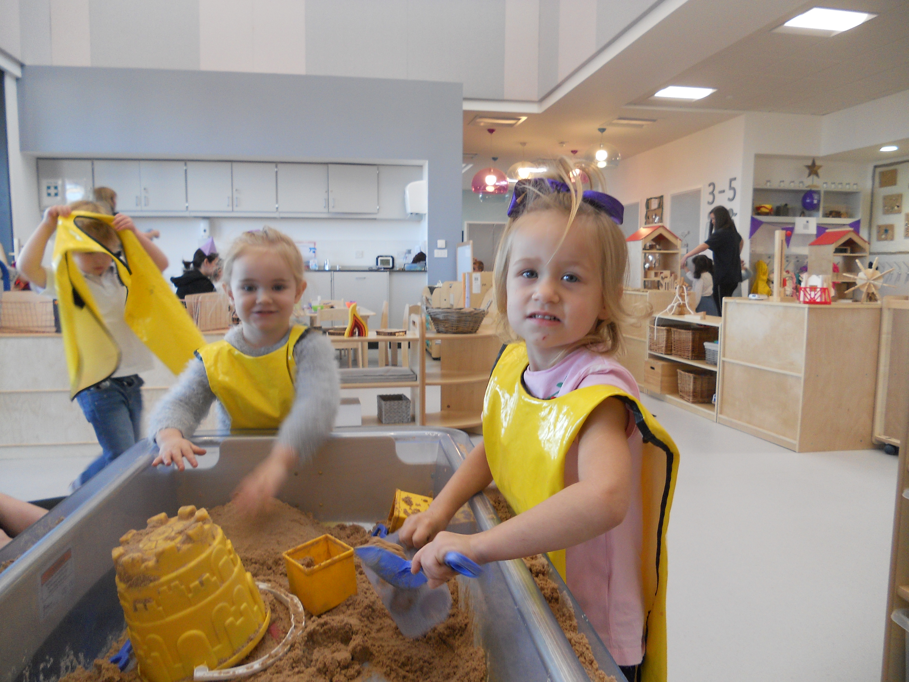

Early Intervention

At Glenpark Early Learning Centre we aim to develop children’s literacy and numeracy skills through play. The centre provides children with a literacy and numeracy rich environment. Children are encouraged to take part in activities and experiences that promote interest and develop early skills in reading and writing and counting.

Children are encouraged to listen carefully to sounds and rhymes, to handle books correctly and to engage with stories. They are encouraged to express their thoughts and feelings with regard to stories and rhymes through retelling them in their own words, recalling and predicting events.

Children are encouraged to enjoy books and stories and other language based activities on a daily basis, and every month the children have a rhyme of the month.
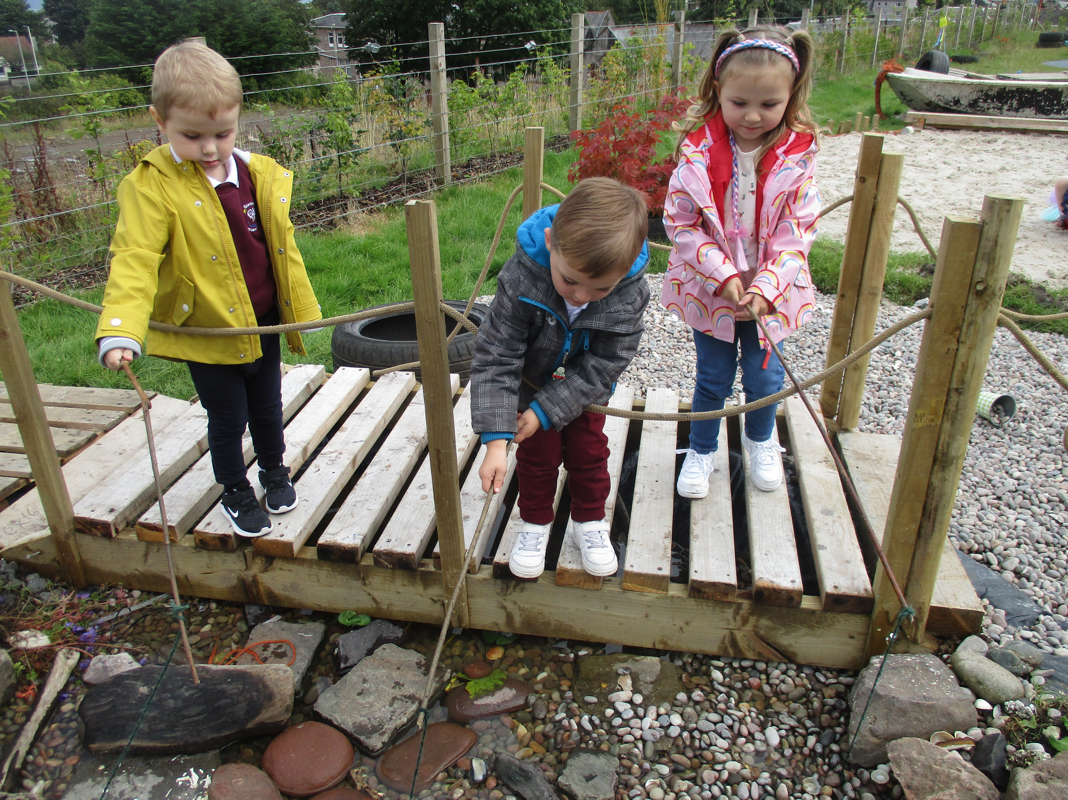

Establishment Procedures for Reporting to Parents

At Glenpark we operate a Keyworker System. We work with parents to support the learning of the individual child by talking and sharing information on a daily basis. The child’s learning logs and stories are sent home for parents to sign and if you wish you can actively be involved in this learning at home. Parents days/evenings are held at regular intervals throughout the year and staff will inform you of these dates. Parents are actively involved in the assessment and recording procedure through the child’s Record of Achievement Book which contains the learning stories and assessment information.

As we operate an open door policy, parents are welcome to visit the Centre at any time to discuss the progress their child has made at the centre.

Further information on Curriculum for Excellence can be found by logging on to Education Scotland Website www.educationscotland.gov.uk or www.educationscotland.gov.uk/parentzone

Parents can also find other information regarding parenting on both these websites.

School Improvement

For all information regarding our nursery improvements, please refer to the nursery standard and quality report and our strategic improvement plan on our website or a copy can be found in the foyer.
http://glenparkelc.inverclyde.sch.uk

Section Five

Transitions

Children experience transitions in a wide range of ways throughout their lives. This can include transitioning from home to nursery or from a 2-3 room to 3-5 room and later to school. We seek to ensure that we support every child with a tailored and unique transition particular to their own needs or experiences.

The key to effective transition is effective communication between the early year’s establishment, school and parents. The transition between the 2-3 room and 3-5 room is integrated within the 2-3 room provision, with shared learning experiences, celebrations and resourcing throughout the year.
The school transition process will begin early in the pre-school year and continues into early primary 1.

We will work closely with our local primary schools to support children through their transition period.
Children are normally transferred between the ages of 4 ½ and 5 ½ years, although this may be negotiated in exceptional circumstances.

Notices about the exact dates and times for registering children will appear in the local press during the first week in January. Notices will also be displayed in this establishment prior to the enrolment dates.

Please note that there is a statutory requirement for all children to attend school by the first entry date after they attain their fifth birthday.

Information about placing requests to a school of your choice or for early entry to school can be obtained from your local primary school, or from the Education Department. See Section 9 under Useful Addresses.
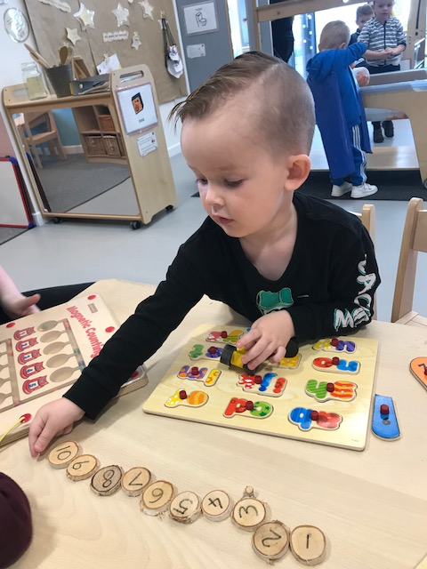

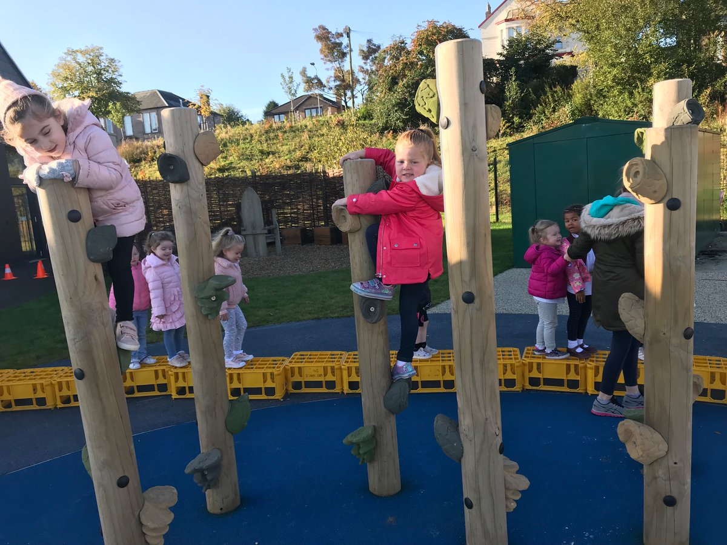

Supporting Children

(GIRFEC)

Every member of staff has a responsibility to support the learning of all children, and our aim is ‘Getting it Right for Every Child.’ The type of support offered will vary according to the needs of the children. This includes consideration given to children who have a disability, children with social, emotional and behavioural difficulties, children with learning difficulties of a specific or general nature, children who are exceptionally able, those who demonstrate underachievement relating to gender issues, children whose learning has been interrupted through absence or illness, bilingual children who have English as an additional language, travelling children and those children whose family circumstances impact on attendance and learning. Partner agencies may be asked to offer support where necessary.

Parents can receive further information and support from the nursery or the local authority.
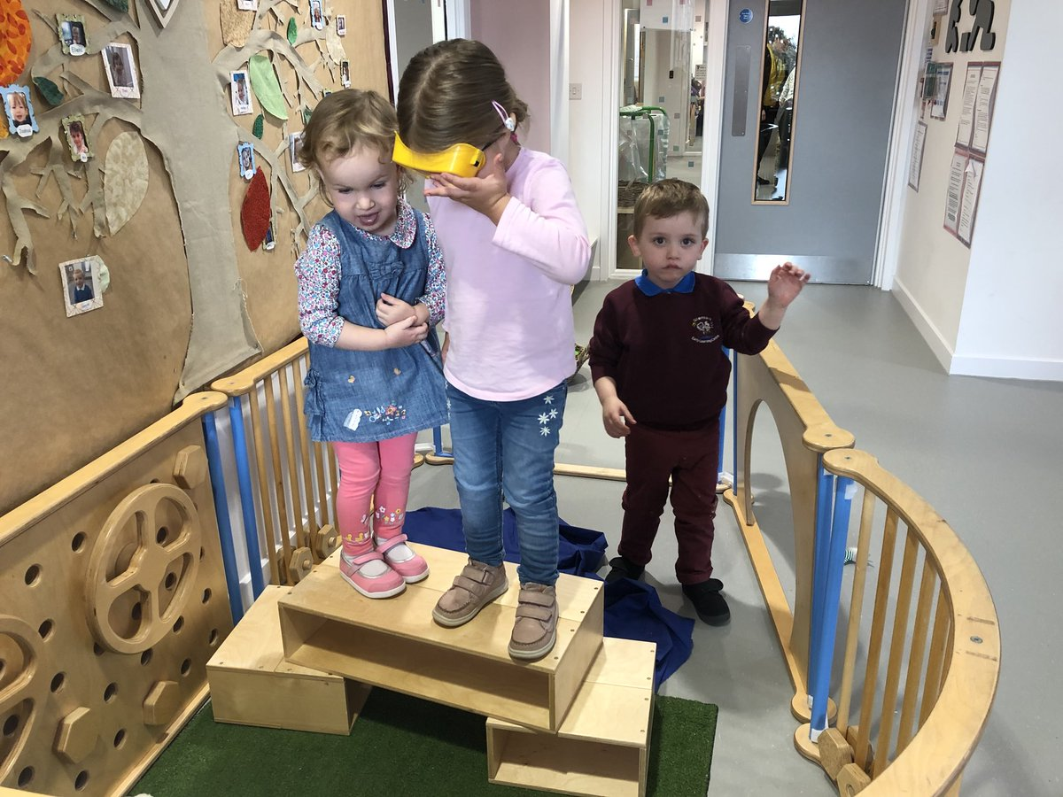

Education (Additional Support for Learning) (Scotland) Act 2009

Inverclyde Council’s Policy in Relation to Provision for Additional Support Needs

A child or young person’s needs are identified at the earliest possible stage and can be met in a number of ways, for example by adaptations to the curriculum or learning environment, as well as input from the Support for Learning Teacher and on occasion support from visiting specialists. The appropriateness of the support is determined through a process of assessment, planning and monitoring, working jointly with parents and carers, and is regularly reviewed.

Reaching Our Full Potential
Learning outcomes for children and young people with additional support needs are set out in a plan and all educational establishments hold regular review meetings with parents and carers to determine needs and the most appropriate supports. Everyone’s views are equally important in order to consider what is currently working and how to determine next steps

Working in Partnership
Children and young person’s needs are identified in a number of ways, and the process of assessment is an on-going, shared process with partnerships with parents and carers at the forefront. On some occasions health service staff or other partner agencies make children known to Education Services. Other additional support needs may be notified to Education Services by parents themselves or identified by one of a range of staff working closely with the child.
Co-ordinated Support Plans
Some children and young people will have additional support needs arising from complex or multiple factors which require a high degree of co-ordination of support from both education and other agencies in order that their needs can be met. In these cases, the school will hold a meeting to decide whether the child or young person meets the criteria for a co-ordinated support plan.
The coordinated support plan is a statutory document which ensures regular monitoring and review for those children and young people who have one.

You have the right to ask the education authority to establish whether your child needs a coordinated support plan. Your child can make this request themselves, if they are aged 16 or over. You and your child, if they want to, will attend a meeting with staff at their school. Other professionals from different agencies who may be involved in providing support for your child will also attend. If your child does not want to attend meetings or feels unable to, their views must still be sought and considered.
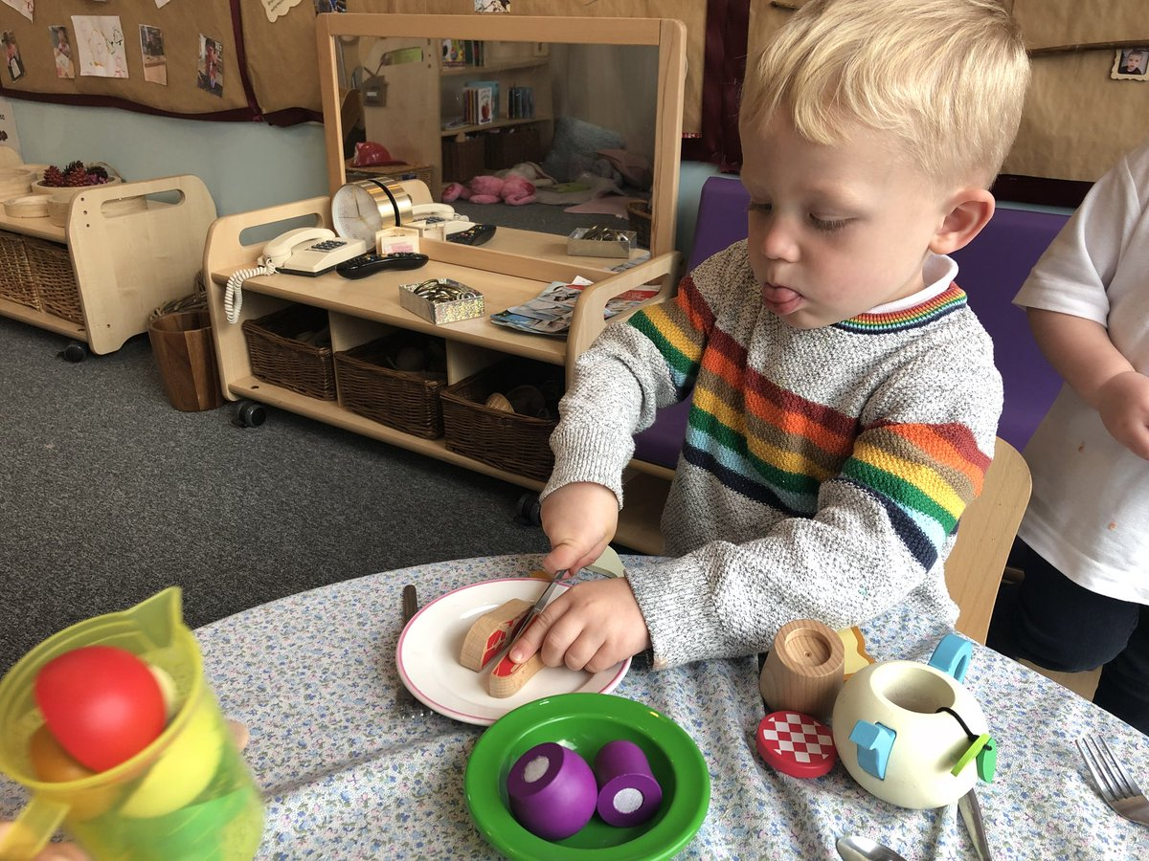

Inverclyde’s mediation service can be accessed by contacting Michael Roach, Head of Education, at the address below

The officer or officers of the authority from whom parents of children having additional support need, and young person’s having such needs, can obtain advice and further information about provision for such needs.

For further advice please telephone 01475 712850
Or write to:

Education Services
Wallace Place
GREENOCK
PA15 1JB
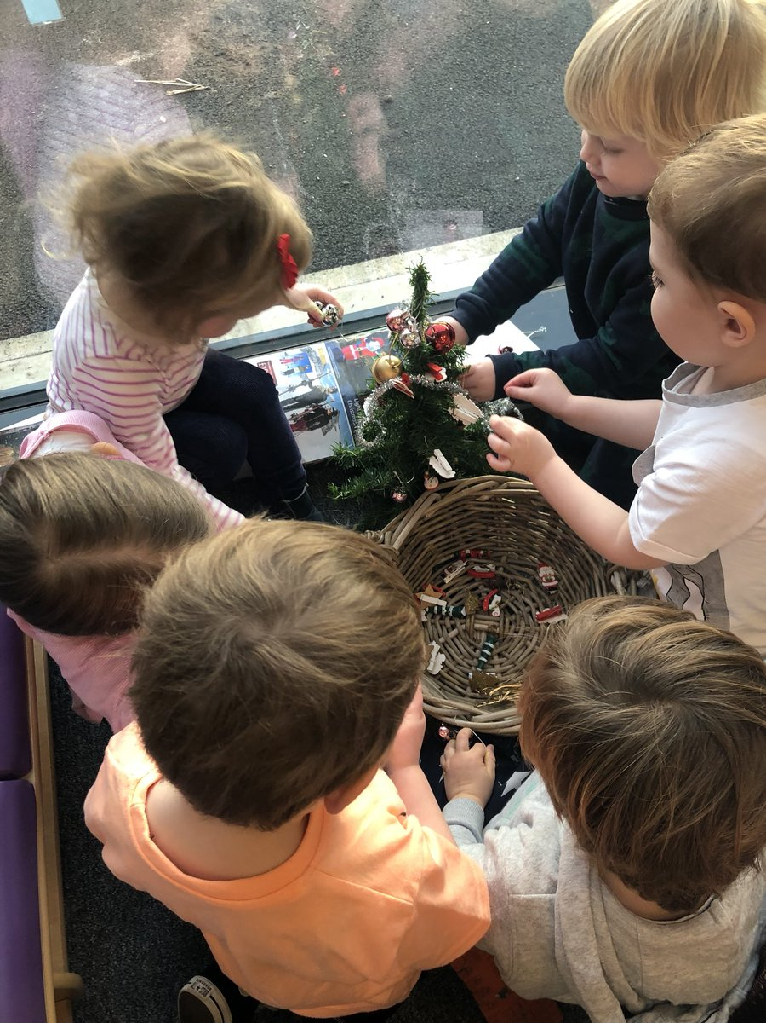

Liaison Arrangements

At the Centre we aim to make the transition to primary school as smooth as possible for your child.

The Centre arranges for teachers from the local primaries to visit the children at work within a familiar setting. Visits are normally arranged during the summer term by your local school for you and your child to meet his/her teacher.

Links with the Local Community

The nursery supports schools in the local community. Each year we provide an opportunity for pupils from the schools to come for work experience to the nursery.

The nursery has developed a programme of visiting local sheltered housing and care homes where we are building relationships through shared experiences such as yoga, singing and games.

Parental Partnership

At Glenpark Early Learning Centre we understand that parents are interested in the education of their children and should be given the opportunity to demonstrate this in a variety ways.

We value the contribution that parents can make to the Centre and appreciate the importance of staff and parents forming warm, non-judgmental and effective partnerships.

The parents group meet regularly on a Friday morning; please feel free to drop in for a coffee.
Parents are encouraged to be actively involved in the monitoring and evaluating of the service.

Regular newsletters are sent home to parents which includes dates for their diary. We keep all parents regularly updated through text messaging, emails and notice boards
.
https://www.inverclyde.gov.uk/education-and-learning/parental-involvement
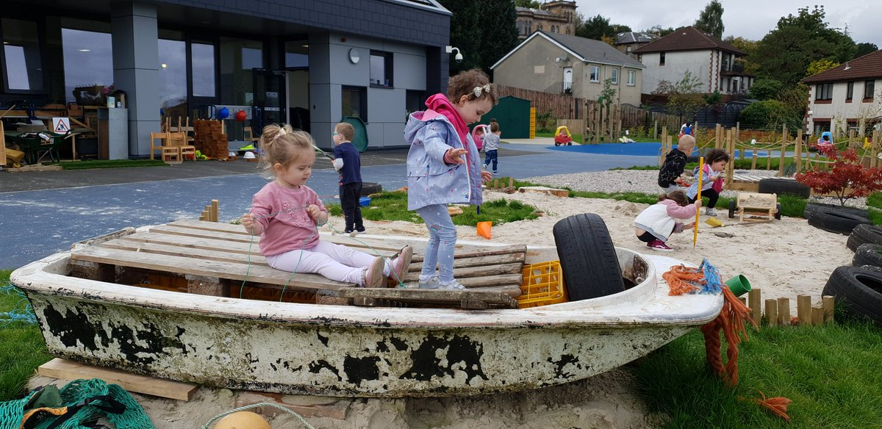

Section Six

Medical and Health
(Information and Procedures)

It is important that staff is informed about any medical condition which requires treatment or of any circumstances which would affect the child’s progress.
While staff is not required to administer medicines or treatment as part of their official duties, nevertheless in the interests of the child most staff are willing to administer prescribed medicines at the discretion of the head of the establishment.

If your child takes ill while at nursery we may have to telephone you to collect your child early. Please ensure that all emergency contacts are kept up to date.

ONLY PRESCRIBED MEDICINES CAN BE GIVEN BY STAFF TO CHILDREN!

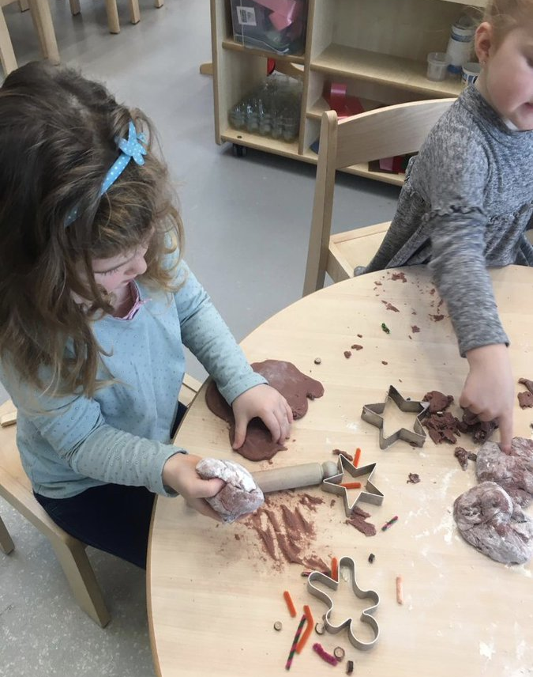

Minor Accidents

If your child has a minor accident while at the nursery, the incident will be dealt with and recorded.

We will inform you at the time, if necessary, or when you collect your child. We will also ask you to sign the Record of Accident/Incident book.

Dentists and dental hygienists continue to visit our pre-5 children providing advice and information.

The permission of parents is requested prior to any dental inspection.

It is essential to report any infections such as head lice, scabies or impetigo, or diseases such as German measles to the Head of establishment so that other parents and, in the latter case, pregnant women in contact with the establishment can be informed.
Eye screening takes place at the nursery periodically – you will be asked to fill in a consent form giving your permission for this to happen.

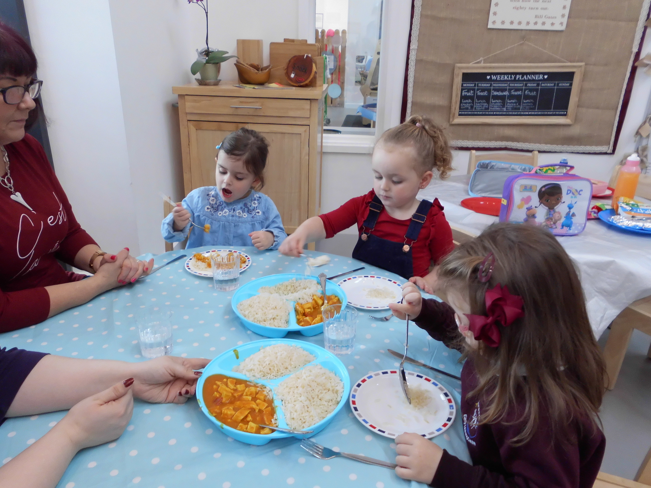

Healthy Eating

Healthy eating is encouraged within the centre by the provision of a snack for children during both morning and afternoon sessions. These snacks vary each day but they generally include milk or water, fresh fruit or toast.

Birthdays are celebrated at the nursery and the children have a ‘large’ snack. Therefore, we ask that you do not send in cakes or food as we provide all snacks for the children.

Smoking

Inverclyde Council has a No Smoking policy in all educational establishments.


Section Seven

Safety

To ensure the safety of children it is a requirement that only a responsible adult can bring a child to or collect a child from a pre-5 establishment.

Children will not be allowed to leave the Establishment unless accompanied by a ‘responsible adult’.
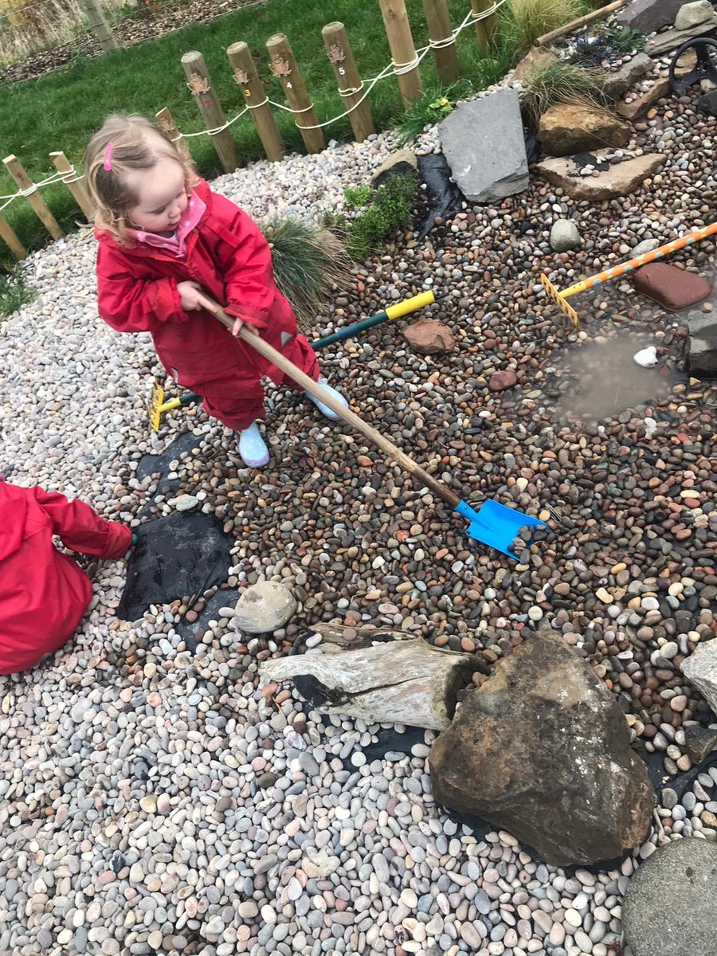

Clothing

There are forms of dress which are unacceptable
in school, such as items of clothing which:

    - Potentially, encourage faction
(Such as football colours)

    - Could cause offence (such as
Anti-religious symbolism or political slogans)

    - Could cause health and safety difficulties such
as loose fitting clothing, dangling earrings
or clothing made from flammable material
for example shell suits in practical classes

    - Could cause damage to flooring

    - Carry advertising, particularly for alcohol
or tobacco and

    - Could be used to inflict damage on other pupils
or be used to do so

The council is concerned at the level of claims being received regarding the loss of children’s’ clothing and/or personal belongings. Parents are asked to assist in this area by ensuring that valuable items and unnecessarily expensive items of clothing are not brought to the establishment. Parents should note that the authority does not carry insurance to cover the loss of such items and any claims submitted are likely to be met only where the authority can be shown to have been negligent.

Parents should note that the activities the children may become involved in may be restricted because health and safety requirements state that jewellery of any kind must not be worn where children are undertaking physical activities. This includes jewellery worn as a result of body piercing.

Outings

Outings and excursions are an important part of the curriculum. When outings or excursions for children are planned, the Head of Centre or your child’s Keyworker will advise you in advance. You will be asked to complete consent forms which give your permission for your child’s participation.

We ensure that a risk assessment has been carried out for each outing.

Please note that children cannot take part in outings unless completed consent forms have been submitted by their parent/guardian.

Fund-raising

The Centre has two major fund-raising events each year: one in the ‘Spring’ to help cover costs of outings and special events and one in the ‘Autumn’ to enable us to purchase a Christmas gift for each child. We also have raffles throughout the year.

We also support one charity per year.
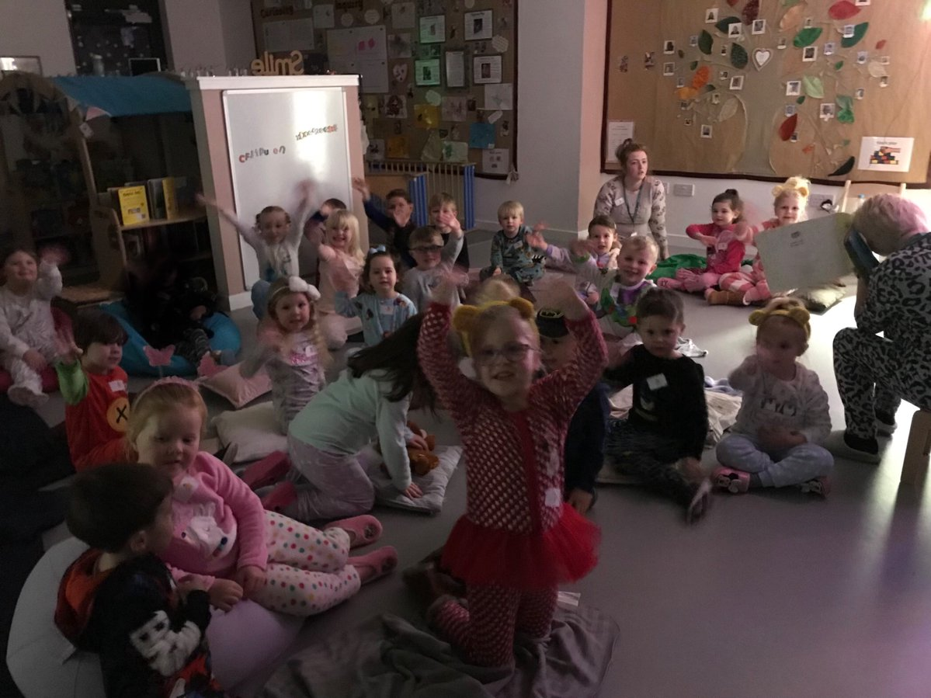

Some of the Centres, Achievement’s & Improvements

The many achievements of the centre include receiving two excellent grades in a recent Care Inspectorate visit, followed by a Grand Ball of Excellence for children to celebrate the achievement.

The staff & children developed our nursery garden to create a stimulating environment for the children to learn outdoors.
Staff implement a comprehensive approach to ‘Getting it Right for Every Child and Family’ using Inverclyde’s GIRFEC pathway. Learning passports are shared with parents enabling parents to continue learning at home.

Each child is supported by a Personal Learning Plan from the beginning of their placement and shared with parents throughout their time at nursery.

The management team will continue to track children’s progress ensuring appropriate learning and teaching is being delivered to all children.

Further information can be found within our ‘Standards & Quality Report’ which is available on the nursery website.

Section Eight

Suggestions and Complaints


We are committed to maintaining and improving our service. If you have any suggestions to make about the service, please contact the head of establishment in the first instance. Similarly, if you have a complaint about any aspect of the service you should contact the Head of Establishment. If you feel your complaint has not been dealt with satisfactorily please see section on useful addresses.

Equal Opportunities and Social Justice

Inverclyde Council Education Services aims to: offer education of the highest quality to all young people within a developing culture of inclusion

Endorse the principles of inclusion, entitlement and equality of opportunity in the development of best practice

Value the diversity of interests, qualities and abilities of every learner

Believe that every child and young person is entitled to educational opportunities which enable the achievement of success and further development of the individual’s learning potential within the least restrictive environment

Affirm the right of all young people to have access to the highest quality of educational provision which is appropriate to learning needs, is supportive of the young person and is delivered in partnership with young people, parents and the wider community

In meeting the needs of all of our pupils we will demonstrate no discrimination on the basis of race, gender, disability, sexual orientation, religion or belief. This encompasses curricular, extra curricular and playroom activities and is foremost in the attitudes which we develop in our pupils.

The Equality Statement for Inverclyde Establishments

‘Inverclyde Education Service is committed to ensuring that no children or members of staff or service users receive less favourable treatment on any ground including gender, race, disability, age, sexual orientation, religion or belief. We have a moral, social and legal obligation to mainstream and put equality at the heart of everything we do. We aim to promote a culture in which equality of opportunity exists for all. We are opposed to all forms of discrimination, direct or indirect, and aim to eliminate all discriminatory practices. We will ensure that, in our schools and other educational establishments, equality permeates the curriculum and underpins all our policies and practices in terms of access to education. We must ensure that all our children achieve their full potential to develop physically, emotionally and academically. Finally, we believe that equality and inclusion should be a given right, where everyone is valued and treated with respect.’

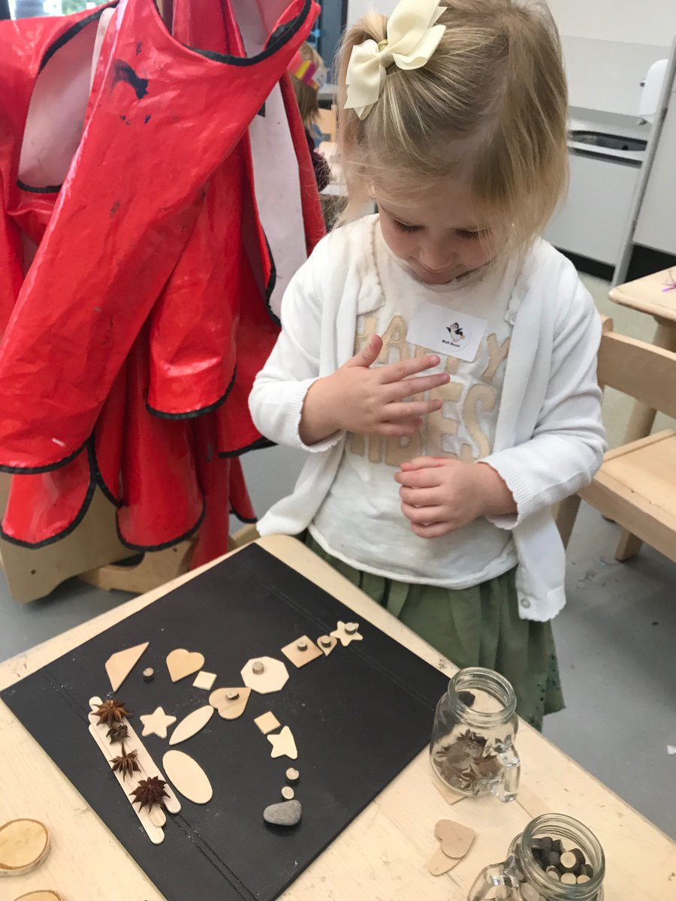

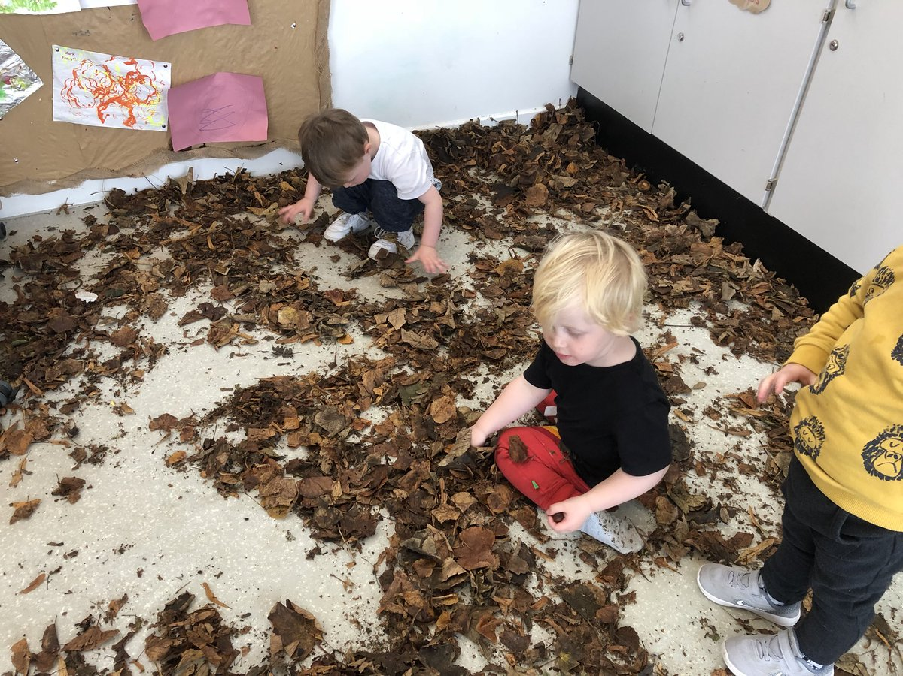

Data Protection Act 1998



Information on children, parents and guardian is stored on a computer system and may be used for teaching, registration, assessment and other administrative duties. In processing personal information, Inverclyde Council must comply with the General Data Protection Regulation and Data Protection Act 2018..

For further information please refer to
https://www.inverclyde.gov.uk/site-basics/privacy or click on the following: Privacy page link

Section Nine

Information in Emergencies



We make every effort to maintain a full educational service, but on some occasions circumstances arise which lead to disruption. Establishments may be affected by, for example, severe weather, and temporary interruption of transport, power failures or difficulties of fuel supply.

In such cases, we shall do all we can to let you know about the details of closure or re-opening. We shall keep you in touch by using text alerts, letters, notices in local shops and community centre’s announcements in local churches and announcements in the press and on local radio.

Useful Addresses and Further Support and Information for Parents


Ruth Binks
Corporate director of Education,
Communities, and Organisational Development
Education Services
Wallace Place
Greenock
PA15 1JB
01475 712850

Michael Roach
Head of Education,
Wallace Place
Greenock
PA15 1JB
01475 712850

Linda Wilkie
Quality Improvement Officer
(Early Years)

Municipal Buildings

Clyde Square
GREENOCK
PA15 1LY
Tel: 01475 712892

Local Councillors

Ward 4 - Inverclyde North

Martin Brennan
Jim Clocherty
Graeme Brooks
Elizabeth Robertson

Children in Scotland:
www.enquire.org.uk

Scottish Independent Advocacy Alliance:
www.siaa.org.uk

Scottish Child Law Centre:
www.sclc.org.uk

If you have any complaints regarding any issues please contact:
The Care Inspectorate



Headquarters, Care Inspectorate
Compass House
11 Riverside Drive
Dundee
DD1 4NY
Tel: 01382 207100

Or
Telephone: 0845 600 9527
Email: enquiries@careinspectorate.com

Although this information is correct at time of presenting, there could be changes affecting any of the matters dealt with in this document –

- before the commencement or during the
course of the school year in question

- in relation to subsequent years

Appendix One:

Clothing grant and free school meals 2018/19

Appendix Two:

Public Holidays & In Service Days
2018-2019

