Week 1 | Monday | Tuesday | Wednesday | Thursday | Friday
Option 1  (Red) | Quorn Katsu Curry  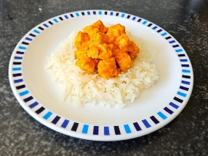 | Chicken Goujons with potato wedges  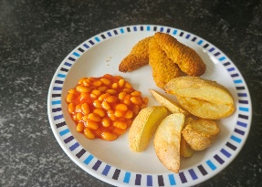 | Beef Bolognaise  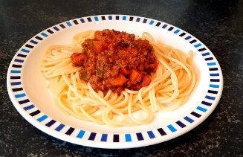 | Quorn dipper with mash potato (v)  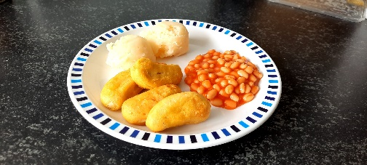 | Fish fingers with mash  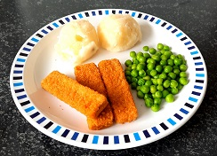
Option 2  (Blue) | Baked Potato with Cheese (v)  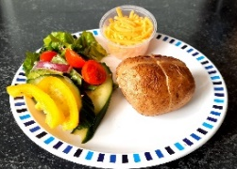  Or Tuna  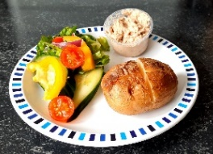 | Tomato and basil pasta(v)  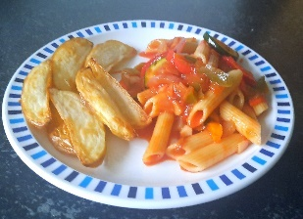 | Baked Potato with Cheese (v)  Or Tuna | Chicken sandwich  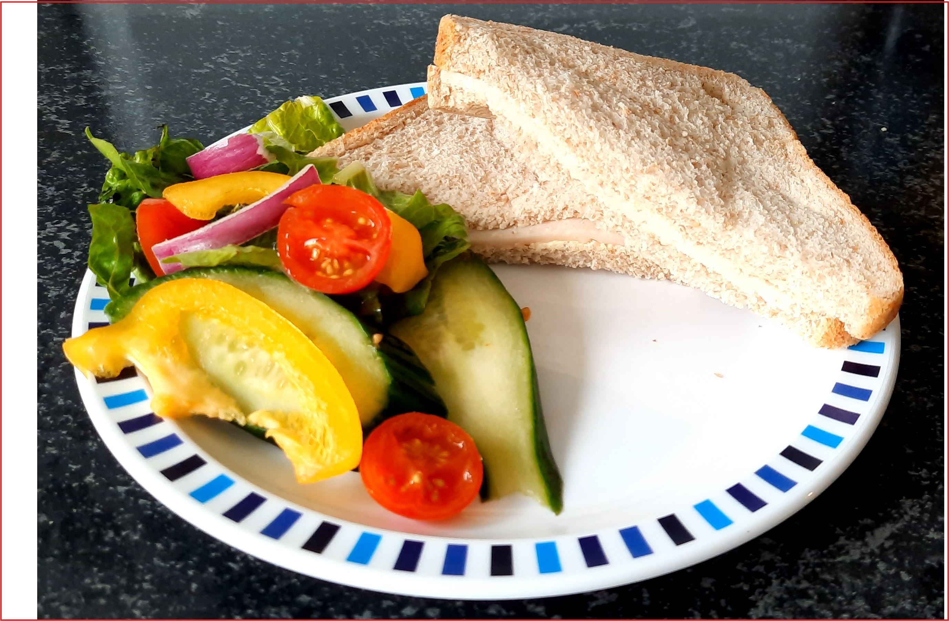 | Cheese Sandwich (v)  