**What age should you start to talk to your child about online safety?**

*“As soon as your child shows an interest in engaging with technology, it’s time to begin sharing simple online safety strategies with them.”*

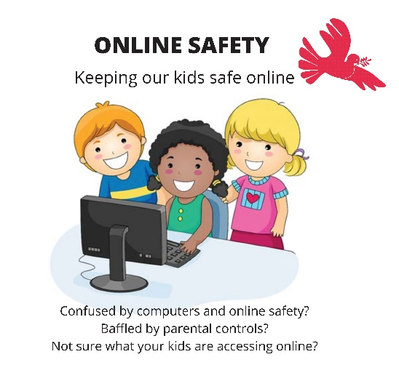*Will Gardener (CEO of Childnet)*

**Online Safety – Tips for parents**

You can:

* manage the content that your children see.
* ensure the interactions they have are suitable.
* manage how long they’re online, in balance with other activities.
* There are several things you can do to help support a child, including using specific apps and checking app settings.
* Avoid electronic devices at least an hour before bed, as mobiles, tablets and computers all throw out blue light that stops sleep.



*Useful Web links:*

[Childnet — Online safety for young people](https://www.childnet.com/?gad_source=1&gclid=EAIaIQobChMIp-7omY7MhAMV-JhQBh3hNAsgEAAYASAAEgLwNvD_BwE)

Please see below information from Barnardo’s about keeping your child safe online:

[Keeping children safe online - Parent’s questions answered | Barnardo's (barnardos.org.uk)](https://www.barnardos.org.uk/blog/online-safety-parents-questions?gclsrc=aw.ds&gad_source=1&gclid=EAIaIQobChMI0rLDv4jMhAMVw5VQBh26ewHoEAAYASAAEgIpN_D_BwE)

Parents Cyber First Aid Kit- designed to for families to support children and young people when they experience a cyber incident by supporting discussions and steps to recovery:

[Parents’ Cyber First Aid Box – DigiLearn (glowscotland.org.uk)](https://blogs.glowscotland.org.uk/glowblogs/digilearn/2022/08/02/cyber-first-aid-box-new-resource/)