Introducing Woodwork in Early Learning and Childcare

A Guide for Staff 2020/23

Inverclyde Education Services

Contents

Introducing Woodwork in the Early Learning and Childcare

A Guide for Staff 2020/23

History 3
2
Benefits of Risky Play 4
Learning and Development 5
Parental Involvement 6
Adult Role 7
Getting Started 8
Tools 9
Introducing Woodwork 10
Appendices 11-16

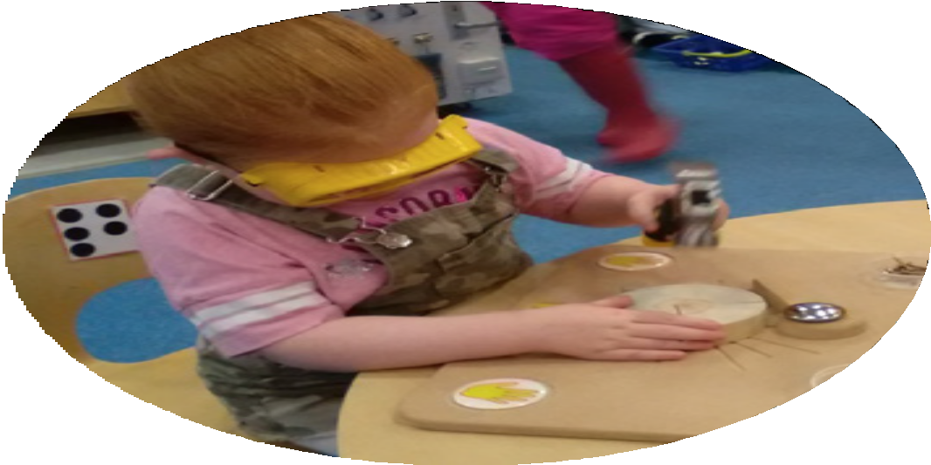

History

Introducing Woodwork in the Early Learning and Childcare

A Guide for Staff 2020/23

Records of woodworking go back as far as Froebel (1782 - 1852) where he believed children were active learners and that woodwork encouraged holistic learning.
3

Woodworking has links to early block play, linking to Froebel’s gifts.

Nursery and primary schools which were established in the late 1800’s had woodwork as a common place in their curriculum. This remained in place right through until 1970s. During the 80s and 90s woodwork became discouraged due to it being deemed too risky, as well as having health and safety implications.

It has only recently started to make a comeback as children are being encouraged to take more risks and challenge their development.

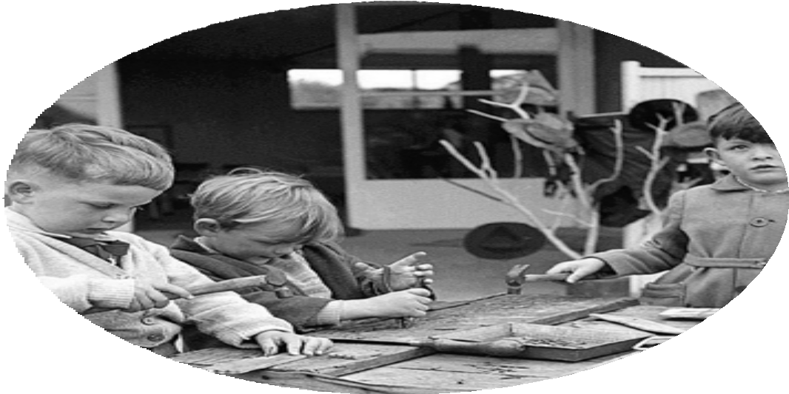

Introducing Woodwork in the Early Learning and Childcare
4

A Guide for Staff 2020/23

Benefits of risky play and the use of tools
Risky play can be defined as play that provides opportunities for challenge, testing limits, exploring boundaries and learning about injury risk. Woodworking is one example of risky play which has many benefits.

These include but are not limited to:
- Hand eye co-ordination and manual dexterity;
- The development of fine/gross motor skills;
- The development of problem solving and creative thinking skills;
- Increased imagination and spatial awareness;
- Developing resilience, persistence and a sense of agency;
- Developing independence skills and fostering a sense of curiosity;
- Developing concentration;
- An increased awareness of risk and how to manage personal safety.
Staff and parents can be apprehensive about risky play; however in the past decade there has been an increased focus on the benefits of this type of play. Staff should not fear this type of play or worry that it is somehow dangerous. If properly managed it is a wonderful addition to the Early Learning and Childcare environment.

Throughout this booklet we will aim to support staff to develop the use of woodwork within their Early Learning and Childcare environment and to provide a step by step guide to introducing tools.

Many external agencies also promote the use of risky play

The Care Inspectorate’s position statement:
“The Care Inspectorate supports care service providers taking a positive approach to risk in order to achieve the best outcomes for children. This means moving away from a traditional deficit model that takes a risk-averse approach, which can unnecessarily restrict children’s experiences attending registered services, to a more holistic risk-benefit model. For example, we encourage services to use risk assessment to support children to enjoy potentially hazardous activities such as woodwork using real tools, exploring nature and playing in the mud and rain.

Health and Safety Executive Position Statement:
Health and safety laws and regulations are sometimes presented as a reason why certain play and leisure activities undertaken by children and young people should be discouraged. Such decisions are often based on misunderstandings about what the law requires. The HSE has worked with the Play Safety Forum to produce a joint high-level statement that gives clear messages tackling these mis-understandings. HSE fully endorses the principles in this Statement.

This statement makes clear that:
- Play is important for children’s well-being and development
- When planning and providing play opportunities, the goal is not to eliminate risk, but to weigh up the risks and benefits
- Those providing play opportunities should focus on controlling the real risks, while securing or increasing the benefits – not on the paperwork
- Accidents and mistakes happen during play – but fear of litigation and prosecution has been blown out of proportion

Introducing Woodwork in the Early Learning and Childcare
5

A Guide for Staff 2020/23

Learning and development
When working with woodwork it is amazing to see how much learning is involved by participating in one simple activity. Woodwork incorporates many areas of learning and development. As well as linking different aspects of the curriculum, it supports current thinking about how children learn. It is the perfect activity to foster curious minds. Lifelong skills are also developed through the participation of woodwork in the following areas:

Personal, social and emotional development:
- Children develop confidence and responsibility when allowed to work with real wood and tools
- They develop their self-esteem and a sense of accomplishment
- They will take pride in their creations and have satisfaction in learning new skills
- They will have increased concentration and problem solving skills
- Development of social skills when sharing ideas with others
- Children develop an awareness of risk management and the ability to take personal responsibility for their own safety.

Physical development:
- Hand eye co-ordination is developed in woodwork and children will gain increasing control over their bodies
- Fine motor skills will develop when using screwdrivers and holding nails
- Increased gross motor skills when hammering and screwing, including the development of larger shoulder and back muscles
- Core strength developed by sawing, filing, drilling, using claw hammer etc

Communication and language:
- Lots of discussions and a variety of language will be used in the woodwork area, when children discuss tools and express their ideas they learn new words and vocabulary
- Children with English as an additional language will have less difficulties as woodwork is visually demonstrated

Mathematics:
- Children will measure pieces of wood, and look at the different shapes, sizes and weight during their explorations in woodworking
- They will expand their learning by estimating what length of nail to use, or how long a piece of wood needs to be
- They will explore numerals when using measuring tapes etc in the course of woodwork

Expressive arts and design:
- Children will explore design and make models using a variety of resources
- Encouraging children to use their imagination and interest to create a model
- They will think creatively, this is a life skill that supports all areas of learning

Literacy:
- Literacy skills will be developed in a variety of ways including:
  - Drawing ideas on paper • Planning a task • Drawing on wood • Writing about their work

Introducing Woodwork in the Early Learning and Childcare
6

A Guide for Staff 2020/23

Parental Involvement
Parents can be apprehensive about woodworking and in order to ensure they are comfortable with this type of learning we must ensure we promote the use of tools and encourage them to understand the benefits.

Woodworking is a good way to engage parents and involve them in their child’s learning. You must support parents to understand the activity, how it is risk assessed and its benefits.

Some of the ways you can do this:
- Create an information leaflet detailing the benefits and the safety measures put in place to protect their child.
- Parents can be welcomed in to see the programme and any concerns can be discussed to reassure them about their children being involved in the programme.
- Drop in workshop/stay & play days are also successful way for parents to get to know the programme and explore the tools alongside their children.
- Parents who have experience in woodwork could share information and their skills and knowledge
- A dedicated webpage and increased use of social media to champion woodwork and it’s benefits

Introducing Woodwork in the Early Learning and Childcare
7

A Guide for Staff 2020/23

Adult role
The adult role is an important one when delivering woodwork to children. Adults are responsible for setting up the area and restocking resources. As well as ensuring children have the opportunity to work through ideas in a way which fosters their curiosity and imagination.

Children should not be encouraged to ‘woodwork by numbers’, but instead be afforded the opportunity to tinker and explore in a responsive way. Adults should carefully scaffold children’s learning and provide support where necessary.

The adult should be comfortable using the tools and be able to support the children in using them. Through effective role modelling the adult should show children how to use the tools safely, scaffolding their learning throughout the programme.

Adults should also have a flexible and tolerant approach to encourage and develop children’s abilities. It is advised that before undertaking woodwork with the children adults tinker and explore the tools for themselves to increase their confidence and ability. Woodworking can be messy and noisy and staff need to be tolerant and flexible.

Heath and safety is important when delivering woodwork. The adult should ensure risk assessments are in place and are followed in line with policy. Adults need to be confident in their ability and adopt a risk benefits approach to this activity.

The Role of the Adult
- Provide physical support - For example helping a child develop grip
- Resourcing - Ensuring the area is well stocked
- Health and Safety - Monitor the safety of the play space
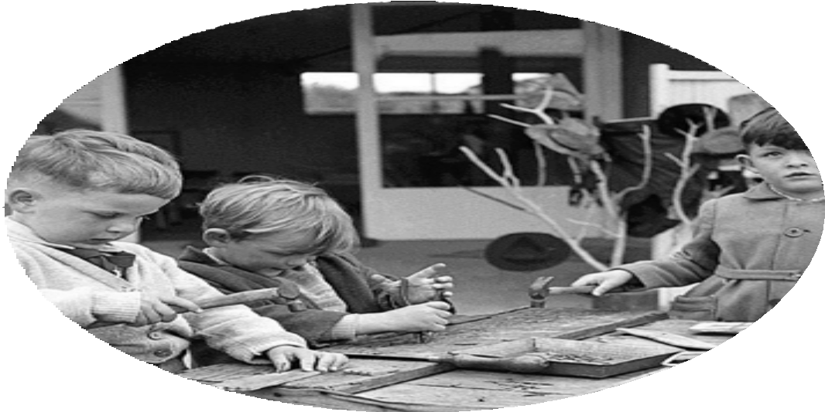
- Interaction - There needs to be dialogue to help scaffold the learning. Practitioners have a fundamental role in ensuring through careful
observation that children are engaged appropriately

Introducing Woodwork in the Early Learning and Childcare
8

A Guide for Staff 2020/23

Getting started
The recommended age for children to participate in woodwork programme is children in their pre-school year, although practitioners will know their children well enough to assess if they have the skills that are required and if the programme will be relevant.

Specific skills are required for participating in the programme. These include:
- Concentration
- Co-ordination
- Listening skills
- Curiosity (Interest in woodwork)
Early skills can be developed through the use of resources such as Tic-Tac (hammer and pins).

Before you introduce woodworking you should:
- Have a discussion with your team and set the rules.
- Purchase appropriate resources.
- Conduct risk assessments - examples can be found in the appendices.
- Evaluate the impact woodworking will have on the play environment - It can be noisy and requires adult supervision.
- Develop a programme which works for your environment - an example of this is given in the appendices.
- Identify the children who are developmentally ready to explore woodwork

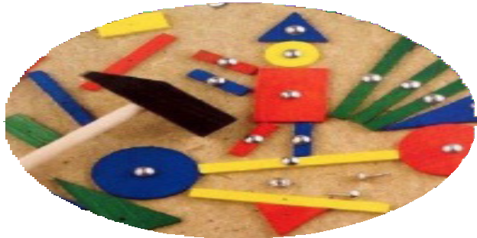
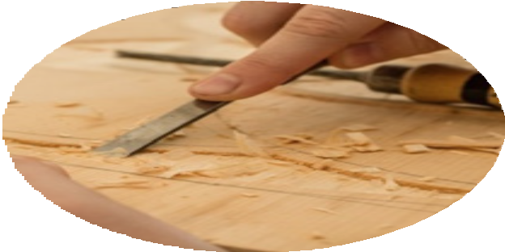

Introducing Woodwork in the Early Learning and Childcare
9

A Guide for Staff 2020/23

Tools
- Workbench with vice • Pozidriv Screwdriver
- Junior safety glasses • Hand drill / Palm Drill
- Stubby claw hammer • Japanese Saw
- Nail Puller • Measuring Equipment
- Rasps • Large Magnet
- Sandpaper • Screws/Nails
- Balsa Wood

Setting up the woodworking area

When setting up your woodworking space here are some things to consider:
- Can it work well both indoors and outdoors - what is best for your service?
- Is it free from distractions?
- How much noise will affect other parts of the play space?
- Is there a safe high space to store saws etc?
- How many children can do woodwork at any one time?
- Which staff member is taking responsibility for the area?
- Do you have enough resources?
- Have the children had opportunities to work through a programme to develop confidence before it is part of the general learning environment?

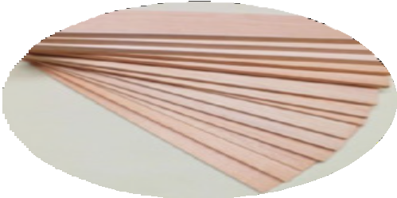
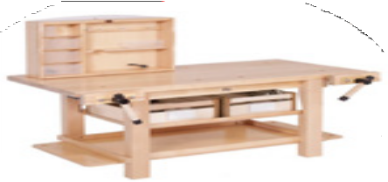
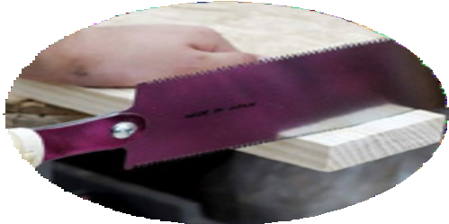

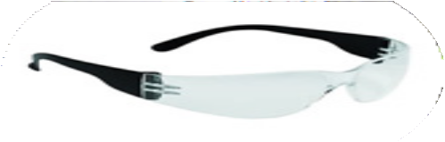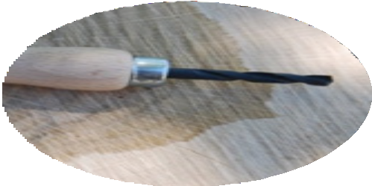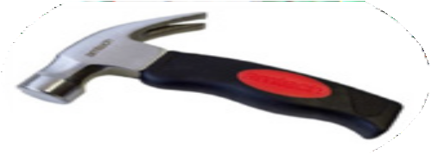

Introducing Woodwork in the Early Learning and Childcare
10

A Guide for Staff 2020/23

Introducing Woodworking
Woodwork should be introduced to a small group initially until all the children have an under- standing of the dangers and can use the tools safely. This is a good way to assess which children are ready for woodworking.

Tools should be introduced one at time in order to teach children the function of them, as well as how to use the tools.

Allow children to explore and tinker with the materials available.

Introducing the tools

Saw
Pete Moorhouse recommends beginning with the saw as the first tool you explore. Children learn how to cut a piece of wood to work with and how to stay safe. This activity should always be undertaken under supervision. When not in use, the saw should be stored out of reach.
2 saws recommended, a small Japanese Dozuki saw and a large pull saw for cutting through thicker wood.
When using the saw the wood should be held firmly in a vice.
Allow children to see and gently feel the teeth of the saw to understand the importance of staying safe.
Wood should be cut close to the workbench so it doesn’t vibrate while being sawn. One to one ratio at all times.
Children should not pass in front of the saw or try to watch from the front as this is a no go area.

Hammer
Introduce the hammer, demonstrate how to hold the hammer, showing children which part of the nail the hammer will hit. Demonstrating safety with hammer and emphasising how important it is to look at what you are doing.
Encourage children to risk assess for themselves and understand the importance of keeping safe.
Recommend use of the wooden dolly peg to hold the nail before hitting it with the hammer as this will prevent hitting thumbs and encourage hand to eye coordination.
Children are more than capable of holding the nail, dolly peg is only a suggestion or for those who need it for support.

Screwdriver/Drill
Introduce the screwdriver last. Demonstrate how to turn a screwdriver. Let children experiment turning the screwdriver into the wood. Continue to encourage safety and the children’s understanding of this.
When using the drill again, show children how to turn drill in the correct direction and keep the drill upright so drill bits don’t break.

Introducing Woodwork in the Early Learning and Childcare
11

A Guide for Staff 2020/23

Appendices

Sample programme (toolbox)
This is a suggested guide to implement a woodwork programme. It may take longer than 6 weeks, or children may work through it quicker, depending on their skills and ability. It is advised that all children have the opportunity to work through this in small groups before woodwork is used as part of any continuous provision.

Week 1
Staff should sit with children and explore the toolbox and the tools in it. Possible Enquiry
What are they used for?
How do they feel?
How do you use them?
What are the dangers?
Week 2
Introduce the saw to the children and discuss safety rules when using it. Provide the children with peg- board and wood vice to be used when using tools. Allow them to explore and use tools, re-enforcing the safety rules.
Week 3
Introduce hammer and screwdrivers and allow the children to tinker and explore how to use these tools and what they are able to do with them. Staff should reinforce safety rules
Week 4
Introduce the drills to the children and allow them to use the resource. Demonstrate what can be done with the drill and remind children of the safety rules. If available, use the drill power tool to show children how they work and discuss comparisons between them. Discuss risks when using the tools.
Week 5-6
Provide resources and pictorial prompts and allow children to explore and create using these. Children can follow the pictorial instruction and also make their own design using the resources available to them. Each week, add different resources from the box and consider what other resources would be available for the children to think about and make suggestions for themselves. Provide resources that do not require any tools to use and that may not be suitable for them to use along with the tools.
Weeks 5—6 will be in preparation for the following sections where children will be drawing and creating their own designs. They will access the materials they think will be best suited for their designs. Children will work at their own pace and not all children will get to these stages.
Throughout these sessions, it will be expected that children will develop a range of skills, these will include (but are not limited to, creativity, problem solving, designing, perseverance, developing their own ideas, turn taking, experimenting, investigating.

Introducing Woodwork in the Early Learning and Childcare
12

A Guide for Staff 2020/23

Appendices

Possible experiences and outcomes

Possible experiences and outcomes covered by woodwork
Week | Task | Experiences and outcomes | Resource
Week 1 | Introduce the tool box to the children and discuss the tools and what they are used for.  Discuss risks with children and how to keep themselves and others safe. | LIT 0-02a HWB –0-16a TCH 0-05a | Tool box
Week 2 | Introduce the hammer and nails to children as tools they can use. Demonstrate this and allow children to use the resources.  Remind children of risk assessing and safety when using the tools. | HWB 0-16a SCN 0-07a | Hammer, nails pin boards, goggles, apron, hard hat
Week 3 | Introduce the drill and screws to the children as tools they can use, Demonstrate this and allow children to use the resources.  Remind children of risk assessing and safety when using the tools. | HWB 0-16a SCN 0-07a | Drills, drill bits, screws, pin boards, hard hat, goggles
Week 4 | Introduce peg boards, resources and pictorial prompts for children to follow instructions.  Allow children to choose the resources they require to create their own model. | EXA 0-02a EXA 0-05a | Drill, drill bits, screws, pin boards, hard hat, goggles, beads, lollipop sticks, wooden rounds, thread,  foam circles, peg boards, pictorial prompts for children to follow
Week 5 | Provide peg boards, resources and pictorial prompts for children to follow instructions.  Allow children to choose the resources they require to create their own model. | TCH 0-10a TCH 0-11a | Peg boards, resources and pictorial prompts for children to follow
Week 6 | Recap all weeks. Use of different tools and how to stay safe when using them. Be independent in creating own model without prompts and be able to make choices of own materials. | MTH 0-16a EXA 0-02a | Peg boards, resources children have used previously

Introducing Woodwork in the Early Learning and Childcare
13

A Guide for Staff 2020/23

Appendices

Risk assessment
INVERCLYDE COUNCIL RISK ASSESSMENT FORM
REF. No

SERVICE EDUCATION |  |  |  | SECTION Early Learning and Childcare |  |  |  | DATE OF ASSESSMENT
TASK Active play (woodwork) using basic tools, wood and other materials |  |  |  | No OF PEOPLE AFFECTED |  |  | NO of PEOPLE INDIRECTLY AFFECTED
FREQUENCY OF TASK | ANNUALLY |  | MONTHLY |  | WEEKLY |  | DAILY |  | CONSTANTLY

POTENTIAL HAZARDS
THIS RISK ASSESSMENT IS TO BE READ AND IMPLEMENTED IN CONJUNCTION WITH THE RESTRICTIONS IN PLACE IN RELATION TO THE COVID 19 PANDEMIC
1 | MACHINERY |  | 8 | HANDLING/LIFTING |  | 15 | WORKING AT HEIGHTS
2 | SLIP/TRIP |  | 9 | VEHICLE |  | 16 | DANGEROUS SUBSTANCES
3 | TRAFFIC |  | 10 | FIRE/EXPLOSION |  | 17 | ELECTRICITY
4 | NOISE/VIBRATION |  | 11 | HYGIENE |  | 18 | WORK EQUIPMENT/ TOOLS
5 | SCAFFOLD/LADDERS |  | 12 | PRESSURISED SYSTEM |  | 19 | TEMPERATURE
6 | MOVING/FALLING OBJECTS |  | 13 | VISUAL DISPLAY EQUIPMENT |  | 20 | WEATHER/ ENVIRONMENT
7 | WORKPLACE |  | 14 | VIOLENCE |  | 21 | OTHERS - sharps; adverse reaction

Introducing Woodwork in the Early Learning and Childcare
14

A Guide for Staff 2020/23

Appendices

Risk assessment

What is being assessed? | What hazards may be present? | What degree of injury could be reasonably expected | What precautions have been put in place to reduce the risk of injury? | What likelihood is there of risk still occurring? | What is the risk rating?
Woodwork Area/Bench | Injury from tools Tripping | Medium | Children should be monitored at all times by staff members close proximity. Woodwork area should be positioned in an area that reduces the flow of traffic and located away from any distractions. Staff ensure that the floor area is clear of obstacles that could be a risk. The number of children working at area should be limited, depending on size and resources available. | Low | Low
Splinters | Infection | Low / High | Avoid working with wood that splinters easily. Adults should sand down wood if necessary, before children use it.  First aider should treat/remove splinter if possible and parents informed if cannot be removed, as medical attention may be needed due to possible infection. | Low | Low
Eye protection | Injury to eyes from dust, debris, etc. | High | Safety glasses should always to be available to children to wear. Children personal glasses may be enough protection from debris.  Goggles to be worn if excessive dust from woodworking. | Low | Low
Woodwork Clothes | General injuries | Low | Ensure children are wearing suitable clothing to allow them to move freely; for example remove any clothing which may hinder their movement. Shoes should be worn to avoid injury. | Low | Low
Treated wood | Toxins | Low | Avoid wood that has been painted or chemically treated wood. If in doubt do not use the wood, and it should be disposed of. | Low | Low
Tools | Impact | Low | Children should be encouraged to walk when handling tools, and hold then by their side.  When introducing tools instructions on how to use them safely should be given and within ratio (1:2 hammer/screwdriver; 1:1 – saw) Ensure that tools are regularly checked and fit for use.  All equipment to remain in woodwork area/ on bench.  If tools are misused children should be removed from area and reminded of risks. A record of who has been taught to use which tool should be kept. | Low | Low
Hammer | Impact to fingers / Hand | Medium | Instructions on how to use hammer safely should be given and any risks clearly explained to the children. When hammering hard, children should be reminded to move their fingers out of the way. Adult supervision should be given when using tools, and any distractions removed where possible. | Low | Low

Introducing Woodwork in the Early Learning and Childcare
15

A Guide for Staff 2020/23

Appendices

Risk assessment

What is being assessed | What Hazards may be  pres-ent | What degree of injury could be reasonably expected | What precautions have been put in place to reduce the risk of injury | What likelihood is there of risk still occurring | What is the risk rating
Saw | Cuts injury to  another child | Medium | Instruction on how to use saw should be clearly explained and children supervised 1:1 at all times when using the saw.  When sawing ensure that no children are watching from in front of the sawing area in case of impact and practitioner should stand in this area to prevent children getting too close to the saw.  Child sawing with Japanese saw or pull saw are to hold the saw with two hands or when using a western saw use with one hand and another hand holding the bench well away from the wood being cut. After use the saw is to be immediately moved out of reach.  Wood should always be clamped in vice when being sawn. Practitioner should check the wood is held firm in vice before sawing commences. | Low | Low
Hand Drill | Body injury | Low | Ensure work is clamped before drilling | Low
Dust | Inhalation and getting in eyes | Low | Large amounts of wood cutting and sanding should be done outdoors .  Goggles should be used to protect eyes goggles if there is a lot of dust. If high levels a dust mask should be worn. | Low | Low
Nails / screws | Piercing skin Risk of swallowing | Low | Any nails protruding from wood to be made safe, e.g. hammered over or removed.  Ensure all nails/screws are collected off floor at end of session. Children should be reminded not to put nails/ screws in mouth | Low | Low
Other Tools - screwdrivers, hand drills, wrench, spanners, , nail puller | Impact injuries Cuts, bruising etc. | Medium | Children should be given clear instructions on how to use any new tools safely.  Emphasis should be placed on tools are not toys and only for woodwork area.  Children initially to be supervised 1:2  Nail puller (if used) to be used as a lever and only used when closely monitored 1:1
Hard wood | Injury | Medium | Avoid using hardwoods as its too hard and very difficult for children to work with. More chance of nails rebounding when being hammered into hard woods. Risk increased as children would have to hammer very hard to get nail into hardwoods. | Low | Low
Battery Screwdriver | Injury to fingers | Low | Clear instructions to be given for safe use and the only to be used with close adult supervision (1:1) Distractions should be eliminated, and any materials being drilled should be clamped. | Low | Low
Children with Additional Support Needs | General injury | Medium | Higher staff ratio required for use of all tools (1:1) | Low | Low
First aid response | Delayed treatment | Low | Locations of first aid kit should be known, as well as being aware of appointed first aiders. | Low | Low

Introducing Woodwork in the Early Learning and Childcare
16

A Guide for Staff 2020/23

Appendices

Example letter to parents

Dear Parent

We are writing to let you know that we will soon be starting woodwork in the nursery playroom. Wood-work has many benefits for the children and is a fantastic experience to develop creativity and aware-ness of safety. You may feel a little apprehensive about
woodworking, but staff have risk assessed and the activity is supervised and as safe as it can be.
Some of the benefits of children having access to woodwork are:

Developing fine and large motor control, developing an understanding of basic mathematical concepts such as measuring, size and shape, understanding safety, developing problem solving skills and many more. We have created a leaflet telling you a little more about the history and benefits of woodwork.
Our robust risk assessments ensure that your child will have the freedom to tinker and explore but never be in danger. Children will perhaps bang their thumb, as we cannot eliminate all risks however the benefits children gain from woodworking far outweigh the potential risks. Staff supervise the activity and work though a programme to ensure children understand how to stay safe using the tools.
Accompanying this letter is our leaflet explaining some of the safety precautions we have in place. If you have any concerns or would like to discuss this learning opportunity further then please do not hesitate to contact me.

Introducing Woodwork in the Early Learning and Childcare
17

A Guide for Staff 2020/23

Appendices

Example tracker

Area of development | Date | Date | Date | Date
I have an understanding of how to be safe when using tools
I can name tools:
Hammer
Screwdriver
Saw
I can talk about how to use tools
I can follow instructions
I can control my fine motor movements

Suggested further reading
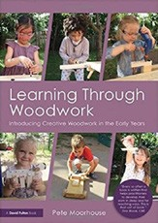
A more in-depth explanation is available in the following booklet.

It is advised that you purchase this before undertaking any woodworking.

There is a wealth of information at the following website or you can scan the code to go directly to the website.

https://irresistible-learning.co.uk/resources/

https://www.communityplaythings.co.uk/learning-library/training- resources/woodwork-in-the-early-years

This booklet has been created for Inverclyde Education HQ by the Notre Dame Cluster
Many Thanks to: Blairmore Nursery School Hillend Children’s Centre Glenbrae Children’s Centre Wellpark Children’s Centre

