Week 1 | Monday | Tuesday | Wednesday | Thursday | Friday
Option 1  (Red) | 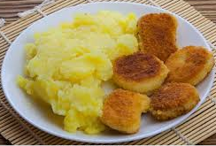  Quorn Dippers with Mash(v) | Quorn Burrito wrap(v)  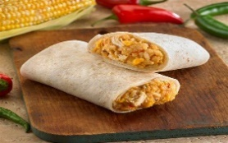 | Spaghetti Bolognaise  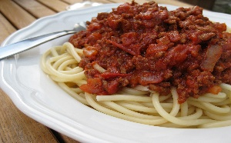 | Macaroni Cheese (v)  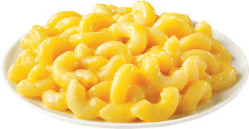 | Fish fingers with mash potato (f)  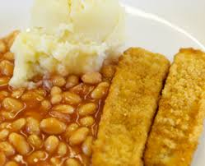
Option 3  (Yellow) | Tuna Mayo Sandwich  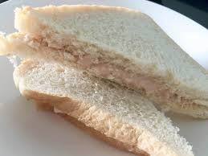 | Chicken Sandwich  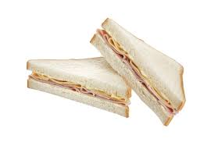 | Cheese Sandwich (v)  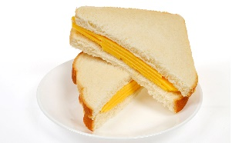 | Chicken Sandwich | Egg Sandwich (v)  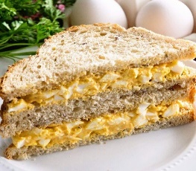

Week Commencing
19th April 21
10th May 21
31st May 21
21st June 21

Week 2 | Monday | Tuesday | Wednesday | Thursday | Friday
Option 1  (Red) | Turkey meatballs and pasta  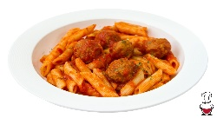 | Macaroni Cheese (v) | ChickenCurry  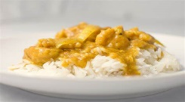 | Steak pie with mash potato  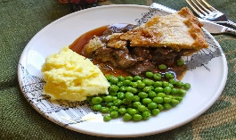 | Salmon and Cod fish cake with potato  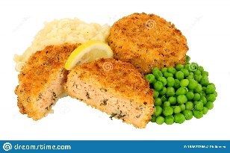
Option 2  (Yellow) | Tuna Mayo Sandwich(f) | Chicken Sandwich | Cheese Sandwich (v) | Cheese Sandwich(v) | Egg Sandwich (v)  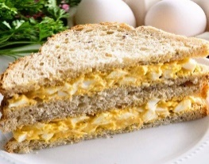

Week Commencing
26th April 21
17th May 21
7th June 21

Week 3 | Monday | Tuesday | Wednesday | Thursday | Friday
Option 1  (Red) | Tomato and Basil Pasta with Garlic Bread(v)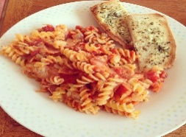 | Quorn Curry with rice(v) | Mince and mash potato  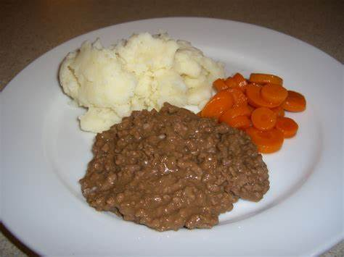 | 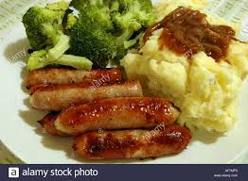  Sausage and mash potato | Fish fingers with mash potato (f)
Option 3  (Yellow) | Tuna Mayo Sandwich(f) | Chicken Sandwich | Cheese Sandwich (v) | Cheese Sandwich(v) | Egg Sandwich (v)  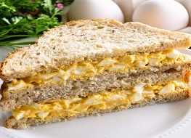

Week Commencing
3rd May 21
24th May 21
14th June 21

