Week 1 | Monday | Tuesday | Wednesday | Thursday | Friday
Option 1  (Red) | Macaroni  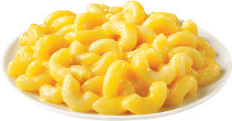  Cheese (V) | 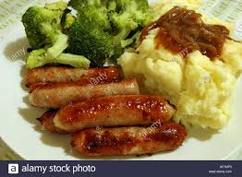  Sausages with Mash Potato | 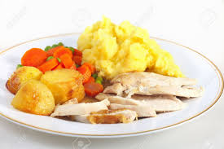  Italiano Chicken with Potatoes | Spaghetti Bolognaise | Quorn Dippers with Mash  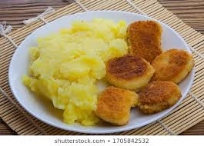  (v)
Option 2  (Yellow) | 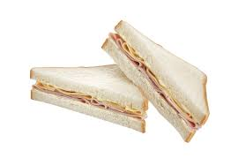  Chicken Sandwich | 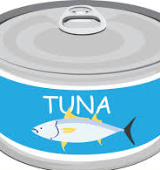  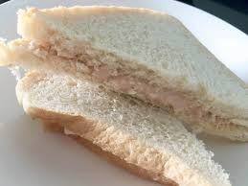  Tuna Mayo Sandwich | 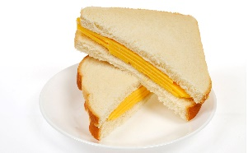  Cheese Sandwich (v) | Cheese Sandwich (V) | Chicken Sandwich

Week 2 | Monday | Tuesday | Wednesday | Thursday | Friday
Option 1  (Red) | 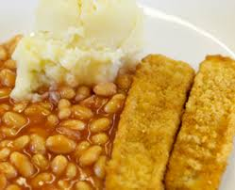  Fish Fingers with Mash Potato | 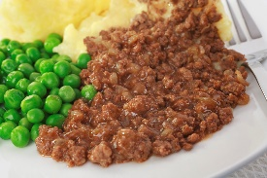  Mince and Potatoes | Macaroni Cheese (v) | Sausage and Mash Potato | Quorn Dippers with Mash
Option 2  (Yellow) | Chicken Sandwich | Cheese Sandwich | Tuna Mayo Sandwich | Cheese Sandwich (V) | Chicken Sandwich

Week 3 | Monday | Tuesday | Wednesday | Thursday | Friday
Option 1  (Red) | Fish Fingers with Mash | 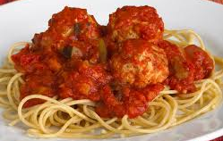  Turkey Meatballs with Spaghetti | 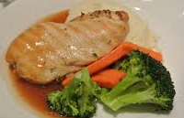  Chicken Breast with Mash Potato | 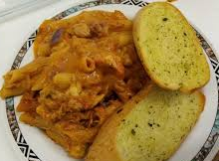  Tomato and Basil Pasta with Garlic Bread | Quorn Dippers with Mash
Option 2  (Blue) | Chicken Sandwich | Tuna Mayo Sandwich | Cheese Sandwich (v) | Cheese Sandwich (V) | Chicken Sandwich

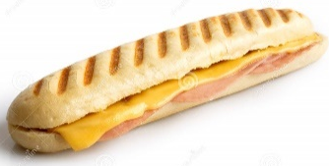
 | W/C
Week 1 | 15.2.21  8.3.21  29.3.21
Week 2 | 22.2.21  15.3.21
Week 3 | 1.3.21  22.3.21

