**Inspiring Learning Creating Opportunities Thriving Together**

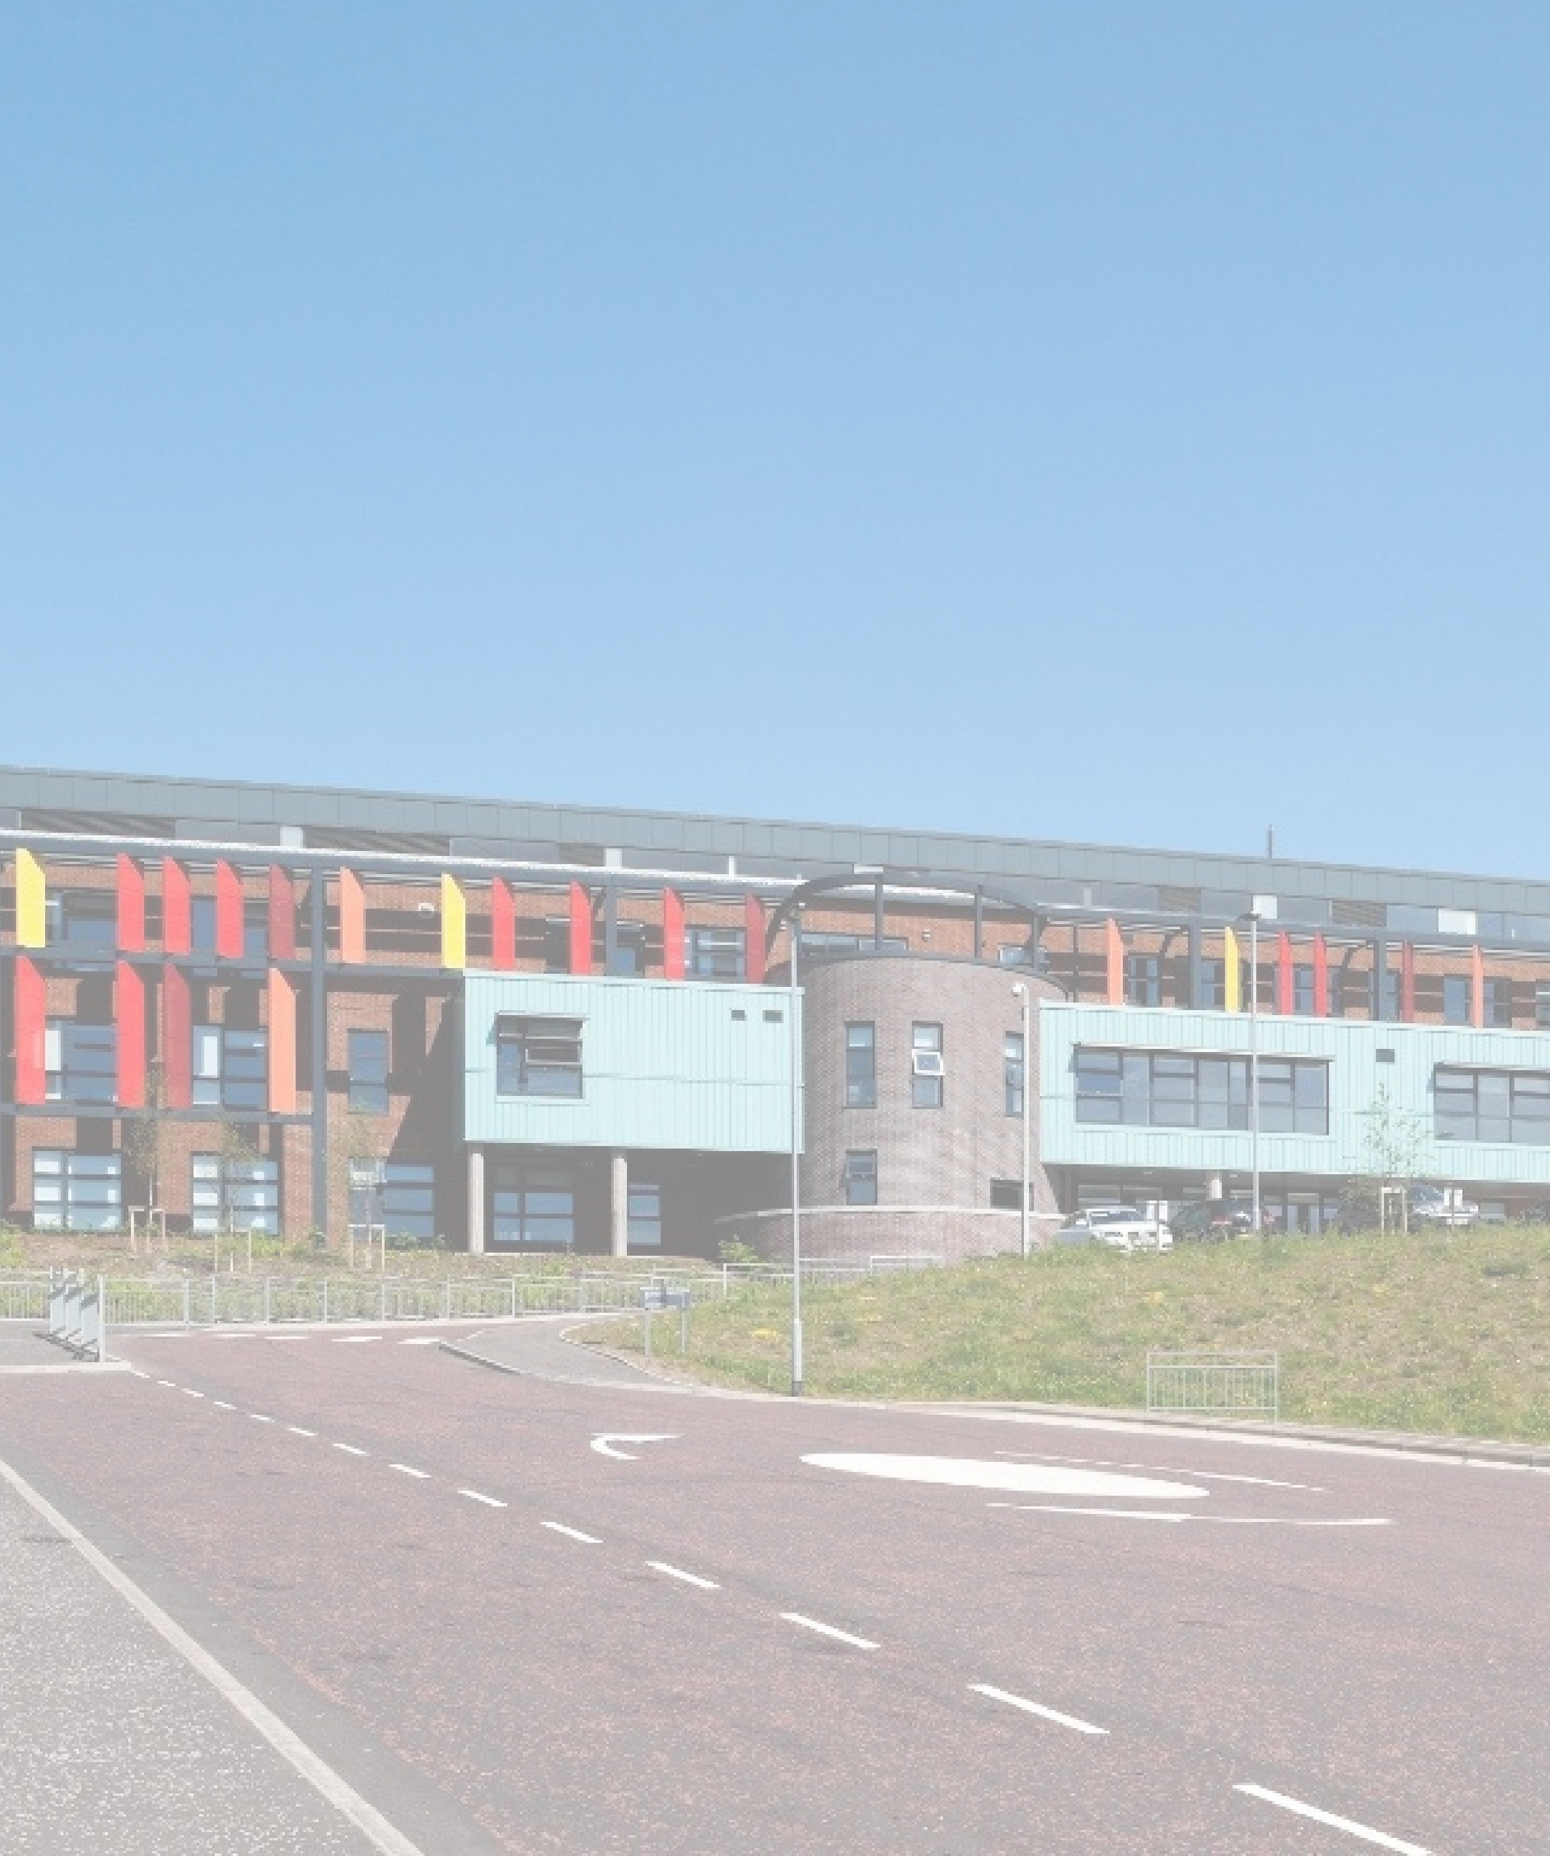

**POSITIVE**

**RELATIONSHIPS**

**POLICY**

“In order to develop trust with others, it is important to hold them in unconditional positive regard. This requires a basic acceptance of, and respect for, who that person is regardless of what they say or do”

Carl Rodgers

**Table of Contents**

Rationale 3

A Whole-School Approach to Nurture 4

Restorative Approach and Language 5

Positive Environment Checklist 5

Recognising Achievement and Rewarding Success 5

MERIT CATEGORIES 6

Merits Guidance - 7

Rights Respecting Language 8

“Positive Expectations” – Ready to Learn Routine 8

Clydeview Academy Staged Response 9

Referral Guidance – Recording a SEEMIS Referral 10

Critical Incidents 10

Partnerships with Parents 11

Exclusion 11

APPENDIX 1 – Restorative Questions Poster 11

APPENDIX 2 - Language is a Vital Means of Communication – Approaches 13

APPENDIX 3 – Positive Environment Checklist 15

APPENDIX 4 – Wellbeing Concern Form 16

APPENDIX 5 – Learning Concern Form 17

APPENDIX 6 – Sample Reflective Exercise 18

# Rationale

*‘Curriculum for Excellence cannot be delivered without good relationships and positive behaviour. Children and young people should feel happy, safe, respected and included in the learning environment and all staff should be proactive in promoting positive behaviour in the classroom, playground, and wider learning community.’* **Curriculum for Excellence**

At Clydeview Academy, pupils have the right to receive an education of the highest quality. This can only take place within an ethos of mutual respect and partnership between learners and all staff who work within the school. We are aware that learner engagement is vital to academic achievement and we understand that in order to encourage active learner participation, we must foster positive relationships based on trust which promote dignity and respect.

We aim to ensure that learners are confident that teachers, adults and their peers in the school care about all aspects of their wellbeing. This is instrumental in improving every aspect of school life and ensuring a positive experience for all young people who attend Clydeview Academy. Better relationships between pupils and teachers leads to, not only, higher academic achievement, but also better behaviour and the creation of an environment more conducive to learning. (Birch & Ladd)

When the learning and teaching process takes place within an atmosphere of co-operation, collaboration and praise, behaviour improves. We know that the quality of teacher-learner relationships is a strong predictor of classroom behaviour (Learner & Kruger). We understand the need for consistency in our approach to working with young people and adopt a nurturing methodology when dealing with behaviour. Respect, equality of opportunity and positive relationships underpin all that we do in Clydeview Academy.

Ultimately, in promoting positive behaviour, we have three main aims:

***“Creating a positive learning environment through positive relationships and behaviour is seen as the responsibility of everyone within each community of learning” (Education Scotland)***

Our Positive Relationships Policy has been developed within the context of the [Inverclyde Council Positive Relationships and Positive Behaviour Policy](Inverclyde%20Council%20PRPB%20Policy.pdf#page=5). Hyperlinks of key documents from this policy can be found throughout this document.

# A Whole-School Approach to Nurture

Nurture is promoted as a key approach to supporting behaviour, wellbeing, attainment and achievement in Scottish schools. Nurturing approaches help young people regulate their emotions, relate to others and behave positively. “Nurture” is defined as “care and attention given to someone or something that is growing or developing*” (*Merriam-Webster, 2016) and is underpinned by the six principles of nurture:

A nurturing approach recognises that positive relationships are central to both learning and wellbeing. The approach can be applied at both the universal and targeted level and promotes inclusive, respectful relationships across the whole school community including learners, staff, parents, carers and partners. (Applying Nurture as a Whole School Approach (Education Scotland))

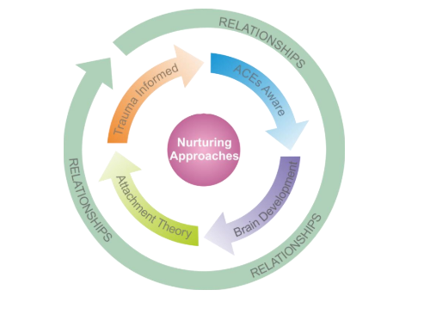

**Nurturing Approach – Key Elements**

* A nurturing approach is embedded within wider school priorities
* All children and young people, staff, parents/carers and partners feel welcomed and supported within the school community which is inclusive and respectful of all.
* Health and Wellbeing is a key focus within Clydeview Academy and is seen as being an important component of raising attainment.
* There is a balance between high expectations and structure with warmth and support across the school – “high structure, high nurture”
* Positive relationships are at the heart of Clydeview Academy and are seen as underpinning all successful learning and teaching.
* Staff view behaviour from an ecological perspective; they seek to understand how individual child, family, community and school factors impact on the behaviour.
* Staff are aware of Trauma-Informed Practice, and recognise that where early experiences have impacted on later development, they are in a key position to recreate some of these missed learning opportunities to support children and young people in ‘second chance learning.’
* All staff communicate with learners in the spirit of “Regulate, Relate and Reason” acknowledging the importance of these steps to “reach the learning brain”(Bruce Perry)

# Restorative Approach and Language

Understanding that a restorative approach cultivates positive relationships leading to more successful outcomes, staff are the behaviour leaders within the school. Being restorative can be proactive (relationship building) or responsive (relationship repairing) and can be used at every level from everyday informal interactions to more formal restorative meetings.

We understand that behaviour, in the same way as literacy or numeracy, is our responsibility to teach and model. Staff use their skills and experience to prevent incidents from occurring or escalating, whilst maintaining a positive relationship with all learners. Consistency of approach is key to our whole school behaviour management processes and to promoting positive behaviour. Restorative language and having restorative conversations can generate opportunities for listening and participation, co-operation, build an awareness of social responsibility, and sensitively recognise social and cultural differences (*Appendix 1*). Relationships are the essential component of restorative approaches. (Education Scotland, 2021)

Each year, Clydeview Academy prioritise a particular focus on one of the six nurture principles in the School Improvement Plan. In 2023-24, our school community is spotlighting “Language is a Vital Means of Communication” (*Appendix 2)*, using a [Plan, Do, Study, Act](PDSA%20Cycle.pdf) (PDSA) approach.

# Positive Environment Checklist

A Positive Environment Checklist is available to support all staff at Clydeview Academy when reflecting on the classroom learning environment and how they promote positive behaviour (*Appendix 3*). The resource aims to ensure classroom teachers to feel empowered in their role as a leader of learning, and to be able to self-evaluate the learning environment when required.

# Recognising Achievement and Rewarding Success

Staff at Clydeview Academy aim to bring out the best in every pupil using positive language, meaningful feedback and taking every opportunity to provide praise. Staff have worked alongside University of Strathclyde and Educational Psychologists from Inverclyde Council to review our approach to feedback. We have placed emphasis on the use of positive language when providing feedback and the need to develop positive relationships between staff and learners in order for feedback to be received and acted upon to improve outcomes for learners.

Systems are in place which recognise the efforts and achievements of pupils and can offer tangible rewards to celebrate success. Our Principal Teacher of Supporting Student Achievement regularly updates the Clydeview Academy “X” (formally known as Twitter) page (@clydeview_a) and Reception Notice Board with pupil achievements both in school and from extra-curricular activities. Our newly-launched House System involves all staff and learners, encouraging healthy competition and comradery through a wide variety of point-scoring opportunities in departments and the wider school throughout each session.

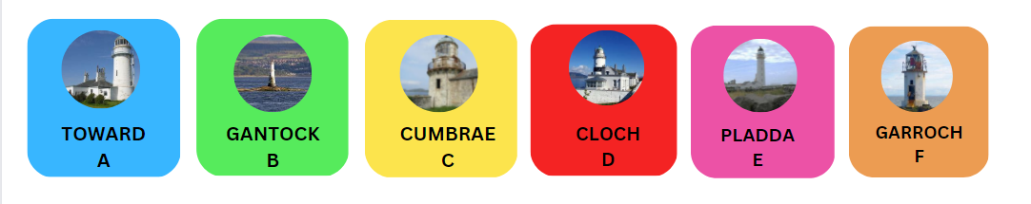

Staff also award merits for a variety of ways of upholding school values. The merit and alert categories were refreshed in 2022 in line with our whole-school Visions, Values and Aims update. Merits are collated at regular intervals and lead to our award and reward events in December and June. Our school community also recognises and celebrates the many different forms of learner success in our termly Community Newsletters.

# MERIT CATEGORIES

# Merits Guidance

* Merits help build a picture of learner progress and should be issued in the spirit of learners consistently meeting or going “above and beyond” our expectations.
* There are a number of merit categories. Not all will link directly to all subject areas but may be more appropriate for the Pupil Support Team or Senior Management to use.
* Please ensure that you let the learner know if they are receiving a merit. It is often the conversation that takes place around the achievement that is the most valuable for building strong relationships.
* Consistency across the school will always be a challenge. However, we need every member of staff to ensure that the system is used across all year groups.
* Departments/faculties must aim to be consistent in approach and regularly monitor through Quality Assurance Calendar and discussions at department/faculty meetings.
* Principal Teachers and Faculty Heads should use SEEMIS to regularly review merits issued in their department/faculty to evaluate consistency, as per Quality Assurance Calendar.
* SMT will also be rigorous in their monitoring of merits issued, regularly celebrating the success of students across all year groups.

**Alerts Guidance**

* An alert should be issued when a learner falls short of our expectations, as per Staged Response guidance (see *Clydeview Academy* *Staged Response* section). The wording of the refreshed alert category has changed to provide a target for the action that would be required to get back on track. The reason for the alert is therefore more implicit e.g. if a learner receives an alert asking them to speak to staff in a more respectful manner, the PT, PT Guidance or DHT will know that the young person was not meeting this expectation.
* Avoid issuing more than one alert in a period. Alerts should only be issued when a learner reaches Stage 4 of the Staged Response approach. If a learner does not take the opportunity to get back on track, the Staged Response Approach for promoting positive relationships should be followed. This may involve your PT/FH and the referral system.
* The alert system will help build a picture of a learner’s progress at school, and although monitored, will not provide immediate support. Where a learner consistently falls below expectations, a discussion should take place with PT/FH and a SEEMIS referral completed (see *Referral Guidance – Recording a SEEMIS Referral* section).
* Departments/faculties must aim to be consistent in approach and regularly monitor through Quality Assurance Calendar and discussions at department/faculty meetings.
* Principal Teachers and Faculty Heads should use SEEMIS to regularly review alerts issued in their department/faculty to evaluate consistency, as per Quality Assurance Calendar.
* SMT will also be rigorous in their monitoring of alerts issued across all year groups.

# Rights Respecting Language

As a school working towards becoming a “Gold” Rights Respecting School, we are guided by the UNCRC and fully recognise the importance of Right Respecting language in our communications with young people. We aim to cultivate an ethos is respect whereby every member of the school community is treated with dignity.

# “Positive Expectations” – Ready to Learn Routine

Our “Positive Expectations” initiative provides basic expectations for young people when in class. This re-informs the structure and predictability that is reassuring for young people, whilst ensuring they are “ready to learn”. Staff are encouraged to adopt “relentless routines”, including the use of modelling and positive reminders.

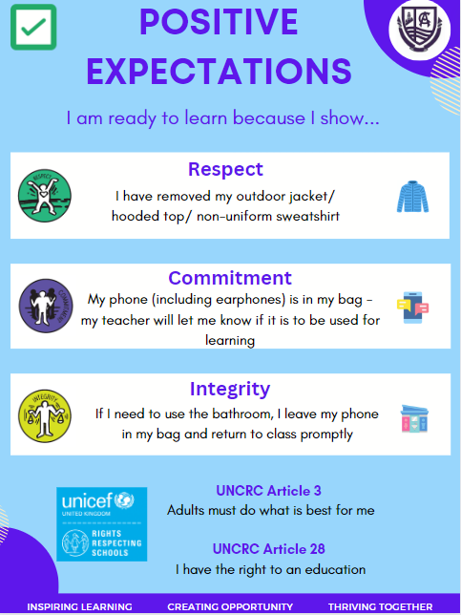

# 

# Clydeview Academy Staged Response

On occasions where the behaviour of a young person negatively impacts on the learning experience of themselves and/or others, the Clydeview Academy Staged Response procedure is followed. This assures consistency in approach to managing behaviour allowing young people to learn how to conduct themselves in classroom situations. Staff must ensure they discuss/model the behaviour we would like to see with learners, and that appropriate, restorative dialogue takes place at each stage.

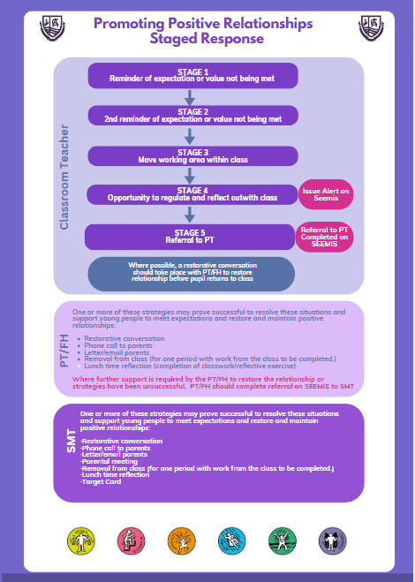

# Referral Guidance – Recording a SEEMIS Referral

* Referrals are an important record to have when the teacher has exhausted all of their strategies and support is required to restore the relationship with the young person.
* Referrals should only be generated after discussions with the PT when agreed strategies have not worked.
* Referrals should tell a full story of what has led to the referral and what strategies have not worked. A full account of each step in the relationships policy should be referred to.
* Referrals should be concise and factual and only name the young person being referred. Any other young people should be referred to by initials only.
* Where possible, a restorative conversation between the teacher, PT and young person (and where relevant Guidance teacher) should take place following every referral and ideally before the young person is next in the class. This should be noted by PT before sending to Year Head for info.

|  |  |
| --- | --- |
| **Behaviour Concern**  Teacher  Principal Teacher (for action)  Year Head(for info or action)  PT Guidance (for info and sign off) | **Critical Incident or serious breach of expectations**  Teacher  Principal Teacher (for info)  Year Head(for action)  PT Guidance (for info and sign off) |

Important Points

* Referrals on Seemis should only be used for concerns about behaviour.
  + If your concern is in relation to attendance or wellbeing please complete the wellbeing concern form (Appendix 4) and email to the relevant PT Guidance
  + If your concern is in relation to learning please complete the learning concern form (Appendix 5) and email to the PT Pupil Support (Ewan Campbell).
* All staff should follow the relationships policy in all cases
* Remember relentless routines and consistency are key
* Fresh start for every young people every lesson
* Only in extreme circumstances should the matter be escalated without going through the four stages of intervention. At each stage the goal is to restore the relationship.

# 

# Critical Incidents

A critical incident is an incident that meets the following criteria:

* + There is a significant or severe risk to health and safety e.g. carrying of a knife.
  + When a pupil has been physically (purposely or significantly) violent towards a staff member.
  + When a pupil has been physically violent towards another pupil in a manner that can be considered severe and a risk to health and safety.
  + If a pupil has destroyed property at a level that the Head of Education should know about and taking account of their additional support for learning needs.
  + If there are risks/threats to staff and pupils from someone external to the establishment.

In the event of a critical incident, a member of Senior Management should be notified immediately. This should be followed up by the submission of a referral on SEEMIS to the relevant year head, who will complete a [Critical Incident Notification and Prevention Report](Critical%20Incident%20Report.docx). This will be submitted to the Authority Screening Group (ASG)

# Partnerships with Parents

*‘The Parental Involvement Act (2006) states that parents, carers and families are by far the most important influences on children's lives.’* (PRPB, Inverclyde Council)

This fact shapes our understanding that the involvement of parents is a vital component in the creation of a school community where there exists an environment which is conducive to effective teaching and learning. Parents are involved in decisions about how the school deals with issues pertaining to behaviour. They are alerted to concerns about their child’s conduct at an early stage.

This happens through the school’s merit and alert system, by telephone calls home by members of the Guidance Team, PTs Subject and SMT. This includes Standard Letters generated by Heads of Department. Guidance and Senior Staff will be proactive in inviting parents into school to discuss how the partnership between home and school can be utilised to ensure that learners meet their full potential. Parents should feel comfortable in the knowledge that the efforts of staff are directed at improving the learning experience for all young people at Clydeview Academy.

# Exclusion

Decisions on exclusions are directed by guidance provided in Appendix 7 of the [Inverclyde Council Positive Relationships Positive Behaviour Policy](Inverclyde%20Council%20PRPB%20Policy.pdf).

# APPENDIX 1 – Restorative Questions Poster

**Restorative Questions (Replacing the ‘why’ with ‘what’)**

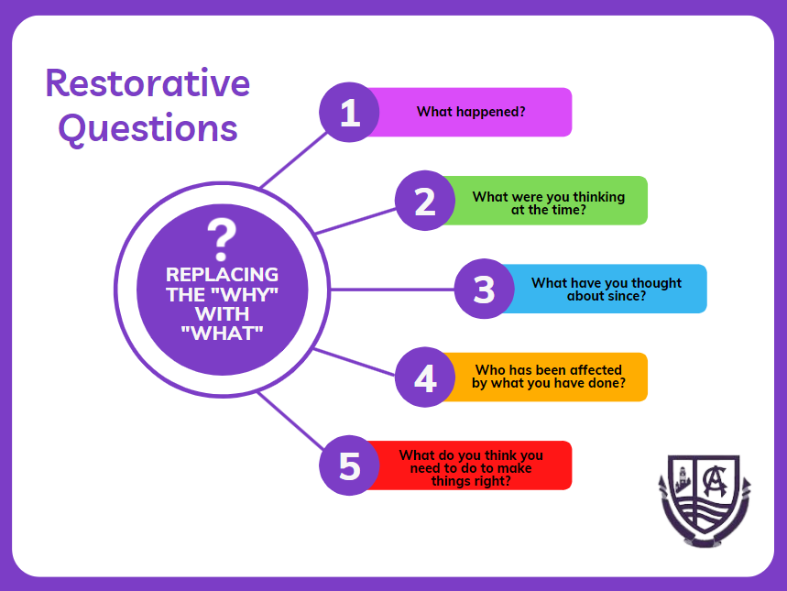

# APPENDIX 2 - Language is a Vital Means of Communication – Approaches

1. Curious not furious

Try to meet more escalated behaviour with curiosity. This will help you de-escalate and open up the communication. Aim to understand the behaviour by asking open questions: “Why are you late?” could evoke a defensive response versus “What has happened today that you have found yourself late?”

2. Co-regulation prompts

Encouraging dialogue around actions and not taking body language personally. For example, in response to a huge exhale or eye roll, instead of stating “Are you rolling your eyes at me” you might say “I can see that you are not very happy, can you tell me about it?”. Instead use phrases like ‘I can see you’re really upset. Let’s leave this just now until you feel calmer. I’m ready to listen when you feel ready to talk.’

3. Slow, Low, Low technique

Speak more slowly, speak more quietly, speak in a low tone- supports the young person to regulate their emotions

4. Leaning in

Not jumping to advise, reassure or provide a solution. Allowing pupils to develop their vocabulary around their emotions. Sitting with them in the moment and acknowledging that their emotions are valid and what they are feeling is acknowledged.

5. Choices:

Instead of: ‘Move onto the next task now’ use ‘Which questions/ sections do you think you can move on to now? ‘

Instead of:’ Put that away in your bag’ Use: ‘Remember we agreed not to bring these out in class, so would you like to put it away in your bag or would you like me to look after it for you till the end of the period?’

6. No room for argument

Don’t provide the opportunity to get caught up in discussion: Try: ‘Please take off your jacket’. Thank you.” and immediately turn away and talk to someone else.

7. Notice positive first

Instead of giving instructions, celebrate those modelling the desired behaviour.

“Fantastic, Jacob! Already started on your personal reading!”

8. Effective Praise

Evidence shows that being very explicit about what is being praised has the greatest effect on pupils’ motivation: time on task, willingness to try harder work, and their view of themselves:

* ‘You’ve managed to lay that out very clearly and I can see what goes with what. Well done’
* ‘You’ve picked out four of the key issues here– great work!’
* I like the way you ….chose that colour next to the blue/ or set out that sum
* I noticed that you….Used the examples given by x to illustrate y
* Tell me how you …….created/ or came up with that idea?

9. Plan ahead.

Have some go to strategies to keep you calm – relax, watch body language, take slow breaths.

10. Facilitative responses

If a pupil does not have their homework instead of the teacher being the expert, “you should have done this, you need to…” the teacher could encourage the student to think about and express what they could have done, “what is the impact of choosing to not do your homework”. Move away from a conflict to a dialogue.

11. Modelling positive relationships

For example upon entering a class, greeting all of the adults in the room and young people. Using eye contact and a friendly tone of voice. Using good manners and listening skills.

12. Welcoming

The language used by staff in the classroom clearly communicates to children and young people that they are welcome and will be supported to achieve and feel safe and happy within the class, for example, “Hello Carol, it’s lovely to see you.”

13. Hold in Mind

Young people respond well to feeling important. By “holding them in mind”, we give them a sense of their worth in our relationship:

* “I watched that film you recommended- it was brilliant!”
* “I saw your team won last night! That was a great result”
* “I was thinking about you over the weekend as I remembered it was going to be a bit tricky for you”

14. Emotional literacy

Language of emotion is modelled by staff in the classroom and used with children and young people:

* “I am feeling a bit distracted this morning because we have a planned fire drill”
* “ I am finding it hard to concentrate at the minute as it’s so close to lunch and I’m really hungry”

15. Increase positive connections

This is particularly required for young people who seek any form of connection (largely negative). Think of the 5:1 rule and the numerous ways to communicate acceptance. Involve parents in positive praise. Remind the young person of ‘that time they were following class rules/ engaging learning’ – appeal to their better side and emphasise this.

16. Mind our language

Be aware of the language we might be using to describe behaviour. Does it have a judgement/ emotion built into it? Is there blame located in the word? When we do this, we are feeling it and it’s understandable to feel these emotions, however, when we regularly use ‘language of blame’ we start to colour the interactions with our experiences. When we use emotive language, we can inflame the situation.

# APPENDIX 3 – Positive Environment Checklist

**Promoting Positive Relationships**

**Positive Environment Checklist**

*This checklist is a support tool to allow school staff to consider a range of factors that may be influencing learner behaviour and engagement. It is designed to help staff proactively review the learning environment and relationships, and recognises that creating a positive learning environment and fostering positive relationships can contribute significantly to encouraging positive behaviour and success.*

|  |  |  |  |
| --- | --- | --- | --- |
| **Classroom Environment** | | | |
| *1 = Disagree (need for improvement)*  *2 = Mostly Agree (room for improvement)*  *3 = Strongly Agree (embedded practice)* | 1 | 2 | 3 |
| There are established routines for when learners enter and leave the classroom |  |  |  |
| Furniture and equipment are arranged to best effect for teaching and learning |  |  |  |
| Learners are seated according to a seating plan |  |  |  |
| The whiteboard is easily seen by all |  |  |  |
| There are established routines for distributing and collecting materials and equipment |  |  |  |
| External noise levels do not interfere with learning |  |  |  |
| Learners have adequate personal work space |  |  |  |
| Where possible, I arrive at the classroom ahead of learners |  |  |  |
| Where possible, materials and equipment are prepared before class |  |  |  |
| **Promoting Positive Relationships** | | | |
| Classroom expectations are positively framed, modelled and reinforced |  |  |  |
| Classroom expectations are discussed with and understood by learners |  |  |  |
| I ensure Clydeview’s “Features of an Effective Lesson” checklist is used in lesson planning and delivery, with particular focus on “4. Needs of all learners met using appropriate differentiation” |  |  |  |
| I am aware of Nurture Principles, and I am conscious to ensure that my classroom environment offers a safe base |  |  |  |
| “Promoting Positive Relationships” restorative interventions are applied consistently and fairly |  |  |  |
| I identify, praise and reward positive conduct, by giving positive attention to positive behaviour |  |  |  |
| Rewards are small and readily achievable by all learners |  |  |  |
| I deliver praise in way that helps learners understand the specific action that is being recognised |  |  |  |
| I lead by example and minimise unnecessary confrontation by responding assertively, not aggressively in challenging situations |  |  |  |
| I am able to defer conversations about challenging situations until all involved are calm enough to communicate positively |  |  |  |

# APPENDIX 4 – Wellbeing Concern Form

# N:\Clydeview Academy\Whole School\School Badge\Badge\Clydeview Embroidery badge final small.jpg

**Clydeview Academy**

**Wellbeing Concern**

(To be completed by Class Teacher)

|  |  |  |  |
| --- | --- | --- | --- |
| Pupil Name |  | Register Class |  |
| Class Teacher |  | Date |  |
| PT/FH has been informed of this wellbeing concern | | | |

**Nature of Wellbeing Concern:**

*Please select an option below and provide a short description of the concern*

Safe  Healthy  Achieving  Nurtured  Active  Respected  Responsible  Included

**Strategies used (if relevant):**

**Please email completed form to relevant PT Guidance.**

|  |  |
| --- | --- |
| **A Classes and 4F** | Kerry Blance / Leanne Ward (Wed only) |
| **B Classes and 1F/6F** | Heather Shearer |
| **C Classes and 2F** | Mark Lamont (Thu-Fri)/ Debbie Connell (Mon-Wed) |
| **D Classes and 5F** | Julie Sloan |
| **E Classes and 3F** | Michelle Nelis |

# N:\Clydeview Academy\Whole School\School Badge\Badge\Clydeview Embroidery badge final small.jpgAPPENDIX 5 – Learning Concern Form

**Clydeview Academy**

**Learning Concern**

(To be completed by Class Teacher)

|  |  |  |  |
| --- | --- | --- | --- |
| Pupil Name |  | Register Class |  |
| Class Teacher |  | Date |  |
| Subject and Level |  | | |
| PT/FH has been informed of this learning concern | | | |

**Nature of Learning Concern**

Please provide a short description of the concern. If possible, please also provide evidence to support your concern (e.g. scanned piece of work)

**Strategies used (if relevant).** If you have evidence of a strategy being successful, please include this)

**Please email completed form to PT Pupil Support (Ewan Campbell)**