“The relationship between a teacher and student is one of the most influential factors in a learning environment. This is a key element affecting students’ progress, engagement of school and academic motivation.” (Little & Koback 2003; Hughes et. Al. 2006)

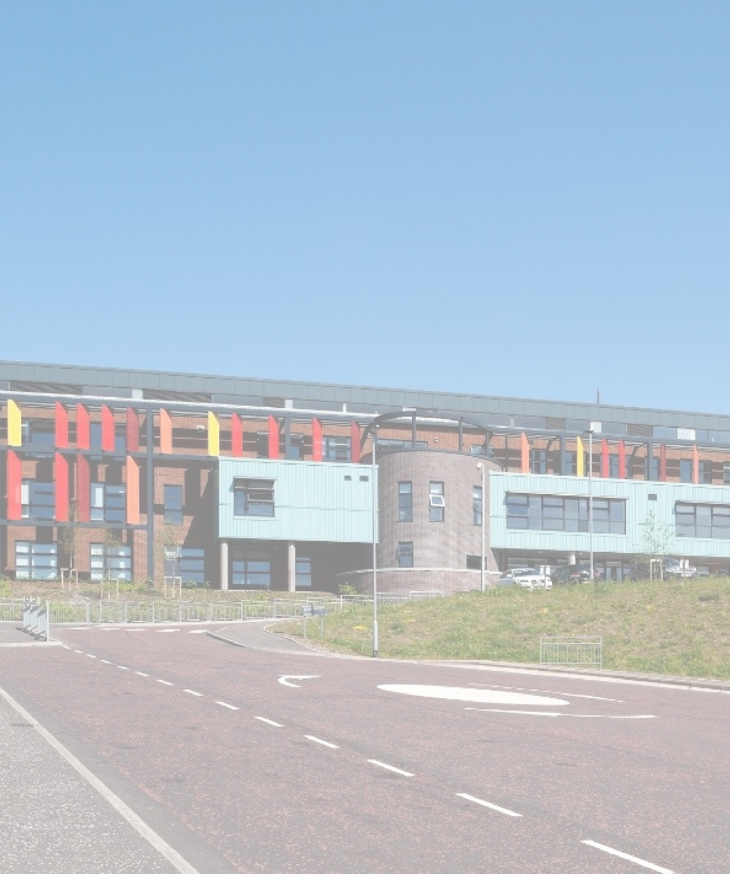

**Learning & Teaching Policy**

**Inspiring Learning Creating Opportunities Thriving Together**

**Contents**

1. **Introduction  
   Rationale  
   Objectives  
   Methods of Achieving Objectives**
2. **Our Goals for Learners  
   Desirable Qualities of Good Teaching Practice**

**The Beginning of a Lesson**

1. **Features of the Clydeview Lesson (list)**

**Pedagogy**

1. **Learning Environment**

**Positive Relationships**

1. **Meeting Learners’ Needs**
2. **Differentiation**
3. **Features of the Clydeview Lesson (explanation)**

**10. Classroom Visit Report**

**INTRODUCTION**

A coherent and consistent whole-school approach to Learning and Teaching is fundamental to what we do at Clydeview Academy. Our approach addresses areas including our goals for learners, good class practice, features of a highly effective lesson, classroom organisation, pedagogy, assessment, support for learning, learning styles and differentiation, among others. The policy must be read in conjunction with other school policies on Positive Relationships, Assessment and Moderation, Support for Learning, ICT, Uniform, Homework and Quality Assurance. The policy draws from national and international guidance and research, for example:

* A Curriculum for Excellence: Building the Curriculum 3 – A Framework for Learning and Teaching
* A Curriculum for Excellence: Building the Curriculum 4 – Skills for Learning, Life and Work
* A Curriculum for Excellence: Building the Curriculum 5 – A Framework for Assessment
* How Good is Our School? 4
* Assessment is for Learning

**RATIONALE**

* The main measure of a school experience is the quality of learning and teaching.
* The quality of teaching in a school is a key factor in promoting effective learning.

**OBJECTIVES**

1. To ensure the highest possible standards of achievement and attainment for every learner.
2. To promote an inclusive and positive ethos in keeping with our school values, our Positive Relationships policy and our Rights Respecting Schools status, all of which are essential for effective learning to take place.
3. To create a learning environment which motivates pupils to work well.
4. To maximise pupils’ achievement and attainment, with a focus on “closing the gap” between the most and least deprived.
5. To equip every pupil with skills for high levels of literacy, numeracy and health and wellbeing.
6. To ensure the use of a variety of effective approaches to learning and teaching, taking into account preferred learning and teaching styles.
7. To ensure that staff interact effectively with every pupil.
8. To promote learning across a wide range of contexts and well-planned experiences.
9. To empower and encourage young people to see themselves as active citizens and agents for change in local, national and global contexts.
10. To encourage and provide opportunities for parents and carers to take an active role in their children’s learning.

**METHODS OF ACHIEVING OBJECTIVES**

* Implement a system for monitoring learning and teaching in line with Inverclyde Council policies.
* Enable regular departmental discussion of current policy and practice.
* Encourage departments to use the Quality Indicators in How Good is Our School? 4 and other means, such as the Monitoring Learning and Teaching Calendar, in order to review learning and teaching regularly.
* Afford teachers opportunities to share their strengths with colleagues thus ensuring a greater measure of coherence and consistency within departments and across the curriculum, through learning communities and learning visits.
* Provide appropriate staff development including the provision of up-to-date information on research and good practice.
* Build capacity in the teaching profession, principally through self-evaluation and network-based Continuous Professional Development.

**OUR GOALS FOR LEARNERS**

Learners learn successfully when they are:

* clear about what they are expected to learn.
* motivated and eager participants.
* actively involved in their own learning and confident in their next steps.
* aware of where to go if they need support.
* given clear and constructive feedback about the quality of their work, and what they can do to improve it.
* valued and praised for their achievements.

**DESIRABLE QUALITIES OF GOOD TEACHING PRACTICE**

A professional practitioner:

* arrives punctually and does not leave the class unattended.
* provides a safe environment for all.
* delivers lessons enthusiastically and makes every attempt to make learning relevant and motivating.
* knows all young people in the class by name.
* prepares thoroughly and makes a prompt start to the lesson.
* establishes routine within their classroom.
* has high expectations of his/her pupils.
* adheres to school policies regarding uniform, latecoming and Positive Relationships and is consistent, fair and firm.
* intervenes swiftly, sensibly and unobtrusively.
* uses praise and rewards appropriately.
* manages unsatisfactory work in a positive and supportive manner.
* is skilled in identifying next steps in learning.
* provides basic resources where required – pens, ruler etc.

**THE BEGINNING OF A LESSON**

* Every lesson should begin with the teacher greeting students at the door, signalling entry into a learning environment where they feel safe and welcomed.
* Pupils that have been absent are welcomed back in order to let them know they have been missed.
* Pupils enter the classroom quietly and remove non-uniform items such as coats and hoodies.
* Resources are swiftly distributed to ensure a prompt start to the learning.
* The teacher takes the register, ensuring that absences are accurately reported. A starter activity should be available, e.g. displayed on the board, for pupils to work through while the register is completed. This task should be linked to prior learning or the content of today’s lesson.
* Any pupil arriving late is encouraged to get in and to work as quickly as possible. If appropriate, the teacher may question the pupil regarding their late arrival: this is done discretely and should not disrupt learning and teaching or draw unnecessary attention to the pupil in question. Persistent latecoming without good reason should be dealt with as per departmental and school policy.
* The teacher recaps prior learning, making use of higher-order questioning as appropriate to do so.
* Learning Intentions and Success Criteria for the day’s lesson are made clear to pupils. Care is taken to ensure that pupils are aware of the purpose of their learning in terms of the wider coverage of the curriculum and exactly what success in this lesson will look like. ‘Success Criteria’ may be differentiated based on the level each pupil is working at and it can also be helpful to have pupils consider what they believe “success” in a particular lesson will look like.
* As well as academic Success Criteria, teachers consider how their lesson helps build success in areas that are the responsibility of all (literacy, numeracy, and health and wellbeing), involve the four capacities (successful learners, confident individuals, effective contributors, responsible citizens) and develop skills for learning, life, and work.

**FEATURES OF THE CLYDEVIEW LESSON (see p7 for a detailed explanation of the 10 key features)**

1. Pupils greeted at the door and lesson starter available to immediately engage pupils on arrival.
2. Learning Intentions and Success Criteria stated at the start of the lesson and prior learning recapped.
3. Account taken of prior learning and attainment.
4. Account taken of varying skills and aptitudes.
5. Use of Benchmarks, Experiences and Outcomes to plan coherently.
6. Suitable breadth and challenge and capable of wider application.
7. Good planning and delivery.
8. A range of teaching approaches used.
9. A range of learning activities as appropriate e.g. individual, paired and group tasks, opportunities to develop listening, speaking, writing, reading, research skills, independent learning.
10. Use of digital technologies as appropriate to enhance learning.
11. Higher Order Thinking Skills evidenced.
12. Achievable success.
13. A range of skilled questioning techniques.
14. Pupils actively involved in their own learning.
15. Effective and timely feedback provided to improve performance and learning.
16. School values referenced and modelled.
17. Pupils valued and praised for their achievements.
18. Departmental and school policies adhered to throughout lesson (e.g. uniform, latecoming, Positive Relationships).
19. Plenary to reinforce/summarise learning and LI/SC revisited.

**PEDAGOGY**Staff use a range of pedagogical approaches, determined by the young people in front of them and the learning intention. At all times, staff are cognisant of a number of themes and work to incorporate these into teaching and learning.

* Suitable range of resources and approaches used, e.g. balance between board and books, direct teaching, independent learning, co-operative learning, whole-class teacher interaction, etc.
* Responsive teaching: i.e. teacher assesses pupils’ understanding and adapts planned activities and explanations as necessary.
* Tasks and language reflect age, stage and prior attainment.
* Higher Order Thinking Skills: staff distinguish between the different types of thinking required for different concepts (e.g. the learning of facts versus creation of new knowledge) and provide opportunities for young people to develop these as appropriate.
* Assessment is for Learning: teachers understand that good teaching begins from where the learner is, so staff carefully plan and skilfully adapt questioning to elicit understanding and reasoning from pupils. Thinking time is given to enhance learning and random questioning encourages engagement and participation by all.
* Effective and timely feedback on pupil work is provided to improve performance and learning: this could be written or verbal, and individual or whole-class, teacher- or peer-led.
* Differentiation, whether by resource, questioning, support offered, timing, or outcome, allows all young people to understand what is required of them, experience success and feel challenged.
* Digital technology is used as appropriate to support and enhance learning, and learners can access key reference materials on Teams.

**LEARNING ENVIRONMENT**

Staff understand the importance of creating a safe and effective learning environment.

* Resources are organised with a particular focus on pupils with Additional Support Needs.
* Class ethos is developed by modelling and the school values.
* Nurture principles are understood and taken into account when interacting with pupils.

**POSITIVE RELATIONSHIPS**“*The relationship between a teacher and student is one of the most influential factors in a learning environment. This is a key element affecting students’ progress, engagement of school and academic motivation*.” **(Little & Koback 2003; Hughes et. Al. 2006)**

“…*positive teacher-student relationships resulted in increased motivation level and also increased in academic achievement…close relationship with the teacher helps motivate the students in their learning in school. As described by the respondents, a teacher that is “approachable”, “friendly” and “helpful” made their learning process more inviting, easier and less stressful*.” **(Yunus, 2010).**

The culture of positive teacher and pupil relationships evolves round the school’s key values.

Features that develop positive teacher and pupil relationships:

* **Ambition:** expectations of staff and pupils are high and excellent behaviour and learning are role-modelled.
* **Creativity:** staff encourage flexibility of thought and provide opportunities for creative problem-solving.
* **Determination:** staff recognise effort before success and support pupils in understanding that errors are integral to the learning process.
* **Integrity:** pupils are honest and take responsibility for, and reflect upon, their actions.
* **Respect:** staff and pupils show an awareness of and consideration for others.
* **Commitment:** staff work together and in line with school and Local Authority policies to make a positive difference to the lives of young people.

**MEETING LEARNERS’ NEEDS**

Young people at Clydeview Academy have a wide range of needs and abilities. Clydeview Academy provides Support for Learning to ensure the needs of all young people are met and that all pupils are provided with whatever they need to maximise their potential. Particular consideration is given to pupils who have identified Additional Support Needs.

* All staff are aware of ASN needs of young people in their care and of their responsibility to adapt teaching and assessment planning and approaches as necessary to meet these needs – see Differentiation section for more detail.
* The Pupil Support department maintains a Confidential Register detailing pupil needs and works with young people on suggested strategies to best support them.
* Class teachers and support assistants use the information in the Confidential Register as a basis, and discuss with pupils the support offered in class.

Procedures

* The Principal Teacher of Pupil Support (Additional Support Needs Team), who operates within the broader Pupil Support department, issues information to all staff at the beginning of the year identifying pupils with ASN, explaining what these are and guidelines on how the class teacher may help these pupils.
* Departments can then request support from the Additional Support Needs Team under various headings; see “Types of Support” section below.
* The Principal Teacher of Pupil Support (Additional Support Needs Team) returns a timetable to each department indicating the name of the support teacher or assistant, and which group or individual pupil he or she will support, and during which period. Every attempt is made to ensure continuity when assigning staff.
* Class teachers can seek further support by following the Staged Intervention Guidelines.

Types of support

There are various types of support which the Additional Support Needs Team can offer:

1. Consultancy Support

* Advice to colleagues on ways of improving the quality and effectiveness of learning and teaching.
* Adapting or providing curriculum materials to suit the learning needs of individual pupils.

2. Cooperative Teaching

* Supporting the work of the class teacher by targeting assistance in a planned way for pupils experiencing barriers to learning.

3. Class Teaching

* Additional Support Needs Team staff teach special programmes to groups who may opt out of the National Qualifications programme. For example, literacy, numeracy and other core skills can be taught to pupils as a substitute for other mainstream subjects.

4. Staff Development

* Additional Support Needs Team staff contribute to the enhancement of colleagues’ professional development through attendance at departmental meetings, seminars, collegiate time and inset days. Additional Support Needs Team staff attend professional development courses where necessary.

Broader whole-school strategies to support pupils

* An ethos which is responsive to pupils who experience Additional Support Needs either in the short term or for longer periods of time.
* Mentoring S1-6 by selected staff (opt-in for pupils).
* S6 Ambassador programme.
* Curriculum flexibility initiatives e.g. additional numeracy or literacy with A. Wilkinson.
* Target setting for each pupil during a 1-1 interview with Pupil Support.
* PTC and PTPS monitoring and tracking to identify pupils who are off- track.

**DIFFERENTIATION**

“Differentiation is the process by which differences between learners are accommodated so that all students in a group have the best possible chance of learning.” **(Geoff Petty, Teaching Today).**

Highly effective teachers acknowledge the spectrum of abilities, interests, dispositions and aptitudes in every class, and their duty to make the curriculum accessible to all learners. This ensures that everyone learns well despite their many differences. This necessitates intervention in the classroom and strategies which accommodate differences in the abilities and characteristics of learners, and which allow all pupils to experience success.

This process involves:

* recognising the variety of individual needs within a class.
* planning to meet those needs.
* providing an appropriate range of activities.
* evaluating the effectiveness of the activities to maximise the achievements of individual pupils.

It is important to recognise that no one strategy in itself will provide the complete solution to the spectrum of abilities. The approach must be flexible and consider a number of strategies, such as:

* Prior learning.
* Class organisation (e.g. setting or no setting, broad banding).
* Individual, paired, group work or cooperative learning groups, whole class work.
* Customised programmes of study.
* Different ways to take in, work with, and learn information.
* A carefully planned blend of assessment opportunities which allows pupils to demonstrate progress.
* Different ways for students to show what they know, for example, mind maps, spider diagrams, bullet points, lists, verbal explanations.
* Different amounts of time to complete the work.
* Same task work - all pupils tackle the same task, with differentiation by level of response and/or time taken.
* Graded tasks – all pupils have the opportunity to move on to increasingly difficult tasks.
* Core and extension – all pupils do core tasks then move on to graded extension work or remediation.
* Flexible open ended tasks or projects on topics in which pupils have an interest.
* Time to talk to those who find tasks difficult and to provide support.
* Consider tasks which support known weaknesses and use known strengths.

Teachers know that organisational solutions when setting or banding, for example, still leave a range of attainment within each class and variations in interest, motivation, aptitudes and learning styles. They ensure that different approaches do not result in individuals or small groups of pupils feeling isolated or excluded.

Consequently, teachers ensure that:

* differentiated approaches aim to provide a common framework and shared contexts for learning, even if pupils need customised or personalised programmes of study.
* they retain a flexible attitude to teaching approaches, structures, resources, pupil groupings, class organisation, etc.
* they seek help and advice from colleagues, making themselves familiar with examples of good practice.

**PLENARY**

Why is a plenary important?

* It can be tempting to skip the plenary, particularly if timing is tight, but it serves an important function because they help pupils to understand and remember what has been learned creating a sense of achievement, gain and completion
* For the teacher, a plenary provides an opportunity to assess learning and plan accordingly

Key features of a plenary?

* A short activity at the end of a lesson which is generally some kind of evaluative activity of what happened during the lesson
* Refers back to and consolidates learning intentions stated at the beginning of the lesson
* Puts the learning in context, by linking it both to prior learning and to the coming stages
* Helps you judge the next steps – important in AifL and in enabling planning of subsequent lessons
* Excellent plenaries will help pupils identify not only what they learned but also how they have learned it (metacognition)

**Features of the Clydeview Lesson**

1. **Clear “ready to learn” routine in place, including Starter Activity along with reference to Learning Intention and Success Criteria (co-create success criteria as appropriate)**

The “ready to learn” routine may look different across subject areas, but all lessons contain some common features:

* Staff take the register;
* Pupils remove non-uniform items such as outdoor jackets/hoodies and put away phones;
* Discussion or display of the lesson’s Learning Intentions and Success Criteria.

Where practicable and appropriate, the “ready to learn” routine may also feature:

* Staff greeting pupils at the door and/or by name and welcome back absentees;
* A starter activity to settle pupils and link to prior learning;
* The co-construction of Success Criteria, including reference to the Skills Agenda;
* The distribution of necessary materials.

1. **Account taken of and link made to prior learning, i.e. retrieval practice**  
   This may include:

* Pupils being reminded of prior learning (possibly already introduced in the starter);
* An illustration or explanation of how this relates to the current lesson, to contextualise content within a larger unit of work;
* Identification of links to wider application of knowledge and/or skills, including across subject areas or in the World of Work.

1. **Needs of all learners met using appropriate differentiation.**

Staff recognise that in any classroom, children and young people have a diverse range of needs, including but not limited to those related to specific learning needs (such as dyslexia), learning style, motivation, prior learning and experience. It is the class teacher’s responsibility to recognise the variety of individual needs, to plan to meet these needs by providing appropriate activities and support, and to evaluate the effectiveness of steps taken. Learners’ needs are met via a range of methodologies:

* Staff being familiar with the Confidential Register and Guidance Flags, with these being taken into account in planning and pupil interactions;
* Differentiation by task, i.e. setting different activities for pupils of different abilities;
* Differentiation by support, i.e. giving more or different support to certain pupils within a group;
* Differentiation by outcome, i.e. setting open-ended tasks and allowing pupil response at different levels
* Differentiation by timing, i.e. allowing more or less time for a given task to be completed;
* Consideration given at departmental and class level to extension activities for more able pupils to ensure appropriate challenge for all.

1. **Good planning and delivery taking into account prior attainment - Responsive Teaching**  
   This may include:

* Staff being fully prepared, e.g. with resources;
* Evidence of Benchmarks and Experiences and Outcomes being reflected in Learning Intentions and Success Criteria (over the course of a unit of work);
* Delivery of the lesson being responsive to pupils in real time and adapting to what they understand, implementing the principles of Assessment is for Learning;
* Particular focus on transition between key stages, e.g. S2 into S3.
* Prior learning, possibly from the previous lessons plenary or progress with success criteria, shapes the content and learning intention of the lesson.
* Where cover is required, departmental staff (in case of a planned absence) or the Principal Teacher/Faculty Head (in case of an unplanned absence) ensure lesson content and resources are available for cover staff.

1. **A range of teaching approaches and learning activities used where practicable.**

As appropriate for the cohort and course, these could include:

* Teacher-led – group – paired – individual tasks;
* Opportunities to develop different skills, such as literacy, numeracy, listening, talking, writing, reading, design, subject-specific practical skills, internet research, proof-reading to check the accuracy of pupils’ own work, self-evaluation (e.g. ability to summarise what to implement from teacher feedback given), exam technique (for example, use of command words). Particular emphasis is increasingly given to skills which appear in the Clydeview Academy Skills Framework, such as resilience (e.g. coping with change, adopting a growth mindset when faced with a challenge), enterprise (for example approaching tasks with a positive, proactive attitude) or leadership (by attending or leading extra-curricular activities or providing support to other members of a group when needed).
* Use of digital technologies.

1. **Achievable success linked to forms of assessment.**

All learners should be able to experience success in lessons as teachers plan opportunities for this. Some ways of achieving this are:

* Pupils being reminded of Success Criteria and self-evaluating their work against these standards;
* Peer assessment linked to Success Criteria;
* Teacher feedback, whether whole-class or individual and verbal or written.

1. **A range of skilled questioning techniques.**

The clarity and purposefulness of teacher questioning is key to ensure questions stimulate thinking and learning:

* Questioning elicits evidence of learning, allowing staff to find out what pupils know;
* Questioning is consciously used to encourage Higher Order Thinking Skills such as analysing (e.g. breaking information into manageable chunks, “connecting the dots” and finding patterns to draw conclusions), evaluating (e.g. assembling all information related to an idea and arriving at judgements supported by reason and evidence) and creating (combining multiple elements to create something new);
* Thinking time is consciously allocated to allow processing of ideas and concepts;
* Different question types are used at key moments in lessons, e.g. hinge questions to check if learners are ready to move on;
* Teacher responses to pupil contributions are positive and inclusive.

1. **Pupils are actively involved in their own learning.**

In line with the principles of Assessment is for Learning, pupils can serve as instructional resources for one another as well as owners of their own learning:

* Effective co-operative learning features group goals as well as individual accountability;
* Practical techniques allow pupils to help each other improve, such as C3B4ME, peer improvement of homework, two stars and a wish, thumbs up/middle/down & giving a clue, be the teacher, etc., or to lead their own learning, for example via traffic lights, learning logs etc.

1. **The Clydeview Academy Ethos is in evidence.**

Staff and young people demonstrate an awareness of and adhere to the school ethos:

* Staff and pupils have high expectations of learning and behaviour and these are consistent throughout departments;
* The school values of Creativity, Respect, Integrity, Determination, Commitment and Ambition are referenced and modelled throughout lessons;
* The Nurture Principles are evident in interactions;
* Pupil achievements are recognised and praise is used effectively as feedback and to encourage;
* The Positive Relationships policy is adhered to and a restorative approach used where expectations have not been met;
* Use of the Merit System is decided departmentally and implemented consistently.

1. **Review LI/SC and include a Plenary Task**

For staff, a plenary provides an opportunity to assess learning and plan accordingly. It provides learners with the opportunity to evaluate their learning against the success criteria.

* Plenary questions used to reflect on the learning, e.g. blooms
* Use of AifL strategies to facilitate reviewing of progress in line with success criteria.

*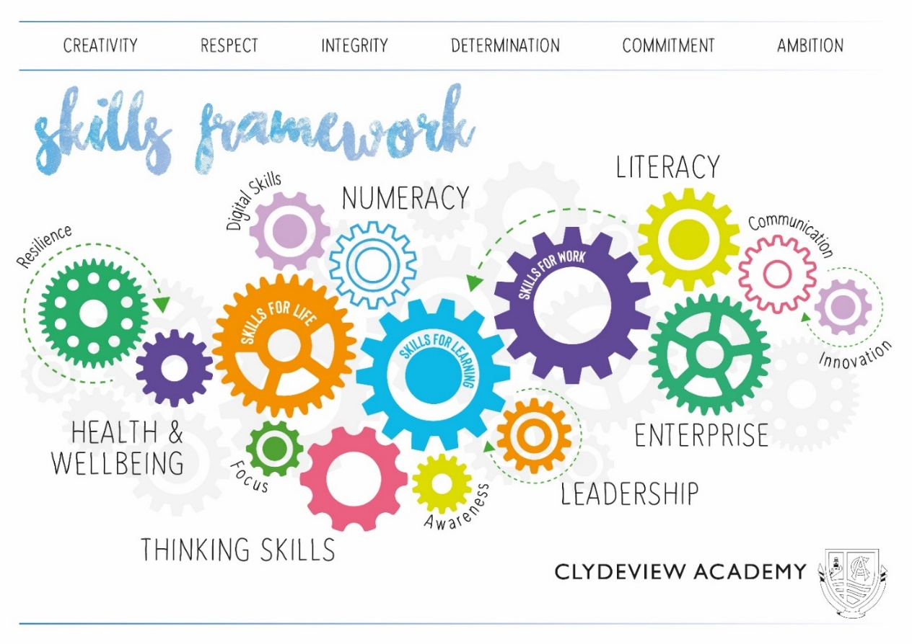This version produced August 2022 and updated in May 2024 by the Learning & Teaching Improvement Group.  
Review date: May 2025.*

**Clydeview Academy – Classroom Visit Report Proforma**

|  |  |  |  |
| --- | --- | --- | --- |
| **Date:** | **Teacher:** | **Subject/level:** | **Class:** |

|  |  |  |  |
| --- | --- | --- | --- |
|  | **Feature** | **** | **Comment** |
|  | **Positive Expectations**  **Removed outdoor jacket/hooded top/non-uniform sweatshirt. Phone & earphones in bag. If leaving for bathroom phone stays in bag and returns to class promptly.** |  |  |
| **1** | **Clear “ready to learn” routine in place, including Starter Activity along with reference to Learning Intention and Success Criteria (co-create success criteria as appropriate)** |  |  |
| **2** | **Account taken of and link made to prior learning, i.e. retrieval practice** |  |  |
| **3** | **Needs of all learners met using appropriate differentiation.** |  |  |
| **4** | **Good planning and delivery taking into account prior attainment - Responsive Teaching** |  |  |
| **5** | **A range of teaching approaches and learning activities used where practicable.** |  |  |
| **6** | **Achievable success linked to forms of assessment.** |  |  |
| **7** | **A range of skilled questioning techniques.** |  |  |
| **8** | **Pupils actively involved in their own learning.** |  |  |
| **9** | **The Clydeview Academy Ethos is in evidence.** |  |  |
| **10** | **Review LI/SC and include a Plenary Task** |  |  |

|  |  |  |
| --- | --- | --- |
| **Time of visit:**  **Teacher:** | **Duration of Visit:**  **Subject:** | **Class:**  **No of Pupils:** |

|  |
| --- |
| **Focus (if appropriate):** |

|  |
| --- |
| **What worked well** |
| **Even better if** |

|  |
| --- |
| **Comments by teacher** |
| Signed ……………………………………………………………… Date …………………………………………… (visitor)  Signed ……………………………………………………………… Date …………………………………………… (teacher) |



