**Inspiring Learning Creating Opportunities Thriving Together**

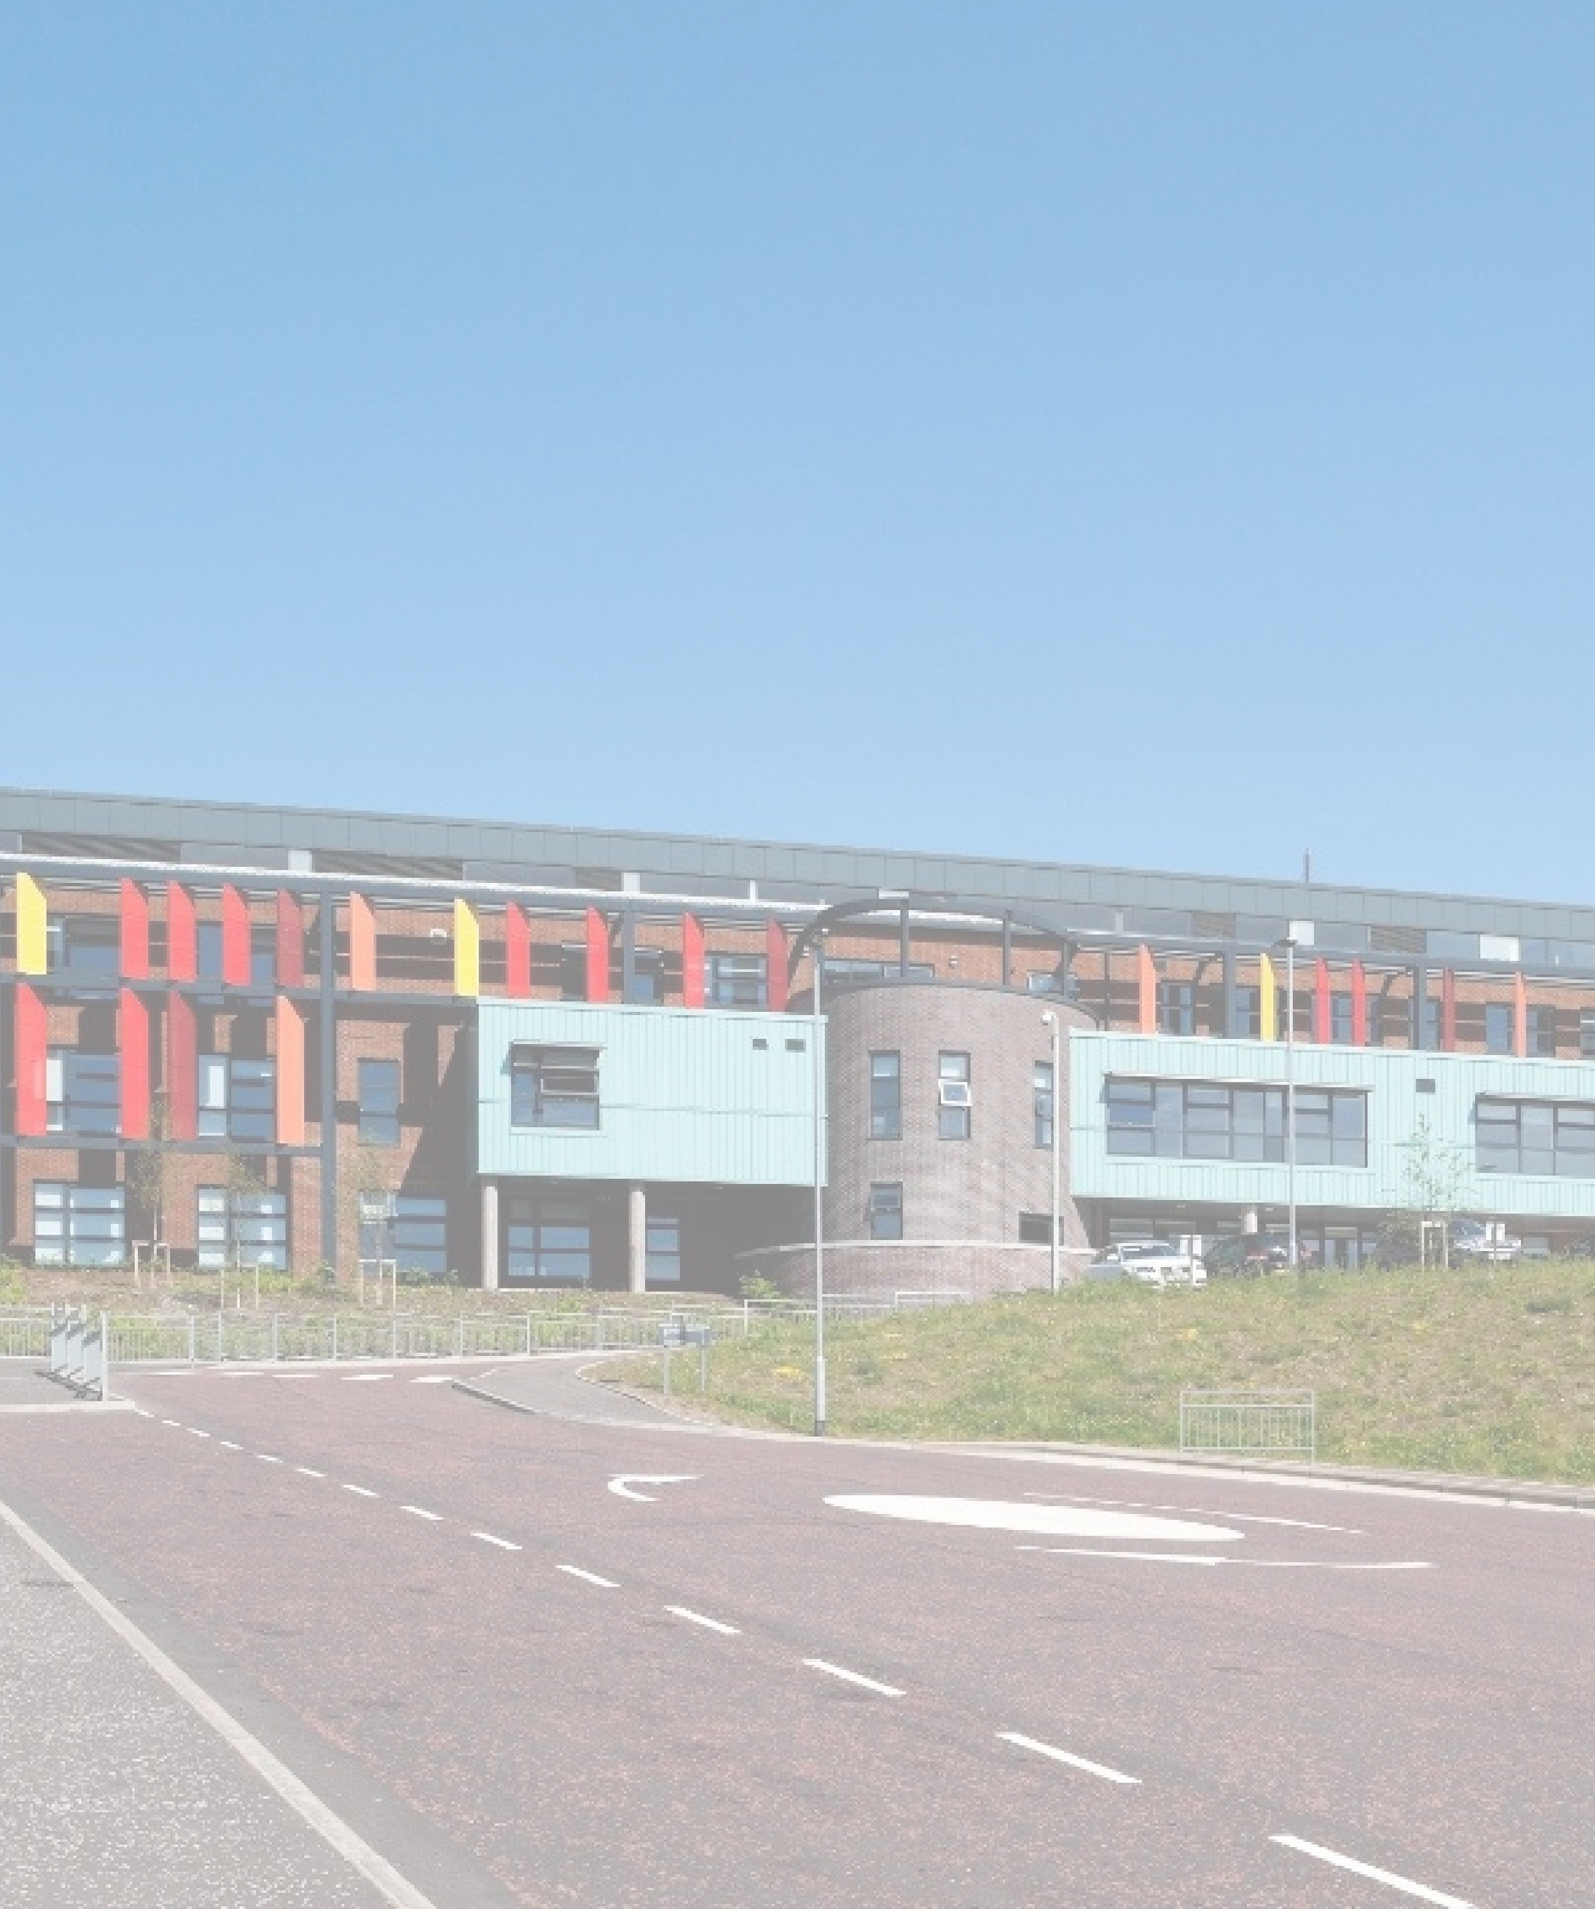

**CLYDEVIEW ACADEMY**

**MAXIMISING ATTENDANCE**

**POLICY**

**Inspiring Learning Creating Opportunities Thriving Together**

**Table of Contents**

Rationale 3

Principles 3

Registration Processes 3

Role of Registration Teacher 3

Morning Registration 8.50 – 9.00am 4

Assembly 4

Pupil Support – Guidance Teacher’s responsibility 4

Class Teacher Responsibilities 4

Pupil responsibilities 4

Parental responsibilities 5

Attendance Management – Daily Procedures 6

Attendance Management – Weekly Procedures 7

Flexible Timetables 7

Achievement Zone 8

Withdrawal from a subject 8

Attendance Tracking and Monitoring 9

Role of PT Guidance 9

Role of Year Head 9

Role of DHT – Pupil Support (Attendance co-ordinator) 9

Role of Head Teacher 9

Maximising Attendance 10

Attendance letters 10

Latecoming letters 11

Attendance Monthly Meetings 11

Monitoring Categories 12

# Rationale

Attendance at school is an increasing challenging issue in Scotland. We are working hard to address the problems it presents, including its impact on attainment, achievement and wellbeing of our young people. We hope we can work together to ensure all our young people are attending school.

# Principles

* All children and young people have a right to education; and education authorities have a duty to provide education.
* All children and young people have the right to get the support they need to benefit fully from education and fulfil their potential.
* All children and young people need to be included, engaged and involved in their learning. Children and young people should be given opportunities to fully engage and participate in the life of the school in order to encourage good attendance.
* Schools should actively engage with parents to try and ensure that any barriers to good attendance are removed.
* Schools and partners should work collaboratively to promote and support good attendance
* The foundation for Clydeview Academy is a focus on positive relationships and an inclusive ethos and culture that promotes good attendance. Attendance should not be considered in isolation.

*Adapted from Education Scotland: “Included, Engaged and Involved Part 1”*

# Registration Processes

## Role of Registration Teacher

Register teachers have an important pastoral role. Daily contact provides an opportunity to build positive, trusting relationships with young people and to notice if there are changes in a young person’s wellbeing. The role of the register teacher is to help children to develop a trusting relationship in school, and therefore develop a safe base. This provides children with a sense of security and enables them to explore their environment, to make the most of school opportunities and to take risks in their learning. This also sets the tone for the whole school day. The register teacher must employ a balanced approach to include both nurture and structure and be consistent with their approach. Any pastoral information or concerns should be passed to the young person’s Guidance teacher.

Register teachers should ensure that the register is completed accurately. Registration is a legal requirement and records of authorised and unauthorised absence may be used at Children’s Panels, the ASN Monitoring Forum or to justify EMA bursaries etc. The School Report will contain a printout of attendance and so it should be as accurate as possible. In addition to that, the Register Teacher has a vital role in establishing the importance of good attendance which is central to the continued attainment and success of our students.

Each day, it is the Register Teacher’s responsibility to:

* Collect class register folder from the office (this should be returned after registration)
* Create a safe, calm and welcoming ethos at Registration with the intention of preparing young people for the day ahead
* Complete an accurate attendance/late coming record to the class on a daily basis
* Issue letters and information via pupils to parents and carers
* Read out the relevant notices in the school newsletter

## Morning Registration 8.50 – 9.00am

Each morning, Register Teachers complete the register using the Seemis system. Any pupil not present in the Registration room should have the code TBC placed against their name on the on-screen register. Pupils entering the room after 8.55am should be marked LAT for late. Ideally, the register should not be completed until the last minute before the 9.00am bell, thus avoiding the need for pupils being sent to the office to report as late.

## Assembly

Each class attends a weekly assembly in the hall on the same day each week. Registration takes place at the beginning of the assembly and the registration is completed on a paper copy which is returned to the relevant member of the SMT. Register Teachers stay with their classes in the Assembly Hall until the 9.00am bell. Period 1 class teachers should ensure that they complete a register upon the pupils’ arrival at class as this will be used as the official attendance mark for the morning session.

## Pupil Support – Guidance Teacher’s responsibility

Principal Teachers - Guidance will liaise closely with the Register teacher to monitor attendance and late coming. Guidance will visit the register class as much as possible, but at least weekly.

## Class Teacher Responsibilities

Class teachers are required to record their class attendance each teaching period of their school day. It is a legal requirement that this takes place each and every period as failure to do so creates anomalies in individual pupil’s attendance figures. When teachers are completing the electronic class register, the system will display a dialogue box if discrepancies occur. This will be monitored by the Office Staff and will alert Guidance and SMT to pupils who are truanting or missing from class without permission. The exceptions to this are Period 1 and Period 5, when a TBC initiates an alert and a truancy call home. Incomplete registers will be monitored period by period and if a member of staff is regularly not completing registers this will be followed up by the Head Teacher.

If a pupil arrives late to class, the class teacher should change the registration mark to LATE on Seemis.

## Pupil responsibilities

* **Pupils have a responsibility to attend school on time.**
* **Pupils who are feeling unwell should report to the school office**. If the pupil needs to be sent home, a member of the office staff will contact home to arrange for pupils to be collected from school. **Pupils should not leave school without permission, nor should they text parents themselves to request collection from school. This must be done through the school office.**
* **Pupils have a responsibility to be at school on time in the morning, after lunch and for each period.**

## Parental responsibilities

* **Parents have a responsibility to ensure their child attends school on time.**
* It is the responsibility of the parent/carer to inform the school of their child’s absence **giving the reason for absence** on the first day of absence, preferably before 9am and each subsequent day thereafter.
  + By telephone call (01475715050)
  + By email ([inclydeview@glowscotland.onmicrosoft.com](mailto:inclydeview@glowscotland.onmicrosoft.com))
  + Using the Parent Portal App
* Student appointments during the school day should be minimised as much as possible. If an appointment is necessary contact should be made with the school and the time recorded as a permission (PER). If the young person is going to be absent for the whole day to attend this appointment, this should be recorded as Medical or Dental Appointment Whole Opening (PWO).

# Attendance Management – Daily Procedures

1. For the purpose of attendance management Period 1 will be used rather than Registration. All class registers should be completed by 9.10am (with the exception of PE, which should be completed by 9.20am. Charlene will check on incomplete registers and alert staff to complete immediately (initially by contacting PTs or departmental bases). If period 1 after assembly, please give an additional 10 mins.
2. Truancy call should be sent by 9.30am. Parent/Carers and all contacts of those young people on the High Risk list should be telephoned immediately and repeatedly until contact is made (Charlene).
3. At 9.45am Lyndsay should run an anomalies report and begin calls for unexplained absence and change codes as appropriate. This should continue until all phone calls are completed.
4. If by 11am a reason for absence cannot be obtained for any student on the High Risk list, the name should be passed to J Wilson Milliken or C Gibson and agencies (SW/Police Scotland) contacted.
5. At 1.25pm office staff will check on incomplete Period 5 registers and alert staff to complete immediately.
6. Truancy call should be sent by 1.35pm
7. At 1.45pm office staff should run an anomalies report and begin calls for unexplained absence and change codes as appropriate. (Monday-Jacqui, Tuesday- Laura and Lyndsay, Wednesday-Laura and Jacqui, Thursday-Laura and Lyndsay, Friday-Lyndsay and Jacqui)
8. If contact has not been possible for two consecutive days and all contacts have been telephoned with messages left, the name should be emailed to J Wilson Milliken copying in C Gibson.
9. All period registers should be completed within the first 10 mins of the lesson (with the exception of PE, which should be completed in the first 20 mins). Period by period absence will be followed up by Charlene through anomalies reports and truancy calls. Charlene will also be responsible for notifying PTs that staff have not completed a register throughout the day. Periods 6 and 7 will be covered by Monday – Mary, Tuesday and Thursday – Lyndsay, Wednesday – Laura and Friday - Jacqui.

# Attendance Management – Weekly Procedures

1. Guidance staff will continue to follow up on TBCs throughout the week at registration and during PSE time. TBCs will be updated with the appropriate registrations mark on Seemis using the anomalies report.
2. Office staff will update college non-attendance on Seemis as and when we receive the attendance information from the college. This is also updated on the college attendance spreadsheet saved in the Guidance folder. Guidance should check this weekly.
3. Year Heads will update Seemis with appropriate registration marks on Seemis as appropriate and will also liaise with Guidance, Office staff and parents/carers to support young people to attend all classes.
4. Any concerns relating to patterns of non-attendance in a particular subject should be flagged up to the Department Principal Teacher in the first instance for action to address any issues relating to that specific subject. If there are wider pastoral concerns relating to the non-attendance this should then be passed by the Department Principal Teacher to Guidance.
5. Concerns regarding patterns of non-attendance of any young person in receipt of EMA should be passed to Michelle Nelis.

# Flexible Timetables

It is the responsibility of the Year Head to update a pupil timetable if a pupil has flexible timetable arrangements. The Year Head should print a copy of the timetable, writing on where the pupil should be for each period of the day, noting the appropriate attendance mark. This should be passed to Jacqui, who will update Seemis, scan a copy of the timetable and save to:

I:\Department - Faculty\Guidance\Flexible Timetables\Copies of flexible timetables

The filename should be the pupil first initial and surname followed by the date, e.g. K Campbell 290224. This will allow all SMT, Guidance and office staff to be able to access the timetables if necessary.

**Achievement Room** (Mondays and Wednesdays - L. Bolger)

* A list of all pupils and the periods attending the achievement room should be sent to the office in advance of the block (L. Bolger)
* Each teacher responsible for the achievement room should take a paper register and send it to the office within the first 10 mins of the period.
* The office staff will change those present to SCH
* If a pupil is absent, and not in their timetabled class, they should be marked as TRU and a truancy call should go home.

Achievement Zone(Monday period 2, Wednesday periods 5 and 6 and Friday period 6 – L. Bolger and E. Forster)

* A list of all pupils and the periods attending the achievement room should be sent to the office each week (L. Bolger and E. Forster)
* Each teacher responsible for the achievement room should take a paper register and send it to the office within the first 10 mins of the period.
* The office staff will change those present to SCH
* If a pupil is absent, and not in their timetabled class, they should be marked as TRU and a truancy call should go home.

## Withdrawal from a subject

* If a pupil is withdrawn from a subject they should continue to attend and remain in the class to study. The teacher should register the pupil.
* Year Head should note on the form the reasons for withdrawal and interventions before passing to Craig.
* If there needs to be a flexible arrangement in place, e.g. the pupil should attend somewhere else and flexible timetable arrangements should be followed.

# Attendance Tracking and Monitoring

## Role of PT Guidance

It is the responsibility of the Guidance Teacher to review the attendance for their caseload. TBCs for individual periods or unexplained absences should be addressed with individual students and subsequent contact made with parents/carers as to the reason for non-attendance. On a weekly basis, TBCs should be removed and the appropriate code marked on the system.

On a monthly basis each student’s attendance percentage should be reviewed using the Attendance Tracker Spreadsheet. If attendance falls below 90% or continues to decline appropriate interventions should be made to help improve a young person’s attendance. These interventions could range from a call home to discuss, a letter home noting the concern, a parental meeting, request for support from the Clydeview Support Team, or Home Link Support. The intervention should be noted on the Attendance Tracker spreadsheet. It is essential that attendance is monitored closely and an early intervention approach applied.

## Role of Year Head

Year Head’s should review the Attendance Tracker spreadsheet regularly. Each month, Year Heads should meet with each Guidance teacher to review interventions to ensure that the appropriate support is in place for any young person whose attendance falls below 90% (see maximising attendance).

## Role of DHT – Pupil Support (Attendance co-ordinator)

The DHT with responsibility for Pupil Support should ensure that the Attendance Tracker Spreadsheet is updated each month (Jacqui) to be accessed by Guidance staff and Year Heads. Each month, the DHT Support will report on current trends in attendance. The DHT Support will also monitor the impact of strategies in place on improving attendance. The DHT Support will also track the attendance of targeted groups (young people impacted by poverty, CEYP, high risk list etc.) to identify any concerns and monitor the effectiveness of interventions. Any concerns in relation to individual young people should be passed to the relevant Guidance teacher.

## Role of Head Teacher

Each term the Head Teacher should ensure that attendance is discussed at an SMT meeting to review and examine the impact of the interventions put in place and discuss trends in particular groupings.

# Maximising Attendance

In addition to all of the above responsibilities in relation to attendance, the following procedures should be followed by PT Guidance staff to maximise the attendance of all pupils in Clydeview Academy.

## Attendance letters

The ultimate responsibility for monitoring pupil attendance and latecoming lies with the PT Guidance who will liaise closely with Registration Teachers and Year Heads.

The threshold for attendance at Clydeview Academy is 90%, although it may be appropriate and relevant for supports to be in place prior to reaching this threshold.

At threshold, the following letters will be sent home and associated action will be taken:

|  |  |  |
| --- | --- | --- |
| **Letter** | **Trigger** | **Action** |
| Letter 1 | Attendance has reached threshold of 90% | Parents/Carers are asked to contact child’s Guidance teacher to discuss reasons for absence. |
| Letter 2 | At next tracking period, if there is no improvement in attendance. | Parents/Carers are asked to contact child’s Guidance teacher to discuss reasons for absence. |
| Letter 3 | At next tracking period, if there is no improvement in attendance. | Guidance Teachers will organise a Maximising Attendance meeting to fully explore reasons for absence and to agree support for pupil to improve attendance. |
| Letter 3B | At next tracking period, if there is no improvement in attendance. | Agreement sought from parent/carer to refer to Joint Support Team. If no agreement, a request for assistance should be submitted to social work. |
| Letter 4 | At next tracking period, if there is no improvement in attendance. | Referral to Children’s Reporter. |

## Latecoming letters

Each tracking period, latecoming will be monitored as follows:

* Each time late in the week – email sent to parent/carer at 12pm
* Pupil regularly late e.g. over 10 times late or regularly late, e.g. every Monday – formal latecoming procedures begin

**Formal latecoming procedures** will begin as follows:

|  |  |  |
| --- | --- | --- |
| **Email** | **Trigger** | **Action** |
| Email 1 | 3 times late in a week or regularly late | Parents/Carers are asked to contact child’s Guidance teacher to discuss further support required. |
| Email 2 | At next tracking period, if there is no improvement in timekeeping | Parents/Carers are asked to contact child’s Guidance teacher to discuss further support required. |
| Email 3 | At next tracking period, if there is no improvement in timekeeping | Guidance Teachers will organise a Maximising Attendance meeting to fully explore reasons for latecoming and to agree support for pupil to attend school on time. |
| Email 3B | At next tracking period, if there is no improvement in timekeeping | Agreement sought from parent/carer to refer to Joint Support Team. If no agreement, a request for assistance should be submitted to social work. |
| Email 4 | At next tracking period, if there is no improvement in timekeeping | Referral to Children’s Reporter. |

## Attendance Monthly Meetings

The DHT Support, relevant Year Head and PT Guidance will meet monthly to review the attendance of pupils below 90%. This will include information about the pupil name, registration class, attendance percentage for the current tracking period and current attendance percentage, reasons for attendance being monitored and the action being taken by the Guidance teacher. This information will be shared with all staff. The following will be discussed and monitored:

- those pupils whose attendance is dropping

- those who are making improvements

- those who are in the ‘at risk’ or ‘chronic absence’ category

- any emerging patterns.

- vulnerable groups of pupils.

e.g.

|  |  |  |  |  |
| --- | --- | --- | --- | --- |
| **Pupil Name** | **Reg Class** | **% attendance** | **Monitoring category** | **Action** |
| Pupil A | 2D | 89% | Short term genuine illness | Letter 1 |
| Pupil B | 4C | 75% | Parental Holiday | Letter 1 |
| Pupil C | 5F | 65% | Truanting. At risk | Letter 3 – Maximising attendance meeting TBA |
| Pupil D | 1E | 69% | Attendance improving | Continue to monitor |
| Pupil E | 3B | 65% | Refusal to attend. Chronic absence | Letter 4 – referral to Children’s reporter |

## Monitoring Categories

Pupil’s attendance will be monitored for the following reasons:

* Short term genuine illness
* Long term genuine illness
* Parental Holiday during term time
* Unauthorised absence (Not in the school building and when contact parent/carer no reasons has been provided)
* Truanting (In school building but not attending classes)
* Refusal to attend (despite efforts of school staff, support services or parents, a pupil will not attend school)
* Attendance improving
* At risk
* Chronic Absence
* Latecoming

**Appendices**

1. Attendance Tree
2. Attendance Codes
3. Attendance Matters at Clydeview – Parental Leaflet part 1
4. Attendance Matters at Clydeview – Parental Leaflet part 2
5. Attendance Letter 1
6. Attendance Letter 2
7. Attendance Letter 3
8. Attendance Letter 3B
9. Attendance Letter 3B Alternative
10. Attendance Letter 4­­