Pathways
S2 Subject Choices

Subject Fayre
11th January 2023

Name:________________________________

Class:________________________________
S2 Subject Choices Timeline
- Thursday 11th January
  - Reports issued
  - period 5 and 6 – S2 Subject Fayre
  - 6pm-7pm – parental information evening
- Next week – PSE – more practice at choosing your subjects (take this booklet with you)
- Wednesday 17th January – S2 Parents Meeting – 3.30pm-5.30pm
- Between Thursday 18th January & Friday 2nd February– Options Interviews
- Deadline for submission of forms – Friday 2nd February

Pathways
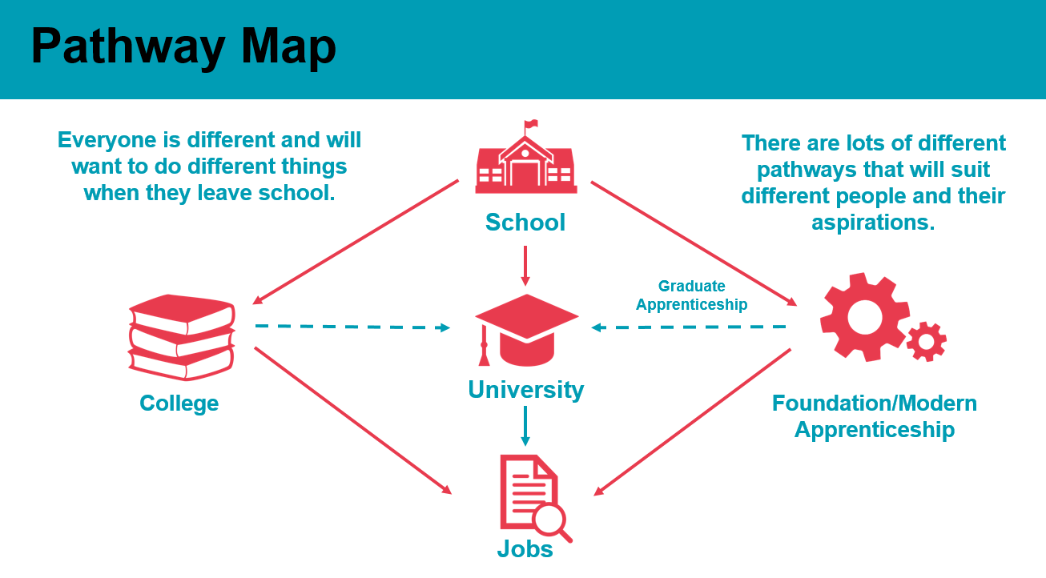
We are asking you to choose subjects to take into S3 which will set you on your pathway for the remainder of school and beyond. The subjects you choose for S3 will be the subjects you choose from to take into S4 and then into S5 so it is really important that you make the right choice for you.
- S1/2 - 14 subjects
- S3 - 11 subjects (5 compulsory (English, Maths, Language, PE, RE & 6 choice)
- S4 - 6 subjects at National 3/4/5 (Eng, Maths & choose another 4 from your S3 subjects)
- S5/6 - 5 subjects at National/Higher/Advanced Higher (choose from your 6 subjects in S4). Further options for wider achievements, college courses, work experience, and apprenticeships.
S3 Subject Choice Form 2023-24
Column C | Column D | Column E | Column F | Column G | Column H | Column I
French  Spanish | Biology  Chemistry  Physics  Science | Business  Geography  History  Modern Studies | Accounts  Admin & IT  Computing  Graphics  Music Tech | Art  Music Perf  Design & Manu  Hospitality  Woodwork | Art  History  PE  Spanish | Admin & IT  Computing  Chemistry  Dance

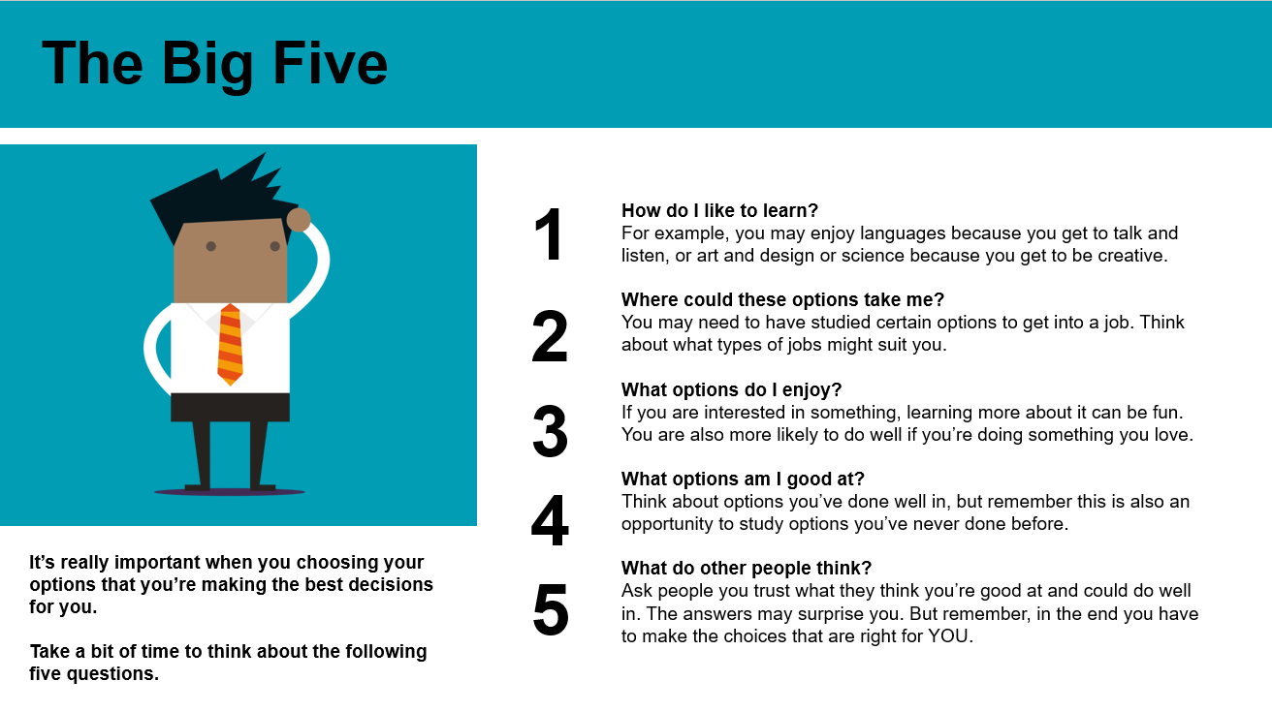
Using the subject choice form above and the Big 5 Questions write down the subjects you are thinking about taking into S3. These are the subjects you should visit first at the subject fayre.

Subject 1:

Subject 2:

Subject 3:

Subject 4:

Subject 5:

Subject 6:

Subject 7:

For English, Maths & each subject above you should visit the stall to find out the following:
English:__________________________________________________

- What kind of things will I learn about in this subject in S3?

- How will we learn? E.g. practical, creative, active, etc

- What pathway would this put me on for S4-S6?

- What might the pathway be after school in this subject?

- What career opportunities might this subject lead to?

Maths:_____________________________________________________

- What kind of things will I learn about in this subject in S3?

- How will we learn? E.g. practical, creative, active, etc

- What pathway would this put me on for S4-S6?

- What might the pathway be after school in this subject?

- What career opportunities might this subject lead to?

Subject 1:__________________________________________________

- What kind of things will I learn about in this subject in S3?

- How will we learn? E.g. practical, creative, active, etc

- What pathway would this put me on for S4-S6?

- What might the pathway be after school in this subject?

- What career opportunities might this subject lead to?

Subject 2:_____________________________________________________

- What kind of things will I learn about in this subject in S3?

- How will we learn? E.g. practical, creative, active, etc

- What pathway would this put me on for S4-S6?

- What might the pathway be after school in this subject?

- What career opportunities might this subject lead to?

Subject 3:__________________________________________________

- What kind of things will I learn about in this subject in S3?

- How will we learn? E.g. practical, creative, active, etc

- What pathway would this put me on for S4-S6?

- What might the pathway be after school in this subject?

- What career opportunities might this subject lead to?

Subject 4:___________________________________________________

- What kind of things will I learn about in this subject in S3?

- How will we learn? E.g. practical, creative, active, etc

- What pathway would this put me on for S4-S6?

- What might the pathway be after school in this subject?

- What career opportunities might this subject lead to?

Subject 5:__________________________________________________

- What kind of things will I learn about in this subject in S3?

- How will we learn? E.g. practical, creative, active, etc

- What pathway would this put me on for S4-S6?

- What might the pathway be after school in this subject?

- What career opportunities might this subject lead to?

Subject 6:___________________________________________________

- What kind of things will I learn about in this subject in S3?

- How will we learn? E.g. practical, creative, active, etc

- What pathway would this put me on for S4-S6?

- What might the pathway be after school in this subject?

- What career opportunities might this subject lead to?

Subject 7:__________________________________________________

- What kind of things will I learn about in this subject in S3?

- How will we learn? E.g. practical, creative, active, etc

- What pathway would this put me on for S4-S6?

- What might the pathway be after school in this subject?

- What career opportunities might this subject lead to?

Use this space to jot down any notes or questions you might have for SDS, Class teacher, Guidance teacher:

Below, write down a couple of jobs you might be interested in having in the future. Try to find out the answers to the questions (you might want to ask subject teachers, Skills Development Scotland, MyWow Ambassadors, SCQF Ambassadors)
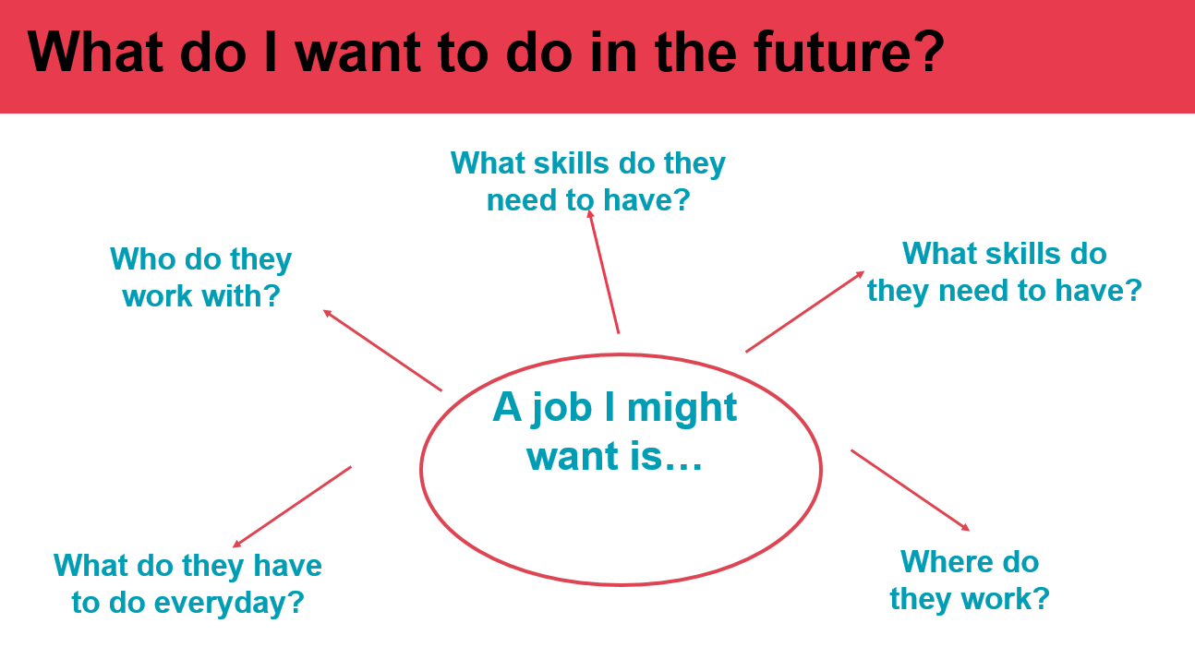

Write down the names of two business partners present at the subject fayre below. What is the name of their job? Can you find out what their pathway was to this job? Write down anything you find out below.

1.

2.

If you have time see if you can find out the following:

- Visit MyWow Ambassadors. How can MyWow help you with your subject choices?

- Visit the DYW Co-ordinator Mrs Rasmussen. How can she help you with your subject choices?

- Visit Skills Development Scotland. How can your careers advisor support you with your subject choices? What other support is available through SDS?

- Visit the SCQF Ambassadors. What is SCQF? What options are available in Clydeview later on in S4/5/6?

Please keep this booklet safe and bring it to PSE next week where you will have the opportunity to discuss subject choices with your Guidance teacher.
Remember to share this information with your parents/carers when you are discussing subject choices.
More information can be found on: www.myworldofwork.co.uk and www.planitplus.net

