Present: Anne Witherow (Chair), Craig Gibson (HT), Val Forsyth, Sandra McAdam, Elizabeth Robertson, Ross McFadzean, Muriel Russell

In attendance: Sue Currie, Sarah Jones, Sandra Campbell, Frances Ramsay, Cllr Graeme Brooks
Apologies: Alan Donaldson, Cllr Lynne Quinn

Item: |  | Action:
1 | Welcome and Apologies  Anne welcomed everyone to the meeting
2 | Minutes of last AGM 23/9/19 – read and accepted  Proposed: Val Forsyth Seconded: Elizabeth Robertson  Minutes to be emailed to school office for display on school website
3 | Chair’s Comments  It gives me great pleasure to report on another great year for Clydeview Academy Parent Council in the session 2018/19.  As a Parent Council, we continue to be involved in the business of the school, including the appointment of our new HT. We welcome Craig and look forward to working partnership with him and his team.  We have continued to support the school at a range of the events, from Parents’ meetings to Jazz nights, concerts, School shows and the Prize Giving. This year the Teach the Parents event in March was replaced by a very successful Health and Wellbeing night which was highly commended by many families. Many thanks to Val, Sandra and Carol Devenny for their input. It is hoped to run this event again in Spring 2020. Unfortunately due to my administrative error the Quiz night did not go ahead last year but it is planned to get this back on the calendar in the autumn. We changed from having our drinks for events delivered by a supplier to purchasing them directly ourselves. This has proved to be more cost effective.  Fundraising plays a major part in what we do, and last year was no exception. With last year’s issues with the bank account now fully resolved we were able to continue our successful ‘Make a Bid’ initiative for departments to apply for funds for a specific purpose, and supported PE, Art and Business Studies requests to a total of £1000. I have asked Craig to inform the PTs that “bids” will be taken again in the near future.  As always I wish to thank staff members for their input to the Parent Council. Thanks go to Sandra McAdam who has stepped down but remains a “willing helper”. I wish to extend a welcome any new staff and invite them to join us as they give another valuable point of view. Our best wishes go to staff who have moved on to pastures new and to those who, like Willie, have taken the opportunity to retire. On behalf of the Parent Council I wish them all well.  Finally, I’d like thank all of you for supporting me and the events we run. Our success as a Parent Council would not be possible without you.
4 | Head Teacher’s Comments  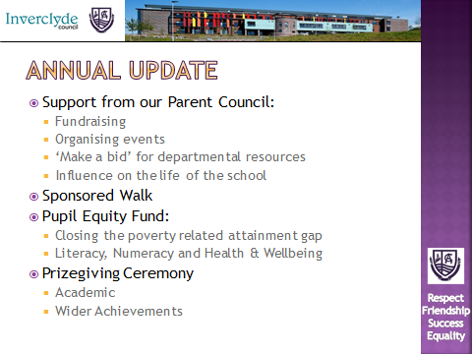  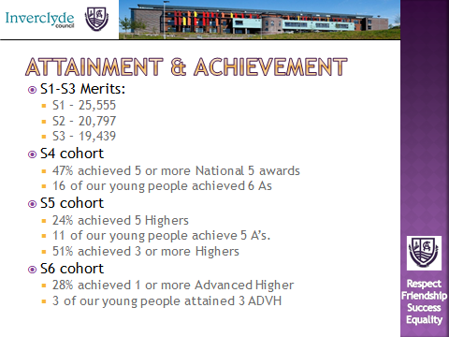  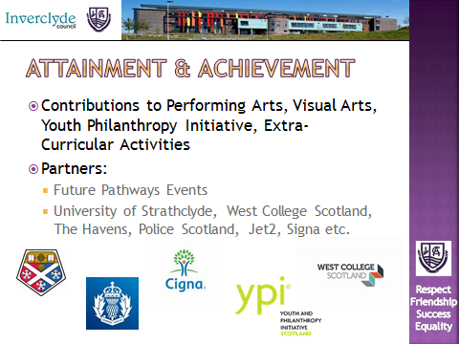  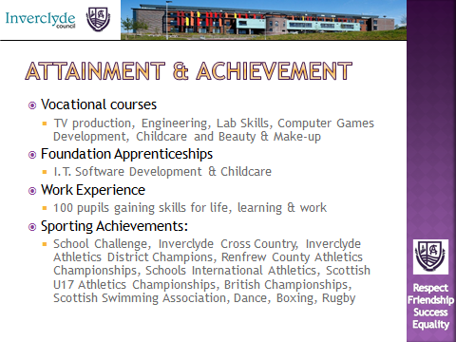
5 | Treasurer’s Report  The outgoing Treasurer was not present to give a financial report. The bank balance is £1401.23. In addition there is a cash float of £49.15. A new Treasurer will need to be appointed at this meeting.
6 | Nomination and Election of Officers Bearers  The following were elected as PC members-Sue Currie, Sarah Jones, Sandra Campbell.  Proposed: Val Forsyth Seconded: Muriel Russell
7 | Nomination and Election on New PC members  The following were elected as officer bearers for the session 2019/20.  Chair Anne Witherow Proposed: Elizabeth Robertson Seconded: Val Forsyth  Vice Chair Val Forsyth Proposed: Elizabeth Robertson Seconded Muriel Russell  Treasurer Muriel Russell Proposed: Elizabeth Robertson Seconded: Sandra McAdam  Secretary Unfilled (Craig Gibson will ask S5/6 ICT pupils if they wish to undertake this role in a paid capacity)
8 | Amendments to the Constitution  There were no proposed amendments to the constitution so it will remain as agreed in September 2018.
9 | AOB  Uniform Bank – plans are in place to start a bank of school uniform including blazers, ties, jumpers and cardigans. A visit to see how the successful uniform bank at Port Glasgow High School runs is to be scheduled. Craig said he hope to get some S6 pupils involved in this project.  UCAS meeting - for S5/6 pupils and their families on Wednesday 25 Sept.  Activities Week- S1-3 pupils will be informed after the October break how trip places have been allocated. Sue asked if pupils who had been unsuccessful getting their first choice would be guaranteed their first choice in the following year(s). Val and Sandra said that whilst every effort would be made to accommodate requests, when numbers and friendship groups were taken into account, this could not be guaranteed but staff did monitor the situation to ensure fairness and equity.  Anne closed the meeting and thanked everyone for attending. | Anne/Craig
10 | Dates of Next Meetings  Monday 28 October 2019  Monday 13 January 2020  Monday 16 March 2020  Monday 1 June 2020  Monday 14 August 2020  Monday 21 September 2020 AGM

