This year we will start our tenth anniversary celebrations and we really want all of you involved. There will be many events and activities throughout the 2021/22 school year that you will be part of and the first one is already here…
Clydeview is TEN!
…Design a logo to represent the school’s tenth birthday/anniversary. The winning logo will feature on lots of souvenirs produced to celebrate this milestone birthday.
The design could include the number 10, the school badge, the river Clyde - YOU decide!!
Please hand in/email your design by the end of term (Wed 23 June) to either Miss Murdoch (incmurdoch001@glow.sch.uk) or Ms Gillespie (inasv288@glow.sch.uk ).
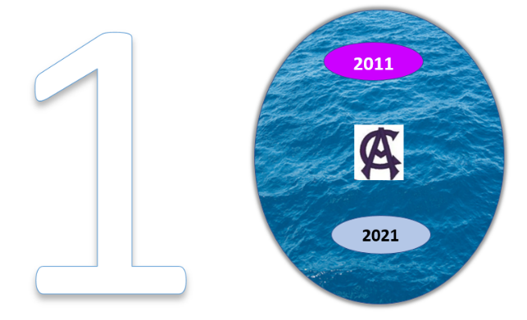
*
*just an example

