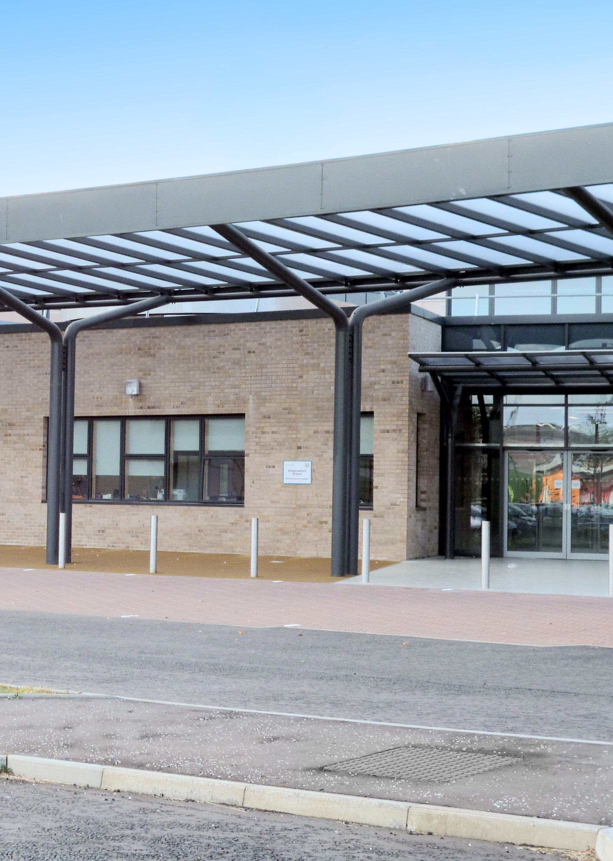
Craigmarloch School
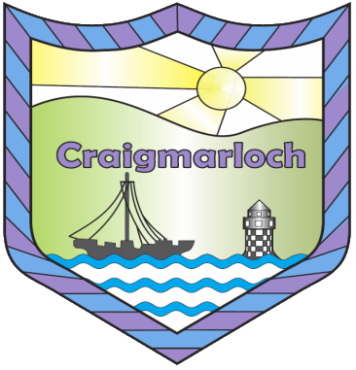
School Handbook
2022-23

welcome

Letter to Parents/ Carers from Head Teacher – George Walker

Dear Parents/ Carers
Welcome to Craigmarloch School. I hope this handbook will be a useful introduction to our school.
At Craigmarloch we strive to provide learning experiences which will help fulfil your child’s full potential both educationally and socially. We welcome your co-operation and we work to provide opportunities which promote parental involvement and partnership.
You will always be welcome in the school and we look forward to you and your family becoming involved in the Craigmarloch School Community.
If you have any questions relating to the handbook or the school in general, please do not hesitate to contact me. I hope that this handbook gives you an insight into the ethos and practical aspects of Craigmarloch School.

Yours sincerely,

George Walker
Head Teacher

School information
Craigmarloch School is a non-denominational, co-educational school for boys and girls with additional support needs. It is part of the Port Glasgow Community Campus. The school opened in 2013 and pupils from all areas of Inverclyde attend. There are currently 22 classrooms within the school, most with quiet rooms attached. There are large outdoor areas with play areas, wet weather sheltered areas, a sensory garden and a MUGA pitch.
We have a sensory room, hydrotherapy pool, two P.E halls, a dining hall, a life skills room, two laundry rooms and a health room.
Our expected school roll for 2022-23 is 200.
To promote a range of learning and teaching opportunities which suit our learners, class sizes are smaller with a higher staff to pupil ratio.

Contact Details
Address: Craigmarloch School
Port Glasgow Community Campus
Kilmacolm Road
Port Glasgow
PA14 6PP

Tel: 01475 715345
Fax: 01475 715344
E-mail Address: incraigmarlochoffice@glowscotland.onmicrosoft.com
School Website: craigmarloch.inverclyde.sch.uk/
Twitter: @CraigmarlochINV

School LEADERSHIP TEAM

Head Teacher: Mr George Walker

Depute Head Teacher (Secondary) Depute Head Teacher (Primary)
Mrs Lynn Smith Miss Aileen Morgan

Mrs Collette Brown Depute Head (PEF) Mrs Donna McCahill Depute Head Primary (PEF)

Principal Teacher: Mr Paul Evans (PEF)
Principal Teacher Miss Laura Stewart (PEF)
Principal Teacher Miss Yvonne Mazzoni (PEF)

The school year 2021-22
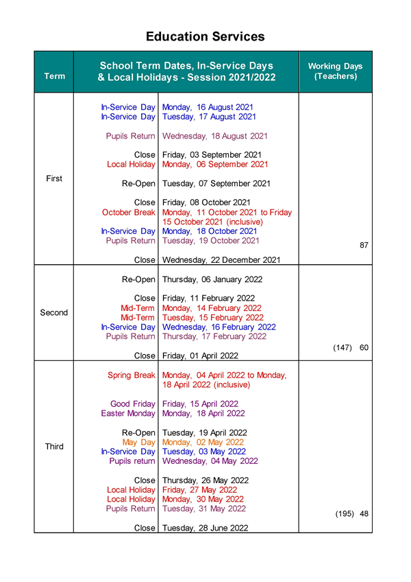

The School day
Primary
Start | Interval | Lunch | Home
9am | 10.25am –  10.40am | 12.05pm-  12.50pm | 3pm

When arriving at school Primary pupils go to the internal playground and class teachers will collect them at 9am. If the weather is wet or icy, Primary pupils gather in the main hall.
Secondary
 | P1 | P2 | Interval | P3 | P4 | Lunch | P5 | P6 | P7 | Home
Mon | 8.50 | 9.50 | 10.40 | 10.55 | 11.45 | 12.35 | 1.15 | 2.05 | 2.55 | 3.45
Tues | 8.50 | 9.50 | 10.40 | 10.55 | 11.45 | 12.35 | 1.15 | 2.05 | 2.55 | 3.45
Wed | 8.50 | 9.50 | 10.40 | 10.55 | 11.45 | 12.35 | 1.15 | 2.05 | Home  2.55
Thu | 8.50 | 9.50 | 10.40 | 10.55 | 11.45 | 12.35 | 1.15 | 2.05 | 2.55
Fri | 8.50 | 9.50 | 10.40 | 10.55 | 11.45 | 12.35 | 1.15 | 2.05 | 2.55

The Secondary timetable to aligns with the timetables of all other Secondary Schools within Inverclyde.
Secondary pupils gather in the dining hall if their bus is early and then go straight to their Period 1 class.
Our Secondary model means that all Secondary pupils will begin each day with a 10 minute registration period, followed by a period of Health & Wellbeing within their tutor group class. Pupils will then move round the subject classes timetabled for them. Some pupils will have a more individualised curriculum experience.

Communication
Good communication between home and school ensures the safety and care of all of our pupils. This may be with the School Office, the Senior Leadership Team, Class Teacher or Bus Escort. Communication methods include diaries, email, phone calls, letters, twitter or the school may send out a text message. Review meetings and Parents’ meetings will take place throughout the school year.

Reporting Absence or Sickness
If your child is absent from school please contact the School Office by telephone as early as possible after 8.30am. On return to school please send a letter in explaining the reason for absence.
Asking a question or raising a concern
Please phone the school office and ask to speak to a member of the senior management team. If they are not able to take your call they will call you back as soon as they are available.
Reporting Progress
Each pupil receives an Annual Progress Report. This contains curriculum information and how well your child is doing in each subject area.
Emergency Contact
If your child becomes ill or is injured at school, we will contact you via the Emergency contact number that you provide us with. We will usually ask that your child be collected from school.
School Closure
If in the event of adverse weather the school is not open, and you have provided the school with a current mobile number, you will be notified by text message from Inverclyde Council as soon as Inverclyde council has made this decision. There will also be information on the Council website.

Uniform

At Craigmarloch School our pupils wear school uniform.
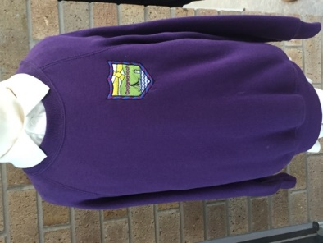
The Primary Uniform is:

A shirt and tie, or white or navy polo shirt and a purple jumper. Black/grey trousers or skirt.
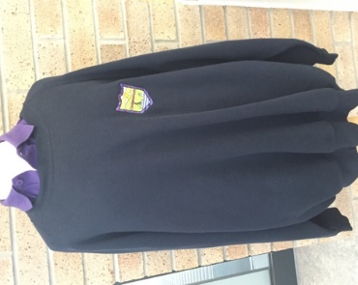
The Secondary Uniform is:

A shirt and tie, or a purple or white polo shirt and a navy jumper. Black/grey trousers or skirt.
Senior pupils have a school blazer.
P.E. Kit
Pupils are encouraged to change for P.E. and there are changing rooms available for both Primary and Secondary pupils.
The following items are recommended as a P.E. kit
- Primary – Purple Craigmarloch t-shirt and shorts
- Secondary – Blue Craigmarloch t-shirt and shorts

Lunches and Snack
Lunch
All pupils in Craigmarloch School are entitled to a free school meal at lunch time. We use Parent Pay to order school lunches and pupils have a choice of options each day. The menu follows a three week rotation and a copy of the menu will be sent home to allow for discussion about food choices. Some pupils prefer to bring a packed lunch.
The dietitian may offer individual advice on eating and pupils are encouraged to extend their range of healthy food intake through taster plates.
P1-S3 have their lunch in the Craigmarloch dining hall.
S4-6 have their lunch in the agora of the Shared Campus, providing extended socialisation opportunities with the young people from St Stephen’s and Port Glasgow High Schools. Some food or drinks offered in the agora may cost more than the amount allocated by ParentPay. Additional funds can be added by parents if required.
(Due to Covid risk reduction mitigations pupils currently eat in their classrooms)
Quiet areas for eating lunch can be offered to some pupils.
Snack
As a health promoting school we encourage you to provide your child with a healthy snack/drink each day. Pupils have their snack at interval.
Water
The school provides water from coolers around the school. This is freely available for pupils throughout the day.

transport
All Craigmarloch pupils are provided with free transport to and from school. This is usually on a school bus. You will be notified by letter of approximate pick up and drop off times. Pupils can only be picked up/dropped off from one address.
There will always be an escort on the bus with pupils. It is the responsibility of the parent/carer to have pupils ready on time for the bus. The bus is not allowed to wait more than 4 minutes as directed by SPT, who manage the bus contracts for the school. Please ensure that you are home on time for the bus to arrive.
All buses have seat belts and pupils must wear these for the duration of the journey. Buses with tail lifts are provided for children who use wheelchairs. The bus escort / driver is responsible for safe handling of your child. Eating or drinking on the bus is not allowed for safety reasons. Pupils may wear headphones and listen to music or have ear defenders on if they find the bus noisy.
All escorts will carry emergency contact details and have medical plans on the bus. You will be provided with a business contact number for your child’s bus escort, in case your child does not need collected for school.
Independent travel for some pupils can be arranged in consultation with the family.

CoMMUNITY ACCESS
To enhance learning and give opportunities for learning in a real-life context a range of outings is organised by the teachers within the school.
The Primary Department will have a community access bus time each week.
The subject specialist teachers within the Secondary Department will organise curricular trips linked to their subject areas.
Consent forms will be sent home at the beginning of the academic year for trips within Inverclyde. If your child/ young person is travelling outwith Inverclyde, a separate consent form will be required for each trip.

Curriculum for Excellence
A Curriculum for Excellence is the Scottish Curriculum for learning and achievement and provides a framework for progression through the different stages of Nursery, Primary and Secondary education.
From P1-S3, pupils will experience and learn from the outcomes of A Curriculum for Excellence at 6 levels.
Pre-Early
Early
First
Second
Third
Fourth
As pupils progress through Craigmarloch they will be given opportunities to maximise their learning potential at each of the levels that are most appropriate for their learning style and abilities.
A Curriculum for Excellence strives to ensure that pupils are;
Successful Learners – giving their best and with support overcoming barriers to learning.
Confident Individuals – taking pride in all that they do to achieve in school and the wider community.
Effective Contributors – becoming involved in the life of the school and class. Taking responsibility and helping others.
Responsible Citizens – learning appropriate behaviour for school, home and community.

Primary curriculum

In our Primary Department pupils will have most of their lessons with their class teacher. We are very fortunate to have a Primary specialist P.E. teacher.
Primary Subjects include:
Literacy and English/ Communication
Maths
Social Subjects -
Religious and Moral Education
Health & Wellbeing – P.E., Personal & Social Education, Home Economics food experiences
Expressive Arts – Art, Music & Drama
Technologies – ICT, Science and Home Economics equipment experiences
Modern Languages – French

Pupils may also be timetabled for rebound therapy, hydrotherapy, soft play and outdoor learning.

Literacy, Numeracy and Health & Wellbeing are taught across learning in curricular areas that lend themselves to contextual learning.

In P7, pupils begin their transition to the Secondary department and will experience access to subject areas taught by specialist staff.

secondary curriculum
S1-3
During S1-3 pupils will continue with the broad, general phase of their education. Timetabled Subjects for S1-3 taught by subject specialists are:
English/ Communication
Maths
Social Subjects – Geography, History, Modern Studies
Science
Technologies - Design& Technology, ICT
Expressive Arts – Art, Drama, Music
Health & Wellbeing – Home Economics, P.E., P.S.E.
Literacy, Numeracy and Health& Wellbeing are the responsibility of all teachers to look for opportunities within their subjects to raise attainment in these three key areas of learning.
In S3 pupils and their parents are supported to make subject choices for S4-6.
S4-6
The Senior Phase offers opportunity for personalisation and pupil choice leading to a range of subject based SQA qualifications and SQA Personal Achievement Awards.
Pupils will be advised about course choices depending on their aptitudes, interests and strengths to ensure the best chance of success. Parents/carers are an important part of this guiding process.
Courses at National 1-4 level will not be graded but will be marked overall pass or fail. Courses at National 5 and above will include work and formal exams marked externally by the SQA.

Assessment
Ongoing formative assessment is an integral part of teaching and learning at Craigmarloch School. This is done through effective questioning, creative ways to find out if pupils have understood their learning intention and by giving feedback that is meaningful and encouraging to pupils. Summative assessments throughout the year allow teachers to gain information about what has been learned and will be used to guide planning.
In S4-6 most pupils will be assessed using SQA National Assessments which from Nat 1- 4 are assessed by teachers within the school and may be verified by the SQA. Pupils are supported to achieve these qualifications, with additional support where required for assessments which are conducted under exam conditions.

reporting
Pupils will receive an annual written report and will have Parents’ meetings with teachers twice per year to get feedback on wellbeing and learning. Review meetings provide an opportunity for all professionals caring for your child/ young person to come together with you to discuss what is going well and what are the challenges to learning being experienced. These meetings are solution oriented and have a nurturing approach to finding the best package of learning and opportunity for our pupils. Pupils can attend review meetings if appropriate and they wish to.

Wider achievement
To provide challenge and breadth of learning in the Secondary department awarding bodies such as ASDAN (Award Scheme Development Accreditation Network), Duke of Edinburgh and John Muir Award provide learners with a wide range of skills for learning and life.
There is a range of lunchtime clubs available including: choir, band, active schools, Greenock Morton Community Trust football coaching and Makaton signing.
The Music Dept. offers excellent opportunities for both Primary and Secondary pupils to be involved in choir performances.
The after-school football club for Secondary pupils takes part in the West of Scotland league and travel to play against other ASN schools.
Some of our pupils take part in the Otters Swimming Club and won gold medals at the recent Special Olympics.

Shared Campus Learning
Pupils from S1-6 can have the opportunity to engage in some of their learning in either Port Glasgow High School or St Stephen’s High School where appropriate. Decisions on whether access to the shared campus is appropriate are made via pupil review meetings.

Developing the young work force
S1-3 experience and prepare for the world of work through a range of activities leading to a more focused experience of work in the Senior Phase.
S4-6 have annual opportunities for relevant, challenging and enjoyable work experience placements within the contemporary work place. The placements are tailored to suit individual needs and help our young people gain skills for life and make informed choices about career options. Some of our pupils have gained employment or voluntary work leading on from these experiences. Some pupils may have ongoing work experience throughout the year if this is agreed to be a beneficial learning environment.
Any enquiries regarding work experience should be directed to the DHT of Secondary in the first instance.

college
In partnership with West College, Scotland we offer a range of courses to enhance learning beyond school. Many of our Senior Phase pupils opt to have their learning experience extended within the College environment. There are half day experiences offered to all S4 pupils, increasing to full day experiences in S5 and S6.

Outdoor learning
In the Primary Dept. there are many opportunities for Outdoor Learning within the school grounds and during community access trips within the local area.
In Secondary these opportunities are extended to learning beyond school in Finlaystone Estate, Lochwinnoch and Cornalees.

Residential Programme
Our residential trips take place in P7, S2, S4 and S6. The opportunity to take part in a residential trip offers pupils the chance to experience a new place and be faced with new challenges that can be overcome in a supported environment. (All trips are suspended due to Covid restrictions)
P7 – Bendrigg Trust Outdoor Centre – Cumbria
S2 – Calvert Trust Outdoor Centre – Cumbria
S4 – Ardentinny Outdoor Centre – Argyll
S6 – City Break – Stirling

Covid 19
Covid 19 situation:
Throughout the Covid 19 situation we will continue to be guided by the national advice and the local authority advice. We will share all information with the school community as it becomes available. Information will be shared via our groupcall system and twitter.
When required our learning will take place remotely primarily via the Microsoft Teams platform. Parent guides to use of Teams have been shared via our school Twitter feed. Please don’t hesitate to contact school if you require any further advice with our remote learning offer.

nurturing Approach
This handbook will give you a flavour of the school and all that we have to offer. This is all achieved through a nurturing approach by all staff towards pupils, supporting and guiding them to overcome barriers to learning and working towards achieving to their fullest potential.

GIRFEC – Getting it right for every child
The GIRFEC approach involves staff in all children’s services meeting the needs of pupils by working together with children and families/ carers so that our pupils can reach their full potential.
Pastoral care is the responsibility of every teacher in Craigmarloch School.
This will include:
- Promoting and safeguarding the health, welfare and safety of pupils.
- Working in partnership with parents, learning assistants and other professionals as appropriate.
- Providing guidance and advice to pupils on issues relating to their education and wellbeing.
- Contributing towards a nurturing classroom ethos which supports good order and encourages good behaviour.
The Senior Leadership Team have specific pastoral care responsibilities. Principal teachers should be the first point of contact for any concerns or issues.
Head Teacher – All pupils
DHT Primary Miss Aileen Morgan - Pastoral overview Early Years, P1, P2 and P3 pupils
DHT Primary Mrs Donna McCahill – Pastoral overview CAL Dept, P4,P5,P6 and P7
DHT Secondary Mrs Collette Brown – Pastoral overview S1 – S3
DHT Secondary Mrs Lynn Smith- Pastoral overview S4 – S6 Secondary pupils

Scotland’s vision is that all children and young people should be –
Safe, Achieving, Included, Nurtured, Active, Healthy, Respected and Responsible.

Postive relationships, positive behaviour

Each class has a positive ethos reward system, and staff together with the leadership team aim to guide pupils towards appropriate and positive behaviours in line with Inverclyde Council’s Positive Relationships/ Positive Behaviour Policy. Head Teacher’s Awards are given out at Assembly.
There is an emphasis on preventative strategies and building good relationships where pupils can be taught the necessary skills required to regulate and manage their behaviour.

We have positive expectations for pupils and our vision for conduct within the school is –
- We are kind and caring.
- We show good manners to everyone.
- We make safe and responsible choices.
- We always try our best.
- We let others learn.
- We look after our school.
Most classes have quiet rooms where pupils can have some time for self-regulation/ reflection. The Senior Leadership Team support pupils to calm and return to learning. If there are ongoing concerns over behaviour parents/carers will be contacted to meet with the Senior Leadership Team and work together on strategies to support positive behaviour.

protecting children and supporting their wellbeing
Inverclyde Council Education Services has Child Protection Guidelines and Procedures which all schools and establishments are required to follow. Standard Circular 9.1 Protecting Children and Supporting their Wellbeing
Education Services work closely with partners in Social Work Services, NHS Greater Glasgow and Strathclyde Police. The common responsibilities of all partners are:

- To protect children from harm and abuse
- To ensure that all children have a safe, caring and stimulating environment
- To promote the wellbeing of all children and
- To respond appropriately when a concern is identified
A TAC (Team Around the Child) meeting may be called by the School or Social work Dept. This is a solution oriented meeting that aims to ensure the wellbeing of your child/ young person.

EQuality Statement
Inverclyde Education Service is committed to ensuring that no children or members of staff or service users receive less favourable treatment on any ground including race, disability, age, sexual orientation, religion or belief. We aim to promote a culture in which equality of opportunity exists for all. WE are opposed to all forms of discrimination, direct or indirect and aim to eliminate all discriminatory practices. We will ensure that in our schools and other educational establishments equality permeates the curriculum and underpins all our policies and practices in terms of access to education. We must ensure that all our children achieve their full potential to develop physically, emotionally and academically. Finally, we believe that equality and inclusion should be a given right, where everyone is valued and treated with respect.

PUPIl Council
There is a very active Secondary and Primary Pupil Council which aims to establish pupil voice and pupil choice within the school. The minutes of the meetings are in the front foyer of the school. The Senior Leadership Team and staff support the pupils to take responsibility for change.

Parent council
The Scottish Schools (Parental Involvement) Act 2006 led to the establishment of Parent Councils in all school in Scotland. The Act recognises the vital role that parents play in supporting their children’s learning. It places a duty on authorities to promote the involvement of parents in children’s education and the wider life of the school. It aims to help parents be:
- Involved with their child’s education and learning
- Welcomed as an active participant in the life of the school
- Encouraged to express their views on school education generally
The Parent Council is made up of volunteers who want to be actively involved in representing Parent views and supporting the school. It aims to support the school through organising events such as The Christmas Fair and the Summer BBQ to promote the school community.
Please contact the school if you would like to be on the Parent Council.

religious Education / observance
In line with Curriculum for Excellence, Religious Education is taught throughout the school as a core subject. The Scottish Government believes that there is value in pupils learning about religion as well as from religion. This is to promote an understanding of the diversity within our society. CfE
Catholic Education is provided for pupils whose parents/ carers request it. We have weekly input from SPRED (Special Religious Education), a diocesan group of volunteers from local parishes who encourage and promote faith development within the school, leading on to evening groups for senior pupils.

additional support for learning
As Craigmarloch is a school for pupils with a wide range of additional support needs we adhere carefully to Council and Government policy from the Education (Additional Support for Learning) (Scotland) Act 2009 which sets out the provision each local authority must make for young people with additional support needs:
- A child or young person’s needs are identified at the earliest possible stage and can be met in a number of ways, for example by adaptations to the curriculum or learning environment, as well as input from visiting specialists. The appropriateness of the support is determined through a process of assessment, planning and monitoring, working jointly with parents and carer and is regularly reviewed.
- Learning outcomes for children and young people with additional support needs are set out in a plan and all educational establishments hold regular review meetings with parents and carers to determine needs and the most appropriate supports. Everyone’s views are equally important in order to consider what is currently working and how to determine next steps.
- Children and young person’s needs are identified in a number of ways and the process of the assessment is an ongoing, shared process with partnerships with parents and carers at the forefront. On some occasions health service staff or other partner agencies make children known to Education Services. Other additional support needs may be notified to Education Services by parents themselves or identified by one of a range of staff working closely with the child.
- Some children and young people will additional support needs ranging from complex or multiple factors which require a high degree of co-ordination of support from both education and other agencies in order that their needs can be met. In these cases the school will hold a meeting to decide whether the child or young person meets the criteria for a co-ordinated support plan.
The co-ordinated support plan is a statutory document which ensures regular monitoring and review for those children and young people who have one.

School Improvement
At Craigmarloch we are developing the school in line with Scottish Government policies and priorities for education and are guided by Inverclyde Council to continually improve standards within the school. This will benefit the children and young people who attend the school by giving them the best opportunities for learning & skills development in all curricular areas.
The Head Teacher will provide a Standards & Quality report and a School Improvement Plan each year to outline the successes of the school and the development needs for the following year.

Medical & Health care
We have a number of specialists who visit Craigmarloch School to support the Health and Wellbeing of our pupils within a familiar environment. This may include Nurses, Doctors, Occupational Therapists, Speech and Language Therapists, Physiotherapists, Play Therapists.
You will be notified of any medical appointments within the school.
Parents/ Carers should notify the school of any medical requirements relating to their child. If a child/ young person requires medication during the school day the appropriate medical form should be filled out, medication must be in date and have a prescription label with the child’s name attached. We cannot administer non-prescribed medication to any child.
If a pupil becomes ill during the course of the day he/she may require to be sent home.

Annual Data
At the start of the school session parents and carers will be issued with the annual data check form. Please ensure it is completed and returned to the school. It is also important for you to let us know if there is a change of mobile number or address or emergency contacts.

Communication friendly school

At Craigmarloch School we use a range of ways to encourage and further develop our pupils’ communication. These include Makaton signing, PECS, Boardmaker symbols and pictures. We have visual timetables to guide pupils through the day. We encourage use of all these methods at home to support a Total Communication package for all our pupils.

Thank you for taking the time to read over the Craigmarloch School Handbook 2020-21. If you have any further questions please contact the school –
Craigmarloch School
Port Glasgow Community Campus
Kilmacolm Road
Port Glasgow
PA14 6PP
Tel: 01475 715345

