

Ardgowan Primary School

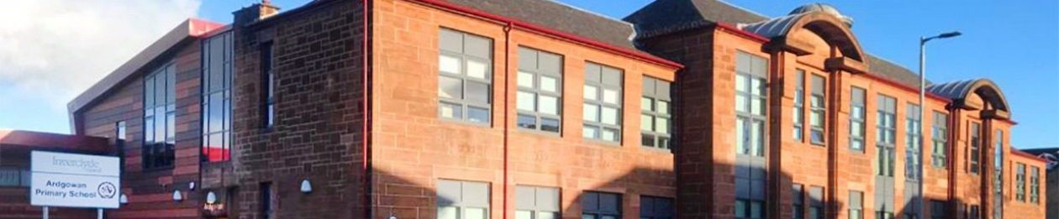

Standards and Quality 2023/24
Context of the Establishment:

Our Establishment

Welcome to Ardgowan Primary’s Standards and Quality Report for the period August 2023 – June 2024.

Ardgowan Primary is committed to delivering high-quality education. The school community creates a school environment that nurtures ambition and aspirations, improves attainment and achievement, and creates and widens opportunities for all children to achieve their full potential. Not every child and family get the same, but they get what they need. Throughout this report you will see examples of how this commitment has been demonstrated during this year.

You will read about our many successes and improving trends in attainment and achievements and we will continue this in 2024/2025 by putting our families at the centre of our plans, activities and improvements. We will build on our strengths and achievements. By doing this, we will demonstrate our ongoing commitment to getting it right for every child and family.

Context
Ardgowan Primary School is non-denominational and is situated in the West End of Greenock.

Our current roll is 447 across 16 classes. Our establishment is a refurbished building in Newton Street. This provides staff and pupils with high quality accommodation over three levels including an extension, housing a gym hall and we have a Multi-Use Games Area (MUGA).

The % of pupils living in SIMD 1 and 2 is approximately 21.5% which led to a PEF allocation to the school of £85,750. Almost 35% of pupils are identified with Additional Support Needs and a further 3.6% with English as an Addition Language. 9 pupils are Care Experienced.

The school’s Senior Management Team consists of 1 FTE Head Teacher and 1 FTE Depute Head Teacher Emma Picken and Greg McGowan. We have a large Senior Leadership Team consisting of 3 Principal Teachers who make up the 2.0 FTE Principal Teacher entitlement (one 0.8 FTE, and two 0.6). We have 26 class teachers (made up of full time and part time remits), which includes 1 NQT, as well as a Support for Learning Teacher (0.5). We also have 1.2 teachers who were funded through our Pupil Equity Fund. We also benefit from support provided by 9 Pupil Support Assistants. Rev. Karen Harbison and Rev. Jonathan Fleming fully support the work of the school. Clydeview Academy is our associated secondary school.

Our School Vision
Our Vision has been chosen and agreed by our school community:
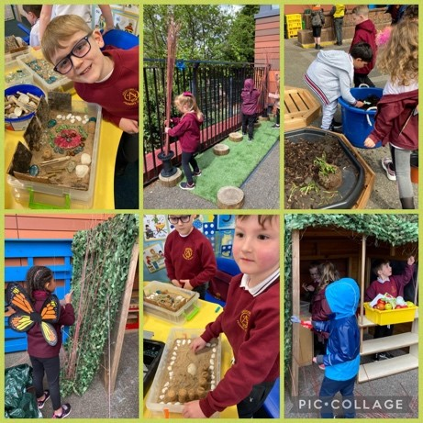
Always be the best that we can be
Respect each other and our community
Develop skills for learning, life and work
Grow in confidence in a happy, nurturing environment
Offer support to others
Work and play together
All have opportunities to be heard
Never give up!

Our school values which have been chosen and agreed by our school community are:
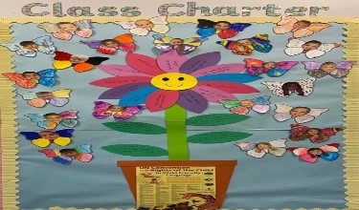
- Honesty
- Respect
- Friendship
- Achievement

Aims
To create successful learners by providing all pupils with equal opportunities for maximum learning and development
To create confident individuals by encouraging respect for every child’s individuality and dignity
To create responsible citizens by developing and fostering positive attitudes and skills for all pupils which prepare them for life in society
To create effective contributors by encouraging an enterprising attitude, resilience and independent learning skills
To develop an open, welcoming and caring school in which all children feel nurtured, safe, active, healthy, achieving, included, respected and responsible.

Establishment priority 1:
NIF Priority  Improvement in skills and sustained, positive school-leaver destinations for all young people  -  NIF Driver  Assessment of children's progress  Teacher professionalism  Parental Engagement | HGIOS/ELC QIs  3.2 Raising attainment and achievement  3.3 Increasing creativity and employability  3.2 Securing Children's Progress  2.3 Learning, teaching and assessment  UNCRC  Article 28: (Right to education):  Article 3 (Best interests of the child):
Outcome:

SIP priorities 2023 / 2024

- By September 2023, PTs and class teachers will identify pupils requiring a device to support their progression in literacy or numeracy.
- By September 2023, pupils requiring devices to support them with progression in writing will be using them to increase their engagement in writing lessons and increase their pace and progression through their personalised writing targets linked to the writing pathway.
- By September 2023, pupils requiring devices to support them with the progression in numeracy will be using them to increase their engagement in numeracy lessons and increase their pace and progression through their personalised numeracy targets linked to the numeracy pathway.
- By November 2023, parents will be introduced to pupil digital profiling and how it can inform pupil progress throughout an academic year.

Progress and impact of outcomes for learners:
- By September 2023 all pupils who were requiring a device to support their progression in literacy and numeracy were identified by level PTs and class teachers. Programmes were put in place to support identified pupils with literacy and numeracy barriers.
- Almost all pupils (96%) stated that they had increased motivation and increased engagement when using devices to learn.
- Digital technology is used appropriately in all classes with evidence of very good use of ‘Nessy’ and ‘Clicker 8.’
- Digital methods are also being used to support children whose first language is not English.
- Introduction of new Ardgowan Express by the Digital Leaders (P6). Pupil Voice is at the heart of the Ethos and Life of the School. Ardgowan Express was shared with parents as a monthly newsletter which focused on Learning and Curriculum, as well as the 4 context of learning.
- Digital profiles where shared with parents and pupils at parents’ evening. This was done through TEAMs and glow email. All pupils could see their progression, particularly in writing.

Next steps:

- By June 25, feedback from a sample group of learners will articulate how they have been given increased opportunities to direct how learning is taken forward in IDL, in comparison to a baseline set in September 2024.
- By June 25 all learners will be involved in pupil directed learning through the four contexts of learning.
- By June 25 all classes will profile learning through the four contexts of learning using a class floor book.
- By October 24 most learners will be able to talk about the different types of meta skills they are developing and tracking through their skills jotters.
- By June 25 most learners will experience clear progression of meta-skills, evidenced through big books and skills jotters.
- By June 25, teaching staff feedback from most staff will indicate greater understanding of what constitutes high quality IDL, including a BRL element compared to a baseline set in September 2024.
- By June 24 most learners will experience high quality music lessons observed by PT through learning walks.
- By October 25 most learners will experience high quality outdoor learning either in school or out with school grounds, linked to STEM and Play and Enquiry.
- By June 2025, most of staff feedback will indicate increased knowledge and confidence in being racially literate from baseline set in September 2024.
- By June 2025, classes at second level will have experienced high quality financial education lessons, built into our development work of STEM and DYW.
- By June 2025, all classes will have experienced high quality food technology lessons linked to the Es and Os, building on their skills for life.

Establishment priority 2:
NIF Priority  Improvement in children and young people's health and wellbeing  Placing the human rights and needs of every child and young person at the centre of education  NIF Driver  Teacher professionalism  Performance information | HGIOS/ELC QIs  1.3 Leadership of change  3.1 Ensuring wellbeing, equality and inclusion  UNCRC  Article 3 (Best interests of the child):  Article 31 (Leisure, play and culture):
Outcome:
- By June 24, through staff increased knowledge and understanding of legislative frameworks related to wellbeing, equality and inclusions all children will experience appropriate interventions in response to wellbeing needs.
- By June 24, using the principles of GIRFEC and the legislative framework surrounding it, children will receive a bespoke single or multi agency support for their universal and targeted wellbeing needs which will improve engagement, achievement and attainment. This will be measured through the leuvens scale, the Glasgow Motivation Tool and attainment tracking.
- Through staff increased knowledge and understanding of nurture principles and approaches, children will experience appropriate interventions in response to wellbeing needs which will be measured through pupil voice conversations.
- From August 23, the Health and Wellbeing PSA interventions will make a positive difference to playground experiences and increased engagement in learning and the curriculum will be evident. This will be measured by the number of referrals made to SMT.
All children will be nurtured by all staff using trauma sensitive approaches which will be recorded through learning walks and captured through pupil voice.

Progress and impact of outcomes for learners:
- School staff use the principles of GIRFEC and demonstrate high levels of skill and commitment to meeting the complex needs of children. Meaningful, real life examples of GIRFEC wellbeing indicators in pupil’s everyday life has been discussed at weekly assemblies and then consolidated with deeper learning in the classroom context. All children now have a greater understanding of their wellbeing and how to ask for help if they need it.
- Nurture approaches across the school has continued to focus on pupil relationships with staff. Observations and discussions with children and their families indicate that this continues to be a challenge. Staff have supported children by discussing feelings through the trauma informed practice CLPL. Through staff’s increase knowledge and understanding of nurture principles and approaches, children have experienced appropriate interventions in response to their wellbeing needs.
- Our targeted Art Therapy provision changed this year due to the cut in PSA allocation. Our well-being PSA (PEF £10,000) took focus groups after school hours (3.30 – 4.30), to allow her to work with more targeted groups within a day. This also allowed her to support learning in class. Children’s progress has been tracked using the Glasgow motivational and wellbeing tool to continue to identify gaps in their social and emotional skills and target them appropriately. Assessments and observations indicate that children have made very good progress. The teacher and parent evaluation have shown a significant impact on pupil engagement and improvement with attendance. 100% of teachers stated that engagement had increased in the classroom throughout the year if the child had attended Art Therapy. Providing a soft start/relaxed entry with our Art therapist improved attendance with 4 out of the 5 targeted children.
• Children’s mental health has been supported through our Trauma Informed Practice training and training from the Ardgowan Hospice, to address the challenges of loss and bereavement, uncertainty, friendships and feeling safe. Targeted children have become more settled as the year progressed.
- All school staff have engaged in the racial literacy development. The BRL lead has undertaken the training across the last year and has delivered CPD to all staff. Children and staff across the school are developing the knowledge, skills and awareness they need to talk thoughtfully about race and racism.
- We did not achieve our ATSSA Bronze award with Jenny Nocks by the end of the year due to staff absence. Almost all classes have a calm box and almost all classes have a safe area and space for children who are dysregulated.
- Environments across the school were re-evaluated and changed to create more safe spaces around the school for chill out zones and calm learning areas.
- The pupil voice asked for a quiet zone at lunchtimes for an alternative environment to the playground. We changed the gym hall into a quiet space, managed by SLT. This has seen a reduction in dysregulated pupils at lunchtime and increased engaged in targeted pupils after lunchtime.
Next steps:
- By November 2024, we will gain our ATSSA Bronze award.
- From August 2024, all staff will use enhanced registers to show how learning/expectations are differentiated to consider the needs of pupils who have experienced adversity.
- From August, staff will consider use of space within/outside classrooms to provide boundaried ‘safe space’ to manage overload/dysregulation
- From August 24, all staff will plan mental health lessons using the Tree Of Knowledge resource.
- By September 24, pupils including the most vulnerable are supported in communicating emotions, feelings and worries.
- By September 2024, children are supported by a trusted adulted during play time and lunchtime.
- By September 2024, alternative lunch time offers will be in place for targeted pupils.
- From August 24, the Health and Wellbeing PSA interventions will make a positive difference to playground experiences and increased engagement in learning and the curriculum will be evident. This will be measured by the number of referrals made to SMT.
- By November 2024, support strategies will be in place in every classroom to support executive function and to reduce over stimulation. eg. Calm boxes/ safe spaces Work alone spaces will be used positively rather than punitively.
- By June 25, teaching and learning will be multi-sensory in all year groups and play and enquiry learning will be planned for and evident in classrooms.
- By June 25, access to younger children is facilitated to allow interactions with developmentally similar children
- By June 25, adults know the developmental, social and emotional age of pupils in their care and recognise and respect that the child is behaving appropriately for their developmental age.
- By June 25, staff will have increased knowledge and understanding of nurture principles and trauma sensitive approaches, children will experience appropriate interventions in response to wellbeing needs which will be measured through pupil voice conversations.
- By November 24, all staff will use standardised visual support for signage, labels and communication eg. Visual timetables, lanyards and individual support.
- By September 24, a parent/carers support groups will be established for foster and adoptive parents.

Establishment priority 3:
NIF Priority  Closing the attainment gap between the most and least disadvantaged children and young people  -  NIF Driver  School leadership  Assessment of children's progress | HGIOS/ELC QIs  3.2 Securing Children's Progress  3.2 Raising attainment and achievement  UNCRC  Article 28: (Right to education):  Article 3 (Best interests of the child):
Outcome:
Attendance

By June 2024, the attendance of all pupils living in SIMD 1 and 2 will be above 94%, a 3% improvement from 2023.

By September 2023, identified pupils in SIMD 1 and 2 from the P3, and P5 year groups will have a targeted intervention plan to improve school attendance.

Attainment
By June 2024, we aim to reduce our poverty related attainment gap in each area of the BGE by 3%.

2022/23 Current Data
Overall BGE gap 11.1% Reading
Overall BGE gap 10.9% Writing
Overall BGE gap 9.9% Numeracy
Overall BGE gap 7.2% Listening and Talking

2023/2024 Target Data
Overall BGE gap 8.1% Reading
Overall BGE gap 7.9% Writing
Overall BGE gap 6.9% Numeracy
Overall BGE gap 4.2% Listening and Talking

PEF used to support closing the gap:

1 FTE Teacher (£66,469) – back fill recovery / back fill PTs
0.2 Teacher (£9466.38) - Back fill recovery / attainment teacher
7.5 hours Attendance Co-ordinators (admin staff /PSA staff) £5000 facilitating a walking bus / pick up

Progress and impact of outcomes for learners:
Attendance
Our senior leadership team make effective use of the layering tool on the dashboard, to identify those children who are not attending school as regularly as expected. Identified families are supported in a variety of ways including a walking bus to both reduce late coming and increase attendance. This has been welcomed by families and has shown success.
We have used our PEF money to fund attendance co-ordinators to target SIMD 1 and 2 pupils with attendance below 90%. All pupils are tracked weekly by the attendance co-ordinators, and interventions were offered to families to support the improvement of attendance, such as an arranged pick up. As a result, the average attendance for pupils living in SIMD 1 and 2 is 91.8%, a 0.5% increase and improvement from 2023, reducing our poverty related attendance gap from -2.6% to -1.9%.

Monthly tracking for classes has been closely monitored and we have seen an average of 93.3% across all stages. Although P6’s attendance is above 90%, the SIMD 1 and 2 pupil attendance is sitting below at 86.5%. Improved attendance has increased engagement, attainment and achievement progress for targeted pupils. The interventions have also supported mental health and wellbeing for parents and families. We are now matching and exceeding our pre-pandemic targets.
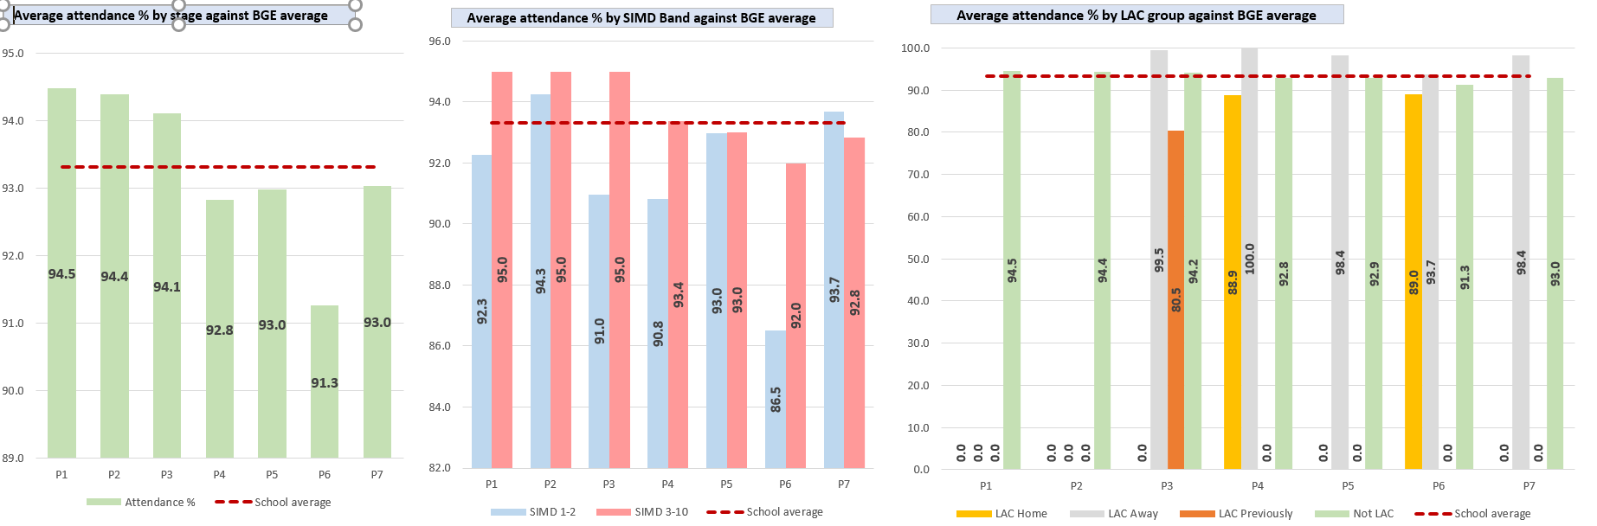
Attainment
We have a very good awareness of children who are in SIMD 1+2. We regularly compare this data to that of children who are in SIMD 3-10 to identify the poverty related attainment gap. This gap is carefully monitored and addressed through a variety of interventions including modelling of teaching and learning by the Principal Teachers, co-operative teaching and targeted approaches.
We continue to have a strong focus on data and the use of data to impact positively on attainment and teaching and learning. All data is shared with class teachers and is discussed through tracking meetings where progress is identified. Almost all staff indicated that they are increasingly confident in the use of data. Teaching staff have also participated in training on the use of the dashboard and data analysis, which will continue next year. We recently piloted the Fact, Story, Action approach to analyse class data. This will be part of the transition data going into August.

We have implemented a revised approach to the learning and teaching of numeracy based on June 2023’s data. Using a ‘teaching sprints’ approach, class teachers are clear on their expectations of numeracy and the senior leadership team monitor this in detail.
A focus on numeracy as a result of moderation has led to increased consistency in assessment and good progression is evident. As with feedback, similar approaches will now be considered for reading.
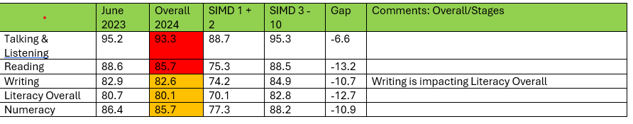
We recognise that although our overall data has maintained and we are above national and Inverclyde’s average, we continue to have a poverty related attainment gap in all elements.
Next steps:

Attendance

By June 2025, the attendance of all pupils living in SIMD 1 and 2 will be above 93%, an increase of 1.2% from 2023/24.

By September 2024, identified pupils in SIMD 1 and 2 from all year groups will have a targeted intervention plan to improve school attendance and late coming which may include working in partnership with Clydeview.

Attainment
By June 2024, we aim to reduce our poverty related attainment gap in each area of the BGE by 1.5%.
23/24 Data
Overall BGE gap 6.6% Listening and Talking
Overall BGE gap 13.2% Reading
Overall BGE gap 10.7% Writing
Overall BGE gap 12.7% Overall Literacy
Overall BGE gap 10.9 % Numeracy

2024/2025 Target Data
Overall BGE gap 5.1% Listening and Talking
Overall BGE gap 11.7% Reading
Overall BGE gap 9.2% Writing
Overall BGE gap 11.2% Overall literacy
Overall BGE gap 9.3% Numeracy

Establishment Priority 4:
NIF Priority  Improvements in attainment, particularly in literacy and numeracy | HGIOS QIs  2.3 Learning, teaching and assessment  3.2 Raising attainment and achievement  UNCRC  Article 28: (Right to education):  Article 3 (Best interests of the child):
Outcome
By June 2024, the number of stages using play pedagogy to increase pupils’ readiness to learn and to focus on skills development will extend to P3.

By June 2024, the review and a refresh of key learning and teaching pedagogies, the teaching of literacy and numeracy will be more effective and lead to raised attainment.

In all stages we are raising attainment for all, however we will have a particular focus on numeracy this year (writing / reading maintenance).

Focus on Numeracy Attainment Targets:

By June 2024, the attainment in numeracy will increase by the following in each stage by implementing a whole school approach to numeracy pedagogy:

· P1 targets: increase from 98.6% to 100 % achieving at Early Level
· P2 targets: increase from 98.6% at E to 100% at achieving F.1
· P3 targets: increase from 93.3% at F.1 to 95% at achieving F.2
· P4 targets: increase from 84.5% at F2 to 90% at achieving First level
· P5 targets: increase from 80.5% at First Level to 90% achieving S.1 ·
· P6 targets: increase from 81.3% at S1 to 85% achieving S2
· P7 targets: increase from 82.5% at S2 to 90% achieving Second Level

Targets for P1, P4, P7
BGE Literacy
- To increase the % of pupils in P1 making expected progress in Literacy from 86.5% to 90%.
- To increase the % of pupils in P4 making expected progress in Literacy from 76.9% 90%
- To increase the % of pupils in P7 making expected progress in Literacy from 81.1% to 82%
BGE Numeracy
- To increase the % of pupils in P1 making expected progress in Numeracy from 98.6 % to 100 %.
- To increase the % of pupils in P4 making expected progress in Numeracy from 80% to 90%
- To increase the % of pupils in P7 making expected progress in Numeracy from 82.4% to 90%

Progress and impact of outcomes for learners:

Our school is very responsive to individual needs. Planning meetings have a strong focus on addressing barriers. As a result, children access appropriate additional support, whenever required. Children receive a range of supports including input from support for learning staff, Pupil Support Assistants and access to variety of partner agencies. Senior leaders have a clear, comprehensive overview of the short and long-term barriers children may face and an ‘enhanced register’ of need is shared with all staff as appropriate. Most staff have a clear understanding of robust systems in place to support all learners.
Our staff have been proactive in promoting positive relationships and interactions and most children indicated they feel confident and safe. There are clear protocols and routines in place to capture pastoral concerns. Children reflect on their wellbeing using a variety of clearly understood formal and informal routes. This includes regular wellbeing check-ins across all classes and weekly ‘drop in’ sessions with the school house captains. The Glasgow Motivation and Wellbeing Tool indicated that almost all pupils feel that their emotional wellbeing is supported.
Feedback from partners highlighted the use of creative approaches in meeting the needs of pupils and addressing barriers to learning. All partners had a clear understanding of roles and responsibilities and all indicated that their contribution was valued. This underpins the work of our school, where building relationships and strong communication can be identified as a key strength.
Our school’s approaches to fully involving children in floor book planning in P1 and P2 was recognised as good practice through our learning visits and learning walks. Children receiving additional support have individual learning plans to monitor and evaluate their progress. Senior leaders involve children in the planning process. As a result, children and families indicated that they felt included in the decisions made about the support they receive and in deciding targets and actions.
Pupil Equity Funding and targeted interventions utilises the strengths within the staff team resulting in a rich universal provision across the school community. The development of the Art therapy provision and the formation of new pupil support groups which has helped to create an inclusive ethos where diversity is celebrated and the needs of individual children considered with compassion and sensitivity.
Children with targeted interventions are able to identify a ‘Trusted Adult’ from across the school community and articulated the positive impact that this had on their wellbeing. This approach is strengthening relationships further, empowering the majority of children to share worries and concerns and providing opportunities for them to share successes.
The social and emotional wellbeing needs of children are met well through a range of bespoke planned interventions. The majority of staff have an increased understanding of pedagogy through a robust offer of CLPL on subjects such as, Adverse Childhood Experiences (ACES), trauma informed practice, dyslexia and bereavement leading to improved outcomes for pupils in reducing inequalities.

Pupil’s Wellbeing and progress was measured using the Leuven Scale and the Glasgow Motivation and Wellbeing Tool. By the end of the year all pupils had made increased progress, which was noted in our enhanced transition meetings with Clydeview SfL team and ICOs.

Play pedagogy has, once again, been a real strength in Adgowan. Play has developed into P3 environments and the Outdoor Classroom has been timetabled during the school day as well as break times and lunchtimes. Creative timetabling has allowed a teacher to lead outdoor learning during lunchtimes for targeted groups. A digital lunchtime club has also been a focus for all P2s as part of their play progression.

Numeracy
The attainment in Numeracy has increased by the following in each stage by implementing a whole school approach to Numeracy pedagogy:

Primary | June 23 | Target for June 24 | Attainment June 24
1 | 98.6% | 100% | 89.8%
2 | 98.6% | 100% | 90.7%
3 | 93.3% | 95% | 93.5%
4 | 84.5% | 90% | 84.2%
5 | 80.5% | 90% | 78.5%
6 | 81.3% | 85% | 80%
7 | 82.5% | 90% | 82.8%

We tracked and predicted to get identified pupils ‘on track’ over the year. These were our stretch aim pupils. We managed to achieve this for some pupils, however the data does not reflect this. We registered a number of pupils throughout the year who were not on track which has had a negative impact on our overall day and achievements with numeracy.

ACEL DATA
Targets for P1, P4, P7
BGE Literacy
- 83.1% of pupils in P1 made expected progress in Literacy.
- 87.7% of pupils in P4 made expected progress in Literacy.
- 78.1% of pupils in P7 made expected progress in Literacy.

BGE Numeracy
- 89.8% of pupils in P1 making expected progress in Numeracy.
- 84.2% of pupils in P4 making expected progress in Numeracy.
- 82.8% of pupils in P7 making expected progress in Numeracy.

Our attainment is higher or in line with National, Inverclyde and our Family Group C average:
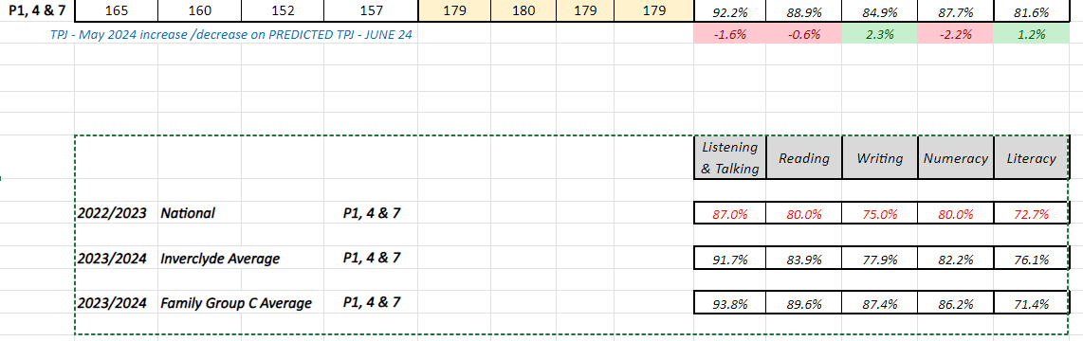

Overall Literacy and Numeracy ACEL DATA
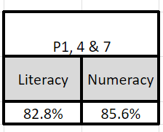

We have seen an improvement in Literacy attainment by 1.1%.

Attendance

Senior leaders and teachers monitor attendance closely. We provide targeted support to several families to help children attend school more regularly and improve late coming. This includes breakfast provision, soft start, walking bus and taxi pickups. ‘Stay and play’ sessions have promoted positive parent partnerships and raised awareness of attendance.
We re-drafted our attendance letters in line with Education Scotland Research showing the impact for attendance.
We have maintained our overall attendance this year but continued to work hard at closing the poverty related attendance gap.
Next Steps:

Attendance

By June 2025, the attendance of all pupils living in SIMD 1 and 2 will be above 93%, an increase of 1% from 2023/24.

By September 2024, identified pupils in SIMD 1 and 2 from all year groups will have a targeted intervention plan to improve school attendance and late coming which may include working in partnership with Clydeview.

Attainment
By June 2025, we aim to reduce our poverty related attainment gap in each area of the BGE by 1.5%.
2023/24 Data
Overall BGE gap 6.6% Listening and Talking
Overall BGE gap 13.2% Reading
Overall BGE gap 10.7% Writing
Overall BGE gap 12.7% Overall Literacy
Overall BGE gap 10.9 % Numeracy

2024/2025 Target Data
Overall BGE gap 5.1% Listening and Talking
Overall BGE gap 11.7% Reading
Overall BGE gap 9.2% Writing
Overall BGE gap 11.2% Overall literacy
Overall BGE gap 9.3% Numeracy

Establishment Priority 5: Building Racial Literacy
NIF Priority  Choose an item.  Placing the human rights and needs of every child and young person at the centre of education | HGIOS QIs  3.1 Ensuring wellbeing, equality and inclusion  2.2 Curriculum  UNCRC  Article 28: (Right to education):  Article 3 (Best interests of the child):
Progress

BRL
Through our revised curriculum design and collaborative working between P7 teaching staff across both schools, 5% of the P7 curriculum will be dedicated to, high quality learning and teaching experiences which will explore a range of topics including faith, race, sectarianism and diversity within Greenock and the West of Scotland.

Transitions
Through our planned collaborative pre-transition events, parents will see an improved partnership within our school communities and will feel more support with the transition and registration process. Catchment area pupils will experience a more consistent approach, pre-registration leading to an improved transition programme. Partnerships and relationships between families and schools will increase during the pre-school year.

Progress and impact of outcomes for learners:

Our whole school community share ownership of the school vision, values and aims. Relationships are strong and everyone demonstrates a palpable sense of belonging to the Ardgowan family.
Our school is committed to creating a culture in which children are valued and empowered. Our senior leadership team have created a learning environment where the wellbeing of children and staff is a priority.

The commitment and effective leadership of the SMT and collaborative leadership at all levels ensures that the need for on- going change and improvement is understood by the whole school community. All are regularly empowered to give their opinion, make suggestions and drive forward change.

Pupil voice is strong and valued throughout the school community. Children at every stage have opportunities to be part of a pupil voice group. Our Senior Leadership Team take very good account of children’s views in identifying areas for school improvement. The Pupil Voice Group have engaged with HGIOUR School? to gather evidence for self -evaluation which is analysed and shared across the school.

Senior leaders and staff have created a learning ethos that encourages children and staff to share their learning with others in the community. Children have very good opportunities for leadership in the school such as, Digital Leaders, ASN Leaders and Mathletes. The Little People, Big Voices group have their say on play and the Pupil Support groups lead on ASN. As a result, they are developing a range of skills that are improving their confidence and developing their understanding about the importance of sharing their learning with others.
We achieved our RRS Silver Award. Our report was extremely positive with aspects of GOLD. We will strive for this next year taking on the action points recommended. The Pupil Leadership Team will lead this work next year, ensuring RRS elements are embedded in our language of learning.
Our senior leadership team and staff are focused on improving outcomes for children. We have a very good understanding about the social, economic and cultural context in which children and their families live. We take account of this when tracking children’s progress and attainment and in the interventions we employ to remove barriers to learning, ensuring children are supported to achieve their best.

Teachers continued to develop key themes of diversity, inclusion and equality, led by a class teacher. This was also a focus of our cluster plan which will continue to develop next year. Children recognise and value individual similarities and differences, especially with the growing diversity of our school culture and context. Due to teacher absence at P7, 3% of the P7 curriculum was dedicated to a range of topics including faith, race, sectarianism and diversity within Greenock and the West of Scotland.
Our Transition Programme was a real strength this year. We met our parental body for August 24 in August 23 and began a journey with them, together as a community, with the two school working together. Our first session focussed on registration and deferred entries. With the knowledge and research around the covid impact, the covid babies were going to be our new cohort of children. Both HTs planned together, 2 workshops on Play and Curriculum and offered a tour in both establishments, building relationships with our community. This enabled strengthened our transition programme in both establishments. Self – evaluation will be gathered in both establishments after the first day of term focussing on the impact of our community transitions programme.

Next Steps:

BRL
- A BRL pathway with be created from P1 – P7 to ensure building racial literacy outcomes and global goals are embedded in our curriculum.
- The P7 cluster will work collaboratively to develop BRL within IDLS.
- Our BRL lead will deliver a CLPL session with our cluster schools to upskill teaching staff.

Transitions
- Continue the work between St Mary’s and Ardgowan to improve a very good transition programme within our community.

Data
Comments
The overall quality of children’s attainment is very good. Across the school most children make very good progress from their prior levels of attainment in literacy and numeracy. Children who need additional support with their learning are making good progress. Overall, there is positive data on attainment across the school.

Data presented in June 24 illustrates that predictions for attainment levels show an upward trend in attainment.

Primary 7 Listening & Talking Reading Writing Numeracy

P7 % | L and T | Reading | Writing | Numeracy
2023 - 2024 | 95.3 | 87.5 | 82.8 | 82.8
2022 - 2023 | 79.3 | 74.6 | 81.1 | 82.4
2021 - 2022 | 93.1 | 84.7 | 77.8 | 73.6
2020 - 2019 | 91.7 | 83.3 | 79.2 | 83.3
2019 - 2018 | 100 | 92.9 | 92.9 | 85.7
2018 - 2017 | 87 | 79.6 | 74.1 | 75.9

Almost all learners are achieving Listening and Talking, with an increase in attainment.
Most learners are achieving Reading, with an increase in attainment.
Most learners are achieving Writing, with an increase in attainment.
Most learners are achieving Numeracy, with an increase in attainment.

Primary 4 Listening & Talking Reading Writing Numeracy

P4 % | L and T | Reading | Writing | Numeracy
2023 - 2024 | 91.2 | 91.2 | 89.5 | 84.2
2022 - 2023 | 95.4 | 86.2 | 80 | 80
2021 - 2022 | 89.1 | 70.3 | 68.8 | 75
2020 - 2019 | 83.3 | 78.3 | 68.3 | 71.7
2019 - 2018 | 89.7 | 89.7 | 82.4 | 83.8
2018 - 2017 | 76.6 | 78.7 | 68.1 | 85.1

Almost all learners are achieving Listening and Talking.
Almost all learners are achieving Reading, with an increase in attainment.
Most learners are achieving Writing, with an increase in attainment.
Most learners are achieving Numeracy, with an increase in attainment.

Primary 1 Listening & Talking Reading Writing Numeracy

P1 % | L and T | Reading | Writing | Numeracy
2023 - 2024 | 94.7 | 86.4 | 89.8 | 89.8
2022 - 2023 | 93.2 | 91.9 | 89.2 | 98.6
2021 - 2022 | 98.3 | 89.8 | 88.1 | 93.2
2020 - 2019 | 94 | 94 | 92 | 92
2019 - 2018 | 91.7 | 91.7 | 91.7 | 91.7
2018 - 2017 | 86.4 | 86.4 | 78 | 93.2

Almost all learners are achieving Listening and Talking with an increase in attainment.
Most learners are achieving Reading.
Most learners are achieving Writing.
Most learners are achieving Numeracy.

Key Strengths of 23/24:

- The strong ethos of the school, described as the “Ardgowan Family”, which permeates all classes creating a palpable sense of inclusiveness and support for all, underpinned by exceptionally positive relationships.
- The exceptionally happy, well-mannered and confident pupils who are responding well to the support the school provides them and the newly developed approaches to the teaching of numeracy.
- The work of the senior leadership team in redesigning the wider leadership team structure and related approaches to self-evaluation, which show signs of positive impact on outcomes for learners and the development of an innovative curriculum.
- The dynamic leadership of the Head teacher and Depute Head, leading by example, held in high regard by all
- The highly effective on-going communication and partnerships with parents, partners and the wider community
- The work of the school to create strong in house universal and targeted approaches to support the health and well-being of its community, as well as the highly effective links with a range of partners to compliment these
- The excellent transition work seen in P1 to support pupils into the school from a wide range of early years settings, alongside the work carried out with the nearest ELC to ensure progress and continuity in provision and approach complimented by the high quality learning and teaching seen through play pedagogy in P1 – P3.

Key Priorities for 23/24:

- Continue to focus on Highly Effective Practice to ensure greater consistency across the school with a focus on the use of meta skills.
- As part of the learning and teaching cycle, continue to review reading approaches to ensure that assessment and moderation are accurate and focussed, with staff being increasingly confident in making accurate judgements as well as improved knowledge of the use of pathways and benchmarks.
- In planning for learning, ensure that the pitch of lessons is accurate, linked to assessment and meets the wide range of needs more effectively with a particular focus on high expectations and challenge for the most able learners.
- As assessment and moderation processes further develop, continue to use data and the FACT, STORY , ACTION model to drive the tracking and monitoring process throughout the year to identify trends, gaps and needs in learning, and plan support for these in a targeted with a key focus on expected outcomes
- Re-visit curriculum innovation through the four contexts of learning.

National Improvement Framework Quality Indicators
1.3 Leadership of change Very Good
Key Strengths:

Very good leadership of the SMT who encourages distributed leadership across the staff team, utilising individual strengths.

The shared vision, values and aims which are intrinsic to the life of the school and to the Ardgowan Family.

The SLT are highly visible within the school and guide and manage the direction of change effectively.

- The school’s improvement journey is clearly documented through the robust School Improvement Plan (SIP),

- Robust self- evaluation processes which underpin the culture within the school

Collaborative approaches by staff are evident throughout the school, within levels and stages, ensuring consistency and maximising outcomes for children.

The school has a climate of high aspiration and ambition for all, driven by a dedicated and responsive staff team who have the autonomy to lead developments within their classes and through improvement groups.

Staff have a very good understanding of the school’s strengths and areas for improvement and show commitment to their part in this journey, supported by ongoing Career Long Professional Learning opportunities.

Children are valued and empowered to take on leadership roles, playing a vital part in driving forward change. Children’s rights and voices are clearly recognised and shared, giving true ownership.

The rigorous approaches being taken by the leadership team to ensure there is accurate evidence across a range of QIs over time.

The role of pupils, parents and partners in gathering evidence and having their voices heard as part of the above process.

The re- structuring of the leadership team is an emerging strength and the impact of this change on outcomes for learners should continue to be monitored.

Key Priorities:
- The SMT should continue to ensure rigour in the use of data for all staff to make informed decisions and improve outcomes for learners.
- Encourage further leadership opportunities at all levels.

2.3 Learning, teaching and assessment Very Good
Key Strengths:

Strong, positive relationships are at the heart of the school with the mantra that not everyone gets the same but everyone gets what they need.

The ethos and culture of the school clearly reflects the positive relationships and mutual respect between staff and children. A high level of mutual respect is evident between children and staff. The value of ‘respect’ underpins all interactions across the school. Children and parents are explicit in the fact they feel respected and valued and that individuality is celebrated.

Children are motivated and engaged in all aspects of school life which has been gathered using the four contexts of learning. They are able to take responsibility for, and take a leading role in, their learning throughout all areas of the school.

Children benefit from opportunities to explore and engage in stimulating outdoor play experiences that develop their independence and social skills within our P1 and P2 outdoor classrooms •

Class teachers show consistency in their core pedagogical approaches, based on current research, contributing to improvements in learning and teaching.

Assessment is for Learning strategies are embedded in all classes as well as in planning and evidence of learning. These support the children’s learning and progress, giving clear feedback and next steps in learning.

Manageable and useful assessment data is used by all staff as part of planning to support learning and progress for all children. Regular professional discussions between class teachers and the SLT analyse this data to ensure improvement.

Staff plan collegiately in levels and in stages to develop progression planners across the curriculum to avoid any gaps in learning. The school has rigorous and focused structures around planning and tracking which support learning and teaching in all areas.

The school uses regular dialogue between the SLT Level Heads and class teachers to discuss planning, monitor every child’s progress and identify their varying needs to ensure that a whole-child holistic view of every child is understood and planned for accordingly.

Key Priorities:
- Continue to seek opportunities to develop pupil independence in learning including opportunities to lead learning through increasingly consistent practice, in order to develop a deeper understanding of the language of learning.
- Continue to assess the pitch of lessons to ensure pace and challenge are embedded across the school, particularly at first and second levels.
- Continue to track the attainment of EAL pupil.
- To revisit the learning, teaching and assessment cycle around reading.
- Continue play and enquiry from P4 – P7

3.1 Ensuring wellbeing, equity and inclusion Very Good
Key Strengths:
The culture and ethos of the school is built on positive relationships where almost all children, and all staff and parents feel safe, valued and respected.

There is a consistent approach to Getting It Right For Every Child (GIRFEC) across the school and nursery. Policy and processes are clear for all staff and the wellbeing indicators are used very effectively.

The rigour of ASN procedures, which maximises positive outcomes for all through a broad range of creative approaches to address barriers to learning.

There are termly planned Team Around the Child meetings (Family Meetings) with parents, staff and the child to evaluate their needs. All voices are heard and included in the process and action planning is written in a child and parent friendly way. The Glasgow Motivation Wellbeing Tool analysis is being used as part of the pupil voice.

Staff are responsive to the individual needs of learners and focus on reducing barriers to learning. As ASN leader, the Depute Head Teacher works closely alongside the Support for Learning and PSAs to support any GIRFEC concerns staff have identified at attainment meetings.

The plans and strategies are monitored and evaluated regularly with effective interventions planned, including use of Art Therapy. All children who have an additional support need, whether they have a confirmation of diagnosis or not, receive the support they require to address barriers to their learning and reach their potential. Comprehensive Wellbeing Assessments are created for children on an Enhanced Universal GIRFEC Pathway or above, where appropriate.

Partnerships with outside agencies enhance and support the provision for children and families ensuring equality and inclusion.

The Wellbeing PSA has created a calm, supportive environment where children are engaged. She has developed positive relationships with the children who access support to develop their Health and Wellbeing skills either in The Blossom Room or when she supports them in their classrooms.

The school complies and engages with statutory requirements and codes of practice. The SLT are aware of and using the updated authority Additional Support for Learning policy which also covers these duties. Staff, children, parents and partners know what is expected in these areas and are involved in fulfilling statutory duties to improve outcomes for children.

The school is effective in supporting children who have EAL, with a variety of languages spoken across the school and nursery. Most of these children have been assessed as requiring additional support for this barrier to learning and individual plans to best meet their needs have been created.

Staff are developing their understanding of the impact of trauma on education, with many having undertaken professional learning on attachment, attunement and nurture. The Depute Head Teacher has engaged in one to one training provided by Dr Jenny Nock and National Trauma Training this session.

The Depute Head Teacher has worked alongside Inverclyde’s Virtual Head Teacher to best support the CEYP. These learners are tracked effectively with individual targets created and interventions provided to ensure they have improved attainment over time.

Key Priorities:

- Continue to develop and align tracking and monitoring systems with a specific focus on wellbeing at a universal level
- Continue to develop restorative approaches and develop capacity and understanding of the 6 Nurture principles
- Continue to develop a shared understanding of wellbeing linked to children’s rights to gain our Gold Award
- Continue to raise awareness amongst staff of legislative frameworks related to wellbeing, equality and inclusion
- Continue to plan progressive curriculum opportunities to explore diversity and multi-faith issues, and to challenge racism and religious intolerance
- Continue to track and monitor the progress of EAL pupils

3.2 Raising attainment and achievement/Securing children’s progress Very good Choose an item.
Key Strengths:

Attainment data is showing that children are making very good progress in their learning.

The robust tracking system that is used to track progress of children’s attainment and the support this offers staff in meeting the needs of learners. Teaching staff have a very good understanding of class data enabling them to closely monitor progress.

The SLT have a clear analysis of pupil attainment and achievement which facilitates professional dialogue during tracking meetings with class teacher, Support for Learning teacher and recovery staff. The SLT and class teachers carefully track individual learning and, as a result, are able to identify groups and individuals who require support.

The high quality interventions that are in place to support raising attainment.

The wide range of opportunities children experience to achieve success within the school , including leadership and self-evaluation opportunities.

Children throughout the school are engaged in a wide range of leadership activities and contribute to the life of the school, wider community and as global citizens. Children speak confidently about their important role within the school in leading pupil voice groups and fully understand the benefits they experience in being a representative on these groups.

Staff have a very good understanding of the needs of the children and the use of PEF to effectively support their raising attainment strategy.

There is a strong focus on high expectations.

Children in P1 – P2 benefit from outdoor learning and continue to develop skills for learning life and work.

Children’s rights are at the heart of our vision and values and the school has been accredited with the Silver Rights Respecting School Award.

The school work in partnership with other organisations such as Inverclyde Shed, The Cricket Club, Active Schools, Action for Children, Children First, Childline and Community Wardens to support the wellbeing of the children.

Staff have a very good understanding of the socio-economic profile of the children in the school. The cost of the school day is at the centre of the school and parent council’s planning.

The school offer a safe, welcoming, and inclusive environment for all children. This year they have offered support to new families from Ukraine and Nigeria where refugees and displaced families are welcomed and supported.

Staff work successfully with Speech and Language, Inverclyde Communication Outreach Service and the EAL team to ensure all children are supported appropriately.

Active Schools work collaboratively with us to ensure that the children have access to a range of sporting and wellbeing activities both within and beyond the school day.

The school has made very effective use of Pupil Equity Funding (PEF) providing additional staffing including 1.2 teachers, additional Pupil Support Assistant hours, Wellbeing PSA, Health and an attendance officer, as well as a range of play resources to help raise attainment and close the poverty related gap.

Key Priorities:
- Continue with the planned development of reading in 2023/2024
- The school should continue with work started to capture and track achievements in their widest sense
- Continue to focus on the gaps in learning identified through the data using FACT STORY ACTION
- Ensure staff are data informed and using the data to plan learning
- Plan more effectively for EAL pupils
- Plan more effectively for pupils who are beyond expectations.

Other quality indictors evaluated from 3 year plan:
2.7 Partnerships
Choose an item.

Key Strengths:
We have established very strong and productive relationships with parents and carers.
They offer families a range of opportunities to come into the school and participate in a variety of activities. This includes stay and play sessions, BAFTA events, assemblies, end of term services, P7 leavers’ events, residential events, World at Work month, parents’ evenings, transition events, Europe showcase, concerts, P1 nativity and Parent Council meetings.

Families greatly appreciate the wide range of opportunities to become involved in the life and work of the school.

We keep families very well informed of their children’s learning through a digital weekly newsletter, Ardgowan Matters, a digital platform and an informative noticeboard and round up of pupil voice and evidence of leadership of change in each of the 4 contexts. The P6 digital leaders share a monthly, digital newsletter focussed on learning and curriculum. Each class teacher shares a digital curriculum flier every term to give parents an insight into their children’s learning pathway.

Practitioners engage very well with families at arrival time and collection time.

There are two formal parents’ meetings each year to share children’s progress and achievements.

We have developed worthwhile links with a range of external agencies. We work effectively in partnership with them to ensure that children and their families are well supported. The staff team has helpfully displayed a range of information on support agencies which parents can access freely.

Key Priorities:

- Introduce and develop a parent support group for our care experienced families and build partnerships to support them in order to get the best outcomes for our care experienced pupils.
- Make further links with our EAL community to collaboratively work on the development of our BRL curriculum.
- Build in SMT meetings with the Head of our Parent Council to further improve the links between our parent body and the school.

Key Achievements of the Establishment

We are proud of the pupils in Ardgowan Primary. They demonstrate the school values in all aspects of school life: friendship, achievement, honesty and respect.

This year our school has welcomed six new members of teaching staff and one new support assistant. All our staff have been highly committed and enthusiastic in their duties to develop and deliver a curriculum which is accessible to all and delivers a coherent, progressive programme of learning.

The school team has effectively identified the strengths of the school and understand the areas to be improved. As a staff we have worked in unison to deliver the best possible outcomes for our pupils and to look after their health, wellbeing and safety. Furthermore, we stay strong, resilient and looked after each other, sharing practice and resources. We have maintained our high standards and expectations of high-quality learning and teaching as well as making sure every child got what they needed.

The SLT have had clear remits all linked to the developments of the four NIF priorities. We have worked together to ensure we have clear, high expectations for the school and have a common drive to ensure we raise the bar for pupils, but simultaneously close the attainment gap. This was challenging at times due to absence cover, however we worked tirelessly to ensure that high-quality learning and teaching remained a priority.

Our school celebrates children’s achievements very effectively. These achievements are recognised by staff in a range of ways. These include wall displays, assemblies, newsletters, star of the week, letters home and through a variety of social media platforms. This supports children to grow in confidence and recognise their own strengths and talents through the four capacities. All children are very proud of their achievements. They demonstrate responsibility through a range of leadership opportunities including committee responsibility, representing the school at sports and music and dance events, and support roles they undertake day to day in the school. Children have developed a range of effective skills through the varied activities and clubs on offer in the school.

We continue to feature in the Greenock Telegraph for numerous events, including our Nativity, our sporting wins, our DYW month, our Health and Wellbeing focus weeks, Maths weeks, the RRS award , including a double spread of our sports day and our Black History Month work.

Our country dancers and Burns’ poetry competition entries continued to be winners again this year.

Our transitions programme and project has been a real success with our community as the Head Teachers have worked collaboratively to bring the parents of the community together. Our Saturday open day was very well attended. Our programme is being used in other Early Years and Primary establishments to improve transitions. This was done in collaboration with Glenpark Early Learning Centre. 14 establishments are feeding into Ardgowan this year.

Our recognition of best practice was shared and Ardgowan presented their transitions and play journey to other leaders and practitioners within Inverclyde.
· Little People, Big Voices reps supported the Head Teacher to lead and present at the Improving our Play conference in April.
Our Scottish Schools Swimming Team won locally, however won GOLD nationally. A hugh achievement for Ardgowan.
Extra-curricular activities have been well represented this year:

- Inverclyde Primary Heptathlon
- Inverclyde Primary Relay
- Primary Highland games
- Girls’ Football
- Girls’ Netball
- Boys’ Football
- Country dancing club for P5 - P7s
- P5 and P6 took part in after school cricket
- Home learning clubs for P4 and P5 classes
- Wind and brass music
- Art therapy classes
- Choir lunchtime club
- Euro Quiz lunchtime club
- Outdoor learning lunchtime club
- Digital lunchtime club
- Ukulele lunchtime club
- Scottish Schools Swimming Events

We are delighted to have such a supportive Parent Council and a wider parent body who are highly involved in the discussion of teaching and learning and continuous school improvement. Their contribution to the wider life of the school is greatly appreciated. Their fundraising has brought in £14,428.14 .

This year they have funded the following:
P1 book bags £360
P7 hoodies £680 23/24
P7 hoodies £650 24/25
P7 leavers party £575
School trips £3,584
School paper £132.83
Story Box resource £180
Christmas art materials £400
Direct payment to school - £2000
This included the purchase of Kapla, entries for all the team events and transport
Annual Sumdog subscription £2000
A total of £10,561.83

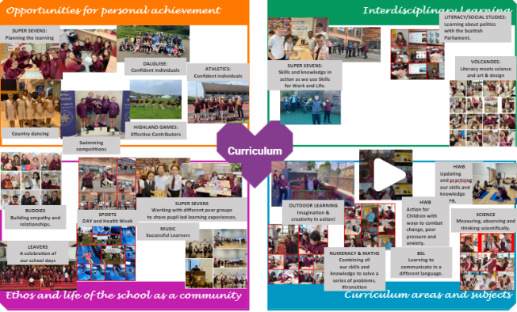
We are a true reflection of what a community stands for and we are proud to say we are an Ardgowan Family.
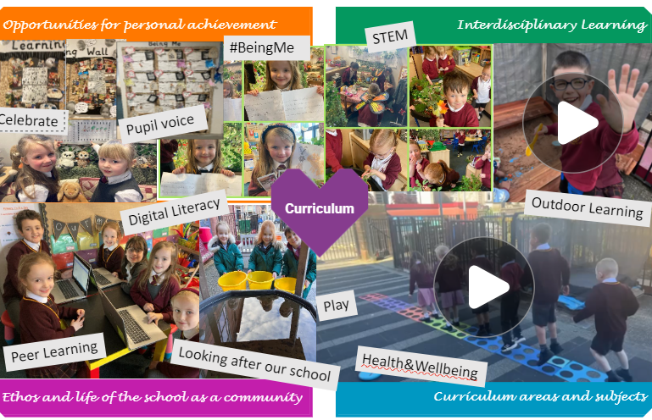



https://sway.cloud.microsoft/M7nhtIs2okYsSf7i?ref=email

