Returning to Ardgowan Primary School

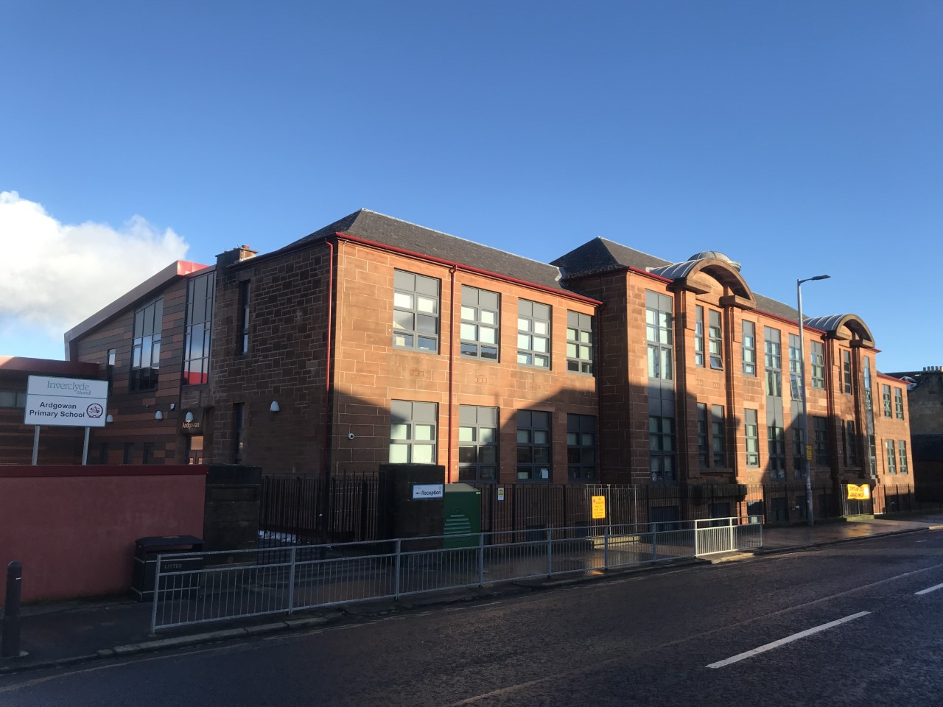

Author: Kathy Stewart
Senior Early Years Outreach Officer (ICOS)

Returning to school in August

In March 2020 to keep me safe and to stop the Coronavirus spreading the Government and the grown-ups who look after me, at home and at school decided the safest way for children to learn was at home.

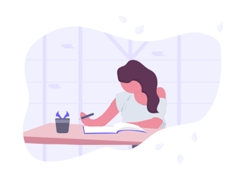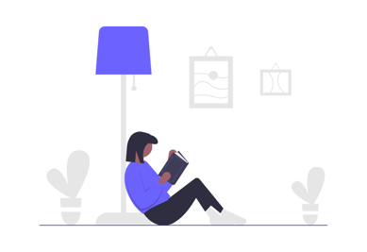

While children were doing their learning at home, scientists and doctors were learning as much as they could about this Virus. They now know more about the Virus and how we can try to stay safer.

When I go back to school in August there may be different rules or instructions to follow to help keep everyone safe. The grown-ups who look after me at home and school will help me to understand the new rules and instructions and what I can do to keep myself and others safer.

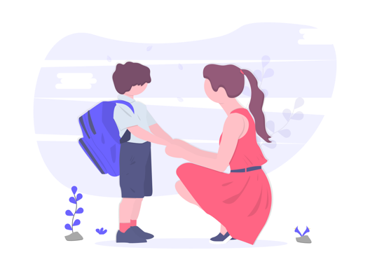

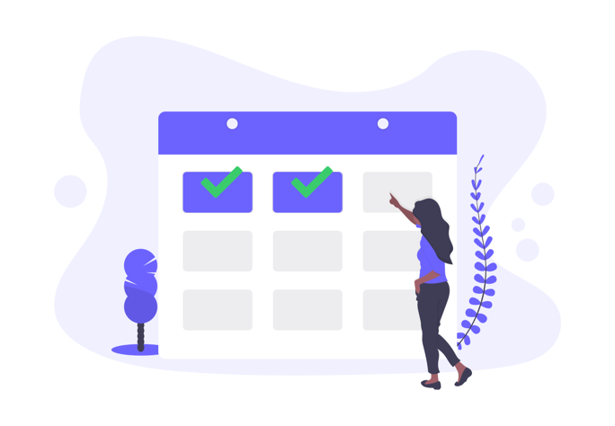

When I go back to school some things will be the same and some things will be different. Things that may be the same are; there will be grown-ups to help me understand how I can learn safely in the classroom and the playground.

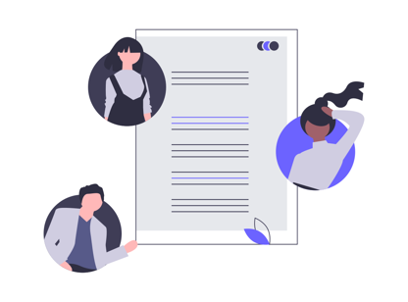

There will still be a play time and a lunch time. I will still need to wash my hands more often.
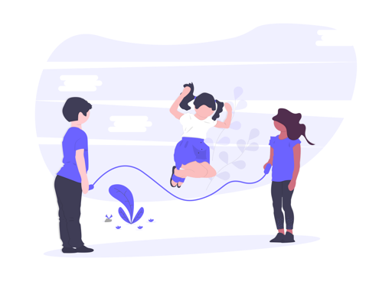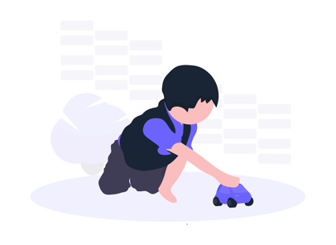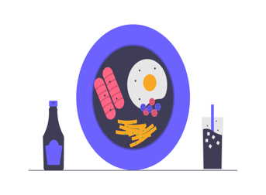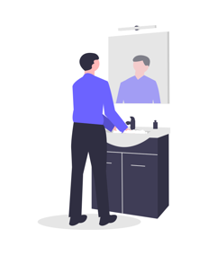

Some things that might be different are; playtime and lunchtime might be at different times, I may have a tray or box at my desk with all the things I need for the day, so I won’t need to bring my own things. There may be more signs that show where to go and how to stay safer.

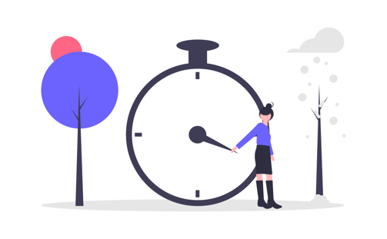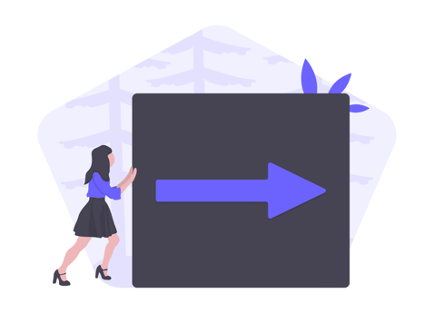

It’s ok to feel a little nervous or unsure when things are different or when things are changing. There are grown-ups I can talk to if I feel nervous or unsure.

The grown-ups who look after me at home and at school will help me to understand what I need to do to help keep everyone safe at school. They will help me to remember the new rules and instructions so I can enjoy learning safely at school.

