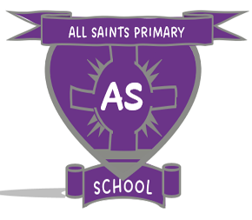
CHILD PROTECTION

KEY INFORAMTION FOR ALL SAINTS PRIMARY & CLB

It is everyone’s responsibility to protect children

All children have a right to grow up in a caring and safe environment. All adults have a responsibility to protect children, including:
Parents Family members Friends Neighbours Professionals
Members of the public Community groups

What might make you concerned?
Most children grow up in homes where they are loved and well cared for however sometimes for a variety of reasons, a child may be abused or neglected. For more information please consult your school’s child protection policy / training slides and Inverclyde Child Protection Committee leaflet issued to all staff.

What to do if you are concerned?
Children can always get help for themselves, they may need you to get help for them.
If you are concerned about a child attending this school please speak to:

MRS LESLEY-ANNE McCABE, HEADTEACHER inallsaints@glowscotland.onmicrosoft.com
or
MRS ANNE-MARIE McAVOY, DEPUTE HEADTEACHER
inallsaints@glowscotland.onmicrosoft.com

If the child is in immediate danger you should contact the police.

You can also talk to
Social Work Services: 01475 715365
Police Scotland: 101
Scottish Children’s Reporters Administration: 0300 2001680
Glasgow & Partners Emergency Social Work Services: 0300 343 1505
Make sure you:
- Act promptly
- Note your concerns
- Give as much information as you can about the child and the family

