Christmas 2020 - Dates for your Diary

Tuesday  15th  December | Christmas Movie afternoon
Wednesday  16th  December | Christmas Lunch  (Remember your packed lunch from home if you have not ordered Christmas lunch from the canteen)  McDougall’s Christmas Party Pantomine - Virtual | 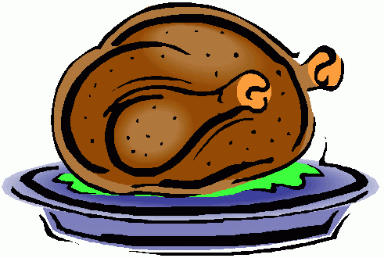
Thursday  17th  December | Advent Service  Virtual Christmas  (Filmed class performances will be shared with the whole school)
Friday  18th  December | Class Christmas Parties  (Children can come to school dressed in party clothes, if they wish)
Monday  21st  December | Christmas Crafternoon  **** Santa Comes to All Saints ****
Tuesday  22nd  December | Christmas Jumper Day  (Or Christmas Accessories, T-Shirt, Hat)  Free School Raffle  (See details below)  School Closes at 2.30pm  (Please note early finishing time)

School Raffle Details
We want to make the last week of this term as special as possible for our children despite having to follow Scottish Government guidelines and keep to our class bubbles. In addition to the daily Christmas activities listed, each child will be given a raffle ticket on every day that they attend school. On the last day, Tuesday 22nd December, we will draw a winner from P1 - P3 and another from P4 - P7. As we cannot leave prizes over the Christmas holiday period within school, if the winner is not present on Tuesday 22nd, we will pick another and so on. Good Luck!

