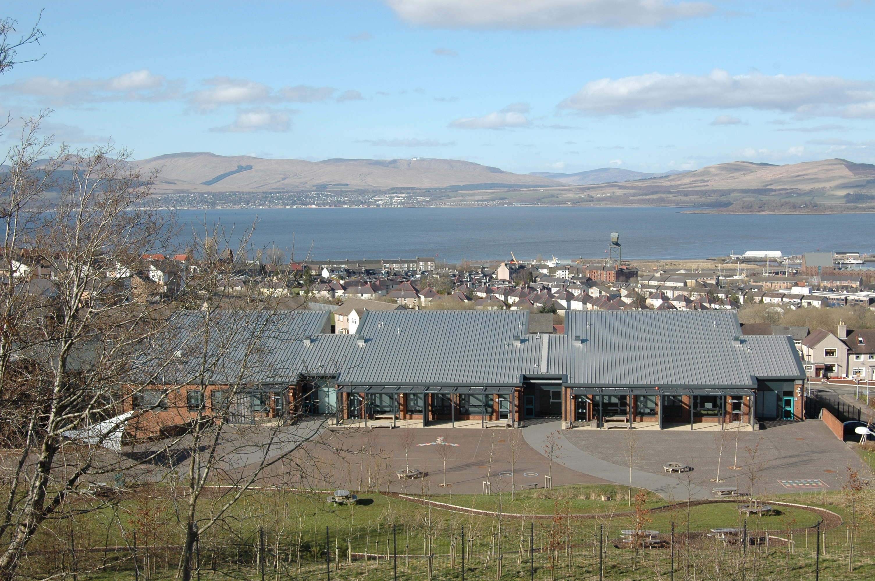

All Saints Primary


Handbook 2021-2022

All authorities are required by law to issue a copy of the school handbook incorporating current policies and practices of both the council and the school to certain parents in December of each year for their use as appropriate.

CONTENTS

- Authority Strategic Statement
- School Information
- School Values & Aims
- A Charter for Catholic Schools in Scotland
- School Staff
- School Staff cont.
- Attendance at school/Information in emergencies
- Attendance at school/Information in emergencies cont.
- Arrival at school/Breakfast Club/School Funds
- School Holidays
- Enrolment
- Catchment Area
- Transport/Placing requests
- Curriculum for Excellence
- Literacy
- Maths & Numeracy
- Health & Wellbeing/Social Studies
- Sex & Relationships/Technology
- Expressive Arts/Sciences/RE
- RE cont./Assessment
- Reporting to Parents/Homework/ Home-school links
- School & Community Links/Information/Health Promoting School
- Additional Support Needs/ Inclusion & Equality
- Useful contacts for Additional Support Needs/Support for Pupils
- Support for Pupils cont.
- Clothing & Uniform
- Clothing & Uniform cont./Rights Respecting Schools/Promoting Positive Behaviour
- Playground Supervision/Medical & Health Care/Emergency Contact(s)
- Child Protection/School Meals
- Letting Procedures/Data Protection/Concerns
- Parent Forum & Parent Council/ Extra-Curricular/Transfer to Secondary
- Useful Addresses & Tele. Nos/Useful Websites/Complaints Procedure/ Community Involvement
- Glossary of Terms

ALL SAINTS PRIMARY SCHOOL

Headteacher: Mrs L. Fisher
Blairmore Road
Greenock
PA15 3JS

Telephone: 01475 715640

Email address: inallsaints@glowscotland.onmicrosoft.com
Website address: http://allsaintsprimary.inverclyde.sch.uk
Twitter: @ASP180

Dear Parent

On behalf of the staff and myself I extend a warm All Saints welcome to you and your child.

This handbook is designed to give you helpful information about our school. As well as sharing our vision, values and aims with you; the handbook will provide you with an understanding of the organisation of the school and I hope it will make you aware of the fabulous facilities available at All Saints.

At All Saints we are committed to supporting every child to reach his/her true potential in a nurturing and stimulating learning environment. We celebrate ambition, achievement and effort. We have high expectations and aspirations for all our children and encourage the school community to understand and follow our five values of faith, family, ambition, respect, and kindness.

As a Catholic Primary School, we seek to develop our Christian faith and have gospel values at the heart of everything we do. Through your help, and with continued support from our parish and diocese, we aim to develop a genuine love of God.

We strive to develop strong partnerships between home and school. By working together we can support your child to develop to his/her full potential and be a caring and responsible member of the local and global community.

Please do not hesitate to contact me should you require any further information.

I look forward to meeting you and your child.

Yours sincerely

Mrs L. Fisher
Head Teacher

AUTHORITY STRATEGIC STATEMENT

Building Inverclyde through excellence, ambition and regeneration.

Goals and Values

Our Core values are: Respect, Honesty and Tolerance.

Our vision for the children and young people of Inverclyde is that they should be ambitious for themselves and be successful learners, confident individuals, responsible citizens and effective contributors.

To achieve our ambition of building Inverclyde through excellence, ambition and regeneration our children must be:

Safe: protected from abuse, neglect and harm by others at home, school and in the community.

Healthy: enjoy the highest attainable standards of physical and mental health, with access to healthy lifestyles.

Achieving: have access to positive learning environments and opportunities to develop their skills, confidence and self-esteem to the fullest potential.

Active: active with opportunities and encouragement to participate in play and recreation including sport.

Respected and responsible: involved in decisions that affect them, have their voices heard and be encouraged to play an active and responsible role in their communities.

Included: have access to high quality services when required and should be assisted to overcome the social, educational, physical, environmental and economic barriers that create inequality.

Nurtured: educated within a supportive environment.

School Information

All Saints Primary is a denominational primary school serving the East End of Greenock.

All Saints Primary School
Blairmore Road
GREENOCK PA15 3JS
Telephone Number: 01475 715640

School Website Address: http://allsaintsprimary.inverclyde.sch.uk
Twitter @ASP180

Accommodation

All Saints Primary is on two levels. There are 14 classrooms within the mainstream school with activity areas outside each. In addition we have a nurture classroom, library and Parent/Family Learning space. There are 3 classrooms within our Communication & Language Base (CLB), a sensory room and quiet room. The school is modern, bright and airy with facilities for the disabled and is surrounded by outdoor learning areas.

School Roll

The present roll of the school is 375 and we have a capacity for 495. Parents should note that the working capacity of the school may vary, depending upon the numbers of pupils at each stage and the way in which the classes are organised. In 2020 -21 our numbers at each stage are:
Mainstream

P1A 20 | P2/1 25 | P3/2 25 | P4A 28 | P5A 22 | P6A 27 | P7A 30
P1B 23 | P2 29 | P3 30 | P4B 27 | P5B 22 | P6B 26 | P7B 27

Communication & Language Base (CLB)

Room 1(P1 – P4) 6 | Room 2 (P4 – P6) 6 | Room 3 (P7) 4 pupils

School Hours

Opening: 9.00 am
Interval: 10.30 – 10.45 am
Lunch: 12.15 – 1.00 pm
Close: 3.00 pm

ALL SAINTS VISION, VALUES AND AIMS

We work in a trio of partnership between school, home and the parish of Saint Laurence’s. We are committed to upholding and providing the moral teaching, faith, tradition and sacramental life of the Catholic Church. In our daily work, we live by the Gospel Values of Love, Faith, Hope and Charity.

To ensure our aims and values remain relevant and central to the work of our school community, we review them on a five year cycle. They were last reviewed by all stakeholders in November 2018 and we agreed the following All Saints core values:
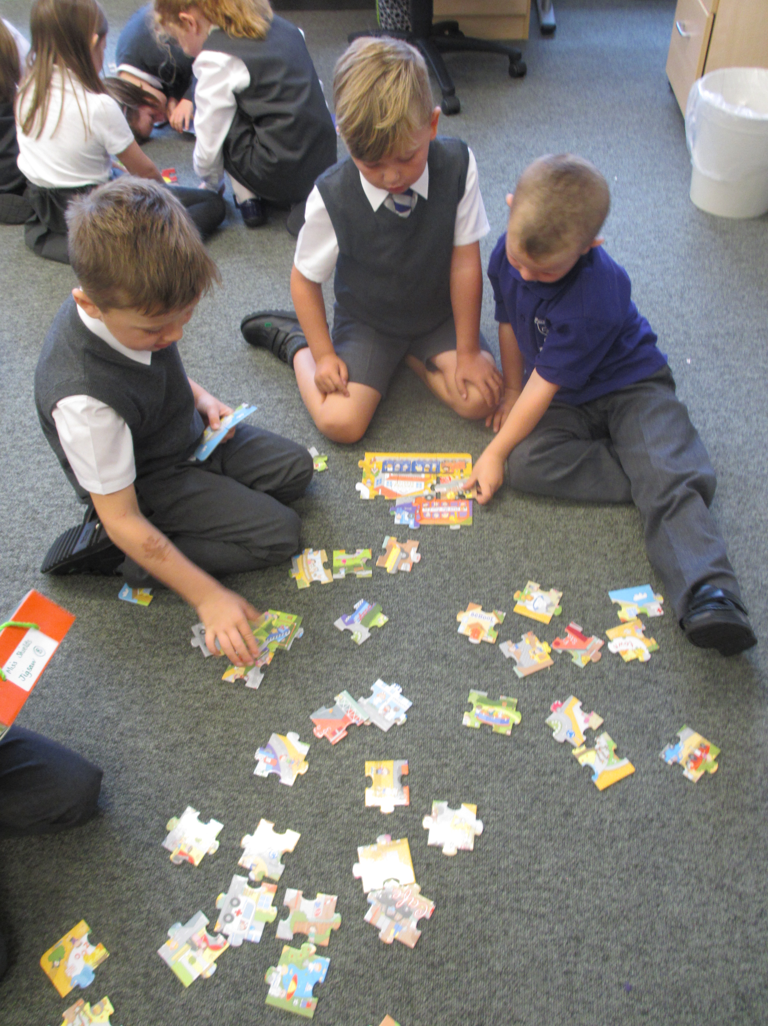
- FAITH
- FAMILY
- AMBITION
- RESPECT
- KINDNESS

Educational Aims

Working within “Curriculum for Excellence”, we strive to provide the highest quality of learning and teaching. We try to ensure that all our children attain and achieve their full potential and acquire a full range of skills and abilities.

We aim for our pupils to become:

Successful Learners

We will aim to provide the highest quality of teaching, providing all with opportunities to develop their talents and achieve their full potential.

Confident Individuals

We want our children to be ambitious for themselves and their school, local and parish communities.

Responsible Citizens

We want our children to have respect for themselves and others. We aim to foster a positive attitude towards Scottish culture and to explore the culture(s) of other countries and faiths.

Effective Contributors

We will aim to provide opportunities for all our children to be enterprising, resilient and independent. We will develop children’s skills and abilities to be able to work using their own initiative and to also be part of a team.

We aim to provide a happy, vibrant, caring environment where everyone in the All Saints school community has an important role to play.

We recognise achievement across our school at weekly assemblies where pupils are rewarded and recognised against the four capacities of Curriculum for Excellence as detailed above. In conjunction with this recognition we invite the family and friends of those pupils recognised at assembly to celebrate at our Pupil of the Week Cafe held each Friday in our dining area from 2:15 to 3pm.

Throughout the year we have ‘focus’ assemblies and recognition for specific values and attributes. For example, between October and December we celebrate ‘Random Acts of Kindness’ across our school community.

Pupils are encouraged to recognise the efforts of their peers by recording achievements in a class Pupil of the Week jotter and parents can also support recognition of individuals or groups by contacting the school.

A Charter for Catholic Schools in Scotland

The mission of the Catholic school is to develop as a community of faith and learning, providing the highest quality of education, and offering formation through the promotion of Gospel values, through celebration and worship, and through service to the common good.

All Catholic schools in Scotland, in honouring Jesus Christ as the Way, the Truth and the Life, will feature the following characteristics:

- a commitment to the integrated education and formation of the whole person, in close partnership with parents as the first educators of their children;
- an inclusive ethos which aims to honour the life, dignity and voice of each person, made in the image of God;
- a commitment to the search for wisdom in life and to the pursuit of excellence, through the development of each person’s unique god-given talents;
- a commitment to the spiritual formation of the school community, through the shared experience of prayer and liturgy, and in partnership with local parishes;
- the provision of religious education programmes which will enable young people to develop their understanding of Gospel values and of how to apply them to life;
- a commitment to uphold the moral teaching, faith tradition and sacramental life of the Catholic Church,
- a commitment to communicate Catholic social teaching and thereby to promote social justice and opportunity for all;
- a commitment to ecumenical action and the unity of Christians;
- the promotion of respect for different beliefs and cultures and for inter-faith dialogue;
- a commitment to support the continuing professional and spiritual development of staff.

Staff appointed to a Catholic school are expected to support and promote the aims, missions, values and ethos of the school, as illustrated in this Charter.

We use “This Is Our Faith” syllabus throughout the school and the approved syllabus for Sex Education, “God’s Loving Plan”.

School Staff

Mrs Lorraine Fisher Head Teacher
Mrs Anne-Marie McAvoy Depute Head Teacher
Miss Jennifer McGachy Acting Depute Head Teacher (PEF funded)
Miss Angela Miller Principal Teacher (CLB)
Mrs Carol Boyle Principal Teacher

P1A Miss Jennifer Sinclair
P1B Miss Julie McBride
P2/1 Miss Lauren Anderson
P2B Mrs Carol Stevens/Mrs Jennifer Kane
P3/2 Miss Maria Shields
P3 Mrs Charlene Alexander/Mrs Anne-Marie Milligan
P4A Mrs Ann Friel
P4B Miss Erin Haggerty
P5A Miss Julia Kershaw
P5B Miss Kathryn Simpson
P6A Mrs Elizabeth Deafley
P6B Mr Aidan Coyle
P7A Mrs Carol Boyle
P7B Mrs Gillian Devenney
CLB 1 Miss Angela Miller
CLB 2 Mrs Fiona Shaw
CLB 3 Mrs Louise McCauley

Nurture Teacher Mrs Jane Aitken

Reduced Class Contact Teachers: Mrs Angela Cassidy, Miss Rachel Foster, Miss Laura Buchan, Miss Marie-Claire Davidson (CLB).

Senior Community Learning & Development Worker (PEF funded)
Mrs Janey MacDonald

Clerical Assistants

Mrs Jan Johnston (Senior Clerical Asst.), Mrs Pauline Burns, Mrs Lynne Bradley & Mrs Pauline Devlin (CLB).

Classroom Assistants

Mrs Barbara Drummond, Mrs Christine Hutchison and Mrs Cheryl Brown

ASN Auxiliaries

Mrs Dawn Love, Mrs Noreen Gourlay, Miss Aileen Gilchrist, Mrs Patricia Rowles (PEF funded), Mrs Sarah McDougall (PEF funded), Mrs Jacquie Thomson.

CLB Learning Assistants

Mr Kevin Hoodless, Miss Brenda Hughes, Mrs Elizabeth Mitchell, Mrs Ishbel McKee, Mrs Vicki Fitzharris and Mrs Susanne Bennett.

Breakfast Club

Mrs Anne McClure and Mrs Tina Clarke.

School Chaplain

Rev Father Eoin Patton

Family Support Worker

Miss Jill Morrow

Music Support

Mr Andrew Digger
Mr Kieran Young
Ms Elysia Wilson

School Cook

Mrs Sharon McPherson

Janitors

Mr Tom Kelly
Mr Colin MacKenzie

Active Schools Co-ordinator

Mr Gary Forbes

Parent Council

Lorna O’Neill Chairperson
Mhairi Rennie Treasurer
Robyn Edgehill Secretary

All Saints Parent Council actively work in partnership with our school staff, parish and community to ensure our pupils are given best opportunities to thrive in a safe, inclusive and nurturing community. The Parent Council meet regularly throughout each school session and welcome your input. Please contact our school office if you would like further information.

Attendance at School

All pupils should enter the school via their designated playground entrance. Please note our playgrounds are supervised from 8:45am. Only those pupils attending Breakfast Club should enter via the main entrance where they will be registered for Breakfast and admitted to the dining area only.

We strive to achieve a high standard of punctuality. Please assist us in this by ensuring that your child is in their line for the bell ringing at 9.00 a.m.
Parents should inform the school by telephone on the first morning of an absence -before 10am - and provide a reason for the pupil’s absence. The school will contact the pupil’s family, and thereafter other emergency contacts, if no contact is made to provide an explanation for a pupil’s absence.

On return to school parents should provide a note explaining the reasons for absence.

Parents should keep the school informed of any changes of address or telephone numbers, both their own and those of the emergency contacts in case of emergency.

Section 30 of the 1980 Education Act lays a duty on every parent of a child of ‘school age’ to ensure that their child attends school regularly.

Attendance must be recorded twice a day, morning and afternoon.
Regulation 7 of The Education (School and Placing Information) (Scotland) Amendment, etc Regulations 1993 requires each child’s absence from school to be recorded in the school register as authorised: i.e. approved by the authority and unauthorised: i.e. unexplained by the parent (truancy) or temporarily excluded from school.

The Scottish Government has provided guidance on the management of attendance and absence in Scottish schools in its publication included, Engaged and Involved – part 1: Attendance in Scottish Schools. Every effort should be made to avoid family holidays during term time as this both disrupts the child’s education and reduces learning time. It has been clarified that family holidays should not be recorded as authorised absence, except in exceptional domestic circumstances, where a family needs time together to recover from distress, or where a parent’s employment is of a nature where school-holiday leave cannot be accommodated (e.g. armed services or emergency services). It is for local authorities and schools to judge when these circumstances apply and authorise absence, accordingly. The categorisation of most term-time holidays as unauthorised absence has been a contentious issue for some families, many of whom are concerned at the higher cost of holidays during school holiday periods.

The Scottish Government has no control over the pricing decisions of holiday companies or flight operators. Our main focus is to encourage parents and pupils to recognise the value of learning and the pitfalls of disrupting learning for the pupil, the rest of the class and the teacher. Clearly where an absence occurs with no explanation from the parent, the absence is unauthorised.

Schools investigate unexplained absence, and Education Services has the power to write to, interview or prosecute parents, or to refer pupils to the Children’s Reporter, if

necessary. Young people of school age may not be able to attend school for a wide range of reasons including illness, accidents or long term medical conditions. In general there will be an automatic referral by the school for education outwith school after 15 days of continuous or 20 working days of intermittent absence, within a single session, for verifiable medical reasons.

We make every effort to maintain a full educational service, but on some occasions circumstances arise which lead to disruption. Schools may be affected by, for example, severe weather, temporary interruption of transport, power failures or difficulties of fuel supply. In such cases we shall do all we can do to let you know about the details of closure or re-opening. We shall keep you in touch by using letters, notices in local shops and community centres, announcements in local Churches, text messages, All Saints website, Twitter, Inverclyde website, announcements in the press and on local radio.

Arrival at School

All Saints Primary has a school travel plan. Copies of this are available from our office and this outlines the safest routes to school.

In order to prevent congestion, we encourage the use of our Park and Stride area located on Blairmore Road and Cardross Crescent. This not only supports our children to enjoy an active lifestyle but reduces traffic congestion around our school.

Entry to the school car-park is strictly prohibited except in emergencies.

Double parking and parking within the no-go areas, is also prohibited.

We have a School crossing patroller based at junction of:

Kilmacolm Road and Blairmore Road

In addition, 2 of our senior pupils have received training to act as Junior Road Safety Officers and, with adult support, they will promote walking to school and safe travel.

Breakfast Club

We are fortunate to have a Breakfast Club which is open from 8.00-8.45am every morning. Please note last entry is at 8:30am. The daily cost of breakfast is £1 payable via Parentpay. (Pupils in receipt of Free School Meals do not pay for Breakfast).

School Funds

Serious in our attempts to reduce the cost of the school day, we consulted with our Parent Council and wider Parent Forum during Term 1 of session 2019 – 2020 as to whether they wished to continue with voluntary contributions towards School Funds. The majority of parents requested we continue to ask for this voluntary contribution, capped at a maximum donation of £20 per year and £40 for families of 3 or more children.

THE SCHOOL YEAR 2021 – 2022

School Holidays 2021/2022 (Pupils do not attend on In-Service Days)

FIRST TERM In-Service Day Monday 16th August 2021
In-Service Day Tuesday 17th August 2021
Re-open Wednesday 18th August 2021
(First day for new Primary 1s)

Close Friday 3rd September 2021
Local Holiday Monday 6th September 2021
Re-open Tuesday 7th September 2021

Close Friday 8th October 2021
October Break Monday 11th October 2021 to Friday 15th October 2021 (inclusive)
In-Service Day Monday 18th October 2021
Re-Open Tuesday 19th October 2021

Close Wednesday 22nd December 2021

SECOND TERM Re-open Thursday 6th January 2022
Close Friday 11th February 2022
Mid-Term Monday 14th February 2022
Mid-Term Tuesday 15th February 2022
In-service Day Wednesday 16th February 2022
Pupils Return Thursday 17th February 2022

Close Friday 1st April 2022

THIRD TERM Spring Break Monday 4th April 2022 to
Monday 18th April 2022 (inclusive)
Good Friday Friday 15th April 2022
Easter Monday Monday 18th April 2022
Re-open Tuesday 19th April 2022

May Day Monday 2nd May 2022
In-Service Day Tuesday 3rd May 2022
Pupils Return Wednesday 4th May 2022

Close Thursday 26th May 2022
Local holidays Friday 27th May 2022
Monday 30th May 2022
Pupils Return Tuesday 31st May 2022

Close Tuesday 28th June 2022

In order to minimise disruption to your child’s education, please make every effort not to take children on holiday during term time.
Pupils do not attend on In-Service Days.

Enrolment

Legislation gives parents freedom regarding the choice of school for their children. However, it is necessary for children to be registered for education at the school which serves their area. Thereafter, parents may, if they wish, make a placing request to have their child enrolled in a school other than that which serves their area.

Children, who reach the age of five years between – 1st March 2021 and 28th February 2022, should be registered for primary school on Wednesday 13th and Thursday 14th of January 2021. A notice always appears in “The Greenock Telegraph” giving details of dates.

Information regarding parental rights and all other matters concerning registration and enrolment will be given to parents on registration or at any time on request.

The same procedure applies to children who move into this area in the course of the session. Anyone wishing to enrol at All Saints Primary School should telephone the school for an appointment with Mrs Fisher, Head Teacher.

New entrants are invited to visit our school during the summer term. We have a full induction programme which includes visits to the school for children and their parents to familiarise themselves with the school and staff and also ask any questions they may have about the school and registration procedures. Whilst invitations are sent in late April/early May, please make an appointment to meet with Mrs Fisher should you have any questions prior to the start of our induction programme.

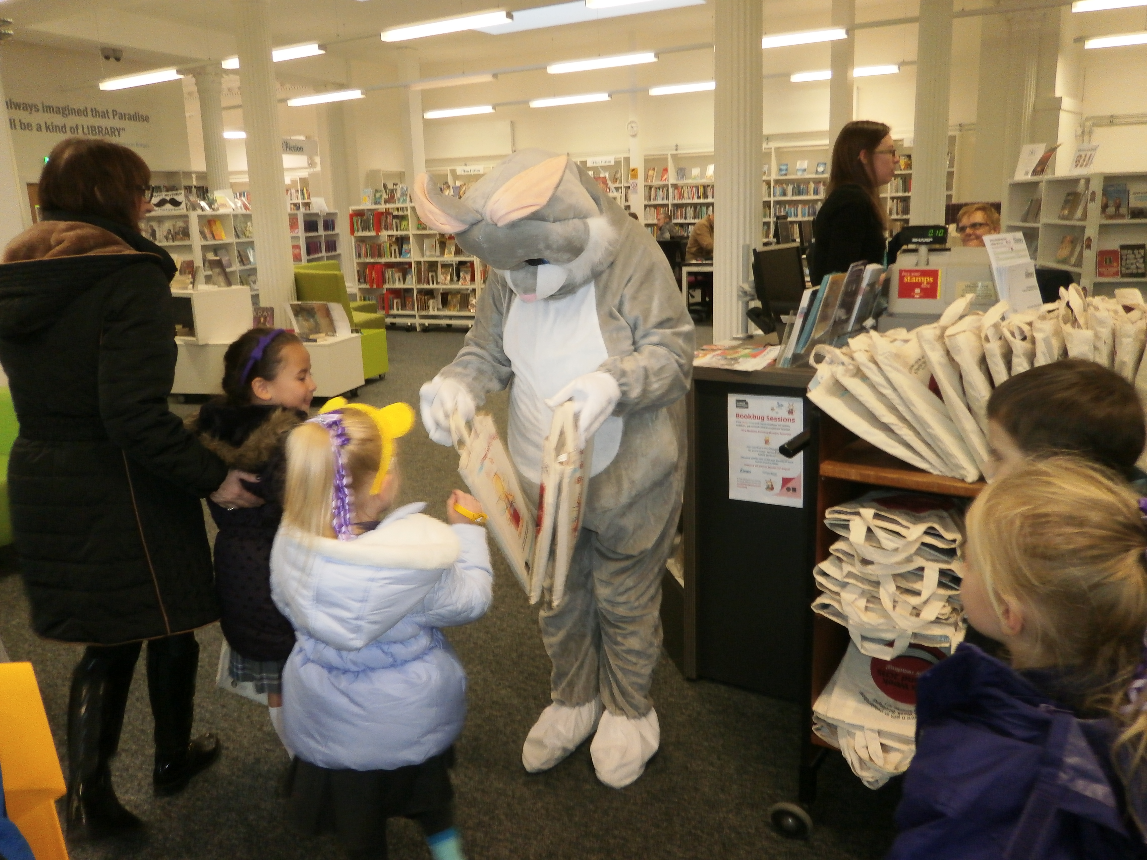

All Saints Primary – Catchment Area
Aberfoyle Road  Adam Street  Alpine Grove  Ardbeg Lane  Ardbeg Road  Arden Road  Ardmore Road  Arthur Street  Auchendarroch Street  Auchenfoil Road (Knocknairshill)  Auchmountain Road  Auchmountain View  Balfron Road  Balloch Road  Balmore Road  Barnhill Street  Bawhirley Road  Baxter Street  Belville Avenue  Belville Street  Blairmore Crescent  Blairmore Road  Bogle Street  Border Street  Bridgend Road  Brown Street  Brymner Street  Burnhead Street  Cardross Crescent  Cardross Place  Carnock Street  Cartsburn Street  Cartsdyke Court  Carwood Court  Carwood Street  Castle Road  Cathcart Street  Cathie Allan Place  Clydeview Road  Clynder Road  Corlic Street  Cross Shore Street  Custom House Place  Custom House Way  Dalmoak Road  Dalrymple Street (98 Inverclyde Centre) | Darndaff Road  Dellingburn Street  East Crawford Street  East Hamilton Street  East William Street  Endrick Road  Fairrie Street  Finnieston Lane  Finnieston Street  Finnieston Way  Fintry Road  Flintmill Lane  Gabriel Street  Galt Street  Gareloch Close  Gareloch Road  Garvald Street  Gilmour Street  Glenbrae Lane  Glenbrae Road  Gray Street  Grant Street  Grosvenor Lane  Grosvenor Road  Hillend Drive  Hillend Place  Hillside Road  Ingleston Street  James Watt Way  John Street  John Wilson Street  Kilcreggan View  Killearn Road  Kilmacolm Place  Kilmacolm Road  Kincaid Court  Ladyburn Street  Laurieston Street  Leitch Street | Leven Place  Leven Road  Lomond Road  Luss Avenue  Luss Place  Macdougall Street  MacGillivray Avenue  MacGowan Way  MacGregor Road  McLeod Street  McPhail Street  Millar Street  Moffat Street  Morris Street  Morton Terrace  Oakfield Terrace  Quarrier Street  Renton Road  Riverside Road  Rue End Street  Shandon Place  Sinclair Street  Springkell Street  St Andrew’s Square  St Andrew’s Street  St Lawrence Street  Stanners Lane  Station Avenue  Strone Crescent  Torrance Road  Weir Place  Weir Street  Whinhill Crescent

Transport

The Council has a policy of providing free transport to all primary pupils who live more than one mile from their local school by the recognised shortest walking route. This policy is more generous than the law requires. This means that the provision of transport could be reviewed at any time. Parents who consider they are eligible should obtain an application form from the school or Customer Service Centre, Clyde Square Greenock, PA15 1LY. These forms should be completed and returned before the end of February for those pupils beginning school in August to enable the appropriate arrangements to be made.

Applications may be submitted at any time throughout the year but may be subject to delay whilst arrangements are made. The appropriate officer has discretion in special circumstances to grant permission for pupils to travel in transport provided by the authority, where spare places are available and no additional costs are incurred.

Pick up Points

Where free transport is provided it may be necessary for pupils to walk a certain distance to the vehicle pick-up point. Walking distance in total including the distance from home to the pick-up point and from the drop-off point to the school in any one direction will not exceed the authority’s limits (see above paragraph). It is the parent’s responsibility to ensure that their child arrives at the pick-up point in time. It is also the parent’s responsibility to ensure the child behaves in a safe and acceptable manner while boarding, travelling in and alighting from the vehicle. Misbehaviour could result in a child losing the right to free transport.

Placing Requests

Education Services does not provide transport for those pupils in receipt of a placing request other than in exceptional circumstances. In the case of under-age placing requests if the child is offered a place in his/her catchment area school, transport will be provided in accordance with Council policy stated above.
Please note that the transport policy for Inverclyde is currently subject to consultation.

Curriculum for Excellence

The curriculum framework for all Scottish educational establishments from ages 3-18 is called the Curriculum for Excellence. The aims of this curriculum are as follows:

- That every child should know that they are valued and will be supported to become a successful learner, an effective contributor, a confident, enterprising individual and a responsible citizen.
- That every child should experience a broad curriculum which has depth and which challenges everyone to achieve all they can. They should develop skills for life and skills for work, with a major focus on literacy and numeracy Health & Wellbeing.
Curriculum Levels
The experiences and outcomes under a Curriculum for Excellence are written at five levels, with progression to qualifications described under the senior phase. These levels are:
Early Level: The pre-school years and Primary 1, or later for some.
First Level: To the end of P.4, but earlier for some.
Second Level: To the end of P.7, but earlier for some.
Third and Fourth: S.1 to S.3, but earlier for some.
Senior Phase: S.4 to S.6 and college/or other means of study.

All pupils should experience a broad general curriculum in their seven years in primary school.
The curriculum should also offer: challenge and enjoyment, breadth, progression, depth, personalisation and choice, coherence and relevance.

Organisation of the Curriculum

The curriculum is organised under eight headings, but every effort is made to link areas of the curriculum together to make learning more real and relevant. This is known as Interdisciplinary Learning (IDL).

The eight areas are: Languages, Mathematics, Health and Well Being, Social Studies, Technologies, Expressive Arts, Religious and Moral Education and Science.

In the next few pages we provide a brief description of each curricular area. Central to all areas of the curriculum is the methodology used by the teacher to actively engage our pupils in their learning.

We are committed to developing skills for learning, life and work; frequently providing pupils with opportunities to use their learning in different contexts. For example, using literacy skills of note taking whilst on a science educational excursion or using skills taught during class P.E. lessons whilst taking part in active pursuits during residential trip at Primary 6.

More information about Curriculum for Excellence and skills development can be found on the following websites:

Education Scotland Parent Zone
Skills Development Scotland

Languages and Literacy

Language is at the core of children’s learning. Through language, our pupils gain much of their knowledge and many of their skills across the curriculum.
The four main components of language are:

Talking, Listening, Reading and Writing

We strive to make sure that each child is successful when first learning to read. At Early stages our children learn to read by taking part in Active Literacy learning where they learn the initial phonics (sounds) which pave the way for successful reading. Each child is encouraged to progress at their own rate and we ask that parents support this progression with daily practice at home. Primary 1 teachers will support you to do this by inviting you to take part in a workshop within term 1 where they will explain how you can support your child with learning the tools for reading at home.

Our core reading scheme is Bug Club. All pupils have access to the online resource and are given a password to use at home to access reading. Parents will be supported to do this during our first Parent workshop and staff are available to further support this across the school session by appointment.

In addition to our core reading scheme, a wide range of texts are used in all classes. Novel studies and non-fiction texts are a regular feature of reading across our school. Pupils are encouraged to make regular use of our school library and also Inverclyde library service. In upper stages pupils learn the skills of Reciprocal Reading and resources such as ‘First News’ help them to extend their knowledge and understanding.

We celebrate reading across our school with regular E.R.I.C. (Everyone Reading In Class) times, Fairytale Friday assemblies once per month and focus weeks such as Book Week. We want our children to see good reading role models and staff will often discuss their own reading choices and skills. Our Primary 6 pupils run a highly successful Book Buddy project whereby the visit pre-schoolers at Blairmore Nursery and read to them. They share the importance of talking and listening and good questioning and thinking skills during their weekly visits.

The importance of Spoken English is another major priority for us. From Primary 1, children are encouraged to develop their talking and listening skills and to become critical thinkers about their learning. The Inverclyde programme “Talking Round Corners” assists us in this objective.

At the early stages of writing we build on drawing and scribing sentences, gradually introducing punctuation, vocabulary, accurate spelling, and sentence/paragraph construction as children progress. We encourage children to take pride in the written presentation of their work and will, from P.4 onwards, use cursive style of handwriting.

Spanish is taught from P1 onwards in line with 1 + 2 Language programme led by Scottish Government.

Teachers use a variety of approaches across all four components, such as-
Active learning, games, songs, role play and interactive whiteboard software to create challenging, enjoyable experiences for all learners.

READ, WRITE, COUNT

The Read, Write, Count programme aims to support parental engagement in literacy and numeracy. Gift bags are distributed annually to all P2 and P3 pupils in Scotland by Scottish Book Trust. The gift bags contain essential literacy and numeracy materials to support children’s learning, as well as advice and support to parents.

Studies show a direct link between a strong family learning environment and progress in reading, writing and counting. In addition to the parent guide included in the gift bags, the Parent Club website (https://www.parentclub.scot/) offers a range of hints, tips and advice to help parents engage in their child’s learning.

FIRST MINISTER’S READING CHALLENGE

The First Minister’s Reading Challenge is an inclusive, exciting programme for all children – fostering a love of reading for pleasure. Research shows that reading for pleasure is crucially important for children’s development.

The Challenge is open to all local authority and independent primary and secondary schools across Scotland, as well as, libraries and community groups. You can find out more information on the Challenge and also how schools can register to take part here: https://www.readingchallenge.scot/

A reading app called Bookzilla, aimed at S1-S3 pupils, helps them find and recommend books and to set themselves reading challenges.

Mathematics and Numeracy

Mathematics is taught using the Inverclyde Maths & Numeracy Progressive Pathways planning format. It is important that learning can be translated into useful skills for everyday life.

The Maths outcomes in Curriculum for Excellence are divided as follows:
Number, Money, Measure, Shape, Position and Movement, Information Handling.
Mental Maths and Active Problem Solving. These are taught at all stages. Teaching staff use a variety of resources to support teaching and learning of Maths and Numeracy including SEAL Maths, Tee-Jay Maths and a variety of additional resources, including interactive whiteboard materials, are used to enrich learning. Interactive Mental Maths is given emphasis throughout the school to encourage quick recall of number facts.

Health and Wellbeing

Health and Wellbeing is a major priority for everyone at All Saints Primary: pupils, staff, parents and wider community. The mental, emotional, social, physical and spiritual wellbeing of our school community continues to grow and develop.

Health and Wellbeing is subdivided into the following areas:

- Mental, emotional, social and physical wellbeing
- Planning for choices and changes
- Physical Education, physical activity and sport
- Food and Health
- Substance Misuse
- Relationships, sexual health and parenthood

Our excellent facilities help to ensure that a minimum of 2 hours quality Physical Education is given to all children. Pupils change for PE lessons into shorts, T-shirt and indoor sandshoes/trainers.

In addition to Physical Education lessons, many classes partake in a Daily Mile challenge. We work closely with Active Schools who lead Breakfast club activities, lunch clubs and after school clubs. Many staff also offer extra-curricular active clus such as football, Netball and Athletics.

Parents should note that pupil activities may be restricted because health and safety requirements state that no jewellery of any kind may be worn when pupils are undertaking games or physical activities. This includes jewellery worn as a result of body piercing.

We are aware of the need for an awareness and understanding of mental wellbeing as well as physical wellbeing. We teach children about developing emotional and mental wellbeing and provide them with a range of strategies to use which can support their mental and emotional wellbeing such as emotional check-ins, understanding wellbeing indicators and restorative approaches.

Social Studies

In Social Studies, pupils look at different times (History) and different places (Geography). For example, this may mean studying about important people and events in the past and in learning about other countries, their lifestyles and their cultures. Learning about our local area and our own Scottish culture is also a high priority.

Educational visits to places of interest will be arranged, whenever possible, to enable the children to see things first hand and so enrich and deepen their enjoyable learning experiences.

We use our extensive school grounds for Outdoor Learning and to teach our children to look after their surroundings and to be curious about nature.

To enhance outdoor learning we work in partnership with various community groups including: Belville Gardens, Bikeability and Finlaystone Ranger Service.

Sex and Relationship Education

This is taught using the programme “God’s Loving Plan”, which is approved for Catholic schools in Scotland. This material is available for parents to peruse at our Parents’ Evenings. Partnership with parents in this is vitally important to us. The assistance from our colleagues in the Health Service also helps with this work. Parents will be fully informed and consulted on the content and purpose of sex and relationship education and can raise any concerns with school staff. On any occasion where a parent wishes to exercise the right to withdraw his/her child from any of these lessons, they should discuss their concerns and alternative arrangements with school staff, as outlined in Inverclyde Council’s Policy “Sexual Health and Relationship Education”.

Technologies

Teaching and learning within this curricular area enables children to:

- Develop an understanding of the role and impact of technologies in changing and influencing societies
- Contribute to building a better world by taking responsible ethical actions to improve their lives, the lives of others and the environment
- Gain the skills and confidence to embrace and use technologies now and in the future, at home, at work and in the wider community
- Become informed consumers and producers who have an appreciation of the merits and impacts of products and services
- Be capable of making reasoned choices relating to the environment, to sustainable development and to ethical, economic and cultural issues
- Broaden their understanding of the role that information and communications technology (ICT) has in Scotland and in the global community
- Broaden their understanding of the applications and concepts behind technological thinking, including the nature of engineering and the links between the technologies and the sciences
- Experience work-related learning, establish firm foundations for lifelong learning and, for some, for specialised study and a diverse range of careers.

As pupils study aspects of Technology, they learn about its impact in the home, in schools, in industry and in the wider community. They have opportunities tobe creative and enterprising and are given the chance to use their own skills and offer solutions to design problems, using different materials and resources.

Information Technology should involve pupils in, for example, using and learning about the use of digital cameras, computers, whiteboards and programmable toys.

Expressive Arts

All children have the opportunity of taking part in Music, Dance, Drama and Art & Design. Visiting specialists use their expertise to assist some of our children in music-making. All Saints Primary places a strong emphasis on encouraging creativity in all area of the Expressive Arts and regular work with partners to take part in community events to showcase our creative talents. In the past year we have worked with Creative Scotland to sing, dance and act at the Beacon Arts Centre and performed in a Samba Drumming band as part of Inverclyde’s Galoshan’s Festival.

We take part in the Inverclyde Music Festival and invite parents and our community to an annual Christmas

Sciences

The new Science curriculum within Curriculum for Excellence challenges us to ensure that all children develop a secure understanding of important scientific concepts and that their experiences of science in school should kindle a lifelong interest in science.

The Science outcomes have been categorised into seven areas:
- Planet Earth
- Energy in the Environment
- Communication
- Forces and Motion
- Life and Cells
- Materials
- Topical Science

Each year our school joins cluster primaries and nurseries at Notre Dame High school to organise and showcase our learning in science at a cluster Science Fayre. This is a popular learning event where pupils get an opportunity to discuss and demonstrate their learning and parents can gain an enhanced understanding of the progression of teaching and learning of Science across our cluster.

Religious Education and Observances

We join our parents and the Catholic community in instructing our children in the knowledge and practice of the Catholic Faith. We follow the ‘This Is Our Faith’ Religious Programme, chosen by our Bishops, which helps us relate Christian teaching to a daily living out of the Gospel message in a meaningful and realistic way. This year P4 pupils will receive the sacraments of Reconciliation and Holy Eucharist and our P7 pupils will be confirmed in St Mirin’s Cathedral, Paisley.

In order to help the children, and staff, in the practice of their faith our School Chaplain, Father Patton is always at hand to offer encouragement and advice. We are grateful for the many opportunities he affords us of having Mass in the school, or in St. Laurence’s Church, on First Fridays and special days of observance.

Parents of ethnic or religious minority may request that their children be permitted to be absent in order to celebrate recognised religious events. Only written requests,
detailing the proposed arrangements will be considered. Appropriate requests will be granted on not more than three occasions in any one session and the pupil noted as an authorised absentee in the register. Throughout their Primary school education, pupils will also be taught about world religions.

It is normal practice for parents who wish to withdraw their child from Religious observance to make suitable arrangements with the Head Teacher. Where Religious Education is integrated with other topics and withdrawal is more difficult, parents should consult the Head Teacher.

Assessment
At All Saints Primary we understand effective teaching and learning can only take place within a framework of clear aims, careful planning, motivation and appropriate assessment and evaluation. To effectively meet the needs of children then regular and reliable information about their attainment and achievement must be gathered. We continually use assessment information to:

  - inform and/or confirm teacher’s professional judgments as to where each child is in the learning process
  - provide reliable information on pupil progress, ensuring a child is in an appropriate working group/class
  - provide the basis for communicating to parents areas of strengths and concerns
  - help identify pupils with additional support needs
  - ensure pupils are working at appropriate levels of difficulty and/or are appropriately challenged
  - compare attainment of particular years and/or groups of learners

We continuously develop strategies for formative assessment. This ensures pace and challenge for pupils and is used daily by all members of staff. This process involves sharing what is to be learned with our pupils and also involves them in self and peer evaluation.

Pupils have regular Learning Discussions with their teacher and work in partnership to set specific learning targets for literacy, maths and numeracy and health and wellbeing. These will be communicated through our Reporting to Parents procedures throughout the session. Teachers also:

  - share learning intentions and success criteria
  - provide opportunities for quality feedback from teacher and peers
  - use written assessment within the classroom
  - regularly reflect on progress made with individuals, groups and/or whole class

All assessment information is used to evaluate and assess pupils’ progress. We work with our cluster partner primaries to moderate our knowledge, understanding and practise of teacher professional judgements ensuring that we are reflective and well-informed practitioners.

Reporting to Parents

Parents’ nights are held twice during the session usually in October and March. In addition each class will invite parents into their classroom on two occasions each session to:
  - celebrate class learning
  - support family learning
  - showcase interdisciplinary learning

Each Christmas we produce and perform a Christmas show which is usually an opportunity for:
  - infants (P1 – P2) to perform their interpretation of the Nativity
  - middle school (P3 – P4) to entertain us with a seasonal performance
  - upper school (P5 – P7) to amuse us with a humorous pantomime

In June of each year we invite our school community to our end of Year and Prize giving Celebration.

Each term teachers work with individual pupils to produce Learning Targets for Literacy, Maths & Numeracy and Health & Wellbeing. These are shared with parents via our Parents Evenings and also through a written report issued in June.

Homework

Good work habits begin at an early age. Therefore, we aim to set regular homework for all stages. This work strengthens liaison between the home and the school, helps reinforce skills taught, encourages initiative, allows unfinished work to be completed and reinforces your role as joint educator of your child.

We are currently revising our Homework Policy and this will be available on our website and from our school office in the near future. If your child is having difficulty with homework, please contact the school straight away.

Home/School Links

Parents are always welcome to visit the school. To ensure you are able to meet with the appropriate personnel please make an appointment, with our office. Our Parent Council meets regularly to discuss matters relating to the school and our pupils achievements and activities. We are always keen to welcome new members.
Our Senior Community Learning and Development Officer (Janey McDonald) works out of our family learning centre ‘The Hive’. Janey offers our families lots of helpful advice, support and opportunities for learning and fun. Please get in touch with her via our school office.

N.B. DISCLOSURE: Any parents who are involved on a regular basis in schools should undertake a PVG check through Disclosure Scotland.

School & Community Links

All Saints Primary is at the heart of the East End community and we work closely with, among others, King’s Oak Primary, Blairmore Nursery, Hillend pre-5 Centre, Glenbrae Nursery and Notre Dame High School.
Our Home/School Link Worker provides great support across a whole range of areas and assists us in further developing lines of communication between school and home.

Information

We strive to keep you up to date with school news and events through:

  - School Newsletters – issued in September, January and May
  - Parent Council Newsletters
  - Texts
  - Letters and reminders
  - Groupcall
  - Local press e.g. Greenock Telegraph
  - Telephone calls
  - Our school website
  - Twitter

Health Promoting School

All Saints Primary is a Health Promoting School and we work closely with parents to maintain this status. We will seek to involve parents, pupils, staff and specialists on our Health Group. Children are encouraged to bring healthy snacks/packed lunches to school. We encourage our pupils to take on leadership roles across our school community. We have appointed members to our Pupil Council, Eco Group, Nurture Champions and Play Champions. We are working towards training Mental Health First Aiders next session.

Additional Support Needs

All children and young people need support to help them learn. The main sources of support in early years and in schools are the staff who, through their normal practice, are able to meet a diverse range of needs. With good quality teaching and learning and an appropriate curriculum most children and young people are able to benefit appropriately from education without the need for additional support. The definition of additional support is a wide one and it is not possible to provide an exhaustive list of all possible forms of additional support.
If you feel your child has additional support needs, please contact Mrs Fisher or Mrs McAvoy, co-ordinator for Learning Support. A number of other staff will give additional support for pupils when, and if, they require additional support. Partner agencies such as Psychological Services, Speech & Language Therapy are sometimes involved with parental consent.

Inclusion and Equality

The aims of Inverclyde Council’s Inclusion Policy are:
- To facilitate personal, social and intellectual development and to provide children and young people with the opportunity to achieve their full potential in learning.
- To recognise individual interests, abilities, motivation and learning needs of all children and young people.
- To provide for diversity in learning and teaching to ensure that all needs are met – social, linguistic, cultural, physical, intellectual and pastoral – by enabling access to high quality education tailored to individual needs.
- In meeting the needs of all of our pupils, we will demonstrate no discrimination on the basis of race, gender, disability, sexual orientation, religion or belief.
This encompasses curricular, extra-curricular and classroom activities and is foremost in the attitudes.
- In All Saints Primary we are determined to make sure that every pupil is supported throughout our school, fairly and equally, regardless of circumstances. This is called social justice and it’s about making sure that all pupils are given an equal chance to reach their potential.

The Equality Statement for Inverclyde Schools

‘Inverclyde Education Service is committed to ensuring that no children or members of staff or service users receive less favourable treatment on any ground including gender, race, disability, age, sexual orientation, religion or belief. We have a moral, social and legal obligation to mainstream and put equality at the heart of everything we do. We aim to promote a culture in which equality of opportunity exists for all. We are opposed to all forms of discrimination, direct or indirect, and aim to eliminate all discriminatory practices. We will ensure that, in our schools and other educational establishments, equality permeates the curriculum and underpins all our policies and
practices in terms of access to education. We must ensure that all our children achieve their full potential to develop physically, emotionally and academically.

Finally, we believe that equality and inclusion should be a given right, where everyone is valued and treated with respect.’

Useful Contacts for ASN

Enquire - the Scottish advice service for additional support for learning. Operated by Children in Scotland, Enquire offers independent, confidential advice and information on additional support for learning through:
- a telephone helpline - 0845 123 2303
- an email enquiry service - info@enquire.org.uk
- an online enquiry service
- two websites - www.enquire.org.uk (for parents/carers and practitioners) and www.enquire.org.uk/yp (for children and young people)
- Enquire also provide a range of clear and easy-to-read guides and fact sheets explaining everything from 'additional support in the early years' to 'what planning should take place for moving on from school'. Other helpful websites are:
- www.siaa.org.uk
- www.sclc.org.uk
Support for Pupils

A child or young person’s needs are identified at the earliest possible stage and can be met in a number of ways, for example by adaptations to the curriculum or learning environment, as well as input from the Support for Learning Teacher and on occasion support from visiting specialists. The appropriateness of the support is determined through a process of assessment, planning and monitoring, working jointly with parents and carers, and is regularly reviewed.

Learning outcomes for children and young people with additional support needs are set out in a plan and all educational establishments hold regular review meetings with parents and carers to determine needs and the most appropriate supports. Everyone’s views are equally important in order to consider what is currently working and how to determine next steps.

Children and young person’s needs are identified in a number of ways, and the process of assessment is an ongoing, shared process with partnerships with parents and carers at the forefront. On some occasions health service staff or other partner agencies make children known to Education Services. Other additional support needs may be notified to Education Services by parents themselves or identified by one of a range of staff working closely with the child.
Some children and young people will have additional support needs arising from complex or multiple factors which require a high degree of co-ordination of support from both education and other agencies in order that their needs can be met. In these cases, the school will hold a meeting to decide whether the child or young person meets the criteria for a co-ordinated support plan.

The co-ordinated support plan is a statutory document which ensures regular monitoring and review for those children and young people who have one.

You have the right to ask the education authority to establish whether your child needs a co-ordinated support plan. Your child can make this request themselves, if they are aged 16 or over. You and your child, if they want to, will attend a meeting with staff at their school. Other professionals from different agencies who may be involved in providing support for your child will also attend. If your child does not want to attend meetings or feels unable to, their views must still be sought and considered.

Inverclyde’s mediation service can be accessed by contacting Tony McEwan, Head of Inclusive Education, Culture and Corporate Policy at the address below.
For further advice please telephone 01475 712850
Or write to;

Education Services
Wallace Place
GREENOCK PA15 1JB

Clothing and Uniform
Names should be put on all items of school clothing, in pen, on the labels, for all children. Pupils are asked to change into soft shoes before going into the carpeted classrooms in order that the floor may be kept as clean as possible. Slip-on sandshoes are, therefore, needed every day and we suggest that they be left in school for convenience. The uniform for All Saints is available from Smith’s Shoes and Sports, West Blackhall Street, Greenock. Purple sweatshirts and polo shirts, or white shirt with school tie, are worn with grey trousers and grey skirts. Given that there is substantial parental and public approval of uniform, schools in Inverclyde are free to encourage the wearing of school uniform. In encouraging the wearing of uniform account is taken in any proposals to prevent any direct or indirect discrimination on the ground of race or gender. Any proposals will be the subject of widespread consultation with the parents and pupils. Against this background it should be noted that it is the policy of the Education & Lifelong Learning Committee not to insist on pupils wearing uniform or having specialist items of clothing as a prerequisite of their attending and engaging in all of the activities of the curriculum. There are forms of dress which are unacceptable in school, such as items of clothing which:
- potentially, encourage faction (such as football colours);
- could cause offence (such as anti-religious symbolism or political slogans);
- could cause health and safety difficulties, such as loose fitting clothing, or clothing made from flammable material for example, shell suits in practical classes;
- carry advertising, particularly for alcohol or tobacco; and could be used to inflict damage on other pupils or be used by others to do so.

In addition, jewellery such as dangling earrings and large rings could cause health and safety difficulties and are unacceptable to be worn in school.
Parents of children receiving one or the following benefits will normally be entitled to monetary grants for footwear and clothing for their children:

- Income Support
- Income-based Job Seeker’s Allowance
- Child Tax Credit, but not Working Tax Credit, and where income is less than £16,105 (in 2019/20) as assessed by the Inland Revenue
- An asylum seeker receiving support under Part IV of the Immigration and Asylum Act 1999
- Any income related element of Employment and Support Allowance
- Parent or carer in receipt of Working Tax Credit and/or Child Tax Credit with Annual Gross Earnings of no more than £11,288.
- Universal credit, where your take home pay does not exceed £915, as shown on your monthly Universal Credit statement.
NB: The above figures may change in the Spring, as may some of the terminology.
Approval of requests for such grants made by parents in different circumstances is at the discretion of the Corporate Director Education & Social Care. Information and application forms may be obtained from schools and from Customer Contact Centre, Municipal Buildings, Clyde Square, Greenock, PA15 1LY.

The Council is concerned at the level of claims being received regarding the loss of pupils’ clothing and/or personal belongings. Parents are asked to assist in this area by ensuring that valuable items and unnecessarily expensive items of clothing are not brought to school. Parents should note that the authority does not carry insurance to cover the loss of such items and any claims submitted are likely to be met only where the authority can be shown to have been negligent.

Rights Respecting

All Saints Primary will build upon the work already done in establishing a values based culture, where rights are respected and responsibilities accepted. From P1 – P7 pupils will learn about children’s rights, as stated in the summary of The United Nations Convention on the Rights of the Child (UNICEF). Through this important work, our children will learn to realise their responsibility to respect the rights of others.

Positive Relationships

All Saints Primary is committed to Getting It Right for Every Child. We aspire to consistently promote positive relationships as the foundation for our learning community. Good behaviour is essential for effective learning to take place. At all Saints Primary School, effective discipline and our positive ethos reflects our core values.

Each classroom provides a safe environment for quality learning and teaching allowing every pupil a sense of security, promoting high self-esteem and recognition of individual attainment and achievement.

‘Curriculum for Excellence cannot be delivered without good relationships and positive behaviour. Children and young people should feel happy, safe, respected and included in the learning environment and all staff should be proactive in promoting positive behaviour in the classroom, playground, and wider learning community. Underpinning this is the emotional health and wellbeing of staff.’ Curriculum for Excellence

We follow the shared view and approach detailed in Inverclyde Council’s Positive Relationships policy (Nov. 2019).

School staff use a variety of strategies to promote positive behaviour alongside consequences and sanctions to deal with unacceptable behaviour. Parents will be kept informed when a pupil falls short of our expectations to ensure consistency between school and home. Parental support is vital in maintaining a high standard of behaviour.

Supervision of Playground

An adult presence is provided in playgrounds at break times in terms of the Schools (Safety and Supervision of Pupils) (Scotland) Regulations, 1990.

Medical & Health Care

Routine checks at age 7, 9 and 11 years and selected medicals/dental checks throughout the school year. The Audiometrician tests the children’s hearing at 5 years and 9 years. All new entrants undergo a medical examination in the first few months
of schooling at which parents must be present. Thereafter, random checks around 9 years and 11 years are done where parents are requested to attend. Regular hygiene visits are made by school nurses and random dental checks carried out. We are conscientious about reporting any suspected defects, such as with hearing, eyesight, speech etc to the appropriate medical authority.
If a child has a serious accident in school, the parent or guardian is informed as soon as possible, normally by telephone. Should the situation be critical, emergency services would be contacted immediately.

Emergency Contact

If a child has had a serious accident, it may be necessary to ask for the child to be collected.

IT IS ESSENTIAL THAT WE HAVE UP TO DATE CONTACT NUMBERS AND THAT WE ARE MADE AWARE OF ANY MEDICAL CONDITIONS, SO THAT SUITABLE ARRANGEMENTS CAN BE MADE.

Medication

If your child is on any medication, for even a short period, and this needs to be administered at school, we will require you to complete an authorisation form, in order for us to assist in this procedure. These forms are available from the main school office.

Inhalers

If your child has been prescribed an inhaler, please ensure that he/she has it with him/her at all times. This is especially important when children are leaving the building to go on outings, or to take part in sporting events. From time to time, please ask your child to being their school inhaler home to allow you to check that it is still working properly.

Allergies/Peanut Free Zone

As some of our pupils are allergic to peanuts, and could suffer an anaphylactic reaction if exposed to them, we ask that children do not bring peanuts/peanut products to school.

Child Protection

Inverclyde Council Education Services has Child Protection Guidelines and Procedures which all schools and establishments are required to follow. Education Services work very closely with other agencies namely Police Scotland, Social Work Services, NHS Greater Glasgow and Clyde and the Children’s Reporter to support children.

Common responsibilities of all staff are to protect children from abuse and exploitation, to respond appropriately when abuse is identified, and to ensure whenever possible that all children are able to exercise their right to be raised in a warm, stimulating and safe environment with the support of staff, their families and carers.

School Meals

Meals are provided by Inverclyde Council Environmental & Consumer Services Catering Division whose mission statement is:
Our aim is to provide a menu system, freshly prepared with health and cost a priority.
The menus are compiled with Scottish Diet Action Plan as a priority and the menu is changed daily.

There is a set cost of £2.05. Payment is via ParentPay and more information on how this system operates is available from the school office. Children in P1-3 receive a free school meal. Children can choose soup and a main course or main course and pudding. A drink, salad and fruit are included in this cost.

Those children who bring packed lunches have their meals along with the other children who remain at school during the lunch hour.
Children of parents in receipt of one of the following benefits are entitled to a free midday meal and free breakfast:
- Income Support
- Jobseekers Allowance (Income based)
- Child Tax Credit, but not Working Tax Credit, and where income is less than £16,105 (in 2019/20) as assessed by the Inland Revenue
- An asylum seeker receiving support under Part IV of the Asylum and Immigration Act 1999
- Any income related element of Employment and Support Allowance
- Parent or carer in receipt of Working Tax Credit and/or Child Tax Credit with Annual Gross Earnings of no more than £11,288.
- Universal credit, where your take home pay does not exceed £915, as shown on your monthly Universal Credit statement.

NB: The above figures may change in the Spring, as may some of the terminology. Information and application forms for free school meals may be obtained from schools and Customer Service Centre, Municipal Buildings, Greenock, PA15 1LY. In addition such children will be entitled to free milk. Every effort is made to encourage children to choose their food sensibly. Vegetarian dishes are also available.

Letting Procedures

Any person or organisation wishing to make an evening let of school premises should contact Community Education by telephone or in writing.
The address and telephone number is as follows:
Booking Office
Greenock Sports Centre
23 Nelson Street
Greenock
PA15 1QH
Tel: 01475 213131
Email: booking office@inverclydeleisure.com

Your Data Protection Rights

The collection, transfer, processing and sharing of data is done in accordance with the Data Protection Act (2018). Fuller details of the uses of pupil data can be found on the ScotXed website (www.scotxed.net).

The Scottish Government Education Department works with a range of partners including HM Inspectorate of Education and the SQA. On occasion, individual data is made available to partners and academic institutions to carry out research and statistical analysis. In addition, partners may be provided with information they need in order to fulfil their official responsibilities. Any sharing of data will be done under the strict control of the Scottish Government Education Department, which will ensure that no individual level data will be made public and that these data will not be used to take any actions in respect of an individual.

General Data Protection Regulations and Data Protection Act 2018

Information on children, parents and guardian is stored on a computer system and may be used for teaching, registration, assessment and other administrative duties. In processing personal information, Inverclyde council must comply with the General Data Protection Regulations & Data Protection Act 2018.

For further information please refer to:

https://www.inverclyde.gov.uk/site-basics/privacy

Concerns

If you have any concerns about the ScotXed data collections you can email the Senior Statistician, Peter Whitehouse, at Peter.Whitehouse@scotland.gsi.gov.uk or write to The ScotXed Support Office, The Scottish Government Education Department, Area 1B, Victoria Quay, Leith, EH6 6QQ. Alternative versions of this page are available, on request from the ScotXed Support Office, in other languages, audio tape, Braille and large print.

Parent Forum and Parent Council

All parents of All Saints Primary are members of the Parent Forum.
We have an active Parent Council at All Saints in line with a constitution. This Parent Council, as a statutory body, will be reflective of Parental and Staff opinion and has the right to information and advice on matters which affect children’s education. Our Parent Council meets regularly and minutes/dates of meetings are available from the school and Parent Council Chairperson.

Scottish Schools (parental Involvement) Act 2006 led to the establishment of Parent Councils in primary, secondary and special schools. The Act recognises the vital role that parents play in supporting their children’s learning. It places a duty on authorities to promote the involvement of parents in children’s education and the wider life of the school. It aims to help parents to be:-
- Involved with their child’s education and learning
- Welcomed as an active participant in the life of the school
- Encouraged to express their views on school education generally

Any parent wishing to stand for election to the Parent Council should contact Mrs Fisher, in the first instance.

Extra-Curricular

Throughout the school year, many different extra-curricular classes are run either at lunchtime or afterschool. This year we have netball, athletics, cross country running, multi-skills and football. Staff give freely of their own time to run these very successful classes.

Transfer to Secondary School

Pupils are normally transferred between the ages of 11½ and 12½ so that they will have the opportunity to complete at least 4 years of secondary education. Parents will be informed of the arrangements no later than December of the year preceding the date of transfer at the start of the new session.
The school to which children from All Saints normally transfer to is:
Notre Dame High School
Dunlop Street
Greenock
PA16 9BJ
Tel: 01475 715150
Head Teacher: Kate Couttie

Parents should be advised that if they wish their child to transfer to this school they must live within the catchment area otherwise a placing request must be made.

Useful Addresses and Telephone Numbers

Corporate Director: Education, Communities & Organisational Development
Ruth Binks
Municipal Buildings
Clyde Square
Greenock Tel: 712761

Councillor Terry Loughran
Convenor of Life Long Learning
Municipal Buildings
Greenock Tel: 712020

Council Leader: Stephen McCabe
Local Councillors: Michael McCormick, Colin Jackson, Jim McEleny
Municipal Buildings
Greenock Tel: 712020

Mr Stuart McMillian MSP Mr Ronnie Cowan MP
26 Grey Place 20 Crawfurd Street
Greenock Greenock
PA15 1YF PA15 1LJ

Tel: 720930 Tel: 721877

Useful Web Sites
www.inverclyde.gov.uk – Inverclyde Council Web Site
www.hmie.gov.uk – School and Local Authority Inspection Reports
www.parentszonescotland.gov.uk – Very useful site for parents
www.scottishschoolsonline.gov.uk – About individual schools

Concerns/Complaints

All complaints will be dealt with in accordance with Inverclyde Council Policy and procedures. Complaints forms can be requested from the school office.

Community Involvement

All Saints Primary is situated in the heart of the East End of Greenock and we work alongside other community organisations such as Active Schools, the local Scout group and many others.

GLOSSARY OF TERMS USED IN THIS HANDBOOK

Curriculum for Excellence Curriculum for Scottish Schools
To encourage the development of children
as Successful Learners, Responsible Citizens, Effective Contributors and Confident Individuals.

Health and Wellbeing Includes Personal and Social Development,
understanding health, physical education and
physical activity.

Expressive Arts This includes Art & Design, Drama, Dance and Music.

Social Studies Includes historical, geographical, social, political, economic and business experiences

Technologies Includes Craft, Design, Engineering, Graphics, Food, Textile and Information Technologies Experiences. (computer, digital camera, video camera etc)

GLOW A powerful online tool to enhance learning and teaching. Our pupils will access this from our school computers and home computers. This will eventually be used by all staff, parents and pupils all over Scotland. It will enable our children to make use of the most up to date resources.

Although this information is correct at time of presenting, there could be changes affecting any of the matters dealt with in the document –
(a) before the commencement or during the course of the school year in question
(b) in relation to subsequent years

