Aileymill Primary School
and Nursery Class

Handbook 2024-2025

CONTENTS

2 Contents | 3 Authority Strategic Statement
4 Headteacher’s message | 5-7 School Values and Educational Aims
8 The school office | 9 Start times, outdoor play and coats
10 Start times and attendance | 11-12 School Staff
13 The School Year and Holidays | 13-15 Parking and Infant Enrolment
15-16 Placing Requests/ High School Places | 16 Transport
17-31 Curriculum | 32 Assessment and Reporting
33 School Improvement | 34 - 36 Attainment and Achievement
37 Home school links | 38 Home Learning
39 - 43 Pupil Voice and Committees | 44 -46 Pupil Support
47 Inclusion and Equality | 48 Equal opportunities and Social Justice
49 Rights Respecting School | 50 Positive Relationships Policy
52 Clothing an Uniform | 54 Child Safety and Child Protection
55- 56 Emergency Contact/ Medication | 57 School Meals and Snacks
58 Attendance Legal Responsibilities | 59 -61 Measures to improve attendance
62 Parent Forum and Parent Council | 63 -75 Aileymill Nursery Information

Goals and Values

Building Inverclyde through excellence, ambition and regeneration.

The core values of Inverclyde Council are:

RESPECT, HONESTY and TOLERANCE

Our vision for the children and young people of Inverclyde is that they should be ambitious for themselves and be successful learners, confident individuals, responsible citizens and effective contributors.

To achieve our ambition of building Inverclyde through excellence, ambition and regeneration our children must be:

- Safe: protected from abuse, neglect and harm by others at home school and in the community.
- Healthy: enjoy the highest attainable standards of physical and mental health with access to healthy lifestyles.
- Achieving: have access to positive learning environments and opportunities to develop their skills, confidence and self-esteem to the fullest potential.
- Active: active with opportunities and encouragement to participate in play and recreation including sport.
- Respected and responsible: involved in decisions that affect them, have their voices heard and be encouraged to play an active and responsible role in their communities.
- Included: have access to high quality services when required and should be assisted to overcome the social, educational, physical, environmental and economic barriers that create inequality.
- Nurtured: educated within a supportive setting.

Inverclyde Council

Telephone: 01475 715647
Fax: 01475 715648
E Mail: : inaileymill@glowscotland.onmicrosoft.com
Website: http://aileymillprimary.inverclyde.sch.uk

Dear Parents and Carers,
Welcome to Aileymill Primary’s Handbook. We are pleased to welcome your family to our school. Aileymill Primary is a bright, spacious and well- resourced space, in which your child will be nurtured and encouraged to reach their full potential; academically, physically and socially. We offer a huge range of experiences for our pupils and are very proud of their many achievements.
Aileymill prides itself on being a safe and nurturing place for your child to achieve in. We recognise that each child is unique and strive to meet the individual needs of all our pupils. This is summed up in our vision statement: Learning to Learn, Learning to Care. This vision ties in with our school values of Honesty, Ambition, Caring, Respect, Responsibility and Tolerance.
We want all of our children to become literate, numerate, compassionate and fully prepared to embrace opportunities in their lives ahead. We aim, at all times, to be supportive and always seek the best for your children and your family.
We believe that links between home and school are vital and there will always be a warm welcome for any parent or carer who visits the school.
Please take the time to read through this handbook- it contains a wealth of useful information!
All week to week information is published in a weekly newsletter (which will be emailed home every Friday). Please do your best to find time to read it as it has information about the following week at school.
Our Aileymill Primary Facebook page is a great way to keep up to date with everything that happens in our busy school. We post photos almost every day.
We look forward to working with you and your children in the coming years.
Simon Simpson
Head Teacher

OUR SCHOOL VISION AND VALUES

At Aileymill, we want all our pupils to be

LEARNING TO LEARN, LEARNING TO CARE

Our core values are:

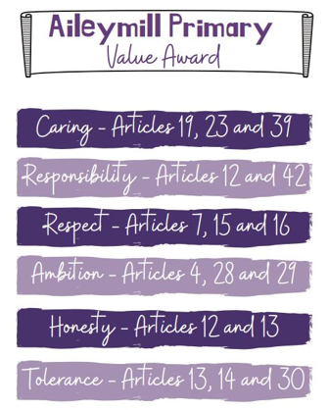

These key values underpin everything that we do.

OUR EDUCATIONAL AIMS

Working within ‘A Curriculum for Excellence’ we strive to provide the highest quality learning and teaching. We try to ensure that all our children attain and achieve their full potential and acquire the full range of skills and abilities relevant to growing, living and working in the contemporary world.

We aim for our pupils to become:

- SUCCESSFUL LEARNERS by providing the highest quality learning and teaching to ensure all our children achieve their potential

- CONFIDENT INDIVIDUALS by encouraging self-respect, ambition, and a sense of physical, mental and emotional well-being with secure values and beliefs and by valuing and celebrating each child’s attainment and achievement.

- RESPONSIBLE CITIZENS by developing and fostering positive attitudes and skills for all pupils enabling them to have respect for themselves and others. We aim for our pupils to know and be proud of Scotland, our language and our culture and to explore the culture of other countries.

- EFFECTIVE CONTRIBUTORS by encouraging an enterprising attitude, resilience, independent learning skills and the ability to work as part of a team.

We aim to get it right for every child and to provide a caring environment in which all children feel safe, healthy, active, respected and responsible, included and nurtured.
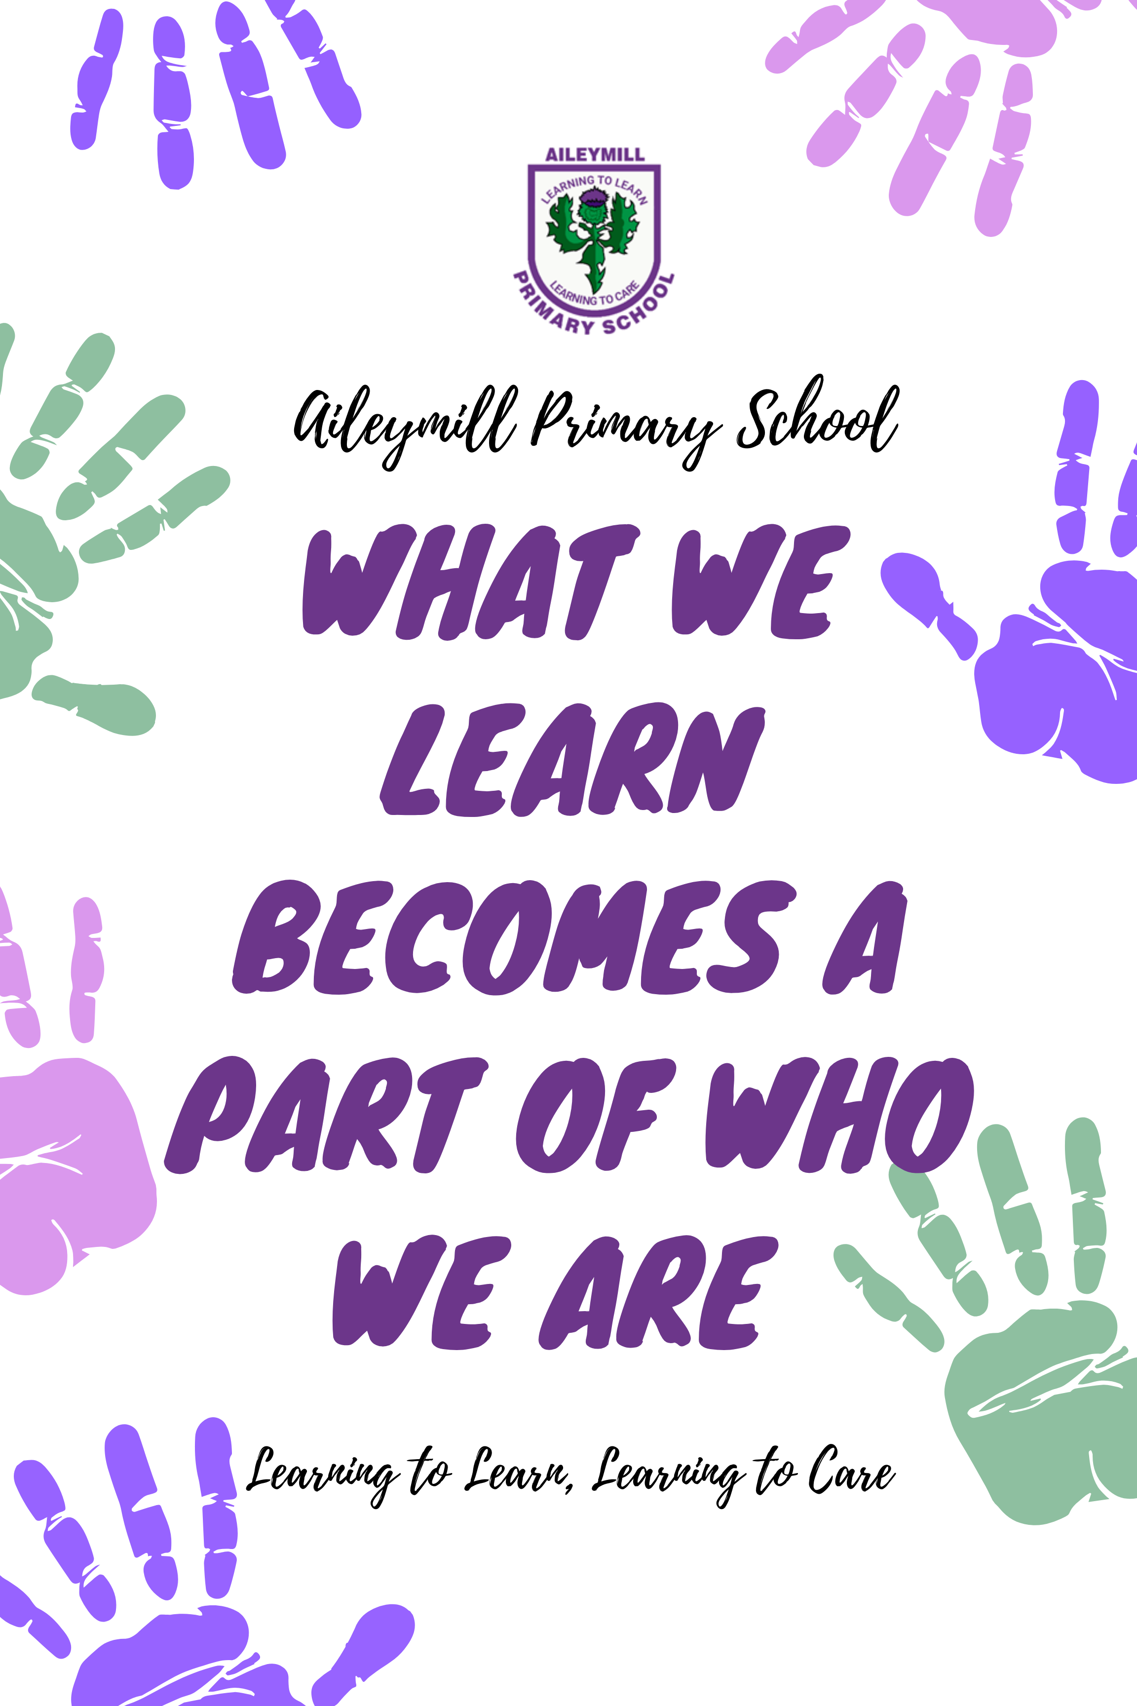

SCHOOL INFORMATION

SCHOOL ROLL
The present roll of the school is 302 and we have a capacity for 429 pupils. Parents should note that the working capacity of the school may vary dependent upon the numbers of pupils at each stage and the way in which the classes are organised.

At 2023-24 our numbers at each stage are:

- P1 - 36
- P2 – 46
- P3 – 41
- P4 – 43
- P5 – 38
- P6 - 50
- P7 - 49
Denominational Status: non-denominational co-educational

ACCOMMODATION
Aileymill Primary is on two levels. Our nursery has its own entrance and facilities but is part of the school.
There are 13 classrooms in the school with activity areas outside each classroom. The school is bright and airy with superb resources, including facilities for the disabled.
On the ground floor, classes can use the space outside their classrooms for outdoor learning activities.
Also on the ground floor is our Rainbow Room, which is a calm and welcoming space.

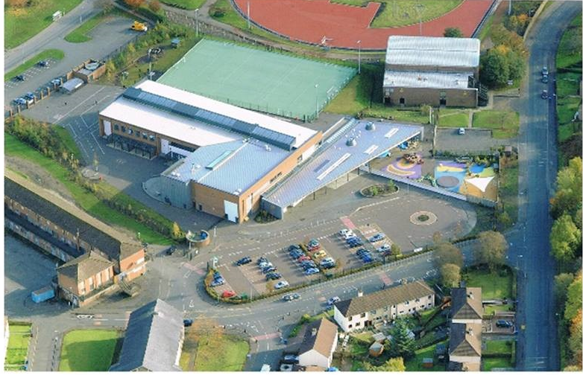

The school office

phone: 715647 email: inaileymill@glowscotland.onmicrosoft.com

For most parents, the office is their first port of call when needing help or information. Our office staff aim to sort any issues you have as quickly as possible and arrange any meetings and callbacks from teachers efficiently. They are the hub of the school! They look after all our records, order everything we need and generally keep the school running efficiently. We could not manage without them!

A number of things that you can do to help our staff are listed under different headings in the pages that come but the office staff have identified the 5 things that you can do to help them most.

- Please read the weekly newsletter that is sent out each Friday. A lot of calls to the office are about information that is last Friday’s newsletter. If you are not getting it, let us know.

- If your child is off – call in by phone as soon as possible or inform us through the Parent Portal ( Mrs McInnes spends over an hour most days calling parents that have not phoned in). It is a parent’s responsibility to contact the school.

- Changes to pick up arrangements. Changes to pick up arrangements are sometimes unavoidable. However, office staff receive between 10 and 20 calls per day changing arrangements. Each change to pick up arrangements breaks up their working time. Please ensure you agree with your child in the morning who will pick them up.

Last minute changes to pick up are very disruptive to the office staff. We cannot guarantee that these messages will get to children. Please arrange pick up in the morning.

- Updating contact numbers. Please update these as soon as possible. You can do so by phone or on Parent Portal.

- Late Snacks and Late Packed Lunches The office staff ask that you organise your child’s packed lunch and any snacks for them before your child comes to school. Delivering snacks and lunches to classes for children is disruptive to the work of the office. Please help the office staff by organising this before school.

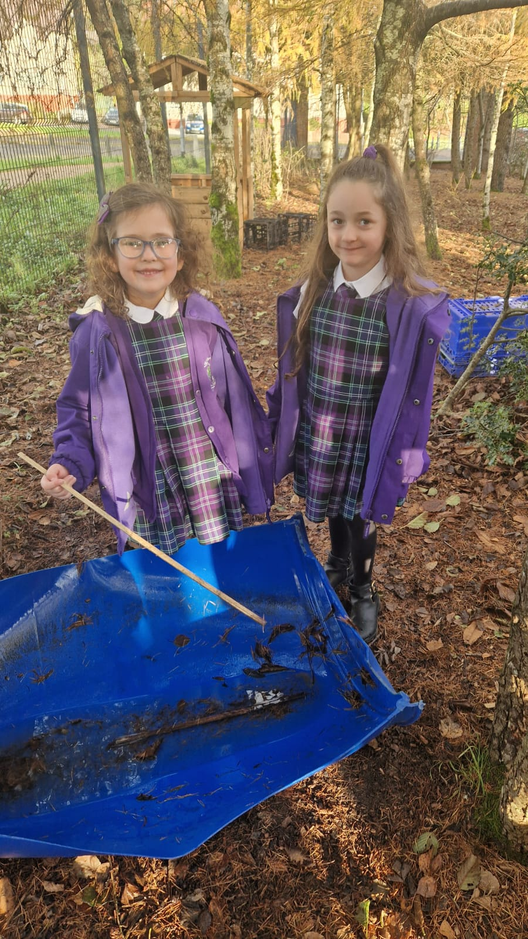
Our fine Scottish weather! The wind and rain.

Before School Starts School starts
When the weather is bad i.e. heavy rain or snow or very high winds, children are invited in by staff at 8.45 a.m. The Cumberland Rd door will be open. Staff will be in the playground to direct pupils inside from 8.45a.m.

Break time and lunch time
We aim to get the children outside if at all possible.
From September Weekend until the 1st / 2nd May holiday all children should bring a coat to school. It’s a parent’s responsibility to ensure children come to school prepared and that includes spending between 15 minutes and 30 minutes outside each day. To ensure your child’s comfort and opportunity to join in games and activities outside please ensure your child has a coat, at school, in the 10 months that we experience regular rain.

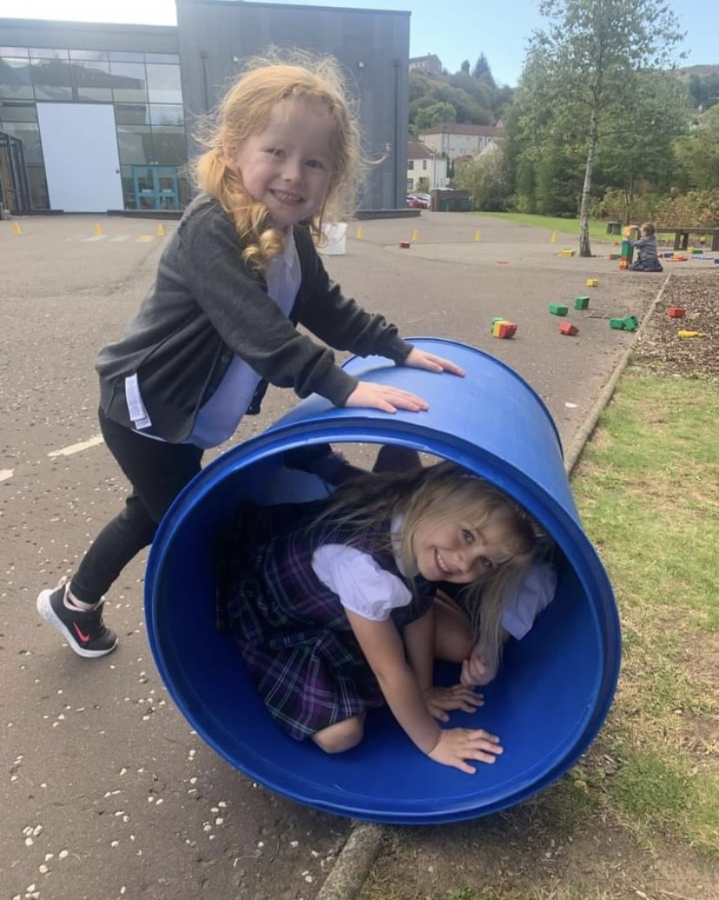
Outdoor Play

In our experience, children need to get time outside, every day, if at all possible.

Coats! Ne’er cast a clout ‘TIL May is oot! (as my mother used to say)

From after the September Weekend holiday until the second May holiday at the end of May we expect all children to bring a coat to school. It is the adults responsibility to make sure children have a coat.

Attendance and Timekeeping
Children thrive on consistency and regularity. Please do your best to ensure children attend school when well enough to so.

Children also learn best when they start the day following the routines and patterns of the school. That’s why being on time for school is so important.

Every child should be in the playground for the bell ringing at 9.00 a.m. This allows the classes to settle to learning immediately with no time wasted by teachers repeating instructions.

Opening 9.00 a.m.
Interval 10.35 a.m. -10.50 a.m.
Lunch 12.30p.m. - 13.15 p.m.
Afternoon Pick up 3pm

Please make pick arrangements with your child in the morning as any changes to the person picking up involves additional work for the office staff.

Last minute changes to pick up arrangements cannot be guaranteed.

Attendance Checks
The school and Inverclyde Council monitor attendance on a regular basis. In school we monitor individual timekeeping and attendance over a period of approximately 6 weeks. If your child’s attendance is below 90% we examine the reasons for absence and will contact you if we have concerns.

If we contact you and there is no sustained improvement, we may involve other agencies or the Scottish Children’s Reporter Administration (known as The Children’s Panel).

Poor timekeeping and attendance has a lifelong effect on outcomes for children. Children with poor attendance in P6 and P7 are at risk of continuing onto extremely poor attendance in secondary school.

Please help us do the best by your child by ensuring their attendance when they are well enough to be at school.

We would rather see them in a bit late than not at all.

Inverclyde Council policy is not to authorise holidays in term time and these, therefore, count towards recorded absence. If a holiday in term time is unavoidable, please contact the school with dates as soon as possible. We do not give work to children when absent for this reason.

Teaching Staff
Mr Simon Simpson | HT
Mrs Angela Ferrier | DHT
Mrs Jaclyn Pavia | PT/P7B
Mrs Louise Quigley | PT Nurture and Inclusion
Miss Stephanie Roy | P7C
Mrs Angela James | P6
Mrs Clair Radford | P6
Miss Claire Spence | P6/5
Mr Ross Boag | P5
Mrs Clair Stevens | P4
Mrs Ashley Bell | P4
Miss Lynette McLaughlin | P4/3
Miss Lauren Hodge | P3
Miss Elaine Marshall | P2C
Mrs Laura McGilp | P2B
Miss Rebecca Mitchell | P1B
Miss Nicola Mitchell | P1C
Mrs Karolyn McGeehan | Support for Learning
Mrs Nicola Bonnar | Support for Learning
Miss Abigail Hearton | RCC/ support for learning
Mrs Elaine Welsford | RCC/ support for learning
Mrs Carla McLaren | RCC/ support for learning

Support Staff
Miss Lynne Anderson | PSA
Mrs Donna Ballingall | PSA
Mrs Janice Boyle | PSA
Mr Graham Carson | PSA
Mrs Donna Cooke | PSA
Mrs Jennifer Scott | PSA
Mrs Elaine Gallacher | PSA
Mrs Lynsey Griffiths | PSA
Mrs Alison Haughey | PSA
Mrs Lorna McVey | PSA
Mrs Jeanette Munro | PSA
Mrs Audrey Brain | PSA
Miss Lynne Anderson | PSA
Mrs Jackie Carson | PSA
Mrs Lisa More | PSA
Mrs Patricia Wilson | PSA
Mrs Caroline Mullan | Family Support Worker Barnardo’s
Office Staff
Miss Vicki Saunders | Office Manager
Mrs Lorna Gorman | Clerical - Nursery
Mrs Lynn Rattray | Clerical
Mrs Kirsten McInnes | Clerical

Nursery Staff
Mrs Kay Anderson | Depute Head
Suzanne McMinn | Senior EYECO
Tracey Tearle | Early Years Graduate
Kaitlyn Middleton | Modern Apprentice
Sophie McGarva | Modern Apprentice
Val McKay | EYECO
Caroline Gillan | EYECO
Dawn McGoldrick | EYECO
Kalen Logan | EYECO
Jo-Anne Stewart | EYECO
Joanne Gavin | EYECO
Sofia Demelas | EYECO
Yvonne McLean | EYECO
Arleen Ptolemy | EYECO
Julia Keen | EYECO
Michael Young | EYECO
Therese Docherty McIntosh | EYECO
Stephanie Gibson | EYECO
Amanda Jeffers | Support Assistant
Barbara Jacher | Support Assistant
Michaela Dougan | Support Assistant
Maria Scullion | Support Assistant

Visiting Specialists
Nicole Robertson | Active Schools
Stuart Tate | Brass Tuition
Angela Charlton | Flute / Clarinet tuition

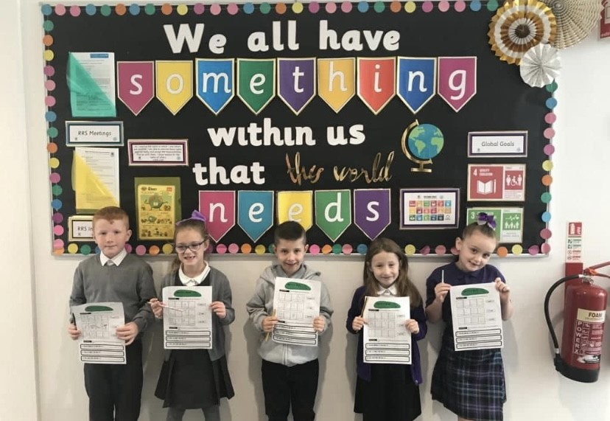

Holiday List 2024-25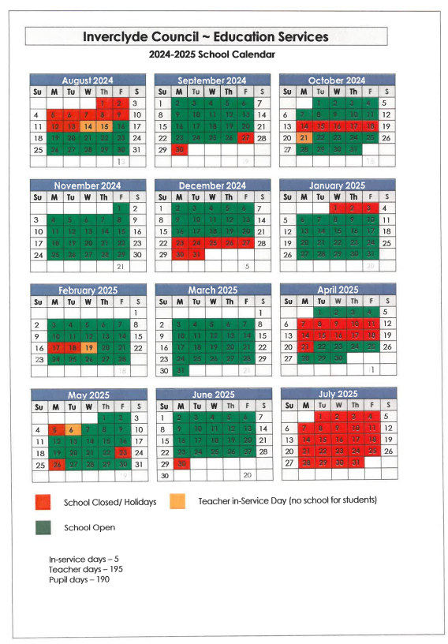

This calendar will help you plan family breaks and childcare.

School Parking
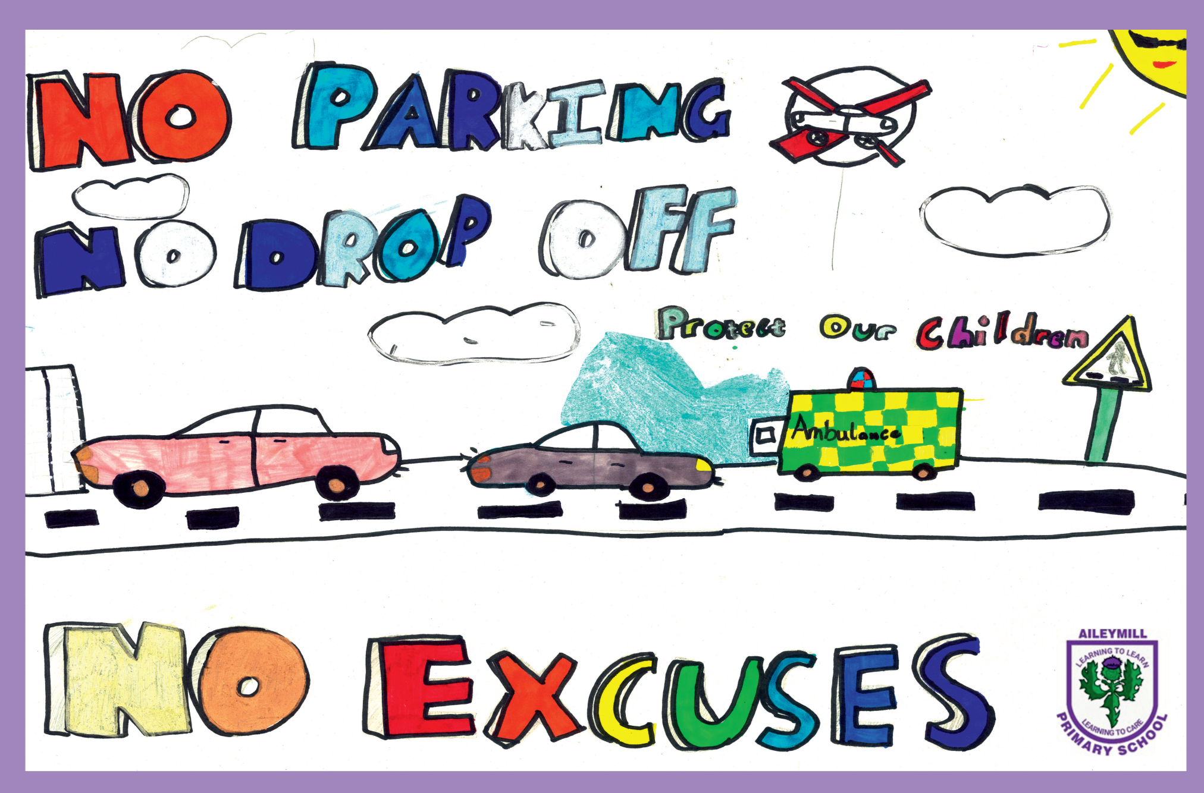
The Norfolk Road Car Park is for staff and deliveries only. It has a limited number of spaces for cars displaying a blue badge.

Parents should use on street parking or our Park and Stride area at the Cumberland Rd entrance to the school. There is a pedestrian path from there to the Norfolk Rd Entrance

At all times when nearby the school driving parents should
For the safety of all children and pedestrians, driving parents should avoid
- Parking outside proper parking spaces
- Double parking
- Blocking cars already parked
At times a small number of parents disregarding this advice put children and adults in danger. Where we are aware of dangerous driving we will report it to the police. The car park is camera monitored.

INFANT ENROLMENT

Legislation has given parents freedom regarding the choice of school for their children.
It is however, necessary for children to be registered for education, at the school which serves their area. Thereafter parents may, if they wish, make a placing request to have their child enrolled in a school other than that which serves their area.
IMPORTANT NOTICE
REGISTRATION INFORMATION FOR CHILDREN STARTING PRIMARY 1 IN AUGUST 2024

Inverclyde Council has changed the way in which children register for primary school. This process will now be undertaken by completing an online application form which can be found on the Inverclyde Council website at http://www.inverclyde.gov.uk/p1-registration.

It’s vitally important that parents follow the online registration process to register their child for a Primary 1 place in an Inverclyde school.

Children who reach the age of five years between 1 March 2024 and 28 February 2025 (this will be children who are born between the 1 March 2019 - 29 February 2020) are due to start primary 1 at the beginning of the new school term in August 2024. (click on link below to register)

School Session 2024-2025 - Inverclyde Council

Once parents have completed the Primary 1 registration, they will have the choice to complete a placing request application to a school other than the catchment primary
(This includes Primary 1 Gaelic Medium education at Whinhill Primary School). A deferred entry application is also available to parents considering deferring their child’s entry to Primary 1 in August 2024.

Parents will be advised of the outcome of their request no later than 30 April.

No documents will be required at this stage; however, we may have to contact you, should we require further information.

Parents who do not have internet access to apply online, are asked to contact their child’s current Early Years Establishment for assistance.

Placing Requests

Education Services does not provide transport for those pupils in receipt of a placing request other than in exceptional circumstances. In the case of under-age placing requests if the child is offered a place in his/her catchment area school, transport will be provided in accordance with Council policy.

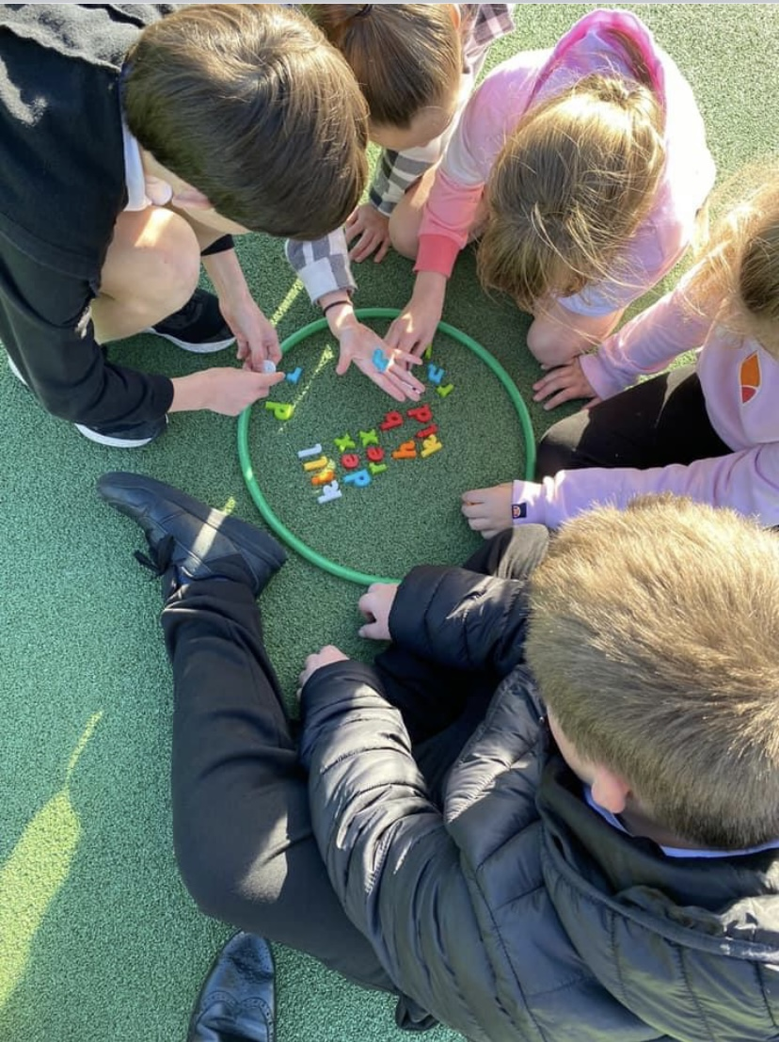

TRANSFER TO SECONDARY SCHOOL

Pupils are normally transferred between the ages of 11½ and 12½ so that they will have the opportunity to complete at least 4 years of secondary education. Parents will be informed of the arrangements no later than December of the year preceding the date of transfer at the start of the new session.
The school to which children from Aileymill normally transfer to is:

Inverclyde Academy
Cumberland Rd.
Greenock
Tel: 01475 - 715100
Headteacher - Denise Crawford

Parents should be advised that if they wish their child to transfer to this school they must live within the catchment area otherwise a placing request must be submitted.

TRANSPORT

The Council has a policy of providing free transport to all primary pupils who live more than one mile from their local school by the recognised shortest walking route. This policy is more generous than the law requires. This means that the provision of transport could be reviewed at any time.
Parents who consider they are eligible should obtain an application form from the school or Education Services at Wallace Place, Street, Greenock, PA15 1JB. These forms should be completed and returned before the end of February for those pupils beginning school in August to enable the appropriate arrangements to be made.

Applications may be submitted at any time throughout the year but may be subject to delay whilst arrangements are made. The appropriate officer has discretion in special circumstances to grant permission for pupils to travel in transport provided by the authority, where spare places are available and no additional costs are incurred.

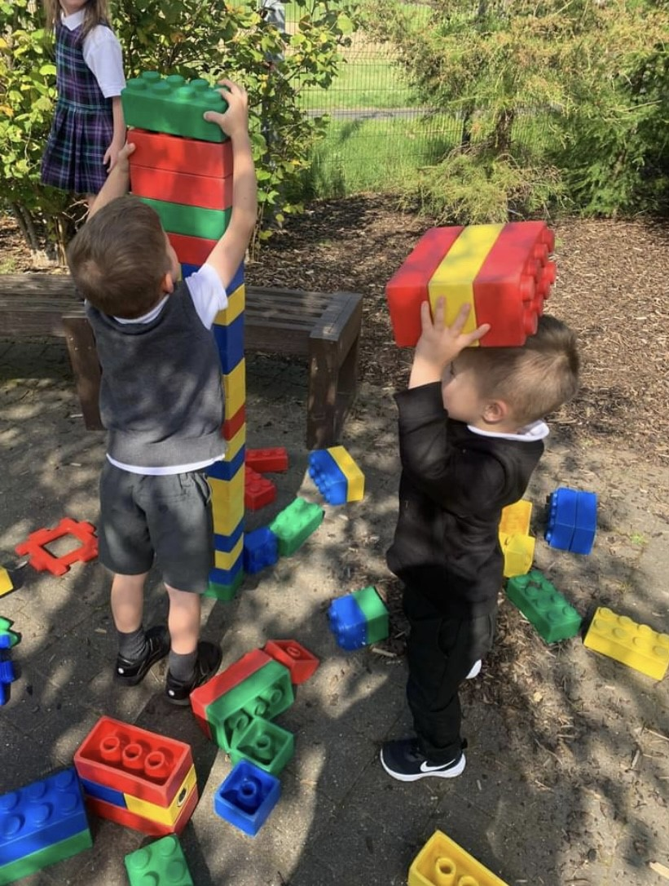

CURRICULUM FOR EXCELLENCE

The curriculum framework for all Scottish educational establishments 3 - 18, called Curriculum for Excellence, aims to offer better educational outcomes for all young people and provide more choices and more chances for those young people who need them.
The aims of Curriculum for Excellence are that every child and young person should:
- Know they are valued and will be supported to become a successful learner, an effective contributor, a confident individual and a responsible citizen;

- Experience a traditionally broad Scottish curriculum that develops skills for learning, skills for life and skills for work, with a sustained focus on literacy and numeracy that encourages an active, healthy and environmentally sustainable lifestyle and builds an appreciation of Scotland and its place in the world.

The experiences and outcomes under Curriculum for Excellence are written at five levels, with progression to qualifications described under the senior phase.

Early Level - the pre-school years and P1 or later for some
First level - to the end of P4, but earlier for some
Second level - to the end of P7, but earlier for some
Third and Fourth - S1 to S3, but earlier for some
Senior phase - S4-S6 and college or other means of study.

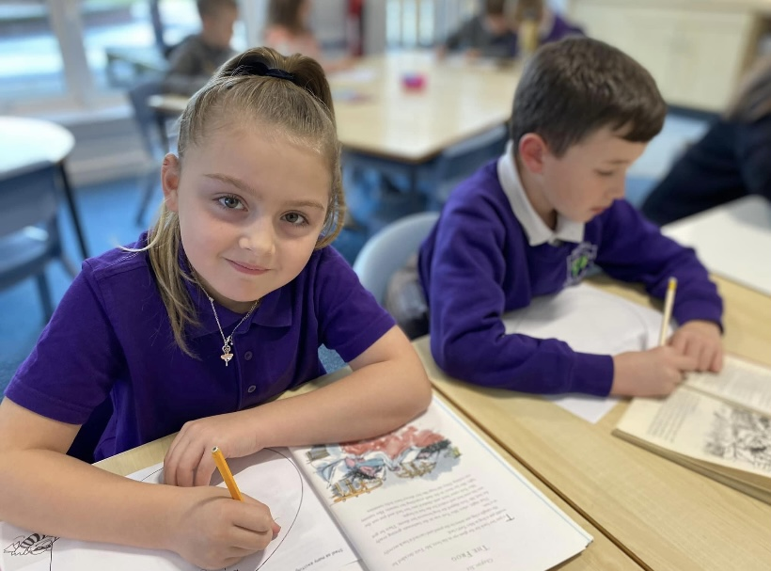

All pupils should experience a balanced curriculum in their seven years in primary school. The curriculum should also offer challenge and enjoyment, breadth, progression, depth, personalisation and choice, coherence and relevance.

Further information can be found by visiting:
https://education.gov.scot/parentzone/

ORGANISATION OF THE CURRICULUM

The curriculum is now organised under eight headings but every effort is made to link areas of the curriculum together to make learning more real and relevant.

The eight areas are Languages, Mathematics, Health and Well Being, Social Studies, Technologies, Expressive Art, Religious and Moral Education and Science.

As a whole school, we have developed a curriculum calendar which ensures appropriate coverage of the curricular areas by having curricular focus weeks throughout the school year. These include Science, Scots Language, Health and Wellbeing, RME and World of Work.
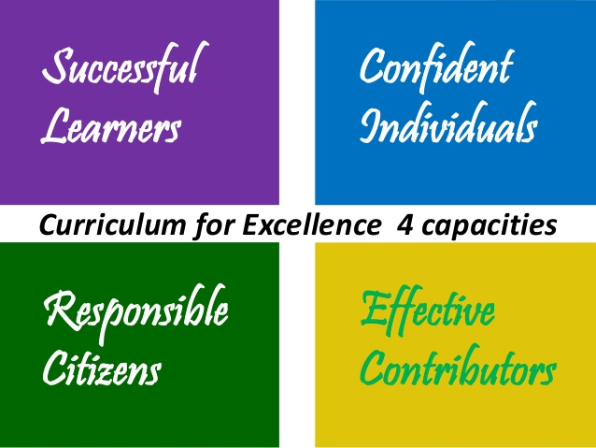

In the next few pages, we have a brief description of the curricular areas.

Central to all areas of the curriculum is the methodology used by the teacher and the need to engage our pupils in their learning.

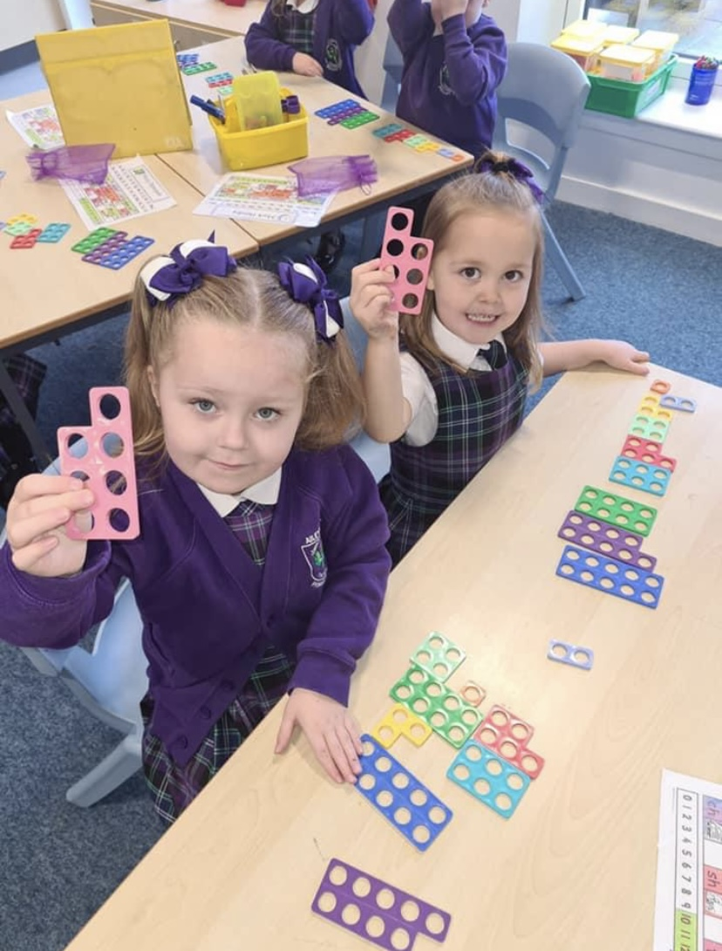

LANGUAGES & LITERACY

Language is at the core of thinking and at the centre of our learning. Through language our pupils gain much of their knowledge and many of their skills across the curriculum. The four main components of language are:

- Talking , Listening , Reading, Writing

The importance of Spoken English is emphasised at Aileymill.
From Primary 1 children are encouraged to develop their skills in talking and to articulate their learning
At the early stages of reading we are using the North Lanarkshire programme of Active Literacy.

A wide range of reading texts is used in all classes.

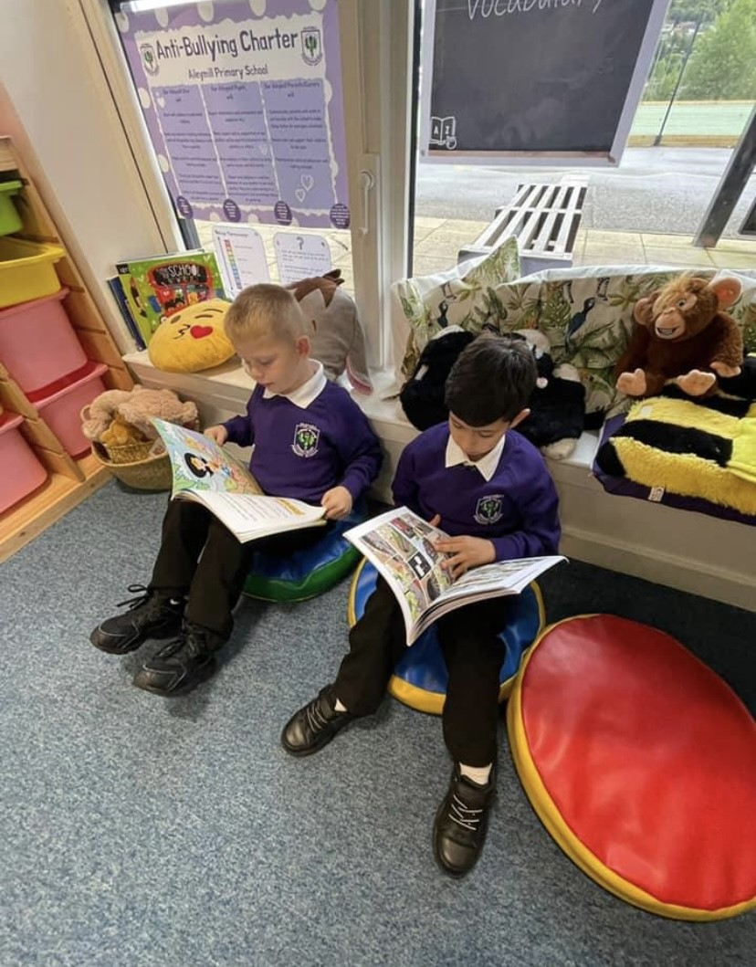
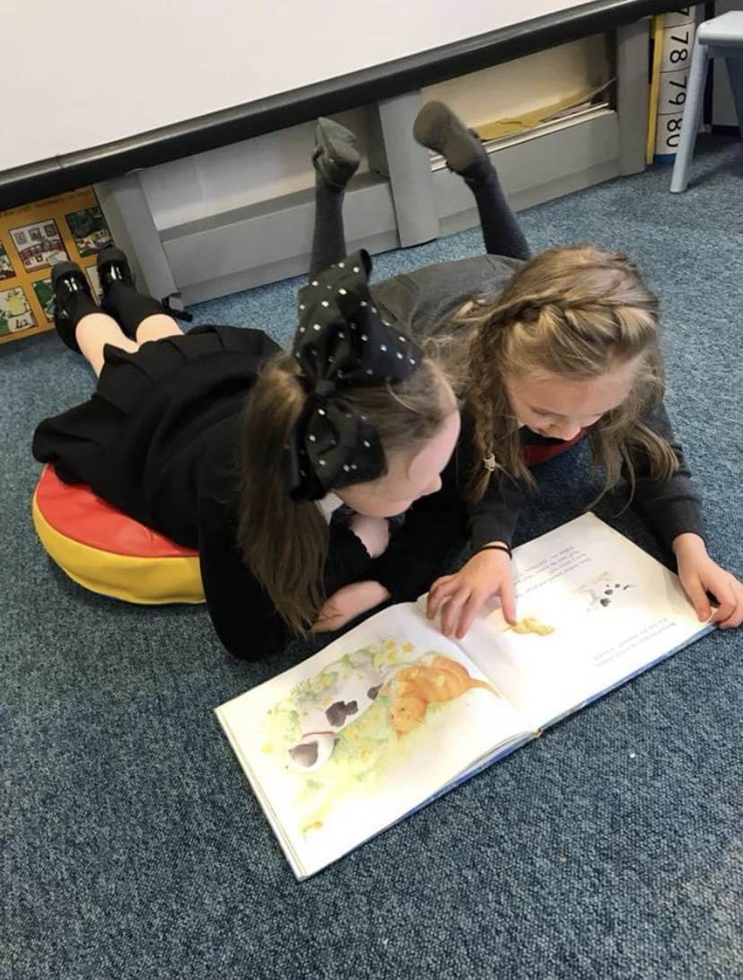

Reading for pleasure, as well as for information, is encouraged throughout the school and we have a well-stocked library. Accelerated Reading is embedded throughout the school and has been highly successful in raising attainment in reading.

At the early stages of writing we build on drawing and scribing sentences and introduce punctuation, vocabulary, sentence construction as the children progress.

We encourage children to develop a legible, fast, cursive style of handwriting.

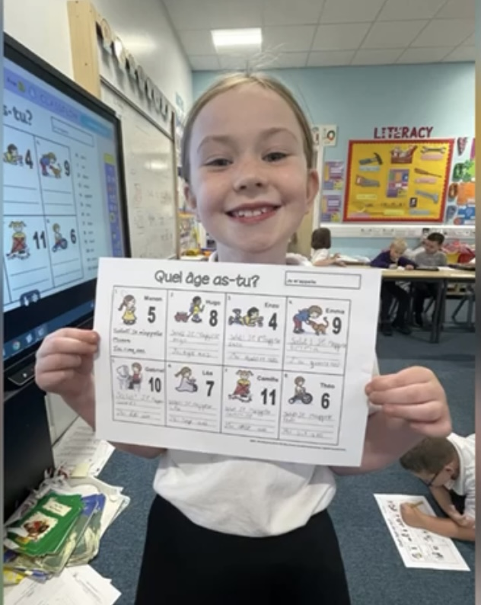

As part of the Scottish Government’s 1+2 Languages Programme, French is taught throughout the school.

Teachers use many approaches including active learning, games, songs, role play and interactive whiteboard software to create relevant, coherent, enjoyable and successful learning experiences.

MATHEMATICS & NUMERACY

Mathematics provides more than opportunities to calculate, it enables information to be handled and communicated and problems to be solved. Mathematics is used in all aspects of everyday life, allowing us to make sense of the world around us. All children are encouraged to be able to explain their learning and builds strong number sense.
Furthermore children need to be confident and competent in their numeracy skills to be able to function responsibly in everyday life and contribute effectively to society.
The mathematics outcomes in A Curriculum for Excellence are outlined within the following organisers

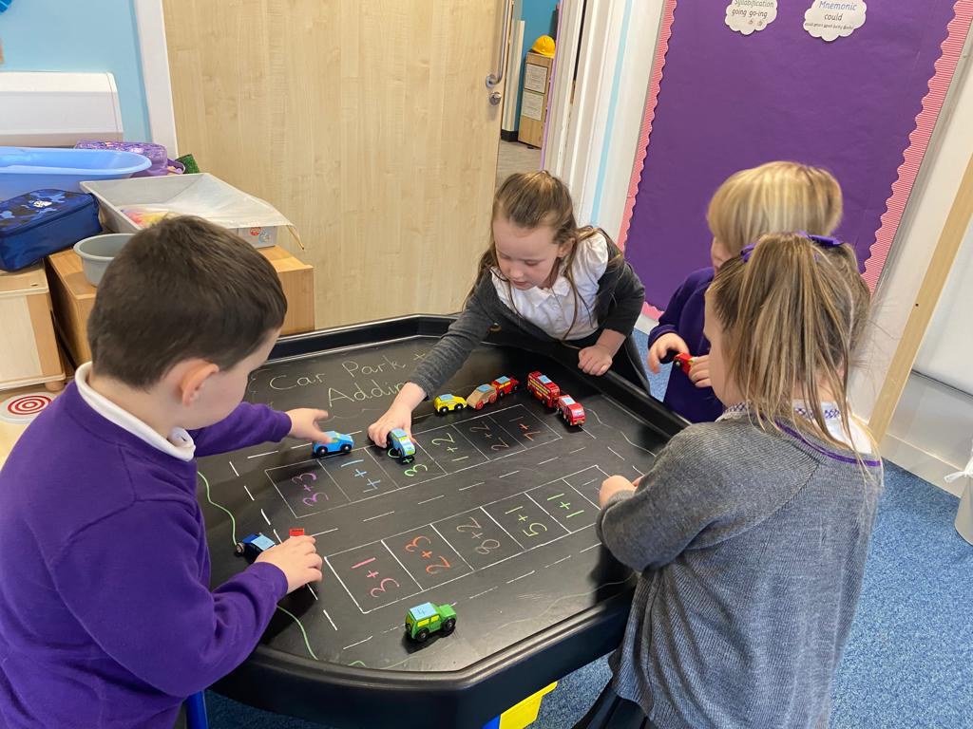

Number, money measure

- Basic number processes
- Measure
- Patterns and Relationships
Shape, position and movement

- Properties of 2D and 3D objects
- Angle, Symmetry and Transformation

Information Handling

- Data and Analysis
- Ideas of Chance and Uncertainty
- Mental Maths is a feature at all stages of the school.

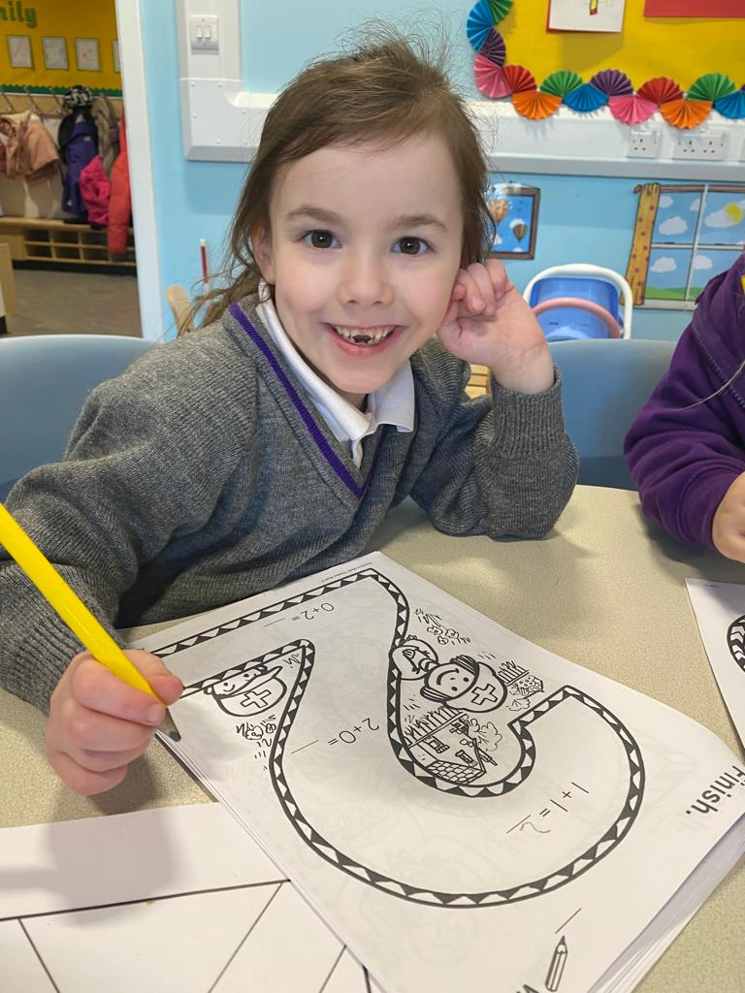

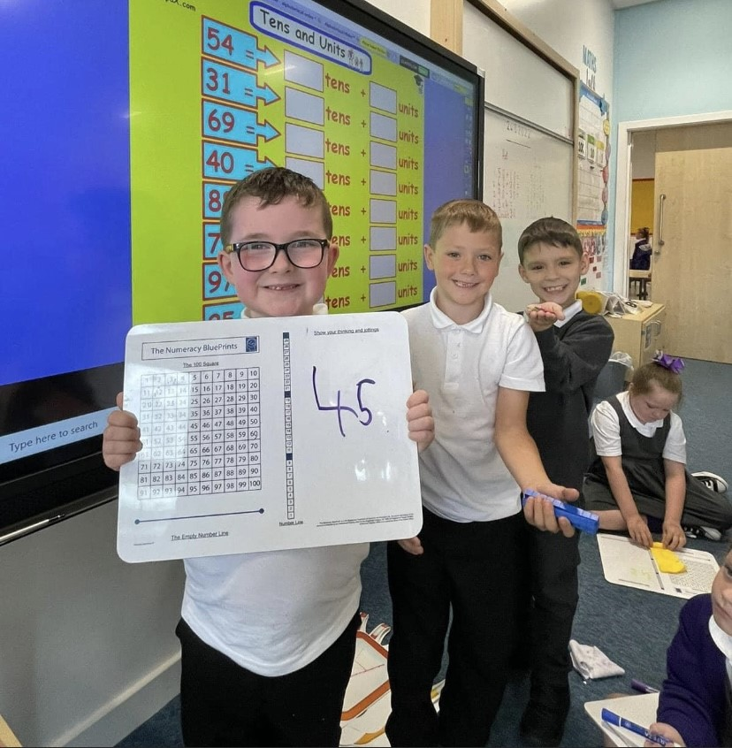

READ, WRITE, COUNT

The Read, Write, Count programme aims to support parental engagement in literacy and numeracy. Gift bags are distributed annually to all P2 and P3 pupils in Scotland by Scottish Book Trust. The gift bags contain essential literacy and numeracy materials to support children’s learning, as well as advice and support to parents.

Studies show a direct link between a strong family learning environment and progress in reading, writing and counting. In addition to the parent guide included in the gift bags, the Parent Club website (https://www.parentclub.scot/) offers a range of hints, tips and advice to help parents engage in their child’s learning.

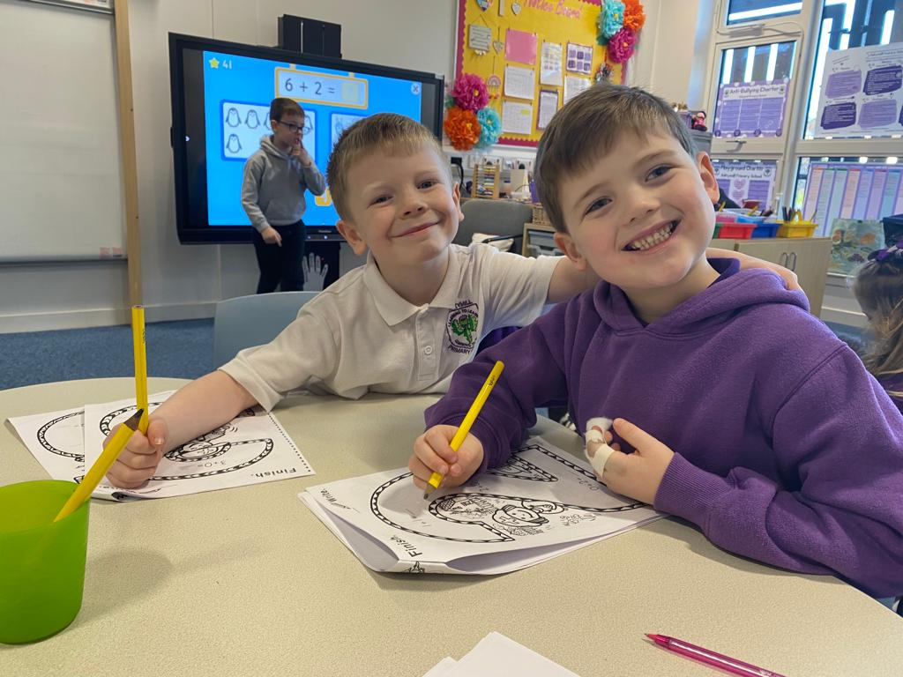

Reading Schools

In November 2023 we received Reading Schools Gold Award status. Reading Schools is a government funded accreditation scheme to encourage and reward schools that go above and beyond in promoting literacy and reading. It is run by the Scottish Book Trust and builds on the work of the First Minister’s Reading Challenge that we were previously a part of. We are very proud to be one of the Gold Award schools.

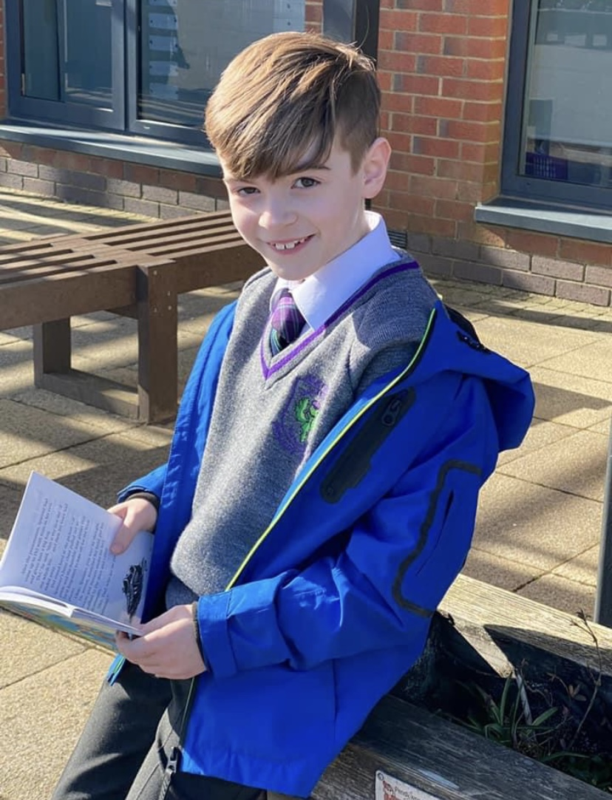

HEALTH & WELL BEING

Health and Wellbeing Education is an important part of the work of Aileymill Primary. It is concerned with all aspects of mental, emotional, social and physical wellbeing now and in the future.

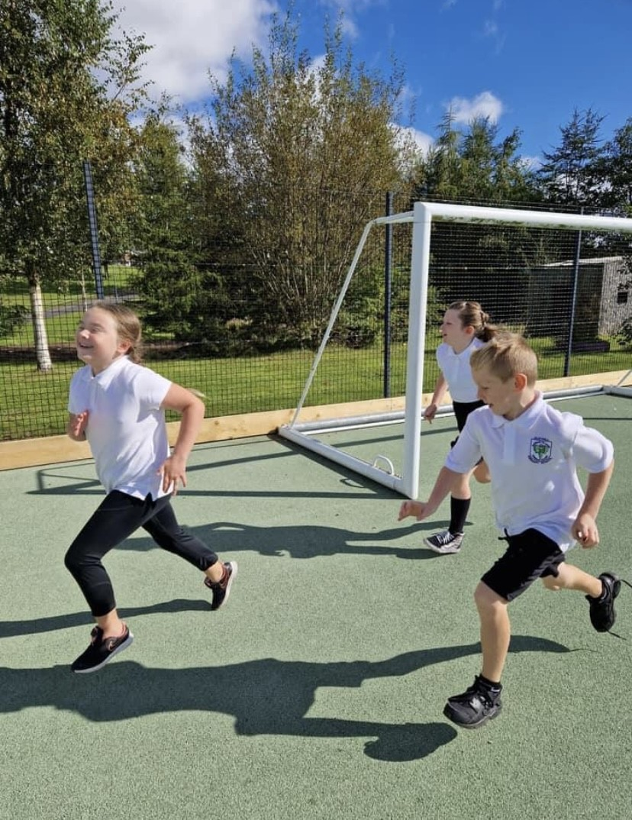

Health and Well Being is subdivided into the following areas:

- Mental, emotional, social and physical wellbeing
- Planning for choices and changes
- Physical education, physical activity and sport
- Food and Health
- Substance misuse
- Relationships, sexual health and parenthood.

Pupils are given well planned opportunities to learn about their own health and well-being, relationships and health and safety in the environment.

All classes are timetabled to have 2 hours quality Physical Education per week.

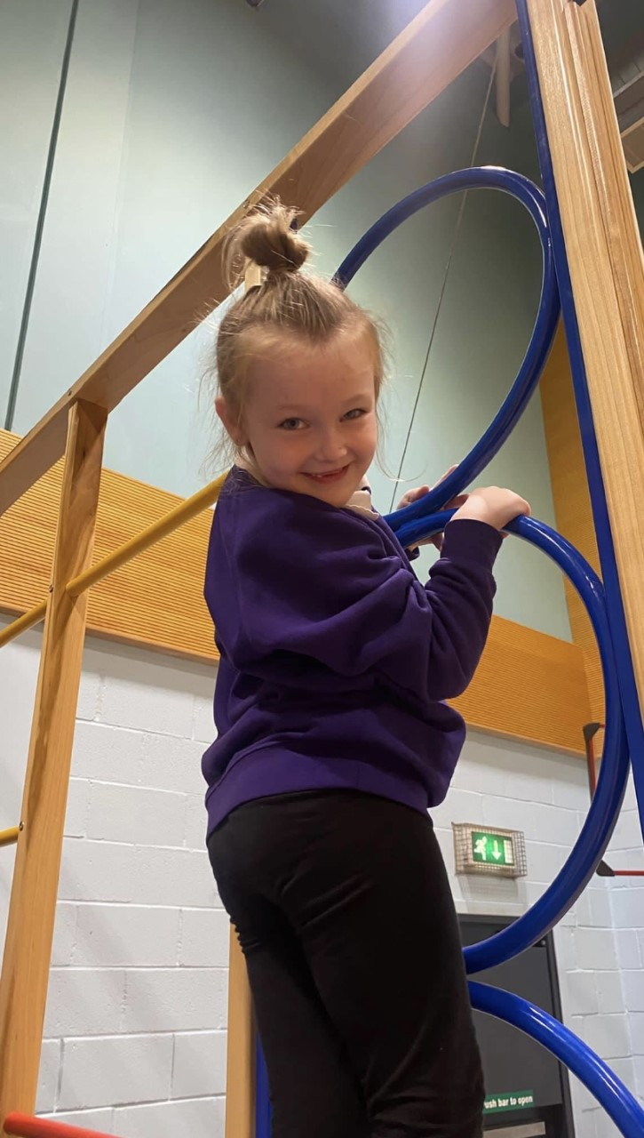
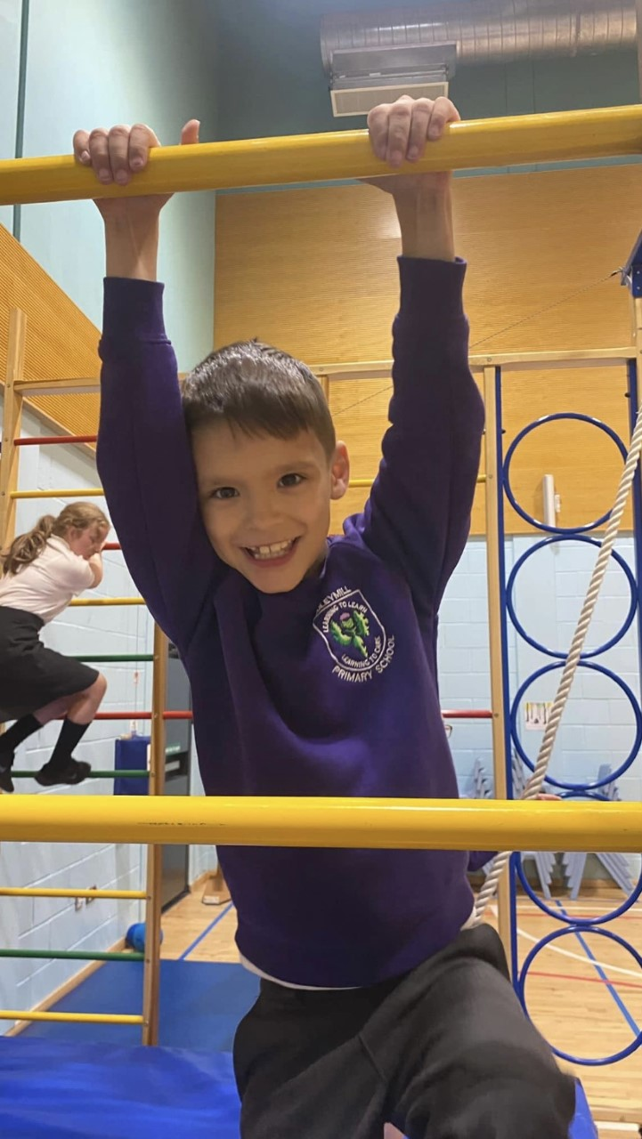
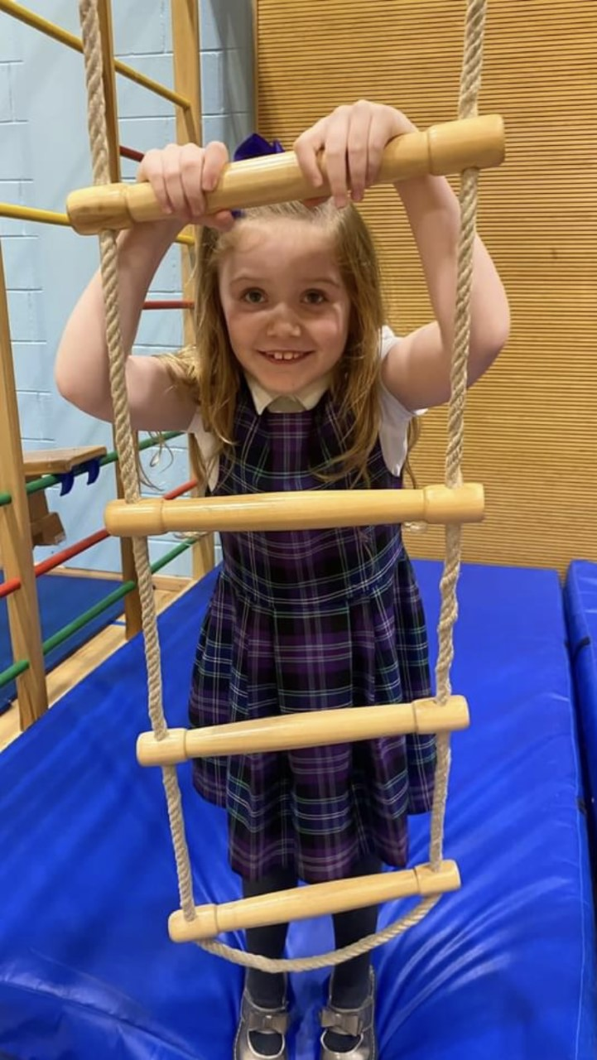

Parents should note that pupil activities may be restricted because health and safety requirements state that jewellery of any kind must not be worn where pupils are undertaking games or physical activities. This includes jewellery worn as a result of body piercing.

Earrings
Council policy is that children must remove earrings for P.E.. If your are planning to have your child’s ears pierced please do this in the last week of June or first week in July as this allows the earrings to be removed for P.E. in August.

SEXUAL HEALTH AND RELATIONSHIPS EDUCATION
Sex Health and Relationship education is an integral part of a school’s health education programme. It focuses on the physical, emotional, moral and spiritual development of all children. Teachers are central to the delivery of sex education from Primary 1-7 and work in partnership with parents/carers and appropriate health professionals.
Parents/carers should be fully informed and consulted on the content and purpose of sex and relationship education in schools, and have the opportunity to raise concerns with school staff. On an occasion where a parent/carer wishes to exercise the right to withdraw his/her child from sex and relationship education they should discuss their concerns and alternative arrangements with school staff (as per Inverclyde Council’s Policy “Sexual Health and Relationship Education”).

SOCIAL STUDIES
In Social Studies pupils look at societies at different times (history) in different places (geography) and also people in society, (modern studies) This will, for example, involve them in studying important people and events in the past, investigating transport and communication networks at home and further afield; and in looking at the ways our communities are run.
Visits to places of educational interest are arranged whenever possible to allow the children the opportunity of seeing things at first hand.
The experiences are designed to encourage links with other areas of the curriculum so that learners have deeper, more enjoyable and more active experiences.

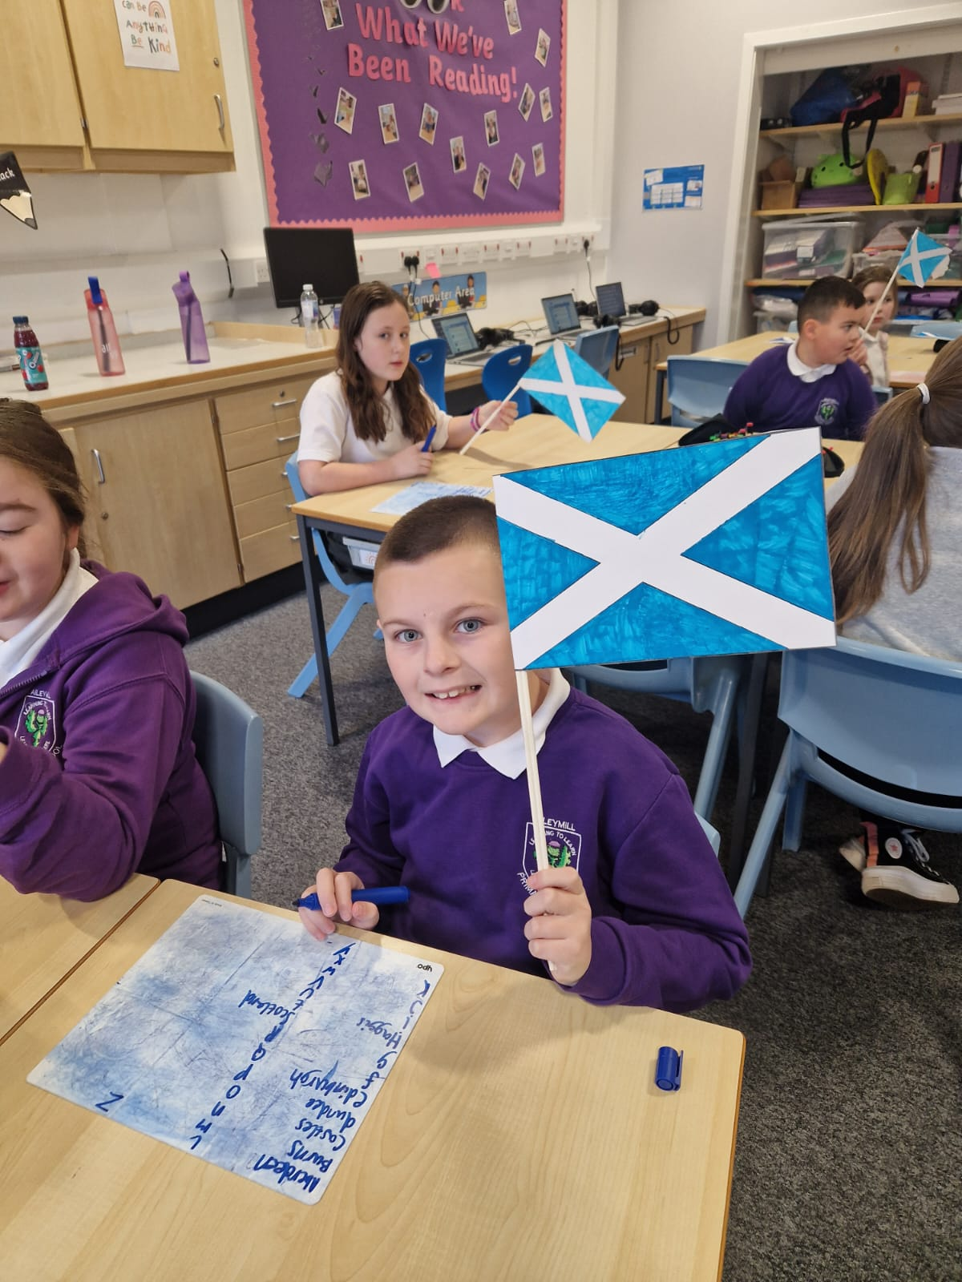

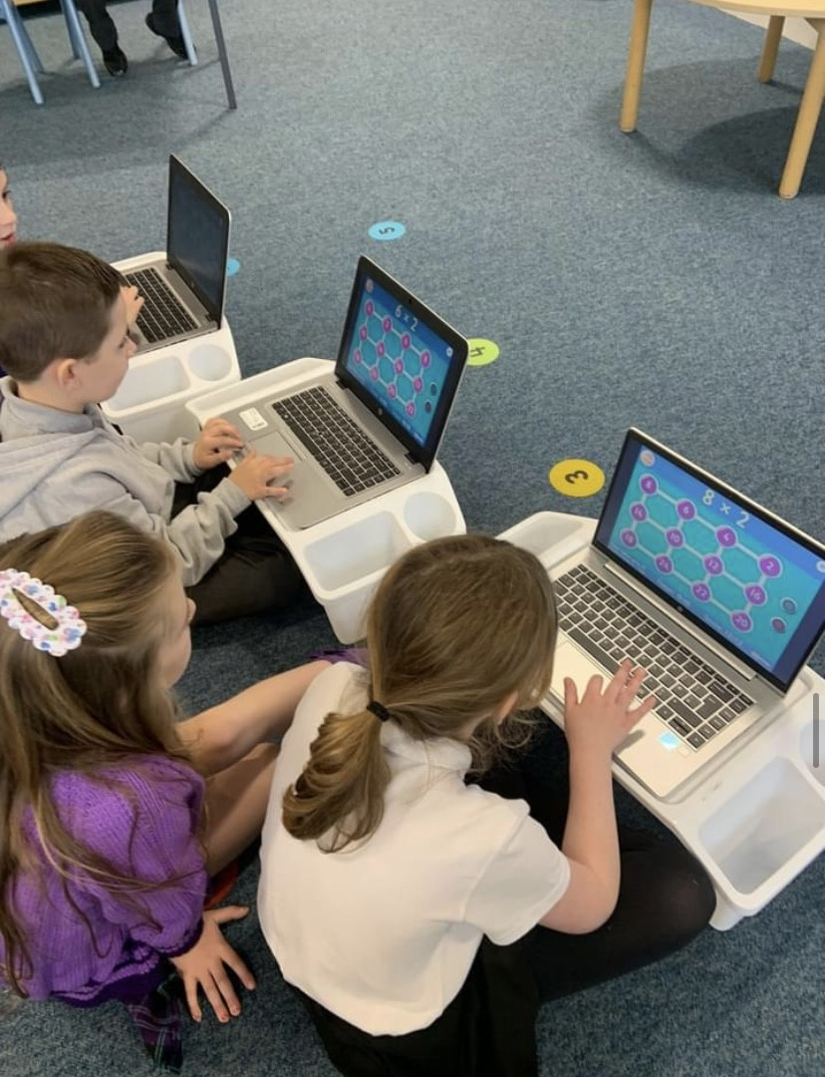
TECHNOLOGIES
As pupils study aspects of Technology, they learn about its impact in the home, in schools, in industry and in the wider community. They should also be given the chance to use their own skills and offer solutions to design problems, using different materials and resources.
Information Technology should involve pupils in, for example, using and learning about audio-visual equipment such as digital cameras, digital microscopes, computers and a variety of computer ‘applications”. At Aileymill Primary we have a two computer towers, each equipped with 15 laptops. All of our classrooms have computers and interactive whiteboards.

EXPRESSIVE ARTS
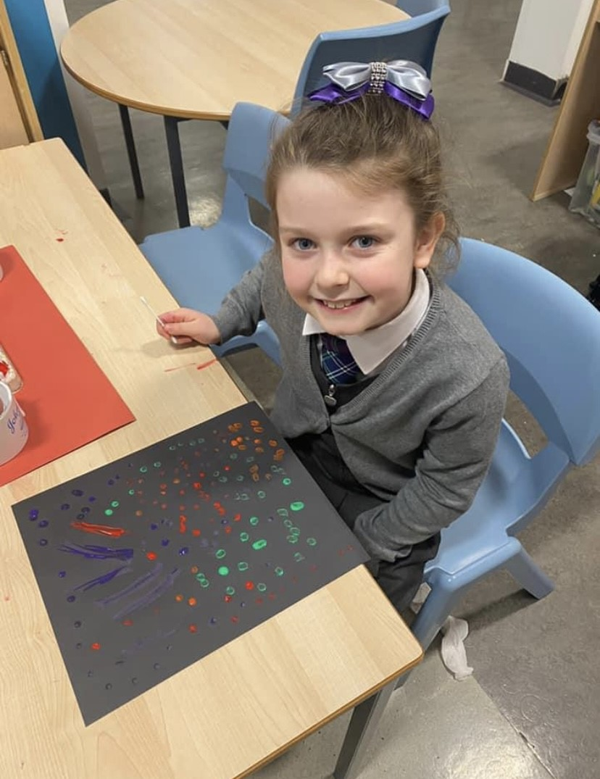

- Art

- Dance

- Drama

- Music

Each of the above subjects has its own body of content to be studied and a range of skills and techniques to be learned. All produce some emotional response and encourage creative expression, all of which are important in the education of every child. These subjects help to stimulate awareness of senses and the acquiring of attitudes and power of discrimination.
The social aspects of recreation activities are especially important in times of greater opportunity for leisure. They touch directly and indirectly on each individual’s health and well-being.
At Aileymill Primary, all children are encouraged to take an active part in all areas of the Expressive Arts.

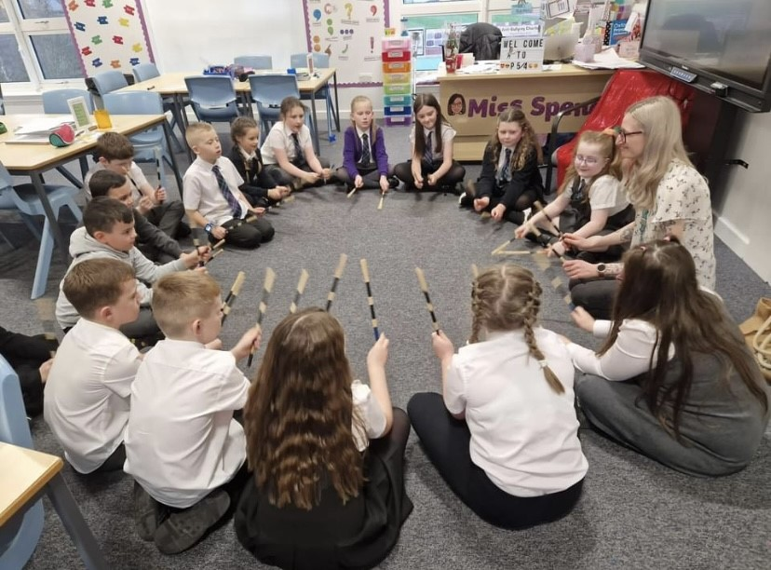

Religious and Moral Education
Religious and Moral Education helps children and young people to explore the world’s major religions and views which are independent of religious belief, and to be challenged by these different beliefs and values.

The Curriculum for Excellence outlines areas to be studied namely Christianity, Other World Religions, Beliefs, Values and Issues and Practices and Traditions are explored in both Christianity and Other World Religions.

Aileymill enjoys close links with St Andrew’s Primary, sharing worship at key times throughout the year.

Religious Observance and Assemblies
Harvest, Christmas, Easter and Closing Festivals are all held in Church where parents are encouraged to join the school in their worship.

We have a weekly for all children in the nursery and school. Children play a very important part in all school assemblies, taking part in instrument playing, reading, narrating, dance etc.

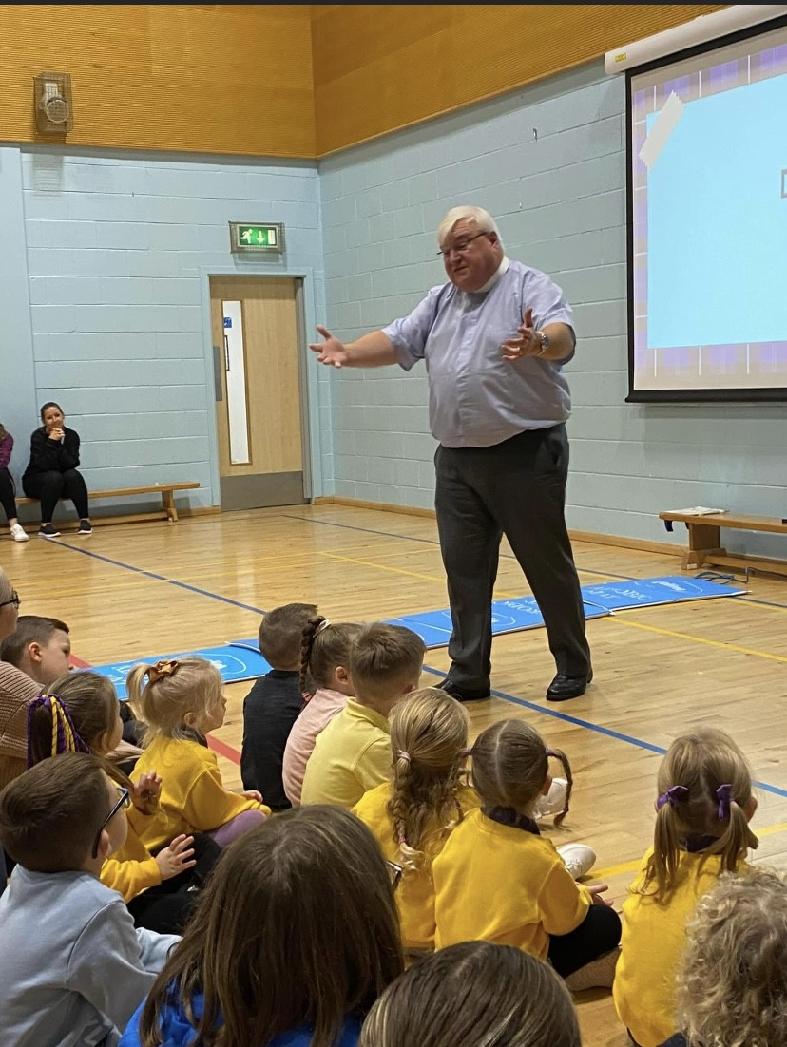
Reverend David Burt is a welcome visitor tour school and frequently joins us where he shares his thoughts and positive message with us. He supports our values as a nurturing, caring school.

Reverend Burt’s churches also support us with financial contributions including paying for our online musical subscriptions.

It is normal practice for parents who wish to withdraw their child from religious observance to make suitable arrangements with the Head Teacher. Where Religious Education is integrated with other topics and withdrawal is more difficult, parents should consult the Head Teacher.
Parents from ethnic minority religious communities may request that their children be permitted to be absent from school in order to celebrate recognised religious events. Only written requests detailing the proposed arrangements will be considered. Appropriate requests will be granted on not more than three occasions in any one school session and the pupil noted as an authorised absentee in the register.
SCIENCE
The new science curriculum within Curriculum for Excellence challenges us to ensure that all children must develop a secure understanding of important scientific concepts and that their experience of science in school should kindle a lifelong interest in science.

The science outcomes have been developed into seven areas
- Planet Earth
- Energy in the Environment
- Communication
- Forces and Motion
- Life and Cells
- Materials
- Topical Science

Further information is available on the following website:
https://education.gov.scot/parentzone

ASSESSMENT AND REPORTING

Assessment is the term used to describe the process of evaluating a child’s progress. We continue to develop formative assessment at Aileymill Primary. This is assessment which directly affects the learning and teaching that takes place. To this end we are involving our pupils in sharing what is to be learned. We are involving pupils in self and peer evaluation and we are concentrating on meaningful feedback for our pupils.
Assessment is an important part of learning and teaching.
Class and group tests are part of our summative assessment programme. This type of assessment comes at the end of a piece of work. Our assessment procedures fulfil three purposes
- To diagnose areas of difficulty
- To provide reliable information on pupil progress
- To provide the basis for communicating to parents areas of strength and concern
Assessment will include:
- Scottish National Standardised Assessments at P1, P4 and P7
- Class based assessments on spelling, reading, writing and maths
REPORTING
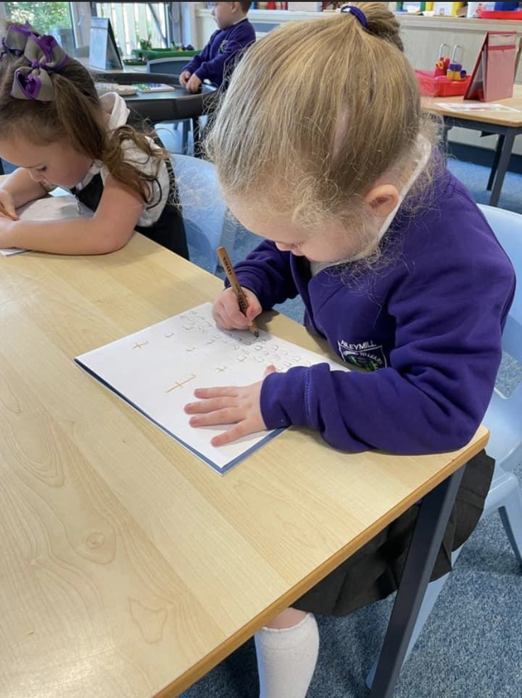
You will be invited to attend two Parents’ Evenings per school year, in October and in March. Formal appointments will be issued for every parent. There will be two formal, written reports issued, in November and in May. In addition to this, each child will have their own Learning Log which will be sent home monthly and which highlights individual targets in Literacy, Numeracy and Health and Wellbeing.

SCHOOL IMPROVEMENT
We are very proud of the improvements made in attainment across the school. These can be examined in detail in our Standards and Quality Report 2022-23 which can be found on our school website.

Aileymill, in line with other schools in Inverclyde, plans for improvement on a three yearly cycle. Again, this can be read in detail in our School Improvement Plan 2022-23 and 2023-24, which can be accessed via the school website, from the end of January 2024.

We believe that high quality interventions from properly trained staff are the most effective way to narrow the poverty related attainment gap and our PEF spend reflects this.

https://blogs.glowscotland.org.uk/in/aileymillps/

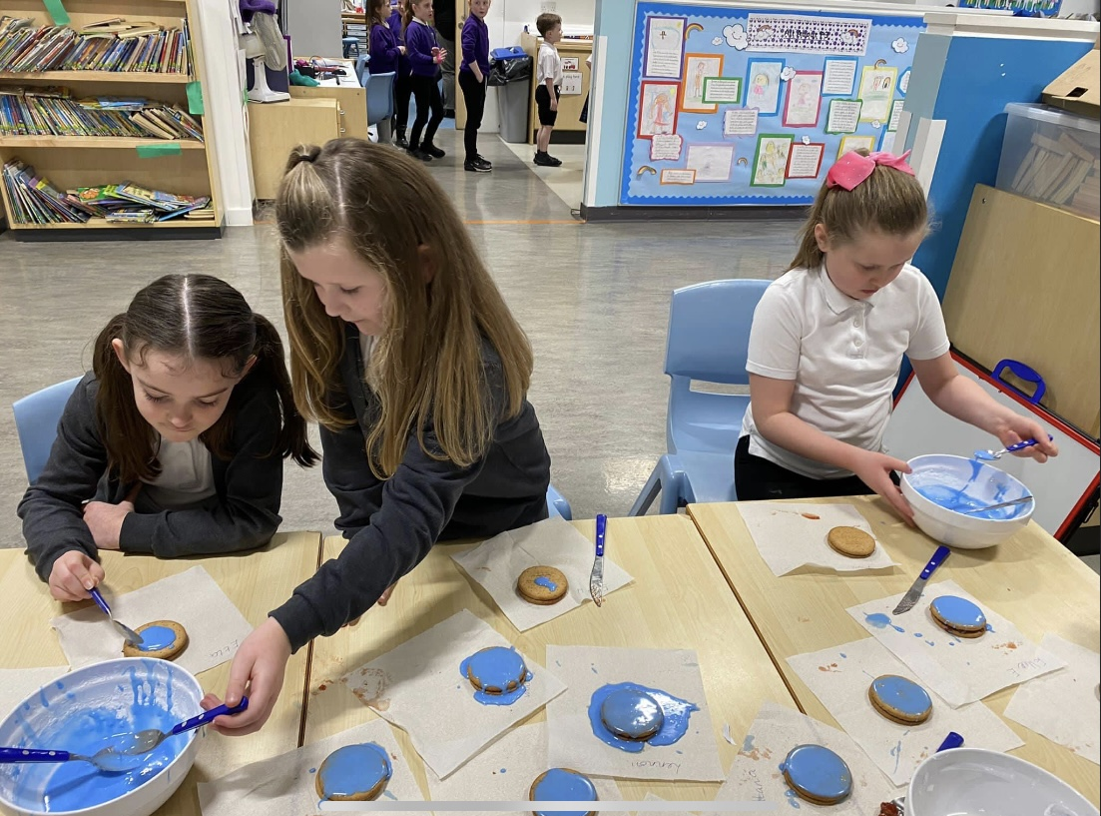

Up-to-date information on current school priorities, achievements and plans for improvement can be found in The School Strategic Plan and Standards & Quality Report. These are located on the school website.

Website http://aileymillprimary.inverclyde.sch.uk
ATTAINMENT and ACHIEVEMENT
Raising attainment in literacy and numeracy is one of our key focuses. Throughout the year, pupils will be assessed at various points, in a variety of ways, including on-line testing, class assessments and teachers’ professional judgement.
Recognising Achievement
Gaining recognition for their achievements and the skills for learning, skills for life and skills for work that are developed through them, benefits all young people.
It can increase their confidence, raise their aspirations, improve their motivation for learning and keep them engaged in education. Many of our pupils are engaged in a range of activities, both in and out of school and have developed skills and capacities not currently recognised. This is celebrated in weekly whole school assemblies and shared on our social media platforms.
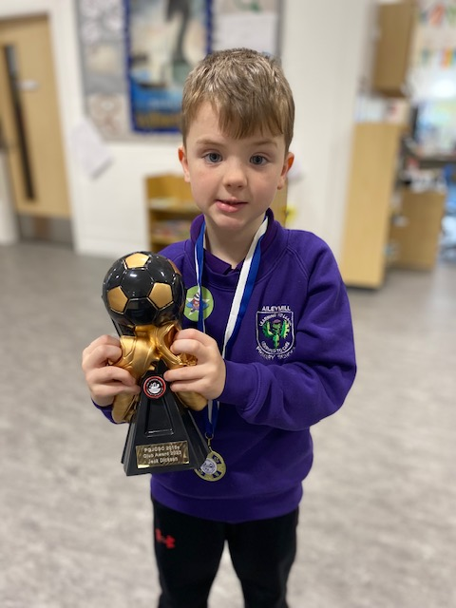
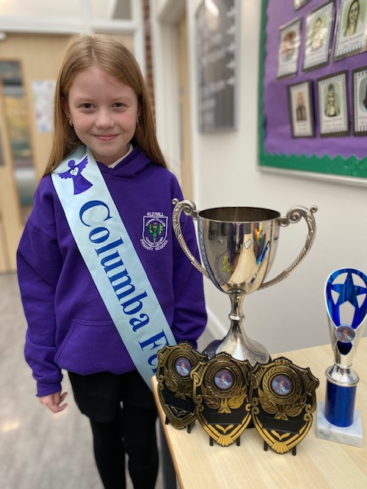

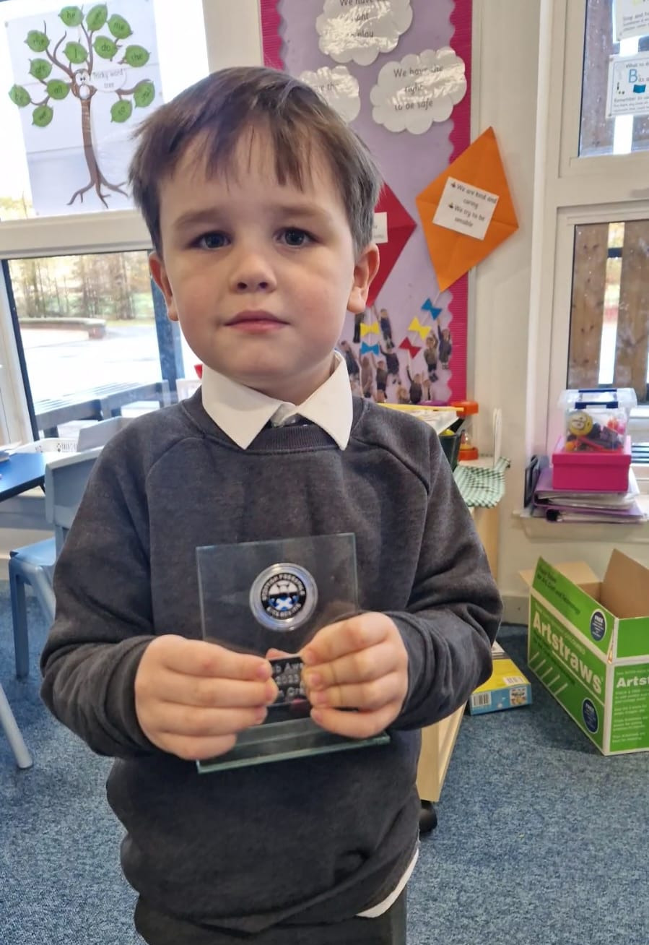
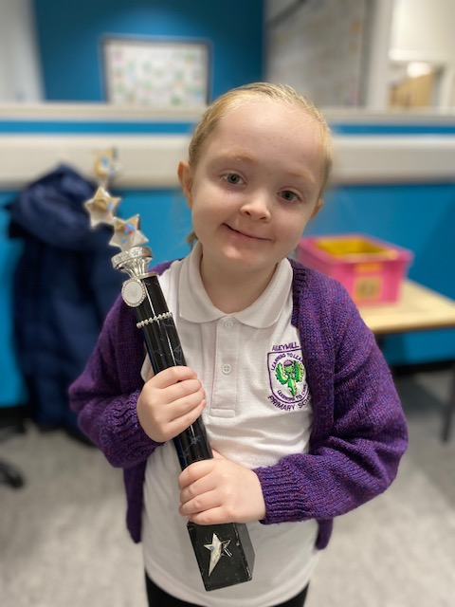

We celebrate in school achievements during our weekly whole school assembly.
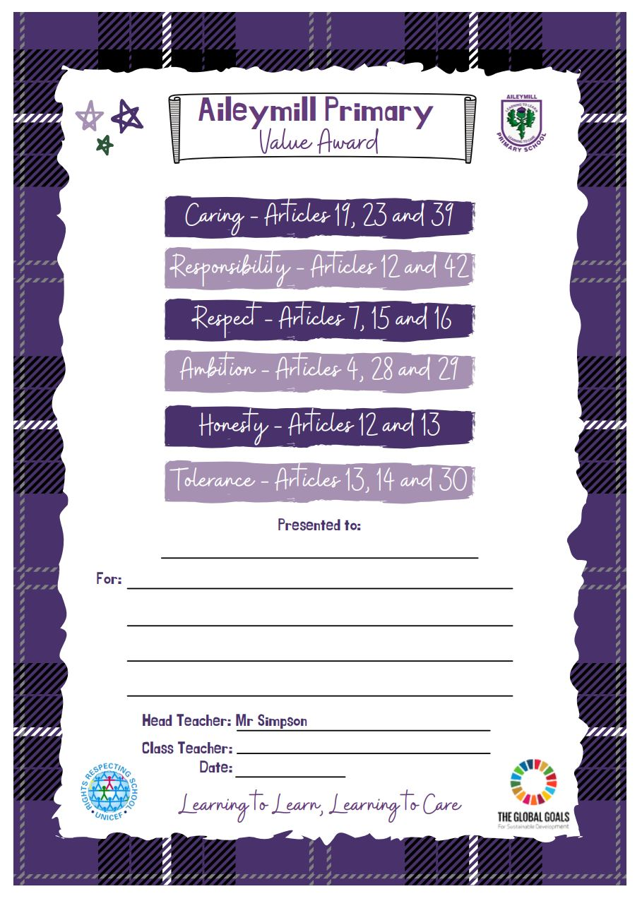

Key Achievements of the school
- The work of the school was recognised through the selection for the Scottish Education Awards of former Head Teacher was one of three finalists in the Lifetime Achievement category award.
- We earned the Gold Rights Respecting Schools Award for fully embedding children’s rights throughout the school, in our policies, practice and ethos.
- We continue to place an importance on establishing a reading culture within the school. This year we gained the Silver Reading Schools Award
- In May, our sports team made up of P6 and P7 pupils won the Inverclyde Inter Schools Heptathlon event.
- Our Care Experienced Young Person Group, the Aileyminis, presented at the International Play Association conference in Glasgow.
- The school nurture champions and our P1 classes worked with story teller and writer Jo Hall to create JoJo Gnomes videos. These were shared nationally.
- Our whole school sponsored dance enabled us to fund a whole school trip to the Pantomime at the Beacon Arts Centre.
- Over the school year, we have enabled a high level of participation at sports events through inclusion at council inter-school Sports Hall Athletics, Rugby, Football, Netball and Relay events.

EXTRA CURRICULAR ACTIVITIES

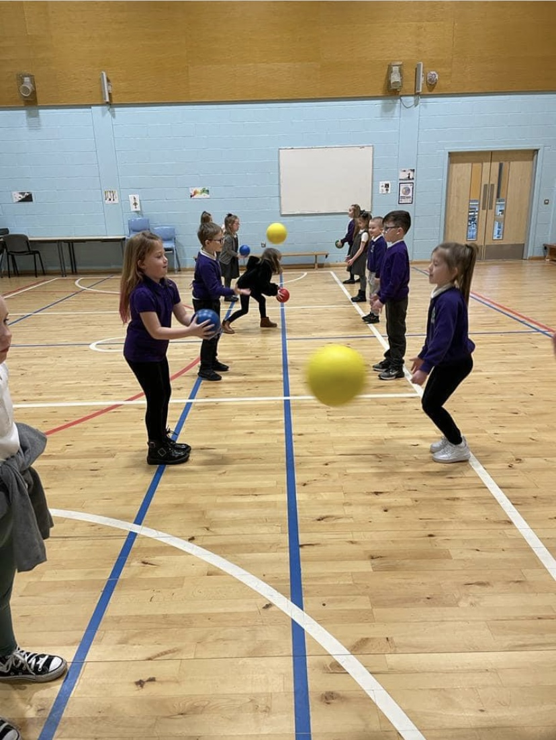
A variety of clubs are offered throughout the school year run by school staff and Active School coaches such as:
- Multi-skills
- Athletics
- Football
- Basketball
- Netball
- Art
- Dance
- Hockey
- Tennis

Pupils are also actively encouraged to participate in local community events and activities e.g.

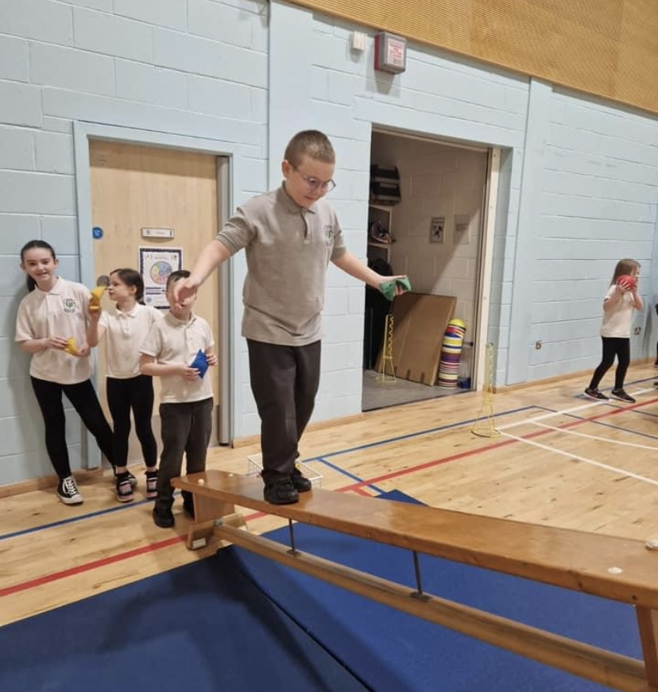
- Inverclyde Music Festival
- Benchball Tournaments
- Sportshall Athletics
- Rugby Festival
- Hockey
- Netball
- Football

HOME – SCHOOL LINKS

A key way of keeping in touch is our Friday Sway. This includes a detailed account of the week to come and any other letters to be distributed. The school Facebook Page will also feature the Friday Sway. All pupils are set weekly targets in Literacy and Numeracy. The targets booklets go home at the end of each week for parents to discuss with their child. Some pupils will be encouraged to use glow blogs and e-portfolios to enhance their learning and to share their learning with those at home.
Parents are always welcome to visit the school to meet with the Headteacher or Depute Headteacher and by appointment to meet with class teachers. At the start of term we have a Meet the Teacher session which allows parents to meet staff and hear what is outlined for the session ahead. Primary 1 Parents are also invited to come and dine with their children during their induction days.

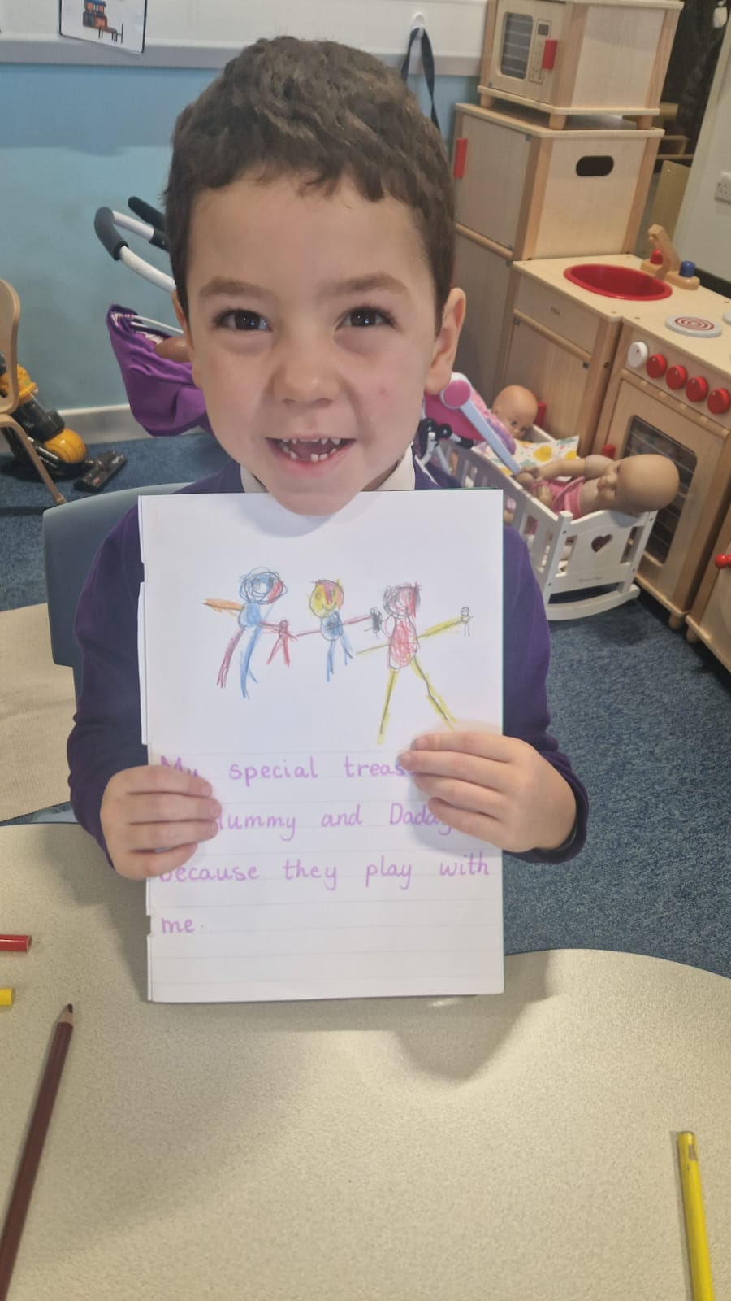

Home Learning
Home Learning activities are designed to involve parents, carers and families in their children’s learning and to give them a clearer understanding of what is happening in the classroom, our focus continues to be on developing the core skill of reading. It is varied in nature, providing opportunities for challenge, personalisation and choice and the practice of basic skills particularly Reading. From P2 onwards, Home Learning may be shared on TEAMS.
Home Learning is issued on Monday and discussed on Friday. It is not a choice activity and should be undertaken by all pupils. While it is appreciated that parents/carers may not be able to participate in all the activities, their encouragement is crucial if the children are to gain maximum impact from the tasks set.

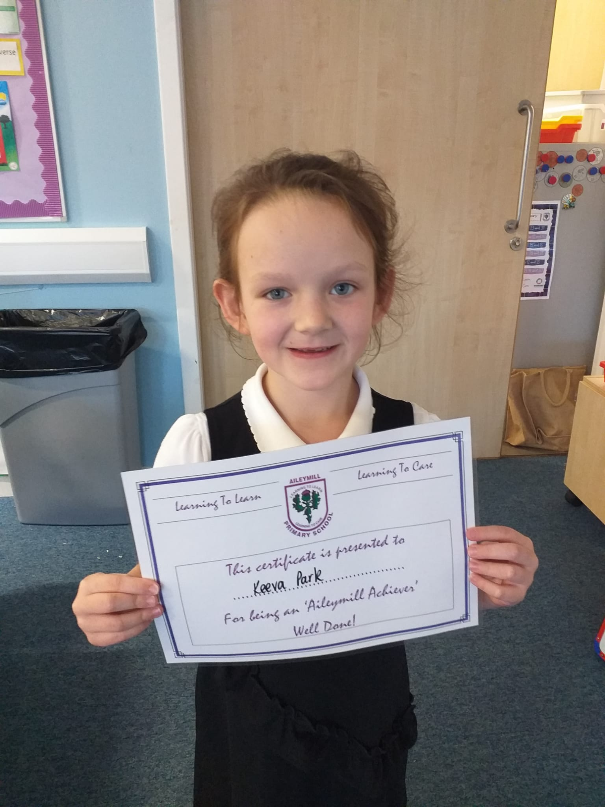

Family Support
Through funding from the Scottish Attainment Challenge, we have access to a Family Support Worker, Caroline Mullan. Caroline is a friendly face, on hand to offer a wealth of support. She can help you work through your concerns in a supportive and non -judgemental way. Caroline is always available on a Friday morning from 9 – 10.30 for a cup of tea and a chat. She can be contacted at any other time through the school.

Family Week Workshops
Each term, we endeavour to organise a variety of class workshops on curriculum, teaching methods and new initiatives. We hope that you will take the opportunity to attend these.
OUR PUPIL VOICE

At Aileymill, we give all our pupils a chance to have an active role in the development of the school. Our new established Pupil Parliament is made up from pupils from primary 6 and 7. These children lead a number of smaller sub committees including, outdoor learning, Fairtrade, road safety, Literacy, Numeracy, eco, 1+2 languages and rights respecting committee. We also have our nurture champions who led on health and wellbeing. They meet regular to discuss important school matters. The main points from these meetings then feed into the larger pupil parliament meetings were final decisions are made and actions taken forward.

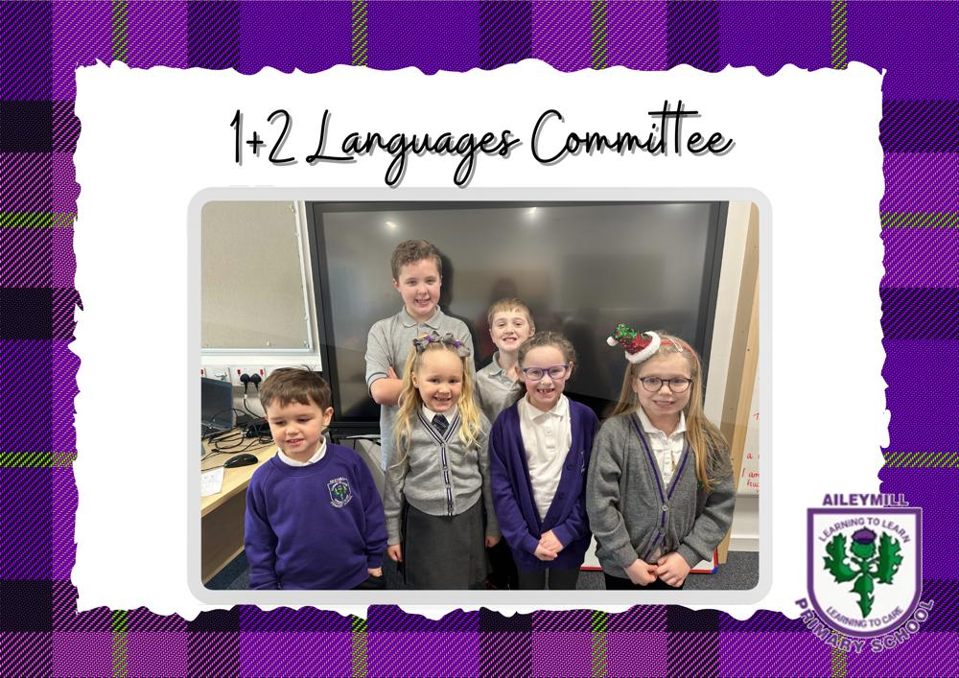

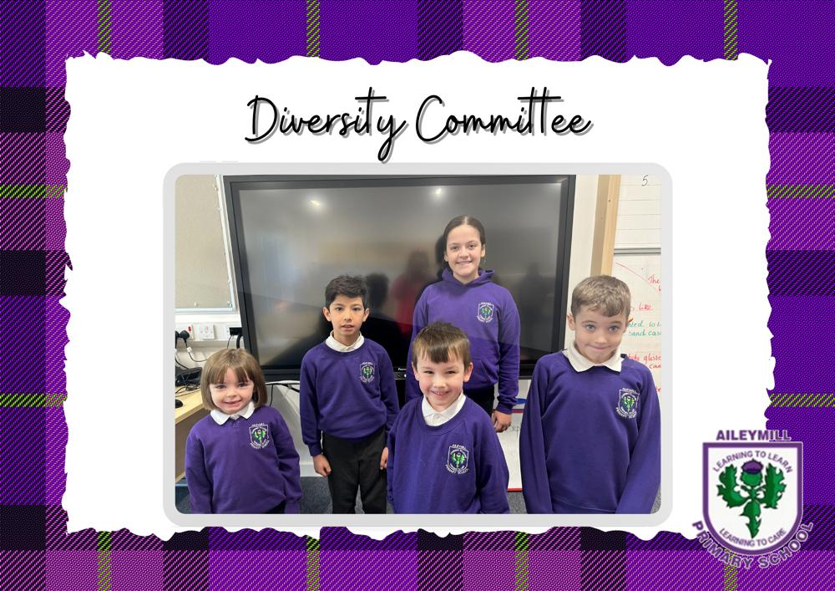

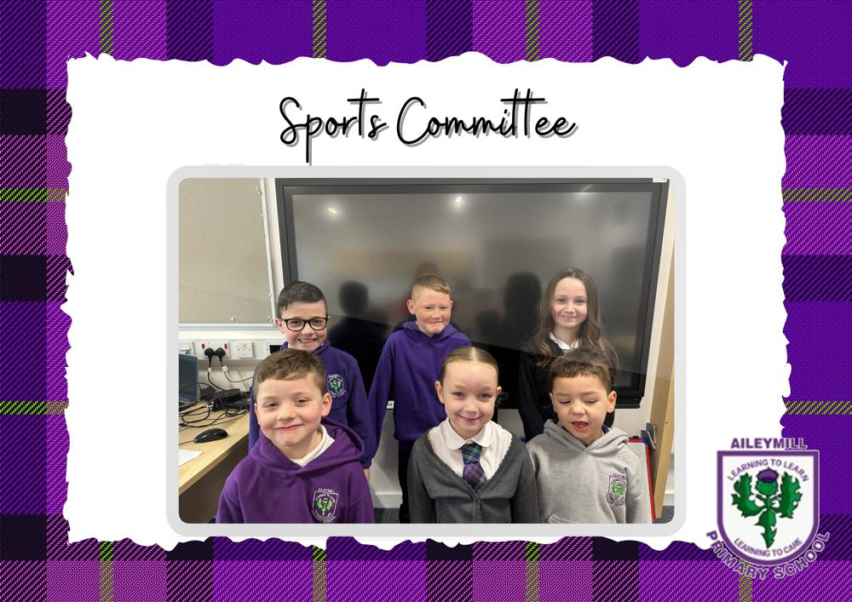
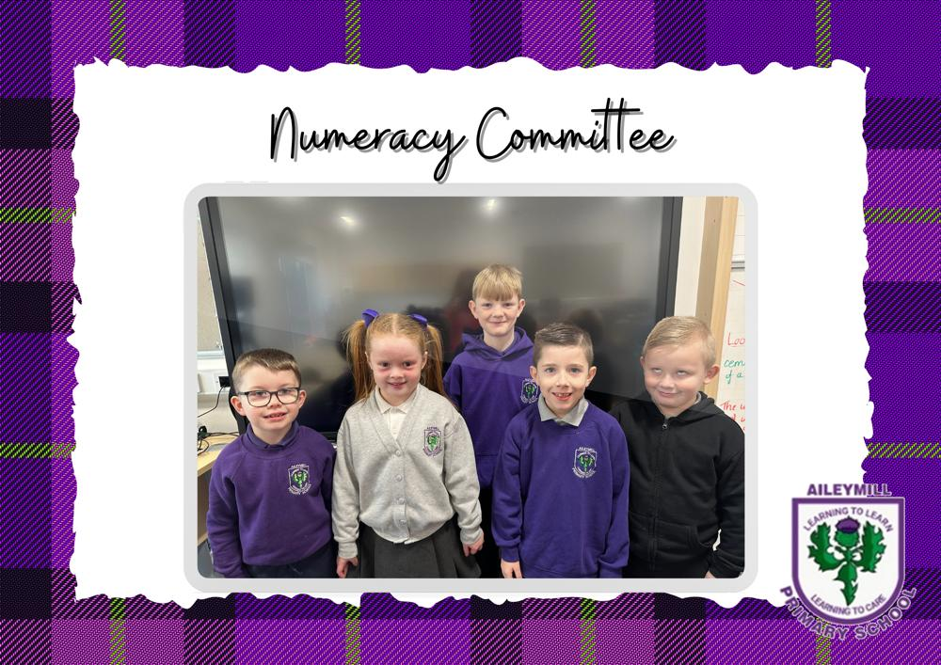

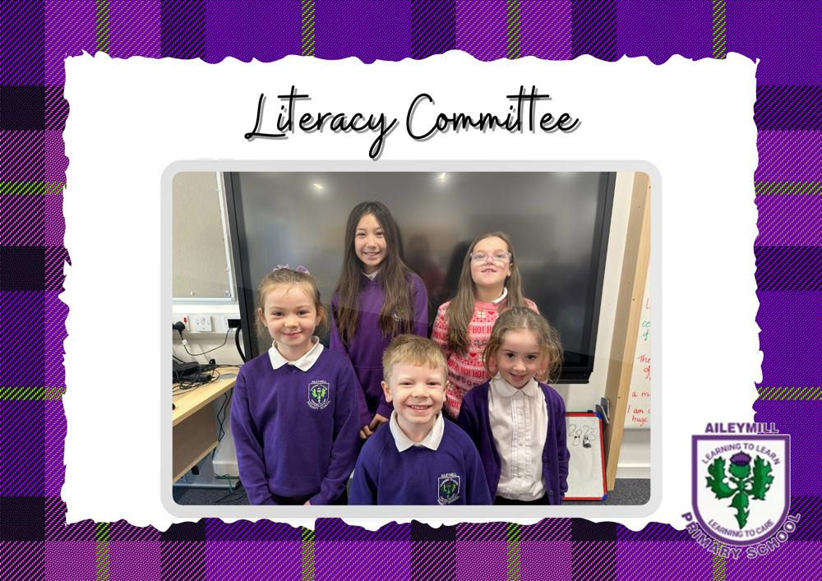

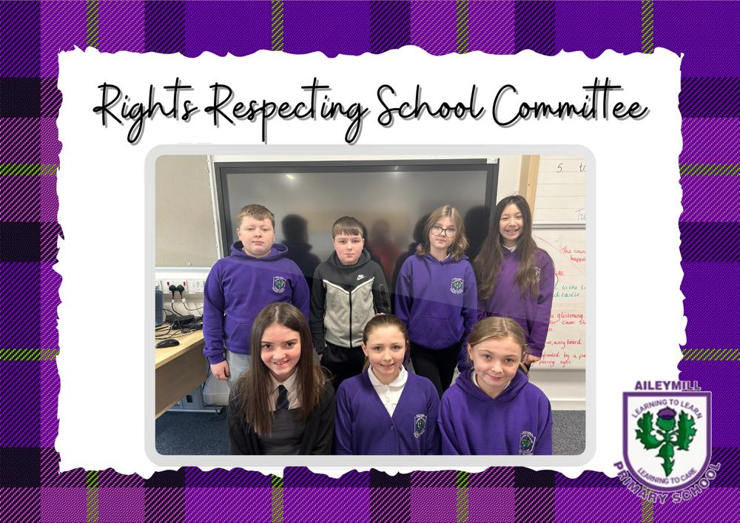

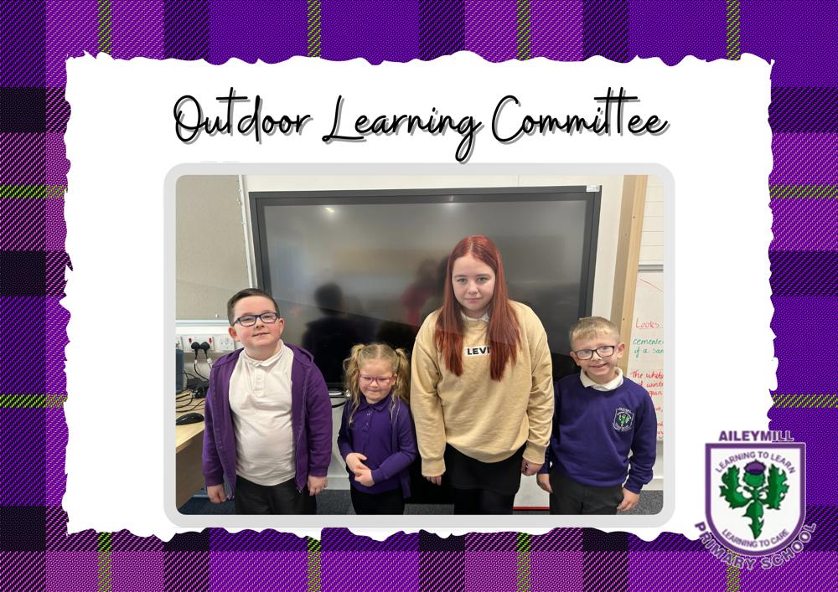

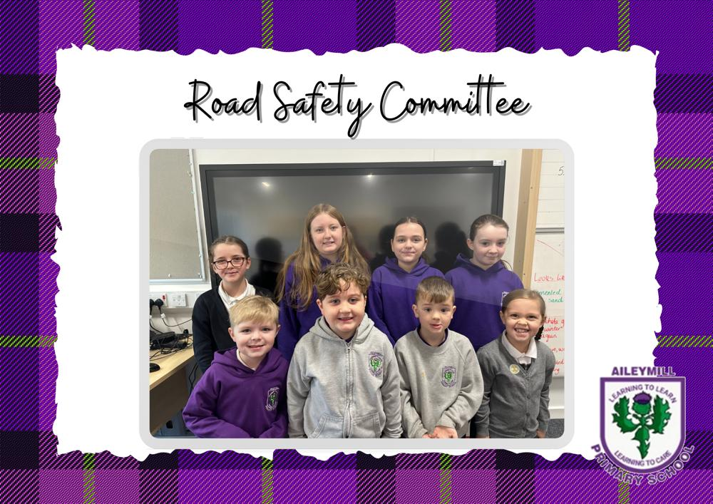

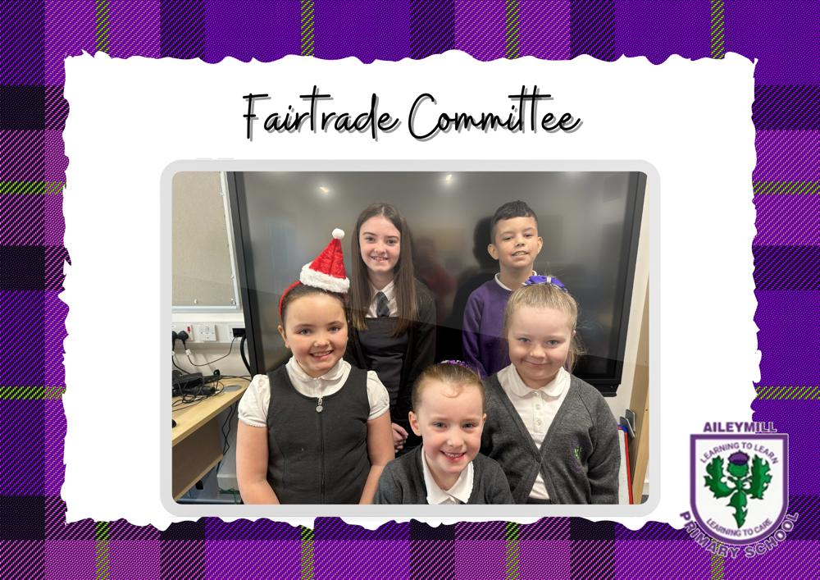

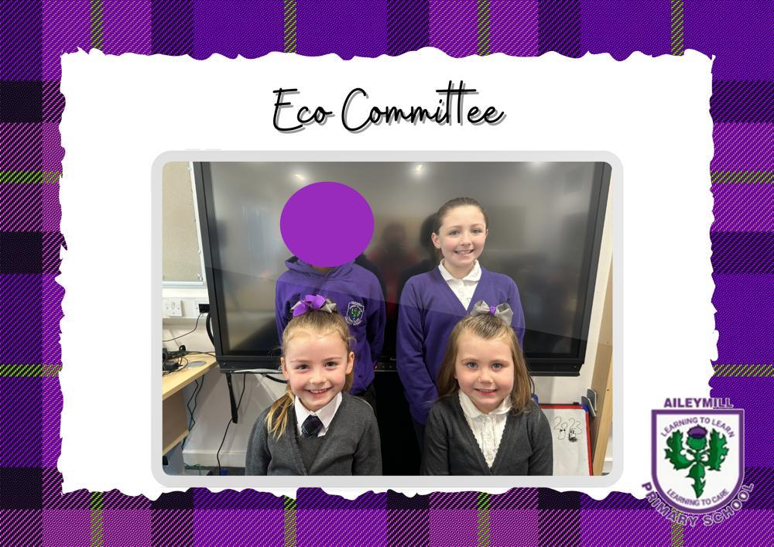

Dyslexia Friendly School
Aileymill Primary School is a dyslexia friendly school. Parents are fully involved in the diagnosis of dyslexia should it be felt that this is appropriate. Once a diagnosis has been made parents are kept up to date with the strategies we use to help pupils access the curriculum.

Eco School Status
Aileymill Primary is an eco-school and we promote eco ideals. Our Eco Group encourages pupils and staff to look after our environment.

Children’s Right Group
Our Children’s Rights Group work very hard to promote the United Nations Convention on the Rights of the Child (UNCRC) to ensure that all children receive their rights. We are working towards Rights Respecting Schools award Level 2.

Fair Trade Group
Pupils and staff work together to raise awareness of issues surrounding fair trade. We gained Fair Trade Status in August 2011 and we try to purchase Fair Trade where possible.
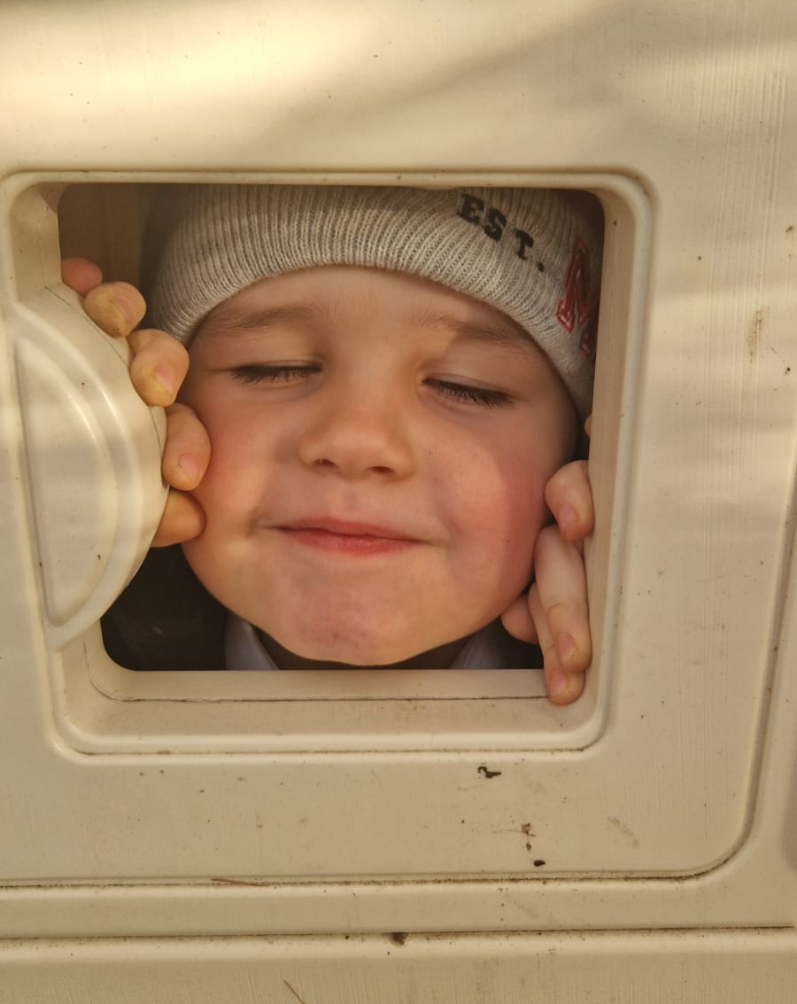
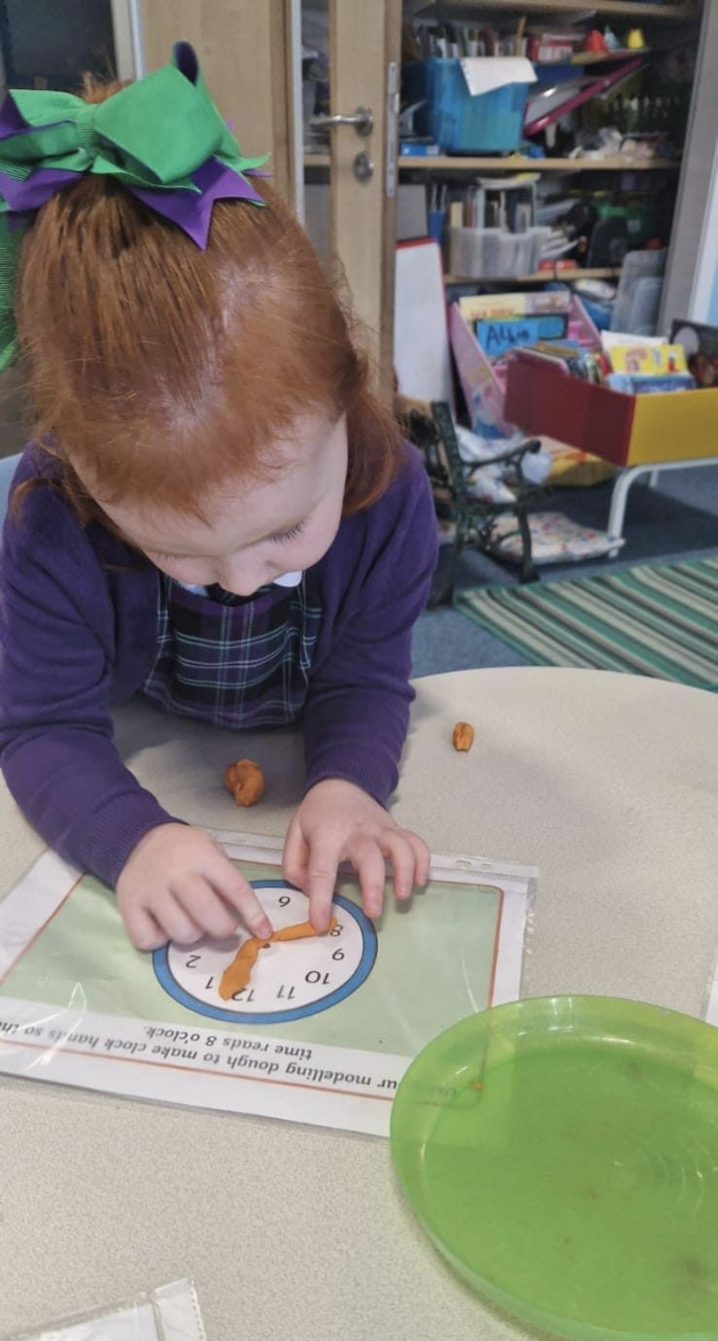
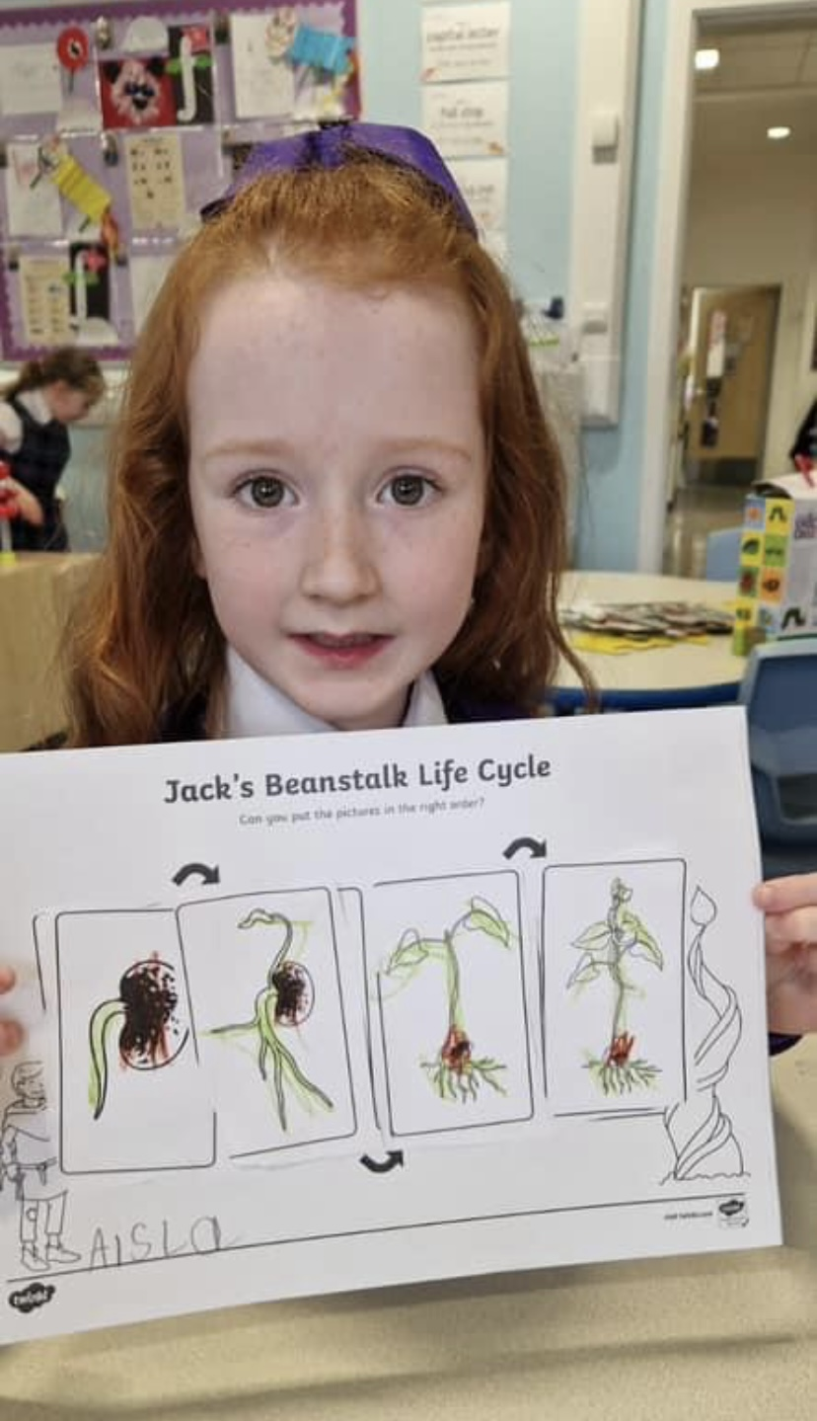

SUPPORT FOR PUPILS

Getting It Right for Every Child underpins everything that we do at Aileymill. Your child’s wellbeing is considered in terms of Safe, Healthy, Achieving, Nurtured, Active, Respected, Responsible and Included.

A child or young person’s needs are identified at the earliest possible stage and can be met in a number of ways, for example by adaptations to the curriculum or learning environment, as well as input from the Support for Learning Teacher and/or our Rainbow Room, and on occasion support from visiting specialists. The appropriateness of the support is determined through a process of assessment, planning and monitoring, working jointly with parents and carers, and is regularly reviewed. When a teacher or parent is concerned about any aspect of their child’s progress, a Wellbeing Assessment may be undertaken.

Learning outcomes for children and young people with additional support needs are set out in a plan and all educational establishments hold regular review meetings with parents and carers to determine needs and the most appropriate supports. Everyone’s views are equally important in order to consider what is currently working and how to determine next steps.

Children and young person’s needs are identified in a number of ways, and the process of assessment is an ongoing, shared process with partnerships with parents and carers at the forefront. On some occasions health service staff or other partner agencies make children known to Education Services. Other additional support needs may be notified to Education Services by parents themselves or identified by one of a range of staff working closely with the child.

Every teacher has a responsibility to support the learning of all pupils in their class. The type of support offered will vary according to the needs of pupils. This includes consideration given to children who have a disability, children with social, emotional and behavioural difficulties, children with learning difficulties of a specific or general nature, children who are exceptionally able, those who demonstrate underachievement relating to gender issues, children whose learning has been interrupted through absence or illness, bilingual children who have English as an additional language, travelling children and those whose family circumstances impact on attendance and learning.

If a parent considers that his or her child has additional support needs and wishes to make enquiries about this, they should contact the head teacher.

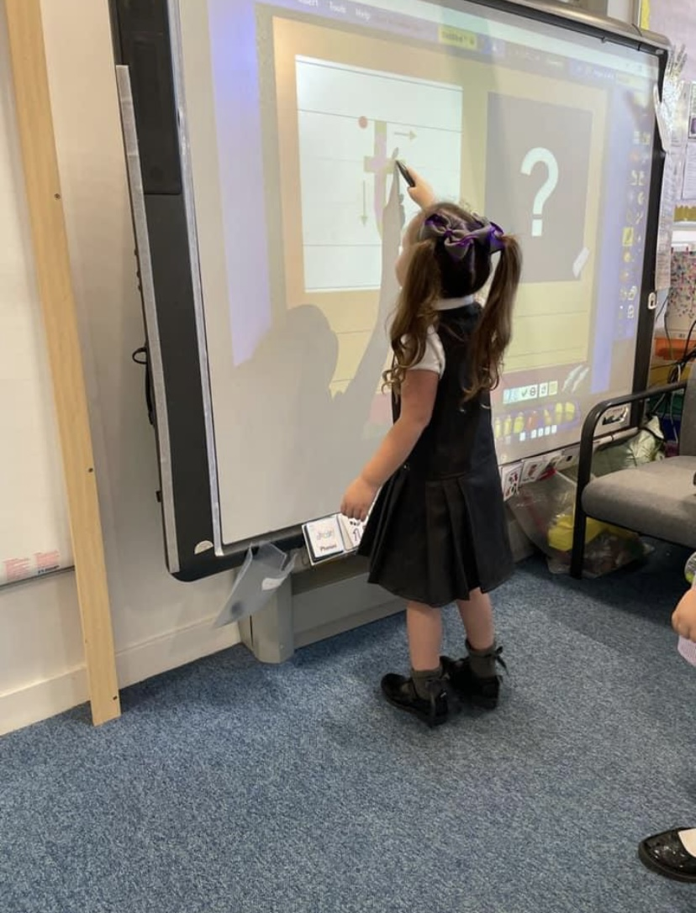

Some children and young people will have additional support needs arising from complex or multiple factors which require a high degree of co-ordination of support from both education and other agencies in order that their needs can be met. In these cases, the school will hold a meeting to decide whether the child or young person meets the criteria for a Co-ordinated Support Plan. The coordinated support plan is a statutory document which ensures regular monitoring and review for those children and young people who have one.

You have the right to ask the education authority to establish whether your child needs a coordinated support plan. Your child can make this request themselves, if they are aged 16 or over. You and your child, if they want to, will attend a meeting with staff at their school. Other professionals from different agencies who may be involved in providing support for your child will also attend. If your child does not want to attend meetings or feels unable to, their views must still be sought and considered.
As with all local authority schools in Scotland, this school operates under the terms of the Additional Support for Learning Act (2009) and its accompanying Code of Practice.
These procedures have been strengthened through the Children and Young People Act (2104).”

Inverclyde’s Mediation Service may be accessed by contacting Michael Roach, Head of Education, or Tony McEwan, Head of Inclusive Education, who may be contacted through Inverclyde Council’s service desk on 01475 717171
Further advice may be available from Enquire, the Scottish advice service for additional support for learning. Operated by Children in Scotland, Enquire offers independent, confidential advice and information on additional support needs.
telephone helpline - 0845 123 2303
email enquiry - info@enquire.org.uk
websites:
- www.enquire.org.uk - for parents,
- www.enquire.org.uk/yp - for children
- www.siaa.org.uk
- www.sclc.org.uk/

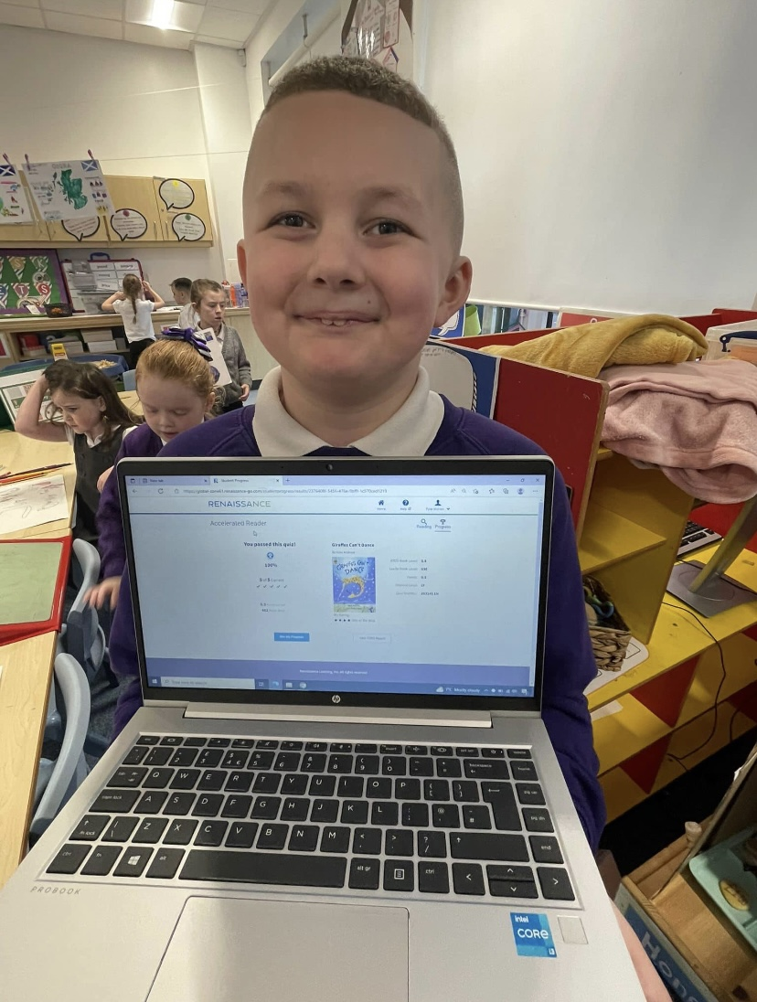

INCLUSION & EQUALITY

Inverclyde Council Education Service aims to:

- Offer education of the highest quality to all young people within a developing culture of inclusion.
- Endorse the principles of inclusion, entitlement and equality of opportunity in the development of best practice.
- Value the diversity of interests, qualities and abilities of every learner.
- Believe that every child and young person is entitled to educational opportunities which enable the achievement of success and further development of the individual’s learning potential within the least restrictive environment.
- Affirm the right of all young people to have access to the highest quality of educational provision which is appropriate to learning needs, is supportive of the young person and is delivered in partnership with young people, parents and the wider community.
- In meeting the needs of all of our pupils we will demonstrate no discrimination on the basis of race, gender, disability, sexual orientation, religion or belief. This encompasses curricular, extra-curricular and classroom activities and is foremost in the attitudes which we develop in our pupils.

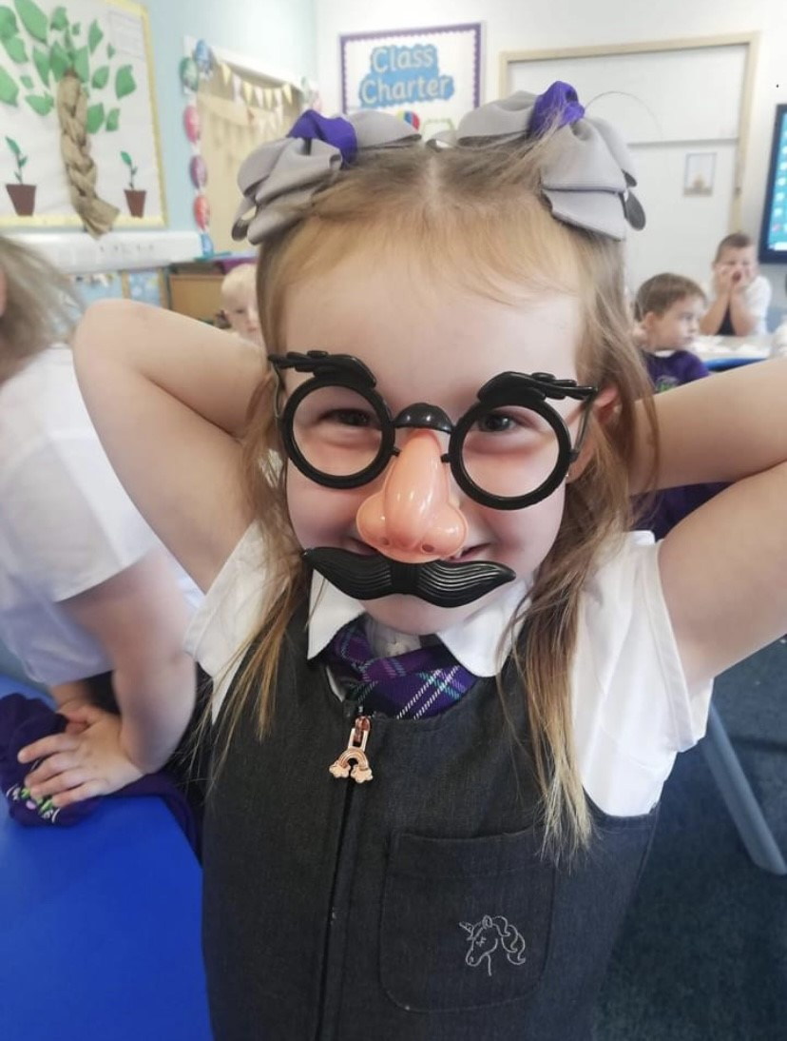

EQUAL OPPORTUNITIES and SOCIAL JUSTICE

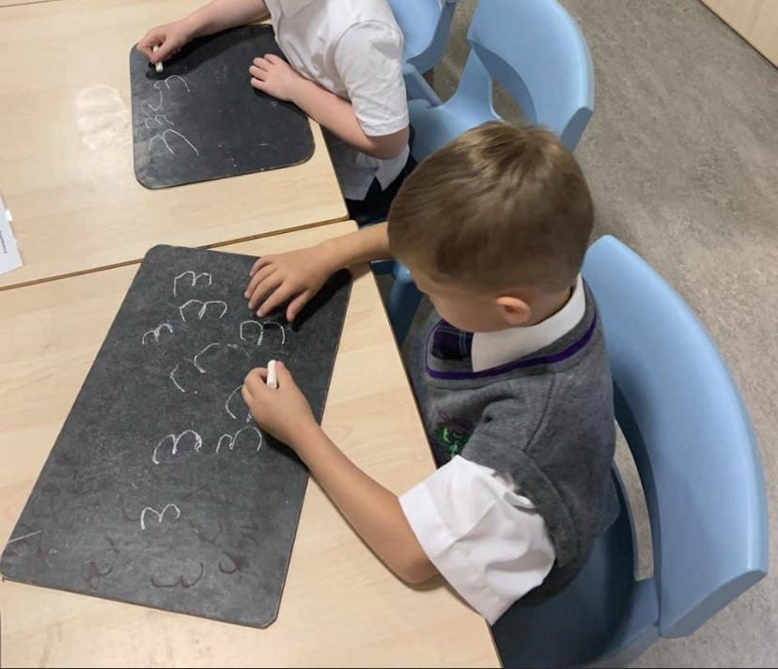

Inverclyde Education Service is committed to ensuring that no children or members of staff or service users receive less favourable treatment on any ground including gender, race, disability, age, sexual orientation, religion or belief. We have a moral, social and legal obligation to mainstream and put equality at the heart of everything we do.

We aim to promote a culture in which equality of opportunity exists for all. We are opposed to all forms of discrimination, direct and indirect, and aim to eliminate all discriminatory practices.

We will ensure that, in all our schools and other establishments, equality permeates the curriculum and underpins all our policies and practices in terms of access to education. We must ensure that all our children achieve their full potential to develop physically, emotionally and academically. Finally, we believe that equality and inclusion should be a given right, where everyone is valued and treated with respect.

RIGHTS RESPECTING SCHOOL

We work in a value based culture where rights are respected and responsibilities accepted. From P1 through to P7 pupils learn about children’s rights as stated in the summary of The United Nations Convention on the Rights of the Child (UNICEF) and as a result realise their responsibility to respect the rights of others. Positive behaviour is reinforced through the language of rights and pupil responsibility to be a rights ‘giver’.

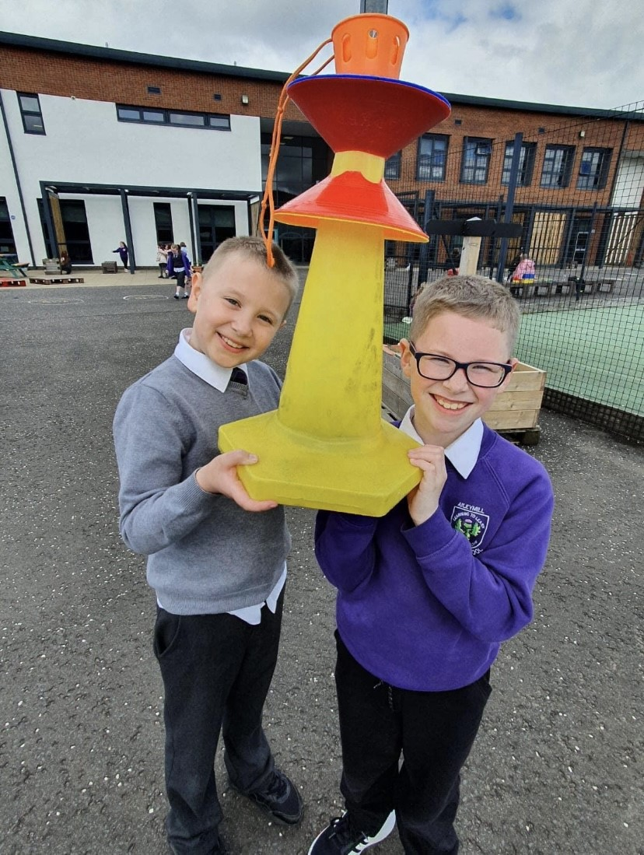
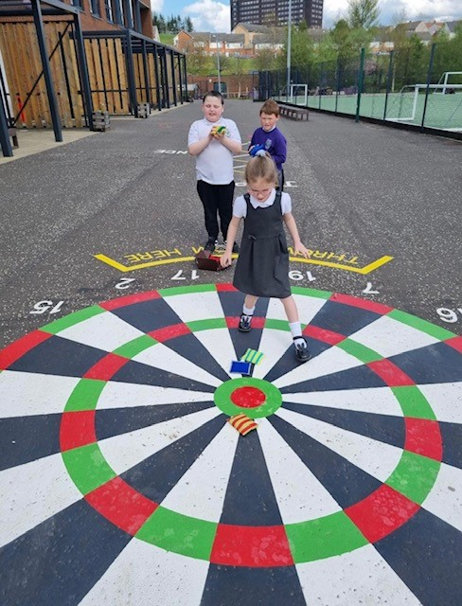

POSITIVE RELATIONSHIPS POLICY

Our school ethos: Learning to Learn, Learning to Care highlights the importance which we place on relationships at Aileymill Primary. We firmly believe that meaningful, respectful relationships, between every person in the school, child and adult alike, underpin our successful school.

Your child will be nurtured and educated in an environment which places huge value on good relationships. Children are explicitly taught, through our PATHS programme, how to relate to each other and to the adults in their lives, how to care for themselves, each other and the environment. Everything we do at Aileymill is underpinned by Inverclyde Council’s policy: Promoting Positive Relationships. A link to this policy can be found on the school website.

The aim of the school is to foster a respect for each other. Parents, staff and pupils have agreed that this is the most important quality. We also actively promote self-discipline, a sense of responsibility, honesty, confidence and a caring attitude. Children respond to kind, courteous, and considerate treatment by adults and will work with concentration and diligence at tasks which are suitable to their abilities.

The aim is to create an atmosphere of order and purposefulness throughout the school; of trust and respect between pupil and teacher.

Where behaviour issues arise, Aileymill aims to resolve these using Restorative Practice, which aims to encourage children to take personal responsibility for their actions and make good any hurt caused in a supportive and non-judgemental atmosphere. We focus on solutions to and disagreements and conflicts.

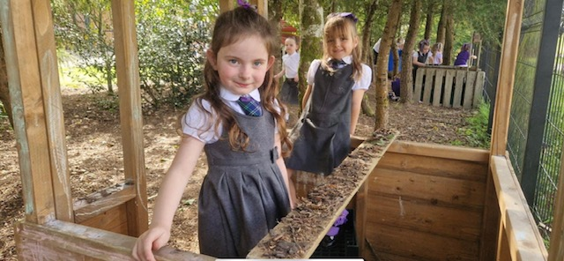

CONCERNS

Aileymill operates an open door policy, there will always be someone available to discuss your concern about any aspect of your child’s education. If your concern is urgent please contact the school by phone on 01475 715647.

We are able to address and resolve most concerns and enquiries quickly.
If you wish to make a formal complaint, issues should be brought up with the school in the first instance and then , if you are not satisfied with the outcome, we will direct you to contact Inverclyde Council Customer Service on 01475 71717

Information about Inverclyde Council’s complaint handling procedure can be found at http://www.inverclyde.gov.uk/council-and-government/complaint Any complaints should be addressed to Mr Simpson either in person or by phone call to the school office.

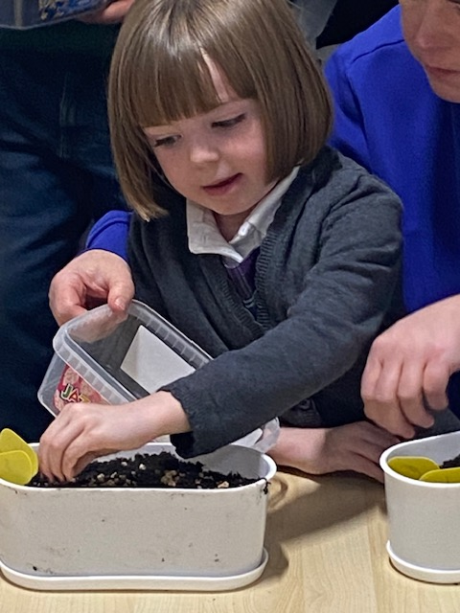
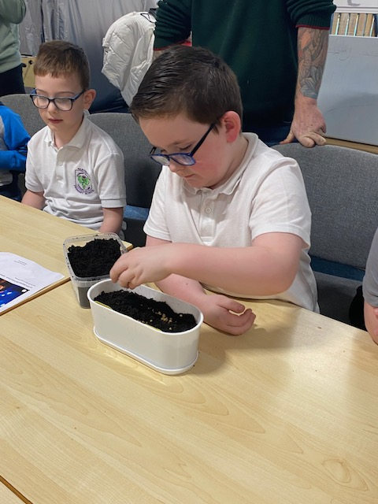

Clothing and Uniform

Given that there is substantial parental and public approval of uniform, schools in Inverclyde are free to encourage the wearing of school uniform. In encouraging the wearing of uniform account is taken in any proposals to prevent any direct or indirect discrimination on the grounds of race or gender. Any proposals will be the subject of widespread consultation with the parents and pupils. Against this background it should be noted that it is the policy of the Education & Lifelong Learning Committee not to insist on pupils wearing uniform or having specialist items of clothing as a prerequisite of their attending and engaging in all of the activities of the curriculum.

There are forms of dress which are unacceptable in school, such as items of clothing which:

- potentially, encourage faction (such as football colours);
- could cause offence (such as anti-religious symbolism or political slogans);
- could cause health and safety difficulties, such as loose fitting clothing, or clothing made from flammable material for example shell suits in practical classes;
- could cause damage to flooring
- carry advertising, particularly for alcohol or tobacco;
- could be used to inflict damage on other pupils or to be used to do so

Or could be used to inflict damage on other pupils or be used by others to do so.

Parents should note that the activities the children may become involved in may be restricted because health and safety requirements state that jewellery of any kind must not be worn where children are undertaking physical activities. This includes jewellery worn as a result of body piercing.

Parents of children receiving one or the following benefits will normally be entitled to
grants for footwear and clothing for their children:
- Income Support;
- Employment and Support Allowance (ESA)
- Income based Jobseekers Allowance (JSA)
- Child Tax Credit, but not Working Tax Credit, ,and where income is less than £16,105 (as assessed by the Inland Revenue)
- An asylum seeker receiving support under Part VI of the Asylum and Immigration Act. 1999
- Universal Credit, where your take home pay does not exceed £915, as shown on your monthly Universal Credit statement
- Any income related element of Employment and Support Allowance
- Parent or carer in receipt of Working Tax Credit with an income below the threshold for receipt of maximum Working Tax Credit (currently income below £11,288)
- An Asylum Seeker, receiving support under Part VI of the Immigration and Asylum Seekers Act 1999

Approval of requests for such grants made by parents in different circumstances is at the discretion of the Corporate Director Education, Communities and Organisational Development.
Information and application forms may be obtained from schools and from
Education Services, Wallace Place, Street, Greenock, PA15 1JB .
The council is concerned at the level of claims being received regarding the loss of pupils’ clothing and/or personal belongings. Parents are asked to assist in this area by ensuring that valuable items and unnecessarily expensive items of clothing are not brought to school.
Parents should note that the authority does not carry insurance to cover the loss of such items and any claims submitted are likely to be met only where the authority can be shown to have been negligent.

At Aileymill Primary, purple sweatshirts and white polo shirts are worn with grey or black trousers or skirts. Tartan skirts and pinafores are available for girls. For formal school wear and special occasions white shirts with our school tie are worn.
Names on jackets are essential. It is also helpful to have names on jumpers, ties and shirts. Please just write on the labels in P.E.

SUPERVISION OF PLAYGROUND

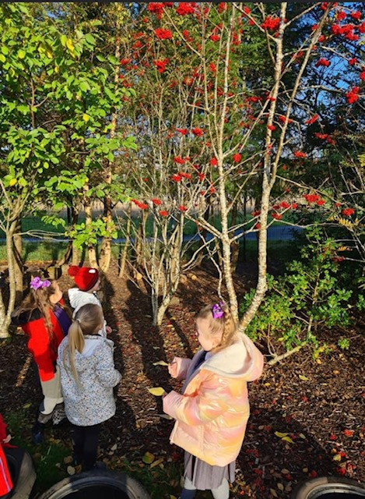
An adult presence is provided in playgrounds at break times in terms of the Schools (Safety and Supervision of Pupils) (Scotland) Regulations, 1990
Our provision of adult supervision significantly exceeds the level required by the act. At times of maximum pupil numbers in the playground we have approximately 12 adult supervision staff. Where possible, a specific Pupil Support Assistants supervise classes that they are very familiar with.

CHILD PROTECTION

Inverclyde Council Education Services has Child Protection Guidelines and Procedures which all schools are required to follow. Education Services work very closely with other agencies namely Strathclyde Police, Social Work Services, NHS Greater Glasgow and Clyde and the Children’s Reporter to support children. Common responsibilities of all staff are to protect children from abuse and exploitation, to respond appropriately when abuse is identified, and to ensure whenever possible that all children are able to exercise their right to be raised in a warm, stimulating and safe environment with the support of staff, their families and carers.

MEDICAL & HEALTH CARE
Routine medical care given to all school children is detailed below.
- The school dentist examines P1 and P7 pupils’ teeth.
- Height, weight and vision screening of all children in P1 and P7
- P7 children are also tested for colour vision.
- Children selected for medicals by school doctor and nurse.
- Children with Additional Supports Needs are reviewed annually by the school doctor.
Parents are always informed in advance if their child is to have an examination by health practitioners.

EMERGENCY CONTACT

If a child is unwell or has had an accident the parent or emergency contact is informed and asked to collect the child. Appropriate first aid will be given in school as soon as possible.
If no one is available the child is kept comfortable in the medical room or in a real emergency taken to Inverclyde Royal Hospital.
It is essential that we have up to date contact numbers so that we can keep in touch.

It is very important that parents inform the school if a child has any particular medical requirements so that arrangements can be put in place.

We make every effort to maintain a full educational service, but on some occasions circumstances arise which lead to disruption.
Schools may be affected by, for example, severe weather, and temporary interruption of transport, power failures or difficulties of fuel supply. In such cases we shall do all we can to let you know about the details of closure or re-opening.
We shall keep you in touch by using letters, texts messages and updates on our school Facebook Page or website.
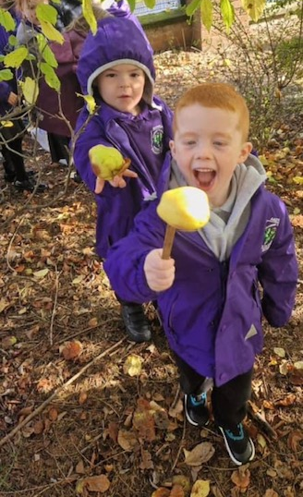

MEDICATION
Parents of children requiring medication during school hours are welcome to come in for this purpose. Should this be impossible we require the parent to complete a Medication Form (available from the school office). Please check with your doctor that the medicine must be given during school hours. Often these times are flexible.

INHALERS
If your child has been prescribed an inhaler, please ensure that he/she has it with him/her at all times. This is especially important when children are leaving the building to go on outings or to take part in sporting events.
From time to time, please ask your child to bring their school inhaler home to allow you to check that it is still working properly.

ALLERGIES/PEANUT FREE ZONE
As some of our pupils are allergic to peanuts and peanut products and could suffer an anaphylactic reaction if exposed to them, we require that children do not bring peanuts/peanut products to school

SCHOOL MEALS
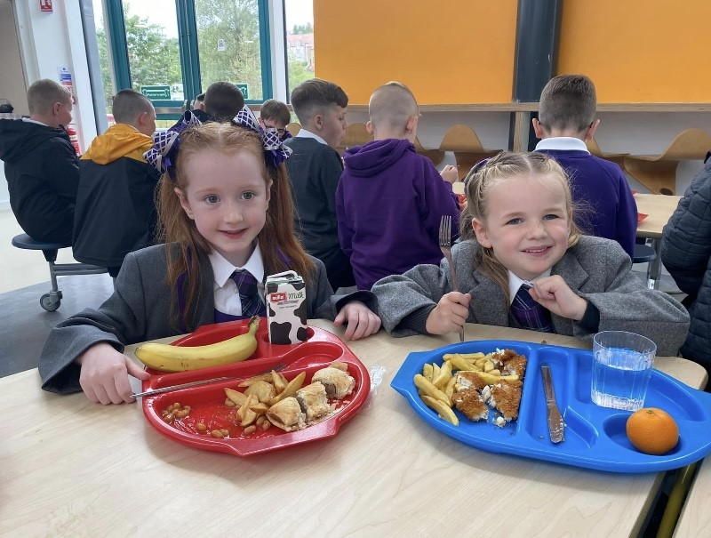
Meals are provided by Inverclyde Council Environmental & Consumer Services, Catering Division, whose mission statement is:
“Our aim is to provide a menu system, freshly prepared with health and cost a priority”.
Meals are available in the dining room each day, all set menus being the same price. Pupils have a copy of the three-week menu rota and can choose from this. Payment for meals is made through Parent Pay. Parents will be given an online account which will enable them to pay for meals whenever they want. All primary 1, 2, 3 and 4 pupils are entitled to a free school meal.
Those children who bring packed lunches have their meals along with the other children who remain at school during the lunch hour.
Every effort is made to encourage children to choose their food sensibly.
Vegetarian dishes are also available.

Parent Pay
Inverclyde Council now operates ParentPay in all primary and secondary school. This is a cashless system which allows parents to pay for schools meals and trips online using a debit or credit card.
For parents/carers who do not wish to set up an online ParentPay account, PayPoint can be used to pay for school lunches/snacks and trips. PayPoint is a system which allows parents to make cash payments at their local shop. The school can issue a barcoded letter or order a PayPoint card to allow you to make payments – the payments will feed through to the school’s Parentpay system within 48 hours.
All trips in primary schools will be required to be paid online, either using ParentPay or PayPoint, unless there are exceptional circumstances.

Playtime
Play pieces may be brought to school. E.g. A biscuit or an apple.
If your child wishes a drink, it should be brought in a clear plastic bottle.
Only unflavoured water may be brought.

Please remember that Aileymill Primary is a peanut free zone

ATTENDANCE

Parents are responsible to contact the school by telephone or through the Parent Portal on the first morning of an absence and provide a reason for the pupil’s absence.

The school will contact the pupil’s family and thereafter other emergency contacts if no explanation is given for the pupil’s absence.

Parents should keep the school informed of any changes of address or telephone numbers, both their own and those of the emergency contacts.

Section 30 of the 1980 Education Act lays a duty on every parent of a child of ‘school age’ to ensure that their child attends school regularly. Attendance must be recorded twice a day, morning and afternoon.
Regulation 7 of The Education (School and Placing Information) (Scotland) Amendment, etc. Regulations 1993 requires each child’s absence from school to be recorded in the school register as authorised: i.e. approved by the authority and unauthorised: i.e. unexplained by the parent (truancy) or temporarily excluded from school.

The Scottish Government has provided guidance on the management of attendance and absence in Scottish schools in its publication included, Engaged and Involved-part1: Attendance in Scottish Schools. Every effort should be made to avoid family holidays during term time as this both disrupts the child’s education and reduces learning time. It has been clarified that family holidays should not be recorded as authorised absence, except in exceptional domestic circumstances, where a family needs time together to recover from distress, or where a parent’s employment is of a nature where school-holiday leave cannot be accommodated (e.g. armed services or emergency services). It is for local authorities and schools to judge where these circumstances apply and authorise absence, accordingly.

The categorisation of most term time holidays as unauthorised absence has been a contentious issue for some families, many of whom are concerned at the higher cost of holidays during school holiday periods. The Scottish Government has no control over the pricing decisions of holiday companies or flight operators. Our main focus is to encourage parents and pupils to recognise the value of learning and the pitfalls of disrupting learning for the pupil, the rest of the class and the teacher.
Clearly where an absence occurs with no explanation from the parent, the absence is unauthorised.

Procedures to improve attendance
Where non-attendance is a factor affecting a child’s learning, support will be initiated through incremental steps when it is established that a pupil’s absence from school is without good reason.
Parents/Carers are Informed of Attendance Record
Where attendance is a cause for concern and falls below 90% within six weeks, or earlier if appropriate, parents/carers will be contacted and given clear information about the child’s attendance record.
The situation will be fully discussed with the parent/carer and their co-operation sought to ensure that the problem is resolved.
Subsequent absences will be monitored. Where a pattern of absence warrants further action, Head Teachers, or their representative, will arrange for the matter to be investigated.
Step 2 - Maximising attendance meeting If there is no sustained improvement in attendance within four weeks or no improvement at all within two weeks, the parent/carer will be invited to attend a maximising attendance meeting to be held within the school. This meeting will normally involve a member of the senior management team and other staff as appropriate. At this meeting attempts should be made to establish the root cause of the problem.
Where it emerges that non-attendance may be due to additional support needs arising from the learning environment, family circumstances, disability or health needs or social and emotional factors, further advice will be sought.

Attendance Figures

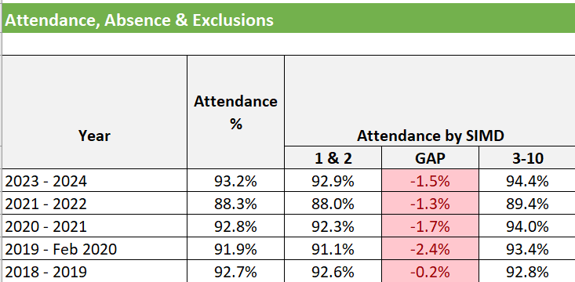

PARENT FORUM AND PARENT COUNCIL

All Parents are members of the Parent Forum. Scottish Schools (Parental Involvement) Act 2006 led to the establishment of Parent Councils in primary, secondary and special schools. The Act recognises the vital role that parents play in the supporting their children’s learning. It places a duty on authorities to promote the involvement of parents in children’s education and the wider life of the school. It aims to help parents to be:-

- Involved with their child’s education and learning
- Welcomed as an active participant in the life of the school
- Encouraged to express their views on school education generally

Aileymill Primary has an active Parent Partnership.
The constitution and minutes of the Parent Council are available in the Parents’ Room and the Parents’ notice board at the front entrance of the school. The Parent Council, as a statutory body, has the right to information and advice on matters which affect children’s education.

Parents who are involved on a regular basis in schools should undertake an enhanced disclosure through Disclosure Scotland.

Aileymill Primary has decided to call our council Parent Partnership or APP for short.
Chair of our Parent Partnership is Frank Smith.

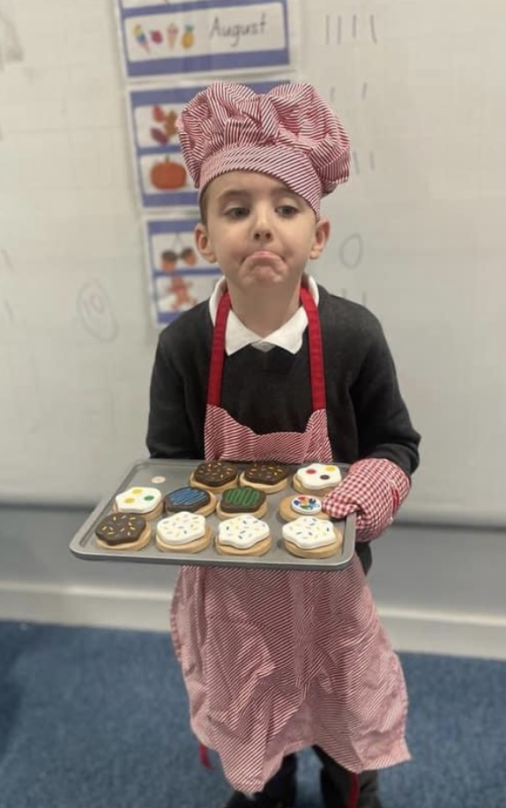
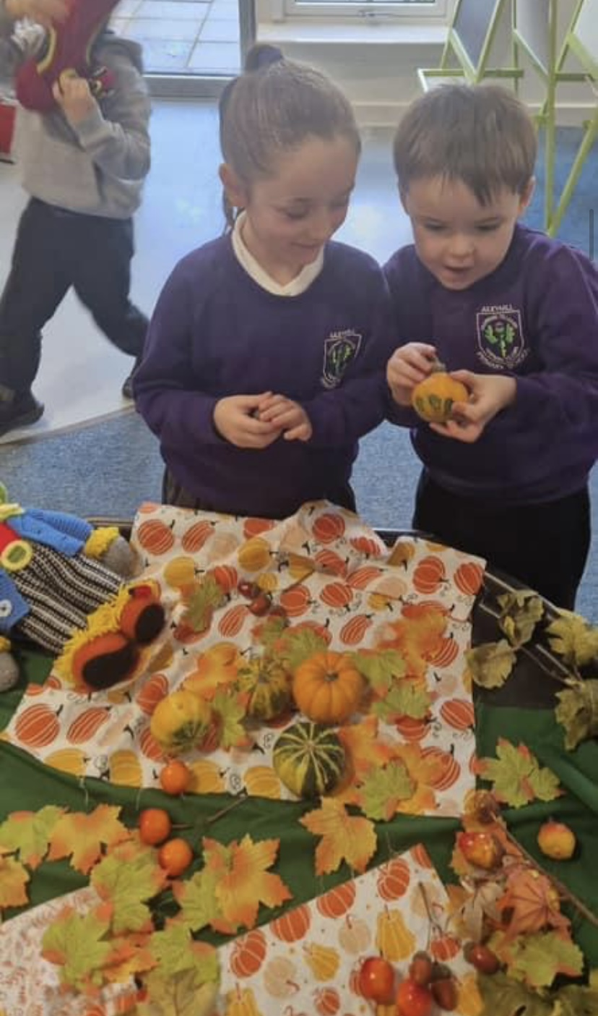

SCHOOL & COMMUNITY LINKS
Aileymill Primary and Nursery is a school at the heart of its community working closely with other establishments namely, St Andrews Primary, Larkfield Children’s Centre and Inverclyde Academy.

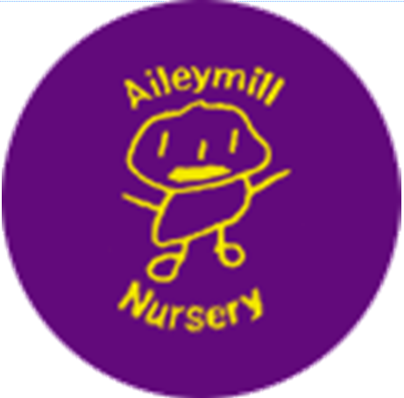

NURSERY CLASS

We provide places for 72 children aged between 3 and 5 years of age all children attend 5 days 8.45am-2.45pm

The nursery is part of Aileymill Primary but has its own entrance and every facility to meet the needs of our young learners.

We work hard to promote effective learning. Children are encouraged to develop a positive attitude to learning, making choices and gaining the confidence to tackle challenges. We look forward to getting to know you and hope you will feel welcome and become involved in nursery life.

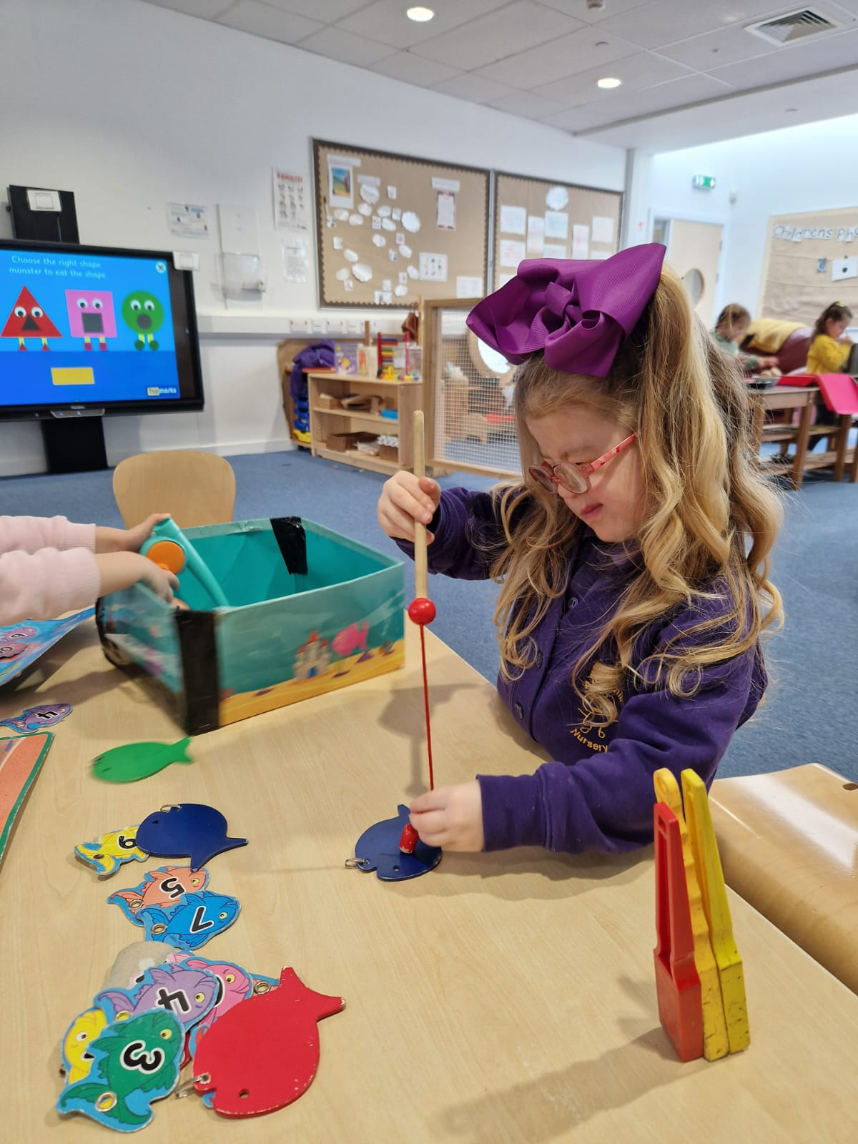

Opening hours and holidays

Hours of opening: Monday –Friday 8.45am -2.45pm

Wraparound Childcare

Inverclyde Council continues to develop quality, affordable, accessible universal childcare. The Council’s strategy is within the Children’s Services Plan, with developments being taken forward by Education & Social Care. In accordance with the Scottish Executive’s policy, Inverclyde Council’s plans focus on meeting the childcare needs of parents in work, training or education and of those who seek to return to work through training or education.
All 3 & 4 year old children are entitled to a nursery education place from the month after their third birthday.
Wraparound childcare is designed specifically to support parents in work, training and/or education. If a parent’s circumstances require additional hours and where the establishment can accommodate such a request a charge is levied. This charge will rise annually in line with the inflationary amount set by the Head of Finance.
If you require further information on this service please speak to the Depute Head.
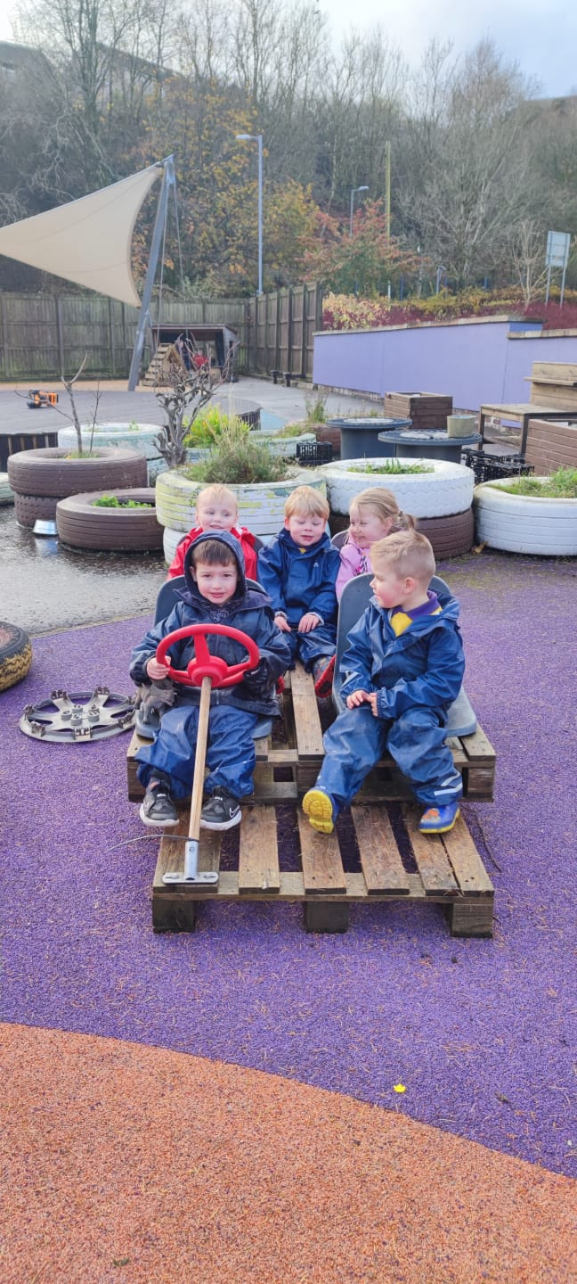

Admissions policy
All children are allocated a nursery place in line with Inverclyde Council’s Early Years Admission Policy.
Enrolment procedures
When your child has been allocated a place, you will be contacted and asked to come along to the nursery for a visit. When you visit, you will be asked to complete enrolment forms and your child’s individual plan.
This gives us time to get to know your child and for your child to become familiar with the nursery and their key worker. If you are a working parent we will be happy for the child’s carer to accompany him/her on this visit. At this time you will be asked to fill out a child profile – a picture of your child’s likes and dislikes, the important people and events in his/her life.

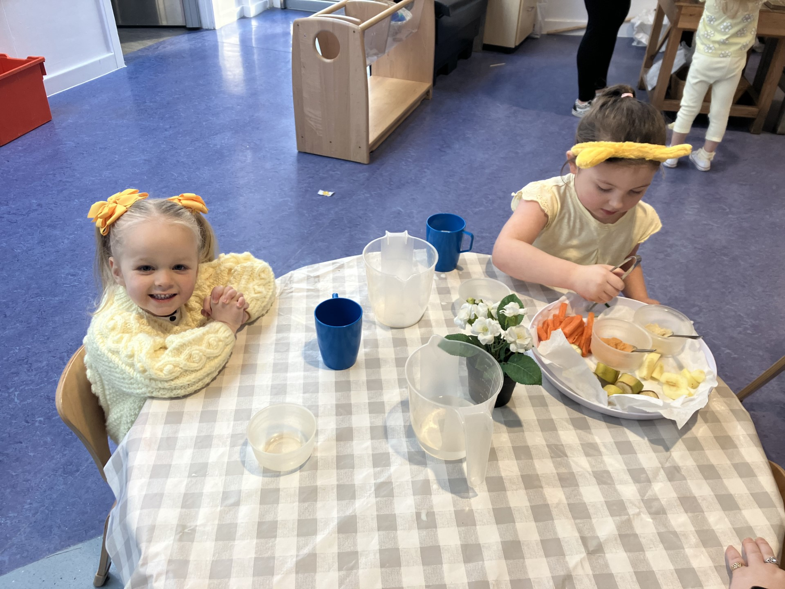

Nursery fund
Children are offered a snack every day at nursery with the emphasis being on Healthy Eating. The children have a choice of milk or water to drink. A selection of fruit and raw vegetables will be available.
A voluntary contribution of £1 a week per family helps with snack, special events and small items of equipment.

Safety
In the interest of safety we ask that you inform us in advance if your child is to be collected by someone who is not known to the nursery staff. Please note that your child must be collected by a responsible adult i.e. 16 years of age or older.

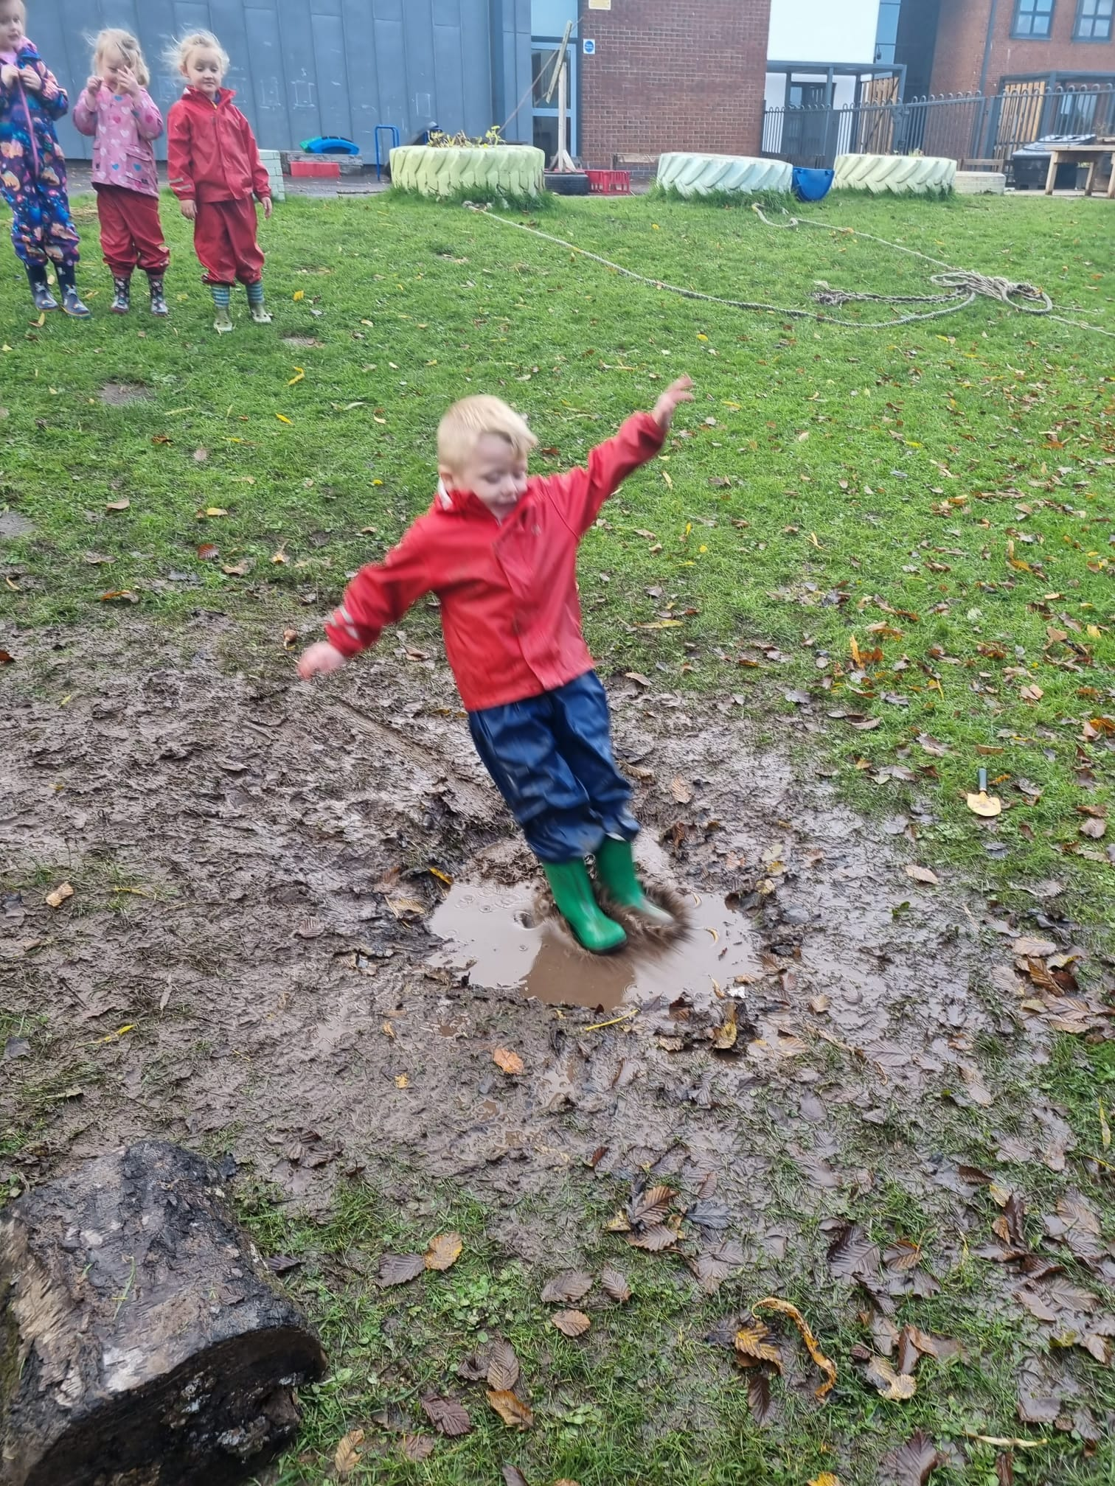

Outings
Children, staff and parents all enjoy outings, and they are a valuable part of the children’s learning. When enrolling your child, you will be asked to give permission for local outings e.g. for walks to the park or local shops. When outings are planned out with the local area, you will be asked to fill in a separate form stipulating when your child is leaving nursery, where he/she is going and when your child is expected to return. Children cannot be taken on these planned trips without this consent form being signed by the parent or carer.
As the ratio of children to adults is higher for these outings you may be asked to come along as a parent helper.

Clothing
Sweatshirts and polo shirts, with the nursery logo embroidered on them can be purchased from Smiths or Dazzles Dance Studio in Greenock. Children often take part in messy activities, so it is wise not to dress them in their best clothes! We ask that the children have soft shoes or to change into when at nursery for safety and comfort. All clothing should be marked with your child’s name. Inverclyde Council’s Policy is that no jewellery should be worn by children when attending educational establishments. Children will not be able to take part in physical activities indoors or outdoors if wearing jewellery.

The council is concerned at the levels of claims being received regarding the loss of children’s clothing and/or personal belongings. Parents are asked to assist in this matter by ensuring that valuable items and unnecessarily expensive items of clothing are not brought to the establishment. Parents should note that the authority does not carry insurance to cover the loss of such items and any claims submitted are likely to be met only where the authority can be shown to have been negligent.

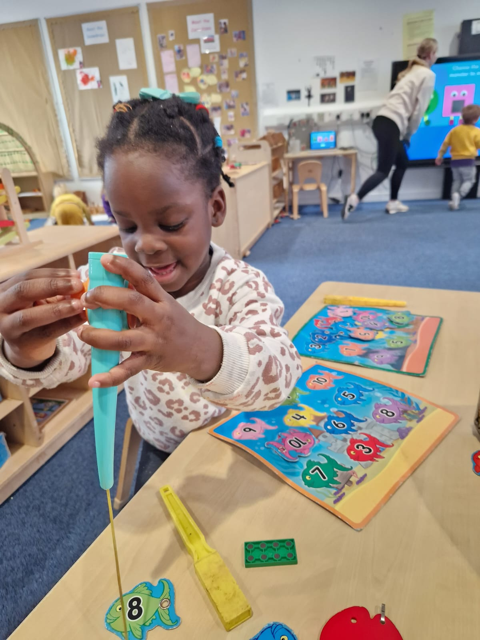

Birthday Celebrations
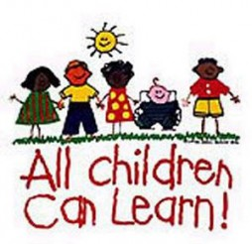
On the day of your child’s birthday, the nursery will celebrate in our special way. This celebration will be at group time, where the children in his/her group will share a small birthday cake (which we supply so every child’s birthday celebration is the same) and sing Happy Birthday. This provides an opportunity for the child to share their excitement, news and birthday plans with their friends.

Children’s learning
Young children learn in a variety of ways. We provide opportunities for children to explore, observe, listen and talk, respond, think and experiment. Play is an

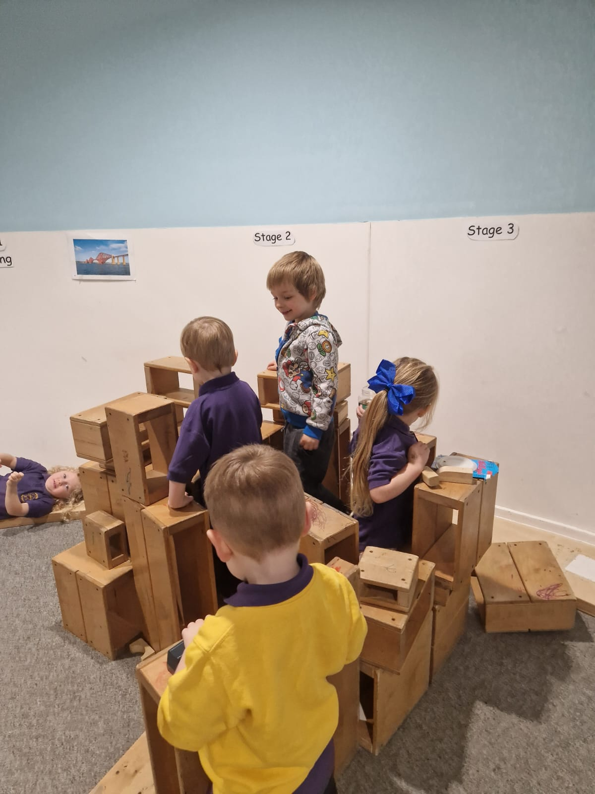

Important way of developing these skills. Play is the way in which young children make sense of the world. It allows them to express ideas and feelings in many different ways, to act out and come to terms with their previous experiences, and to experiment with new ideas without fear of failure.
We encourage the children to plan their own learning, offering open ended resources which allows children to be creative, imaginative and develop problem solving skills.
There is an ethos of praise and encouragement and we celebrate all children’s achievements.

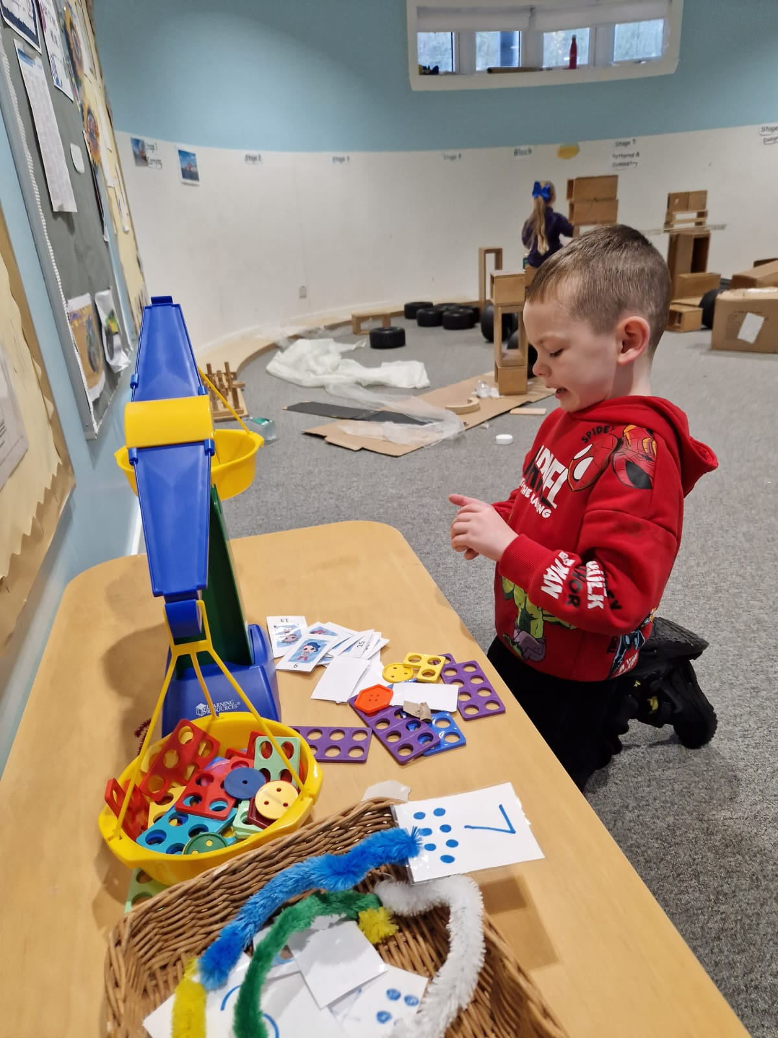

Assessment
Assessment is a continuous process. Staff members observe the children at play, socialising and working with adults and other children. This allows us to assess the child’s development and plan for the “next stage”.
The children also have a part to play in their assessment - we encourage them to discuss the skills they are developing and measure their success.

Supporting children
If a staff member feels a child is in need of help in order to achieve his/her full potential, this will be discussed with all staff and with parents. Strategies would be put in place to support the child. Staff will monitor the progress regularly and continually adapt the programme of activities to meet the needs of the child.
Some children may need more support to achieve their potential, we have a wide network of specialist agencies including Psychological Services, Speech and Language Therapy and Inverclyde Communication and Outreach Services (ICOS). Parents/carers will be consulted before any agencies are involved with their child.

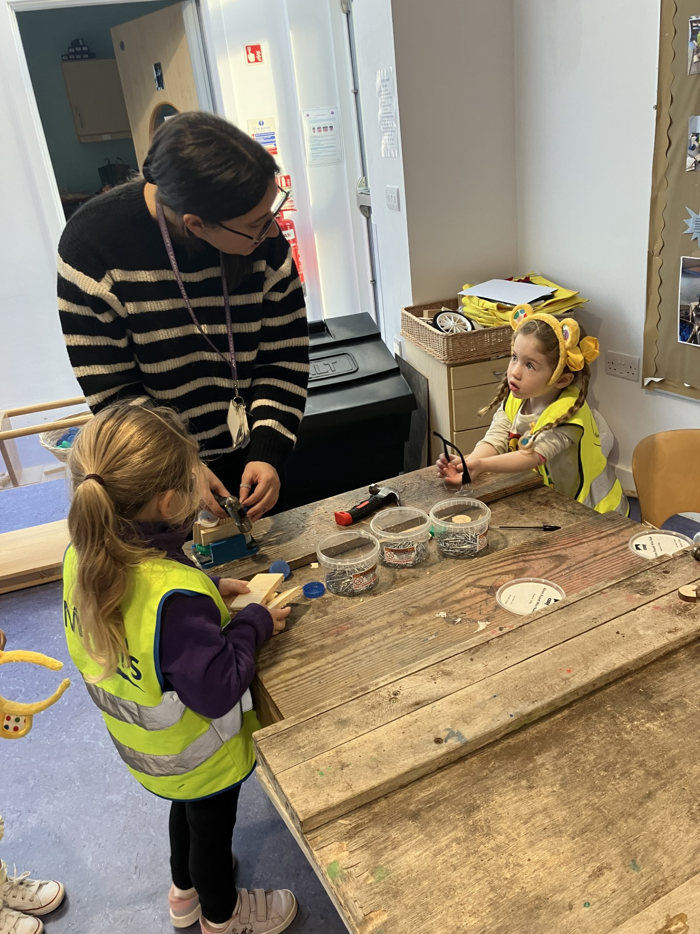

Reporting to parents
Our “open door” policy gives parents/carers and staff the chance to keep each other up to date with the child’s learning at home and in the nursery. You will receive a monthly newsletter keeping you up to date with events in the nursery.
There will be opportunities during the year to discuss your child’s progress and update their Personal Plan. Each child has their own Learning Journal you will be given your own personal link, which can be accessed by parents at home, where you can comment on your child’s learning and upload any special events that can be discussed with the keyworker. Each child will be given their own personal Scrapbook, which will be a link from home. The children can add to this book both at home and in nursery.
A report of your child’s progress during their time at nursery is passed onto the P1 Teacher. This report is discussed with you beforehand.

Parents and friends group
Our parents and friends group meet once a term. They are consulted on how best to spend our budget, as well as our nursery funds. They also help us to make decisions about outings and policy development etc.
Our Parents and Friends group support all aspects of nursery life. If you would like to be part of this group please give your name to Kay or Suzanne

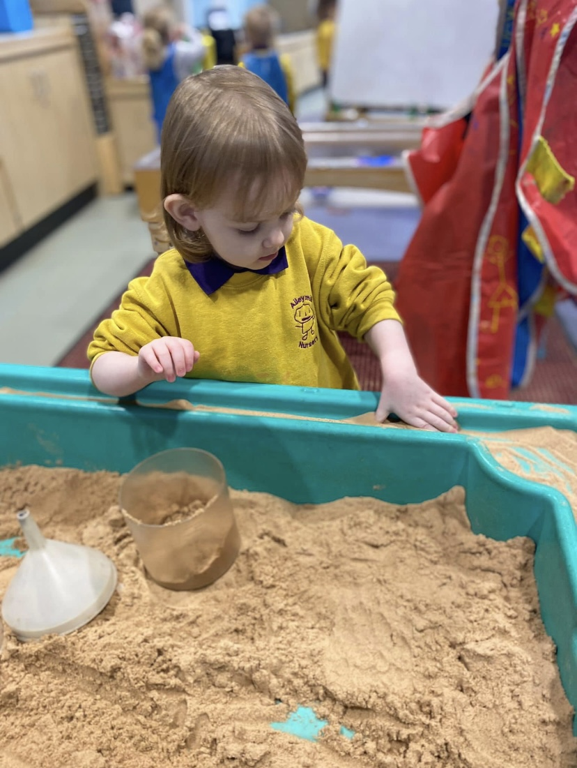

Medical and health
It is important that staff members are informed of any medical condition which requires treatment, or any circumstances which would affect the child’s wellbeing or progress. Please let us know about any allergies your child may have.
Whilst staff are not required to administer any medicines or treatment as part of their official duties, nevertheless, in the interest of the child, our staff team are willing to administer prescribed medicines.
Only prescribed medicines can be administered by staff to children. Please ask a member of staff for the appropriate form, which should be completed at the time of medicine being passed to nursery staff. All prescribed medicines, which should have the dispensing label with the child’s name and instructions, will be kept in the medical cupboard. Medicines should not be in the child’s possession or placed with the child’s belongings at any time.
If your child becomes ill while at nursery a member of staff will firstly try to contact you at home, if unsuccessful we will try one of the emergency numbers on your enrolment form.

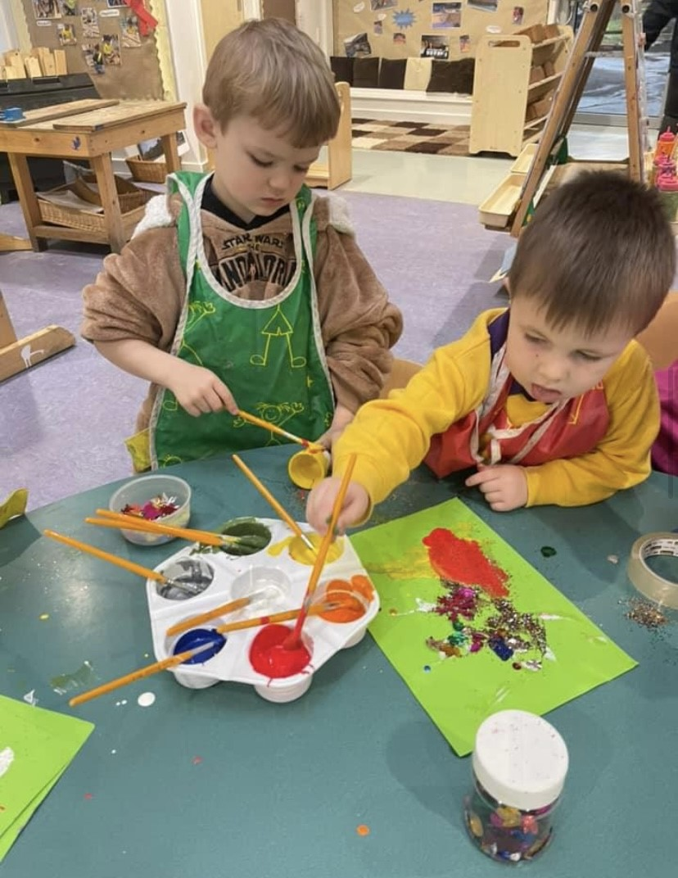

Care Inspectorate
The nursery is inspected by the Care Inspectorate, using the Health and Social Care Standards for Early Education and Childcare as indicators of good practice. Parents are consulted during the inspection and your views of the service form part of the report. A copy of the report is available to read within the nursery or is available from the Depute Head.
If at any time you wish to contact the Care Inspectorate personally you can contact them at:

The Care Inspectorate
Central West Regional Office
4th Floor
1 Smithhills Street
Paisley
PA1 1EB
Tel: 0345 600 9527

Useful Addresses and Telephone Numbers

Corporate Director of Education, Communities and Organisational Development,
Municipal Buildings,
Clyde Square,
Greenock,
01475 717171

Local Councillors
Mr Ciano Rebecchi Mr Gerry Dorian, Mr Innes Nelson
Municipal Buildings
GREENOCK
Tel 712020

Mr Stuart McMillan MSP
Constituency Office
26 Grey Place
GREENOCK
Tel 720930

Mr Ronnie Cowan MP
20 Crawfurd Street,
Greenock,
PA15 1LJ
Tel: 721 877

Useful Web Sites

- www.inverclyde.gov.uk - Inverclyde Council Web Site
- www.hmie.gov.uk - School and Local Authority Inspection Reports
- www.parentszonescotland.gov.uk - Very useful site for parents
- www.scottishschoolsonline.gov.uk - About individual schools

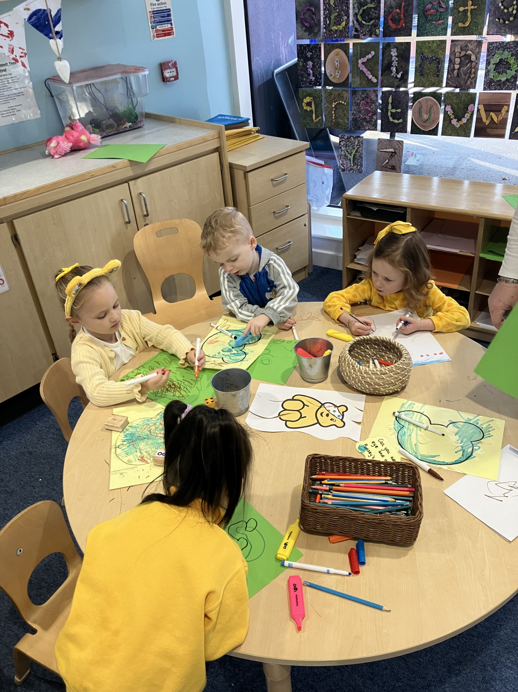

General Data Protection Regulations

General Data Protection Regulations and Data Protection Act 2018

Information on children, parents and guardian is stored on a computer system and may be used for teaching, registration, assessment and other administrative duties. In processing personal information, Inverclyde Council must comply with the General Data Protection Regulation and Data Protection Act 2018.

For further information please refer to https://www.inverclyde.gov.uk/site-basics/privacy

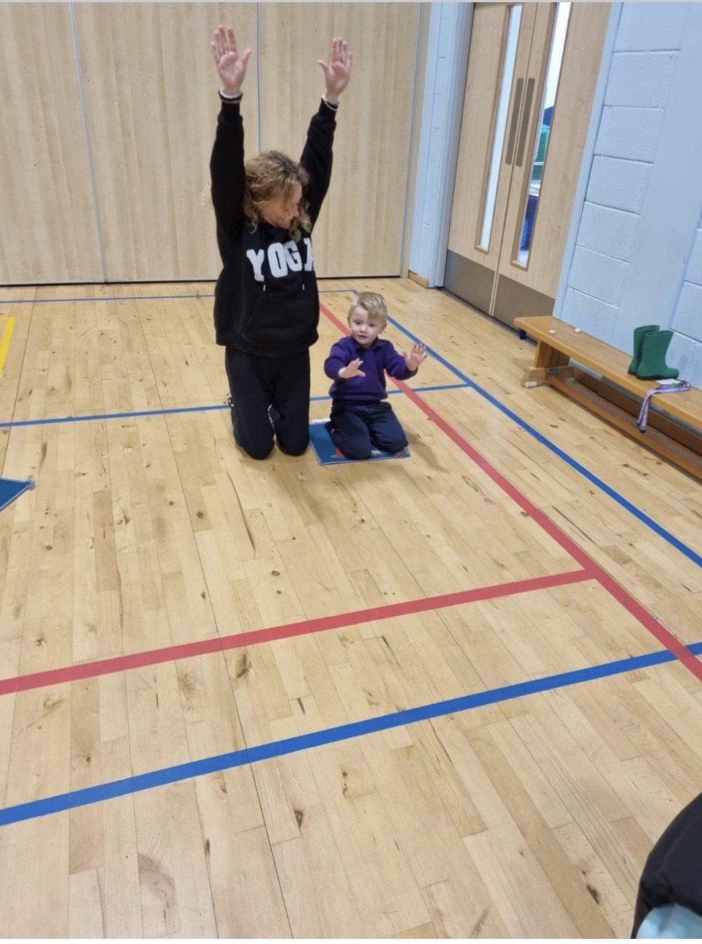

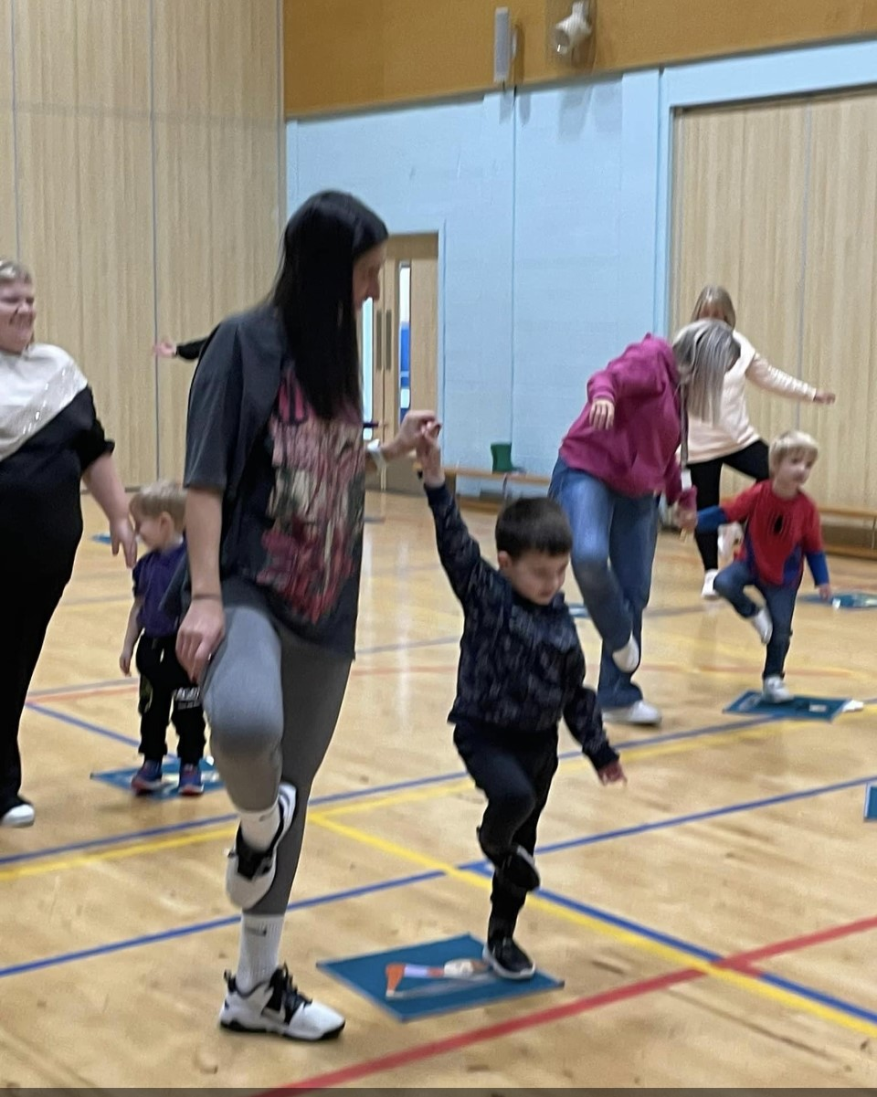

GLOSSARY

ASN Additional Support Needs.

EYECO Early Years Education Childcare Officer.

Assessment The process by which a pupil’s progress is determined.
This may be carried out by observation or by formal
testing of various types

PSA Pupil Support Assistant

Curriculum The totality of all that is planned for children and
young people throughout their education.

- Ethos and life of the school as a community
- Curricular areas

In Primary that is,

- Languages
- Mathematics
- Health and Wellbeing
- Expressive Arts
- Science
- Technologies
- Social Studies
- Religious and Moral Education.
- Learning across the curricular areas i.e. interdisciplinary learning or cross curricular learning.
Non –denominational A school which has pupils of all religions and
School denominations and pupils who have no religious
beliefs.

Reporting The way in which information about each pupil’s progress
is communicated to parents. This happens at least twice a
Year in Autumn and Summer term and is followed by
Parents’ Nights to allow a discussion of the report.

Although the information in this handbook is correct at time of printing, there could be changes affecting any of the matters dealt with in the document –

a) Before the commencement or during the course of the school year in question
b) In relation to subsequent school years.

