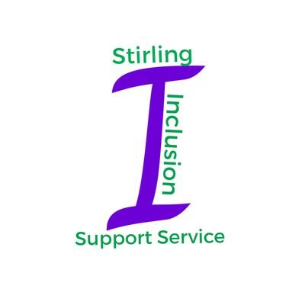

Staff Support and Development Sessions
Nurturing Stirling’s Schools

Booking Form

Name:
Establishment:
Email Address (to be used for invite to session via Microsoft Teams):

Please tick the age group and sessions you plan to attend:

Age Group

EY/Primary Secondary

Sessions

19/08/20 Session 1: Increasing Felt Safety

26/08/20 Session 2: Regulating Behaviour and Stress

02/09/20 Session 3: Supporting Wellbeing

09/09/20 Session 4: Getting Ready to Learn

16/09/20 Session 5: Theme to be decided through staff survey

23/09/20 Session 6: Theme to be decided through staff survey

Please return form to psychological@stirling.gov.uk

Thank you.

