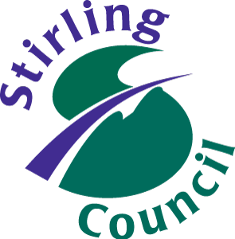
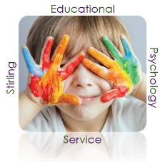

Dear Colleague,

Nurture Ambassador Support and Development Workshops

Places available for 2019/20 Session

Throughout the 2019/2020 session we intend to run a Support and Development Workshops for Nurture Ambassadors to support establishments to implement whole school nurturing approaches.

Stirling Children’s Services is promoting a relationships approach and implementing whole school nurturing approaches across all establishments is the foundation to this. Whole school Nurturing Approaches will allow schools to evidence they are working towards local and national priorities (e.g. closing the attainment gap, improved health and wellbeing of children and young people, and responding to ACEs).

This will be an opportunity for key staff to develop their knowledge of child development, attachment and nurture and be supported to plan and implement whole school nurturing approaches within their establishment (including evaluation supports).In addition it will provide an opportunity to have peer discussions, sharing of good practice, and support from the Educational Psychology Service. Each workshop will have a practical focus and will provide Ambassadors with resources and guidance to help with implementation.

We have two blocks of workshops (max 20 participants per block) running in 2019/2020, which will take place on the following dates from 2pm – 4.30pm with the location to be confirmed:

Block 1:
01/10/19 Session 1: Introduction to Group and Implementation
29/10/19 Session 2: Implementation, Nurture Principles and Discussion
12/11/19 Session 3: Nurture Principles and Discussion
03/12/19 Session 4: Feedback and Planning

Block 2:
21/01/20 Session 1: Introduction to Group and Implementation
11/02/20 Session 2: Implementation, Nurture Principles and Discussion
03/03/20 Session 3: Nurture Principles and Discussion
24/03/20 Session 4: Feedback and Planning

More information is provided on the flyer but if you have any queries please contact your link Educational Psychologist or the details at the bottom of the flyer.

Yours sincerely,

William Corral
Depute Principal Psychologist

Nurture Ambassador Support and Development Workshops

Places available for 2019/20 Session

Nurturing Approaches in Stirling
Stirling Children’s Services is promoting a relationships approach and implementing whole school nurturing approaches across all establishments is the foundation to this. The aim is to implement a Nurture Ambassadors model to ensure a consistent ethos and culture by providing a framework in relation to promoting children and young people’s wellbeing, resilience, attainment and achievement. Evidence suggests that a focus on embedding the 6 nurture principles can promote inclusive practice, raise attainment, improve parental engagement, increase staff confidence in building positive relationships and improving the wellbeing of children and young people. Therefore adopting nurturing approaches supports establishments within Stirling to implement the four priorities outlined in the National Improvement Framework and Plan (Scottish Government 2019).

Becoming an Nurture Ambassador
We are currently supporting a cohort of Nurture Ambassadors to implement whole school nurturing approaches within their establishment. Ambassadors attend four workshops and then ongoing reconnectors to develop their knowledge of child development, attachment and nurture and for support to implement within their establishment. We are currently looking for individuals to sign up to the next cohorts which will take place in session 2019/20. These workshops can be used to support individuals CLPL and for establishments to meet local and national priorities.

Aims of Workshops
Following the workshops Ambassadors will:
- feel confident in their knowledge of child development, attachment, trauma/adverse childhood experiences and nurture
- be supported to plan and implement whole school nurturing approaches
- guided on how to evaluate and evidence impact of implementation with links to HGIOS 4

Requirements

- Two members of staff attend including one member of SMT (smaller and rural schools may send one representative – to be discussed with link Educational Psychologist)
- Contact made with link Educational Psychologist for more information/readiness support
- Commitment to all four workshops
- Agreement that data collected will be used to support local authority evaluation
- Whole school nurturing approaches to be placed on school improvement plan.

For further information or to confirm attendance please contact:

William Corral - Educational Psychologist
Phone: 01786 237 818 | Email: psychological@stirling.gov.uk |

