This WORD version of the Round 4 STEM Grant Application Form has been made available to support offline preparation of your application. Your application must be submitted through the online application form which will go live on 19 April 2022.

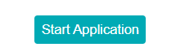

Your application should be submitted by 12:00 pm on Wednesday 11th May 2022.  
  
Please refer to our [supporting guidelines](https://blogs.glowscotland.org.uk/glowblogs/stemnation/stem-grants-2022).  
  
If you need help or advice with your application then please contact us by email: [stem@educationscotland.gov.scot](mailto:stem@educationscotland.gov.scot)  
 **IMPORTANT instructions - please read carefully before you complete this application.  
  
1. We strongly advise you to prepare your application form offline initially, in MS Word or similar. You should save this draft to your own computer before beginning the online application process. This will ensure you have a back-up copy of the main body of your text should anything go wrong. This will also make the online application process quicker as you will be able to cut and paste your responses into the main sections of the online application form.  
  
2. Each time you log in to this system you have a three hour window to complete and submit your application. After three hours your session will time out and any unsaved information will be lost. To avoid losing the information you have entered, you must either save your application, or submit it, within this three-hour timeframe.  
  
3. For data security reasons, you should avoid leaving your computer unattended whilst the online application process remains open. You should also ensure you are connected to a secure network. For example, you should avoid completing this application using a public Wi-Fi network, such as in a café, where others may be able to access your connection and data.  
  
4. Please ensure you provide relevant levels of detail for all questions in this application form to avoid completion errors. If you fill in any box incorrectly, a completion error will appear on the left hand side below the menu options. Please check this before you progress onto the next page.  
  
The Save option on the left hand side allows you to save your application for a later date. You can use this and exit the form at any time. Take a note of your receipt number so you can return quickly to your partially-completed application.**For information regarding accessibility please see [accessibility statement](https://education.gov.scot/education-scotland/accessibility-formic).



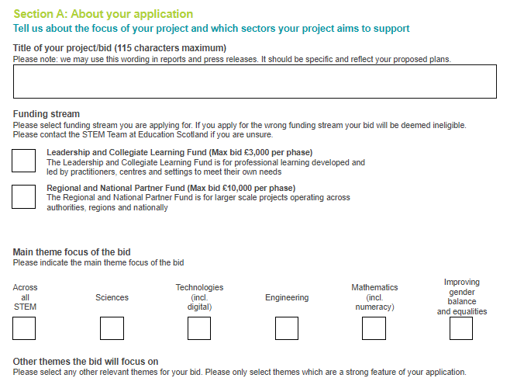

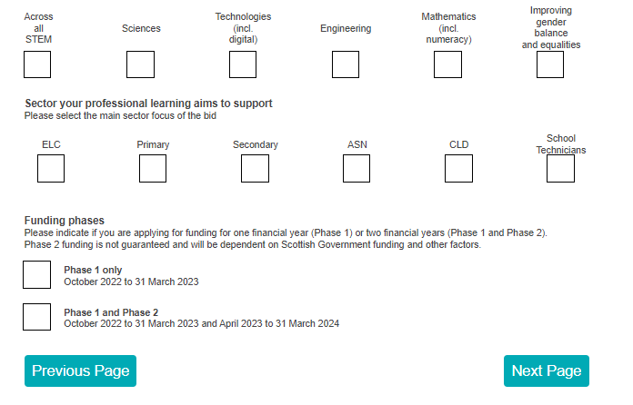

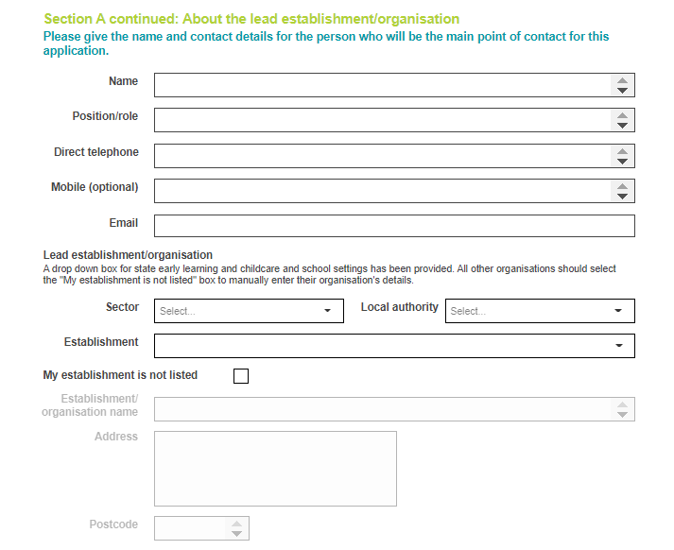

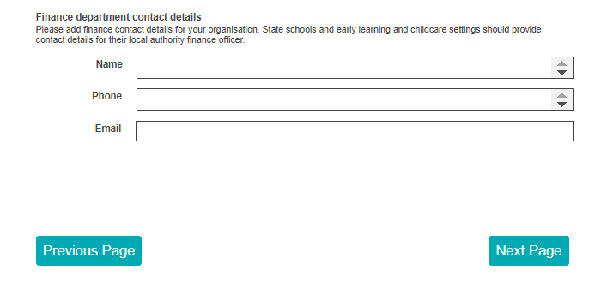

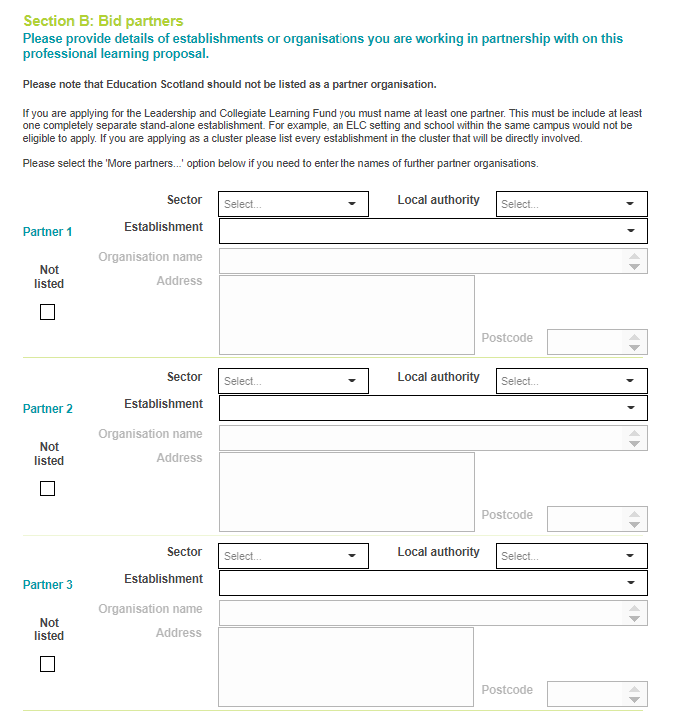

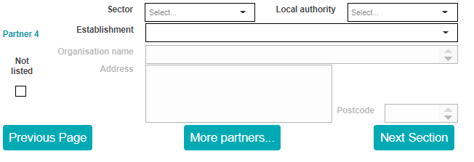

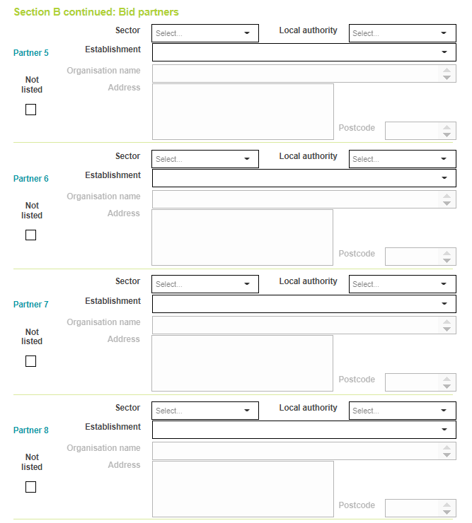

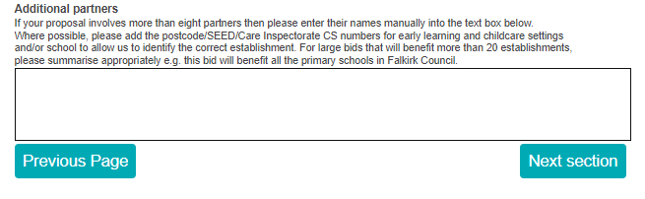



**1. Addressing the aim & ambition of the fund (maximum characters 2750)**Please include details of your plans including:  
- A clear explanation of what you plan to do and how you plan to do it over the course of the funding period.  
- A clear description of why you are submitting the proposal and the need you are seeking to address  
- How will it address the recommendations of:  
    - the [STEM Education and Training Strategy](https://www2.gov.scot/Resource/0052/00526536.pdf) and/or  
    - the [Making Maths Count](https://www.gov.scot/publications/transforming-scotland-maths-positive-nation-final-report-making-maths-count/) report  
    - the [Multiplying Skills, Adding Value Thematic Report](https://education.gov.scot/media/2ljhvxsl/multiplying-skills-adding-value-full-report.pdf)  
- Equity and equality: Please explain how your work will address inequity and promote equality in relation to the protected characteristics such as gender balance and disability and for people who are care experienced or from black, asian and minority ethnic communities.





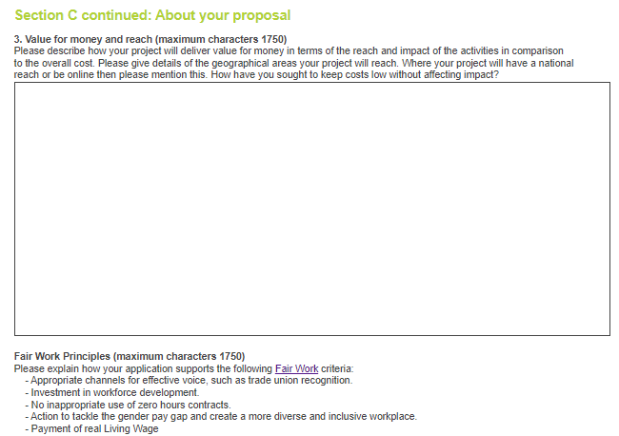

**Fair Work Principles (maximum characters 1750)**Please explain how your application supports the following [Fair Work](https://www.gov.scot/binaries/content/documents/govscot/publications/strategy-plan/2021/02/fair-work-action-plan/documents/fair-work-action-plan/fair-work-action-plan/govscot%3Adocument/fair-work-action-plan.pdf) criteria:  
    - Appropriate channels for effective voice, such as trade union recognition.  
    - Investment in workforce development.  
    - No inappropriate use of zero hours contracts.  
    - Action to tackle the gender pay gap and create a more diverse and inclusive workplace.  
    - Payment of real Living Wage

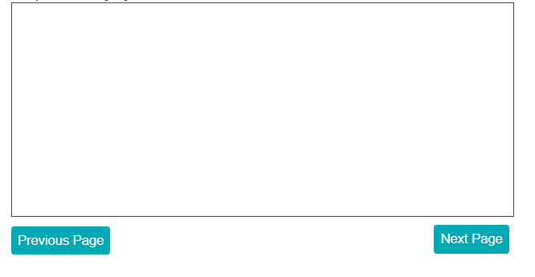

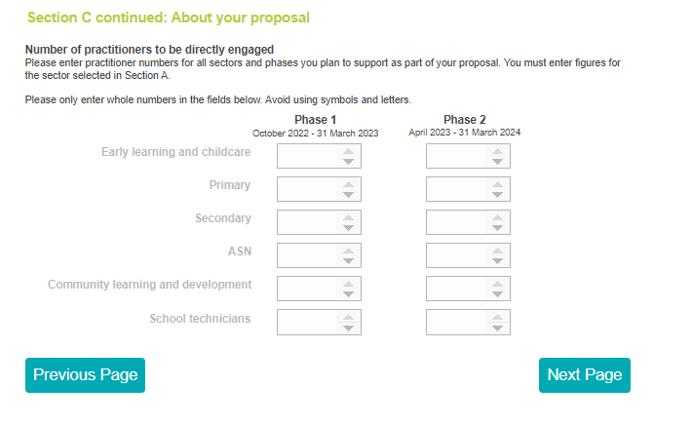

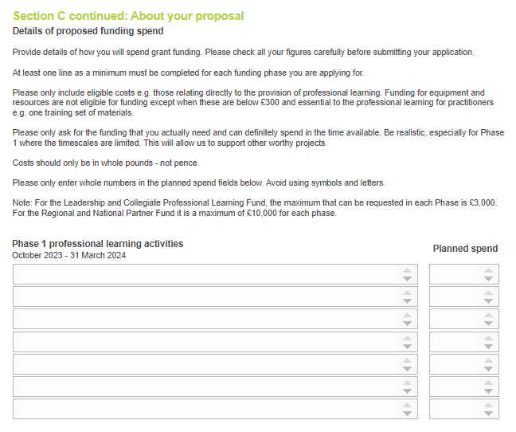

April 2023 - 31 March 2024

October 2022 - 31 March 2023

