Enhancing Professional Learning in STEM
Grants Programme

Round Four (2022 – 2024)

Application Guidance

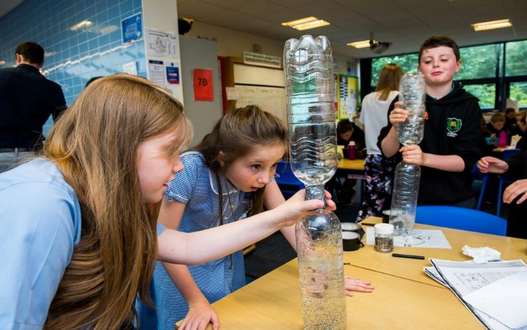
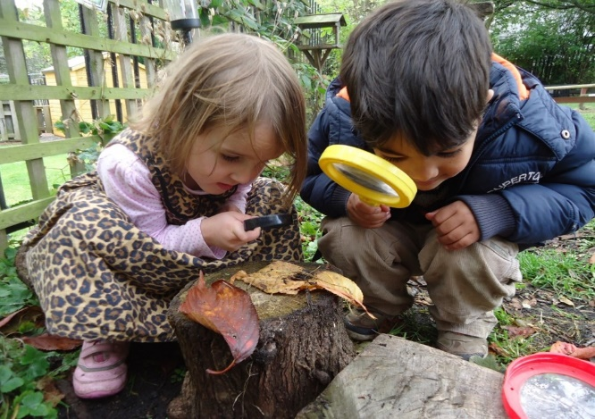

Closing date for applications
12 noon on Wednesday 11 May 2022

Please apply using our online application form:
https://forms.education.gov.scot/s/
You will need to register to begin your application

For Scotland's learners, with Scotland's educators

Aim of the grants programme

The aim of the Enhancing Professional Learning in STEM Grants Programme is to stimulate, support and grow projects that enhance the professional learning available to practitioners with a responsibility or interest in STEM-related learning, teaching and assessment.

The grants programme was established in October 2018 to deliver on the ambitions of the STEM Education and Training Strategy for Scotland (2017), namely, to ensure that educational practitioners are ‘well-equipped with the knowledge, skills and confidence to develop and deliver inspirational, high-quality interdisciplinary STEM (Science, Technology, Engineering and Mathematics) teaching for all learners, across all ages and stages’.

The grants programme continues to be informed by the findings from the Annual STEM Practitioner Surveys [See the National STEM Data section of STEM Summary page]. A significant focus of the programme is to address the barriers that practitioners face in accessing professional learning that meets their needs.

The Enhancing Professional Learning in STEM Grants Programme supports practitioners in a range of settings.
- Early learning and childcare
- Additional support needs
- Primary
- Secondary
- Community learning and development
- School-based technical support staff
Programmes will only be considered for funding if they are primarily targeted at practitioners in publicly-funded settings, including local authority partner providers in the early learning and childcare sector.

Priority areas this year
Bids for all STEM areas are welcomed. Out of a total fund value of £400k, £200k will be allocated to STEM-related bids and £200k will be allocated to Numeracy and Mathematics-related bids.
Bids where Numeracy and Mathematics is listed as the Main or Secondary theme will be considered to be applying for the Numeracy and Mathematics funding. It is important therefore that where Numeracy and Mathematics is listed as a Main or Secondary theme then it is a strong and well-defined feature of your proposed programme of professional learning. Please note that in some circumstances Education Scotland may make a grant award to a lower-scoring bid over a higher-scoring bid to ensure an equivalent distribution of funds across STEM and Numeracy and Mathematics.
Bids for engineering, technologies and integrated-project based learning in STEM are particularly welcome as our survey findings indicate that practitioner confidence in these areas needs to be supported. There is also an enhanced focus on digital learning and teaching in Round 4 and we would like to encourage more bids in this aspect of STEM also.
Our survey findings also indicate that the following sectors are under-served and are, therefore, priority areas: additional support needs, early learning and childcare, community learning and development and school-based technical support staff.
There is an expectation that applications demonstrate how the proposed professional learning activities promote equity and equality of opportunity in relation to protected characteristics and people who are care experienced. Applications should also demonstrate how measures taken will address gender stereotypes and unconscious bias. Bids which demonstrate links to Developing the Young Workforce, Learning for Sustainability and Creativity are also strongly encouraged.

Funding streams explained
Two funding streams are available. Please ensure that your application aligns with the correct funding stream. If your bid is entered for the wrong funding stream it will be deemed ineligible and will not be considered.
- The Leadership and Collegiate Learning Fund is for professional learning developed and led by practitioners, centres and settings to meet their own needs. You can bid up to a maximum of £3,000 for this funding stream in any one Phase.

- The Regional and National Partner Fund is for larger scale projects operating across authorities, regions and nationally. You can bid up to a maximum of £10,000 for this funding stream in any one Phase.

Scoping your plan
The questions below may support initial thinking:
- Who will lead the bid and activity? Who will be involved in the professional learning? How will collaboration enhance the approach and outcome?
- What do you want to achieve? How are you going to do this?
- How much funding is it likely to require?
- Impact what will this look like and how will you evidence this?

Funding can be used to provide time for practitioners to collaborate and work collegiately to engage in professional learning. Practitioners can be released to develop, lead and coordinate professional learning. This can include the provision of supply cover for practitioners leading professional learning, or enhancements for those taking on additional responsibilities. Funding for STEM resources, equipment and pupil activities are ineligible costs and should not be included.

Please include details in your application of any other funding sources or contributions that are supporting your wider ambitions. This may increase your scoring against the value for money criterion (Appendix 2).
Leadership and Collegiate Learning Fund Guidance
If you are applying for the Leadership and Collegiate Learning Fund you should discuss your plan with a relevant contact within your authority. This could be a Quality Improvement Officer, Education Officer, Programme Manager or similar. This is important for a number of reasons as your authority contact may:
- be able to provide some form of central support or guidance;
- be aware of potential overlap with other proposals that are being developed, or already exist; and
- be able to suggest ways in which the scope or impact could be increased.
If your bid is successful, Education Scotland will allocate funding to your local authority for your establishment or network to draw down. It is important therefore, that your local authority is aware of this in advance and has agreed to support your bid.
For details of your local authority please contact Education Scotland’s STEM Team by email: stem@educationscotland.gov.scot
Support available
Contact the STEM regional officers via email: stem@educationscotland.gov.scot if you have any questions regarding the STEM Grants programme application or to discuss STEM-related bids.
Questions relating specifically to Numeracy and Mathematics bids should be directed to email: mathematics@educationscotland.gov.scot
Questions relating specifically to Community Learning and Development (CLD) bids should be directed to email: John.Galt@educationscotland.gov.scot

Accessing the application form

Bids should be made using the online application form: https://forms.education.gov.scot/s/.
You will need to register to begin your application.

The closing date for applications is 12 noon on Wednesday 11 May 2022.

We strongly advise that you prepare the text for your application in advance and paste it into the relevant sections of the online form. The form will time out after 3 hours and you may lose your work. We also advise that you submit the application well before the deadline in case of any technical issues.

Prior to completing the form, applicants are required to register using a valid email address. If you forget your password, please email stem@educationscotland.gov.scot and ask for it to be reset manually.

The document can be saved as you progress through. You will be given a receipt ID that can be used to access the partially completed form if it does not automatically appear when you log back in. You can log back in and make further edits to your application at any point up until the submission deadline.

When submitting your form – if you have missed out some of the fields this will appear in red on the left hand side of the application page. These hyperlinks will take you directly to the part that requires completion. We strongly advise that you save your completed form as a PDF before you submit it. You can view a read only copy.
Once your application has been submitted, you will be issued with a receipt ID – please take a note of this for your own records. You will then receive an email to say that your application has been received and remind you of your unique reference code. Please use this in all correspondence regarding your bid.
The application form
The application form contains four sections (A-D). Details of the information required in each section is outlined below.
Section A
- Title of your project/bid (5 - 20 words)
- The funding stream you are applying for
- The focus area(s) of STEM of your project
  - Across all STEM
  - Sciences
  - Technologies (including digital)
  - Engineering
  - Mathematics (including numeracy)
  - Improving gender balance and equalities
- The sector(s) your professional learning aims to support
  - Early learning and childcare (ELC)
  - Primary
  - Secondary
  - Additional support needs (ASN)
  - Community learning and development (CLD)
  - School technicians
- Funding Phase – if you are applying for funding for one financial year (Phase 1, October 2022 to March 2023) or two financial years (Phase 1, October 2022 to March 2023 and Phase 2, April 2023 to March 2024). Phase 2 funding is not guaranteed and will be dependent on Scottish Government funding and other factors.
- Name and contact details for the person who will be the main point of contact, establishment/organisation details and finance contact (for local authority establishments this should be the local authority finance department contact).

Section B

Bid partners – the fund is designed to support collaborative working. Please provide details of establishments or organisations you are working in partnership with for this professional learning proposal. Education Scotland should not be listed as a partner organisation.
If you are applying for the Leadership and Collegiate Learning Fund you must name at least one partner establishment or setting. This has to be a completely separate and distinct establishment or your bid will be deemed ineligible.
If you are applying as a cluster – please specify every participating establishment in the cluster. If you wish to enter more partners then use the More partners button to add others. If there are more than eight partners, use the free field text box to enter their names manually in the Additional partners box. The postcode/SEED/CI number for schools and early learning and childcare centres should be added, where possible. All applications should seek to build sustainable relationships, partnerships and collaborative models of working. This section contains drop down menus to select establishments. If your establishment/organisation is not listed, please select Not listed to enter details manually.
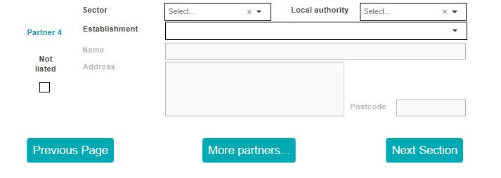
Section C
This section requires an overview of your proposed activities under four headings.
- Addressing the aim and ambition of the fund (free text box – 2750 characters)
- Strategic approach to professional learning activities planned for Phase 1 and beyond into Phase 2 (free text box – 2750 characters)
- Value for money and reach (free text box – 1750 characters) and Fair Work (free text box – 1750 characters)
- Additionality (free text box – 1750 characters)

You will be required to submit details of proposed spend and practitioner numbers under the heading Value for Money. There is no need, therefore, to address this under previous headings.

1. Addressing the aim and ambition of the fund
Please include sufficient details of your plans.
- A clear explanation of what you plan to do and how you plan to do it within Phase 1 (October 2022 – March 2023). An October start should be planned for to allow time for the funds to reach you.
- A clear description of why you are submitting the proposal and the need you are seeking to address.
- How it will address the recommendations of the STEM Education and Training Strategy and/or Making Maths Count and Multiplying Skills, Adding Value reports.
- Equity and equality: please explain how your work will promote gender balance, equity and equality in relation to the protected characteristics and for people who are care experienced.
2. Strategic approach to professional learning activities planned for Phase 1 (October 2022 – March 2023) and beyond into (Phase 2 April 2023 – March 2024)

Please include sufficient details of your plans.
- How the professional learning activities reflect the national model for professional learning.
- How the proposal displays strategic approaches to ensure impact and legacy for practitioners.
- How you plan to evaluate the impact of your work e.g. survey, focus groups or other means. Please set out the anticipated impact of your work in terms of professional learning, leadership and capacity of practitioners, and impact for learners.
- Phase 1 funding will cover October 2022 – March 2023. If you would like funding to scale up or extend your project into Phase 2 from April 2023 – March 2024 then you should enter details in this section. There is no guarantee that Phase 2 funding will be provided as it is subject to Scottish Government budgets.

3. Value for money and reach

Include sufficient details of your plans.
- Details about the reach and scale including in relation to sector and geography.
- Describe how your proposal will deliver value for money in terms of the reach and impact of the project in comparison to the overall cost.
- Indicate the number of practitioners to be directly engaged (you must enter a value for each of your focus sectors, even if this is 0).

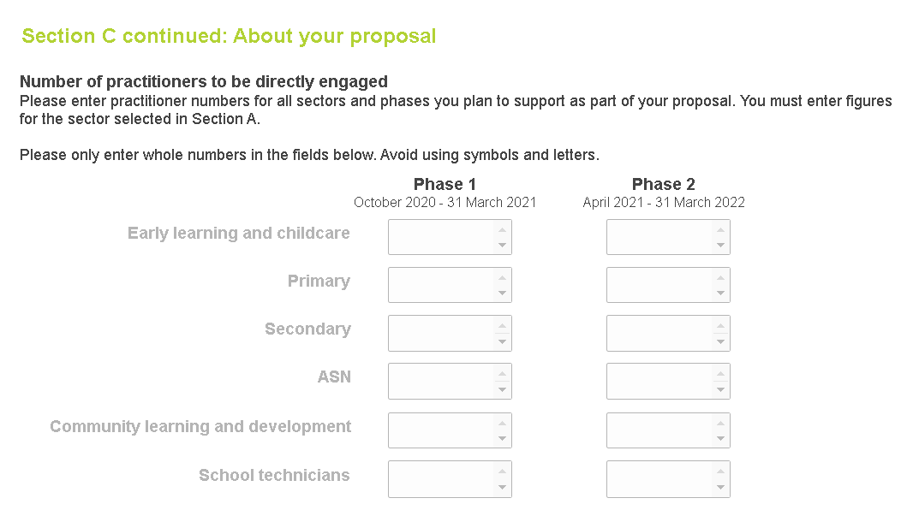
Fair Work Principles
Please explain how your application supports the following Fair Work criteria:
• Appropriate channels for effective voice, such as trade union recognition
• Investment in workforce development
• No inappropriate use of zero hours contracts
• Action to tackle the gender pay gap and create a more diverse and inclusive workplace
• Payment of real Living Wage.

The Fair Work Principles section will not be scored against the criteria. However, it is important you complete this section as projects supported through Scottish Government funding need to be aligned to Fair Work principles.

- Details of planned spend.
  - Provide details of how you will spend the funds you have requested. This should be in whole pounds and not pounds and pence. Please double check this section before submitting your form. The amount requested must be within the limits of the funding stream you are applying for.

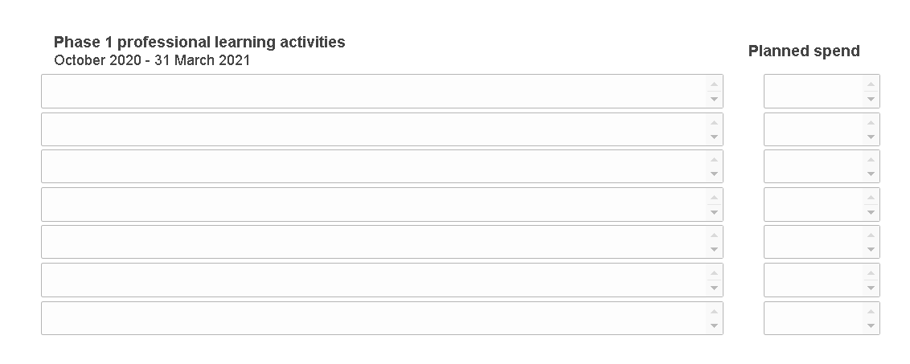

  - Only eligible costs should be included – those relating directly to the provision of professional learning. Equipment and resources are not eligible for funding except where these are low cost and essential to the provision of professional learning for practitioners e.g. one training set of materials to a maximum of £300.

4. Additionality
The following details should be provided in this section:
- How your proposal addresses gaps in current professional learning provision
- How your proposal will add value or extend current professional learning provision
- Evidence of any pilot activity or impact of existing activity
- How your proposal addresses priority themes and sectors as outlined in the guidance
- Where you have other sources of matched funding or contributions in kind for your proposal please provide details.

Section D
This section asks you to confirm you have considered and are in agreement with a set of statements before submitting your application. The statements are as follows:
  - I/We confirm that all the information in this application is true and correct.
  - I/We confirm that I will tell you if anything changes which could affect this application in any way.
  - I/We confirm that I am happy for you to provide copies of this form to any person or organisation you need to consult about this application.
  - I/We note that any funding awarded will be subject to standard and specific conditions.
  - I/We agree to complete the STEM professional learning tracker document.
  - I/We confirm that I am happy to include information about the grant in relevant promotional materials and events.
  - I/We confirm that I am willing to support the external evaluation of the grants programme and engage in relevant evaluative activity.

- Additional statements for local authority early learning & childcare settings and schools only:
  - I/We confirm that I have discussed this application with my head teacher or setting manager.
  - I/We confirm that this application has the support of my local authority contact (Quality Improvement Manager QIO or equivalent).
  - I/We give permission to Education Scotland to share this bid with my local authority STEM lead officer or equivalent.

- Additional statement for independent early learning & childcare settings and schools only:
  - I/We confirm that I have discussed this application with my head teacher or setting manager.
  - I/We give permission to Education Scotland to share this bid with my local authority STEM Lead officer/s.

- Additional privacy statement
  - I/We confirm that I have read the ES privacy policy and understand how my personal data will be used.

Post-application process

Your proposal will be scored using set criteria (Appendix 2) and judged on a competitive basis with other applications.
Any Phase 2 plans which are listed will be evaluated and scored along with Phase 1 proposals.

Appendix 1 – Further guidance on priority areas

STEM

In Round 4 of the STEM Grants programme, a £200k fund is available for STEM professional learning and an additional £200k has been made available for Numeracy and Mathematics. Bids for the STEM-related fund should set out how the funding requested will enhance the access and equity of provision of professional learning in STEM. This professional learning should be aligned to the four themes of the STEM Education and Training Strategy. In Round 4 there is also an increased focus on supporting digital learning and teaching.

Excellence
To ensure that we are a nation that builds its STEM enthusiasm, skills and knowledge we need practitioners in our education system who are well equipped with the knowledge, skills and confidence to develop and deliver inspirational, high-quality interdisciplinary STEM teaching for all learners, across all ages and stages.

Equity
We need to build the capacity and understanding of practitioners to promote gender balance in STEM courses, training and work and improve equity of access and uptake. There are other disparities in participation and achievement in STEM in terms of protected characteristics and for care experienced young people that need to be tackled.

Inspiration
The need to challenge societal perceptions of STEM and to demonstrate the opportunities it presents for all children, young people and adults is an ambition of the STEM strategy. Practitioners need to be supported to better engage parents and families as they are key influencers in terms of young people’s attitudes and choices, including the subjects they study and the careers they pursue

Connection
Practitioners need to be supported to increase learners’ awareness of the opportunities that exist with colleges and industry in their region and beyond. Connections and collaboration across sectors needs to be encouraged. In particular, we need to promote effective progression in learning within clusters and partnership working with colleges and employers.

To discuss ideas relating specifically to grant bids relating to STEM, please email: stem@educationscotland.gov.scot

Numeracy and mathematics
Within Round 4 of the STEM Grants Programme, £200k out of a total budget of £400k will be allocated to bids with a specific Numeracy and Mathematics improvement focus.
Where applications are targeted primarily at the Numeracy and Mathematics improvements, then they will be required to specifically focus on the impact of professional learning on children and young people. They will also be expected to align with the key actions and recommendations in Education Scotland Mathematics Thematic Review: Multiplying Skills, Adding Value (2019) and the Making Maths Count Report (2016).
Possible routes of focus/ themes include (but are not exclusive to):
- leadership for learning and review of the curriculum to ensure effective progression of learners;
- school/ cluster-wide improvement planning to strengthen consistency in effective practice;
- investment in pedagogy to strengthen learning, teaching and assessment;
- effective use of assessment data and tracking in primary schools to drive improvement;
- strengthened numeracy application within the Broad General Education particularly at secondary;
- effective application of Numeracy and Mathematics skills;
- effective transition through the continuum of learning, specifically at second- third and third-fourth CfE levels;
- effective pace and progression of learning at transition from early years- primary sector/ early level CfE; and
- effective monitoring, progression and pace in Numeracy and Mathematics within play pedagogy.
- further support for family learning and/or financial education.
And, in addition, there is a need for:
- primary schools to further explore the potential of STEM and Developing the Young Workforce to add value to children’s experiences in Numeracy and Mathematics, alongside more local contexts including the school’s own provision for interdisciplinary learning;
- more opportunities for learners to engage with real-world Numeracy and Mathematics contexts; and
- steps to address the gap in performance between children and young people from the least and most deprived areas, especially at fourth level of the curriculum.

To discuss ideas relating specifically to grant bids where Numeracy and Mathematics is the leading theme, please email: mathematics@educationscotland.gov.scot.

Appendix 2 – Scoring your application

Criteria | Score  (0 - 4) | Weighting (1- 5) | Max score  available
How well does the project address the aim and ambition of the fund? |  | 5 | 20
How well does the proposal display a strategic approach to professional learning activities? |  | 4 | 16
Reach and scale (including value for money) |  | 3 | 12
Additionality |  | 3 | 12
Total |  |  | 60

Applications will be scored on a scale of 0 - 4
0 | Does not meet the criterion
1 | Does not meet the criterion in one or more significant respects
2 | Does not meet the criterion in some minor respects
3 | Meets the criterion
4 | Exceeds the criterion in one or more respects

Appendix 3 – Equity and equality

Definitions
Equality: Equality relates primarily to the protected characteristics found in the Equality Act 2010, where having equality of opportunity means that everyone gets the same opportunity with ‘reasonable adjustments’ to facilitate this as necessary
Equity: Equity is more focused on whether people are able to have equity of experience, and that this is underpinned by fairness and impartiality. Ensuring that everyone has equality of opportunity is not the same as ensuring that they have an equitable experience.
Gender stereotype: A gender stereotype is a widely held belief or generalisation about the behaviours, characteristics and roles performed by women and men.
Unconscious bias: Unconscious biases are social stereotypes about certain groups of people that individuals form outside their own conscious awareness. Everyone holds unconscious beliefs about various social and identity groups, and these biases stem from one’s tendency to organise social worlds by categorising. Unconscious bias is far more prevalent than conscious prejudice and is often incompatible with one’s conscious values.

Link between gender stereotypes/unconscious bias and gender imbalance in subject uptake and pathways: gender stereotypes can often mean young people feel they have to act or behave a certain way. It can also affect the choices they make as they feel the pressure to conform to gender stereotypes. Gender stereotyping has a big influence therefore on whether a learner feels STEM is for them, and, if we are to effectively tackle this imbalance it is necessary to look at addressing stereotypes in a long-term sustainable way.
Further support and resources
Education Scotland NIH resources https://education.gov.scot/improvement/learning-resources/improving-gender-balance-3-18
GTCS equality and diversity hub
https://www.gtcs.org.uk/professional-standards/key-cross-cutting-themes/equality-and-diversity/

Appendix 4 – Grant conditions

1. Eligible costs
- Staffing
- Teacher cover (for practitioners involved in the delivery/facilitation of professional learning activity rather than attendees)
- Reasonable travel and subsistence (only where essential and should be no more than £300)
- Professional learning events ̶ including venue and catering
- Training materials (including printing of training materials books and a single training set of resources to maximum value of £300)

2. Ineligible costs
- Purchasing of equipment, laptops, devices or science/STEM resources
- Costs for learner-focused events, experiences or learning

3. Other sources of funding
There is no requirement to find partnership funding but please let us know of other sources of funding you may use to develop your professional learning including those listed below.
- A contribution from your own organisation, either financial or in-kind (please assign a monetary value to any ‘in-kind’ funding).
- Funding from other organisations, programmes, competitions or industry.
- Grants from trusts and foundations.

4. Timely reporting
Education Scotland issues grants to numerous bodies and organisations each year. Grantees are encouraged to respond to communications in a timely manner including completion of grant paperwork, reports and other requests. This will free up our staff time to better support your work and plans.

5. Monitoring and evaluation
- We will need to know what happened as a result of our funding and will ask you to monitor project activities in order to measure the impact of your project in relation to the intended outcomes of the fund. If your application is successful, you should complete the monitoring and evaluation activity that you outlined in your original application.
- Please note that we will want to report on the outcomes from a national perspective and will send out a tracking template to capture the number of practitioners you have reached. Education Scotland has also commissioned an external evaluation of the grants programme. Should you be successful in your grant application then we will also ask you to support this process in a proportionate and appropriate way, for example, by promoting surveys to your participants or engaging in focus groups discussions with evaluators.
- One of Education Scotland’s regional officers will contact you once your funds have been awarded. They will be available to discuss your progress and provide support, particularly prior to the submission of your interim report and your final report. The due dates for these will be given in the grant award letter and email communications.

6. Conditions of award
- Your proposal should respond directly to the intended aims of this fund as stated in this guidance document.
- Applications can only be considered if they meet the funding criteria.
- All professional learning is to be provided on a non-commercial basis and must be available free of charge to participants.
- The intellectual property developed through your grant-funded programme will reside with the Crown and must continue to be made available free of charge to practitioners beyond the funding period.
- Successful applicants should keep to the grant conditions shown in both our offer letter and any accompanying document. In particular:
  - You should not make changes to the project without notifying us first
  - You should carry out your project in line with the timescales given in your application and within the time limits shown in our offer letter. It is very important that you let us know about any delay or difficulties in keeping to the grant conditions so that we can advise and help you as necessary.

7. Additional important information
Please note that Education Scotland may, by giving at least 7 days written notice, assign any of its rights and obligations under an award, either wholly or in part, to any other person.

8. Publicity
Information on funding awarded may be made public by Education Scotland. If you are successful in your funding bid then we will also ask you to include information about the grant fund in your promotional materials and through your events. This is to ensure practitioners and networks across Scotland are made fully aware of the funding that is being provided by Education Scotland and Scottish Government to support the STEM Education and Training Strategy and the Making Maths Count Report.

Images submitted in support of your application may be stored electronically by us. If we later seek to use these for publicity purposes, we will contact you in order to obtain permission to do so.

9. Openness and accountability
Reports from information you supply within your application and from comments made on your application by external assessors and staff members will be held digitally. The information you supply will be made available to those evaluating your application.

For the purposes of the Freedom of Information (Scotland) Act 2002 (FOISA) Education Scotland is obliged, as a Scottish public authority, to make your information (which will include your application) available by anyone making a Freedom of Information request.

By submitting your application, you waive any right to raise any type of legal proceedings against Education Scotland as a consequence of, or in contemplation of, any disclosure of the contents of your application in response to an information request made under FOISA.

10. Information that we may release
If your application is successful, we will release the following information from your funding application if we receive a FOI request:
- Your name
- The amount of funding requested
- The summary description of your project.

If more detailed information is requested, we will consider this request under FOISA and apply the Act’s exemptions and the public interest test appropriately. If more detail from your funding application is to be disclosed, we will contact you and advise you of this.

For further information on FOISA please see the Scottish Information Commissioners website: www.itspublicknowledge.co.uk

11. Data protection
Information supplied by you in support of your application will be stored on our records system. The data we hold may be used for the following purposes:
- To report statistics
- To evaluate applications
- For accounting purposes
- For contacting you.

Your name, address and contact details will be held on our records system. We will use this information to correspond with you. We will not forward your details on to any other organisations, except to the research company appointed to undertake the external evaluation. They will need your contact details to engage with you in the surveys and evaluation activity.

The details of your application may become public information (see Openness and Accountability above). However, your personal details will be held by us and only our staff, appointed auditors and those involved in evaluating or monitoring awards will have access to them.

You have a right under the Data Protection Act 2018 to see the information we hold on you. By signing your application form you are agreeing that we can use your information as shown above.

“Data Protection Laws” means any law, statute, subordinate legislation, regulation, order, mandatory guidance or code of practice, judgment of a relevant court of law, or directives or requirements of any regulatory body including the Data Protection Act 1998, the Data Protection Act 2018 and any statutory modification or re-enactment thereof and the General Data Protection Regulation (GDPR). For more information on the Data Protection Act 2018 see Data Protection Act 2018 (legislation.gov.uk)

See Annex A on Page 50 of the STEM Education and Training Strategy for Scotland for a definition of what constitutes ‘STEM’.
² Protected characteristics: gender identity, race, disability, sexual orientation, sex, age, marriage and civil partnership, pregnancy and maternity, religion and belief.
³ See Appendix 3 for more information about equity and equality.
⁴ Please see Appendix 1 for summary guidance on priority areas of STEM Education and Training Strategy and Multiplying skills, adding value that will be particularly welcomed in applications.

