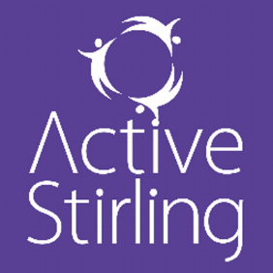
Active Stirling

Active Stirling are committed to supporting all of Stirling citizen’s to join in sporting and fitness activities.
As part of their corporate parenting role, Active Stirling support care experienced young people to overcome barriers to accessing sport. As such, young people who have social work input are able to request free access to Active Stirling Sporting activities as part of their Child’s plan. Support is approved on a case by case basis.
For further information please contact Dougie Porteous email: porteousD@ActiveStirling.org.uk

