Time4Me
Time4Me is a one to one mentoring service offered to students entering Forth Valley College who may face additional barriers to sustained and successful transition, the ultimate aim of which is to improve educational outcomes for such students. Mentoring sessions take place on a weekly basis during term time, for the full academic year.

To be eligible for referral, students must be
· Care Experienced
· Young Carers/Young Adult Carers
· Reside in regeneration areas (SIMD>20)

The project is led by Sarah Tervit, Mentor Coordinator, who is happy to visit prospective students within their current school environment to discuss what mentoring involves and what is expected (along with a member of school staff if deemed appropriate)

Referrals from staff member are encouraged as early as possible prior to leaving school, after the student has made an application. However, before making a referral, please contact Sarah for an initial discussion to determine the appropriateness of the potential referral.
sarah.tervit@forthvalley.ac.uk
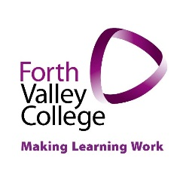
01324 403000 ext. 7128

