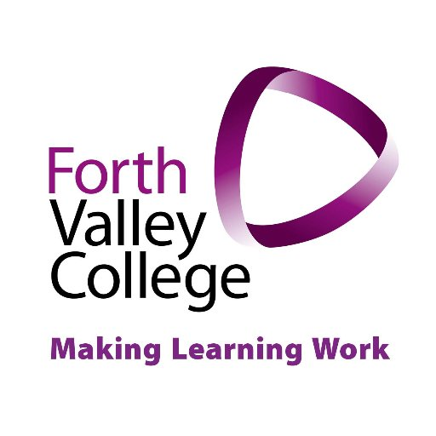
Forth Valley College Corporate Parenting
Forth Valley College wants all Care Experienced students to be successful during their time studying here. We want everyone to gain a place on an appropriate course, learn new skills, gain qualifications, and progress into a positive destination whether that be further education, higher education, training or employment.
Applicants are strongly encouraged to indicate they have been in care via their college online application. This information will allow the Student Services team to contact applicants and ensure they are aware of the wide range of support available pre-entry and on-course.

The support offered is wide and varied and depends on each individual student and what is right for them, but broadly includes:
· Priority processing for funding
· Pre-application help
· Guaranteed interview if entry requirements met
· Dedicated Learner Adviser once a conditional or un-conditional offer has been accepted
· Additional financial advice and support
· Care Experienced Student Bursary (eligibility criteria apply)
If you are working with a Care Experienced young person who is interested in college, please contact us and we will be happy to meet the young person prior to them applying so we can answer any questions they may have about the course they want to enrol on, what courses may be best for certain careers or to find out more about any financial help they may be entitled to.

For more information on the overall support at Forth Valley College, please contact Kim Reid, Student Advice Coordinator – kim.reid@forthvalley.ac.uk

