Recording and Monitoring of Peer to Peer Bullying Incidents
Procedural Guidance for Educational Establishments

August 2018

Context
In line with the national message from the Scottish Government around the recording and monitoring of bullying incidents in schools and the November 2018 launch of Stirling’s Approach to Respect for All: Preventing and Challenging Bullying Behaviours, Stirling schools have a responsibility to safeguard children and young people by recording bullying incidents accurately and timeously. While schools have recording formats at establishment level, the national message makes it clear that a consistent and uniform approach is required through the Bullying and Equalities module within SEEMiS.
What should be recorded on the Bullying & Equalities module?
Peer to peer bullying behaviours

In line with Stirling’s Approach to Respect for All: Preventing and Challenging Bullying Behaviours, bulling behaviours can include:
- Being called names, teased, put down or threatened face to face/online
- Being hit, tripped, pushed or kicked
- Having belongings taken or damaged
- Being ignored, left out/having rumours spread about you (face to face and/or online)
- Abusive messages/pictures/images on social media/gaming platforms/phone
- Controlling behaviours which make people feel like they are not in control of themselves or their lives (face to face and/or online), e.g. intimidation, playing on someone's self-esteem, coercion, etc.
- Labelling, e.g. name calling, etc.
- Targeting because of who you are or who you are perceived to be (face to face and/or online), e.g. homophobia, sexism, racism, etc.
If a child or young person reports that they feel they are on the receiving end of actions such as these, schools have a responsibility to record the information on the SEEMiS Bullying & Equalities module as a starting point of the investigation process.
When recording, the following information must be included:
- The children and young people involved
- Where and when bullying has taken place
- The type of bullying experienced, e.g. name-calling, rumours, threats etc.
- Any underlying prejudice including details of any protected characteristic(s)
- Consideration of personal or additional support needs and wellbeing concerns
- Actions taken including resolution at an individual or organisational level
At the end of the investigation, the conclusion may be that the allegation of bullying behaviour(s) is unfounded and this can be recorded as such in the Bullying & Equalities module.
There may be occasional circumstances where the information is recorded retrospectively (post-investigation), any unfounded reports must still be recorded and marked as such in these circumstances.
In line with the national message, we are committed to ensuring that no reported incidents are missed in the recording process as this allows for the identification of recurring patterns and the need for potential early intervention.
Recording Process
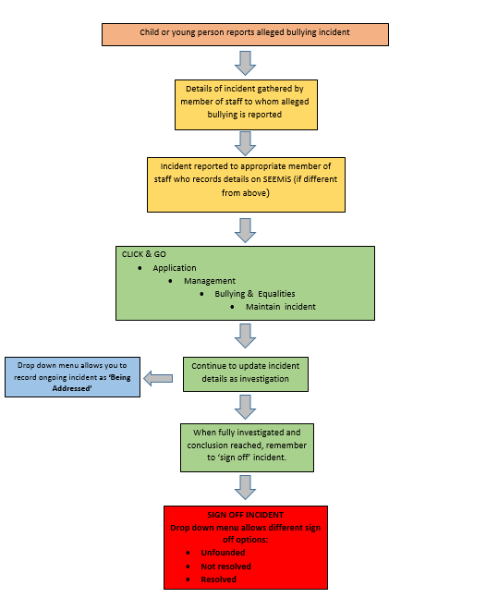

Action Timeline September 2017 – March 2019
September 2017 | - Anti-Bullying review group established to begin policy refresh in line with Respect For All, the national approach to anti-bullying for Scotland’s children and young people. SEEMiS Bullying and Equalities module referenced nationally as good practice within schools.
January 2018 | - SEEMiS Bullying & Equalities module pilot begins in 3 schools.
May 2018 | - The Scottish Government confirms requirement for SEEMiS Bullying & Equalities module to be used in schools to record and monitor bullying incidents.
June 2018 | - Draft procedural guidance created to support colleagues in how and when the module should be used. Safeguarding Network consulted on the draft.
June 2018 | - Stirling Council attendance at RAMBIS Operational Support Group. Stirling schools to be part of phase 2 of RAMBIS national roll out.
July 2018 | - Procedural guidance remaining in draft form awaiting module update from SEEMiS
August 2018 | - Module update from SEEMiS complete  - Revision of draft procedural guidance
September 2018 | - Confirmation of procedure with Safeguarding Network > release of procedural guidance  - All secondaries using module from end of September 2018  - National RAMBIS implementation begins
October 2018 | - First data pull by ASN & Wellbeing team end of October  - Feedback from Safeguarding Network re progress in secondaries
November 2018 | - Feedback from Safeguarding Network re progress in secondaries
December 2018 | - Second data pull by ASN & Wellbeing team mid-December
January 2019 | - Feedback from Safeguarding Network re progress in secondaries  - Primary schools: soft start period January – end February
February 2019 | - Feedback from Safeguarding Network re progress in secondaries
March 2019 | - All schools using module  - Third data pull by ASN & Wellbeing team end March

